Amateur Chamber Music Society
http://www.acms-australia.org/concerts/
— PROGRAM —
Nikolai Rimsky-Korsakov
Song of the Indian Guest from 'Sadko'
Violin: Stephen Harvey, Guitar: Nick Stokes
Bohuslav Martinu
Sonata for flute, violin & piano
Flute: Sally Cousins, Violin: Stephen Harvey
Piano: Nick Stokes
Anthony Verbalis Woodwind Quartet
Eugene Bozza
Trois Pièces pour une Musique de Nuit
Isaac Albéniz
Three Pieces from España, Op 165
Flute: Cathy Wainwright, Oboe: Lorna Hall,
Clarinet: Lindsay Wanstall, Bassoon: Helen Boyton
— Interval —
Ludwig van Beethoven
Cello Sonata No 3 in A major, Op 69
Cello: Robyn Godfrey, Piano: Murray Brown
— refreshments —
- Notes -
Nikolai Rimsky-Korsakov (1844 – 1908) - arr. Nick Stokes
Song of the Indian Guest from ‘Sadko’ (1896)
The opera tells the story of Sadko, who leaves his wife and home in Novgorod and eventually returns a wealthy man. During his years of travel he amasses a fortune, weds the daughter of the King and Queen of the Ocean and has other adventures. The city and his abandoned wife rejoice on his return.
The Song of the Indian Guest is one of the best known arias from this rarely performed work. It has been arranged for instruments such as the harp and solo piano - and in this evening's performance, violin and guitar.
Bohuslav Martinu (1890 – 1959) Sonata for Flute, Violin & Piano (1937)
(i) Allegro poco moderato (ii) Adagio (iii) Allegretto (iv) Moderato (poco Allegro)
Martinu was born in the belfry of a church in Policka, a small Czech town, and he spent a lot of time up in the bell tower when very young. One of the most prolific of 20th century composers, he wrote a wealth of music, including ballets, operas, chamber music and piano music. Starting in 1942, he wrote 6 symphonies which were successful in his new home in New York, whence he had fled from war-torn Europe.
This sonata was written in the year before the Nazi invasion of Czechoslovakia. While it has some of the grace and elegance of Poulenc, it also features disjointed rhythms, spiky dissonances and shrill textures. The finale in particular shows the influence of Prokofiev as well as blues harmonies and jazzy syncopations.
The dedication of this work is to Madame Moyse, wife of Marcel Moyse – the famous French professor of flute and internationally renowned soloist. Martinu and his wife knew the Moyses and stayed with them for a time around 1936. Martinu also wrote a double concerto for flute & violin that was also premiered by Moyse.
Anthony Verbalis (b.1945) Woodwind Quartet (2012)
Anthony Verbalis is a retired College physics teacher living in Pennsylvania, USA. Having played piano, violin, viola and clarinet since childhood he now enjoys spending his time composing music. This quartet is dedicated to Dr Paul Salerni, a Professor of Music at Lehigh University, Bethlehem, Pennsylvania. Dr Salerni allowed Verbalis to join his composition class and this quartet was one of his assignments. Verbalis says his greatest musical influences are the nineteenth century composers such as Brahms, Dvořák, Mahler and Bruckner. More of Verbalis’ music can be found at http://imslp.org/wiki/Category:Verbalis_Anthony
Eugene Bozza (1905 – 1991) Trois Pièces pour une Musique de Nuit (1954)
(i) Andantino (ii) Moderato (iii) Allegro vivo
Eugene Bozza was a French violinist, and a prolific composer of chamber music for wind and brass instruments. He wrote particularly well for wind instruments, music that is enjoyable to play and also interesting for the listener. Bozza won awards for violin, composition and conducting.
Isaac Albéniz (1860 – 1909) -arr. Adam Lesnick Three Pieces from España Op.165
(i) Tango (ii) Capricho Catalán (iii) Zortzico
Albéniz was a leader in the Spanish National School of Musicians. He was a talented pianist, touring to support himself until 1890, when he decided to take composition seriously. He studied under Pedrell, then moved to Paris in 1893 where he was influenced by D’Indy and Dukas. His compositions were generally for piano, many of which have been transcribed for other instruments.
The Tango, transcribed for classical guitar, has become one of the most important works in the classical guitar repertoire. España was originally written for piano in 1890, and has six movements: Prelude, Tango, Serenata, Malaguena, Capricho Catalan and Zortzico. This arrangement features just three of those movements.
Ludwig van Beethoven (1770-1827) Cello Sonata No.3 in A major, Op.69
(i) Allegro, ma non tanto (ii) Scherzo: Allegro molto (iii) Adagio cantabile
(iv) Allegro vivace
This sonata is a major work from Beethoven's incredibly productive middle period. Other works from this period include the 5th and 6th symphonies and the 'Ghost' piano trio. Soon to follow were the 'Emperor' piano concerto and the 'Harp' string quartet.
It was dedicated to Beethoven’s intimate friend Baron Ignaz von Gleichenstein, an amateur cellist, who helped to organise a pension for the composer from a group of rich patrons and joining with him in the courtship of the sisters Anna and Therese Malfatti. Anna's marriage to Gleichenstein in 1811 brought his close friendship with Beethoven to an end.
The acclaimed cellist Steven Isserlis writes:
'Beethoven worked on this sonata between 1806 and 1808; by then, his deafness was acute, if not quite complete. In his tragic letter known as the Heiligenstadt Testament, written in October 1802, Beethoven had admitted that he had harboured thoughts of suicide. "It was only my art that held me back. Oh, it seemed to me impossible to leave the world until I had produced all that I felt was within me."
Yet this sonata - in common with several other works from the same period - is one of the most positive works imaginable; from the opening phrase, it radiates serenity, humour and joy. There is not a note that is trivial, however. The A major Sonata is a thoroughly classical work, its proportions carefully measured, the themes answering each other in perfect symmetry.
It is also the first equal sonata for cello and piano. Previous cello sonatas had either been cello solos with continuo accompaniment or, like Beethoven's first two, piano sonatas with cello obbligato. Here, every theme is perfectly conceived for both instruments; Beethoven had invented a new genre'.
(http://www.theguardian.com/music/2007/jan/12/classicalmusicandopera)

Concert organiser: Murray Brown
Volunteer staff of the Kirribilli Neighbourhood Centre provide light refreshments (wine juice and savouries) and charge $10 entry donation ($5 concession/seniors)
to cover costs and to raise funds for the Centre
To get information on future concerts, go to the website
http://www.acms-australia.org/sydney/
(or Google “ACMS chamber music society Australia”)
and click on “Concerts”
All chamber music players are welcome to join the
Amateur Chamber Music Society, which matches players depending on their experience
and arranges informal playing days, an annual music camp, and concerts.
If interested, go to the website and click on “Join Us”, or
email membership.secretary@acms-australia.org, or
write to ACMS Membership Secretary,
PO Box 584, Balgowlah NSW 2093

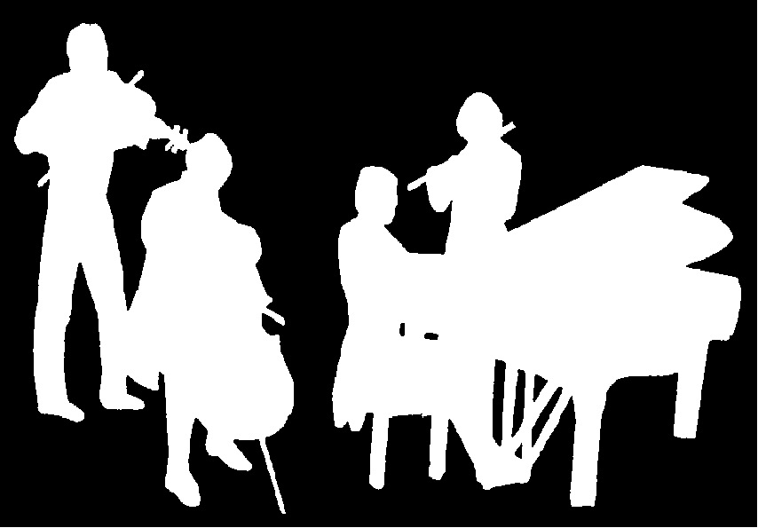
Kirribilli Neighbourhood Centre
www.KNCsydney.org
Amateur Chamber Music Society
http://www.acms-australia.org/
Chamber Music Concert
Sunday 6 September 2015
5pm

