ACMS
www.acms-australia.org/concerts/
— Concert —
5pm Sunday 3rd April 2016
Kirribilli Neighbourhood Centre, 16 Fitzroy St Kirribilli
www.KNCsydney.org tel: 9922 4428
— PROGRAM —
GLINKA Sonata for Viola and Piano First Movement
(1) Allegro moderato in D Minor
viola Michelle Urquhart piano Keith Mitchell
FAURE Trio in D minor Op 120
(1) Allegro, ma non troppo (2) Andantino (3) Allegro vivo
violin Chris Middleton cello Jane Smith
piano Susan Butler
— Interval —
BLAKE Trio for Flute, Clarinet and Piano
(1) Allegretto (2) Andante – Waltz – Andante
(3) Allegro assai
clarinet Leanne Walton flute Richard Tardif
piano Matthew Breadon
DVORAK Theme from New World Symphony
PACHELBEL Canon in D
CARULLI Poco allegro from Three Trios Op 20 No 5
Sydney Guitar School Ensemble: Giuseppe Zangari, Claudie Moffatt, Vicki Spoulos, Brent Sennitt, Bridget McVicar, Michael Simmons
BRUCH Double Concerto for Clarinet, Viola and Orchestra
(1) Andante con moto (2) Allegro moderato
(3) Allegro molto
clarinet Andrew Kennedy viola Michelle Urquhart
piano Gregory Kinda
- Notes -
GLINKA (1804-1857) Sonata for Viola and Piano
Glinka is best known as the "Father of Russian Opera", and the "Father of Russian music". He was a pianist and violist.
The Sonata in D minor for viola and piano was written early in his career, before he travelled to Europe. His view was that the composition was the best of his pre-Italian works due to its tight construction and clever use of counterpoint. The first movement was written in1824 and after a considerable break, the second movement was written in 1828. Unfortunately he did not complete the Rondo, the last movement of the sonata, before his death.
The sonata has a complex, almost concerto-like piano part, whilst the viola line is often lyrical, playing the melodic themes, but often accompanying these melodic lines in the piano. The movement is a work of beauty, the melodies easily sung and the contrasting tempi within its balanced structure give the first movement a sense of being a complete work within itself.
FAURE (1845-1924) Trio in D minor Op 120
Faure’s music forms a bridge from nineteenth century Romanticism to new musical expressions of the twentieth century.
The trio is a late work written between August 1922 and March 1923 – initially for clarinet, piano and cello. The Andantino (in F major) was completed first.
The first public performance was in honour of Faure’s 78th birthday in May 1923.
In each movement elegant melodies weave from player to player. Their progression makes the trio very interesting and satisfying to play, the work ending triumphantly in D major.
BLAKE (b.1938) Trio for Flute, Clarinet and Piano
Howard Blake wrote, directed and edited a 16mm film called 'A Few Days' whilst working at The National Film Theatre in 1961/2. He also composed the music score. In 1964 Blake was approached by the music publishers Chappell and Co. who suggested that he might revise the Romantic Theme (2.Allegro) from the film and use it to create a first movement of a trio, also suggesting that it would be more 'useful' if the harp part could be replaced by piano. Blake agreed to this and also composed the second movement (Andante-Waltz-Andante) and the third movement (Allegro). The completed work was published by Chappell’s imprint 'Music for Education' (Music for instrumental ensemble) in 1964 as 'Trio for flute, clarinet and piano'.
CARULLI, Ferdinando (1770-1841) Poco allegro from Three Trios Op 20 No 5
Carulli was born in Naples and his first instrument was the cello. Soon after he discovered the guitar, which he devoted his life to teaching and playing. As there were no professional guitar teachers in Naples at the time, Carulli developed his own style of playing. He later moved to Paris where he became one of the most successful teachers there. Carulli was among the most prolific composers of his time. He wrote more than four hundred works for the guitar, and many others for various instrumental combinations, always including the guitar.

BRUCH (1838-1920) Double Concerto for Clarinet, Viola and Orchestra
Op 88 (1911)
Bruch's Double Concerto, written for his son, an accomplished clarinetist, uses a rare combination of two instruments with nearly identical ranges and remarkable blending qualities. Clarinet and viola treated as equals - they soliloquize, converse, reflect, and affirm each other throughout.
After a declamatory introduction for each instrument, letting the listeners familiarise themselves with the two personalities, complex episodes of opposition and teamwork begin. Listen and watch for the musicians alternating as soloist, sometimes passing the tune more or less rapidly to create either serenity or intensity, and at other times uniting to fill out glorious or melancholy harmony. In live performance the audience can readily grasp the warm connection and intimate teamwork between the musicians. The pianist must represent the accompanying orchestra, sighing over the top like flutes and oboes, scurrying like violins, or providing a huge brass-like force at climactic points.
The first movement with its long melodic solos could be seen as a tragic, balladic tale. Next we move perhaps to a gentile waltz at a garden party, drifting into the cool night as lovers shy away to a secluded place in the dark. In the third, the piano invokes the seemingly ominous trumpet and drum fanfare, soon giving way to ecstatic flourishes from the "violins", which preface jolly turns from the two soloists. A smile will never be far from your face as you see children imitating overly-serious soldiers in their innocent joyful games.
Andrew Kennedy and Michelle Urquhart will be performing this work with the NSW Doctors Orchestra in aid of the charity, Lions Save Sight Foundation, on Sunday 15 May at 2.30pm at Chatswood Concourse.

concert organiser: Susan Butler
Volunteer staff of the Kirribilli Neighbourhood Centre provide
light refreshments (wine, juice and savouries) and
charge $10 entry donation ($5 concession/seniors)
to cover costs and to raise funds for the Centre

To get information on future concerts, go to the website
www.acms-australia.org
and click on “Concerts”
All chamber music players are welcome to join the
Amateur Chamber Music Society.
If interested, go to the website and click on “Join Us”,
or email membership.secretary@acms-australia.org,
or write to ACMS Membership Secretary,
PO Box 584, Balgowlah NSW 2093

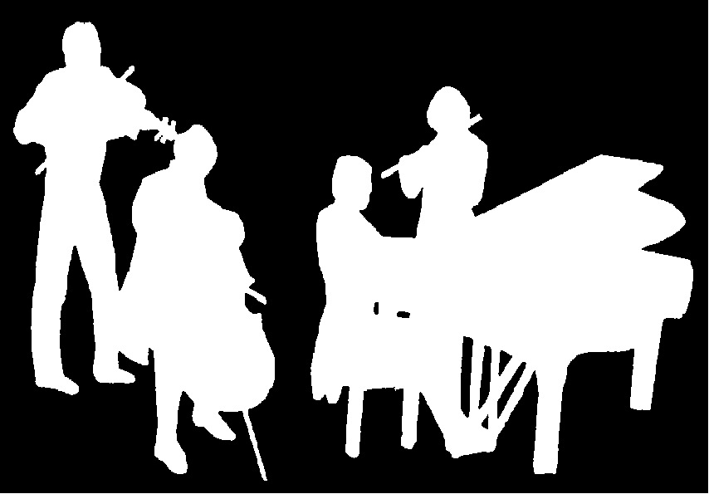
Kirribilli Neighbourhood Centre
www.KNCsydney.org
ACMS
www.acms-australia.org/
Chamber Music Concert
Sunday 3rd April 2016
5pm

