ACMS
— Concert —
5pm Sunday 7 August 2016 (first Sunday in August)
Kirribilli Neighbourhood Centre, 16 Fitzroy St Kirribilli
www.KNCsydney.org tel: 9922 4428
— PROGRAM —
BRAHMS Trio in A minor Op 114
(1) Allegro (2) Adagio
(3) Andante grazioso (4) Allegro
clarinet Lindsay Wanstall cello Caroline Slaytor
piano Murray Brown
35’

— Interval —
YOKOYAMA, SHIN-ITCHIRO L’Epice d’Asie
flute Cathy Fraser cello Caroline Slaytor
bassoon Petrina Slaytor
5’
FALLA Seven Spanish Popular Songs
(1) Movement name (2) Movement name (3) Movement name
(4) Movement name (5) Movement name
mezzo soprano Jo Burton piano Murray Brown
25’

— refreshments —
- Notes -
BRAHMS (1833-1897) Trio for Clarinet, Cello and Piano in A minor Opus 114
This is the first of four chamber works featuring the clarinet written by Brahms. Thinking he had written his last work, Brahms was inspired by the magnificent clarinet playing of Richard Muhlfeld. This inspiration led Brahms to write this Trio in 1891, followed by the Clarinet Quintet, Op 115, and two Sonatas for Clarinet and Piano, Op 120.
The first movement opens with a cello solo, establishing a sombre mood that prevails throughout. Romantic yet introspective motives are interwoven between all three instruments. The Adagio is a dignified movement with interaction between clarinet, cello and piano. Andante grazioso is a waltz style, more playful in mood, with much interplay between clarinet, cello and piano. Allegro, the final movement, makes full use of the versatility of all tree instruments.
Adapted from: https://en.wikipedia.org/wiki/Clarinet_Trio_(Brahms)
YOKOYAMA, SHIN-ITCHIRO L’Epice d’Asie
Yokoyama is a Japanese cellist and composer who lives in France, near Paris. Yokoyama has written many work for piano and also for a variety of other instruments, including a solo bassoon work. He studied at Ecole Normale de Musique de Paris Alfred Cortot.
This work was composed in 2002. It is in ternary form and is being performed in the original instrumentation.
MANUEL de FALLA (1876-1946) Seven Spanish Popular Songs
Like the Frenchman Paul Dukas, the Spaniard Manuel de Falla was a very fastidious and self-critical composer, and this significantly affected the volume of his output. Partly for this reason, his published works are of a consistently high quality.

In 1907 Falla moved to Paris, a city that was at that time a magnet for composers from all around the world. During his seven-year visit he befriended many leading composers such as Dukas, Albéniz, Debussy, Fauré and Ravel. He wrote the Siete Canciones populares Españolas (Seven Popular Spanish Songs) in 1913.
The work was not premiered until the spring of 1915 in Madrid, after Falla and other Spanish composers had been forced to leave Paris and return home at the start of the First World War. It was the first work of his maturity as a composer and was followed by the popular ballets Love the Magician and The Three-Cornered Hat, as well as the opera La Vida Breve and other works.
Apart from the last song, Polo, the Siete Canciones are melodically identical to the folk tunes on which they're based. It is the originality and diversity of the piano accompaniments that gives the group of songs their special quality; while undeniably Spanish, they are also imbued with Falla's own unique expressive qualities as a composer.

concert organiser Lindsay Wanstall
Volunteer staff of the Kirribilli Centre provide
light refreshments (wine juice and savouries) and
charge $10 entry donation ($5 concession/seniors)
to cover costs and to raise funds for the Centre

To get information on future concerts, go to the website
http://www.acms-australia.org/sydney/
(or Google “ACMS chamber music society Australia”)
and click on “Concerts”
All chamber music players are welcome to join the
Amateur Chamber Music Society. If interested, go to the website and click on “Join Us”, or email membership.secretary@acms-australia.org, or write to ACMS Membership Secretary, PO Box 584, Balgowlah NSW 2093

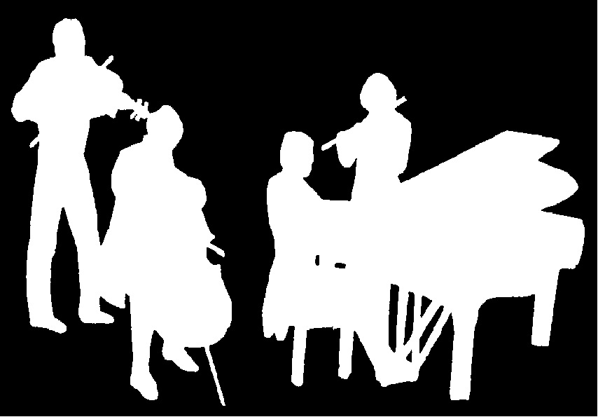
The Kirribilli Centre
www.thekirribillicentre.org
ACMS
http://www.acms-australia.org/concerts
Chamber Music Concert
Sunday 7 August 2016
5pm

