- program -
BEETHOVEN Sonata No 4 in A minor Op 23
(1) Presto (2) Andante scherzoso più allegretto (3) Allegro molto
violin George Carrard piano Murray Brown
20’
HAYDN Trio in D major Hob XV:16
(1) Allegro (2) Andantino più tosto allegretto (3) Vivace assai
violin Greta Lee cello Clara Blazer piano Kian Woo
14’
C P E BACH Variations on the Spanish Folia
clavichord Ivan Foo
9’
interval
C P E BACH Rondo No 1 Wq 58/1
clavichord Ivan Foo
6’
Two Pieces for Cello and Piano
SAINT-SAËNS Allegro appassionato Op 43
FAURÉ Après un Rêve Op 7 No 1
cello Sharon Maennl piano Neil Semmler
7’
PROKOFIEV Sonata D major Op 94 first two movements
(1) Moderato (2) Scherzo: Presto
flute Cathy Wainwright piano Linda Kurti
12’
GERSHWIN/arr SEMMLER Three Songs
(1) Maybe (2) Summertime (3) Fascinatin’ Rhythm
violin Debbie Gray viola John Keller
cello Sharon Maennl piano Neil Semmler
12’
REFRESHMENTS
Notes
BEETHOVEN (1770-1827) Sonata in A minor Op 23
Beethoven was 31 when he composed this sonata in 1801. He intended to publish Op 23 and 24 (“The Spring”) as Op 23 No 1 and 2, but the sonatas were separated owing to an printing error. In the 1790s Beethoven had already captured the imagination of Viennese audiences as a virtuoso pianist and his 1795 piano trios Op 1 established his credentials as an up-and-coming composer keen to distinguish himself from his esteemed teacher, Haydn.
Beethoven’s late symphonies can be seen as pairs according to their prevailing mood: Nos 3 (“Eroica”), 5 and 7 being dramatic or heroic and Nos 6 (“Pastorale”) and 8 more gentle. There is a similar pattern with his violin sonatas. Of the three Op 12 sonatas No 1 is dramatic and Nos 2 and 3 more serene. No 4 is dramatic, 5 (“Spring”) serene. The three Op 30 sonatas string are numbered 6 to 8: No 7 is the dramatic one with 6 and 8 more serene. No 9 (“Kreutzer”) is dramatic, No 10 has a gentle mood.
Beethoven's disregard for the customary niceties is apparent in the opening Presto of Op 23, which plunges the listener into a maelstrom of roiling triplets. Only after a minute or so does he introduce a smoothly flowing theme that gives the music a countervailing semblance of repose. He dispenses with the traditional pair of middle movements (adagio and minuet or scherzo); in their place, he gives us a hybrid andante scherzando in A major, fleshed out with recurring fugal passages. Most unconventional of all is the finale, which combines three sharply contrasting themes in an episodic structure that is tightly knit yet full of unexpected twists and turns.
HAYDN (1732-1809) Trio in D major Hob XV:16
As with much of Haydn’s output, this work imbued with wit and rhythmic energy. The keyboard part is particularly exuberant, is dominant and central to the structure, while the violin part is more a vital obbligatto line, possibly Haydn’s clever solution to add extra carrying power to the then keyboard’s weak upper registers. The cello does not have an independent part; it adds weight to the resonance of the lower registers of the keyboard. Publication of this work was in 1790, the eve of Haydn’s move from Eszterháza to London. Haydn wrote all of his later keyboard trios between 1784 and 1797. Interestingly, twenty-seven of these trios are listed as ‘sonatas’ and only three as ‘trios’. The instrumentation of numbers 15, 16 and 17 is given as ‘harpsichord/pianoforte, flute and violoncello’, while number 17 has the added ‘flute/violin’ option. These works were probably composed more for private entertainment than public performance. Today we will perform number 16 on piano, violin and cello.
C P E BACH (1714 - 1788) Two pieces for Clavichord
Rondo No 1 Wq 58/1, Variations on the Spanish Folia Theme Wq 118/9
The clavichord and the harpsichord appeared during the 14th century—the clavichord probably being earlier. They were both common until widespread adoption of the piano in the 18th century. C P E Bach loved his clavichord, Haydn would have used them until about 1770, but later he, Mozart, Beethoven and Brahms would have an early piano (a fortepiano) in mind.
Dr Charles Burney visited C P E Bach and his family on the 12th October 1772 and wrote “M. Bach was so obliging as to sit down to his … clavichord and favourite instrument, upon which he played three or four of his choicest and most difficult compositions ... In the pathetic and slow movements, whenever he had a long note to express, he absolutely contrived to produce, from his instrument, a cry of sorrow and complaint, such as can only be effected on the clavichord, and perhaps by himself. … After dinner … I prevailed upon him to sit down again to a clavichord, and he played, with little intermission, till near eleven o'clock at night. During this time, he grew so animated and possessed, that he not only played, but looked like one inspired. His eyes were fixed, his under lip fell, and drops of effervescence distilled from his countenance. He said, if he were to be set to work frequently, in this manner, he should grow young again …”
Two Pieces for Cello and Piano
FAURÉ (1845-1924) Apres Un Reve Op 7 No 1 originally written for voice and piano is popular in its arrangement for cello replacing the voice. The text of the song is a dream of romantic flight with a lover, away from earth "towards the light". On waking to the truth the dreamer longs to return to the "mysterious night" and the ecstatic falsehood of his dream. SAINT-SAËNS (1798–1835) Allegro appassionato Op 43 is transparently scored and elegantly tuneful, its lively rhythms create a mood similar to that of the composer’s well-known Cello Concerto in A minor. Undoubtedly, the piece's melodiousness and numerous repeats of minimal material are the reasons for its popular success.
PROKOFIEV (1891-1953) Sonata for Flute and Piano in D major Op 94
Prokofiev settled in Paris after the 1917 Bolshevik Revolution and returned to Russia in 1934. Despite personal tragedies, many of his most beloved works were written after this time. Commissioned by the Committee on Artists’ Affairs, and written during the dark days of World War II, this Sonata was premiered in 1943 by the flautist Nicolai Kharkovsky and pianist Sviatoslav Richter. It is Prokofiev’s only significant work for flute and is considered one of the most significant twentieth century masterpieces for the instrument. With the proportions of some of the greatest violin sonatas it is a true duo, showcasing the agility, stamina, technical and interpretive skills of both performers. Later Prokofiev arranged the sonata for violin and piano (Op 94a) at the request of David Oistrakh. The Sonata is neoclassical in style, and has many resonances with Prokofiev’s “Classical” Symphony, also in D Major, and his first Violin Concerto.
GERSHWIN (1898-1937)/arr SEMMLER Three Songs
Neil Semmler arranged four songs by George Gershwin for piano quartet performed here last November, and now presents three more: Maybe is from the musical Oh, Kay! (1926) set in the prohibition and jazz era. Its refrain melody uses the pentatonic scale, which can be demonstrated by playing any group of five consecutive black keys on a piano. Summertime is an aria sung frequently in the opera Porgy and Bess (1934). Over the years the aria’s popularity has increased to more than 30,000 recorded performances. Neil’s arrangement evokes a Sydney flavour – a hot steamy summer's day, with perhaps a slight wisp of breeze arriving at the end. Fascinatin’ Rhythm is a popular song from the Broadway musical Lady Be Good (1925). The arrangement capitalises on the rhythmic surprises of the melody. The opening 'verse' is a clash of wills between the strings & piano: the strings want to skip the verse but the piano insists on starting with it. (Postscript: George Gershwin’s grandniece, Lisa-ann Gershwin, works for the CSIRO in Tasmania and recently published a book showing how jellyfish are taking over as the sea temperature warms.)
concert organiser George Carrard
Volunteer staff of the Kirribilli Neighbourhood Centre provide light refreshments (wine juice, savouries and fruit) and charge $10 entry donation ($5 concession/seniors)
to cover costs and to raise funds for the Centre
To get information on future concerts, go to the website
http://www.acms-australia.org/concerts/
All chamber music players are welcome to join the
The Amateur Chamber Music Society which matches players depending on their experience and arranges informal playing days, an annual music camp, and concerts. If interested, go to the website and click on “Join Us”, or write to ACMS Membership Secretary, PO Box 584, Balgowlah NSW 2093 or
email membership.secretary@acms-australia.org

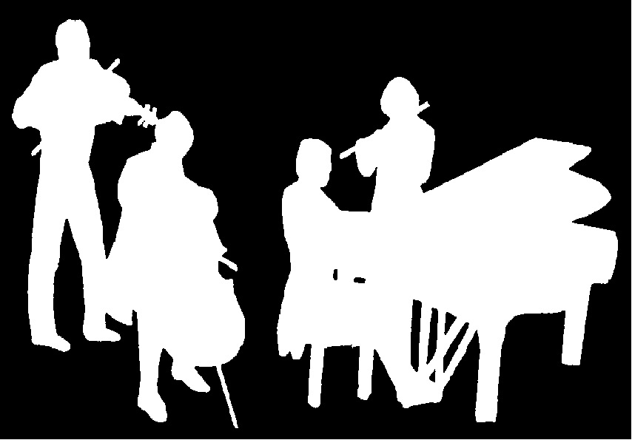
The Kirribilli Centre
www.thekirribillicentre.org
Amateur Chamber Music Society
http://www.acms-australia.org/
Chamber Music Concert
5pm Sunday 3 July 2016
Kirribilli Neighbourhood Centre
www.KNCsydney.org
Amateur Chamber Music Society
http://www.acms-australia.org/
Chamber Music Concert
Sunday 3 July 2016
5pm

https://www.carnegiehall.org/m/event.aspx?view=prog&id=10737421478, http://beeri.org/notes/beethoven-violin-sonatas.html, https://en.wikipedia.org/wiki/Violin_Sonata_No._4_%28Beethoven%29, Beethoven symphonies in New York Review of Books 3 December 2015.
http://www.peter-bavington.com/bachaydn.htm, https://en.wikipedia.org/wiki/Keyboard_instrument#History

