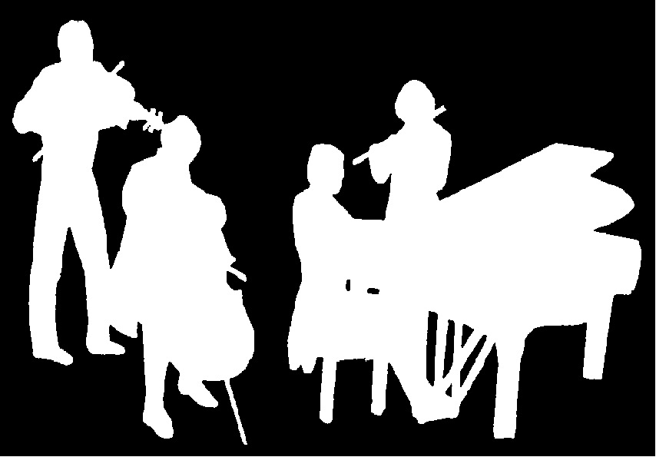
Kirribilli Neighbourhood Centre
www.KNCsydney.org
ACMS
www.acms-australia.org/
Chamber Music Concert
Sunday 12th June 2016
5pm

ACMS
www.acms-australia.org/concerts/

— Concert —
5pm Sunday 12th June 2016
Kirribilli Neighbourhood Centre, 16 Fitzroy St Kirribilli
www.KNCsydney.org tel: 9922 4428

— PROGRAM —
RESPIGHI Sonata in B Minor for violin and piano
(1) Moderato (2) Andante Espressivo (3) Passacaglia – Allegro moderatro ma energico
violin Tracey Tsang piano Ben Chan
BACH Jesu Joy of Man’s Desiring
CARULLI Poco Allegro
CARULLI Allegretto
The SGS Guitar Ensemble (Quartet) guitars Claudie Moffatt, Brent Sennitt, Vicki Spoulos, Giuseppe Zangari

DOWLAND Lesson for Two Lutes
MILAN All My Life I Have Loved You
ROBINSON Toy for Two Lutes
guitar Tessie Sato guitar Giuseppe Zangari, bassoon Liam Webb

— Interval —
IRADIER La Paloma
The Halpman Wind Quartet flute Lien Duckett oboe Phoebe Masnick clarinet Ashleigh O’Young bassoon Hamish McLennan
piano Su-Lee Oei conductor Liam Webb

— noticeboard —

Michelle Urquhart in Concert (concert two of the series). Guest artists – Con Brimo Ensemble. Olena Zaporozhets – violin, Michelle Urquhart – viola, violin, Deborah Coogan – cello, Julia Brimo – piano. Performing piano quartets by Dvorak, Mahler and Brahms

Sun 12 June, 2pm at St Luke’s Anglican Church, Cnr Ourimbah Road and Heydon Street, Mosman

Tickets and enquiries: urquhart4strings@gmail.com 0405 357 849
Adults-$30 Concession- $20 Children- $5

Sydney Guitar School (Five Dock and Kirribilli) - End of Term Concert
You are invited to an evening of beautiful guitar music performed by the students of the Sydney Guitar School. The concert showcases the work of term 3 in a combination of solos, duos, trios and guitar ensembles

Fri 24 June, 700 pm at Ridley Hall, 175 Great North Road, Five Dock

Tickets and enquiries: info@sydneyguitarschool.com.au 0439 192 555
Entry: Gold coin donation

ACMS Sunset Concert – July Sunset Concert
Works by Beethoven, Haydn, CPE Bach, Saint-Saens, Prokofiev and Gershwin. Organiser – George Carrard ACMS

Sun 3 July, 500pm at Kirribilli Neighbourhood Centre, 16-18 Fitzroy Street, Kirribilli
Tickets-$10 Concession-$5

Giuseppe Zangari, accordionist Marcello Maio, flautist Jane Rutter celebrate the music of Italy with Vivaldi, Giuliani, Corelli and Rossini. The concert includes Tarantellas, Southern Italian dances and Piovani’s Beautiful that Way from the beloved film, Life is Beautiful. Viva L’italia!

Wed12 October, 12pm at the Concert Hall, Chatswood Concourse

Tickets and enquiries: 8075 8111
Adult-$30 Concession-$27 (Lunch add $15)
– Notes –

RESPIGHI, Ottorino (1879 - 1936 ) Sonata for Violin & Piano in B Minor

Composed in 1917, the Violin Sonata in B minor is contemporary with two of Respighi’s most popular orchestral works: La boutique fantasque, based on music by Rossini written for Diaghilev’s Ballets Russes, and Fontane di Roma, the first piece in his great Roman trilogy. It was his first large-scale chamber work since an unpublished string quartet from 1909.

The first performance of the B minor Sonata was given in Bologna on 3 March 1918, played by Respighi’s old teacher, Federico Sarti, with the composer himself at the piano. Respighi was delighted, writing to his old friend (a fellow-pupil in Sarti’s class) Arrigo Serato: ‘Inni! Non faccio per dire, ma abbiamo suonato bene. Io compreso!’ (‘Praise be! I shouldn’t say so, but we played it well. Me included!’). It was described by Edward Moore in the Chicago Daily Tribune as being of interest for several reasons: ‘Quite outside of its own merits, which were many, this sonata served to indicate how the new generation of Italian composers is labouring to get away from the theory that Italian music means Italian opera … Respighi has written rather a good sonata … conceived along broad lines and on large ideas.’

The opening Moderato - with its soaring, rhythmically supple cantilena theme, dark and stormy middle section, and radiant coda—is strikingly reminiscent of César Franck’s Violin Sonata in A Major. Respighi’s harmonic language is highly chromaticised but essentially tonal; the Andante espressivo, an elegiac meditation in B major, is built around a gently rocking arpeggio figure that is almost purely diatonic. Listen for a reprise of the urgent theme from the first movement, which also returns in the finale, a vigorous passacaglia with Bachian overtones that is equally rich in counterpoint and lyricism.

BACH, Johan Sebastian (1685-1750) Jesu Joy of Man’s Desiring
Jesu, Joy of Man's Desiring is the tenth and last movement of the cantata ‘Herz and Mund und Tat und Leben’ (Heart and Mouth and Deed and Life), BWV 147, composed by Johann Sebastian Bach. This music comes from Bach’s Weimar period. The music’s wide popularity has lead to many instrumental arrangements, notably the classical guitar.
CARULLI, Ferdinando (1770-1841) Allegretto
Carulli was born in Naples and his first instrument was the cello. Soon after he discovered the guitar, he devoted his life to teaching and playing the instrument. As there were no professional guitar teachers in Naples at the time, Carulli developed his own style of playing. He later moved to Paris where he became one of the most successful teachers there. Carulli was among the most prolific composers of his time. He wrote more than four hundred works for the guitar, and many others for various instrumental combinations, always including the guitar.

DOWLAND, John (1563-1626) Lesson for Two Lutes
Considered the greatest lute virtuoso and composer of the English school in the early 17th century, John Dowland (1563–1626) composed and collected many works for the lute. At that time the lute was the most popular instrument in the Western world. It became the symbol of the magic and power of music. This work, although found in the Lute Book of Dowland, is of anonymous origin. Its simple structure consists of two repeated sections and presents a delightful and fresh work that has been adapted for the modern guitar.

MILAN, Luis (c1500 – c1561) All My Life I Have Loved You

This song is from a Spanish Renaissance composer, vihuelist (a forerunner to the baroque guitar), and writer on music, Luis Milan (c. 1500 – c. 1561). It was originally included in a work entitled “El Maestro” - with the instructions being that with the simple accompaniment the singer could ornament the song. However, when the guitarist played the more elaborate accompaniment, the singer was to sing the song plainly. This arrangement has the clarinet playing the role of the singer and the two guitars providing the more elaborate setting.

ROBINSON, Thomas (c. 1560 – c. 1610) Toy for Two Lutes

This duet is from, “The Schoole of Musicke” (1603) by the English renaissance composer and music teacher, who flourished around 1600, Thomas Robinson (c. 1560 – 1610 (Julian calendar)). He taught and wrote music for lute, cittern, orpharion, bandora, viol, and singing. This work, originally for the lute, consists of four sections that are repeated. The repeated sections were originally designed to allow the performers to swap parts and extend their performance experience.

GRANADOS, Enrique (1867 – 1916) Spanish Dance No 4: Villanesca

Villanesca is one of twelve dances for piano entitled 12 Spanish Dances Op. 37 by the Spanish composer Enrique Granados. The playful and tuneful dance is surrounded by a beautifully plaintive four-voice chorale. The music of Granados is in a uniquely Spanish style and is a good representation of musical nationalism.

TRADITIONAL - Cueca (Chilean Dance)

Originating in Chile and Bolivia in the 1900s, the cueca is a slow and sensual handkerchief dance in 6/8 time. It is now the national dance of Chile. The clothing worn during the cueca dance is very traditional Chilean clothes. They wear black costumes or dresses. The men in the dance wear the huaso's hat, shirts, flannel poncho, riding pants and boots, short jacket, riding boots, and spurs. Women wear flowered dresses. Cueca dancing resembles a rooster-chicken relationship. The man approaches the woman and offers his arm, then the woman accompanies him and they walk around the room. They then face each other and hold their handkerchief in the air, and begin to dance. They never touch, but still maintain contact through facial expressions and movements. The white handkerchief must be waved.

SVOBODA, Paul (1959) Wongaling from Life’s a Beach Suite

Wongaling is the first movement of "Life's a Beach" suite for guitar ensemble. Paul Svoboda named the four movements after beaches that he lived on in the early 1980's in North Queensland. That part of the world is sub-tropical, secluded, hot and balmy. The composer writes, "Wongaling is a long beach, perfect for jogging in the late afternoon, or just having a party..."

IRADIER, Sebastian (1809 – 1865) La Paloma
Iradier was a Spanish Basque composer, best known for his song titled La Paloma written in 1860 after his visit to Cuba. “La Paloma” belongs to a genre of songs called “habaneras” that has distinct rhythms reflecting the fusion of local Cuban songs that Spanish sailors of the time brought back with them from their travels. La Paloma means “The Dove’ which symbolised the white dove that returns home, a final message of love from a sailor who is lost at sea. “La Paloma" very quickly became popular outside of Spain, particularly in Mexico, and soon spread around the world including Hawaii, the Philippines, Germany and Romania where it gained folk song status. Over the years the popularity of "La Paloma" has surged and receded periodically, but never subsided. Unfortunately, Iradier died in obscurity in 1865, never to learn how popular his song would become.

2 Latin-American Folk Tunes
Las Mananitas is a traditional Mexican lullaby. It is also a birthday song usually sung to awaken the birthday person and also to serenade a woman. Marchinha de Carnaval is from Brazil. It is a comic genre of music which satirizes the seriousness of military marches.ROTA, Nino (1911-1979) Intermezzo
Nino Rota was an Italian composer known for his film scores which include all the films of Federico Fellini and Francis Ford Coppola’s The Godfather. He composed many other works in a wide variety genres, including opera and chamber music. The Intermezzo (1945) for viola and piano is a one movement work. It exhibits Rota’s gift of melody, immediacy and drama. It contains an extended and almost incessant middle section surrounded by a consoling and nostalgic theme.

GRANADOS Spanish Dance No 4 : Villanesca
TRADITIONAL Cueca (Chilean Dance)
KOCH (arranged by Richard Charlton) Rumba Flamenca
SVOBODA – Wongaling from “Life’s a Beach” Suite
The SGS Guitar Ensemble (Quintet) guitars
Greg Allardice, Claudie Moffatt, Tommaso Girotto, Brent Sennitt, Giuseppe Zangari

ROTA – Intermezzo for violin and piano
viola Michelle Urquhart piano Kian Woo

— END —

Concert organiser: Su-Lee Oei
Volunteer staff of the Kirribilli Neighbourhood Centre provide
light refreshments (wine, juice and savouries) and
charge $10 entry donation ($5 concession/seniors)
to cover costs and to raise funds for the Centre

To get information on future concerts, go to the website
www.acms-australia.org
and click on “Concerts”
All chamber music players are welcome to join the
Amateur Chamber Music Society.
If interested, go to the website and click on “Join Us”,
email membership.secretary@acms-australia.org,
or write to ACMS Membership Secretary,
PO Box 584, Balgowlah NSW 2093

