ACMS
www.acms-australia.org/concerts/
— Concert —
5pm Sunday 6th March 2016
Kirribilli Neighbourhood Centre, 16 Fitzroy St Kirribilli
www.KNCsydney.org tel: 9922 4428
— PROGRAM —
HAYDN String Quartet Op 77 No 1
(1) Allegro Moderato (2) Adagio
(3) Menuet:Presto (4) Finale: Presto
violins Marjorie Hystek and Benjamin Chan
viola Michelle Urquhart cello Jane Smith
MOZART Violin Sonata KV 526
(1) Molto Allegro (2) Andante (3) Presto
violin Pam Hepworth piano Ludwig Sugiri
Franz and Karl DOPPLER Fantasy on Rigoletto
flutes Cathy Wainwright and Beate Birr piano Jane Smith
— Interval —
MOZART The Magic Flute KV 620 arr by A A Scott
Phyllis Avidan LOUKE As Eagles Flew
flutes The Valentine Sextet:
Beate Birr, Cathy Fraser, Bruce Lane, Peter Scaysbrook,
Richard Tardif and Cathy Wainwright
MOZART Divertimento in E flat Major KV 563
(1) Allegro
violin Michelle Urquhart viola Daniel Morris
cello Nichole McVicar
— refreshments —
- Notes -
HAYDN (1732-1809) String Quartet Op 77 No 1 (1799)
When Haydn had written this quartet Mozart had died, a young Beethoven had just published his Op 18 string quartets and Australia had been established as a penal colony.
In this work virtuosic concertante solos are soon echoed by all parts. As in multiple places throughout the quartet, the cello rises in partnership with the first fiddle for some of the most independent part writing to date. This is one of the most elaborate of Haydn’s quartets complete with multiple themes, an adventurous development section, a recapitulation full of fresh innovations. The elaborate polyphony bounding with energy makes for a showcase of both technique and bravado character.
MOZART (1756-1791) Violin Sonata KV 526
The last decade of Mozart's life was, for the most part, a very fruitful period for him as a composer. The Sonata for Piano and Violin in A Major, KV 526 dates from these years. By this time, Mozart was no longer in salaried employment but was his own master.
The two instruments in KV 526 are showcases for the brilliance of their players. Of the sonatas Mozart wrote for violin and piano, KV 526 is the most virtuosic, requiring of its players versatility of both fingers and mind. Rather than composing this work for amateurs, Mozart likely had himself in mind for the piano part. He was at the keyboard for the work's premiere although, because of the deadline of an already-scheduled performance, he had not quite finished writing out the piano part and was forced to play from a very basic sketch.
Franz and Karl DOPPLER (1821-1883, 1825-1900) Fantasy on ‘Rigoletto’
The Fantasy on Verdi’s Rigoletto, though often attributed to Franz Doppler appears to be the work of both Franz (1821-1883) and his younger brother Karl (1825-1900). The brothers were born in Lwów (now Lviv) in Austria. Franz later settled in Vienna where he was a ballet conductor at the court opera and teacher at the Conservatoire. Karl gave concerts all over Europe before becoming Kapellmeister at the court in Stuttgart, where he remained for 33 years. The two brothers were outstanding players of their generation, masters of every nuance of tone and expression, and their perfect ensemble playing in even the most difficult passages won critical acclaim. Together they added a small but significant portfolio of works for two flutes and piano to the repertoire, including a Fantasy on Rossini’s Barber of Seville and a Hungarian Fantasy. This work presents three of Verdi’s “hit tunes” in highly decorated garb: ‘La donna è mobile’, ‘Caro nome’, the great Act 3 quartet, and then concludes with a waltz treatment of ‘Caro nome’.
MOZART (1756-1791) The Magic Flute KV 620 arr by A A Scott
This transcription of Mozart’s Magic Flute Overture is faithful to the original, and is suitable as a Flute Quintet (omitting the bass flute) or massed ensemble performance with several on a part. The bass flute is optional, but is highly desirable for added tonal depth. The Flute Choir as a medium is increasing in popularity, and with the greater availability of the various members of the Flute Family, should become more so. When sufficient attention is paid to intonation, neatness of execution and precision of ensemble, the lovely ethereal tone quality unique to this idiom makes a lasting impression.
P A LOUKE (1954- ) As Eagles Flew
(“As Eagles Flew” is a programmatic piece written in memory of P A Louke’s friend, Bob Clew, who passed away in the fall of 2004. This piece seeks to capture Bob’s life as an Aerospace Engineer, his kind and gentle side (and his impish side), as well as his Irish heritage.
It begins with a soaring Andante theme in D major that culminates with a rocket launch, followed by a slow Irish theme in D minor. The centre section is a military style march in 6/8 time alternated with the Irish theme played in a jaunty style by the piccolo. Brief fragments of the opening appear in the last section until the peaceful reprise of the andante theme at the end.
As “Eagles Flew” is scored for piccolo, 3 C flutes, alto flute, bass flute, and optional contrabass flute or string bass.
Phyllis Avidan Louke (b. 1954), is Music Director of Rose City Flute Choir and principal flute with Oregon Pro Arte Chamber Orchestra and Oregon Symphonic Bank, She adjucates, maintains a private studio, and freelances in Portland, Oregon.
Ms Louke has been arranging for flute ensembles since 1990 specialising in folk songs and Jewish music. Her original compositions for flute choir include Suite Butterfly, Une chanson du Printemps, Under the Big Top, Of Wizards and Witches and Cloud Images. Echoes in the Wind (a Native American soliloquy) and Castle In the Mist are for alto flute and piano.
MOZART (1756-1791) Divertimento in E flat Major KV 563
One could say the Divertimento in E Flat is a concerto for string trio without accompaniment. Technical thrills and spills throughout demand soloistic abilities from each player, and yet the grand scale of the entire work has a sonorous playfulness that begs a light-hearted interpretation. It is the only string trio Mozart wrote, some say the first of its kind in the repertoire. He wrote it in payment of a debt in September of 1788, and he himself played the viola part in its premier performance in Dresden the following April.
concert organiser: Jane Smith
Volunteer staff of the Kirribilli Neighbourhood Centre provide
light refreshments (wine, juice and savouries) and
charge $10 entry donation ($5 concession/seniors)
to cover costs and to raise funds for the Centre
To get information on future concerts, go to the website
www.acms-australia.org
and click on “Concerts”
All chamber music players are welcome to join the
Amateur Chamber Music Society.
If interested, go to the website and click on “Join Us”,
or email membership.secretary@acms-australia.org,
or write to ACMS Membership Secretary,
PO Box 584, Balgowlah NSW 2093

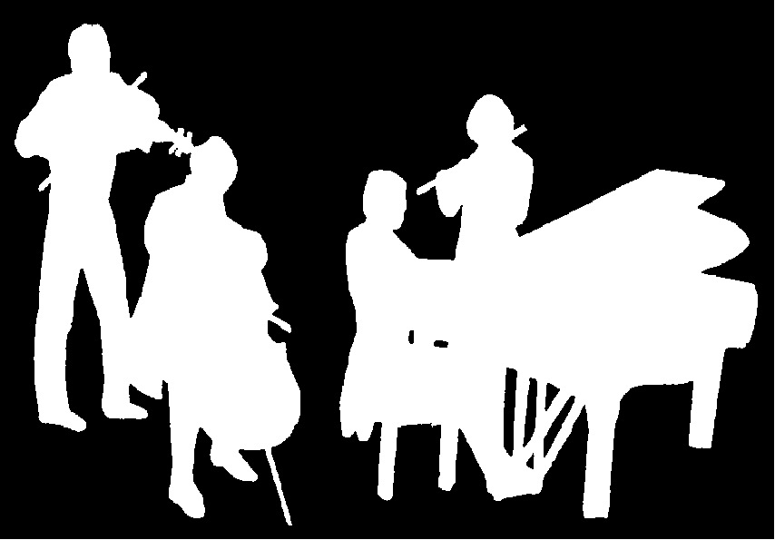
Kirribilli Neighbourhood Centre
www.KNCsydney.org
ACMS
www.acms-australia.org/
Chamber Music Concert
Sunday 6th March 2016
5pm

