— Sunset Concert —

Ludwig Thuille Sextet for Piano & Wind, Op.6
(1) Allegro moderato
(4) Finale. Molto vivace
piano Linda Kurti, flute Richard Tardiff, oboe Adele Haythornthwaite clarinet Lindsay Wanstall, horn Neil O'Donnell, bassoon Petrina Slaytor
Antonin Dvorak Piano Quintet, Op. 81
- Allegro, ma non tanto
piano Patsy Short, violins Sheila Fitzpatrick & Marian Arnold, viola Danny Morris, cello Nicole McVicar

- Interval —

Mel Bonis Suite en Trio, Op. 59
Serenade, Pastorale, Scherzo
Christopher Caliendo Caliente
flute Sally Cousins, violin Steve Harvey, piano Nicholas Stokes

Duke Ellington Satin Doll
Jim Henson and Sam Pottle Theme from the Muppets
Colin Cowles Soliloquy and Promenade
Henry Mancini Pink Panther
George Gershwin Liza
saxophones Andrew Cousins (Soprano & Alto), Carolyn LaMotte (Alto), David LaMotte (Tenor), Peter Scaysbrook (Baritone)

— REFRESHMENTS (Concert concludes before 6:30pm) —

Concert Organiser: Nick Stokes.

- Notes -
Ludwig Thuille (1861-1907) Sextet for Winds and Piano, Op. 6
Ludwig Thuille has been one of the more neglected composers of the 19th century. Orphaned at young age, the young Austrian received musical training via the generosity of a wealthy widow. During his youth, Thuille befriended a composer that would be remembered much better than he would, Richard Strauss. The composers were close musically as well as personally; the two represented the late-century Munich school of composition. Thuille wrote for all genres with a focus on opera and chamber music, but his chamber music is how he is now remembered, with the sextet the most performed piece.
Composed in 1888, Strauss was instrumental in arranging for the premiere performance and held a high opinion of the work. The first movement begins nobly with a horn solo. The finale, Vivace, is an exciting romp, full of high spirits.
Source http://bridgechamberfestival.org/downloads/2014notes.pdf
Dvorak Quintet in A major Opus 81 - Allegro non troppo
Written in 1887 when Dvorak was 46, this quintet is one of the great Romantic chamber works. The first movement, while in sonata form, seems to evolve out of folk song and sprung dance rhythms, and has an improvisatory character.
The cello introduces the first subject which the piano and first violin reinforce. The viola initiates the second subject in a five-bar phrase, passing it to the first violin, the piano, then first and second violin as a duet. The piano restates the second subject to finish the exposition (which is repeated).
Dramatic shifts of mood, key and dynamics in the development contribute to the narrative style, while the recurring cross-rhythms and shifting instrumental textures allow each player to move fluidly between leading and supporting.
The recapitulation shifts the instrumental roles with the first violin initiating the first subject and the cello taking the second subject. The movement resolves to A major in an upbeat mood; clearly the story has a happy ending, and the coda sounds suspiciously like a polka.

Mélanie Hélène Bonis (1858-1937)
Mel Bonis, was a prolific French composer who wrote works for piano, organ, choir and orchestra. Her music is essentially Romantic, with a more Impressionist style in later years.
Self-taught until she was 12, Bonis entered the Paris Conservatoire at 18 with the assistance of César Franck. She excelled in harmony, composition and piano accompaniment. Her parents eventually withdrew her from the Conservatoire and arranged her marriage to a wealthy widower. For the next ten years she cared for their eight children. Later, she resumed composing, and was rewarded with prizes and commissions from prestigious Parisian editors.
This suite was written in 1903, and we chose to play it today as each movement has something beautiful and unique to offer. Sérénade has a plaintive main theme, echoed between the instruments; Pastorale has a lilting melody that is passed between the flute and violin. The final movement is a playful Scherzo with a scale-based and arpeggiated main theme but also includes some chromatic runs with complex harmonies and rhythmic interest.
No Strings Attached -
play both as a clarinet and a saxophone quartet employing the most common range of instruments within these genres and it is their pleasure to perform on saxophones for you today. They have been playing together as a group for approximately three years, having met at ACMS playing days. Their saxophone repertoire is varied as will be seen this afternoon, including jazz, classical and well known novelty numbers.

For information on future concerts, go to the website
http://www.acms-australia.org/ and click on “Concerts”.
All chamber music players are welcome to join the Amateur Chamber Music Society. If interested, go to the website, click on “Join Us.

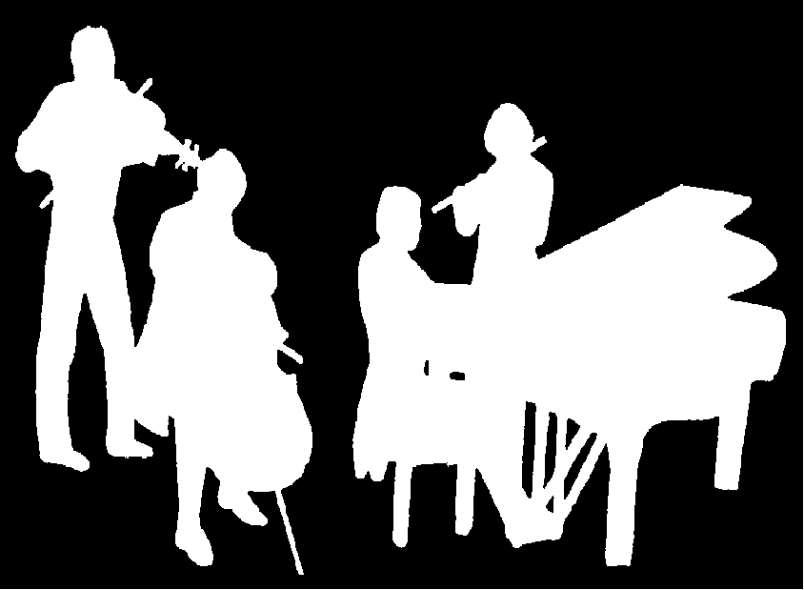
A Concert of Chamber Music
Brought to you by ACMS
5pm Sunday 1 May 2016
16 Fitzroy St Kirribilli
Kirribilli Neighbourhood Centre
16 Fitzroy St Kirribilli tel: 9922 4428
www.KNCsydney.org
Amateur Chamber Music Society
http://www.acms-australia.org/

5pm

