ACMS
http://www.acms-australia.org/concerts/
— Concert —
5.00pm Sunday 6th November 2016 (first Sunday in November)
Kirribilli Centre, 16 Fitzroy St, Kirribilli
www.KNCsydney.org tel: 9922 4428
— PROGRAM —
SCHUBERT String Quartet Op. 125, No. 1
Allegro moderato – Scherzo – Adagio - Allegro
violin Sheila Fitzpatrick violin Regula Scheidegger
viola Eve Salinas cello Jane Smith
duration 20’
BRAHMS Piano Trio in c minor Op 101
Second Movement – Presto non assai
Third Movement - Andante grazioso
violin Susan Mitchell cello Felicia Mitchell piano Susan Butler
duration 10’
— Interval —
RAVEL Piano Trio in A minor First movement - Modéré
violin Richard Willgoss cello Jane Smith piano John Hughes
duration 11’

SYDNEY GUITAR SCHOOL ENSEMBLE
Colleen Meehan, Greg Allardice, Claudie Moffatt, Noel Camilleri, Lois Brown, Giuseppe Zangari
Thomas Robinson - Twenty Waies upon the Bels
Karl Jenkins – Palladio (arr. R Charlton)
El Vito – Trad Spanish Dance (arr. F Ohtsuka)
Natalicio Lima - Tenura

- Notes -
BRAHMS (1833-1897) Piano Trio in c minor Op 101
Brahms himself premiered this work in 1886 in the company of two regular chamber music partners, Eugen Huber and David Popper, themselves half of the Budapest quartet. Brahms had written the piece in the summer of that year so it was very fresh. The work was performed alongside a cello sonata, a couple of songs and the B flat string sextet. Apparently the Hungarian audience loved the trio. Brahms was in the habit of choosing a pleasant spot to spend the summer and write music. In 1886 he chose Hofstetten near Lake Thun in Switzerland. He pronounced himself to be very happy with his choice, particularly because ‘there are lots of Biergartens around – to which the English don’t come! No small matter for my comfort’.
The two movements performed today exhibit the character of his compositions of this period - an elegant sparseness, a rhythmic complexity and ambiguity, and a lyricism kept under tight control. As the Hungarian reviewer said ‘much grace is hidden in the “Presto non assai” and the Andante grazioso tells us of “secret love” and “old tales”.’
RAVEL (1875-1937) Piano Trio in A minor (first movt - Modéré)
Ravel's creative musical language for piano is given full reign in his sole work for trio ensemble (piano, violin, and cello) composed in 1914. All four movements are strikingly innovative - although it is only the first movement that is being performed this evening. The dominant motif of the movement is in 8/8 time and is stated at the outset - thereby establishing that the eight pulses are divided oddly into a rhythmically off-beat 3+2+3 pattern. This simple motif evolves through lots of tonal impressionism right up until the dramatic climax - after which the music dies away and ends languidly in C major.
Twenty waies upon the bels is an old English song, originally written for two lutes, composed by Thomas Robinson. Robinson (c. 1560- 1610) was an English renaissance composer and music teacher. He mainly taught and wrote for lute, cittern, orpharion, bandora, viola, and voices. Some of his most notable pupils included Princess Anne and Queen Sophie. ‘Twenty waies upon the bels’ was published in 1603 as part of his second book ‘The Schoole of Musicke’, which displaced John Alford’s book ‘A Briefe and Easye Instruction’ from 1574, and subsequently Robinson became the most important lute tutor in England from then on.
Palladio is a composition for string orchestra written in 1995. The work, in three movements, is in the form of a concerto grosso. It is inspired by the 16th century Italian architect Andrea Palladio (1508-1580), whose work embodies the Renaissance celebration of harmony and order. Two of Palladio's hallmarks are mathematical harmony and the use of ancient classical architectural elements. These are reflected in Jenkin s’ approach to composition - with repeated musical structures; steady musical development; and a call to the performer for precise and controlled performance. The first movement (Allegretto), which has been arranged for guitar ensemble by Richard Charlton, was adapted for the De Beers A DIAMOND IS FOREVER television commercial, and may be familiar to some listeners.
El vito is a traditional folk song and dance music of Andalusia whose origins can be traced back to the 16th century. Its name refers to the "disease" known as St. Vitus's dance, for its lively and vivid character. It was created in the nineteenth century as a dancing song typical of the bolero. It includes steps of the art of bullfighting and is usually played by women. The typical costume includes jacket and brimmed hat. The melody of El vito is played in fast 3/8 time and it uses the harmonic minor scale for the ascending motives, and the Phrygian mode, which is the most characteristic of Andalusian music, for the descending mode, which generates an harmonic accompaniment based on the Andalusian cadence. It is also sung with different lyrics, humorous or serious.

concert organiser Tony Tenney
Volunteer staff of the Kirribilli Centre provide
light refreshments (wine juice and savouries) and
charge $10 entry donation ($5 concession/seniors)
to cover costs and to raise funds for the Centre.

For information on future concerts, go to the website
http://www.acms-australia.org/sydney/
(or Google “ACMS chamber music society Australia”)
and click on “Concerts”

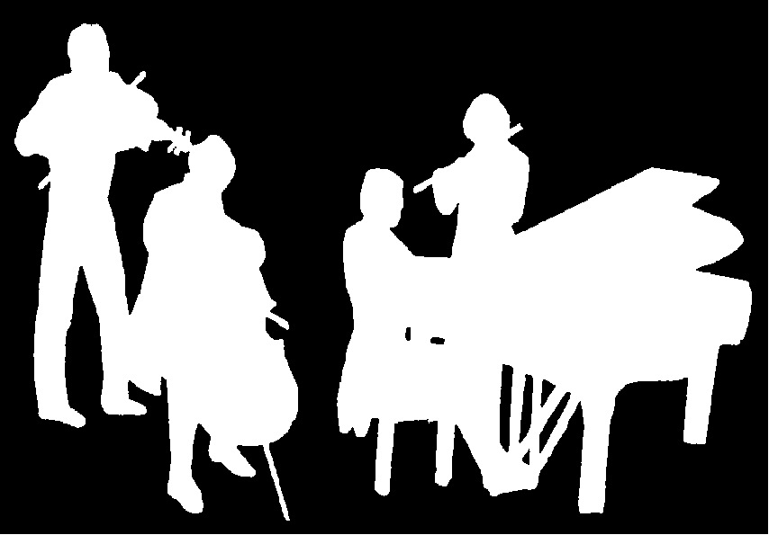
The Kirribilli Centre
www.KNCsydney.org
ACMS
http://www.acms-australia.org/
Chamber Music Concert
Sunday 6th November 2016
5.00pm

