Amateur Chamber Music Society
http://www.acms-australia.org/concerts/
— Concert —
5pm Sunday 4 September 2016 (first Sunday in September)
Kirribilli Centre, 16 Fitzroy St Kirribilli
www.KNCsydney.org tel: 9922 4428
—PROGRAMME —
Arthur Frackenpohl - Waltz and Rag
clarinet Lindsay Wanstall, bassoon Petrina Slaytor,
piano Jenni MacRitchie

Five Songs
Scarlatti, Schumann, Sanderson, Keel, Wood
baritone Mark Berriman, piano Patsy Short

CPE Bach
Trio for Clarinet, Bassoon and Piano in B flat Major
Allegretto, Allegro molto, Allegro, Allegro,
Andante, Allegro (quasi Allegretto)
clarinet Lindsay Wanstall, bassoon Petrina Slaytor,
piano Jenni MacRitchie

Bach - Cello Suite no 1 in G major
Prelude, Allemande, Courante. Menuet 1 and 2, Gigue
cello Daniel Morris
— Interval —

Dvorak - Piano Quintet no 2 in A Major op 81
Allegro ma non troppo, Dumka, Scherzo furiant, Finale
violins Sheila Fitzpatrick, Marian Arnold
viola Daniel Morris cello Nicole McVicar
piano Patsy Short

— refreshments —

Notes

Frackenpohl Waltz and Rag
Arthur Frackenpohl was born in 1924 in the USA. He studied composition with Darius Milhaud and Nadia Boulanger, and won first prize for composition while he was in France. He spent most of his life as a Professor of Music at the State University of New York. He has published over 250 instrumental and choral compositions. This cheerful little Waltz and Rag, written for the Little River Trio, shows no obvious influence of either Milhaud or Boulanger that we can discern!

Five Songs

Gia il sole dal gange, by Alessandro Scarlatti, and Die Beiden Grenadiere, by Schumann are both popular recital songs. However the three English seafaring songs, published by Boosey & Co in 1913, from a collection entitled The Pick of the Bunch of Sailors’ Songs, although popular hits in their day, are now rarely performed. Shipmates O' Mine, Trade Winds and The Sea Road written by Wildred Sanderson, Frederick Keel and Haydn Wood respectively suggest interesting links - with the English Art Song, Vaudeville and the Musical.

CPE Bach Trio for Clarinet, Bassoon and Piano in B flat Major. CPE Bach (1714 - 1788) was the fifth child of JS Bach who was his son’s only teacher. His godfather was Georg Philipp Telemann after whom he was named. Carl studied law at University, but then devoted his life to music. He became court musician to Frederick the Great for whom he wrote 30 compositions for the music box and musical clock, thanks to Frederick’s enthusiasm for mechanical instruments. He also wrote 50 keyboard concertos and was admired by Mozart, Haydn, Beethoven and later Brahms, who edited some of his music. This work, composed in 1767-8 seems, unfortunately, to be the only work he wrote for this combination of instruments.

Bach Cello Suite no 1 in G major
Little is known about the origins of Bach’s six cello suites; they were probably composed in Cothen where Bach worked from 1717 for Prince Leopold. No original manuscript survived and the music was virtually unknown until Pablo Casals came across a copy in a Barcelona bookshop one afternoon in 1890. He practised them every day for twelve years before performing them in public, after which they became a cornerstone of every cellist’s repertoire.

Dvorak Piano Quintet no 2 in A Major op 81
The Dvorak Quintet written in 1887 is one the most loved chamber pieces for this grouping. Spontaneous rivers of dances, ballads and laments flow over the four movements. Dvorak’s melodic invention is a feature of this work, and these melodies are influenced by the rhythms, scales and irregular phrasing of the Czech folk music he loved. The four movements are structured in sonata form, rondo, ternary and sonata rondo. The second movement, marked Dumka, is based on a Czech narrative ballad tradition, which includes abrupt changes of mood. The Third movement, marked Furiant, is based on a traditional dance rhythm, which features cross rhythms and syncopation. In the final movement Dvorak plays with a number of polka melodies.
One of the great pleasures of performing this piece is that every instrument has an important role to play, and shares in the generous melodic material.

concert organiser Patsy Short
Volunteer staff of the Kirribilli Centre provide light refreshments (wine juice and savouries) and charge $10 entry donation ($5 concession/seniors)
to cover costs and to raise funds for the Centre

To get information on future concerts, go to the website
http://www.acms-australia.org/sydney/
(or Google “ACMS chamber music society Australia”)
and click on “Concerts”
All chamber music players are welcome to join the
Amateur Chamber Music Society, which matches players depending on their experience
and arranges informal playing days, an annual music camp, and concerts.
If interested, go to the website and click on “Join Us”, or
email membership.secretary@acms-australia.org, or
write to ACMS Membership Secretary,
PO Box 584, Balgowlah NSW 2093

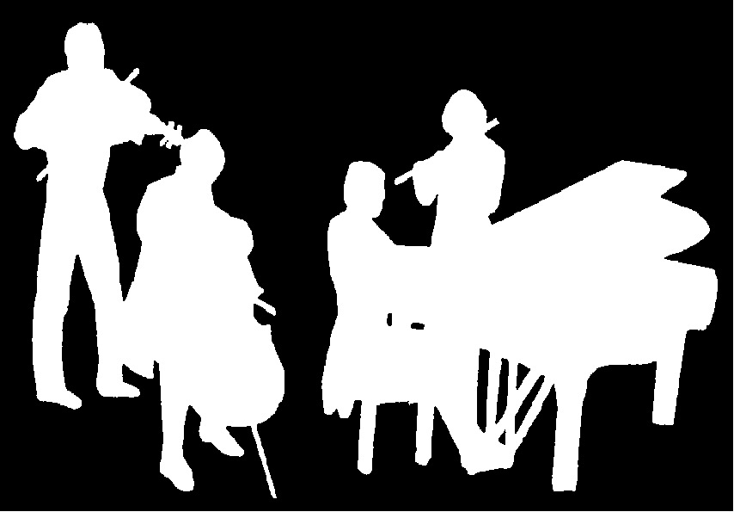
Kirribilli Centre
www.thekirribillisydney.org
Amateur Chamber Music Society
http://www.acms-australia.org/
Chamber Music Concert
Sunday 4 September 2016
5pm

