Amateur Chamber Music Society
http://www.acms-australia.org/concerts/
APRIL SUNSET Concert
— PROGRAM —

SCHUBERT Andante and Scherzo from Octet in F
(1) 2nd Movt Andante un poco Mosso (2) 3rd Movt - Scherzo
Beverly Gibbs (1st Violin)
Marjorie Hystek (2nd Violin)
Ian Colley (Viola)
Jane Smith (Cello 1)
Hugh Wilson (Cello 2)
Petrina Slaytor (Bassoon)
Lindsay Wanstall (Clarinet)
Paula Stokes (Horn)
30’

— 10 Minute Interval —

BOËLLMANN Sonata for Cello and Piano Op.40
- Maestoso (2) Allegro con fuoco (3) Allegro molto
Sharon Maennl (Cello) and Neil Semmler (Piano)
25’

STRAUSS Sonata for Violin and Piano in E Flat Op 18
- First Movement Allegro ma non troppo
- The second movement, Improvisation (3) Finale movement
Tracey Tsang (Violin) and Ben Chan (Piano)
25’
— refreshments —

- Notes -

Franz Schubert (1797-1828) Andante and Scherzo from Octet in F
This Octet of Schubert was written during 1824 a very productive year in Schubert’s short life of 31 years. During this time the song cycle Schone Mullerin composed, along with other chamber music gems.
Schubert’s Octet in F was commissioned by Frederick Count Troyer who was a clarinettist and a member of Archduke Rudolph’s musical establishment. The octet was composed at Troyer’s request, and modelled on Beethoven’s septet in Eb.
Paintings of the period show groups of friends and musicians gathered together for an evening of chamber music. No doubt this work was played often in these gatherings. It is a long work of six movements.
It is a tragedy that Schubert’s life was cut short after only 31 years. He is now one of the most endeared composers known for his Chamber music, vocal works nine Symphonies among others. His beautiful melodies and their harmonic richness are beautiful in their simplicity.

Léon Boëllmann (1862-1897) Sonata for Cello and Piano Op.40

Boëllmann was born in Ensisheim, Upper Alsace. He moved to Paris after the Franco-Prussian War and studied organ, piano and composition at the Ecole de Musique Classique, winning many honors.
The Cello Sonata in a minor dates from 1897, the year of the composer’s death. It was dedicated to the famous French cellist Jules Delsart. The sonata shows the influence of Cesar Franck harmonically and also in the way a cross-thematicism is employed.
The opening movement begins with a slow Maestoso introduction. The main section, marked by a change of time signature to 6/8 consists of a powerful Allegro con fuoco.
The second movement is an andante, mainly in D minor but ending in D major. Thematic material from the opening introduction of the first movement is used but presented in an entirely different manner.
The opening theme of the brilliant finale, Allegro molto provides evidence of modal thought, in A minor with F sharps and G naturals. Filled with defiance and power, its thematic material shows solidarity with the previous two movements.

Richard Strauss (1864-1949) Sonata for Violin and Piano in E Flat Op 18

The German composer Richard Strauss possessed a very identifiable compositional style that combined extravagantly swirling lines and intricately layered textures with advanced chromatic harmonies. Following on the innovations of Liszt and Wagner, Strauss took Romanticism to heady extremes of complexity, intensity and harmonic experimentation. Strauss was mainly renowned for his operas – Der Rosenkavalier, Elektra, Salome, Ariadne auf Naxos, Capriccio – his orchestral tone poems – Don Juan, Till Eulenspiegel, Ein Heldeleben – and his songs. However, he did produce a small number of chamber works, mostly earlier in his career. These include the Cello Sonata, the Piano Sonata, and the Violin Sonata in E-flat major.
The Violin Sonata was written in 1887-8 and is considered the last of his works to adhere to classical forms (mainly the sonata allegro of the first movement, Allegro ma non troppo). Strauss wrote the sonata aged only 23, while he was in love with the soprano Pauline de Ahna, and the work exudes a youthful, optimistic exuberance and an undercurrent of sweetness that pervades even the bold virtuoso writing for both instruments. The second movement, titled Improvisation, meanders gently; its wistfulness and hovering dreaminess are qualities that recur throughout much of his oeuvre. The closing Finale movement opens with a sombre introduction in the piano, after which follows a constant interplay between the two instruments, full of Straussian richness, and these ideas are expanded in a wide range of imaginative moods bringing this impressive Sonata to a grand conclusion.

Concert organiser Su-Lee Oei
Volunteer staff of the Kirribilli Centre provide
light refreshments (wine juice and savouries) and
charge $10 entry donation ($5 concession/seniors)
to cover costs and to raise funds for the Centre

To get information on future concerts, go to the website
http://www.acms-australia.org/sydney/
(or Google “ACMS chamber music society Australia”)
and click on “Concerts”
All chamber music players are welcome to join the
Amateur Chamber Music Society. If interested, go to the website and click on “Join Us”, or email membership.secretary@acms-australia.org, or write to ACMS Membership Secretary, PO Box 584, Balgowlah NSW 2093

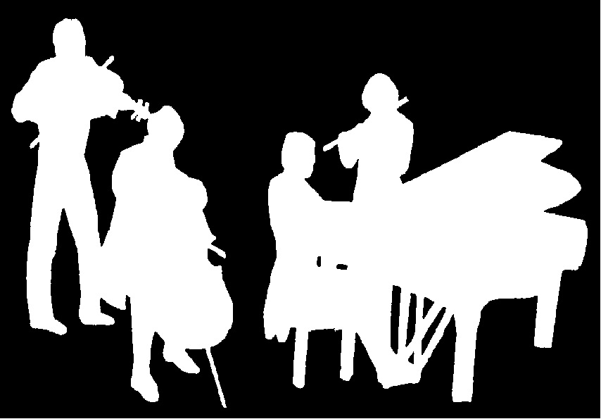
The Kirribilli Centre
www.thekirribillicentre.org
Amateur Chamber Music Society
http://www.acms-australia.org/
Chamber Music Concert
5pm
Sunday 2 April 2017

