Amateur Chamber Music Society
http://www.acms-australia.org/concerts/
— Concert —
— PROGRAM —
ROTA Trio for Flute, Violin and Piano
(1) Allegro ma non troppo (2) Andante sostenuto
(3) Allegro vivace con spirito
flute Sally Cousins violin Stephen Harvey
piano Nick Stokes
BRAHMS Piano Trio in C minor Op 101 First Movement
(1) Allegro Energico
violin Susan Mitchell cello Felicia Mitchell
piano Susan Butler
— Interval —
MYASKOVSKY String quartet No 13 Op 86
(1) Moderato (2) Presto fantastico
(3) Andante con moto e molto cantabile
(4) Molto vivo energico
violins Sheila Fitzpatrick and Jenny Allison
viola Lynn Dalgarno cello Anne Stevens
BEETHOVEN Trio in C major Op 87
(1) Allegro (2) Adagio
(3) Menuetto. Allegro molto scherzo and Trio (4) Finale. Presto
cellos Ann Kwan, Jane Grimm and Nicole McVicar
CHERUBINI Ave Maria
LACHNER Auf Flügeln des Gesanges
SUTHERLAND The Orange Tree
soprano Sara Arnold clarinet Andrew Cousins piano Ross McDonald
— REFRESHMENTS —
concert organiser Jenny Allison
- Notes -
ROTA (1935–1979) Trio for Flute, Violin and Piano (1958)
Giovanni "Nino" Rota (b. 3 Dec 1911, d. 10 Apr 1979), was an Italian composer, pianist, conductor and academic who is best known for his film scores, writing more than 150 scores for Italian and international cinema productions. He also wrote chamber music over a 37 year span from 1935 to 1972, with this trio being written in 1958.
An interesting quote from Rota:
"When I’m creating at the piano, I tend to feel happy; but - the eternal dilemma - how can we be happy amid the unhappiness of others? I'd do everything I could to give everyone a moment of happiness. That's what's at the heart of my music."
BRAHMS (1833-1897) Piano Trio in C minor Op 101
Brahms himself premiered this work in 1886 in the company of two regular chamber music partners, Eugen Huber and David Popper, themselves half of the Budapest quartet. Brahms had written the piece in the summer of that year so it was very fresh. The work was performed alongside a cello sonata, a couple of songs and the B flat string sextet. Apparently the Hungarian audience loved the trio. Brahms was in the habit of choosing a pleasant spot to spend the summer and write music. In 1886 he chose Hofstetten near Lake Thun in Switzerland. He pronounced himself to be very happy with his choice, particularly because ‘there are lots of Biergartens around – to which the English don’t come! No small matter for my comfort’.
The movement performed today is the most dramatic of the four movements but still exhibiting a clarity and emotional control, with a rhythmic complexity noticeable in the opening passage.
NIKOLAI MYASKOVSKY (1881-1950) String Quartet No 13 Op 86
The Russian composer Myaskovsky grew up in a military family and continued the tradition while at the same time pursuing his love of the arts. He played the piano and taught himself to play the violin and when the family moved to St.Petersburg in 1895 he attended concerts and mixed with members of the city’s top music circles. When he succeeded in entering the St. Petersburg Conservatory he commenced composition as his main focus. He wrote his first symphony in 1908 and continued composing even through the Revolution and his involvement in World War I. He became a professor at the Moscow Conservatory teaching such musicians as Kabalevsky and Khachaturyan. Myaskovsky wrote 27 symphonies: with Prokofiev and Shostakovich he is considered the greatest of the Russian symphonists. His string quartet no. 13 was his last. One of his biographers, Z.K.Gulinskay wrote in 1985 that the first movement’s theme appeared in “many guises striving for a symphonic texture” while the second movement is a “fantastic scherzo”. Its theme was originally intended for a symphony. The slow movement is a “lyrical meditation”, the last, full of contrapuntal episodes similar to those of the first movement.

Beethoven (1770-1827) String Trio Op 87
Beethoven composed this trio in Vienna in 1794 when he was 24 years old. It was originally written for two oboes and English horn. It is a fun, friendly and charming piece in a typical classical four movement sonata form.
In order to accommodate the unique combinations of instruments that arose from social chamber music that was common in Vienna in those days, the trio was readily subject to arrangements; versions exist for two violins and bass line, two flutes and viola, two clarinets and bassoon, a sonata for violin and piano, and two violins and viola. Later, in the 1900's, the trio was arranged for the three cello combination.
The piece was assigned a very misleadingly high opus number of 87, due to when it was published. This would appear to place it in his 'middle period' near the Seventh Symphony (opus 92, composed between 1811 and 1812). The music was actually composed almost 18 years earlier before his first piano sonata, and more typical of his 'early' period.
Luigi Cherubini (1760–1842) Ave Maria (Hail Mary)
Luigi Cherubini was an Italian composer who spent most of his working life in France during the period of transition from Classicism to Romanticism; he contributed to the development of French opera and was also a master of sacred music. Beethoven regarded Cherubini as the greatest of his contemporaries.
This setting of the traditional Roman Catholic and Eastern Orthodox prayer Ave Maria was originally for small string orchestra and cor anglais but is commonly performed with clarinet or flute.
Franz Lachner (1803–1819) Auf Flügeln des Gesanges (On Wings of Song)
Franz Lachner was a German composer and conductor whose output as a composer was influenced by Beethoven and his friend Franz Schubert. His songs, some of which are set to the same texts that Schubert, Mendelssohn and Schumann used in their songs, contributed to the development of the German Lied. Auf Flügeln des Gesanges (On Wings of Song) from Lyrisches Intermezzo of 1823 by Heinrich Heine(1797-1856) tells of a melody's power to transport lovers to the most beautiful night garden. The poem is more commonly known in the setting by Mendelssohn.
Margaret Sutherland (1897 - 1984) The Orange Tree
Margaret Sutherland AO OBE was an Australian composer, among the best-known female musicians Australia has produced. Her output ranged in genres from opera, ballet and incidental music for the theatre, to vocal, orchestral, chamber and instrumental music, and much music written for young performers.
This song is a setting of the John Shaw Neilson (1872-1942) poem The Orange Tree. The poem is a conversation between a young girl and an adult who are looking at an orange tree. It is well known that children see the world with different eyes. The girl sees things that the adult can’t see. She sees all the beautiful things in this simple orange tree and it is obvious that she has a special connection to nature. While the adult in this poem only sees the materialistic. He sees only a tree and the benefits he could get from this tree. The girl tries desperately to explain to the adult what it really is, but the adult is not able to see it. After asking the adult twice to listen, she gives up.

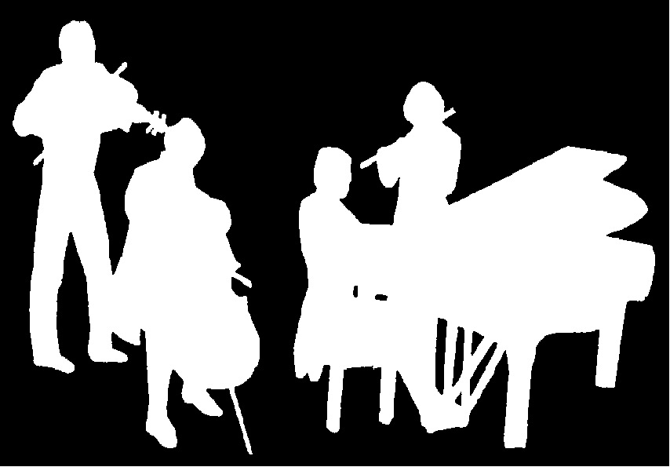
The Kirribilli Centre
www.thekirribillicentre.org
Amateur Chamber Music Society
http://www.acms-australia.org/
Chamber Music Concert
5pm Sunday 06 August 2017

