— PROGRAM —
CORELLI Christmas Concerto
(1) Vivace (2) Allegro (3) Adagio-Allegro-Adagio
(4) Vivace (5) Allegro (6) Largo Pastorale
violins Susan Mitchell Susan Butler
viola Peter Mitchell cello Felicia Mitchell
DVORAK Quartet Op 51 in Eb
(1) Allegro ma non troppo (2) Dumka
(3) Romanza (4) Finale - Allegro
violins Ian Colley Marjorie Hystek
viola Paul Whitbread cello HughWilson
—INTERVAL —
ANDINO Bird
flute Richard Tardif piano Susan Butler
SCHUMANN Violin Sonata no.2 in D minor Op.121
- Ziemlich langsam - Lebhaft (2) Sehr lebhaft
(3) Leise, einfach (4) Bewegt
violin Tracey Tsang piano Benjamin Chan
CHRISTMAS MUSIC
Leanne VEITCH: I Heard the Bells on Christmas Day
Heinrich SCHÜTZ (1585-1672): Meine Seele Erhebt den Herren
Thomas Washington TALLEY (1870-1952): Behold that Star
Swedish TRADITIONAL: Staffan var en stalledräng
William BYRD (c. 1540-1623): From Virgin's Womb
soprano: Susan Butler, Glenda Woolnough,
Katharina Raffelsberger-Dhabalia
alto: Rosemary Rayfuse, Eveline Schultheiss
tenor: Heather Powrie bass: Ian Butler, Hugh Wilson
piano: Patsy Short
strings: Glenda, Ian, Heather and Hugh
— REFRESHMENTS —
- Notes -
CORELLI 1683-1713) Concerto Grosso No 8 in G minor (circa1690)
Archangelo Corelli’s origins are unclear, but he was brought up in Ravenna where he was educated as a musician. He travelled extensively in Europe, where he developed his skills as a violinist and composer before settling in Rome in 1687. Here he enjoyed great success and wealthy patronage. The Christmas Concerto, which was commissioned by Cardinal Pietro Ottoboni, was completed around 1690, with the manuscript bearing the words “Fatto per la note di Natale” (written for Christmas night). However, it was not published until 1714 after Corelli’s death as one of twelve concertos. The twelve concertos consisted of eight Church concertos and four secular Chamber concertos, with the Christmas concerto being the last of the Church concertos. They were composed in the form of concerti grossi, in which a solo group contrasted with a larger ripieno ensemble. The last movement of the Christmas concerto is a Pastorale. This was associated in seventeenth century Italy with Christmas, as a representation of the shepherds who attended Jesus’ birth. Today we are playing an arrangement of this concerto for string quartet.
DVORAK(1841-1904) Quartet Op 51 No in E¨
Dvorak wrote this quartet in 1879 at the request of the Florentine Quartet. It is folksy, vibrant, colourful and rich in musical ideas. It is often known as the “Slavic”, reflecting Dvorak’s intense interest in expressing nationalism through art and music. And yet, despite the influence of nationalism, the quartet (as with all Dvorak’s music) is rooted firmly in the mainstream of musical development, drawing from the heritage of the classical and early romantic eras, and situated comfortably with peers such as Brahms and Tchaikovsky.
ANDINO Bird (2012)
Jane Andino is a composer, arranger and pianist, writing and performing in classical, jazz and Latin-American styles. After an early grounding in the classical AMEB curriculum, and some studies with jazz pianist Chuck Yates, Jane began composing, arranging and playing piano in a wide variety of ensembles. Jane's particular field of expertise has been in Latin-American music performing with salsa, Afro-Peruvian and Latin-jazz groups. She formed the group Ritmo with her husband, guitarist and singer Ricardo Andino. She also plays in the tango group, Alturas.
Jane began composition studies in 2007 with the composer Amanda Handel, further developing her formal skills. Her compositions have been influenced by the music of Bartók, Messiaen, Sculthorpe and Takemitsu. This piece for flute and piano shows evidence of those influences.
SCHUMANN (1810-1856) Violin Sonata no.2 in D minor Op.121
All three of Schumann’s violin sonatas date from the last years of his creative life, that final burst of hectic activity that preceded his attempted suicide and mental collapse early in 1854. They were composed relatively fast. The first sonata was drafted in a matter of days. The second, heard at this afternoon’s concert, took all of three weeks, and the third one was finished in about the same amount of time.
The four movements of the d minor sonata are all based on a motif composed of the notes of the d-minor triad in the order D-A-F-D, most likely a theme suggested by the violinist Ferdinand David’s name; to whom this sonata was dedicated. Out of this motif, Schumann constructed an extremely diverse work, highly virtuosic, emotionally profound, and rather sophisticated in its use of harmony and rhythm.
The opening movement begins with a tightly wrought introduction in a slow tempo, followed by a fast section bursting with energy. The D-A-F-D motif is present both in its original form and in a modified version where its rhythmic outline (four half-notes) is retained but the actual pitches may change. The second movement is a scherzo with two trios, where the four-note theme is never far from the surface. Near the end of the movement, Schumann suddenly reveals the kinship of his theme with the chorale melody Mendelssohn had used in the last movement of his Piano Trio in c minor.
Another chorale-like variation of the four-note theme appears as the melody of the slow third movement: the violin plays pizzicato (plucking the strings), and the piano uses the soft pedal. In the course of a set of variations on this theme, the accompaniment keeps changing while the melody stays the same. Because of all the motivic links among the movements, a quote from the scherzo blends in naturally with the surrounding music. In the tempestuous finale, Schumann discovers still more possibilities to exploit his core motivic idea, deriving from it a new theme which is constantly repeated, varied and developed as the momentum keeps increasing. Just before the end, the key changes from d minor to D major, allowing the sonata to end on a bright and exuberant note.
concert organiser Susan Butler
Volunteer staff of the Kirribilli Centre provide
light refreshments (wine, juice and savouries) and
charge $10 entry donation ($5 concession/seniors)
to cover costs and to raise funds for the Centre

To get information on future concerts, go to the website
www.acms-australia.org
(or Google “ACMS chamber music society Australia”)
and click on “Concerts”
All chamber music players are welcome to join the
Amateur Chamber Music Society. If interested, go to the website and click on “Join Us”, or email membership.secretary@acms-australia.org, or write to ACMS Membership Secretary, PO Box 584, Balgowlah NSW 2093

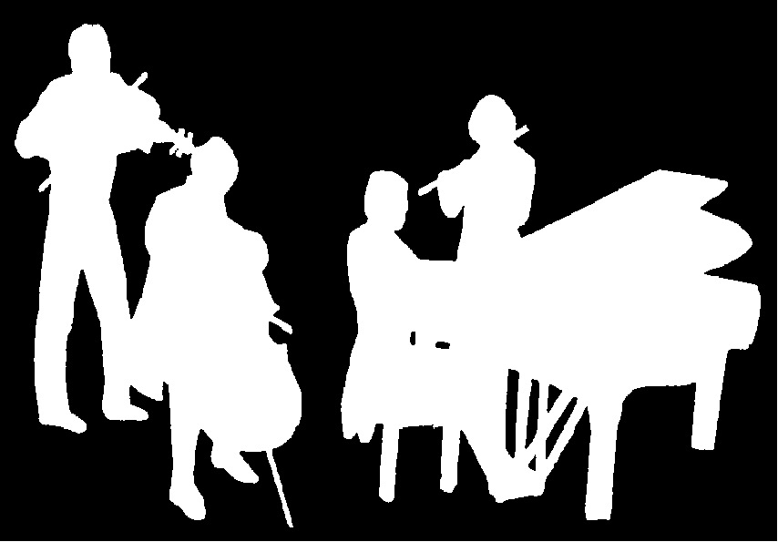
The Kirribilli Centre
www.thekirribillicentre.org
Amateur Chamber Music Society
http://www.acms-australia.org/
Chamber Music Concert
5pm Sunday 03 December 2017

