Amateur Chamber Music Society
http://www.acms-australia.org/concerts
— Concert —
5pm Sunday 4th June 2017
Kirribilli Centre, 16 Fitzroy St Kirribilli
www.thekirribillicentre.org tel: 9922 4428
— PROGRAM —
BEETHOVEN String Quartet in A major Op18 No 2
(1) Allegro (2) Adagio Cantabile
(3) Scherzo (4) Allegro Molto
violins Jenny Allison and Regula Scheidegger
viola Eve Salinas cello Anne Stevens
BRAHMS Sonata in Eb Op 120 No 2
(1) Amabile (2) Scherzo and Trio (3) Theme and variations
viola Michelle Urquhart piano Keith Mitchell
— INTERVAL —
MOZART Trio in Eb “Kegelstatt”
(1) Andante (2) Menuetto (3) Allegretto
clarinet Lindsay Wanstall violin Barbara Robinson
piano Susan Butler
BEETHOVEN Sonata No 5 in F major Op 24 “Spring”
(1) Allegro (2) Adagio molto espressivo
(3) Scherzo: Allegro molto (4) Rondo: Allegro ma non troppo
violin Tracey Tsang piano Ji-Hyun Kim
— refreshments —
- Notes -
BEETHOVEN (1770–1827) String Quartet in G Op18 No 2
Beethoven wrote the Opus 18 string quartets between 1798-1800 and they were published in 1801. He was not a good string player himself, and although he had written a number of other works by this time, he was not comfortable writing string quartets. It has been said that one of the reasons is that he was conscious of the skill of Haydn and Mozart and it is known that he made several revisions to these first string quartets. The playing of string quartets was generally popular in musical circles and it was in one of these such activities that Beethoven met the violinist Karl Amenda. He turned the pages for Amenda when the latter was playing quartets in the home of a friend of Mozart’s widow. Beethoven wrote the Opus 18 quartets as a commission for Prince Joseph Franz Maximilian Lobkowitz who employed Karl Amenda. The quartet is in four movements: Allegro, Adagio Cantabile, Scherzo and Allegro Molto. There is a scherzo also in the middle of the Adagio.
BRAHMS (1833-1897) Sonata in Eb Op 120 No 2
Johannes Brahms was one of the major composers of the Late Romantic Period and is regarded as a more conservative composer compared to contemporaries such as Wagner and Liszt. His works display a formal structure which harks back to that of the Classical Period and he eschews the more radical harmonies being explored by others, such as Wagner and Schoenberg.
During his long career Brahms wrote a large amount of chamber music as well as sonatas for various instruments and piano. In the early 1890s Brahms had decided he was going to retire from composition until he heard the German clarinetist Richard Mühlfeld, who Brahms called the greatest wind player in the world. Brahms postponed his retirement to write his four final works, all featuring the clarinet.
The two sonatas Opus 120 Brahms also arranged for viola, changing the scoring to suit the range of the instrument, adding some double stopping passages and slight melodic modifications.
The Sonata in E♭, Op 120 No 2, which is being performed today consists of 3 movements. The first is indicated Allegro Amabile, the second a Scherzo and Trio and the third is in a Theme and Variations form.
MOZART (1756-1791) Trio in Eb “Kegelstatt”
Composed in 1786, this exquisite trio was first played by Mozart on viola, Anton Stadler on clarinet and Franziska von Jaquin on piano.
The first movement, Andante, presents a warm theme employing a “grupetto” or turn, which occurs throughout the movement. The entire movement is quite relaxed, in 6/8 time and without repeats.
The second movement, uncommonly, is a Menuetto. In ¾ time and displaying dynamic contrasts, this movement develops contrapuntally and is followed by a Trio with a 4-note theme.
The final movement, Allegretto, is a 7-part Rondo, whose A section is drawn from the 1st movement. This movement, in 2/2 time, having presented and developed themes from each section (ABACADA), closes with a florid and exciting coda.
The name, Kegelstatt, which means “bowling alley”, although not attributed to Mozart, has remained. It appears to have been added by publishers in the 19th Century.
BEETHOVEN (1770–1827) Sonata in F Op 24
Nine of Beethoven's ten sonatas for violin and piano were composed between 1797 and 1803, for his own performances with various violinists. In the Classical era such works were often described as sonatas for piano with violin accompaniment and Beethoven, though continuing the trend toward full partnership begun by Mozart, certainly wasn't about to undercut the presence of his own instrument.
Op. 24 was completed in 1801 and was probably intended as a pair with Op. 23; both were dedicated to the banker Count Moritz von Fries, who also commissioned the Op. 29 String Quintet composed about the same time. The Sonata's nickname "Spring" was not given by the composer, but it does capture the generally cheerful sense of zesty blossoming in the work. The opening movement is a big, bold sonata form, its gentle first theme contrasting starkly with the dramatic stress of the second. The lyrical Adagio marries variation techniques to song form, and the short, soft Scherzo and Trio is a Haydnesque comic interlude. The Rondo finale sums it all up, matching the harmonic adventures of the first movement, the tuneful grace of the Adagio, and the wit of the scherzo.

Concert organiser Jenny Allison
Volunteer staff of the Kirribilli Centre provide
light refreshments (wine juice and savouries) and
charge $10 entry donation ($5 concession/seniors)
to cover costs and to raise funds for the Centre
To get information on future concerts, go to the website
www.acms-australia.org
(or Google “ACMS chamber music society Australia”)
and click on “Concerts”
All chamber music players are welcome to join the
Amateur Chamber Music Society. If interested, go to the website and click on “Join Us”, or email membership.secretary@acms-australia.org, or write to ACMS Membership Secretary, PO Box 584, Balgowlah NSW 2093

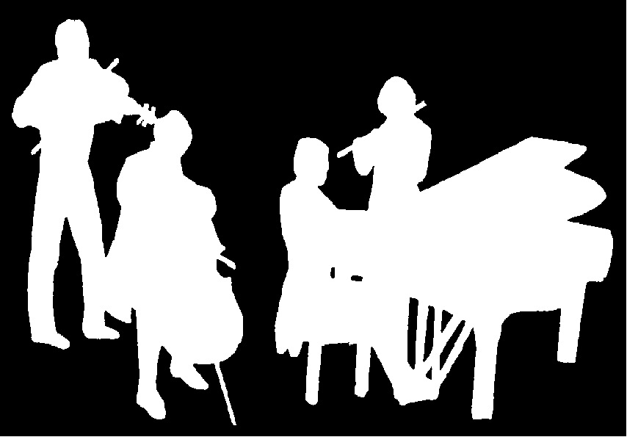
The Kirribilli Centre
www.thekirribillicentre.org
Amateur Chamber Music Society
http://www.acms-australia.org/
Chamber Music Concert
5pm Sunday 4th June 2017

