Amateur Chamber Music Society
http://www.acms-australia.org/concerts/
— Concert —
5pm Sunday 7 May (first Sunday in May)
Kirribilli Centre, 16 Fitzroy St Kirribilli
www.thekirribillicentre.org. tel: 9922 4428
— PROGRAMME —
Robert Schumann Adagio and Allegro op 70
cello Daniel Morris piano Kian Woo

Howard Blake Trio op 25
Allegretto, Andante Waltz Andante , Allegro Assai
flute Richard Tardif clarinet Lindsay Wanstall
piano Susan Butler

Alexander Glazunov Elegy op 4
viola Daniel Morris piano Patsy Short

Frank Bridge Miniatures for Piano Trio
Valse Russe, Hornpipe, Marche Militaire
violin Beverley Gibbs, cello Clara Blazer
piano Patsy Short

— Interval —

Gabriel Faure Dolly Suite op 56
Berceuse, Mi-a-o, Le Jardin de Dolly, Kitty-Waltz, Tendresse, Le Pas Espagnol
flute Richard Tardif clarinet Lindsay Wanstall
piano Susan Butler

Dmitri Shostakovich The Gadfly Suite
Overture, Kontratanz, Elegy, Galopp, Romanze, Prelude, Volksfest
violins Beverley Gibbs & Regula Scheidegger
viola Ian Colley cellos Clara Blazer & Anne Stevens
piano Patsy Short

— Refreshments —

Notes
Robert Schumann (1810 - 1856) composed and transcribed the Adagio and Allegro Op 70 for horn (or cello) and piano over a period of five days in February 1849. Clara Schumann wrote: “The piece is splendid, fresh and passionate - just the way I like it!” The piece starts with a tender Adagio followed by a brilliant Allegro.
Howard Blake (b 1938) wrote, directed and edited a 16mm film called 'A Few Days' whilst working at The National Film Theatre in early sixties. He also wrote the 'stream of consciousness' voice-over and composed the music score. He later arranged the Romantic Theme from the film to create the first movement of a trio, adding the second (Andante-Waltz-Andante) and the third (Allegro) movements.
Alexander Glazunov (1865–1936), prominent Russian composer, taught at the St. Petersburg Conservatory from 1905 to 1928 (which became the Petrograd Conservatory, then the Leningrad Conservatory, following the Revolution), where he taught and mentored Shostakovich. He befriended the Shostakovich family commandeering the vodka at their parties. Elegy, written in 1893, develops a simple theme using canon, pedal point, hemiola and a rich harmonic vocabulary.
Frank Bridge (1879 – 1941), English composer, conductor and violist, wrote songs, chamber music and orchestral music, and taught Benjamin Britten. His colourful use of dissonance borrows from Purcell, with an occasional wave to Cole Porter.
Gabriel Fauré (1845-1924) The Dolly Suite is dedicated to Hélène Bardac, the daughter of a close friend. singer Emma Bardac. Hélène was known to her family as "Dolly," and some speculate that she may have been Fauré's daughter. The original version is for piano duet, but the work has been arranged for many combinations. The chamber music arrangement performed today is by the clarinettist Michael Webster.
Dmitri Shostakovich (1906 -1975) spent his teenage years improvising soundtracks to silent films. While he is revered today for his symphonies and string quartets, his film scores, including The Gadfly (1955), have taken on a life of their own, This piano sextet arrangement is by HJ.Rogoll. We have inserted two extra pieces for two violins and piano into this arrangement. The Elegy comes from an earlier Ballet, while the Prelude is an additional theme from the Gadfly film; both are from Five Pieces for Two Violins and Piano arranged from the originals by L. Atovmyan.

concert organiser Patsy Short
Volunteer staff of the Kirribilli Centre provide light refreshments (wine juice and savouries) and charge $10 entry donation ($5 concession/seniors)
to cover costs and to raise funds for the Centre

To get information on future concerts, go to the website
http://www.acms-australia.org/sydney/
(or Google “ACMS chamber music society Australia”)
and click on “Concerts”
Chamber music players are welcome to join the Amateur Chamber Music Society, which matches players depending on their experience
and arranges informal playing days, an annual music camp, and concerts.
If interested, go to the website and click on “Join Us”, or
email membership.secretary@acms-australia.org, or
write to ACMS Membership Secretary,
PO Box 584, Balgowlah NSW 2093

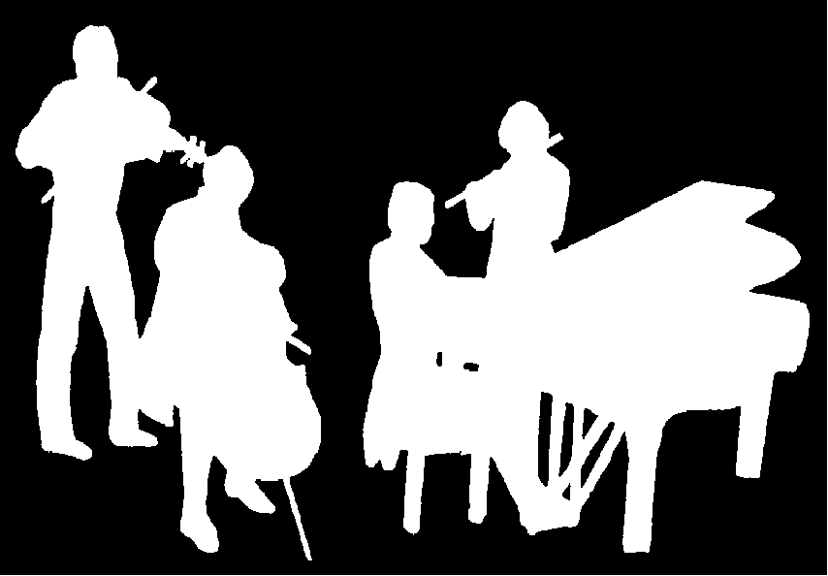
Kirribilli Centre
www.thekirribillisydney.org
Amateur Chamber Music Society
http://www.acms-australia.org/
Chamber Music Concert
Sunday 7 May 2017
5.00pm

