Amateur Chamber Music Society
http://www.acms-australia.org/concerts/
— PROGRAM —
FAURÉ - Piano Quartet in C minor Op15
(1) Allegro molto moderato (2) Scherzo - Allegro vivo
(3) Adagio (4) Finale - Allegro molto
violin Michelle Urquhart viola Daniel Morris
cello Nicole McVicar piano Kian Woo
30’
— Interval —
GRIEG - Sonata in G major Op 13
(1) Lento doloroso – Allegro vivace (2) Allegretto tranquillo
(3) Allegro animato
violin George Carrard piano Christine Edwards
23’
HEIDEN - Trio
(1) Allegro agitato (2) Adagio (3) Vivace (4) Allegretto
violin Vania Chan cello Debra Leong
piano Nicholas Stokes
22’
— refreshments —

- Notes -
Gabriel FAURE (1845-1924) Piano Quartet No 1 Op 15
At the age of 32, after wooing her for five years, Fauré had finally become engaged to Marianne Viardot, daughter of the famous singer Pauline Viardot. The engagement lasted for less than four months, and Marianne broke it off, to Fauré’s considerable distress. It was in the later stages of their relationship that he began work on the First Piano Quartet, completing it three years later in 1879.
The late 1870s was also a time when Wagner fever was spreading throughout Europe. Faure admired Wagner’s composition technique but remained true to his own musical style. His use of harmony - exploring its limits but not destroying tonality - still sounds fresh today. The First Piano Quartet is considered one of Faure’s early masterpieces along with the First Violin Sonata and the Ballade for piano. It is a confident and optimistic work, despite the circumstances of its creation.
The first movement begins with a stern theme declared in unison by strings, offset with chords from the piano. Various sections flow seamlessly into one another - energetic sections lead to lyrical passages - and thematic material is distributed evenly in dialogues between instruments.
The second movement is playful and light with rhythmic contrasts and frequent pizzicato.
The third movement is darker and elegiac in nature. Echoes of his requiem can be heard. Rippling passages in the piano, as in the first movement, underscore the string lines.
The finale has a driving rhythm, galloping in the piano, with soaring melodies. It leads to a joyous coda.
en.wikipedia.org/wiki/Piano_Quartet_No._1_(Fauré), cmnc.org/recommended/paQ4.htm#Faure
Edvard GRIEG (1843-1907) Sonata in G major Op 13
Grieg’s father was a merchant and his mother a piano teacher. His mother’s father was a wealthy politician Edvard Hagerup, after whom Grieg was named. His mother started teaching him piano when he was six years old, and when he was 15 his parents sent him to Leipzig to study, where he majored in piano and organ. At 17 he nearly died from a lung disease but recovered sufficiently later that year to make his debut as a concert pianist. By the age of 24, he had a well established European reputation as a pianist and composer - his work was known to Liszt, who recommended him to the authorities for a travel grant. In that year he married his cousin, Nina Hagerup, a concert singer. On their three-week honeymoon, he composed the sonata that we will hear today, which not surprisingly has a happy feel to it. A year later he composed his famous Piano Concerto in A minor.
Grieg’s style shows the influence of Norwegian folk music.
The first movement of the Sonata Op 13 is introduced by a sad section, which gives contrast to the happy mood of the remainder of the movement.
The second movement is an elegant and delicate song in a minor key with a middle section in a major key. From time to time the piano imitates the strummed chords of a guitar or lute. Short phrases with grace notes and triplets suggest bird calls.
The third movement is light and cheerful, with a peasant dance influence.
Bernhard HEIDEN (1910-2000) - Trio for violin, cello & piano
Born in Germany as Bernhard Levi, Heiden composed his first pieces when he was six. When he began formal music lessons he learned music theory in addition to piano, clarinet, and violin. Aged 19, he entered the Hochschule für Musik in Berlin and studied composition under Paul Hindemith.
With the rise of the Nazis he changed his surname to Heiden and, at 24, he married a former Hochschule classmate. A year later they migrated to Detroit where he taught piano, harpsichord, general chamber music, and conducted the Detroit Chamber Orchestra. After becoming naturalised as a US citizen he joined the army (1943) where he made over 100 arrangements for an Army Services Band. Post-war he joined the staff of the renowned Indiana University School of Music. Conductor, composer, and writer Nicolas Slonimsky described Heiden's music as "neoclassical in its formal structure, and strongly polyphonic in texture; it is distinguished also by its impeccable formal balance and effective instrumentation." en.wikipedia.org/wiki/Bernhard_Heiden

concert organiser Tony Tenney
Volunteer staff of the Kirribilli Centre provide
light refreshments (wine juice and savouries) and
charge $10 entry donation ($5 concession/seniors)
to cover costs and to raise funds for the Centre

To get information on future concerts, go to the website
www.acms-australia.org
(or Google “ACMS chamber music society Australia”)
and click on “Concerts”
All chamber music players are welcome to join the
Amateur Chamber Music Society. If interested, go to the website and click on “Join Us”, or email membership.secretary@acms-australia.org, or write to ACMS Membership Secretary, PO Box 584, Balgowlah NSW 2093

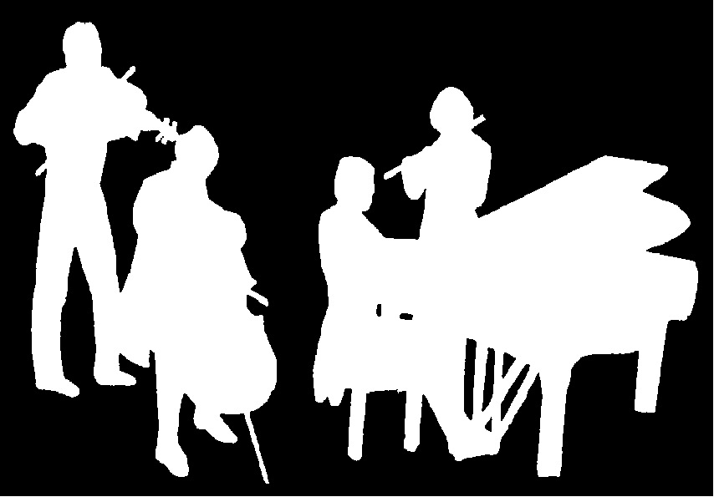
The Kirribilli Centre
www.thekirribillicentre.org
Amateur Chamber Music Society
http://www.acms-australia.org/
Chamber Music Concert
5pm Sunday 5 November 2017

