Amateur Chamber Music Society
http://www.acms-australia.org/concerts/
— Concert PROGRAM —
SCHUBERT Trio No 1 in B flat major D898
(1) Allegro moderato (2) Andante un poco mosso
(3) Scherzo (4) Rondo - allegro vivace
Tracey Tsang (violin), Benjamin Avanzi (cello),
Ji-Hyun Kim (piano)
35’
SAINT-SAËNS Danse Macabre
Tracey Tsang (violin), Benjamin Chan (piano)
7’
— Interval (10 MIN) —
Three Romantic Songs
(1) BRODSZKY Be My Love (2) D’HARDELOT Because
(3) GADE Jealousy
Michael Riddiford (tenor), Kian Woo (piano)
10’
GRIEG Sonata No 3 in C minor Op 45
(1) Allegro molto ed appassionato (2) Allegretto espressivo
(3) Allegro animato – Prestissimo
Tracey Tsang (violin), Benjamin Chan (piano)
25’
— refreshments —
SCHUBERT Trio No1 in B flat major Op. 99 D898
This famous trio was composed in November 1827 and finalised in 1828, over the two last years of Schubert’s short life (1797-1828), as he was dying of syphilis in relative poverty. Contrary to most of his compositions towards the end of his life, this piece is light-hearted, and mostly absent of dark and depressed episodes. This absence of bipolar mood in the composition, together with the fantastic maturity and beauty of Schubert’s final works, makes it really special. To give it more context, the trio was composed in the same month as the Winterreise (the “journey of/in Winter” set of Lieder for male voice). The temper of both pieces could not be any different, although the second movement of the trio has a lyricism reminiscent of the Winterreise.
The first movement is bright, elegant, and bubbly (like Champagne). Dramatic at times, it draws on the virtuosity of all players to import lyrical and adventurous themes. The second movement is a romantic gem, with passionate motifs and turbulent episodes. The third movement is in minuet form, with a relaxed waltz that is wrapped around a contrasted Scherzo (literal translation is a “joke”). The final movement, Rondo, alternates different characters, be it gay, dramatic, fierce, or bouncy. A presto round them up to an end.
SAINT-SAËNS Danse Macabre
The well-known Danse Macabre originated as an art song for voice & piano, based on the poem ‘Egalité, Fraternité’ (Henri Cazalis, 1872). Two years later, Saint-Saёns re-worked the piece as a tone poem for solo violin & orchestra, which has since been transcribed and arranged for a variety of instrumentations, including violin and piano.
According to legend, "Death" appears at midnight on Halloween. Death calls forth the dead from their graves to dance for him while he plays his fiddle. His skeletons dance for him until the rooster crows at dawn, when they must return to their graves until the next year. The piece opens with a single note played twelve times (the twelve strokes of midnight). The violin then enters with the dissonant tritone, known as "the Devil in music" during the Medieval and Baroque eras, consisting of A and E♭.
The violin introduces the first and second themes, a descending scale accompanied by soft chords from the piano. Fragments of these themes are heard throughout the piano part. The piece becomes increasingly energetic and at its midpoint, right after a contrapuntal section based on the second theme, there is a direct quote of Dies irae (a Gregorian chant from the Requiem that is melodically related to the work's second theme), presented unusually here in a major key. The original themes then return and climax with very strong dynamics for both instruments before an abrupt break. The coda represents the dawn breaking (a cockerel's crow) and the skeletons returning to their graves.
Three Romantic Songs
(1) BRODSZKY Be My Love: Written for Mario Lanza for the 1950 movie “The Toast of New Orleans.” It was also the theme song for Mario’s radio program “The Mario Lanza Show.”
(2) D’HARDELOT Because (1902): It was sung and recorded in French by Enrico Caruso. It was also recorded by Mario Lanza in the 1951 movie “The Great Caruso”.
(3) GADE Jealousy (1925): Written as a tango. Recorded by many famous singers including Richard Tauber who was known as the “SOS Tenor” because of his ability to learn roles extremely quickly (even overnight!).
GRIEG Sonata No 3 in C minor Op 45
Grieg wrote three violin sonatas. He completed the first two in a matter of weeks when he was in his early 20s. They have a Norwegian flavour, evoking fjords and mountains. One of Grieg’s mentors, the Danish composer and musician Niels Gade, advised Grieg to write a subsequent violin sonata that was “less Norwegian”, to which Grieg retorted that it would be more so. However 20 years later he stated that his outlook had become more cosmopolitan. In the third sonata, which took him several months to complete, the influence of Norwegian folk music appears, but does not dominate.
In 1892, Belgian musicologist Ernest Closson wrote that the third sonata “must be classed with the most inspired scores ever written … is a marvel of inspiration, intelligence … [had] Grieg composed nothing but this sonata it would suffice to hand his name down to posterity.” In view of this it is hard to understand why this sonata is not as well known as the violin sonatas of Beethoven, Brahms and Franck.

Concert organisers: Tracey Tsang & Benjamin Chan
Volunteer staff of the Kirribilli Centre provide
light refreshments (wine juice and savouries) and
charge $10 entry donation ($5 concession/seniors)
to cover costs and to raise funds for the Centre

For information on future concerts, go to the website
www.acms-australia.org
(or Google “ACMS chamber music society Australia”)
and click on “Concerts”
All chamber music players are welcome to join the
Amateur Chamber Music Society. If interested, go to the website and click on “Join Us”, or email membership.secretary@acms-australia.org, or write to ACMS Membership Secretary, PO Box 584, Balgowlah NSW 2093

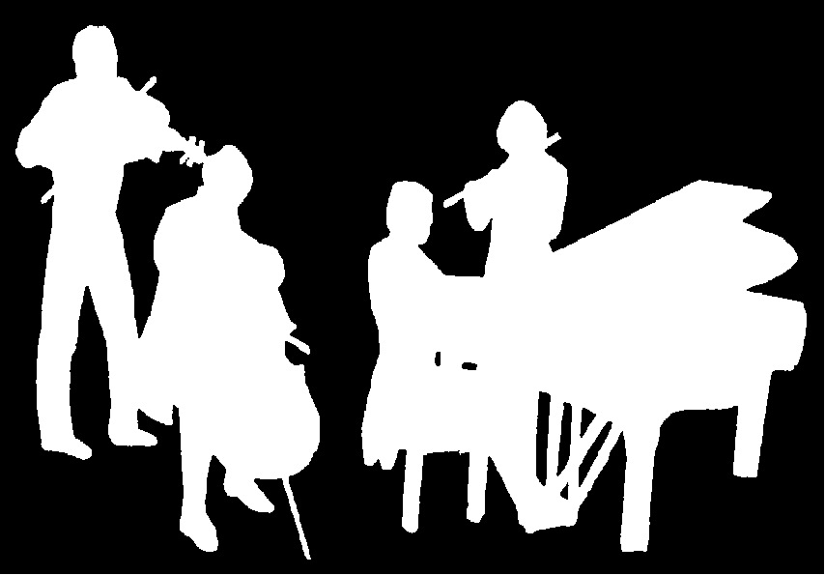
The Kirribilli Centre
www.thekirribillicentre.org
Amateur Chamber Music Society
http://www.acms-australia.org/
Chamber Music Concert
5pm Sunday 8 October 2017

