Amateur Chamber Music Society
http://www.acms-australia.org/concerts/
— PROGRAM —
J.S. Bach, Cantata BWV 209
1. Sinfonia 2. Recitative: Non sa che sia dolore 3. Aria: Parti pur e con dolore 4. Recitative: Tuo saver al tempo e l'età contrasta
5. Aria: Ricetti gramezza e pavento
Katharina Raffelsberger-Dhabaliya, soprano
Alex Chervonsky, flute Justin White, violin
Tassia Kolesnikow, violin Steve Harvey, viola
Jane Grimm, cello Peter Nickolas, harpsichord
duration: 21’
C.P.E. Bach, Quartet in A minor Wq 93
1. Andantino 2. Largo e sostenuto 3. Allegro assai
Alex Chervonsky, flute Steve Harvey, viola
Jane Grimm, cello Peter Nickolas, fortepiano
duration:14’
— Interval —
L.V. Beethoven, String quartet Op 18 No 4 in C minor
1 Allegro ma non tanto 2 Andante scherzoso quasi allegretto
3 Menuetto - Allegretto 4. Allegro – Prestissimo
Beverley Gibbs, violin 1 Hanako Ward, violin 2
Eve Salinas, viola Anne Stevens, cello
duration: 25’
— refreshments —
J.S. Bach (1685-1750) Cantata BWV 209
Very little is known about the Italian cantata Non sa che sia dolore: date, purpose, author of the text and much else remain obscured from us. Some have doubted whether the cantata is by Bach at all and others have speculated, given the quality of some of the music, whether this is a pastiche, knitted together by hand unknown from bits and pieces by various composers. The sources of parts of the text have been identified: the opening line is from Guarini's Il pastor fido and most of the final aria is ripped out of a piece by Metastasio. It has often been remarked that the text is a jumble of Germanicised Italian but a quick reading of a translation suggests strongly that it was composed or compiled for the departure of a dear friend. Bach's pupil Lorenz Mizler has been suggested as a possibility.
Having raised doubts about the authorship of the work, it's important to redress the balance by saying that whoever composed it was highly talented because it really is a very attractive work indeed. The cantata is for solo soprano with orchestral accompaniment that strongly features obligato flute and the work gives ample opportunity for both the vocal and the instrumental soloist to shine!
The work opens with a very fine and quite lengthy sinfonia that conceivably might be a movement from a lost flute concerto. Indeed the ubiquity of the flute throughout suggests that other movements may have been pressed into use, parodied for this work. The remainder of the cantata is made up of two fine, if a trifle lengthy, arias separated by recitative. The text and music of the first is sad and wistful, that of the second at odds: miserable text with upbeat music, reinforcing the suggestion of parody.
Copyright © 1999, Simon Crouch. (Source: http://www.classical.net/music/comp.lst/works/bachjs/cantatas/209.php)completed
C.P.E. Bach (1714-1788) Quartet in A minor Wq 93
C. P. E. Bach wrote three quartets for flute, viola, cello, and fortepiano (Wq. 93 - 95) in his mid-70s; these may have been his last instrumental works. No printed cello or bass part survives, so it is assumed that the left hand of the keyboard player is to be doubled. (This is a vestige of the Baroque figured bass practice.) Unlike in the Baroque, however, the keyboard functions as an equal member of the ensemble rather than simply as accompaniment. As is quite evident in these pieces, Bach had skillfully mastered his ability to compose for the flute during his service to King Frederick the Great of Prussia, a fine amateur flutist. The first movement of the Quartet in A minor, Andantino, is in a rondo form (rarely used in a first movement). Bach popularized this form in his keyboard sonatas. The middle movement, Largo e sostenuto, is filled with the expressive ornaments, such as appoggiaturas (dissonance stressed on the strong part of the beat, resolving on the weaker part of the beat), which were becoming so important to the empfindsamer Stil (German: “sensitive style”). This device creates the feeling of a "sigh" or longing. Ornaments and embellishments became an integral part of the emotional expression, rather than simply superficial decoration. The growing use of chromaticism (movement in half steps) served to intensify the dramatic effect. The final movement, Allegro assai, is in a modified rondo form. It is more developmental and virtuosic in nature than the first movement and moves in the direction of the sonata-allegro form, one of the crowning achievements of the Classical era. (Source: https://www.allmusic.com/composition/quartet-for-flute-viola-cello-keyboard-in-a-minor-h-537-wq-93-mc0002543187.)
L. V. Beethoven (1770-1827) String Quartet Op 18 No 4 in C minor
The only quartet from Beethoven's Opus 18 set to be cast in a minor key, this was also, despite its number, the last of the six to be completed.
C minor would come to be a key Beethoven reserved for highly dramatic works, including most famously the Fifth Symphony. Before this quartet, though, he'd used C minor without any special sense of tragedy; now, for the first time, he invests his C minor music with a special emotional depth, particularly in the sonata form Allegro ma non tanto. This opening movement immediately spins forth a worried violin theme over agitated accompaniment, interrupted by a series of jagged chords. The violins continue with lyrical, minor mode material, still with a restless accompaniment in the viola and cello. The exposition continues through several brief episodes in the same vein, ending with an odd sequence of quiet chords, a soft allusion to the jagged chords heard earlier. In the development section, Beethoven heightens the anxiety through key modulations while essentially repeating the structure of the exposition; apparently he felt little need to wrench the thematic components apart and recombine their fragments. By the time the recapitulation arrives, the thematic pattern has been clarified.
The surprise comes with the structure of the inner movements. There's no traditional slow movement; instead, Beethoven offers a scherzo followed by a minuet, both in moderate tempos. The scherzo is not the raucous joke Beethoven would favour in his symphonies. It feels more like a traditional minuet, with a fairly capricious character (the key is now C major). The structure could be considered a sonata form, with the central section being a largely polyphonic development of the themes Beethoven has already introduced.
The minuet proper, Allegretto, returns to C minor. If the scherzo seemed more like a minuet, this minuet has the character of a scherzo, fairly quick and unsettled. The trio features a jittery eighth note figure in the first violin, under which the second violin trades two-bar phrases with the viola and cello.
The concluding C minor Allegro is a rondo that begins with an impassioned theme dominated by the first violin. The second section is more placid, and the next contrasting episode features humorous triplets rising from the cello up through the ensemble. The third contrasting episode picks up more of the agitation of the rondo theme, so when the latter returns one last time it can make its full effect only if played, as Beethoven indicates, as quickly as possible. (Source: https://www.allmusic.com/composition/string-quartet-no-4-in-c-minor-op-18-4-mc0002662506.)
Concert organiser: Alex Chervonsky
Kirribilli Centre charges $10 entry donation ($5 concession/seniors)
to cover costs and to raise funds for the Centre
To get information on future concerts, go to the website
www.acms-australia.org
All chamber music players are welcome to join the
Amateur Chamber Music Society. If interested, go to the website and click on “Join Us”, or email membership.secretary@acms-australia.org, or write to ACMS Membership Secretary, PO Box 584, Balgowlah NSW 2093

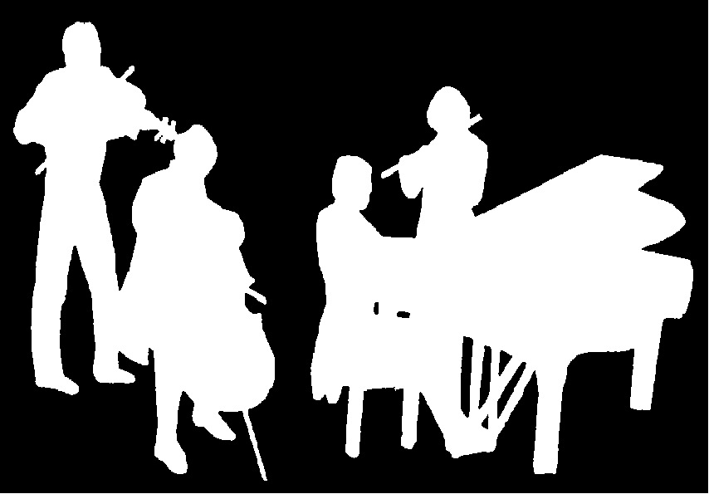
The Kirribilli Centre
www.thekirribillicentre.org
Amateur Chamber Music Society
http://www.acms-australia.org/
Chamber Music Concert
5pm Sunday 5 August 2018

