— PROGRAM —
VIVALDI Concerto in C for 2 Guitars, first movement
(1) Allegro
guitars Marcus Chun and Giuseppe Zangari
4’
ALBINONI/arr CALUDA Adagio
HOUGHTON Becoming Water
ANONYMOUS Mi Favorita
Sydney Guitar School Quartet directed by Giuseppe Zangari
Colleen Meehan, Sharyne Waddell, Greg Allardice, Paula Montgomerie
14’
BRAHMS Sonata no.1 in G major Op 78, first movement
(1) Vivace ma non troppo
Greta Lee violin
Kian Woo piano
11’
— Interval —
SHOSTAKOVICH/arr ATOVMIAN Five Pieces for 2 Violins and Piano
(1) Prelude (2) Gavotte
(3) Elegy (4) Waltz (5) Polka
violins Benjamin Chan and Marjorie Hystek
piano Lye Lin Ho
10’
MENDELSSOHN Piano Trio No 2 in C minor Op 66
(1) Allegro energico e con fuoco (2) Andante Espressivo (3) Scherzo (4) Allegro appasionato
violin Tracey Tsang cello Benjamin Avanzi
piano Benjamin Chan
30’
— refreshments —
— NOTES —

Sonata No 1 for Violin and Piano, Op 78 in G Major (first movement) – Johannes Brahms (1833-1897)
Brahms completed his Op 78 during the summer of 1879. It is thought that he was working on three or four other sonatas for violin and piano; however Op 78 is the first published.
The unifying element of the movement is a dotted rhythm figure; derived from the opening of Brahms’s two Op 59 songs. The violin begins with this simple motif and the rest of the first theme seems to spring from the energy of the first three notes. The piano accompaniment of the first movement surprisingly avoids contrapuntal treatment which gives added melodic freedom to the violin.
This piece was immediately beloved by audiences and musicians alike; the revered 19th century pianist Clara Schumann once wrote to the composer: “I played it at once, and could not help bursting into tears of joy over it.” Nicknamed the "Rain Sonata" because of the final movement's incorporation of a theme from Brahms' earlier work, Regenlied ("Rain Song"), Clara said of it: “I wish the last movement could accompany me … to the next world.”
Shostakovich, 5 Pieces for 2 Violins – Dimitri Shostakovich (1906-1975)
Shostakovich is perhaps one of the most prolific 20th century composers, with his output including symphonies, string quartets, film scores, piano music, operas and songs, and his music seeming to speak so vividly to so many listeners. While much of his music is epic, intense, dark and rife with spiky modernisms, Shostakovich composed many beautiful, "neo-classical" pieces full of lyricism, personality, fine craftsmanship and sheer musical delight. Among his incidental music, ballets and suites is this arrangement completed by Lev Atovmian, a student of Shostakovich, for violin duo with piano accompaniment. As a young man, Shostakovich had a job playing piano at the theatre for silent movies improvising a live soundtrack on the fly. These vignettes make a reel of compelling scenes, each one a little short story including a prelude, an elegy and three different dances, each more lively than the last.
Piano Trio No.2 in C minor Op 66 – Felix Mendelssohn (1809-1847)
Felix Mendelssohn’s second piano trio is a late work. It is, in fact the last chamber work that the composer lived to see published. It was composed and premiered in 1845, only two years before his death at the age of 38.
The opening movement in traditional sonata form, with the first theme featuring a rather dark and stormy emotional tone. This movement is particularly indicative of Mendelssohn’s rich harmonic language, constantly shifting and unfolding into unexpected places. The intensity of the opening is allayed by the appearance of a more delicate and tuneful second theme, and Mendelssohn deftly uses this contrast to keep the ear off-balance for the remainder of the movement.
Simple, lyrical, and beautiful—the second movement serves as a much-needed respite from the wild harmonic explorations and dramatic outbursts of the opening Allegro energico. The piano begins alone and introduces us to the main theme unaccompanied by the two strings. This textural contrast is especially effective; when the violinist and cellist do enter several bars later, we have almost forgotten they were on stage.
The Scherzo is a tightly wound tour-de-force, equally challenging to each player. The intricate counterpoint and constant trading of lines among members of the ensemble endow this particular movement with a kinetic force much unlike the other movements.
The final movement, indicated as Allegro appassionato, is a rollicking fast movement laced with a great deal of lyrical beauty, as well. A certain amount of gravitas is present, in no small part due to Mendelssohn’s quotation of a chorale melody (Praise to You, Jesus Christ”) that dates back to a 16th-century psalter. There are some interesting technical demands; some very beautiful, singing moments; and not a small amount of the minor-mode angst of the opening of the work. Near the end, the chorale tune returns, now in a triumphant C major, as if to cast away the storm of the beginning.

concert organiser Benjamin Chan
Usually volunteer staff of the Kirribilli Centre provide
light refreshments (wine juice and savouries) and
charge $10 entry donation ($5 concession/seniors)
to cover costs and to raise funds for the Centre
To get information on future concerts, go to the website
www.acms-australia.org/concerts
(or Google “ACMS chamber music society Australia”)
and click on “Concerts”
All chamber music players are welcome to join the
Amateur Chamber Music Society. If interested, go to the website and click on “Join Us”, or email membership.secretary@acms-australia.org, or write to ACMS Membership Secretary, PO Box 584, Balgowlah NSW 2093

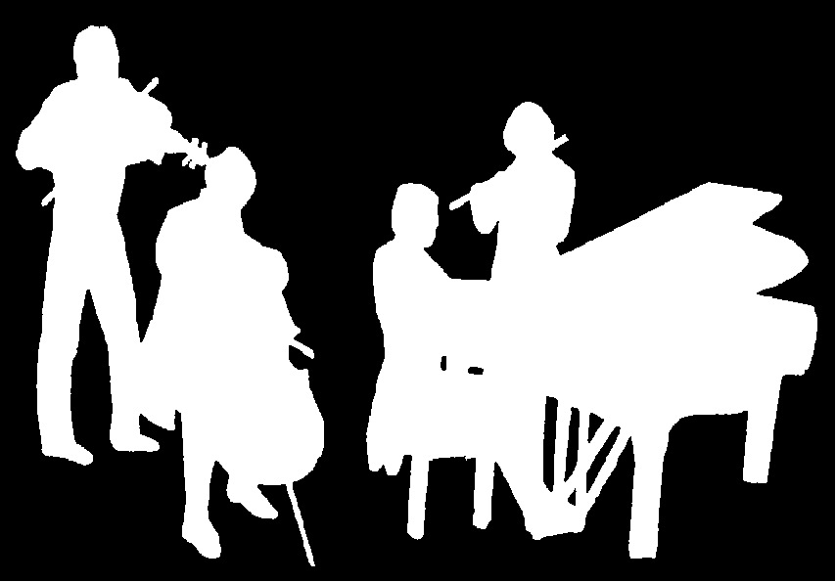
The Kirribilli Centre
www.thekirribillicentre.org
Amateur Chamber Music Society
http://www.acms-australia.org/
Chamber Music Concert
5pm Sunday 1st July 2018

