Amateur Chamber Music Society
http://www.acms-australia.org/concerts/
— Concert PROGRAMME —
GRIEG Sonata No 1 in F major Op 8
(1) Allegro con brio (2) Allegretto quasi andantino
(3) Allegro molto vivace
violin George Carrard piano Christine Edwards
22’
FAURÉ Five Songs
(1) Mandoline (2) Les berceaux (3) Nell
(4) Après un rêve (5) Fleur jetée
mezzo-soprano Christine Middleton piano Jane Smith
10’
— Interval —
ELGAR String Quartet Opus 83
violins Richard Willgoss and Pam Hepworth
viola Barra Boydell Cello Jane Smith
30’
— refreshments —
GRIEG (1843-1907) Sonata No 1 in F major Op 8
Edvard Hagerup Grieg’s grandfather Alexander Greig was a Scottish immigrant to Bergen, Norway, where he established business interests. His mother was a music teacher and daughter of a solicitor and wealthy politician Edvard Hagerup. On the advice of family friend and famous violinist Ole Bull, Grieg’s parents sent him, then aged 15, to Leipzig to study piano. At 18 he gave his debut as a concert pianist; at 20 he went to Copenhagen and at 22 he composed Sonata No 1 while on a summer holiday with a friend near Copenhagen.
The key, F major, is the same as that of Beethoven’s ‘Spring’ Sonata, and indeed there is a spring-like freshness about Grieg’s invention throughout this work. He tackled sonata-form not on its own ground but by overwhelming it with a profusion of lyrical ideas. Even so, he was careful to set them in context.
Although there are discreet echoes of Norwegian folk-music in the first movement, it is not until the second—which is both slow movement and scherzo and trio—that he explicitly simulates the music of the hardingfele, with the trio presenting the double-stopping and pedal points of a springar. (A hardingfele, also known as Hardanger fiddle, is a Norwegian version of the violin used for dancing, with four extra resonating strings mounted under the bowed strings. A springar is a Norwegian couple's folk dance with an uneven 3/4 rhythm.) The finale, like the first movement, builds its structure from a chain of three contrasting melodies that sparkle like a mountain waterfall.
This sonata was first published in a timorous print-run of 125 copies. It was one of those, though, which brought the work to Liszt’s attention, occasioning this handwritten letter to Grieg: “Sir, I am glad to be able to tell you of the sincere pleasure that I have derived from reading through your Sonata, Op 8. It bears witness to a talent for composition—vigorous, reflective, inventive, and of excellent material—which has only to follow its own way to rise to the heights. I assume that in your own country you receive the success and encouragement you deserve. You will not lack these elsewhere, either: and if you come to Germany this winter, I warmly invite you to visit Weimar for a while, so that we may get to know each other. - F. Liszt, 29 December 1868.” From the point of view of richness of invention, it's a fair question to ask whether Grieg ever surpassed this work, or for that matter whether Liszt could equal it. Liszt was not being condescending, the letter was presented to the parliament, which granted Grieg a pension, so he could concentrate on composing.
(https://en.wikipedia.org/wiki/Edvard_Grieg, https://en.wikipedia.org/wiki/Violin_Sonatas_(Grieg)#Violin_Sonata_No._1_in_F_major,_Op._8, https://www.hyperion-records.co.uk/dw.asp?dc=W6997_67504, http://etudemagazine.com/etude/1936/11/the-gift-of-liszt-to-grieg.html)
FAURÉ (1845-1924) Five Songs
Gabriel Fauré, a composer, organist, pianist, and teacher, was regarded as the leading French composer of his day. His many songs are an important part of his legacy. His music has been described as linking the end of romanticism with the modernism of the early twentieth century. For words and translations, please see attached sheet.
ELGAR (1857-1934) String Quartet Opus 83 (Brinkwells 1918)
Edward Elgar, who helped his ‘lower class’ father run a music shop, married upwards in his class-ridden society. His devotion to his ‘upper class’ wife Alice was matched by her love for him, notwithstanding her family’s opposition. He had built his fame as a composer around the turn of the twentieth century on major large scale works such as Enigma Variations, Dream of Gerontius and two symphonies. But the Great War demanded composition in the cause of the war effort and for him to become a police inspector. His pre-war achievements seemed to be almost discarded by an indifferent public.
Towards the end of the war in 1918, they bought a house, Brinkwells, on the Sussex Downs and repaired there for Elgar to recover from a tonsils operation, serious surgery in those days. They could feel the ground shake and hear the gunfire from the front across the channel. England had become utterly weary of The Great War, despairing of millions of young men sacrificed seemingly to no good cause. Elgar is known to have felt even more compassion for the collateral senseless slaughter of the cavalry. Amidst such a bleak background, in the space of a year, he refocused on the delicacy and intimacy of chamber music, composing a violin sonata, string quartet and piano quintet.
The string quartet was adored by Alice who called the Piacevole middle movement ‘like captured sunlight’. She would write ‘booful’ in her diary about the melodies she heard as the quartet was practiced. This serene second movement is bracketed by a contemplative first movement and a strident, almost frenetic, third movement. As for how it should be played, our second violinist put it succinctly, ‘you just have to play it how you feel it’.

Concert organisers: Richard Willgoss
Volunteer staff of the Kirribilli Centre provide
light refreshments (wine juice and savouries) and
charge $10 entry donation ($5 concession/seniors)
to cover costs and to raise funds for the Centre

For information on future concerts, go to the website
www.acms-australia.org
(or Google “ACMS chamber music society Australia”)
and click on “Concerts”
All chamber music players are welcome to join the
Amateur Chamber Music Society. If interested, go to the website and click on “Join Us”, or email membership.secretary@acms-australia.org, or write to ACMS Membership Secretary, PO Box 584, Balgowlah NSW 2093

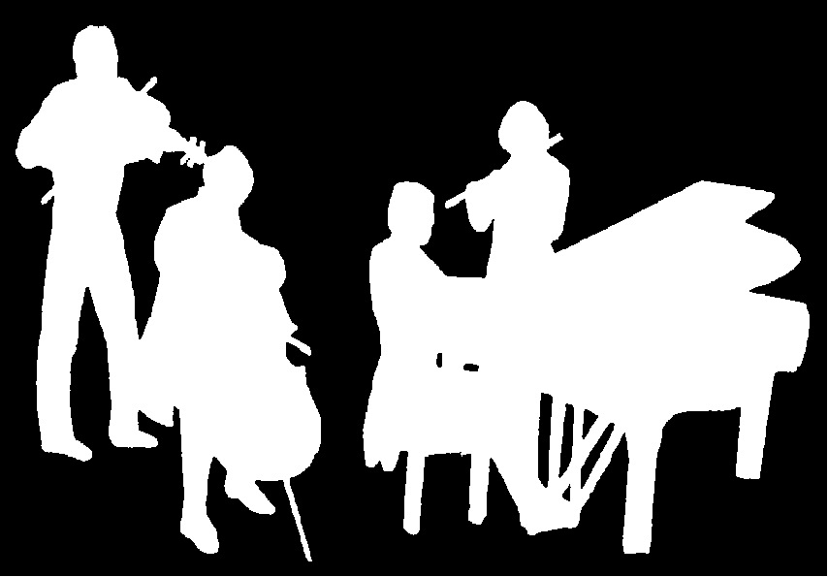
The Kirribilli Centre
www.thekirribillicentre.org
Amateur Chamber Music Society
http://www.acms-australia.org/
present
Chamber Music Concert
5pm Sunday 6 May 2018

