ACMS
http://www.acms-australia.org/concerts/
— Concert —
— PROGRAM —
GLAZUNOV String quartet No 3 in G major Op 26 “Quartet Slav”
(1) Moderato (2) Interludium
(3) Alla Mazurka (4) Finale – Une Fete Slave
violin 1 Sheila Fitzpatrick violin 2 Jenny Allison
viola Lynn Dalgarno cello Anne Stevens

BOCCHERINI Cello Sonata in C Major
(1) Allegro (2) Largo Assai (3) Rondo Allegro
cellos Danny Morris and Nicole McVicar
SCHUMANN Piano Quartet in E flat Major Op 47
(1) Sostenuto assai – Allegro ma non troppo (2) Scherzo
(3) Andante Cantabile (4) Finale
violin Jenny Allison viola Eve Salinas
cello Clara blazer piano Ludwig Sugiri

-------------------------------

At the end of the concert, please join us for light refreshments
– wine, juice and nibbles
- Notes -
GLAZUNOV (1865-1936) String quartet No 3 in G major Op 26 “Quartet Slav”
Alexander Glazunov was a Russian composer, music teacher and conductor. He was a musical prodigy beginning composing at the age of 11. He became a student of Rimsky-Korsakov who premiered one of his early works in 1882. He became the director of the Saint Petersburg Conservatory, where one of his students was Shostakovich, from 1905 to 1928. He left Russia in that year to spend the rest of his life living in Paris. He composed a number of symphonies, three ballets, seven string quartets, two piano sonatas, five concertos and some songs and other instrumental pieces.
Glazunov has been called the “idol of nationalist composers” as he based his compositions on Russian popular music. The String Quartet No 3 in G Major is an example of this. Its title is “Quartet Slav” and consists entirely of Slavic melodies. The first theme of the first movement is elegiac with a more lively second theme using pizzicato chords. The second movement Interludium is introduced by the cello and continues in a peaceful sombre mood which has been compared to a Russian Orthodox liturgy. The third movement Alla Mazurka is bright and lively with orchestral effects when all four voices play double-stopped chords simultaneously. The last movement Allegro Moderato is subtitled Une fete Slave. It is densely scored with the various moods that one might find in a village festival.
BOCCHERINI (1743-1805) Cello Sonata in C Major
Luigi Boccherini was born in Lucca Italy but spent most of his adult life living in Spain. His father played the double bass and Boccherini played the cello. He began appearing In concerts from about 13, went to Vienna in 1757 to join the orchestra of the court theatre and thence to Paris and Milan. In 1768 he left for Spain with his friend violinist Manfredi.
He composed about 460 works many of them written to exploit the technical resources of the cello: concertos, sonatas and chamber music including works for string quintet with two cellos. Of the sonatas he wrote for cello and basso continuo only 34 survive. His style was characteristic of the period in which he lived: that of Haydn.
“The sonata in C Major, G17, using principally the higher register of the cello, soon moves forward to a modulating passage of double-stopping. The second of the two repeated sections, using a wider range of the cello, moves through C mInor to E flat major for a return to the opening theme, returning to the home key for the secondary thematic material and closing section. The C minor slow movement with its cadenza leads directly to an exciting final Rondo Allegro, its opening theme calling for a rapid alternation of strings and providing the framework for a series of contrasting episodes, including an excursion into the key of C minor”.
SCHUMANN (1810-1856) Piano Quartet in E flat Major Op 47
Robert Schumann and his wife the pianist Clara Wieck Schumann, in the second year of their marriage 1842, spent evenings studying musical scores together. So inspired was Schumann that in the summer of that year he wrote three string quartets, a piano quartet, a piano quintet and a piano trio. The piano quartet in E flat Major op. 47 was written with Clara in mind but was dedicated to his patron Count Mathieu Wielhorsky. He began composing it a few days after he finished the piano quintet but although it was played with friends, it was not printed until 1845. It premiered in Leipzig in December 1844 the performers being Clara, Wielhorsky on cello, Ferdinand David on violin and Niels Gade on viola.
There are four movements. The first is in sonata form and begins with a reflective introduction followed by a spirited Allegro. Unusually, the second movement is a Scherzo and the third movement is a songlike Andante although this order was sometimes used by Haydn and Beethoven. The last movement is a spirited rondo with some contrapuntal layering of simultaneous melodies.

concert organiser Jenny Allison

To get information on future concerts, go to the website
http://www.acms-australia.org/sydney/
(or Google “ACMS chamber music society Australia”)
and click on “Concerts”
All chamber music players are welcome to join the
Amateur Chamber Music Society. If interested, go to the website and click on “Join Us”, or email membership.secretary@acms-australia.org, or write to ACMS Membership Secretary, PO Box 584, Balgowlah NSW 2093

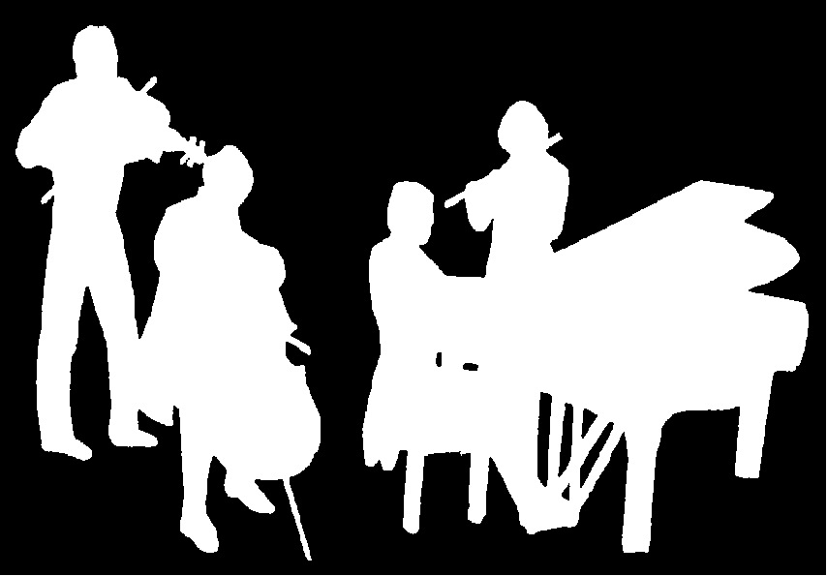
The Kirribilli Centre
www.thekirribillicentre.org
ACMS
http://www.acms-australia.org/
Chamber Music Concert
3 pm Sunday 2nd Sept 2018

