ACMS
http://www.acms-australia.org/concerts/
— Concert —
5pm Sunday 3rd March 2019
Kirribilli Centre, 16 Fitzroy St Kirribilli
www.thekirribillicentre.org tel: 9922 4428
— PROGRAM —
KOECHLIN Divertissement Op 90
(1) Tres calme (2) Allegretto quasit andante (sans lenteur)
(3) Final: allegro, bien decide
flutes Cathy Wainwright, Cathy Fraser
clarinet Lindsay Wanstall
11’

SCHOENFIELD Café Music
(2) Rubato. Andante moderato (1) Allegro
violin Heng Lin Yeap cello Terry Neeman
piano Miriam Blatt
11’

— INTERVAL —
SCHUBERT Trio No 1 in B flat Major D 898
(1) Allegro moderato (2) Andante un poco mosso
(3) Scherzo. Allegro
flute Richard Tardif cello Robyn Godfrey
piano Kian Woo
30’

—REFRESHMENTS—
- Notes -
KOECHLIN (1867-1950) – Divertissement Op 90 (1923/24)
Charles Koechlin was a Frenchman whose music mirrors a century of fluctuating musical styles. Born in Berlioz’s lifetime, he studied with Massenet and Fauré, he mingled with Debussy and Ravel, he taught Poulenc and Ravel, and towards the end of his lifetime he was to hear Messiaen and Boulez.
A dedicated composer with no other occupation or position, he built on a framework of Bach-ian style counterpoint with the materials of each epoch.
His early works written in the first twenty years of his life reflect the late Romantic style. In the following twenty years he wrote in an Impressionistic style, and his later works reflect many layered elements ranging from medievalism to jazz. Rudyard Kipling was a later source of inspiration as were Hollywood movies. His wide-ranging influences are shown by the many pieces written in homage to female film stars of the 1930s.
This particular work is written for two flutes and either alto flute or clarinet and reflects the late Impressionistic period of Koechlin’s writing. The title Divertissement means a pastime or entertainment.
SCHOENFIELD (1947-) Café Music
A dedicated Talmud and mathematics scholar, and Professor of composition at University of Michigan, Paul Schoenfield is a composer and pianist known for combining popular, folk and classical music forms. He wrote his first composition in 1954-55 at a tender age of 7, graduated with B.A. degree from Carnegie-Mellon and Doctor of Music Arts from University of Arizona.
One of Schoenfield's most performed pieces, Café Music (completed in 1986) was commissioned for the St Paul Chamber Orchestra (SPCO). Schoenfield gathered inspiration to write this piece after sitting in one night for a pianist at Murray's Restaurant in Minneapolis. Maintaining elements played by Murray's Restaurant Piano Trio, the piece incorporates Broadway, 20th century American, Viennese, gypsy and Classical style. The second movement is reminiscent of Chassidic melodies. Today, we will perform the first two movements only, playing the second movement first. Structurally, the first two movements are written in traditional forms, sonata (1st) and ternary (2nd). Café Music is suited not only for high-class dinner music but is also a crowd-pleaser at concert halls with its electrifying technical passages.
SCHUBERT (1797-1828) Trio No 1 in B flat Major D 898
The Trio No. 1 in B-flat major for piano, violin, and cello, D. 898, was written by Franz Schubert in 1827. The composer finished the work in 1828, in the last year of his life. It was published in 1836 as Opus 99, eight years after his death. Like the E-flat major trio, it is an unusually large scale work for piano trio, taking around 40 minutes in total to perform. Today, we will be playing the first three movements only.
Of all the large-scale works of his last years, the B flat Trio is the one that comes closest to the popular image of the blithe, companionable Schubert, pouring out a stream of spontaneous melody. From its soaring opening theme to the sublimated echoes of Viennese popular music in the finale, the he music exudes life-affirming energy, belying Schumann’s (to us) laughably sexist characterization of it as ‘passive’ and ‘feminine’, in contrast to the ‘dramatic’ and ‘masculine’ E flat Trio. Yet in the first movement, especially, the unfettered lyricism is underpinned by some of Schubert’s most subtle harmonic and structural thinking.
In today’s performance the violin part has been rearranged for flute.

concert organiser Sue Butler
Light refreshments (wine juice and savouries) are provided.
$15 entry donation ($10 concession/seniors) to cover costs.
To get information on future concerts, go to the website
http://www.acms-australia.org
All chamber music players are welcome to join the
Amateur Chamber Music Society. If interested, go to the website and click on “Join Us”, or email membership.secretary@acms-australia.org

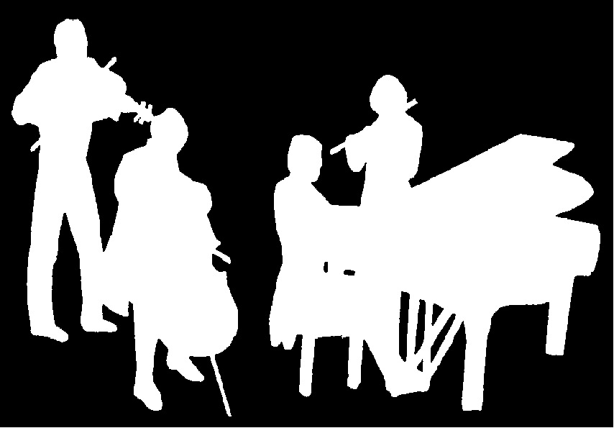
The Kirribilli Centre
www.thekirribillicentre.org
ACMS
http://www.acms-australia.org/
Chamber Music Concert
Sunday 03 Mar 2019
5pm

