FASTA Utilities User’s Guide
http://www.ProteomicAnalysisWorkbench.com/FASTA_utilities.html

Written by Phillip Wilmarth (email: wilmarth at ohsu.edu),
Oregon Health & Science University, 2010-2012

Overview: This guide tells you how to install and run a collection of Python programs that automate downloading, organizing, naming, and managing FASTA protein databases. The excellent database descriptions and tools developed by Matrix Science for Mascot use (http://www.matrixscience.com/help/seq_db_setup.html) were the inspiration for these programs. This link is very informative and makes a strong case for tools to preprocess FASTA database downloads before use by database search programs such as Mascot, SEQUEST, or X!Tandem. There can be many steps in getting a current FASTA database and preparing it for use by a search engine. The database has to be downloaded from an FTP site. A folder needs to be selected or created for the download. The database may need to be renamed to include version numbers. The database will need to be uncompressed to a text file. Many database releases include proteins from a large number of species and specific species subset databases (human, mouse, etc.) may need to be extracted. Common contaminant sequences (trypsin, keratins, etc.) often need to be added. Decoy sequences need to be created and appended to the databases when using that method of error estimation. The version numbers, download dates, and number of protein sequences should be recorded and saved for inclusion in subsequent publications. It is easy to make mistakes with so many steps or delay updating databases because it is too much work. Hopefully, this set of utilities addresses many of these issues.

Python v2.7 installation: Python is implemented as a platform-independent virtual machine similar to Java and this software should run on any computer capable of running Python. Development and testing has been under Windows XP and Mac OSX. I have Python v2.7 installed on our SEQUEST computer (running Windows XP) since I usually perform most data analysis on that computer. You will probably want to install Python and these tools on any computers that run your particular search programs. Here is the link to download Python:
http://www.python.org/download/releases/2.7.7/
Installation is very straightforward. Older versions of Python will probably work fine, but development has been done with version 2.5, 2.6, and 2.7. The next major release of Python (version 3) is not backward compatible with versions 2.x and the programs will need to be rewritten to be compatible with version 3 changes. This is planned for a future release.

How to run Python programs: I have a folder on my C:\ drive called “commands_scripts” where I keep a variety of Windows batch file scripts, Perl programs, and Python programs (I have a “Python” subfolder). The “commands_scripts” folder is in my Windows PATH environment variable but this is not necessary to run the Python programs. If you run Python programs from IDLE, all that is required is that the file “fasta_lib.py” (a library of functions and classes) is located in the same folder as the main python database tools described below. NOTE: If you want to run the programs from the command line or double click on icons, you may need to add your python programs folder to the environment variable PATH. To run “count_fasta.py” using IDLE, for example, first browse to the folder where the Python programs are located and right click on the file “count_fasta.py” as shown below. Select the option “Edit with IDLE”. This will launch the IDLE Python programming environment.

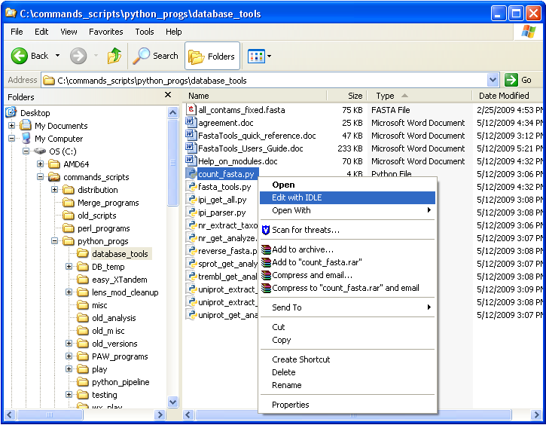

The two windows shown below will be created, one contains the source code for the program (a simple text editor window on the left) and one is the Python interpreter window (the window with a “>>>” prompt on the right). There are a couple of ways to run the programs from IDLE. You can select the source code window so that its title bar is highlighted, then push the “F5” function key. You can also select “Run Module” from the “Run” menu of the source code window. If you accidently (or intentionally) made any changes to the source code, you will be asked to save the file before it can be run. It is usually fine to save the file and try running it. Python error messages are pretty informative. If you made an accidental change and the program gives an error, you can always download a new copy of the program if you can’t fix the error.

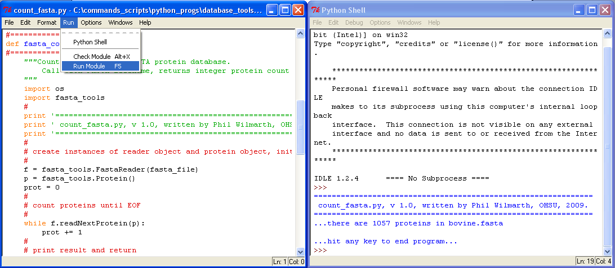

When the program runs, a dialog box will pop up asking you to select a FASTA database. The database can be a text FASTA file or a GZipped (extension .gz) compressed file. Sample program output is shown above in the right window. The program can also be executed by double-clicking its icon or from a Windows command line prompt. Most of the programs are designed to get file or folder names interactively from dialog boxes like the one below.

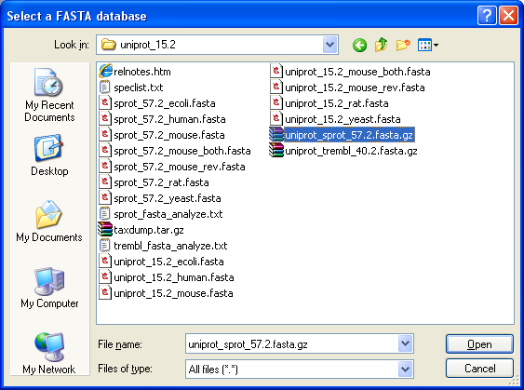

There are many books about Python and extensive online documentation (help is also available from the Python interpreter or from IDLE). The python website where you downloaded Python is a great resource and a good place to start. Normally you will not need to modify the Python program source code except for some possible initial setup/configuration details. You may want to edit the taxonomy:name dictionary for species extraction in one or more of the three extraction programs rather than passing in a long list of taxon numbers on the command line, for instance. It is very easy to modify these programs so it is worth a little time learning some very basic Python. You may want to keep a backup copy of the programs in case any of your changes break something. You can always download the software again.

Fasta Utilities Modules:
The collection of Fasta Utilities Python programs, a common contaminants FASTA protein database, this guide and some other help files are located at this URL address:
http://www.ProteomicAnalysisWorkbench.com/FASTA_utilities_download.html
The python source code files and documentation are saved in a Zip archive. You will need to download the archive and unzip the files. You will probably want to copy them to an appropriate location on your computer. The software is distributed under an open source license agreement that is at the top of most of the source code files and also included as a separate document in the distribution. The main programs are listed in the tables below. The first table gives program names and brief descriptions. The second table lists optional command line arguments and the default dialog box behaviors. Notice that the three extraction programs will always create a dialog box for file selection. The command line arguments for these programs are a mechanism to override the taxon:name dictionaries at the top of the program source code files, not to allow automated scripting

The programs fall into three categories: programs to automatically download and name the major database releases (NCBI nr, UniProt, and IPI [Note: IPI databases are no longer updated]), programs to extract species-specific subsets of the databases, and programs to prep databases for use by search engines (adding contaminants, cleaning up accession numbers and protein descriptions, and making decoy databases). Most programs write log files (“fasta_utilities.log”) containing the information printed to the screen. More detailed descriptions of the programs by category follow the tables. If the description is unclear, try running the program and looking at the FASTA files it generates. If you have any questions, please contact me.

Table 1. Main programs and descriptions:
Program name | Description
ipi_get_all.py | Fetches all of the final release of IPI FASTA databases
nr_get_analyze.py | Fetches ncbi nr database, analyzes content
sprot_get_analyze.py | Fetches UniProt Sprot database, analyzes content
uniprot_get_analyze.py | Fetches both UniProt databases, analyzes contents
extract_by_string.py | Extracts proteins having “string” in accession or description
nr_extract_taxon.py | Extracts specific species entries by taxon number
uniprot_extract_from_one.py | Extracts species by taxon number from Sprot or Trembl
uniprot_extract_from_both.py | Joint extraction by taxon number from Sprot and Trembl
add_extras_and_reverse.py | Adds extra sequences to databases and reverses entries
check_for_duplicates | Checks database for redundant sequences
count_fasta.py | Counts the number of protein sequences in databases
ipi_parser.py | Parses accessions and descriptions in IPI FASTA databases
remove_duplicates | Removes duplicate sequences and creates an “nr” database
reverse_fasta.py | Makes sequence-reversed concatenated FASTA databases
taxon_group_analyzer.py | Summarizes analysis info for taxon nodes (taxon groups)
fasta_lib.py | Main library of classes and functions
Table 2. Optional command line arguments and dialog box behavior for each program.
Program name | Optional command arguments | Dialogs
ipi_get_all.py | IPI download folder path | Folder browser (if no path)
nr_get_analyze.py | NCBI “nr” download folder path | Folder browser (if no path)
sprot_get_analyze.py | UniProt download folder path | Folder browser (if no path)
uniprot_get_analyze.py | UniProt download folder path | Folder browser (if no path)
extract_by_string.py | Pairs of “strings” and names (enclose strings in double quotes if they contain spaces) | File browser to select FASTA database file
nr_extract_taxon.py | Pairs of taxon numbers and simple names for each desired species (default set of species if no arguments; edit source to change) | File browser to select “nr” database file
uniprot_extract_from_one.py | Pairs of taxon numbers and simple names for each desired species (default set of species if no arguments; edit source to change) | File browser to select either “sprot” or “trembl” database file
uniprot_extract_from_both.py | Pairs of taxon numbers and simple names for each desired species (default set of species if no arguments; edit source to change) | Folder browser to select uniprot download folder
add_extras_and_reverse.py | Extra FASTA file path, main FASTA file path, and output FASTA file path | File browser dialogs to select FASTA database files
check_for_duplicates | FASTA database (full path) to check | File browser to select FASTA database file
count_fasta.py | FASTA database (full path) to count | File browser to select FASTA database file
ipi_parser.py | Specific IPI database path to parse | File browser to select “ipi” database file
remove_duplicates | FASTA database (full path) to process | File browser to select FASTA database file
reverse_fasta.py | FASTA database (full path) to reverse and concatenate | File browser to select FASTA database file
taxon_group_analyzer.py | Taxon node number (single integer) | Folder browser to select database download folder

nr_get_analyze.py, sprot_get_analyze.py, tremble_get_analyze.py, uniprot_get_analyze.py, and ipi_get_all.py: These related programs fetch current versions of the respective databases from their FTP sites, create folders and files containing version numbers, get any release/readme files, get related taxonomy files, and provide detailed species information (if the databases contain more than one species). Latin scientific names, taxonomy numbers, total protein sequence counts (and RefSeq protein counts for nr), scientific name lengths, and flags for virus entries are written to tab-delimited text files that can be opened with Excel or word processors. Filtering, sorting, and searching can be used to find particular species. The databases are rapidly expanding as DNA sequencing efforts increase and a strategy of less-restrictive searching of the analysis text files is recommended before selecting taxonomy numbers for extracting specific species. After locating any desired species and their taxon numbers, a collection of extraction programs can be used to find all of the desired protein sequences and write them to separate files. The above “get” programs generally check current database versions (or date for ncbi nr) and will download databases if newer versions exist (or they do not find appropriately named folders in the proper relative locations). It is possible with downloads of files that are nearly several GB in size, that the download will occasionally fail. Sometimes a different FTP client can help, or the download can be tried at a different time of day. The Matrix Science website (near the top of this document) has links for manually downloading the databases. Just put any manually downloaded database into the appropriate newly created database folder and re-launch the program. These programs will “pick up where they left off”. Just make sure any partially downloaded files are deleted before re-running the programs. You do not need to rename a database downloaded from another FTP program, just make sure it is in the proper database folder. Trembl and NCBI nr are large files and can take several hours to download. The separate program for Sprot downloads, sprot_get_analyze.py, will be faster if you do not want (or need) the large Trembl database. The uniprot_get_analyze.py program gets both Sprot and Trembl databases and produces a combined analysis file.

taxon_group_analyzer.py: The individual “database”_fasta_analyze.txt files created by the “database”_get_analyze programs contain information for each species taxonomy number present in the database (species name, protein counts, etc.). In some cases a group of species may be of interest, such as rodents, mammals, plants, etc. The taxonomy numbers associated with these groups can be obtained using the NCBI taxonomy browser (http://www.ncbi.nlm.nih.gov/Taxonomy/). This program will find all of the species belonging to a specified group taxonomy number and create a subset analyze text file named with the group taxon number appended. This file can be helpful in deciding which specific species taxonomy numbers to extract or what minimum protein sequence limits are appropriate.

nr_extract_taxon.py, uniprot_extract_from_one.py, and uniprot_extract_from_both.py: These programs extract specific species from the respective databases. The analysis files created by the download programs should be the primary reference for taxonomy numbers. Online sources can be used to find potential taxonomy numbers and Latin species names to use in searches of these files. It is recommended that more relaxed search strategies of the analysis files be used. The species information may be far richer than anticipated. It may be challenging to decide which species or how many different, related species to extract. Unfortunately, there has been little discussion of this topic and I cannot offer much advice. You may have to try creating different databases and see what seems to work best. Databases with many similar proteomes can cause false positive identifications and may not be the best search strategy. Strategies using a collection of representative proteomes followed by a refined search with additional proteomes of just the likely species present may be more successful. There are built-in dictionaries (at or near the top of the source code files) that extract human, mouse, rat, and yeast entries by default. The dictionaries can be edited to extract different or additional species. The internal dictionaries can be overridden by passing in pairs of taxon numbers and names on the command line. Note that “names” must be a single word (no whitespace). This command line would get Aurantimonas bacteria proteins from the nr database:

>>>python nr_extract_taxon.py 287752 Aurantimonas

Most of the execution times of these programs are spent reading the database files, which can take many minutes for NCBI nr or UniProt Trembl files, and it is more efficient to extract more than one species at a time. If there are several species that you want to extract into a single database (maybe several insects, for example), use the same “name” for all taxon numbers that you want to group together. This command line would make a combined hamster (Golden and Chinese), mouse, and rat Sprot database (assuming a UniProt Sprot database is selected during program execution):

>>>python uniprot_extract_from_one.py 10036 rodent 10029 rodent 10090 rodent 10116 rodent

Taxonomy groups (nodes) can also be extracted by specifying the appropriate taxonomy number and setting an internal flag to allow group expansion (set EXPAND_GROUPS = True). Assuming the EXPAND_GROUPS flag in nr_extract_taxon.py has been set to True, this line would extract all rodent sequences from the nr database:

>>>python nr_extract_taxon.py 9989 rodents

Remember that Sprot and Trembl are (essentially) complementary. If you find species entries that you would like to extract from Trembl, it is strongly recommended that you extract the same taxon numbers from both databases into a single file using the program uniprot_extract_from_both.py. This is also a nice way to get a more complete (and less redundant) database for an organism. The NCBI RefSeq project (http://www.ncbi.nlm.nih.gov/RefSeq/) can make a tremendous improvement in the quality of proteomes extracted from nr and there is a flag to extract only RefSeq entries in nr_extract_taxon.py (on by default). NOTE: databases extracted from nr are non-redundant by species in contrast to species-specific databases downloaded via the NCBI website (e.g. searching for a taxonomy number, selecting proteins, formatting in FASTA, then saving to file). Cleaning up of accession numbers and descriptions is provided via source code logical flags located near the top of the source code files; however, cleaning can cause some loss of information. If you are unsure about cleaning, it is recommended that you extract with and without cleaning and compare the resulting FASTA files.

extract_by_string.py: Extracts any proteins having a string (text pattern) match in the header lines (accessions plus descriptions). Only headers containing matching strings are written to the output files. A flag in the source code determines whether matching is case sensitive or not. A match occurs if the header contains the string. The default is no “cleaning” of accessions or descriptions so that NCBI nr formatting is preserved. Cleaning can be enabled with a logical flag in the source code or can be done with “reverse_fasta.py”, if desired. This extraction method is inferior to extraction by taxon number for species extraction. This method may extract unwanted sequences. Use with caution!

add_extras_and reverse.py: This program is a variation of reverse_fasta.py. It adds any extra protein sequences from small, custom FASTA files (along with common contaminants from the file “all_contams_fixed.fasta”) to a main FASTA database. It creates new accession strings for the extra sequences to avoid conflicts with the main entries. Main database entry accessions and protein descriptions can be parsed (cleaned) to simplify them if desired. Choice of output files is set using internal Boolean flags and can be a concatenated target/decoy database with extras and contaminants, or separate target and decoy databases (or all three). Running the program is slightly more involved because two input FASTA databases have to be selected and a location and base name for the output files must be specified. All interaction is still via simple dialog boxes (or passed in from the command line). If the contaminants file cannot be found, it will be skipped with a warning.

check_for_duplicates.py: Checks a FASTA database for multiple copies of the same sequences. Prints information about duplicates to the screen and to “duplicates.txt” file. Many species-specific databases downloaded from web sites are not really “non-redundant” databases. Note that checking for subset sequences is not performed.

count_fasta.py: Counts the number of entries in a FASTA database with some degree of error checking. The database can be a GZipped FASTA file or a text FASTA file. The program checks that all accession numbers in the database are unique. Optionally, via source code changes, amino acid sequences can be checked for valid characters. Invalid sequence characters are skipped and a warning is written to the console window. Note that subsequent parsing of accession numbers by other software could still result in non-unique accession numbers that can be a serious source of error.

ipi_parser.py: Produces a forward-sequence-only IPI database with the accessions and descriptions “cleaned” up. Note that parsing/cleaning can also be done in reverse_fasta.py. IPI accession number versions are retained. There is a flag that controls whether or not gene identifiers are removed from the protein descriptions during cleaning. The default is to remove both taxonomy and gene identifiers from protein descriptions.

remove_duplicates.py: Creates a “non-redundant” database by collapsing duplicate sequences. The first protein accession number encountered in the database is kept and all identical sequences removed. The accessions and descriptions of removed proteins are added as additional header elements, separated by Control-A characters, to the retained protein entry. The new database has the same name as the original with “_nr” appended. Checking for subset sequences is not done and subset sequences are not removed.

reverse_fasta.py: This program does several things to prepare extracted databases for use. It adds common contaminants from the file “all_contams_fixed.fasta”, parses accession strings and protein descriptions to simplify them (if flags are set correctly), creates sequence-reversed entries, and creates one or more output files, such as concatenated target/decoy database with contaminants, or separate target and decoy databases (or all three). Choice of output files is set using internal Boolean flags. If the contaminants database is not found (or renamed), it is skipped. Incorrect end-of-line characters or blank lines can be eliminated from FASTA files by running “reverse_fasta.py” and creating a forward database. Reading and writing databases will result in blank lines being skipped and correct end-of-line characters being written for the platform where programs are run. Decoy sequences are denoted by prefixing a “decoy_string” to the beginning of an appropriate part of the accession number. This is designed to be (possibly) more compatible with regular expression parsing of accession numbers without losing the decoy designations.

Protein Database Recommendations: I recommend using UniProt Sprot databases when possible rather than NCBI nr or IPI protein databases. For any NCBI databases, use of RefSeq entries is strongly recommended. Use of multi-species databases can be problematic and is not recommended. They can make it difficult to know what species are really present in your sample (when analyzing environmental samples, for instance) if highly homologous proteins from many species are in the database.

Decoy databases essentially provide an analysis control and are highly recommended but they double search times. No enzyme searches are a powerful use of distraction (as are decoy databases) and can improve the identification of fully tryptic peptides but also increase search times significantly. A smaller, more accurate database helps to offset these more costly search strategies. For example, if you have human samples, I would suggest using a human species subset of Sprot with concatenated reversed entries. Large, unnecessarily redundant databases reduce the discriminating power of DeltaCN (for SEQUEST searches) and may adversely affect parsimony filtering.

For studies of non-model organisms, it can be challenging to create a good protein database for searching. Genomic information is rapidly growing with more and more species being sequenced. Hopefully, the database analysis text files will help locate available sequences for subsequent extraction and these tools will allow more frequent updating of databases. Google and the NCBI Taxonomy site (http://www.ncbi.nlm.nih.gov/Taxonomy/) can be useful if you are having trouble locating the name or taxonomy number of a species of interest. Searching for a species at http://expasy.org/sprot/ is also a good way to find the text and/or taxon numbers to use in searching the analysis files. Both taxonomy numbers and scientific names can vary between databases and double-checking information in the analysis text files is important.

The non-redundant aspect of NCBI nr results in a less proteomics-friendly FASTA database. A single protein sequence can map to more than one species and/or more than one gi number (and description) per species. Many, if not most, of the protein sequences will have more than one header element (an accession number and protein description). These extraction programs will remove any header elements that do not match the taxonomy or text patterns of interest, preserving the normal NCBI nr formatting if cleaning is turned off. The accession cleaning option retains the first header element that matches the taxonomy or text patterns of interest and this can cause some potential loss of information. It is safer to extract (string or taxon numbers) without cleaning and apply cleaning at later stages (eg. reverse_fasta.py). A powerful way to process NCBI nr sequences is to first extract by taxonomy number to an intermediate database file, then process that database with a string extraction of “|ref|” to retain “Reference Sequences” only (Note: this is now incorporated into “nr_extract_taxon.py” and can be controlled by an internal flag). The Reference Sequence project is described in more detail at: http://www.ncbi.nlm.nih.gov/RefSeq/. See the “Observations.doc” file for more details on how the formatting of NCBI nr may cause small differences depending on which method is used to extract sequences. You are encouraged to look at the created FASTA databases to see if they are what you expected.

Please contact me at the email address at the top of the document if you have any problems, questions, or suggestions for improvements.

-Phil Wilmarth, 2010.

