Paul Winzer

CS 520

Hood College - Spring 2018

1. [COMPLETE]

$\sum_{i=1}^{n}{}i^{2}=\{1 +4+9+16+25+...+n^{2}\}$

Inductive proof that $∀ n ≥1 : \sum_{i=1}^{n}{}i^{2}= \frac{1}{6}n(n+1)(2n+1)$

$\frac{1}{6}n(n+1)(2n+1)+{(n+1)}^{2}=\frac{1}{6}(n+1)((n+1)+1)(2(n+1)+1)$

$\frac{1}{6}(n^{2}+n)(2n+1)+{(n+1)}^{2}=\frac{1}{6}(n+1)(n+2)(2n+3)$

$\frac{1}{6}({2n}^{3}+ {3n}^{2}+ n)+{n^{2}+2n+1}^{}=\frac{1}{6}(n^{2}+3n+2)(2n+3)$

$\frac{{2n}^{3}}{6}+ \frac{{3n}^{2}}{6}+ \frac{n}{6}+{\frac{{6n}^{2}}{6}+\frac{12n}{6}+\frac{6}{6}}^{}=\frac{1}{6}({{2n}^{3}+ 9n}^{2}+13n+6)$

$\frac{{2n}^{3}}{6}+ \frac{{9n}^{2}}{6}+ \frac{13n}{6}+{\frac{6}{6}}^{}=\frac{1}{6}({{2n}^{3}+ 9n}^{2}+13n+6)$

1. $\frac{1}{6}({2n}^{3}+9n^{2}+13n+6)=\frac{1}{6}({{2n}^{3}+ 9n}^{2}+13n+6)$ [both sides identical]
2. QED

2. [COMPLETE]

----------------BEGIN CODE----------------------

import time

# iterate raising x to the n

def pow_it(x, n):

print 'Raising {0} to the {1}'.format(x,n)

start = time.time()

a = 1

i = n

if n == 0:

return 1

else:

while i > 0:

a *= x

i -= 1

stop = time.time()

run_time = stop - start

print 'Raised {0} to the {1} in {2}'.format(x,n,run_time)

return a

# recursively raising x to the n

def pow_re(x,n,top=True):

if top:

print 'Raising {0} to the {1}'.format(x,n)

start = time.time()

a = x

if n == 0:

return 1

else:

a = pow_re(a, n-1, False)

if top:

stop = time.time()

run_time = stop - start

print 'Raised {0} to the {1} in {2}'.format(x,n,run_time)

return a

----------------END CODE----------------------

(code also included as pow_pdw.py in .zip)

|  |  |  |  |
| --- | --- | --- | --- |
| x | n | Iterative time (sec) | Recursive time (sec) |
| 5 | 1 | 5.01E-006 | 5.96E-006 |
| 5 | 10 | 8.11E-006 | 1.22E-005 |
| 5 | 50 | 2.29E-005 | 4.20E-005 |
| 5 | 100 | 4.10E-005 | 8.01E-005 |
| 5 | 250 | 0.0001120567 | 0.0001969337 |
| 5 | 500 | 0.0002708435 | 0.0004451275 |
| 5 | 750 | 0.0003890991 | 0.0006871223 |
| 5 | 998 | 0.00050807 | 0.0010251999 |
| 5 | 999 | 0.0005640984 | Fatal, max recursion level reached |

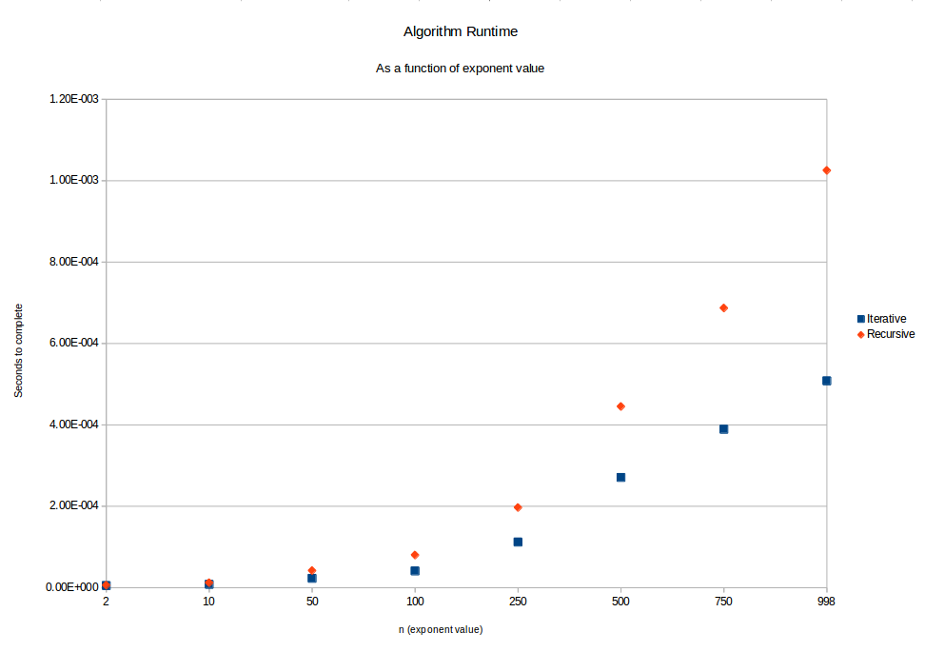

Both iterative and recursive algorithms run in O(n); it looks quadratic but the exponent size (x axis) grows unevenly from 0 to 998, though it grows evenly from 250 to 998, which is the best place to see the linear growth. Though the time complexities are the same, the recursive algorithm takes longer to complete on for all exponents tested. The recursive algorithm also had the disadvantage of topping out at an exponent of 998; it would not recurse more than that.

3. [COMPLETE] Using the BST definition that all element values are unique, the second 10 isn’t inserted because there is already a 10 in the tree.

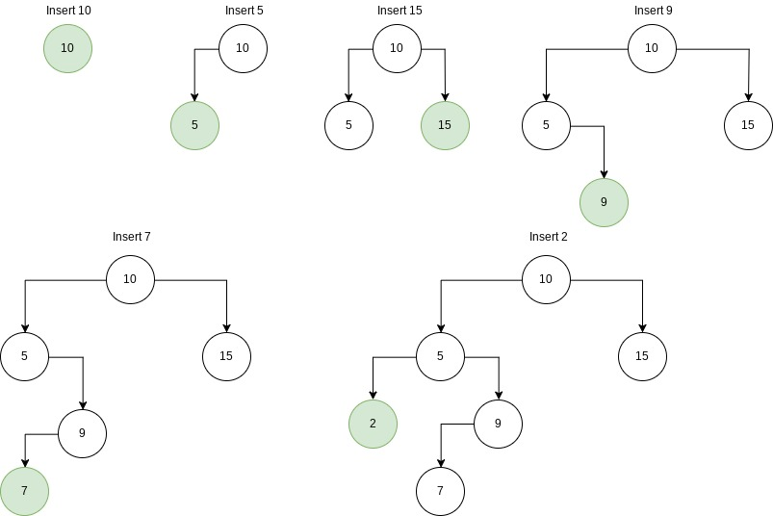

3. (continued)

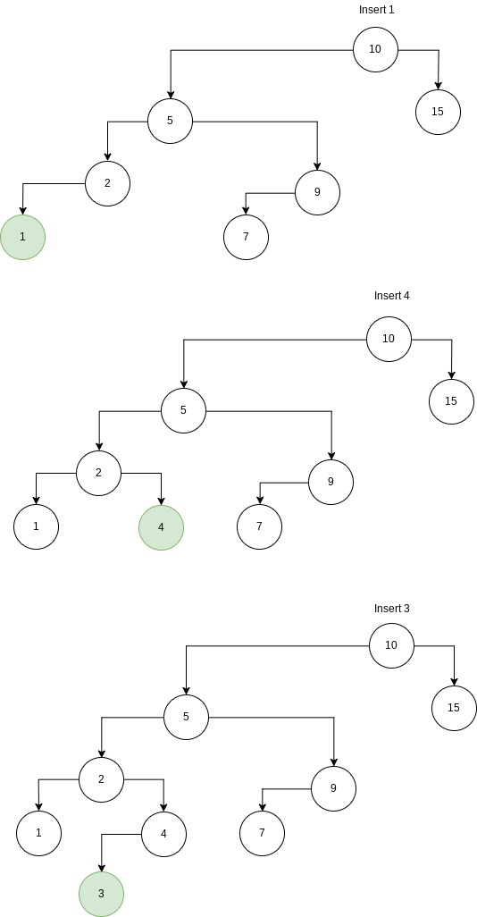

3. (finished)

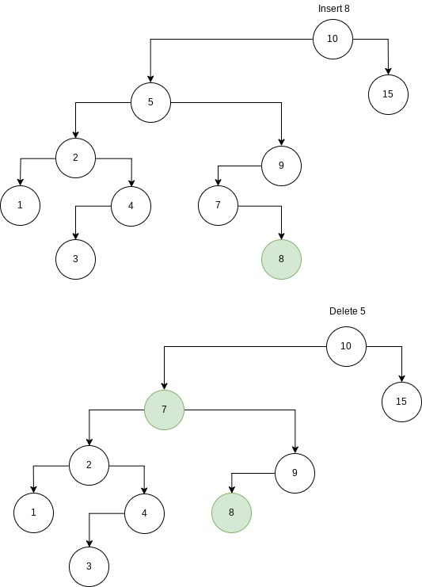

4. [COMPLETE]

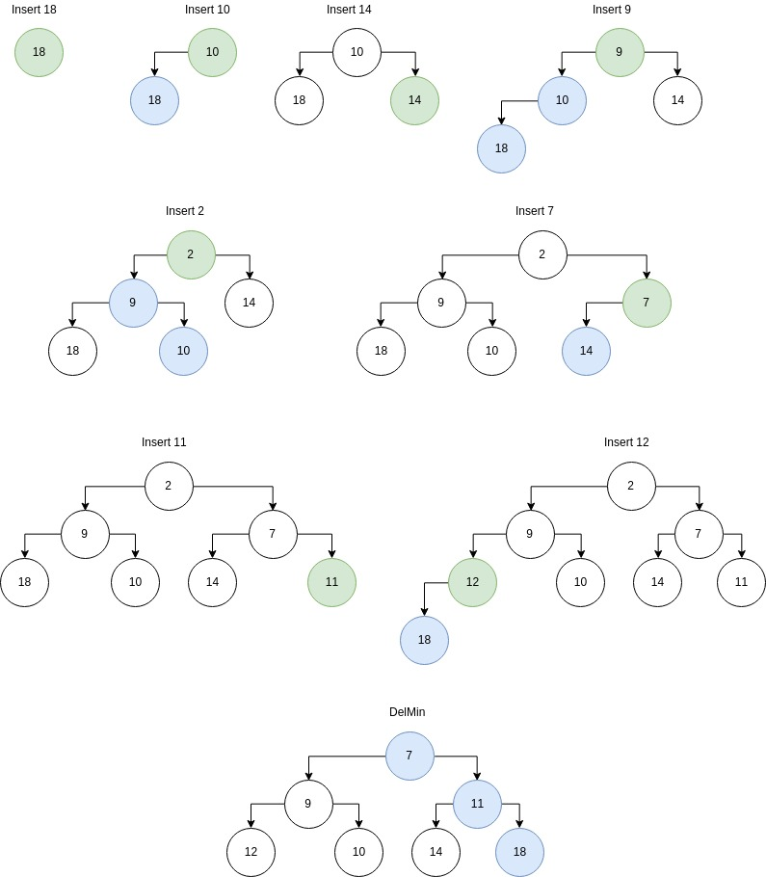

5. [COMPLETE]

1. For height and depth, I print the values as I go, instead of returning them all in one one structure at the end. They also use 0-based indexing; leaf height = 0, root depth = 0.

**NumLeaves**(T):

// no children means it’s a leaf

if (T → lchild is null) and (T → rchild is null):

return 1

// if it has only rchild, search that

else if (T → lchild is null):

return NumLeaves(T → rchild)

// if it has only lchild, search that

else if (T → rchild is null):

return NumLeaves(T → lchild)

// if it has two children, search both

else:

return NumLeaves(T → lchild) + NumLeaves(T → rchild)

**HeightEveryNode**(T):

// no children means height == 0

if (T → lchild is null) and (T → rchild is null):

print 0

return 0

// if it has only rchild, it’s 1 more than the height of that

else if (T → lchild is null):

h = 1 + HeightEveryNode(T → rchild)

print h

return h

// if it has only lchild, it’s 1 more than the height of that

else if (T → rchild is null):

h = 1 + HeightEveryNode(T → lchild)

print h

return h

// if it has two children, it’s 1 more than the height of the taller

else:

h = 1 + Max(HeightEveryNode(T → lchild), HeightEveryNode(T → rchild))

print h

return h

**DepthEveryNode**(T,D=0):

// no children means max depth

if (T → lchild is null) and (T → rchild is null):

print D

return D

// if it has only rchild, it’s 1 less than the depth of that

else if (T → lchild is null):

d = -1 + DepthEveryNode(T → rchild, D+1)

print d

return d

// if it has only lchild, it’s 1 less than the depth of that

else if (T → rchild is null):

d = -1 + DepthEveryNode(T → lchild, D+1)

print d

return d

// if it has two children, it’s 1 less than the depth of either

// depth of both children are the same, so we only need one

// but we must call both to find the depth of every node in tree

else:

d = -1 + DepthEveryNode(T → lchild, D+1)

DepthEveryNode(T → rchild, D+1)

print d

return d

**IsFull**(T):

// a node with no children does not rule out fullness

if (T → lchild is null) and (T → rchild is null):

return true

// a node with exactly one child does rule out fullness

else if (T → lchild is null) or (T → rchild is null):

return false

// if node has two children, see if subtrees are full

else:

return IsFull(T → lchild) and IsFull(T → rchild)

b. All these routines compute in O(n) time complexity. They all require at least one operation and at most two operations on every node representing a subtree. Returning the base case or returning the recursive call to a single subtree would be one operation, whereas calling down both subtrees would be two operations. Because all these routines require traversing every subtree and visiting every node, we cannot reduce the complexity to O(log n) like we can with BST search or inserts. And because the length of each basic operation does not depend on the number of nodes in the tree, we don’t see complexity of O().

6. [COMPLETE] The asymptotic time complexity of a good algorithm to sum all the elements of an ‘n by n’ 2 dimensional matrix grows linearly with the number of inputs in the matrix. The actual number of inputs to the routine is some number $m$ where $m=n^{2}$. Since the run time of the algorithm is a function of the number of inputs, and n is the square root of the number of inputs, we would say that the algorithm grows in O(m) time. If we were to say that the growth of runtime was O(n), that n would not be equal to the n in the ‘n by n’ size of the matrix, and that would be confusing.

7. [COMPLETE]

a) This function computes the $n^{th}$ number in the Fibonacci series.

b) $Fibonacci(n) = \{ 1 : n ≤1$

$Fibonacci(n-1) + Fibonacci(n-2) : n >1 \}$

c) There are 12 additions in $unknown(6)$.

The recurrence relation for the number of additions is:

$FibAdds(n) = \{ 0 : n ≤1$

$FibAdds(n-1) + FibAdds(n-2) + 1: n >1 \}$