Benznidazole therapy saves costs compared to usual follow-up care for indeterminate chronic Chagas disease in a European healthcare setting

Authors: Philip Erick Wikman-Jorgensen^{1,2}, Clara Crespillo-Andújar^{3,4}, Jara Llenas-García^{2,4,5}, Jose A. Perez-Molina^{3,4}

- Infectious Diseases-Internal Medicine Service. Elda General University Hospital-FISABIO.
- Clinical Medicine Department. Miguel Hernández University, Elche, Spain.
- National Reference Centre for Tropical Diseases. Infectious Diseases Department. University Hospital Ramón y Cajal (IRYCIS), Madrid, Spain
- CIBERINFEC, Carlos III Health Institute, Madrid, Spain
- Infectious Diseases-Internal Medicine Department. Hospital Vega Baja-FISABIO.

Corresponding authors:
- Philip Erick Wikman Jorgensen, Internal Medicine Service. Elda General University Hospital, Ctra Elda-Sax s/n, CP 03600. Spain.
- Jose A. Pérez-Molina, National Reference Centre for Tropical Diseases. Infectious Diseases Department. Universitary Hospital Ramón y Cajal. Carretera de Colmenar Km 9,1. Madrid 28034, Spain.

Keywords: Benznidazole, Neglected tropical diseases, Trypanosoma cruzi, Chagas Disease, cost-effectiveness analysis, Health access.

Abstract
Background. Chagas disease is increasingly prevalent in Europe, but the most effective treatment available, benzinadole, is still under-used. This study aimed to assess the cost-effectiveness of benznidazole for chronic indeterminate Chagas disease in a European setting from the perspective of the healthcare system, with a 20-year time horizon.
Methods. The study took place in a European healthcare environment. The model was specifically calibrated to reflect the Spanish epidemiological situation. An economic evaluation (cost-effectiveness analysis) was performed using a Markov model and Monte Carlo simulations and probabilistic sensitivity analysis (PSA) to characterise uncertainty. Key input data included transition probabilities (derived and calibrated from the literature) and costs.
Findings. The model projects that treating Chagas disease with benznidazole would yield about 712 678 QALYs at a total cost of €0·95 billion over 20 years, whereas the usual follow-up care would generate 704 580 QALYs at €1·44 billion. Thus, benznidazole confers an additional 8098 QALYs while saving roughly €496 million, producing a negative incremental cost-effectiveness ratio (−€61 294 per QALY). Thus, benznidazole treatment seems to be more effective and less costly (“dominant”) compared with no treatment. The expected value of perfect information (EVPI) was calculated at €0·83 million per year over the study period.
Interpretation. Benznidazole appears to be a cost-saving treatment for chronic indeterminate Chagas disease patients in the studied healthcare setting. While some residual uncertainty exists, the results suggest that investing in future research to reduce this uncertainty would be reasonable, up to the calculated EVPI value.
Funding.

Introduction
Chagas disease is a neglected tropical disease that affects nearly six million people in Latin America and is becoming increasingly prevalent in non-endemic regions due to migration. Often asymptomatic during its acute phase, it can progress to a chronic stage in which individuals eventually develop severe cardiac or digestive involvement, accompanied by an increased risk of mortality.¹ Benznidazole is highly effective in the acute phase, in early chronic infection, and in preventing mother-to-child transmission, but its efficacy is questionable in late chronic infection, particularly when there is visceral involvement.^{2,3} The safety profile is far from ideal, with frequent discontinuations due to toxicity.⁴ Nonetheless, despite these limitations, benznidazole is considered under-used due to a lack of disease awareness, late diagnosis, cost, and barriers to treatment access,⁵ resulting in a significant loss of its potential benefits.
Chagas disease, caused by Trypanosoma cruzi, remains endemic in 21 countries, accounting for 12 000 deaths per year—particularly in the Southern Cone, where 70·2 million individuals are at risk.^{1,6} Through globalisation and migration, the disease has reached non-endemic regions, with a prevalence of approximately 347 000 cases in the United States and 123 078 in Europe.^{7–9} Acute infections are often asymptomatic and therefore frequently go undetected. They can occur at any age and may present with fever, lymphadenopathy, hepatosplenomegaly, and a localised lesion at the site of parasite entry (referred to as a “chagoma”). However, severe cases are uncommon (1–5%).¹ This initial phase lasts approximately 4–8 weeks and, if not treated, typically progresses to a chronic stage. At 10 to 30 years after the initial infection, about 30–40% of chronically infected individuals develop visceral involvement, most commonly manifesting as cardiomyopathy, gastrointestinal complications, or both.¹
Benznidazole demonstrates high efficacy in the acute and early phases of T. cruzi infection, achieving serological cure rates of up to 100% in congenital cases treated within the first year of life and 76% in cases of acute disease.^{1,3} In the chronic phase, cure rates decrease to 60–93% in children up to 13 years old and are lower still in adolescents under 18.^{1,3} Treatment effectiveness appears to be lower in adults with chronic Chagas disease (2–40%), but in cases with visceral involvement, it remains uncertain whether benznidazole stops disease progression.^{1,3} Treatment has also proven highly effective in preventing mother-to-child transmission.¹⁰ Benznidazole has a poor tolerability profile, leading to treatment discontinuation due to toxicity in approximately 14% of adults.⁴
In countries such as Spain, where awareness of Chagas disease is high, the undertreatment rate of chronic Chagas disease remains substantial, estimated at 82·5% in patients aged 15 years or older and 60% in children. Barriers to treatment include limited medication availability, challenges in accessing healthcare services, clinicians’ hesitancy to prescribe it due to limited evidence of efficacy, and insufficient training on Chagas disease and its medications costs.^{5,11} This undertreatment may result in a higher number of new cases, due to vertical transmission, and disease progression among those infected, leading to significantly increased expenses for care, complex treatments, the use of devices such as defibrillators or pacemakers, and a decline in patients’ quality of life.¹²
In this study, we aim to analyse whether the use of benznidazole is cost-effective for chronic Chagas disease in order to provide arguments to expand its application, particularly among vulnerable populations facing access issues.
Methods
Design and setting
This economic evaluation assesses the cost-effectiveness of benznidazole for patients with chronic indeterminate Chagas disease attending a publicly funded specialist infectious disease outpatient clinic. It was performed in Spain from a national healthcare provider’s perspective, from which the costs of interventions were derived. This includes costs only for the government and related to the follow-up and treatment of the patients. Patients’ costs, like time and travel costs as well as opportunity costs, were not considered. Results were extrapolated to the rest of the European Union using purchasing power parity indicators.
Target population and subgroups
The target population were migrants to Spain from South and Central America, aged 15 to 69 years, who had chronic Chagas disease without organ involvement. The sample was stratified by sex and by 5-year age groups. Background mortality was adjusted by age group using data from the Spanish National Statistics Institute.^{5,13}
Comparators
We compared two potential intervention strategies. The baseline scenario, a follow-up approach, involves monitoring patients with chronic indeterminate Chagas disease who are not treated with benznidazole or another parasiticide, and managing any damage caused by the parasite (for example, treating heart failure if it occurs). The second scenario involves treating every patient with chronic indeterminate Chagas disease with benznidazole at 5·0–7·5mg/kg/day twice daily for 60 days.
Outcomes, time horizon and discount rate
Health outcomes were evaluated using quality-adjusted life-years (QALYs). QALY weights used were taken from Requena-Mendez et al.¹⁴ Each health state had a QALY weight attached to it, and total QALYs were calculated for the time horizon. As chronic Chagas disease is a lifelong infection, a 20-year time horizon was chosen, and a yearly time step was considered appropriate. QALYs were discounted at an annual rate of 3%, as is commonly accepted.¹⁵
Measurement of effectiveness
As a measure of effectiveness, we used the risk reduction of heart disease progression reported in the meta-analysis by Crespillo-Andújar et al.³ and the estimate of risk reduction of progression to the intestinal form published by Nunes Da Costa et al.¹⁶
Costs
Costs used were taken from published insurance reimbursement lists from the Spanish National Health System. The cost of benznidazole was obtained by direct query to the Department for Foreign or Compassionate Use Medicines (Spanish Agency of Medicines). A cost was calculated for each health state of the model considering routine follow-up visits, tests, interventions and frequency of complications in each state (detailed explanation in supplement). Costs were also discounted at an annual rate of 3%.
Model
A Markov model was chosen as Chagas disease patients experience several disease states over time. The model represents a cohort of migrants from endemic areas to Spain with chronic indeterminate Chagas Disease (Fig. 1). The model starts with a Chagas disease patient in the upper left corner (chronic indeterminate Chagas disease). From there, a patient may develop chronic Chagas heart disease (upper right corner) or chronic digestive disease (bottom left corner). From all three of the mentioned states, a patient may die and transition to the fourth state, death (bottom right corner). The model was stratified by age group and sex. Transitions between states were governed by parameters presented in table 1. The initial parameters were selected through extensive literature research conducted by the study investigators, based on a qualitative assessment. Further details are available in the Supplementary material.
To calibrate the transition parameters, the model was run 100 000 times, and the set of parameters that best reproduced the same deaths due to Chagas disease as those reported by Ramos-Rincón et al.¹⁷ were chosen for the deterministic analysis.
The total population was assumed to remain constant. To achieve that, dead individuals were replaced by new patients of the youngest age group.
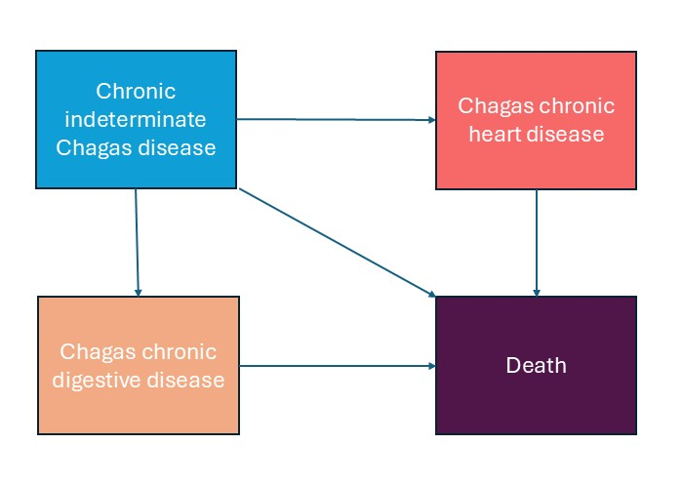
Figure 1. Simplified representation of the Markov model. The model starts with a patient with chronic indeterminate Chagas disease in the upper left corner. From there, a patient may develop determinate chronic Chagas heart disease (top right corner) or chronic digestive disease (bottom left corner). From all three of these states, a patient may die and transition to the fourth state, death (bottom right corner). The model was stratified by age group and sex.
Data analysis
The model and the analysis were developed in R version 4.3.1.¹⁸ A cost-effectiveness analysis was undertaken, simulating two cohorts: one treated with benznidazole and one not treated. For each arm, QALYs and costs were calculated with the model as well as the incremental cost-effectiveness ratio (difference in costs divided by difference in QALYs).
A deterministic sensitivity analysis was conducted, introducing variations on key parameters individually within the extreme values of their possible range, and the results were presented as tornado plots. In addition, a probabilistic sensitivity analysis (PSA), where the parameters were given probability distributions and the simulations run 1000 times (i.e. Markov chain Monte-Carlo simulations) was undertaken and presented as a scatter plot and cost-effectiveness probability curves. The number of iterations to produce stable results was estimated by visual inspection of a graphic representation of the cumulative average net monetary benefits (Fig. S5. Supplementary material).
The expected value of perfect information (EVPI) was calculated by comparing two net monetary benefit (NMB) scenarios: (1) the NMB obtained when the decision-maker selects the intervention with the highest expected NMB based on current evidence, and (2) the NMB that would be realised if the true parameter values were known in advance, allowing for the optimal intervention to be chosen. The difference between these two expectations represents the EVPI. This quantity establishes an upper limit on rational spending for additional research.
Reporting of the study was done in accordance with the CHEERS statement.¹⁹
Results
Study parameters
Table 1 presents transition probabilities derived from literature as well as those obtained after calibration and the distribution used for PSA analysis.

 | Mean (95% CI) | After calibration | PSA distribtution | Reference
Probability of progression to Chagas heart disease per year | 0·0175 (0·01-0·03) | 0·0189 | Beta (mean=0·0175, 95% CI 0·01-0·03) | Chadalawada et al. 2020²⁰
Relative risk Mortality due to Chagas heart disease | 12 (4-16) | 2·57 | LogNormal (mean=2·57, 95% CI 1·1-5) | Chadalawada et al. 2021²¹
Relative risk Mortality due to Chagas digestive disease | 2·1 (1·52-2·91) | 1·25 | LogNormal (mean=1·25, 95% CI 1-2) | by Cucunuba et al. 2016.
Probability of progression to digestive Chagas disease per year | 0·011 (0·008-0·0136) | 0·035 | LogNormal (mean=0·035, 95% CI 0·01-0·04) | Castro et al. 1994²²
Relative risk reduction of progression to Chagas heart disease | 0·49 (0·19-1·25) | NA | LogNormal (mean=0·49, 95% CI 0·019-1·25) | Crespillo-Andújar et al. 2022³
Relative risk reduction of progression to digestive Chagas disease | 0·88 (0·55-1·42) | NA | LogNormal (mean=0·88, 95% CI 0·55-1·42) | Nunes da costa et al. 2021¹⁶
Table 1. Key model parameters, their mean values, uncertainty ranges (95% confidence intervals), with calibrated values where applicable, and assigned probability distributions used in probabilistic sensitivity analysis (PSA). Parameters include disease progression probabilities, relative risks of mortality for Chagas-related complications, and treatment effects. Where calibration was performed, the final calibrated parameter value is shown. References correspond to the original data sources used to inform parameter estimates.

Costs
The costs of laboratory tests, diagnostic procedures, medical attention, drugs, and medical devices are presented in Table 2.

 | Unit Cost (€) | Annual Units | Annual Cost (€) | Source
Treatment | 131 | Once | 7 | Direct query to the Department of foreign medicines of the Spanish Agency of Medicines and Medical Devices.
Complete Blood Count (CBC) | 10 | 2 | 20 | BOJA 2024.²³
Basic Biochemistry | 20 | 2 | 40 | BOJA 2024.²³
ECG | 40 | 2 | 80 | BOJA 2024.²³
Echocardiogram | 100 | 0·05–1 | 5·00–100 | BOJA 2024.²³
Trypanosoma cruzi Serology | 20 | 2 | 40 | BOE 2023.²⁴
Trypanosoma cruzi PCR | 44·26 | 2 | 88·52 | BOE 2023.²⁴
Cardiac Pacemaker (MCP) | 6 000 | 0–0·02 | 0·00–120 | BOJA 2024.²³
Heart Transplant | 100 000 | 0–0·01 | 0·00–1 000 | BOJA 2024.²³
Implantable Cardioverter Defibrillator (ICD/DAI) | 25 000 | 0–0·03 | 0·00–750 | BOJA 2024.²³
Barium Enema | 80 | 0·05–1 | 4·00–80 | BOJA 2024.²³
Barium Esophageal Transit Study | 90 | 0·05–1 | 4·50–90 | BOJA 2024.²³
Gastroscopy | 150 | 0–1 | 0·00–150 | BOJA 2024.²³
Esophageal Manometry | 1 955 | 0–0·05 | 0·00–97·75 | BOJA 2024.²³
Surgery | 6 277 | 0–0·01 | 0·00–62·77 | BOJA 2024.²³
Endoscopic Sphincterotomy | 978 | 0–0·01 | 0·00–9·78 | BOIB 2021.²⁵
Medical Consultation | 98 | 2 | 196· | BOIB 2021.²⁵
Sacubitril/Valsartan | 705 | 12 | 8,462·52 | Spanish retail price.
Bisoprolol | 5·93 | 12 | 71·16 | Spanish retail price.
Dapagliflozin | 46·02 | 12 | 552·24 | Spanish retail price.
Furosemide | 2·25 | 12 | 27 | Spanish retail price.
Hospitalization | 2,727·32 | 0–0·04 | 0·00–109·09 | Delgado et al.²⁶

Table 2. Costs and utilization. Unit cost and utilization reflect average or typical values used in the cost-effectiveness model of Chagas disease management. Ranges are shown where item use varies by clinical state (indeterminate and cardiac or digestive visceral involvement detailed breakdown by disease state is shown in tables 1-3 in the Supplementary material).
Cost-effectiveness analysis
The model projects that, using a 20-year time horizon, treating Chagas disease with benznidazole would yield about 712 678 QALYs at a total cost of €0·95 billion, whereas usual treatment without benznidazole would generate 704 580 QALYs at €1·44 billion. Thus, benznidazole confers an additional 8098 QALYs while saving roughly €496 million, producing a negative incremental cost-effectiveness ratio (≈ −€61 294 per QALY). Thus, benznidazole treatment seems to be more effective and less costly (“dominant”) compared with no treatment (Table 3).

 | QALYS | Costs (2023€) | Increase in QALYS | Increase in Costs | ICER  2023€/ QALYs gained
No treatment | 704580·7 | 1,448,005,658·5 | NA | NA | NA
Benznidazol | 712,678·7 | 951,645,660·1 | 8,098·01 | −496,359,998 | −61,294·07

Table 3. Costs, Qalys and Incremental Cost-effectiveness ratios of BZN. NA: Not applicable. ICER: Incremental cost effectiveness ratio. QALYs: Quality adjusted life-years.
In the deterministic sensitivity analysis, the only parameter that would make the ICER positive (i.e. not cost-saving) would be the highest value of the relative risk reduction of developing the cardiac form of Chagas disease when treated with benznidazole. Nevertheless, it still fell below the cost-effectiveness threshold set at the value of the GDP-per capita of Spain (Fig. 2).
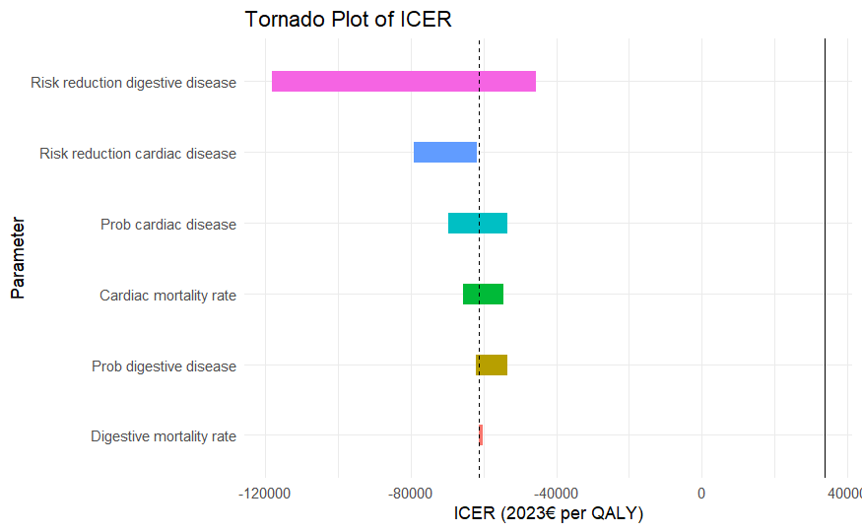
Figure 2. Tornado plot of the incremental cost-effectiveness ratio (ICER) expressed in 2023 Euros per quality-adjusted life year (QALY) gained. The plot displays the results of a one-way sensitivity analysis assessing the impact of individual parameter uncertainty on the ICER. Parameters are ordered by their influence, with the widest bars indicating the greatest effect. The vertical dashed line indicates the base-case ICER. The vertical line indicates the willingness to pay threshold.
We performed a probabilistic sensitivity analysis where we repeatedly sampled every uncertain input to see how combined parameter uncertainty shapes the cost-effectiveness results (Fig. 3). We found a median ICER of –€69 270 per QALY (95% credible interval –€172 071 to –€27 361), and 95% of our simulations fell below the willingness-to-pay (WTP) threshold, showing that, even under wide uncertainty, treatment with benznidazole remains highly likely to be both more effective and less costly than the alternative.

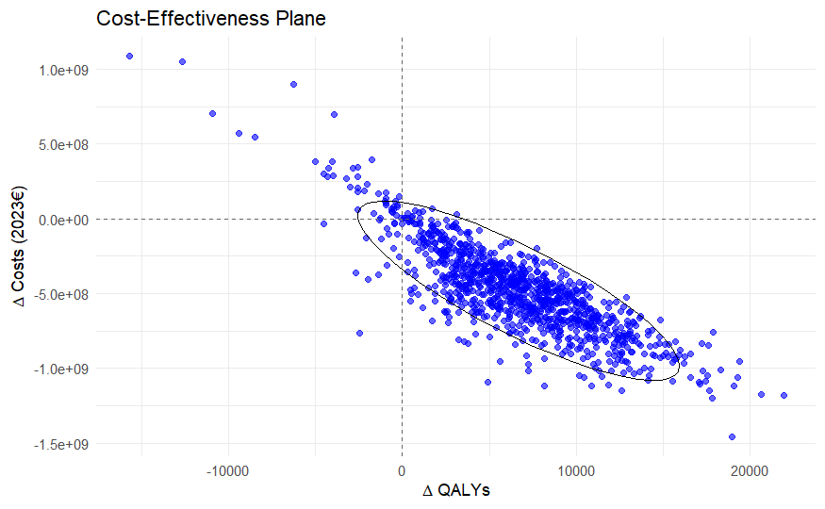
Figure 3. Cost-effectiveness plane based on 1 000 probabilistic simulations. Each point represents the incremental costs and QALYs of the intervention compared to the comparator under one simulation draw. Most simulations fall in the southeast quadrant, indicating that the intervention is both cost-saving and more effective. All costs are expressed in 2023 euros (€).
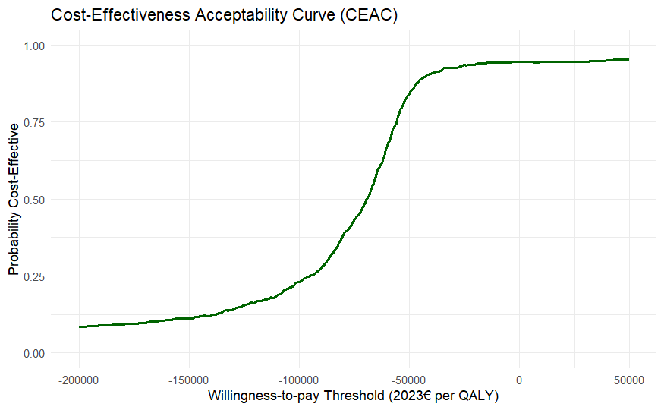
Figure 4. Cost-effectiveness acceptability curve (CEAC) showing the probability that benznidazole treatment is cost-effective compared with no treatment across a range of willingness-to-pay (WTP) thresholds expressed in 2023 € per quality-adjusted life-year (QALY) gained. Each point represents the proportion of 1 000 probabilistic sensitivity analysis iterations in which the intervention yields a net monetary benefit greater than comparator at the specified WTP. The curve approaches 1·0 at thresholds above approximately € –25 000/QALY, indicating near‐certainty of cost‐saving effectiveness in those scenarios.
For our target population and time horizon, the estimated value of perfect information amounts to €23·01 million in total, equivalent to approximately €0·83 million per year or €15·18 per patient annually. Therefore, any future research aimed at reducing the remaining uncertainty would be economically justified only if its cost remains below these thresholds.
Discussion
Our results indicate that, using a 20-year time horizon, treating patients with chronic indeterminate Chagas disease using benznidazole is a cost-saving strategy, as it produces more QALYs and results in lower overall costs than conservative follow-up of people diagnosed with the disease. Both the deterministic and probabilistic sensitivity analyses show consistent results, reinforcing the robustness of our findings. Only under the most extreme assumptions about benznidazole’s lack of effectiveness in preventing progression to heart disease does the ICER increase to a level where the strategy is no longer cost saving. However, even in these scenarios, the ICER stays below the WTP threshold.
Currently, benznidazole is not commercially available in Spain and is not universally covered free of charge within the Spanish public health system. The drug must be imported, and in most autonomous communities, it is dispensed only through specific pharmacies for foreign medicines not marketed in the country, rather than through regular community pharmacies. As a result, migrants – a particularly vulnerable population – face treatment barriers related to both cost (a typical course of treatment has a retail cost of €131) and access. According to our findings, providing benznidazole free of charge would be a cost-effective measure. Failing to do so is estimated to cost the healthcare system approximately €28·8 million annually. Moreover, previous studies have also found Chagas disease screening programmes to be cost-effective.^{14,27} Furthermore, our analysis does not account for the additional QALYs gained by preventing congenital transmission, which could potentially occur in untreated women. Such cases are considered to be happening in Spain.²⁸
In deterministic sensitivity analyses, benznidazole only became non-cost-effective under an implausibly low relative risk reduction for progression to heart disease; the most credible estimate suggests the drug is effective. Since no reliable prognostic markers exist, we cannot distinguish high- from low-risk asymptomatic individuals, so some treated patients would never progress or have a very low risk of doing so. Nevertheless, our analysis shows that even when this low-risk group is included, treating all eligible patients remains a cost-effective approach. Similarly, the probabilistic sensitivity analysis indicated that benznidazole is most likely cost-saving: over 95% of simulations remain well below the WTP threshold. Some uncertainty persists, however. The EVPI was €0·83 million annually over the study horizon, that is, the maximum amount a decision-maker should invest in further research to reduce current uncertainty. These findings could guide research funding and policymaking by highlighting key uncertainties, such as progression rates of visceral involvement in different populations, surrogate markers for prognosis or treatment response, and data on benznidazole efficacy in adults with indeterminate disease or across varying degrees of visceral involvement.
Research in context
Chagas disease is a public health concern in Europe, particularly in Spain, whose population includes a large number of migrants from endemic regions. Previous studies have identified multiple barriers to accessing treatment, including regulatory, logistical, and socioeconomic factors. For some patients, the cost of benznidazole remains a substantial barrier, despite its effectiveness in reducing disease progression.
To our knowledge, this is the first study to evaluate the cost-effectiveness of benznidazole treatment for Chagas disease within a European health system. Using a dynamic Markov model, we demonstrate that benznidazole is not only cost-effective but also cost saving when provided to eligible patients, resulting in lower long-term healthcare costs that far outweigh the drug acquisition costs.
Removing financial barriers to treatment for affected migrant populations would improve health outcomes, promote health equity, and generate savings for European healthcare systems. Additionally, further research should be funded to refine long-term strategies.
Strengths and limitations
The strengths of our study are that we calibrated the model to reflect the Spanish epidemiological situation, which allows for a better evaluation of the need. Additionally, comprehensive sensitivity analyses were conducted, and even when the variables were adjusted to extreme values, the results remained consistent, showing that benznidazole is cost-saving. We also calculated the EVPI to inform funding decisions for scientific studies that could enhance the model and reduce uncertainty. Of particular interest is the adjustment for treatment discontinuations and adverse effects, as benznidazole is known to have a poor tolerability profile.
Our study has some limitations. First, we assume a constant cohort of migrants, which may be somewhat unrealistic. Additionally, several study parameters have considerable uncertainty, such as the rate of progression of digestive involvement or the effectiveness of benznidazole treatment for Chagas disease in adults, which is primarily based on observational studies. However, some of these limitations have been addressed through extensive sensitivity analysis and the reported EVPI. Furthermore, the generalizability of the results to other settings may be limited, as the parameters are specific to the Spanish healthcare system. Nevertheless, given the very favourable results, benznidazole would very likely be cost-effective, at least in the European context.
Our study suggests that benznidazole is a cost-saving drug for the treatment of patients with chronic indeterminate Chagas disease. Facilitating access to treatment, specifically by providing the drug free of charge, would help overcome current barriers to therapy and unlock its individual and societal benefits.

Contributors
PW was responsible for study design, execution, analysis and manuscript writing and submission.
JLLG collaborated to study design, data collection, and manuscript review.
CCA collaborated to study design, data collection, and manuscript review.
JAPM collaborated to study design, data collection, and manuscript writing and review.

Declaration of interests
All authors have no conflicts to declare.

Use of AI
AI tools (specifically OpenAI’s ChatGPT) were used throughout the study to assist in code development, the formatting of manuscript text and tables, and to improve the overall clarity and readability of the writing. All outputs generated by AI were reviewed and verified by the authors for accuracy, scientific validity, and appropriateness. No content was generated without human oversight, and the final responsibility for all aspects of the manuscript lies with the authors.

Data availability statement
Data and codes are available at https://github.com/pwjpwj/Benznidazole-CEA

References
1 Pérez-Molina JA, Molina I. Chagas disease. The Lancet 2018; 391: 82–94.
2 Bern C, Martin DL, Gilman RH. Acute and Congenital Chagas Disease. Adv Parasitol 2011; 75: 19–46.
3 Crespillo-Andújar C, Comeche B, Hamer DH, et al. Use of benznidazole to treat chronic Chagas disease: An updated systematic review with a meta-analysis. PLoS Negl Trop Dis 2022; 16: e0010386.
4 Crespillo-Andújar C, Venanzi-Rullo E, Lopez-Velez R, et al. Safety Profile of Benznidazole in the Treatment of Chronic Chagas Disease: Experience of a Referral Centre and Systematic Literature Review with Meta-Analysis. Drug Saf 2018; 41: 1035–48.
5 Navarro M, Reguero L, Subirà C, Blázquez-Pérez A, Requena-Méndez A. Estimating chagas disease prevalence and number of underdiagnosed, and undertreated individuals in Spain. Travel Med Infect Dis 2022; 47: 102284.
6 WHO. Chagas disease in Latin America: an epidemiological update based on 2010 estimates. Wkly Epidemiol Rec 2015; 90: 33–43.
7 Manne-Goehler J, Umeh CA, Montgomery SP, Wirtz VJ. Estimating the Burden of Chagas Disease in the United States. PLoS Negl Trop Dis 2016; 10: e0005033.
8 Requena-Méndez A, Aldasoro E, De Lazzari E, et al. Prevalence of Chagas Disease in Latin-American Migrants Living in Europe: A Systematic Review and Meta-analysis. PLoS Negl Trop Dis 2015; 9: e0003540.
9 Gonzalez-Sanz M, Crespillo-Andújar C, Chamorro-Tojeiro S, Monge-Maillo B, Perez-Molina JA, Norman FF. Chagas Disease in Europe. Trop Med Infect Dis 2023; 8: 513.
10 Moraes FCA de, Souza MEC, Dal Moro L, et al. Prevention of congenital chagas disease by trypanocide treatment in women of reproductive age: A meta-analysis of observational studies. PLoS Negl Trop Dis 2024; 18: e0012407.
11 Iglesias-Rus L, Boquete T, Romay-Barja M, Benito A, Jordan B, Blasco-Hernández T. Diagnostic pathways of Chagas disease in Spain: a qualitative study. BMC Public Health 2023; 23: 332.
12 Andrade MV, Noronha KVMDS, De Souza A, et al. The economic burden of Chagas disease: A systematic review. PLoS Negl Trop Dis 2023; 17: e0011757.
13 INE. Instituto Nacional de Estadística. INE. https://www.ine.es/ (accessed May 3, 2025).
14 Requena-Mendez A, Bussion S, Aldasoro E, et al. Cost-effectiveness of Chagas disease screening in Latin American migrants at primary health-care centres in Europe: a Markov model analysis. Lancet Glob Health 2017; 0: e439–47.
15 Edejer TT-T, World Health Organization, editors. Making choices in health: WHO guide to cost-effectiveness analysis. Geneva: World Health Organization, 2003.
16 Nunes Da Costa EAP, Victória C, Fortaleza CMCB. Predictors of development of cardiac and digestive disorders among patients with indeterminate chronic Chagas Disease. PLoS Negl Trop Dis 2021; 15: e0009680.
17 Ramos-Rincon J-M, Llenas-García J, Pinargote-Celorio H, et al. Chagas Disease-Related Mortality in Spain, 1997 to 2018. Microorganisms 2021; 9: 1991.
18 R Core Team. R: A Language and Environment for Statistical Computing. 2023. https://www.R-project.org.
19 Husereau D, Drummond M, Petrou S, et al. Consolidated Health Economic Evaluation Reporting Standards (CHEERS)—Explanation and Elaboration: A Report of the ISPOR Health Economic Evaluation Publication Guidelines Good Reporting Practices Task Force. Value Health 2013; 16: 231–50.
20 Chadalawada S, Sillau S, Archuleta S, et al. Risk of Chronic Cardiomyopathy Among Patients With the Acute Phase or Indeterminate Form of Chagas Disease: A Systematic Review and Meta-analysis. JAMA Netw Open 2020; 3: e2015072.
21 Chadalawada S, Rassi A, Samara O, et al. Mortality risk in chronic Chagas cardiomyopathy: a systematic review and meta‐analysis. ESC Heart Fail 2021; 8: 5466–81.
22 Castro C, Macêdo V, Rezende JM, Prata A. Estudo radiológico longitudinal do esôfago, em área endêmica de doença de Chagas, em um período de 13 anos. Rev Soc Bras Med Trop 1994; 27: 227–33.
23 Consejería de salud. Orden de 24 de mayo de 2024, por la que se establece el importe de los servicios, actividades y bienes de naturaleza sanitaria, prestados en centros sanitarios del Sistema Sanitario Público de Andalucía, que deben ser retribuidos mediante precios públicos por los terceros obligados legalmente al pago. Bol Of Junta Andal 2024; : 1–163.
24 Ministerio de Ciencia e innovación. Resolución de 14 de noviembre de 2023, del Instituto de Salud Carlos III, O.A., M.P., por la que se modifica el Anexo de la Resolución de 3 de abril de 2019, por la que se establecen los precios públicos correspondientes a la prestación de servicios y actividades del organismo. Bol Of Estado 2023; published online Dec 5.
25 Consellería Salut i Consum. Resolución del Director General del Servei de Salut de modificación de la Orden de la Consellera de Salut i Consum de 22 de diciembre de 2006, por la que se establecen los precios públicos que han de aplicar los centros sanitarios de la red pública de les Illes Balears para la prestación de servicios sanitarios cuando existan terceros obligados al pago o usuarios sin derecho a la asistencia sanitaria de la Seguridad Social. 2021.
26 Delgado JF, Oliva J, Llano M, et al. Costes sanitarios y no sanitarios de personas que padecen insuficiencia cardiaca crónica sintomática en España. Rev Esp Cardiol 2014; 67: 643–50.
27 Iglesias Rodríguez IM, Miura S, Maeda T, et al. Analysis of the Chagas disease situation in Japan: a cross sectional study and cost-effectiveness analysis of a Chagas disease screening program. Lancet Reg Health - West Pac 2023; 31: 100574.
28 Llenas-García J, Wikman-Jorgensen P, Gil-Anguita C, et al. Chagas disease screening in pregnant Latin American women: Adherence to a systematic screening protocol in a non-endemic country. PLoS Negl Trop Dis 2021; 15: e0009281.

