Cost-effectiveness of lenacapavir versus tenofovir disoproxil fumarate plus emtricitabine for pre-exposure prophylaxis to prevent HIV-1 transmission in gay, bisexual and other men that have sex in a European country

Authors: Philip Erick Wikman-Jorgensen^{1,2*}, Carlos Iniesta^{3,4}, Federico Pulido^{4,5}, Jose Antonio Pérez-Molina^{4,6}, Jara Llenas-García^{2,4,7}.
- Internal Medicine & Infectious Diseases Department, Elda General University Hospital-FISABIO, Elda, Spain.
- Clinical Medicine Department. Universidad Miguel Hernández, Elche, Spain
- Spanish Interdisciplinary AIDS Society (SEISIDA), Madrid, Spain,
- Centre of Biomedical Research for Infectious Diseases (CIBERINFEC), Madrid, Spain
- HIV Unit, Institute for Healthcare Research Hospital 12 de Octubre (imas12), Universidad Complutense de Madrid, Madrid, Spain.
- Tropical Medicine Unit, Hospital Ramon y Cajal, Madrid, Spain.
- Infectious Diseases-Internal Medicine Department, Hospital Vega Baja-FISABIO, Orihuela, Spain.

*Corresponding author: Jara Llenas-García, Servicio de Medicina Interna/Unidad de Enfermedades Infecciosas, Hospital Vega Baja, Ctra. Orihuela – Almoradí, S/N, 03314 Orihuela, Alicante, España.

Keywords: HIV, Pre-exposure prophylaxis, Homosexual and Gender minorities, Cost-Effectiveness, Tenofovir Disoproxil, Lenacapavir, Sustained-Release Preparation.

Abstract

Introduction / Objective
Lenacapavir (LEN) has proven to be superior to current recommended regimen, tenofovir disoproxil fumarate plus emtricitabine (TDF/FTC), as pre-exposure prophylaxis (PrEP) for key populations at high risk of HIV acquisition. However, to date no studies have evaluated the cost-effectiveness of this strategy at a national level. This study aims to compare the cost-effectiveness of currently approved daily PrEP in Spain, with tenofovir disoproxil fumarate plus emtricitabine (TDF/FTC), in gay, bisexual and other men who have sex with men (GBMSM) versus the newer alternative with subcutaneous lenacapavir every 6 months (LEN).

Methods
We fitted a dynamic compartmentalized Markov model that represents the dynamics of HIV-1 transmission in GBMSM in Spain. The model was calibrated to replicate the epidemiological data of the HIV epidemic in GBMSM in Spain from 2019 to 2023. We used the perspective of the national health system and applied a 20-year time horizon. Quality-adjusted life years (QALY) were the health outcome variable, and the cost was accounted for in 2023 Euros (€). Our outcome variable was the incremental cost-effectiveness ratio (ICER) for PrEP. We used the 2023 gross domestic product per capita of Spain (€31,339) as the willingness-to-pay (WTP) threshold.

Results

Conclusion
Twice yearly subcutaneous LEN is not cost-effective at current market prices. For LEN to be deemed cost-effective it should be marketed at a price of 8,880 € per six-month dose.

Background
Pre-exposure prophylaxis (PrEP) is the use of an antiretroviral medication by HIV-negative people to reduce the risk of HIV acquisition. PrEP is a strategy that is a key part of the combination prevention approach to HIV infection, recommended by UNAIDS to achieve the 95-95-95 targets and meet the goals of Sustainable Development Goal 3 by 2030(1).
Pre-exposure prophylaxis (PrEP) with daily tenofovir disoproxil fumarate/emtricitabine (TDF/FTC) is a highly effective strategy to prevent HIV infection among individuals at high risk, including gay and bisexual men, heterosexual individuals, people who inject drugs, and sex workers. Daily TDF/FTC has demonstrated high efficacy in clinical trials and real-world settings(2–6). Daily TDF/FTC remains a cornerstone of PrEP, but ongoing research has led to the development of new effective regimens, such as such as tenofovir alafenamide/emtricitabine (TAF/FTC)(7) and every 2 months injectable cabotegravir (CAB)(8). These alternatives may have advantages over existing regimens; TAF/FTC has a better safety profile with less bone and kidney toxicity(9) while CAB seems especially attractive as it does not have bone and kidney toxicity and has demonstrated superiority over TDx/FTC in preventing new HIV infections(8). Moreover, these newer options offer additional flexibility and convenience for individuals at high risk of HIV infection(10).
More recently, injectable lenacapavir (LEN), a new-in-class HIV-1 capsid inhibitor administered subcutaneously every 6 months has proven to be superior in efficacy to TDF/FTC for PrEP in both cisgender women(11) and in men and gender diverse people(12).
Despite the effectiveness of oral PrEP, uptake and adherence remain suboptimal, hindering progress towards UNAIDS targets(1). The burden of daily dosing and antiretrovirals’ associated stigma poses significant barriers. To address these challenges, there is a clear preference for long-acting PrEP options, particularly injectables, among key populations and the general population(13).
These new alternatives are costlier than TDF/FTC raising the question of whether their introduction in National HIV Programs would be cost-effective. In October 2024 Gilead announced that it had signed non-exclusive, royalty-free voluntary licensing agreements with six pharmaceutical manufacturers to make and sell generic LEN, subject to required regulatory approvals, in 120 high-incidence, resource-limited countries, which are primarily low- and lower-middle income countries(14). A recent study has explored LEN impact and cost-effectiveness in Eastern and Southern Africa, suggesting that lenacapavir could avert substantial HIV incidence and that price thresholds and budget impacts will vary by setting and coverage(15). However, many middle and high-income countries, including most European countries, would not benefit of that licensing agreement. Therefore, cost-effectiveness studies in those settings are crucial for informing price thresholds that enable cost-effective implementation in National Programs.
Spain approved PrEP in 2019 for individuals at high risk of HIV infection, including gay, bisexual, and other men who have sex with men (GBMSM), transgender people, and female sex workers. In 2021, PrEP eligibility was expanded to anyone at high risk(16). Recommended PrEP regimen consists of daily tenofovir disoproxil fumarate/emtricitabine (TDF/FTC), provided free of charge through the national health service. Alternative regimens such as tenofovir alafenamide/emtricitabine (TAF/FTC) and injectable CAB) have been explored but have not yet been introduced in the Spanish National Health System. A recent study by our group showed that TDF/FTC is a cost-saving strategy but neither TAF/FTC nor CAB are cost-effective at their current retail price. (17)
In this study, we aimed to estimate the health and economic effects of LEN scale-up as PrEP in Spain. As the per-dose price of LEN is uncertain, we estimated the maximum price that could achieve cost-effectiveness in Spain.

Methods

Target population, setting and interventions
The target population were GBMSM 16 years or older receiving care in the Spanish National Healthcare System. The baseline scenario was 2023 with a PrEP program in place consisting in daily TDF/FTC (present scenario). We evaluated the implementation of a different PrEP regimen: LEN injected subcutaneously every 6 months. In each case, we considered that patients underwent a baseline medical visit, screening for HIV and other sexually transmitted infections (STIs), an educational intervention for safe sex practices, and a series of regular follow-ups, as recommended in the Spanish Infectious Diseases Society guidelines(16)

Model development
A stochastic, dynamic, transmission Markov chain model was developed and calibrated to replicate the results of the HIV epidemic in Spain. The model (Fig. 1) represents the current estimated population of GBMSM in Spain. Starting at the top left corner, the “susceptible state” represents non-HIV infected GBMSM at risk for HIV acquisition. People in this state may acquire HIV and transition into the first of the 8 states in the natural history of HIV infection, in accordance with previously used models(18). At any point in those 8 states, the patient may be diagnosed and started on ART. The susceptible person may be started on PrEP, where the risk of infection is much lower, but still possible, and transition through the HIV infection stages, and at any stage they may be started on treatment. In each state, the person has a mortality rate µ. Each state had a cost and a health measure attached.
Susceptible non-HIV infected GBMSM may be started on PrEP and transition into the “susceptible on PrEP” state. In this state they have a drastic reduction in HIV acquisition probability but may still acquire HIV and transition into the 8 states of HIV infection or may go off PrEP and back into the susceptible state.
The probabilities of transitioning from one state to another are governed by the parameters presented in table 1. The model was stratified by age group and by sexual activity risk groups. The initial population for each state was estimated using published data. Due to the chronic nature of HIV infection, a time horizon of 20 years was chosen, together with a weekly time step.
Model parameters were obtained from published studies, systematic reviews and meta-analyses, and—when no other source was found—through expert consultation.
For calibration, the model parameters were given a probability distribution, and the model was run 150,000 times. Each time, a random draw from each of the distributions was used as a model parameter. The goodness-of-fit of the model to the HIV mortality and new AIDS cases for the 2019-2023 period was evaluated using the least squares method. The set of parameters with the best fit was the final set of parameters used for the cost-effectiveness analysis. Analyses were undertaken using R language for statistical analysis(19).

Cost evaluation
The cost evaluation used a healthcare provider perspective and a micro-costing approach. The costs were estimated using different published insurance reimbursement lists. Costs are presented as 2023 euros (2023€) and were calculated with the model, depending on the population in each state at each time point.

Health outcomes
The model was used to obtain estimates of the number of new HIV infections, deaths and new HIV and AIDS cases averted. The weights of the study by Tengs et al.(20) were employed to calculate quality-adjusted life years (QALYs).

Cost-effectiveness evaluation
We ranked interventions by effectiveness and then calculated incremental cost-effectiveness ratios (ICER)—i.e., the difference in costs divided by the difference in health effects, measured in 2023 €/QALY—by comparing each intervention to its immediately less effective strategy. Both effectiveness and costs were subject to an annual discount measure of 3%.(21) The willingness-to-pay (WTP) threshold used was the per capita gross domestic product of Spain in 2023 (2023 €33,895). For comparison purposes we also compared with the lowest (2023 €21,865 Croatia) and highest (2023 €128,678.2 Luxembourg) GDP per capita of the EU as well as the GDP per capita of the EU as a whole (2023 €45,130.01).

Sensitivity analysis
A one-way sensitivity analysis was performed, modifying each of the parameters separately through its spectrum of possible values, and it is presented as a tornado plot.
A probabilistic sensitivity analysis (PSA) was also carried out, assigning probability distributions to the model parameters, and subsequently carrying out Monte-Carlo simulations. The specific number of simulations was determined by visual inspection of a graphical representation of the average cumulative net monetary benefits. The ICERs for each strategy are presented with their confidence intervals, along with cost-effectiveness planes and cost-effectiveness probability curves.

Results

Model parameters and costs
Fig. 1 shows the model; table 1, the model parameters and transition probabilities; and table 2, the costs. The model was adjusted to fit AIDS mortality and new AIDS cases (supplemental material).
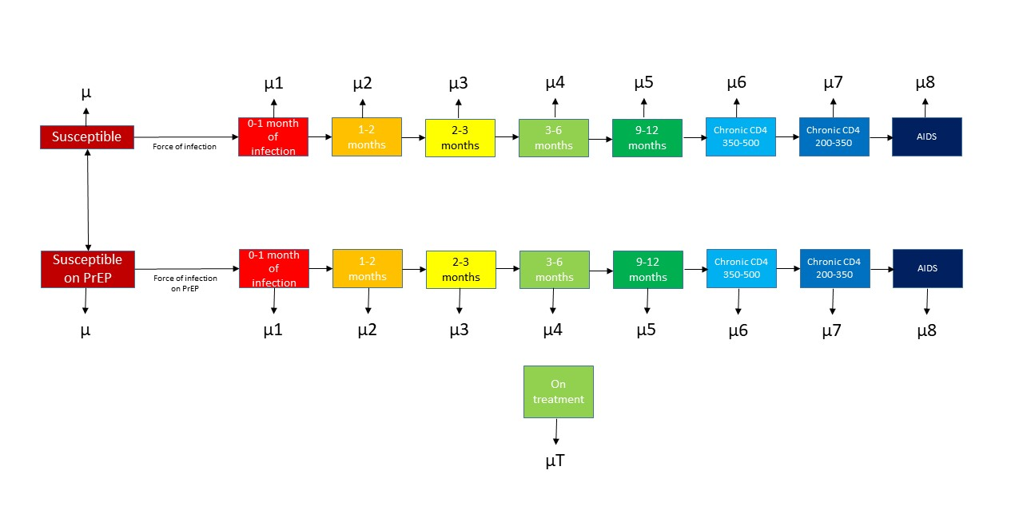
Figure 1. A Markov chain model for the transmission of HIV and the influence of pre-exposure prophylaxis (PrEP). µ: mortality. Starting at the upper left corner, the “susceptible state” represents non-HIV infected GBMSM at risk for HIV acquisition. People in this state may acquire HIV and transition into the first of the 8 states that represent the history of HIV natural infection, in accordance with previously used models.(22) At any point in those 8 states, the patient may be diagnosed and started on ART. The susceptible persons may be started on PrEP, where the risk of infection is much lower, but still possible, and transition through the HIV infection stages, and at any stage they may be started on treatment. In each state the person has a mortality rate µ.

Table 1. Key parameters of the model. These parameters govern the initial population of the different model states and the probabilities of transition between each state.
Parameter | Value and OWSA range | Prior distribution | Source | Posterior distribution
Number of GBMSM | 892955 | NA | Spanish National Institute of Statistics (23) | NA
Number of GBMSM living with HIV | 33558 | Normal (33558,4000) | Hospital survey 2018(24) | Normal (32898,1000)
Baseline proportion of infected people on treatment | 0.89 | Beta (0.89,0.1) | Hernando et al.(25) | Beta (0.96,0.1)
% GBMSM that go off PrEP | 11.56% annually | NA | Aparicio et al.(26) | NA
% GBMSM that start PrEP | 30% annually | NA | Nichols et al.(22) | NA
Mortality of PLWHIV | >350  200-350  <200 | Beta (0.0000538, 0.000048)  Beta (0.00012692, 0.000061)  Beta (0.04/52, 0.04/52) | Alejos et al.(27)  Kasaie et al.(28) | Normal (8.18e-06, 1.63e-06)  Normal (0.000148  , 2.95e-05)  Normal (6.41e-05, 1.28e-05)
Partner change rate in very high-risk compartment | 52.5/year | Gamma (52.5/52, 52.5/52) | Nichols et al.(22) | Normal (2.75, 0.55)
Partner change rate high-risk compartment | 9/year | Gamma (9/52, 9/52) | Nichols et al.(22) | Normal (0.036  , 0.007)
Partner change rate in low-risk compartment | 2.5/year | Gamma (2.5/52, 2.5/52) | Nichols et al.(22) | Normal (0.029  , 0.005)
Partner change rate in very low-risk compartment | 0.2/year | Gamma (0.2/52, 0.2/52) | Nichols et al.(22) | Normal (0.003  , 0.0006)
Proportion of the population in each group | Very high risk 0.1,  High risk 0.4,  Low risk 0.3,  Very low risk 0.2 | Dirichlet (0.1,0.4,0.3,0.2) | Nichols et al.(22) | Dirichlet (0.75, 0.03, 0.17, 0.03)
Per partnership transmissibility | 0.024 | Beta (0.024,0.024) | Nichols et al.(22) | Normal (0.032, 0.006)
Duration in HIV infection stage 1,2 and 3 | 1-exp(-0.25) | Beta (1-exp(-0.25), 1-exp(-0.25)) | Nichols et al.(22) | Beta(0.32, 0.06)  Beta (0.36, 0.07)  Beta (0.56, 0.11)
Duration in HIV infection stage 4-7 | 1-exp(-0.25/3) | Beta (1-exp(-0.25/3), 1-exp(-0.25/3)) | Nichols et al.(22) | Beta (0.044, 0.009)  Beta (0.12, 0.024)  Beta(0.15, 0.03)  Beta(0.016, 0.003)
Duration in HIV infection stage 8 | 1-exp(-0.25/52*3) | Beta (1-exp(-0.25/52*3), 1-exp(-0.25/52*3)) | Nichols et al. (22) | Beta( 0.0003), 06.8e-05)
Duration in HIV infection stage 9 | 1-exp(-0.25/52*3.5) | Beta (1-exp(-0.25/52*3.5), 1-exp(-0.25/52*3.5)) | Nichols et al. (22) | Beta (0.0006, 0.0001)
Probability of starting treatment according to cd4 count | <200 0.00264423  200-500  0.00168269  >500  0.0005288 | Beta (0.00264423,0.00264423)  Beta (0.00168269,0.00168269)  Beta (0.0005288,0.0005288) | Nuñez et al.(29) | Beta(0.016, 0.003)  Beta(0.002, 0.0004)  Beta(0.0003, 6e-05)
PrEP effectiveness | TDx/FTC 86% risk reduction  LEN 96% risk reduction |  | PROUD(30)  PURPOSE2(31) | NA

Table 2. Costs of patients on PrEP and costs of patients on ART used for the PrEP cost-effectiveness calculation.
Item | Unit cost (2023€) | Annual units | Weekly cost  (2023 €) | Source
Patients on PrEP
TDx/FTC | 0.97 | 365 | 6.8 | Spanish retail price
LEN | 16.76 | 365 | 878.68 | Spanish retail price
Nurse administration (only LEN arm) | 27 | 2 | 3.11 | The cost of each unit of resource has been estimated as the average of the public prices (to be applied by health centers to third parties obliged to pay or to users without the right to health care corresponding to the health services provided by the health services of the different autonomous communities)
HIV specialist 1st visit | 148.78 | 1 | 2.86
HIV specialist 2nd visit | 92.92 | 1 | 1.78
HIV serology | 13.53 | 4 | 6.99
Syphilis reaginic test | 7.30 | 4 | 0.56
TPHA test | 17.67 | 4 | 1.35
Hemogram | 4.34 | 4 | 0.33
Na and K+ | 3.06 | 4 | 0.23
Creatinine | 0.75 | 4 | 0.05
Glycemia | 0.71 | 4 | 0.05
Phosphorus | 0.71 | 4 | 0.05
Transaminases | 3.92 | 4 | 0.30
Urine sediment | 4.31 | 4 | 0.33
PCR for Chlamydia and Gonococcus | 85.38 | 4 | 6.56 | Lopez-Seguí et al.(32)
Total |  |  | 21.74
Patients on ART
ART | 23.56 | 365 | 165.38 | The cost of each unit of resource has been estimated as the average of the public prices (to be applied by health centers to third parties obliged to pay or to users without the right to health care corresponding to the health services provided by the health services of the different Autonomous Communities)
Test for resistances | 328 | 1 | 6.30
Viral load | 96.81 | 2 | 3.72
CD4 count | 25.17 | 2 | 0.96
Consultation | 427.54 | 1 | 8.22
HLA-B5701 | 151 | Once in life | 2.90
Hemogram | 4.34 | 2 | 0.33
Na and K+ | 3.06 | 2 | 0.23
Creatinine | 0.75 | 2 | 0.05
Glycemia | 0.71 | 2 | 0.05
Phosphorus | 0.71 | 2 | 0.05
Transaminases | 3.92 | 2 | 0.30
Total |  |  | 188.54
Abbreviations: TDx/FTC, tenofovir disoproxil/ emtricitabine; TAF/FTC, tenofovir alafenamide/ emtricitabine; ART, Antiretroviral therapy; PCR, polymerase chain reaction.

TDF/FTC
This was considered the base case scenario, as TDF/FTC is currently the standard of care. With only TDF/FTC as the drug for PrEP, the simulation showed a total of 8,546,030 QALYs at a cost of 2023 €8,457,028,025 for the next 20 years. This constitutes an average cost-effectiveness ratio of 2023 €989.58 per QALY obtained (table 3).

LEN
A scenario where LEN was used instead of TDF/FTC, would cost a total of 2023 €47,062,063,906 (a difference of 2023 €38,605,035,881) and produce a total of 9,030,933 QALYs (i.e. an increase of 484,903.7 QALYs), yielding an ICER of 79,613.82 QALYs (table 3).
Table 3. Results of the cost-effectiveness analysis. ICER: Incremental cost-effectiveness ratio. This quantity is calculated as the difference between the intervention and the less effective alternative.
Strategy | QALYs | Costs  (2023€) | Incremental QALYs | Incremental Costs (2023€) | ICER  incremental costs 2023€/ incremental QALYs
TDx/FTC | 8,546,030 | 8,457,028,025 | Baseline | Baseline | Baseline
LEN | 9,030,933 | 47,062,063,906 | 484,903.7 | 38,605,035,881 | 79,613.82
Abbreviations: QALY, quality-adjusted life-year, TDx/FTC, tenofovir disoproxil fumarate/ emtricitabine, LEN, lenacapavir, ICER, incremental cost effectiveness ratio.

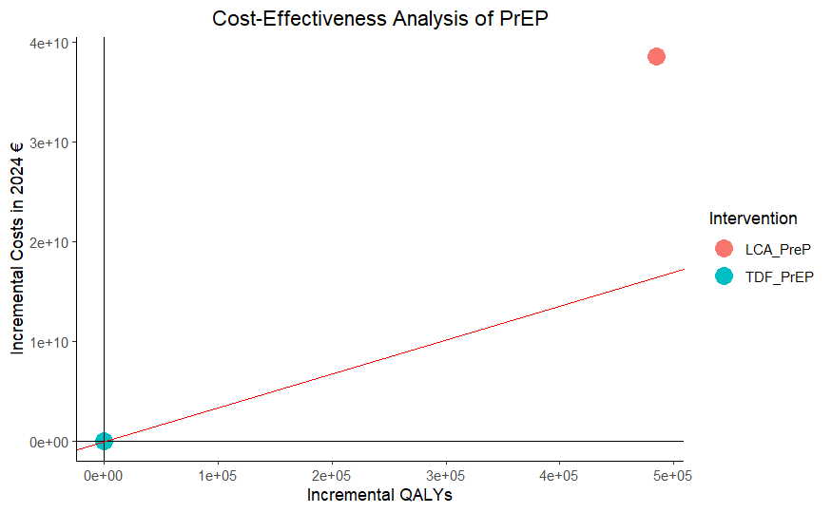

Figure 2. The representation of the Cost-effectiveness plane for LEN PrEP compared to PrEP with TDF.

Sensitivity analyses
One-way sensitivity analyses are presented in figure 3 as a tornado plot. The LEN strategy does not fall below the willingness to pay threshold in any of the plausible range of values.

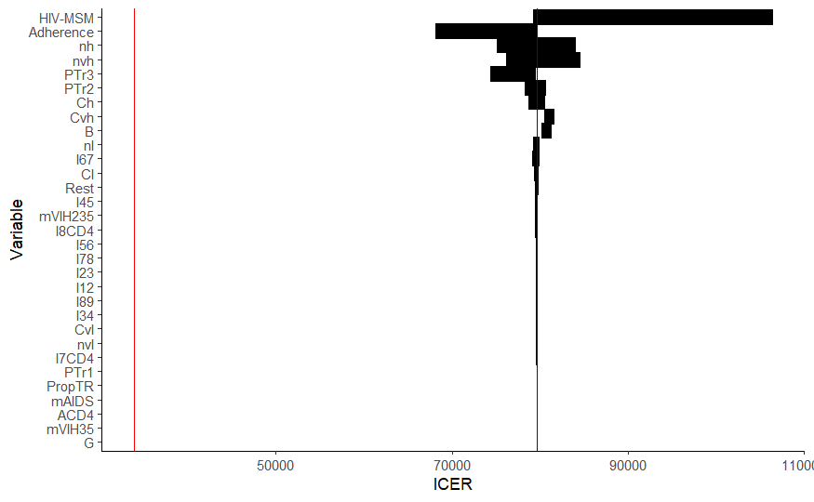
Figure 3. Tornado plot of the one-way sensitivity analysis for the introduction of lenacapavir instead of TDF/FTC. The vertical red line represents the willingness-to pay-threshold.
Rest: Proportion of patients with more than 500 CD4; PTr3: Probability of starting treatment with less than 200 CD4; PTr2: Probability of starting treatment with CD4 between 200-500; PTr1: Probability of starting treatment with more than 500 CD4; PropTR: Proportion of HIV infected patients on treatment; nvl: Proportion of the total population of GBMSM in the very low risk group; nvh: Proportion of the total population of MSM in the very high risk group, nl: Proportion of the total population of MSM in the low risk group; nh: Proportion of the total population of MSM in the high risk group; mVIH35: mortality with more than 350 CD4; mVIH235: mortality with CD4 between 200-350; mAIDS: mortality with CD4 below 200; I8CD4: Proportion of PLWH with CD4 between 200-350; I89: Probability of transitioning from state 8 to AIDS; I7CD4: Proportion of PLWH with CD4 between 350-500; I78: Probability of transitioning from state 7 to state 8; I67: Probability of transitioning from state 6 to 7; I56: Probability of transitioning from state 5 to 6; I45: Probability of transitioning from state 4 to 5; I34: Probability of transitioning from state 3 to 4; I23: Probability of transitioning from state 2 to 3: I12; Probability of transitioning from state 1 to 2; HIV-MSM: Number of HIV infected GBMSM; G: Population growth constant; Cvl: Partner change rate in the very low group; Cvh: Partner change rate in the very high group; Cl: Partner change rate in the low group; Ch: Partner change rate in the high group; B: per partnership transmissibility; ACD4; Proportion of patients with less than 200 CD4.

The PSA is presented in Figure 4. On visual inspection it becomes clear that none of the points fall below the established WTP. The median ICER would be 81060(P₂₅-P₇₅; 70,168, 98,498) with 100% of simulations above the WTP.

A)
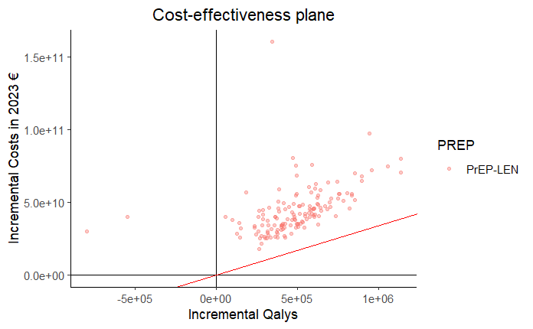
B)
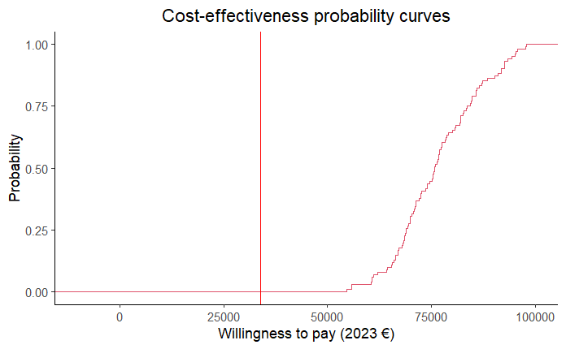
Figure 4. A) Probabilistic sensitivity analysis presented in the cost-effectiveness plane. B) Cost-effectiveness probability curves.

Establishing the maximum drug price for cost-effectiveness
We iterated over several values till we found the maximum cost of LEN that would render the strategy cost-effective in the deterministic analysis. This value was determined at 8,880 € per six-month dose.
In the one-way sensitivity analysis the tornado plot showed that at this cost, the variability would be centered around the WTP, making it uncertain if it would be cost-effective.
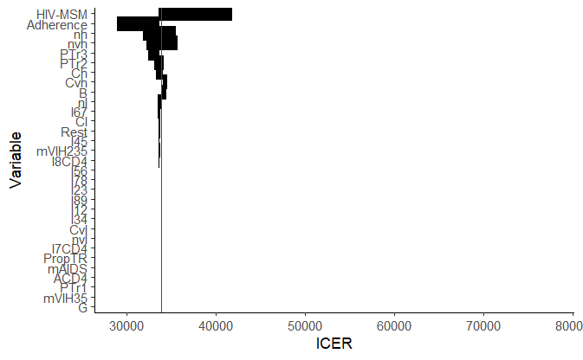
Figure 5. Tornado plot of the one-way sensitivity analysis for the introduction of lenacapavir instead of TDF/FTC at a cost of 8,880€ per 6 month dose. The vertical red line represents the willingness-to pay-threshold.
Rest: Proportion of patients with more than 500 CD4; PTr3: Probability of starting treatment with less than 200 CD4; PTr2: Probability of starting treatment with CD4 between 200-500; PTr1: Probability of starting treatment with more than 500 CD4; PropTR: Proportion of HIV infected patients on treatment; nvl: Proportion of the total population of GBMSM in the very low risk group; nvh: Proportion of the total population of MSM in the very high risk group, nl: Proportion of the total population of MSM in the low risk group; nh: Proportion of the total population of MSM in the high risk group; mVIH35: mortality with more than 350 CD4; mVIH235: mortality with CD4 between 200-350; mAIDS: mortality with CD4 below 200; I8CD4: Proportion of PLWH with CD4 between 200-350; I89: Probability of transitioning from state 8 to AIDS; I7CD4: Proportion of PLWH with CD4 between 350-500; I78: Probability of transitioning from state 7 to state 8; I67: Probability of transitioning from state 6 to 7; I56: Probability of transitioning from state 5 to 6; I45: Probability of transitioning from state 4 to 5; I34: Probability of transitioning from state 3 to 4; I23: Probability of transitioning from state 2 to 3: I12; Probability of transitioning from state 1 to 2; HIV-MSM: Number of HIV infected GBMSM; G: Population growth constant; Cvl: Partner change rate in the very low group; Cvh: Partner change rate in the very high group; Cl: Partner change rate in the low group; Ch: Partner change rate in the high group; B: per partnership transmissibility; ACD4; Proportion of patients with less than 200 CD4.

The PSA yielded a median ICER of 2023 €34,479 (29,876-41,917) per QALY gained and probability curves showed that 50% of simulations would fall within the WTP. Therefore, we continued to iterate the drug cost down to 2023 €4320 where the median ICER would be 2023 €17,121 per QALY (14,815-20,789) with 93.6% of simulations falling below the WTP.
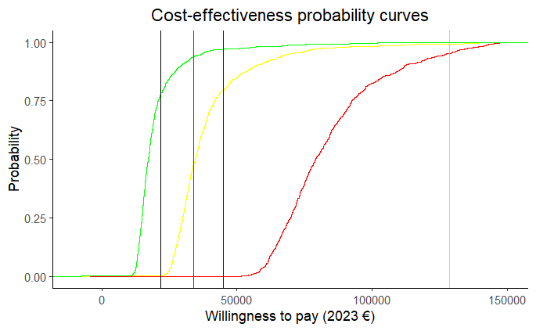
Figure 6. Cost-effectiveness probability curves with the different drug costs evaluated. Sigmoidal curves: red (2023 €21,088.5), yellow (2023 €8,880), green (2023 €4,320) Vertical lines; Black: GDP of Croatia; Red: GBP of Spain; Blue: GDP of Euro Zone, Yellow: GDP of Luxembourg.

Discussion
Our analysis indicates that twice-yearly subcutaneous LEN for PrEP with could be a cost-effective alternative within the Spanish Health System should a substantial price reduction be achieved.
(17,33–35).
It is well-established that generic oral TDx/FTC PrEP is a cost-saving strategy across Europe compared to no PrEP (17,33–35).. Therefore, any novel PrEP intervention should be benchmarked against this baseline.. While newer drugs often carry higher costs, their improved safety profiles, enhanced efficacy, and less frequent dosing regimens make them attractive options. In our study, the substitution of TDx/FTC with LEN, which offers potentially reduced toxicity and superior efficacy, did not fall within the established WTP threshold at its current market price. Our evaluation suggests that LEN would need to be priced at €4,320 per 6-month dose (in 2023 values) to achieve a cost-effectiveness probability exceeding 90%. Nevertheless, injectable LEN for PrEP has demonstrated an 89% reduction in HIV infection risk compared to oral TDx/FTC (11,12). Results from the PURPOSE 1 and PURPOSE 2 trials provide compelling evidence for lenacapavir's potential to transform HIV prevention across diverse global populations. The observed higher relative reduction in HIV risk with injectable PrEP, compared to oral TDx/FTC, is likely influenced by improved adherence to the dosing schedule. It is widely recognized that oral PrEP efficacy is highly dependent on adherence, and trials comparing long-acting CAB and LEN to oral PrEP have shown that most infections in the oral group occurred in participants with low adherence. PrEP. .
The WHO recommends that people accessing PrEP services receive comprehensive counseling on all available PrEP and HIV prevention options, empowering them to make informed decisions. Values and preferences for different PrEP modalities vary across diverse populations and offering a range of products can potentially improve PrEP uptake, persistence, and effective use, allowing individuals to choose methods that align with their needs, preferences, and lifestyles at any given moment in time.
Given the potential for evolving product availability, the WHO also recommends frequent updates on all available options for both potential and current PrEP users.
Injectable PrEP should be prioritized for individuals with contraindications to the use of TDx/FTC, those at high risk of toxicity or those with adherence challenges to oral PrEP. Identifying the target population and establishing a sustainable market price are crucial for the successful integration of LEN PrEP into the Spanish National Health System. Moreover, monitoring drug levels for oral PrEP adherence may facilitate early detection of non-adherence and timely transition to long-acting injectables for those who would benefit most..
The implementation of LEN may encounter challenges. Despite its approval two years ago, the global rollout of long-acting CAB for PrEP has been slow, hindered by limited access, high costs, logistical complexities, strict dosing schedules, and the risk of long-acting early viral inhibition syndrome. In the United States, where the drug is available, it represents a small fraction of PrEP prescriptions. These challenges, particularly the need for trained personnel and structured follow-up, highlight potential barriers to the future implementation of similar long-acting agents like LEN.
The primary limitations of our study stem from the uncertainty associated with certain parameters. However, we have mitigated this concern through extensive sensitivity analyses. Additionally, we did not account for the potential benefits of injectable LEN in terms of reduced renal and bone toxicity. While these benefits are acknowledged, their translation into quality-of-life metrics remains unclear. Furthermore, we did not model changes in risk behaviors following PrEP initiation or evaluate potential increases in sexually transmitted infections (STIs). However, the impact of STI increases on cost-effectiveness is uncertain, with previous studies suggesting that PrEP remains cost-effective despite such increases (36). Our analyses were based on retail prices, whereas actual prices negotiated by the NHS are often lower but not publicly disclosed. Nevertheless, we have determined the maximum price at which injectable LEN would be cost-effective.
Another limitation is the unknown acceptability of LEN within Spanish GBMSM populations. Given that our study is specific to the Spanish health system, its findings may not be directly generalizable to other European countries. While we included WTP thresholds from other European nations for comparative purposes, the model was tailored to the Spanish context, and the costs used are specific to Spain, necessitating further adjustments for application in other countries.
Recent phase 1 studies have demonstrated the safety and tolerability of once-yearly intramuscular LEN, achieving plasma concentrations associated with efficacy in phase 3 studies of twice-yearly subcutaneous LEN for PrEP over at least 56 weeks. Our study did not evaluate the cost-effectiveness of once-yearly LEN due to the lack of established efficacy data. However, the results are likely to be similar to those presented here, given the comparable costs (with one less yearly administration visit) and expected efficacy.

The strengths of our model include its incorporation of transmission dynamics and its robust calibration, which resulted in a good fit with published official data on new HIV and AIDS cases among GBMSM in Spain from 2019 to 2023.
Advances in HIV prevention have expanded PrEP options, facilitating more personalized approaches. PrEP should not be considered a lifelong commitment, and individuals should feel empowered to initiate, discontinue, or resume PrEP as needed. Currently, daily oral TDx/FTC PrEP is effective, flexible, cost-saving, and a critical component of combined HIV prevention strategies. However, its long-term toxicity remains uncertain, daily oral administration can pose adherence challenges, and PrEP discontinuation is a concern. Injectable LEN has the potential to address these limitations and contribute to achieving UNAIDS prevention goals. Nevertheless, at its current market price, LEN is not cost-effective in our setting, falling above the WTP threshold. A price of €4,320 per 6-month dose is required for LEN to be considered cost-effective.
In conclusion, from a health policy and decision-making perspective, LEN should be priced below its current market value to be considered cost-effective for PrEP among GBMSM in Spain. A strong commitment is necessary to ensure equitable access across key risk groups and to make PrEP universally available.
References
1. UNAIDS. Prevailing against pandemics by putting people at the centre. Geneva: Joint United Nations Programme on HIV/AIDS (UNAIDS); 2020. p. 1–92.
2. McCormack S, Dunn DT, Desai M, Dolling DI, Gafos M, Gilson R, et al. Pre-exposure prophylaxis to prevent the acquisition of HIV-1 infection (PROUD): effectiveness results from the pilot phase of a pragmatic open-label randomised trial. Lancet. 2016 Jan 2;387(10013):53–60.
3. Huang X, Hou J, Song A, Liu X, Yang X, Xu J, et al. Efficacy and Safety of Oral TDF-Based Pre-exposure Prophylaxis for Men Who Have Sex With Men: A Systematic Review and Meta-Analysis. Front Pharmacol. 2018 Sep 4;9(SEP).
4. Volk JE, Marcus JL, Phengrasamy T, Blechinger D, Nguyen DP, Follansbee S, et al. No New HIV Infections With Increasing Use of HIV Preexposure Prophylaxis in a Clinical Practice Setting. Clin Infect Dis. 2015 Nov 15;61(10):1601–3.
5. Molina JM, Capitant C, Spire B, Pialoux G, Cotte L, Charreau I, et al. On-Demand Preexposure Prophylaxis in Men at High Risk for HIV-1 Infection. N Engl J Med. 2015 Dec 3;373(23):2237–46.
6. Molina JM, Ghosn J, Assoumou L, Delaugerre C, Algarte-Genin M, Pialoux G, et al. Daily and on-demand HIV pre-exposure prophylaxis with emtricitabine and tenofovir disoproxil (ANRS PREVENIR): a prospective observational cohort study. Lancet HIV. 2022 Aug 1;9(8):e554–62.
7. Mayer KH, Molina JM, Thompson MA, Anderson PL, Mounzer KC, De Wet JJ, et al. Emtricitabine and tenofovir alafenamide vs emtricitabine and tenofovir disoproxil fumarate for HIV pre-exposure prophylaxis (DISCOVER): primary results from a randomised, double-blind, multicentre, active-controlled, phase 3, non-inferiority trial. Lancet. 2020 Jul 25;396(10246):239–54.
8. Landovitz RJ, Donnell D, Clement ME, Hanscom B, Cottle L, Coelho L, et al. Cabotegravir for HIV Prevention in Cisgender Men and Transgender Women. N Engl J Med. 2021 Aug 12;385(7):595–608.
9. Grant PM, Cotter AG. Tenofovir and bone health. Curr Opin HIV AIDS. 2016;11(3):326–32.
10. Kamya MR, Balzer LB, Ayieko J, Kabami J, Kakande E, Chamie G, et al. Dynamic choice HIV prevention with cabotegravir long-acting injectable in rural Uganda and Kenya: a randomised trial extension. Lancet HIV. 2024 Oct 9;11(11).
11. Bekker LG, Das M, Abdool Karim Q, Ahmed K, Batting J, Brumskine W, et al. Twice-Yearly Lenacapavir or Daily F/TAF for HIV Prevention in Cisgender Women. N Engl J Med. 2024 Oct 3;391(13).
12. Kelley CF, Acevedo-Quiñones M, Agwu AL, Avihingsanon A, Benson P, Blumenthal J, et al. Twice-Yearly Lenacapavir for HIV Prevention in Men and Gender-Diverse Persons. N Engl J Med. 2024 Nov 27;
13. Lorenzetti L, Dinh N, van der Straten A, Fonner V, Ridgeway K, Rodolph M, et al. Systematic review of the values and preferences regarding the use of injectable pre-exposure prophylaxis to prevent HIV acquisition. J Int AIDS Soc. 2023 Jul 1;26 Suppl 2(Suppl 2).
14. GILEAD. Gilead Signs Royalty-Free Voluntary Licensing Agreements with Six Generic Manufacturers to Increase Access to Lenacapavir for HIV Prevention in High-Incidence, Resource-Limited Countries [Internet]. [cited 2024 Dec 11]. Available from: https://www.gilead.com/news/news-details/2024/gilead-signs-royalty-free-voluntary-licensing-agreements-with-six-generic-manufacturers-to-increase-access-to-lenacapavir-for-hiv-prevention-in-high-incidence-resource-limited-countries
15. Wu L, Kaftan D, Wittenauer R, Arrouzet C, Patel N, Saravis AL, et al. Health impact, budget impact, and price threshold for cost-effectiveness of lenacapavir for HIV pre-exposure prophylaxis in eastern and southern Africa: a modelling analysis. Lancet HIV. 2024 Nov 1;11(11).
16. GESIDA. Recomendaciones sobre la Profilaxis Pre-Exposición para la Prevención de la Infección por VIH en España. 2023. p. 1–67.
17. Wikman-Jorgensen PE, Ruiz-Algueró M, Iniesta C, Pulido F, Llenas-García J. Cost-effectiveness of cabotegravir versus tenofovir alafenamide plus emtricitabine versus tenofovir disoproxil fumarate plus emtricitabine for pre-exposure prophylaxis to prevent HIV-1 transmission in gay, bisexual and other men that have sex with men. Enferm Infecc Microbiol Clin. 2025;
18. Nichols BE, Boucher CAB, van der Valk M, Rijnders BJA, van de Vijver DAMC. Cost-effectiveness analysis of pre-exposure prophylaxis for HIV-1 prevention in the Netherlands: a mathematical modelling study. Lancet Infect Dis. 2016 Dec 1;16(12):1423–9.
19. The RCore Team. R: ALanguage and Environment for Statistical Computing [Internet]. 2016 [cited 2024 Dec 12]. p. 1–3802. Available from: https://web.mit.edu/r_v3.3.1/fullrefman.pdf
20. Tengs TO, Lin TH. A meta-analysis of utility estimates for HIV/AIDS. Med Decis Making. 2002 Nov;22(6):475–81.
21. Tan-Torres T, Baltussen R, Adam T, Hutubessy R, Acharya A, Evans D, et al. Guide to cost - effectiveness analysis. Geneva; 2003.
22. Nichols BE, Boucher CAB, van der Valk M, Rijnders BJA, van de Vijver DAMC. Cost-effectiveness analysis of pre-exposure prophylaxis for HIV-1 prevention in the Netherlands: a mathematical modelling study. Lancet Infect Dis [Internet]. 2016;16(12):1423–9. Available from: http://dx.doi.org/10.1016/S1473-3099(16)30311-5
23. INEbase / Demografía y población /Cifras de población y Censos demográficos /Estadística continua de población / Últimos datos [Internet]. [cited 2023 Dec 19]. Available from: https://www.ine.es/dyngs/INEbase/es/operacion.htm?c=Estadistica_C&cid=1254736177095&menu=ultiDatos&idp=1254735572981
24. Centro Nacional de Epidemiología - Instituto de Salud Carlos III. Encuesta Hospitalaria de pacientes con infección por el VIH. Resultados 2018. Análisis de la evolución 2001-2018 [Internet]. 2018. Available from: https://www.mscbs.gob.es/ciudadanos/enfLesiones/enfTransmisibles/sida/vigilancia/InformeEncuestaHospitalaria2016DEF.pdf
25. Hernando V, Nuñez O, Díaz A. ACTUALIZACIÓN DEL CONTINUO DE ATENCIÓN DEL VIH EN ESPAÑA, 2021-2022 [Internet]. Madrid; 2023 [cited 2025 Mar 19]. Available from: https://www.sanidad.gob.es/ciudadanos/enfLesiones/enfTransmisibles/sida/vigilancia/docs/Continuo_atencion_VIH_mayo_2023.pdf
26. Aparicio P, Polo R, Cataluña GF, Colom J, Mansilla R, Mª D, et al. Estudio de Factibilidad de Implementación de la PrEP [Internet]. Madrid; 2019 [cited 2024 Dec 22]. Available from: https://www.sanidad.gob.es/ciudadanos/enfLesiones/enfTransmisibles/sida/docs/INFORME_PREP_FINAL.pdf
27. Alejos B, Hernando V, Iribarren J, Gonzalez-García J, Hernando A, Santos J, et al. Overall and cause-specific excess mortality in HIV-positive persons compared with the general population Role of HCV coinfection. Medicine (United States). 2016;95(36).
28. Kasaie P, Radford M, Kapoor S, Jung Y, Novoa BH, Dowdy D, et al. Economic and epidemiologic impact of guidelines for early ART initiation irrespective of CD4 count in Spain. PLoS One. 2018 Nov 1;13(11).
29. Nuñez O, Hernando V, Díaz A. Estimating the number of people living with HIV and the undiagnosed fraction in Spain in 2013. AIDS. 2018 Nov 13;32(17):2573–81.
30. McCormack S, Dunn DT, Desai M, Dolling DI, Gafos M, Gilson R, et al. Pre-exposure prophylaxis to prevent the acquisition of HIV-1 infection (PROUD): Effectiveness results from the pilot phase of a pragmatic open-label randomised trial. The Lancet. 2016 Jan 2;387(10013):53–60.
31. Kelley CF, Acevedo-Quiñones M, Agwu AL, Avihingsanon A, Benson P, Blumenthal J, et al. Twice-Yearly Lenacapavir for HIV Prevention in Men and Gender-Diverse Persons. N Engl J Med [Internet]. 2024 Nov 27 [cited 2025 Mar 17]; Available from: http://www.ncbi.nlm.nih.gov/pubmed/39602624
32. López Seguí F, Oyón Lerga U, Laguna Marmol L, Coll P, Andreu A, Meulbroek M, et al. Cost-effectiveness analysis of the daily HIV pre-exposure prophylaxis in men who have sex with men in Barcelona. PLoS One. 2023 Jan 1;18(1 January).
33. Cambiano V, Miners A, Dunn D, McCormack S, Ong KJ, Gill ON, et al. Cost-effectiveness of pre-exposure prophylaxis for HIV prevention in men who have sex with men in the UK: a modelling study and health economic evaluation. Lancet Infect Dis. 2018 Jan 1;18(1):85–94.
34. O Murchu E, Teljeur C, Hayes C, Harrington P, Moran P, Ryan M. Cost-Effectiveness Analysis of a National Pre-Exposure Prophylaxis (PrEP) Program in Ireland. Value Health. 2021 Jul 1;24(7):948–56.
35. van de Vijver DAMC, Richter AK, Boucher CAB, Gunsenheimer-Bartmeyer B, Kollan C, Nichols BE, et al. Cost-effectiveness and budget effect of pre-exposure prophylaxis for HIV-1 prevention in Germany from 2018 to 2058. Euro Surveill. 2019 Feb 14;24(7).
36. Reitsema M, Hoek AJ Van, Van Der Loeff MS, Hoornenborg E, Van Sighem A, Wallinga J, et al. Preexposure prophylaxis for men who have sex with men in the Netherlands: impact on HIV and Neisseria gonorrhoeae transmission and cost-effectiveness. AIDS. 2020 Mar 15;34(4):621–30.

