**Sacred Landscape and Cultural Astronomy on the Marcahuasi Plateau, Peru.**

David M. Carballo1, Luis Octavio Ruzo2, Qi Zheng1, and Peter Kassakian3

1. Archaeology Program, Boston University, 675 Commonwealth Avenue, Suite 347, Boston, MA 02215
2. Affiliation
3. Affiliation

**Abstract**

**Keywords:** Archeoastronomy; Solar Alignments; Pleiades; Statistical Significance; Huarochirí; Andes

**Introduction**

The dramatic landscapes of the highland Andes were and continue to be sacralized in the worldviews and ritual practices of Andean peoples. Some landscapes were sacred by virtue of stone, in the form of towering mountain peaks or particular rock outcroppings, whether in their natural states or modified by humans; others were settings for charting calendrical and mythical time through the passage of celestial bodies; and some sit at the interface of the two, in the celestial alignments of stone buildings or monuments that materialize the cultural astronomies of various groups (e.g., Aveni 1981, 2015; Dearborn and Schreiber 1987; Dulanto 2015; Ghezzi and Ruggles 2007; Sanhueza et al. 2020; Sanhueza Tohá 2017; Schreiber 2005; Staller 2008; Zuidema 1983, 2008). The Marcahuasi Plateau, in Peru’s Huarochirí province, receives international tourists today because of its landscape of anthropomorphic and zoomorphic rock formations, prehispanic structures, and expansive vistas of the Cordillera Occidental, the westernmost mountain range of the Andes (González Mantilla and Bahl 2017; Salazar and Iannacone 2007; Zavala Carrión 2006). Historical and ethnographic studies document the sacred nature of the plateau and its “stone forest,” and it seems likely that ancestral Andean peoples would have been similarly compelled by its topography strewn with evocative rock formations.

In this paper we evaluate whether certain of Marcahuasi’s rock formations possess alignments to solar and astral rising and setting events of known significance to Andean cultural astronomy that may have drawn prehispanic peoples to the plateau and reinforced its status as a sacred landscape. We present a novel method for assessing the statistical significance of potential alignments allowing for a range of error in horizon-based azimuth measurements. We do not provide a detailed assessment of the geological origin of the formations and what elements of them may be anthropogenic. Rather, following Schreiber (2005:138; see also Bradley [1998, 2000]), we assess whether certain rock formations on the northwestern plateau represent a combination of “natural” landscape and “cultural” monuments that would have been of significance to the prehispanic inhabitants of, and visitors to, the plateau based on their alignment to particular rising and setting points in the solar calendar and the final appearance of the Pleiades star cluster in the western horizon.

**The Marcahuasi Plateau**

Sitting high in the Central Andes of Peru, at an altitude of approximately 4,000 m (13,123 ft), the Marcahuasi plateau (also written as Marka Wasi and Markawasi) is located approximately 90 km (56 miles) east of Lima following the Rimac River, near the town of San Pedro de Casta (Figure 1). The surrounding Huarochirí region was traditionally the territory of diverse peoples, including those referred to in various texts as Chaclla, Huanca (Wanka), and Yauyos, who were conquered by the Inca and incorporated into their empire in the mid fifteenth century (Hernández Garavito 2020; Salomon 1991; Spalding 1984). Following the Spanish invasion of Peru and dismantling of the Inca Empire, the colonial period document known as the Huarochirí Manuscript was compiled by the friar Francisco de Ávila in the town of San Damián de Checa sometime between 1598-1608, marking his first arrival to the region to its most consensus publication date (Hernández Garavito 2021:258; Isbell 1997:82; Salomon 1991:25). The manuscript is a rarity for the Andes and is of great historical value in detailing elements of Indigenous religion and cosmovision in the native language of Quechua. It was nevertheless recorded in a colonial context and is inflected with the introduction of Christianity to the region in the final third of the sixteenth century, particularly by missionizing Jesuits, as well as by Ávila’s editorial filter in overseeing the manuscript’s composition (Dulanto 2015; Salomon and Urioste 1991). With these caveats in mind, the Huarochirí Manuscript was compiled only some 55 km (35 miles) to the southeast of Marcahuasi, and therefore provides rich information on local ritual, religion, and cosmology relevant to assessing sacred landscapes in the region (Salomon 1991:12).

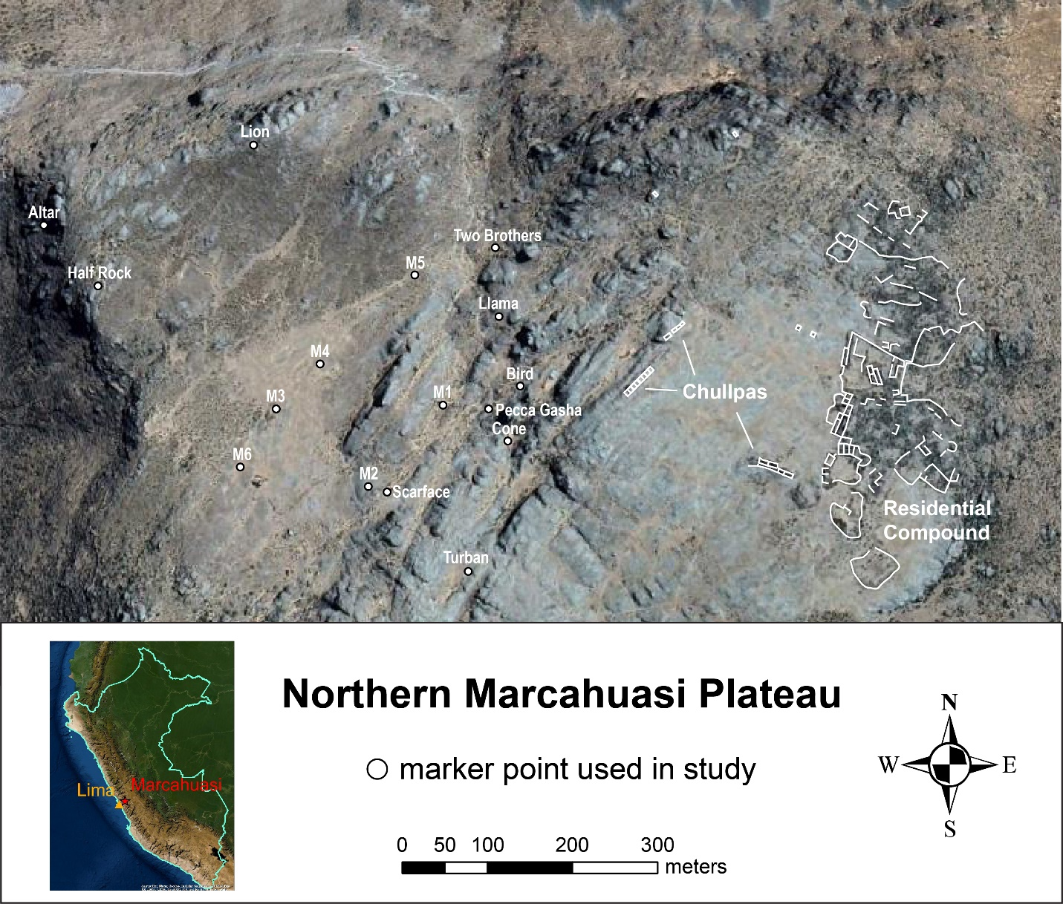

Figure 1. Northern Marcahuasi Plateau showing prehispanic structures to east and markers used in study to west. Satellite imagery of main map from Google Earth and of inset map from ESRI.

The prehispanic architecture at Marcahuasi is concentrated on approximately 5.5 ha of the northeastern plateau. Architectural remains consist of a network of residential room-blocks and walls covering some 1.25 ha to the east, interpreted by some as a fortress (Salazar and Iannacone 2007), and four clusters of open sepulchers usually designated *chullpas* (Bongers et al. 2022; Isbell 1997) located west of the residential area, several of which still retain ancestral remains (Figure 2). None of the structures have been systematically excavated but, based on stylistic similarities with others in Huarochirí province, the chullpas appear diagnostic of the Late Intermediate Period (ca. 1000-1450 CE) prior to the Inca conquest of the region (Chase 2015; Hernández Garavito 2021; Hrdlička 1914:7-13; Huamán Santillán 2021; Isbell 1997:192-195). They are rectangular in form, have small doors located at ground level, and either consist of a single structure or a line of attached ones—the longest featuring eight aligned chambers with doors. Circular enclosures with low walls, visible particularly to the south of the residential compound, likely served as corrals for flocks of camelids.

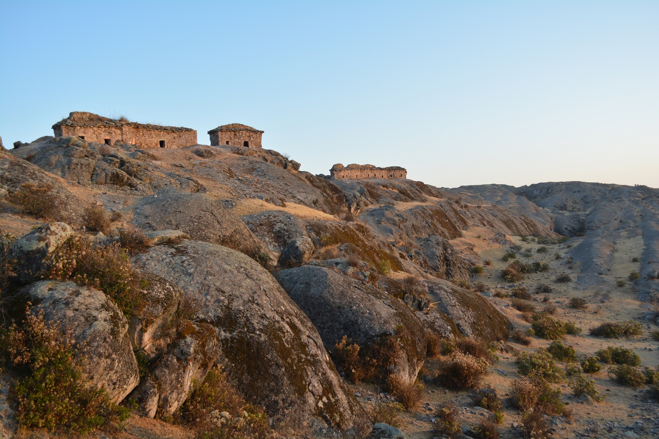

Figure 2. Rows of chullpas on ridge separating architectural remains of northwestern plateau from markers of northeastern plateau. Photo by David Carballo.

A century ago, the pioneering Andean archaeologist and ethnographer Julio C. Tello, who hailed from Huarochirí, visited Marcahuasi and San Pedro de Casta. Along with Próspero Miranda, a resident of Casta, Tello documented the beliefs and ritual practices of the Casteños of the time. These included veneration of the deity Huallallo (also Wallallo), who is also a protagonist in the narrative of the Huarochirí Manuscript and to whom Casteños of the early twentieth century made offerings at a sacred stone located between Casta and Marcahuasi in association with rituals relating to water and irrigation (Tello and Miranda 1923; see also Bennison [2019]). In several passages of the Huarochirí Manuscript, supernatural entities are recounted as having been turned to stone (Dulanto 2015; Salomon and Urioste 1991). The embodiment of a sacred entity within particular stones or rock outcroppings is consistent with the Andean notion of *huanca* (also *wank’a*), representing a concrete, physical manifestation of sacred beings (Dean 2010:44). At the site of Ampugasa, located south of Marcahuasi, the sacred core consists of a rock outcropping with formations that Hernández Gravito (2021) contends embody elements of the mythic narrative of the Huarochirí Manuscript.

Daniel Ruzo began documenting Marcahuasi’s enigmatic stone formations in 1952 as part of a research project that continued for decades (Ruzo 1980). This project has continued up to present under Luis Ruzo (Marcahuasi-Ruzo Webpage). Since certain rock formations were considered sacred to inhabitants of the region for the last four or five centuries, it seems probable that the same applied in prehispanic times, a proposition we evaluate here. Among a number of interesting formations, we focus on those that spread over some 12 ha of the northwestern plateau and, in particular, monolithic formations that we designated as “markers” (M1-M6) or following projected formal attributes in use at the site. The rock formations designated as markers are smaller, and could be either glacial erratics, likely for some, or purposefully moved or modified by humans, possible for others (Figure 3). They are clustered in the center of the northwestern plateau while those formations with designations based on some formal similarity to anthropomorphic, zoomorphic, or inanimate entities represent protuberances on the landscape ringing the markers. The most famous of these is known as Peca Gasha (“head in the alley” in Quechua), an impressive outcrop approximately 40 m tall that shows evidence of clear human modification in a gridded petroglyph on its southern face (Figure 4) and uncertain modification for what are interpreted to represent facial features.

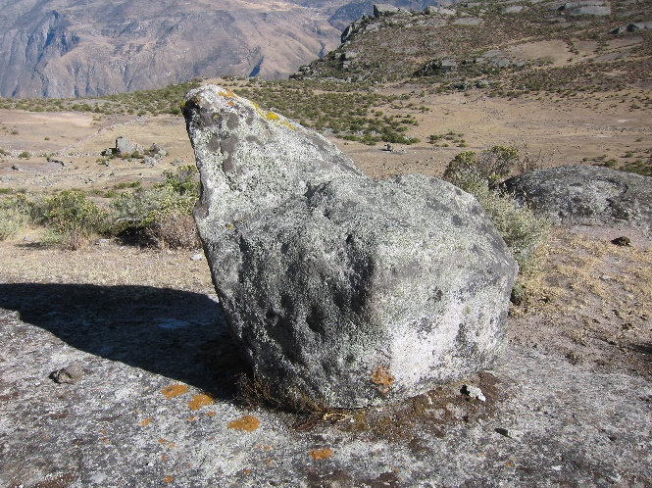 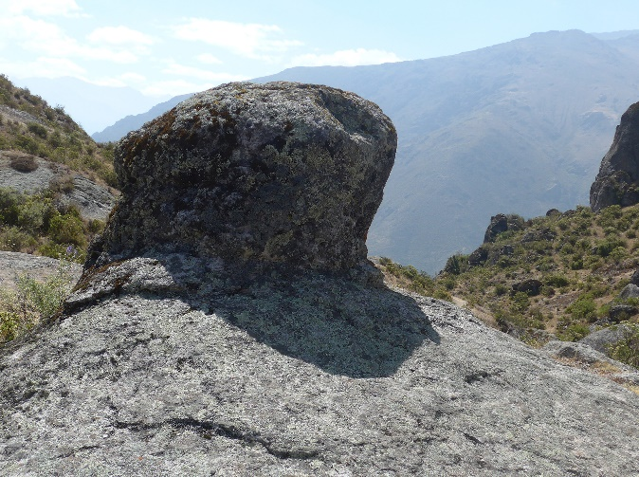

Figure 3. Examples of markers: (left) freestanding Marker 2 and (right) protuberance of Marker 5 connected to basal rock layer. Photos by Luis Ruzo.

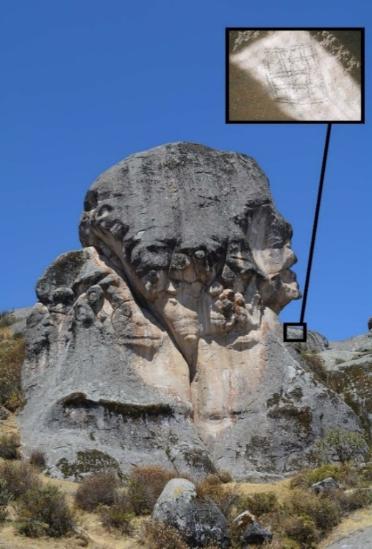

Figure 4. Pecca Gasha monument with gridded petroglyph under raking light in inset. Photos by David Carballo and Luis Ruzo.

**The Sun and Pleiades in Andean Cultural Astronomy**

Scholarship on Andean cultural astronomy is rich and spans the study of possible alignments in some of the earliest monumental centers of the ancient Americas, in Supe Valley centers dating to some five millennia ago (González García et al. 2021), to a wealth of information on alignments, calendars, and cosmological narratives of the Inca and contemporary descendant communities (e.g., Aveni 2015; Dearborn and Schreiber 1987; Zuidema 1983, 2008). Purposeful alignments to events in the solar cycle are particularly well documented for the Inca and their predecessors, and include rising or setting during the solstices, equinoxes, and zenith passage—the phenomenon observable only in tropical latitudes when the sun is directly overhead at noon (e.g., Ghezzi and Ruggles 2007). In addition to the possible astronomical alignments of buildings, the Inca practice of charting solar and astral passages along the horizon using open platforms or other viewing spaces (*ushnu*) and gnomon-like stone pillars to establish lines of sight is well documented by colonial period chroniclers, though the corresponding dates and celestial phenomena under observation remain points of scholarly debate (e.g., Dearborn and Schreiber 1987; Moyano 2014). These included milestones along the Inca road system, the Quapaq Ñan, that took the shape of rock-pile cairns or freestanding monoliths, referred to as *saywas* or *tupus*, used to chart the solar cycle and conspicuously incorporate it symbols of the imperial realm (Sanhueza et al. 2020; Sanhueza Tohá 2017).

The solstices were particularly important to the Inca ritual calendar as marking the major festivals of Inti Raymi (“Sun Month”) and Capac Raymi (“Royal Month”) associated with the June and December solstices, respectively (Zuidema 1977, 2008). Yet other celestial phenomena were also culturally significant to Andean peoples who charted their progress through the night sky, including those involving the Milky Way and the Pleiades. We can again turn to the Huarochirí Manuscript for ethnohistoric details. The manuscript documents the role of priests who tracked solar movements (Chapter 9) and the importance of the Milky Way and the Pleiades, recorded using the Spanish term Las Cabrillas (Chapter 29), to the cosmological narratives of the region (Salomon and Urioste 1991). Solar priests carried the title *yanca*, and the manuscript relates that, in order to time rituals to the mountain deity Pariacaca, “This man observes the course of the sun from a wall constructed with perfect alignment” (Salomon and Urioste 1991:72). Regarding astral observations, Chapter 29 of the Huarochirí Manuscript mentions the llama and other “dark star” constellations perceived in spaces with fewer stars along the celestial axis of the Milky Way, possibly three bright stars of the constellation Orion’s Belt in Western astronomy, and the Pleiades. Of the last, the manuscript notes that if the star cluster was observed to be large it was a harbinger of a bountiful year, whereas if it was small times would be hard (Salomon and Urioste 1991:133).

Tello and Miranda (1923:521) documented how the importance of the Pleiades star cluster continued well into the twentieth century to the inhabitants of San Pedro de Casta:

Cuentan los mayores de Casta, que oyeron decir a sus antepasados, que a comenzar el año gentílico, esto es, durante el mes de Junio, cuando hacen su aparición las Cabrillas, los habitantes de los hoy arruinados pueblos de Pampa Kocha, Waya Kocha, Kasha, Achin, Waksa K'aka, Opika y otros, dejaban simultáneamente sus residencias, para acudir en grandes romerías a Marka Wasi, a presenciar el terrible espectáculo, del sacrificio de la víctima humana.

(The elders of Casta recount hearing from their ancestors that at that start of the pagan new year, that is, during the month of June, when the Pleiades make their appearance, the inhabitants of the today ruined towns of Pampa Kocha, Waya Kocha, Kasha, Achin, Waksa K’aka, Opika and others, descend simultaneously from their residences to form great pilgrimages to Marka Wasi to witness the terrible spectacle of the sacrifice of a human victim.)

It should be noted that the Huarochirí Manuscript only mentions the sacrifice of llamas, not of humans, in association with the rituals to Pariacaca, and does not mention sacrifices in relation to the Pleiades. Nevertheless, the date in June recognized by twentieth century Casteños is the same as in the Huarochirí Manuscript, occurring around the time of the Christian festival of Corpus Christi. The last evening appearance of the Pleiades in the West at the latitude of Marcahuasi (-11.75 degrees) would occur around June 3. Based on these historical and ethnographic accounts of what celestial cycles were salient to the cultural astronomy of inhabitants of the region, we therefore used this alignment for the Pleiades in addition to those for the rising and setting of important events in the solar year—solstices, equinoxes, zenith passage—for our study of rock outcroppings on the northwestern Marcahuasi Plateau.

**Analytical Methods**

Field methods for the study involved multiple trips to Marcahuasi to map and document rock outcroppings and prehispanic architecture using a portable GPS (Garmin GPSMAP 62sp) that was then overlain on satellite imagery acquired using Google Earth Pro. Rock formations included the 15 monolith-like markers and other distinctive outcroppings in the northwestern plateau labeled on Figure 1: M1, M2, M3, M4, M5, turban, half rock, African lion, pecca gasha, bird, cone, llama, two brothers, scarface, and altar. We did not omit any of these possibilities, previously identified by Ruzo, so as to not bias the sample under study. The coordinates of all 15 features were input into the Omni azimuth calculator (<https://www.omnicalculator.com/other/azimuth>) to compute azimuth alignments, resulting in a total of 210 potential target alignments (Figure 5, Table 1).

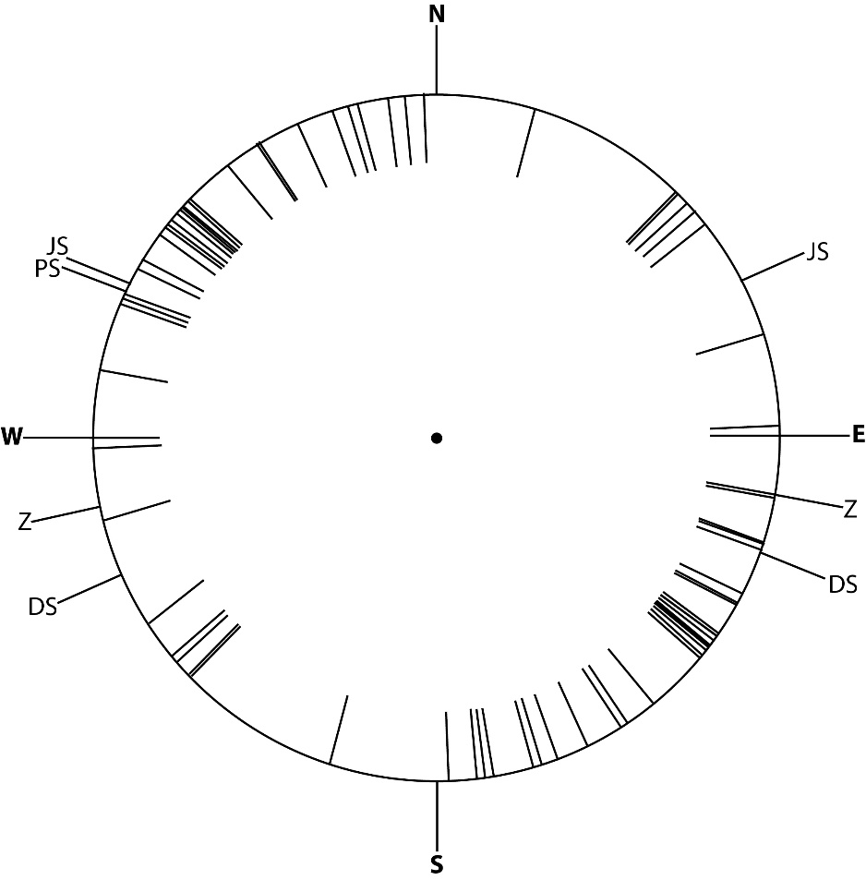

Figure 5. Visual representation of azimuths for alignments between markers and monuments in study. Key: JS = June Solstice; DS = December Solstice; Z = Zenith Passage; PS = Pleiades Set; Equinoxes calculated from cardinal E and W.

A few variables create uncertainty in the dataset including, most importantly, error in coordinate measurement based on satellite accuracy of the GPS and uncertainty in the target date for occupation and observation on the plateau, which introduces variability in potential alignment targets due to precession—the wobble in the Earth’s axis impacting azimuth calculations over time (Aveni ??). Not knowing exactly what rock features might be significant and when observations might have taken place therefore introduces significant noise in the data. We approached this variability by allowing for a range of error of 2.5 degrees for all azimuth calculations. In other words, if a potential target azimuth were 270 degrees—due West, as a sunset on the equinox—we accepted values between 267.5 and 272.4, two degrees to the North or South of the target with decimal rounding.

Horizon zero:

292.8 for 1500 CE

290.8 for 1000 CE

288.6 for 500 CE.

Horizon 3 degrees:

293.7 for 1500 CE

291.7 for 1000 CE

289.4 for 500 CE

Horizon 6 degrees:

294.5 for 1500 CE

292.5 for 1000 CE

290.2 for 500 CE.

Kassakian text on algorithm

Algorithm purposefully allows one to enter range of error in degrees to compensate for possible noise in data from measuring coordinates and relevant horizon points.

**Celestial Event Azimuth Alignments**

*Rise Set Rise Set*

***Equinoxes***

March/September 21 90 270 M3-M1 M1-M3

M3-Pecca M5-Half

Half-M5 Pecca-M3

***Solstices***

June 21 66 292 M3-Llama M1-M4

Scarface-Cone M1-Half

M4-Half

Pecca-Altar

Bird-Altar

Cone-Half

December 21 112 246 M4-M1 Llama-M3

Half-M1 Cone-Scarface

Half-M4

Half-Cone

Altar-Pecca

Altar-Bird

***Zenith Passage***

February 18/October 23 100.5 257.5 M1-Pecca Llama-M4

M4-Bird Bird-M1

Altar-M5

***Pleiades Last Appearance***

June 3 NA 298.8M1 – Half

Pecca – Half

Bird – Altar

Cone – Half

**Results**

Presence of certain solar alignments statistically significant beyond random distribution.

Table with azimuth values

Figures: azimuth distribution on 0-360 degree compass; bell curve of statistical significance

**Discussion**

Demonstration of significance does not mean that markers are anthropogenic, but could mean that certain human modification and/or that meseta would have been culturally significant to Andean peoples disposed to charting solar alignments.

Pleiades also culturally significant to Andean peoples and future work could evaluate heliacal rise alignments and markers as a terrestrial “map” of star cluster.

Algorithm is open source and could be put to evaluating other possible alignments elsewhere.

**Acknowledgements**

Luis Jaime Castillo, Liz Arkush, others…

**References**

Aveni, Anthony F.

1981 Horizon Astronomy in Incaic Cuzco. In *Archaeoastronomy in the Americas*, edited by Ray A. Williamson, pp. 305-318. Ballena Press and Center for Archaeoastronomy, Los Altos and College Park.

2015 Understanding Time, Space, and Social Organization in the Inca Ceque System of Cuzco. In *The Measure and Meaning of Time in Mesoamerica and the Andes*, edited by Anthony F. Aveni, pp. 105-118. Dumbarton Oaks Resarch Library and Collection, Washington, D.C.

Bennison, Sarah

2019 Waqay. *Anthropological Linguistics* 61(4):459-490.

Bongers, Jacob L., Juliana Gómez Mejía, Thomas K. Harper, and Susanna Seidensticker

2022 Assembling the Dead: Human Vertebrae-on-Posts in the Chincha Valley, Peru. *Antiquity*, online first version: <https://doi.org/10.15184/aqy.2021.180>

Bradley, Richard

1998 *The Significance of Monuments: On the Shaping of Human Experience in Neolithic and Bronze Age*

*Europe.* Routledge, London.

2000 *An Archaeology of Natural Places.* Routledge, London.

Dearborn, David S.P., and Katharina J. Schreiber

1987 Here Comes the Sun: The Cuzco-Machu Picchu Connection. *Archaeoastronomy* 9:15-37.

Chase, Zachary J.

2015 Andean Wak’as and Alternative Configurations of Persons, Power, and Things. In *The Archaeology of Wak'as*, edited by Tamara L. Bray, pp. 3-19. University Press of Colorado, Boulder.

Dean, Carolyn

2010 *A Culture of Stone: Inka Perspectives on Rock.* Duke University Press, Durham, North Carolina.

Dulanto, Jalh

2015 Time and the Other: The Early Colonial Mythohistorical Landscapes of the Huarochirí Manuscript. In *The Measure and Meaning of Time in Mesoamerica and the Andes*, edited by Anthony F. Aveni, pp. 141-163. Dumbarton Oaks Resarch Library and Collection, Washington, D.C.

González-García, A. César, Aldemar Crispín, Ruth Shady Solís, José Ricra, Felipe Criado-Boado,

and Juan A. Belmonte

2021 The River and the Sky: Astronomy and Topography in Caral Society, America’s First Urban Centers. *Latin American Antiquity* 32(1):154–172.

Ghezzi, Ivan, and Clive Ruggles

2007 Chankillo: A 2300-Year-Old Solar Observatory in Coastal Peru.  *Science* 315(5816):1239-1243.

González Mantilla, Pedro G., and Miguel Bahl

2017 A Importância do Posicionamento Internacional do Bosque de Pedras Marcahuasi como Destino Turístico no Peru. *Revista Turismo em Análise – RTA* 28(2):345-357.

Hernández Garavito, Carla

2020 Producing Legibility through Ritual: The Inka Expansion in Huarochirıí (Lima, Peru). *Journal of Social Archaeology* 20(3):292-312.

2021 Experiencing Community: Continuity and Transformation of Residential Life under the Inka Empire in Huarochirí (Lima, Peru). *Latin American Antiquity* 32(2):255-273.

Hrdlička, Ales

1914 *Anthropological Work in Peru in 1913, with Notes on the Pathology of the Ancient Peruvians.* Smithsonian Miscellaneous Collections, vol. 61, no. 18. Smithsonian Institution, Washington, D.C.

Huamán Santillán, Yomira Silvia

2021 Consideraciones sobre el sitio arqueológico Marcahuasi de Iris, distrito de San Juan de Iris—Huarochirí: cuenca del río Santa Eulalia. *Arqueología y Sociedad* 35: 411-418

Isbell, William H.

1997 *Mummies and Mortuary Monuments: A Postprocessual Prehistory of Central Andean Social Organization.* University of Texas Press, Austin.

Marcahuasi-Ruzo Webpage: <https://www.marcahuasi-ruzo.com/>

Moyano, Ricardo

2014 Astronomical Observations on Inca Ushnus in the Southern Andes. In *Inca Sacred Space: Landscape, Site and Symbol in the Andes*, edited by Frank M. Meddens, Katie Willis, Colin McEwan, and Nick Branch, pp. 187-196. Archetype Publications, London.

Ruzo, Daniel

1980 *Marcahuasi: La Historia Fantástica de un Descubrimiento*. Mundo Hispano, Lima.

Salazar, Neil, and José Iannacone

2007 Markawasi: un patrimonio cultural y natural del Perú. *Biologist (Lima)* 5(1):19-26.

Sanhueza, Cecilia Sanhueza, José Berenguer, Carlos González, Cristián González, Juan Cortés, Sergio

Martín, and Jimena Cruz

2020 Saywas y geografía sagrada en el Qhapaq Ñan del Desplobado de Atacama. Chungara Revista de Antropología Chilena 52(3):485-508.

Sanhueza Tohá, Cecelia

2017 Las saywas del Inka en el desierto de Atacama: ¿Una inscripción del calendario en el Quapaq Ñan? *Boletín de Museo Chileno del Arte Precolombino* 22(2):133-152.

Salomon, Frank

1991 Introductory Essay: The Huarochirí Manuscript. In *The Huarochirí Manuscript: A Testament of Ancient and Colonial Andean Religion*, edited and translated by Frank Salomon and George L. Urioste, pp. 1-38. University of Texas Press, Austin.

Salomon, Frank, and George L. Urioste (ed. and trans.)

1991 *The Huarochirí Manuscript: A Testament of Ancient and Colonial Andean Religion*. University of Texas Press, Austin.

Schreiber, Katharina

2005 Sacred Landscapes and Imperial Ideologies: The Wari Empire in Sondondo, Peru. *Archaeological Papers of the American Anthropological Association* 14:131–150.

Spalding, Karen

1984 *Huarochirí: An Andean Society Under Inca and Spanish Rule.* Stanford University Press, Stanford.

Staller, John E.

2008 Dimensions of Place: The Significance of Centers to the Development of Andean

Civilization: An Exploration of the Ushnu Concept. In *Pre-Columbian Landscapes of Creation and Origin*, edited by John E. Staller, pp. 269-313. Springer, New York.

Tello, Julio C., and Próspero Miranda

1923 Wallallo. Ceremonias gentilicias realizadas en la región cisandina del Perú Central (Distrito Arqueológico de Casta). *Revista Inca* 1(2):475-549.

Zavala Carrión, Bilberto

2006 Monumento natural Marcahuasi, proyecto de espacio natural con características de geoconservación. *XIII Congreso Peruano de Geología: Resúmenes Extendidos*, pp. 67-70. Sociedad Geológica del Perú, Lima.

Zuidema, R. Tom

1977 The Inca Calendar. In *Native American Astronomy*, edited by Anthony F. Aveni, pp. 219-250. University of Texas Press, Austin.

1983 Towards a General Andean Star Calendar in Ancient Peru. In *Calendars in Mesoamerica and Peru: Native American Computations of Time*, edited by Anthony F. Aveni and Gordon Brotherston, pp. 235-259. BAR International Series 174. B.A.R., Oxford.

2008 The Astronomical Significance of Ritual Movements in the Calendar of Cuzco. In *Pre-Columbian Landscapes of Creation and Origin*, edited by John E. Staller, pp. 249-267. Springer, New York.

Tables

Figures and Legends

Supplemental Material (algorithm)