Lentera Technologies Private Limited
Technology Solutions & Digital Services
Email: madan@lenteratech.com | Phone: +91-9150047507 | Web: www.lenteratech.com

Date: [Date]
Ref: [Quotation number]

To,
[Customer details].

Sub: Proposal for SOCIAL MEDIA & DIGITAL MARKETING PROPOSAL

WHAT'S INCLUDED

Scope of Work

Google Business Profile Registration
Creation and setup of Google Business Profile with business information, category, contact details, location and supporting information.

Social Media Account Registration
Registration / setup of up to [X] social media platforms based on the client's business requirements.

Social Media Content Creation
Management of up to [X] social media platforms, including the creation of [X] professional posts per month aligned with the client's brand and business objectives.

Social Media Publishing Support
Scheduling / publishing of approved posts across the selected social media platforms.

Basic Digital Presence Management
Maintaining consistent branding, business information and content presentation across the selected digital channels.

WHERE WE'LL SHOW UP

Proposed Social Media Platforms
Up to 6 platforms, selected based on the client's target audience and business requirements. Final platforms will be confirmed during project initiation.
- Facebook
- Instagram
- LinkedIn
- YouTube
- X / Twitter
- Pinterest*
* Or other platform relevant to the client's audience

HOW WE'LL WORK TOGETHER

Engagement Model
We propose a monthly digital marketing support model focused on establishing and maintaining a consistent online presence.

Activity | Frequency
Google Business Profile Registration | One Time
Social Media Account Registration | Up to [X] Platforms – One Time
Social Media Creative Posts | [X] Posts / Month
Content Planning | Monthly
Post Design & Formatting | [X] Posts / Month
Publishing / Scheduling Support | Monthly
Basic Digital Presence Review | Monthly

Monthly Digital Marketing Engagement
A steady, predictable cadence of content and publishing support — designed to build consistent brand presence month over month.

CONTENT, EVERY MONTH

Monthly Deliverables
[X] Social Media Posts Per Month
Content will be prepared based on the client's business information, available materials and approved monthly content direction.

THE POSTS MAY INCLUDE
- Product / Service Highlights
- Company Updates
- Promotional Content
- Educational / Informative Content
- Industry-related Content
- Festive / Occasion-based Content
- Brand Awareness Content
- LinkedIn Organic Page Follower Growth
- LinkedIn Page Visibility & Reach Enhancement
- Content Optimization for Better Organic Engagement

PROCESS

Digital Marketing Workflow

Monthly Content & Publishing Workflow
1. Business Information / Requirements
2. Monthly Content Planning
3. Content & Creative Development
4. Client Review & Approval
5. Revisions, if required
6. Final Approval
7. Publishing / Scheduling
8. Monthly Content Completion

CONSISTENT & ON-BRAND

Social Media Content We Deliver
Our social media creatives will be designed to maintain a professional and consistent digital presence.

CONTENT CATEGORIES
- Brand Awareness
- Product & Service Promotion
- Company Updates
- Customer Engagement
- Industry Insights
- Promotional Campaigns
- Events & Announcements
- Festival / Occasion Posts

CREATIVE APPROACH
- Brand-aligned visual design
- Consistent typography and colours
- Platform-appropriate dimensions
- Clear messaging and call-to-action
- Professional and engaging layouts

PORTFOLIO

Sample Creative Work
A glimpse of the creative range and design quality our team delivers.
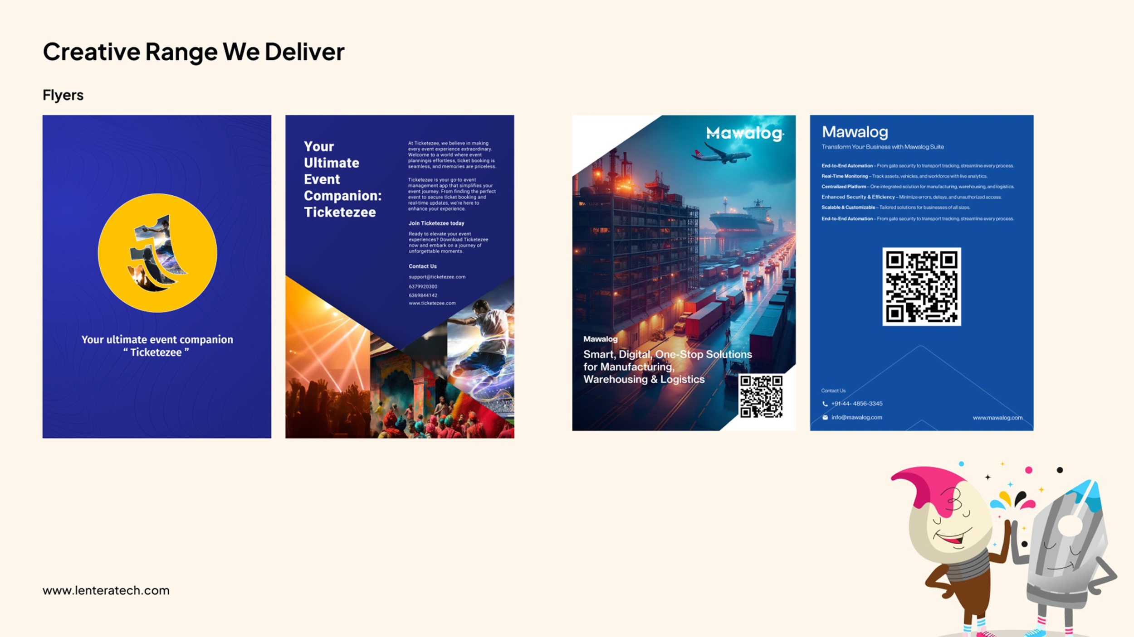

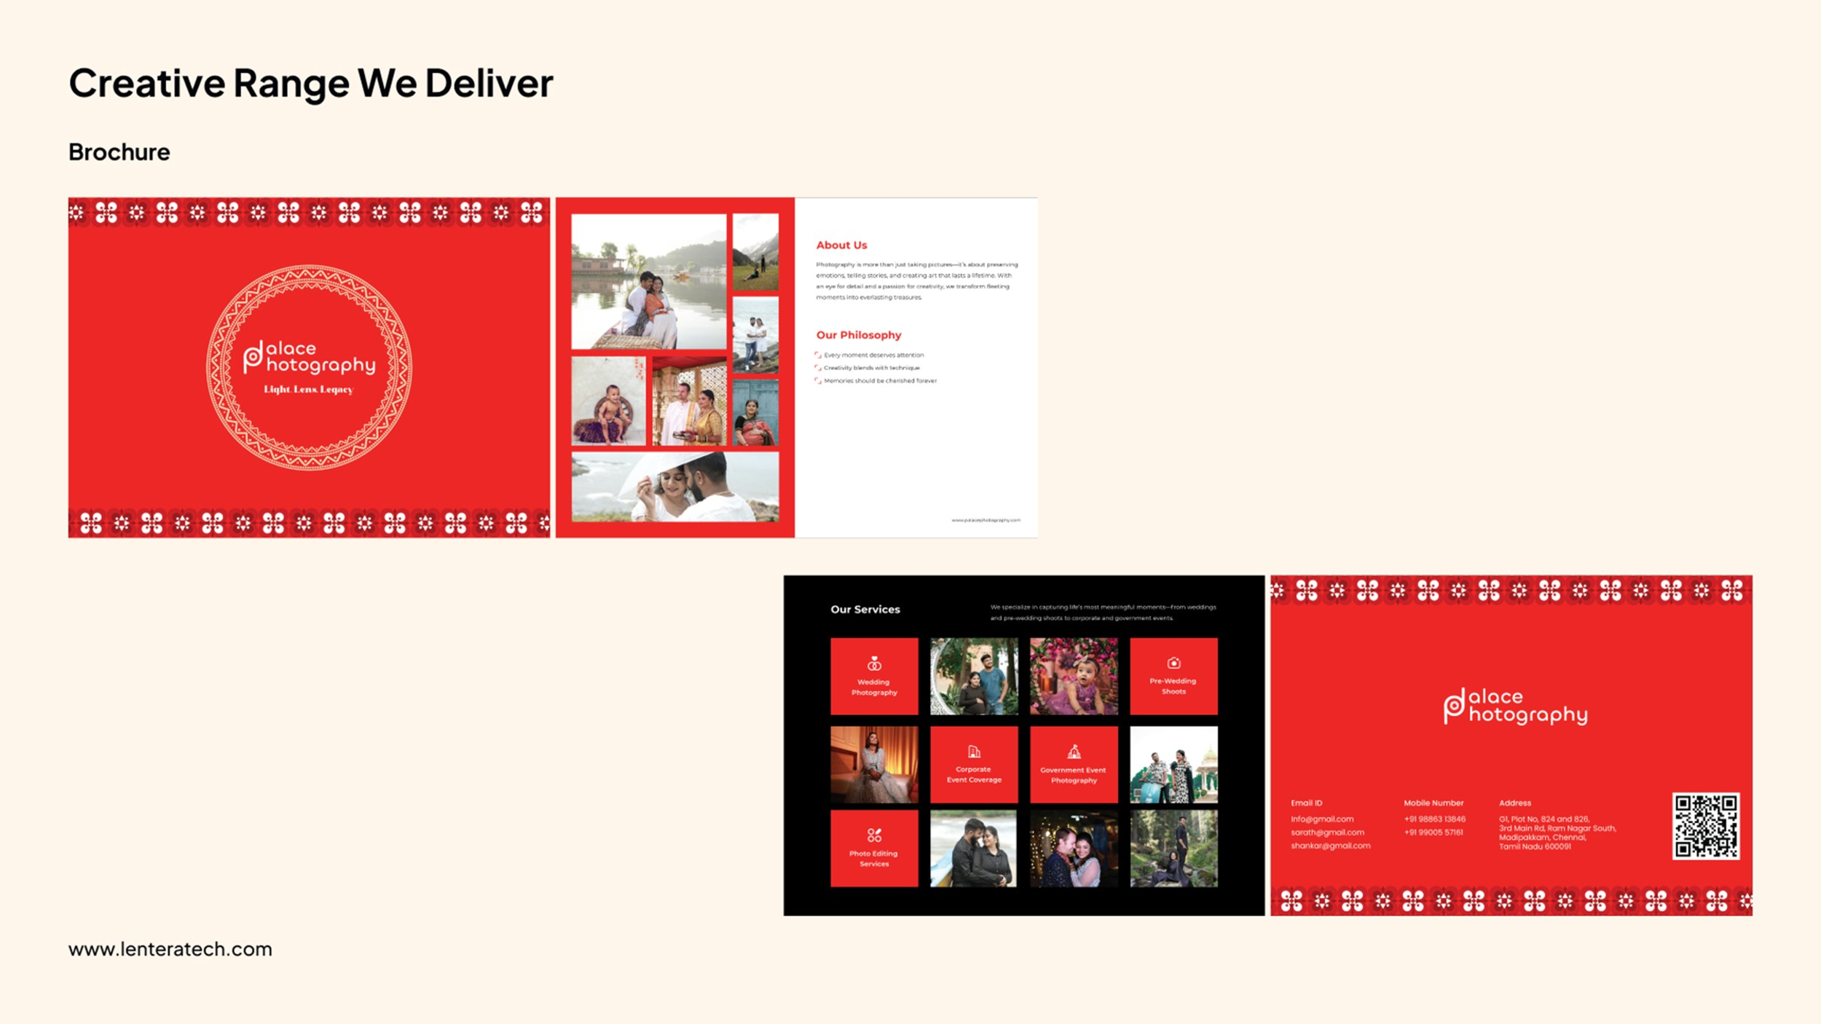
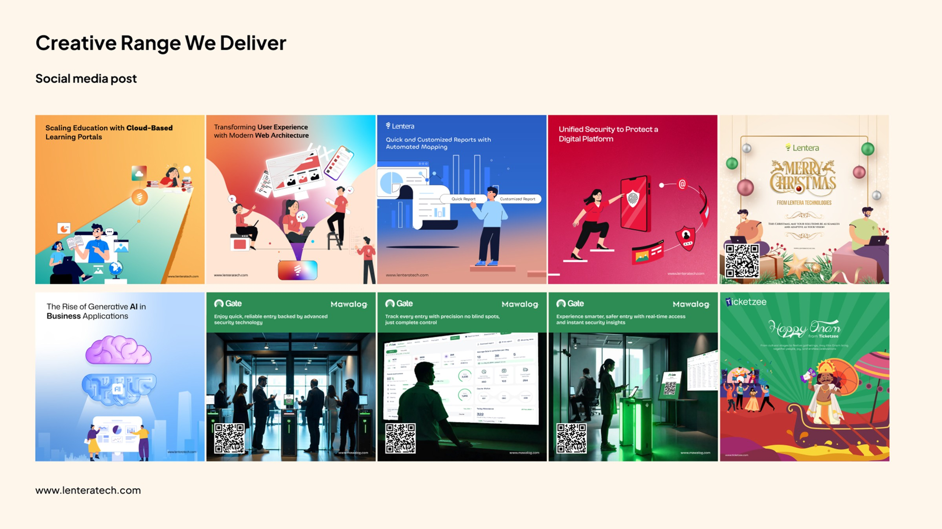
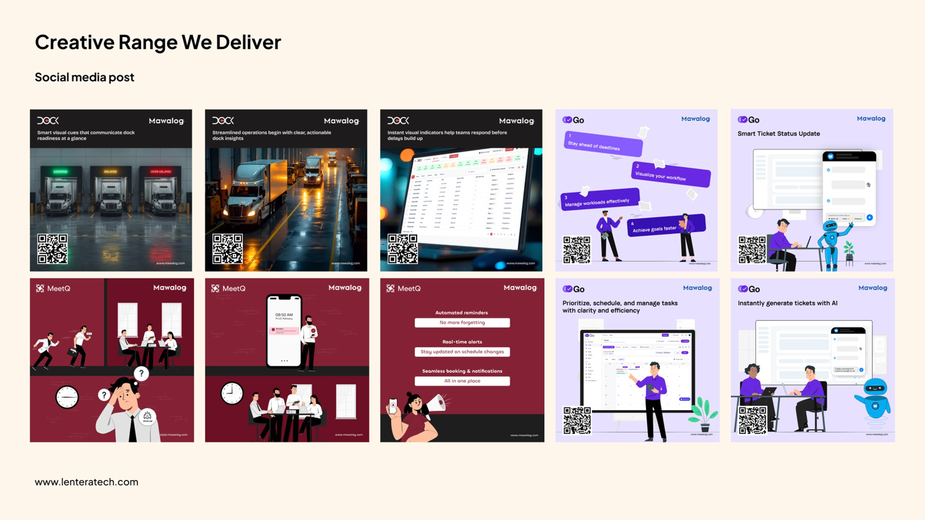
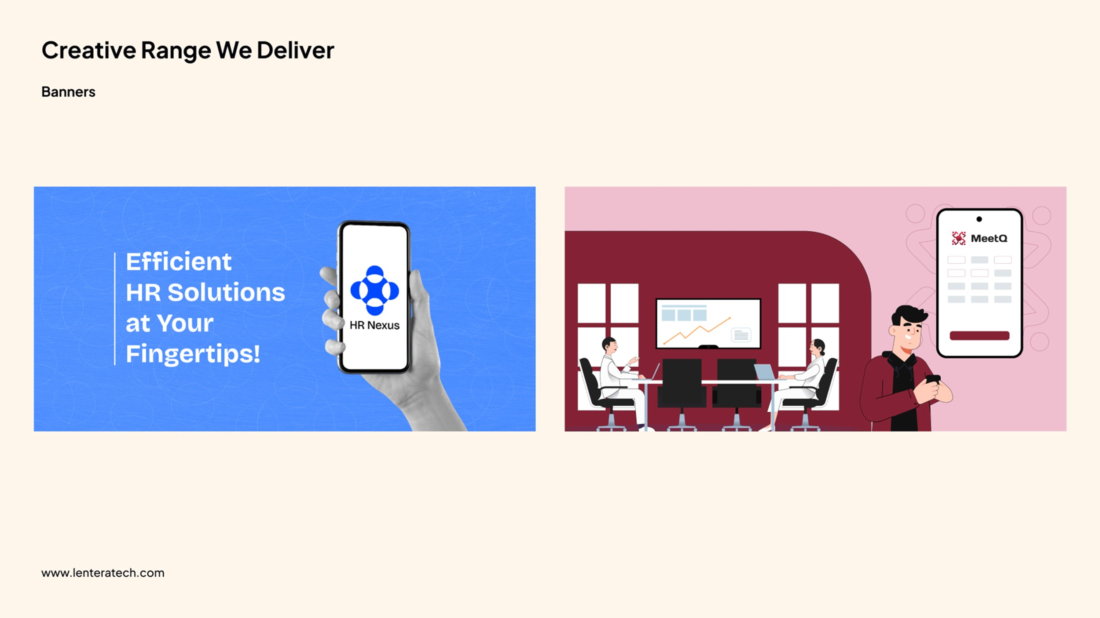

LOCAL VISIBILITY

Google Business Profile Setup
We will support the client in establishing their business presence on Google.

SCOPE
- Google Business Profile registration
- Business name and category setup
- Business description
- Address / service area configuration
- Contact information
- Website information
- Business hours
- Logo and cover image setup
- Basic business information optimization
- Verification support

IMPORTANT NOTE
Google's verification process and approval are controlled by Google. Any verification method, documentation or additional requirements requested by Google will need to be fulfilled by the client.

INVESTMENT

Commercial Proposal
Service | Type | Cost
Google Business Profile Registration & Setup / [X] Social Media Account Registration / Setup | One Time | ₹[X,XXX]
Digital Marketing – [X] Social Media Posts / Month | Monthly | ₹[X,XXX] / Month
Additional Charges |  | ₹[XXX] / Post
All prices are exclusive of applicable GST. Detailed commercial breakdown follows on the next slide.

INVESTMENT

Commercial Summary
Commercial Item | Amount
ONE-TIME SETUP | ₹[X,XXX] + GST
MONTHLY DIGITAL MARKETING | ₹[X,XXX ]+ GST / Month
TOTAL FIRST MONTH | ₹[XX,XXX] + GST
Subsequent Months | ₹[X,XXX] + GST / Month

INCLUDED IN MONTHLY RETAINER
- [X] social media creatives
- Content planning
- Creative design
- Content formatting
- Publishing / scheduling support
- Basic digital presence management

NOT INCLUDED
- Paid advertising / ad spend
- Influencer marketing
- Professional photography / videography
- Video production / reels
- Website development
- SEO
- Paid third-party tools or subscriptions
- Premium stock images / assets, if required

Terms & Conditions
- 18% GST will be applicable as per prevailing regulations.
- Google Business Profile registration is subject to Google's verification and approval process.
- Social media account registration requires the client to provide necessary business information, credentials and verification details.
- Monthly retainer includes [X] social media posts per calendar month.
- Unused monthly post deliverables cannot be carried forward to subsequent months.
- Content will be developed based on information, images and business inputs provided by the client.
- Client approval is required before publishing the content.
- Reasonable revisions are included within the agreed scope.
- Additional creatives or deliverables beyond the agreed monthly scope will be treated as additional work and quoted separately.
- Paid advertising / media spend is not included in the above commercials.
- Third-party subscription, premium stock image, video, music or other licensed assets, if required, will be charged separately.
- Monthly support / digital marketing services are billed as per the agreed monthly engagement.
- Payment is due within 10 days from the date of invoice.
- Services will be delivered according to the agreed schedule and monthly content plan.
- Any additional requirements outside the defined scope will be treated as a Change Request and quoted separately.

Warm regards,

Madan Kumar B
Chief Technology Officer
Lentera Technologies Private Limited
9150047507 | madan@lenteratech.com
This proposal is confidential and intended solely for the addressee.

