Climate and Oceanic Indicators
Over the past few years, the Council has incorporated climate change into the overall management of the fisheries over which it has jurisdiction. This 2025 annual SAFE report includes a now standard section on indicators of climate and oceanic conditions in the Western Pacific Region. These indicators reflect both global climate variability and change, as well as trends in local oceanographic conditions.
The section begins with a brief summary of the state of the ocean and climate in 2025. This is followed by a list of all selected indicators. These indicators are then examined through summaries focused on natural climate variability and on anthropogenic climate change. Information on the background of these indicators, their development over time, and ongoing research needs can be found at the end of this section.

Indicators at a Glance
Based on the information provided by the indicators in this chapter, long-term climate trends persisted in the Western Pacific region in 2025. Modes of interannual climate variability were mixed with ENSO neutral conditions prevailing throughout the year, the PDO remaining negative, and the NPGO being negative as well.
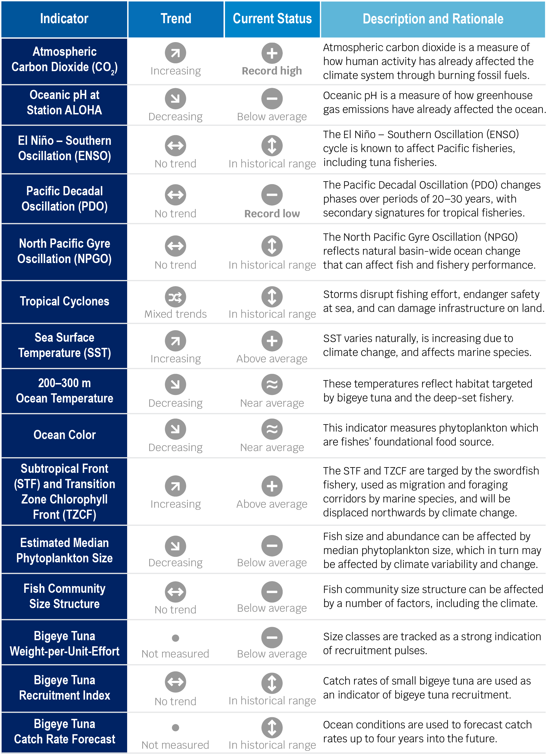
Figure 3.4.2.1-1: Summary of the trends and status of the ocean and climate indicators 2025

Selected Indicators
The primary goal for selecting the indicators used in this report is to provide fisheries-related communities, resource managers, and businesses with a climate-related situational awareness.
- Atmospheric concentration of carbon dioxide (CO₂)
- Oceanic pH at Station ALOHA;
- El Niño – Southern Oscillation (ENSO);
- Pacific Decadal Oscillation (PDO);
- North Pacific Gyre Oscillation (NPGO);
- Tropical cyclones;
- Sea surface temperature (SST);
- Ocean temperature at 200–300 m depth;
- Ocean color;
- North Pacific Subtropical Front (STF) and Transition Zone Chlorophyll Front (TZCF);
- Estimated median phytoplankton size
- Fish community size structure;
- Bigeye tuna weight-per-unit-effort;
- Bigeye tuna recruitment index; and
- Bigeye tuna catch rate forecast.

Natural Climate Variability Summary
The ocean and climate indicators described here can be used to understand the effects of natural climate variability.
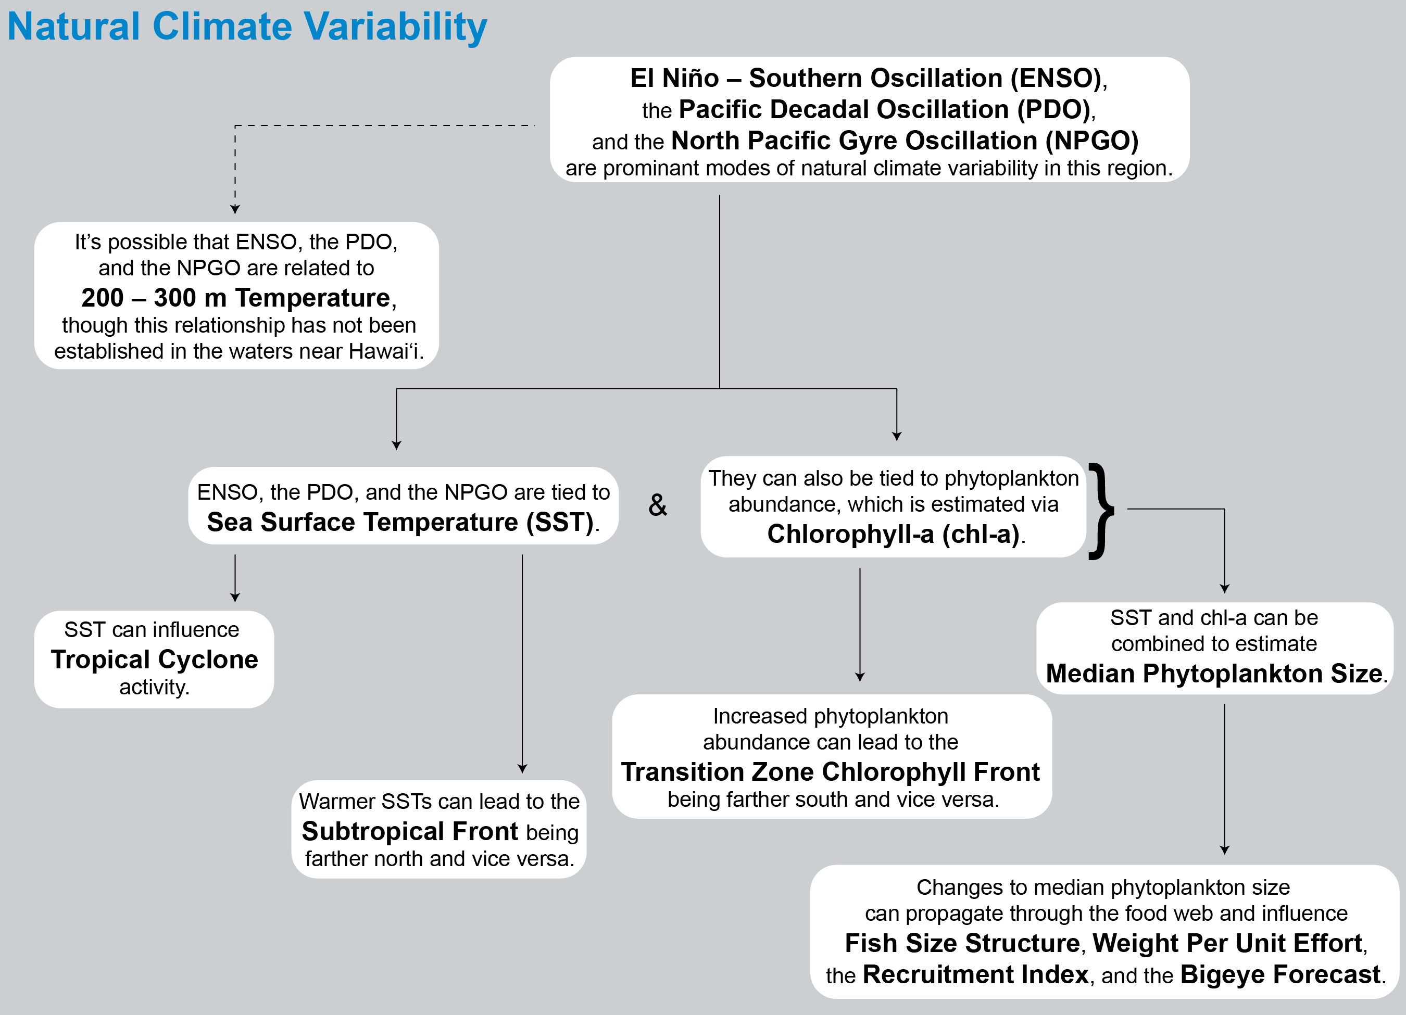
Figure 3.4.2.1-1: Schematic diagram illustrating the relationships between the ocean and climate indicators from the perspective of natural climate variability
The El Niño – Southern Oscillation (ENSO), the Pacific Decadal Oscillation (PDO), and the North Pacific Gyre Oscillation (NPGO) are prominent modes of natural climate variability in the North Pacific. ENSO cycles are known to impact Pacific fisheries including tuna fisheries. The Oceanic Niño Index (ONI) is a measure of ENSO phase that focuses on ocean temperature, which has the most direct effect on these fisheries.

