Layer Cake Charts and Summary Data

Table of Contents
Layer Cake Charts and Summary Data 1
ML Classifier Performance Summary 3
ML Representation Form Summary (Vertical Box Plots) 4
ML Language Model Summary 5
ML Classifier Performance Summary by Dataset 6
ML Representation Form by Dataset 8
20newsgroups 8
Ohsumed 9
ML Timelapse Performance by Representation Form 10
20newsgroups 10
Ohsumed 10
Language Model Performance Summary by Dataset 11
Timelapse Performance by Language Model 13
Language Model Performance by Representation (by Dataset) 14
ML Representation Form Summary – by Dataset 16

ML Classifier Performance Summary
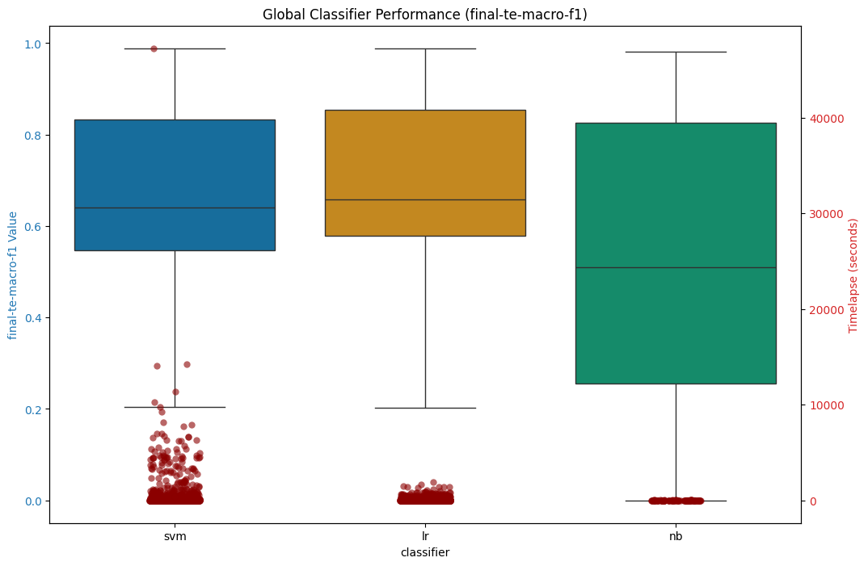
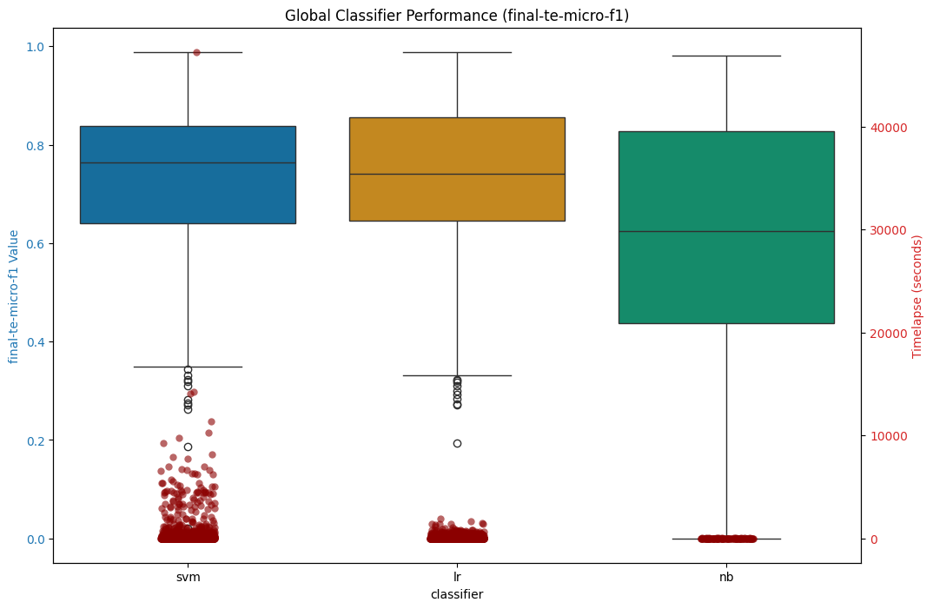

ML Representation Form Summary (Vertical Box Plots)
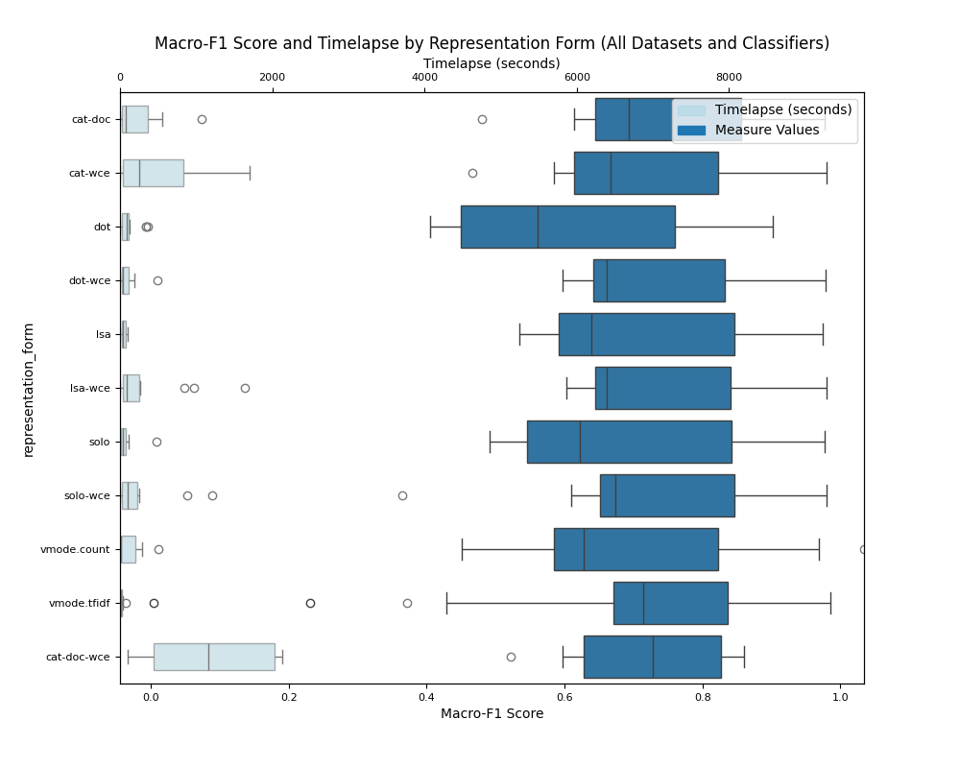
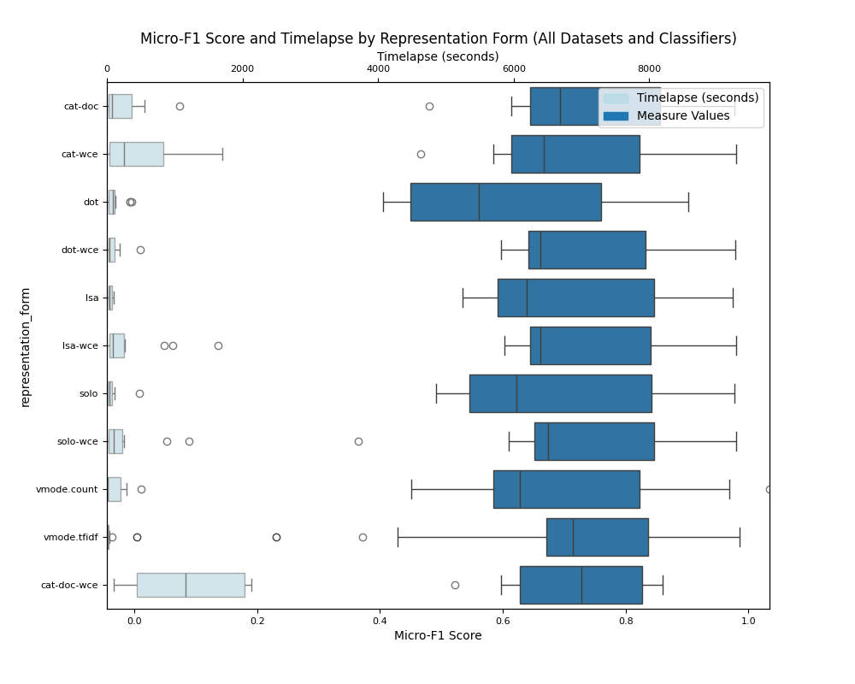

ML Language Model Summary
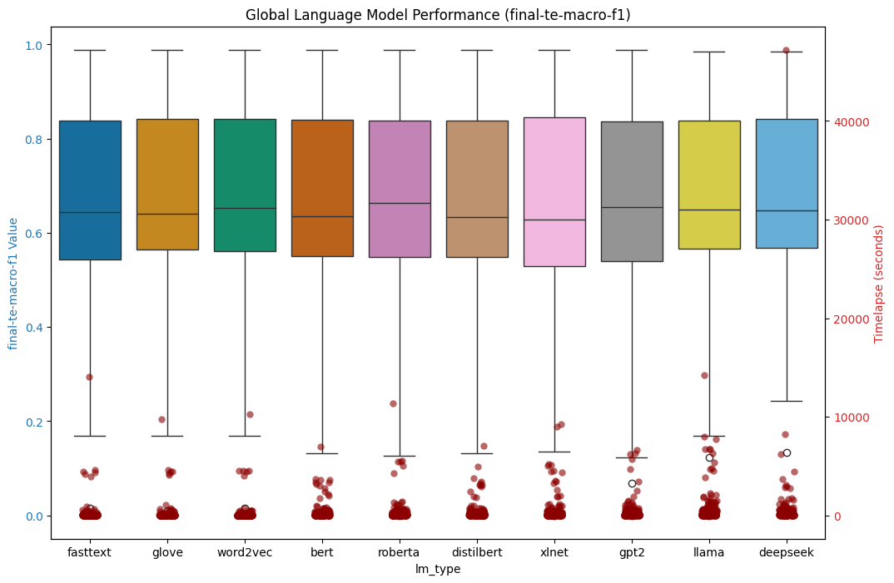
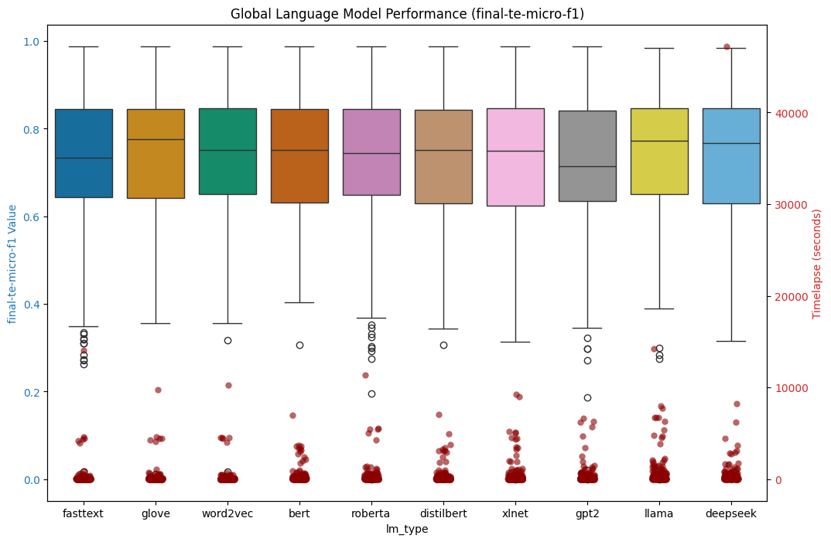

ML Classifier Performance Summary by Dataset

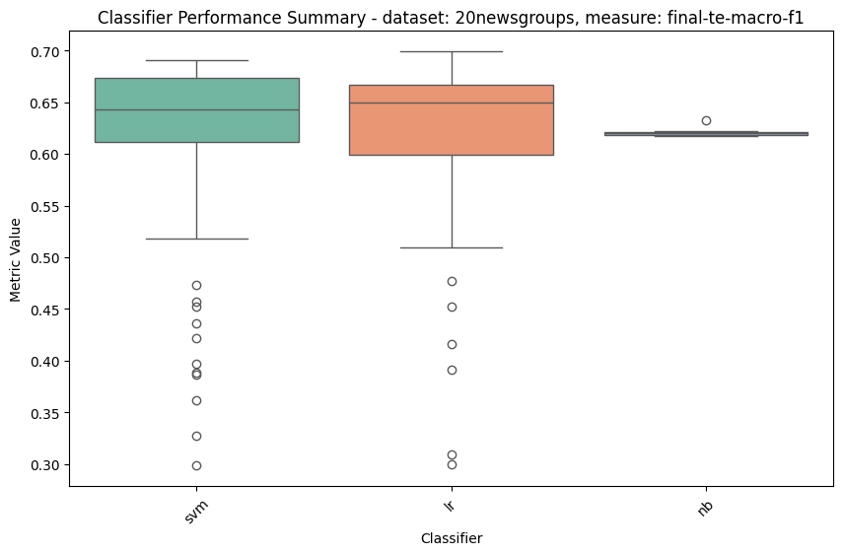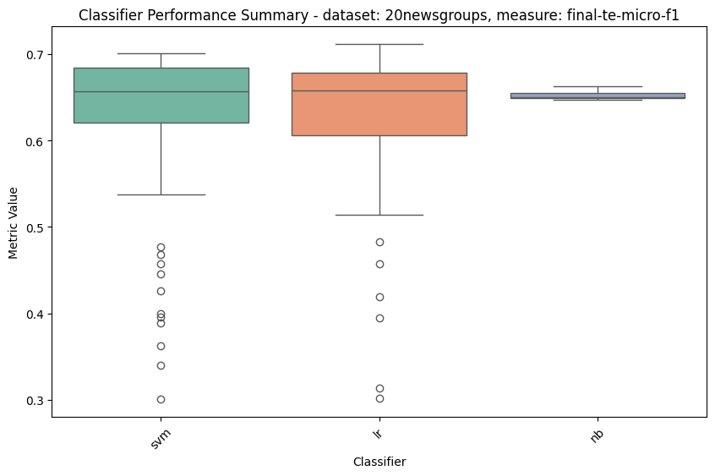
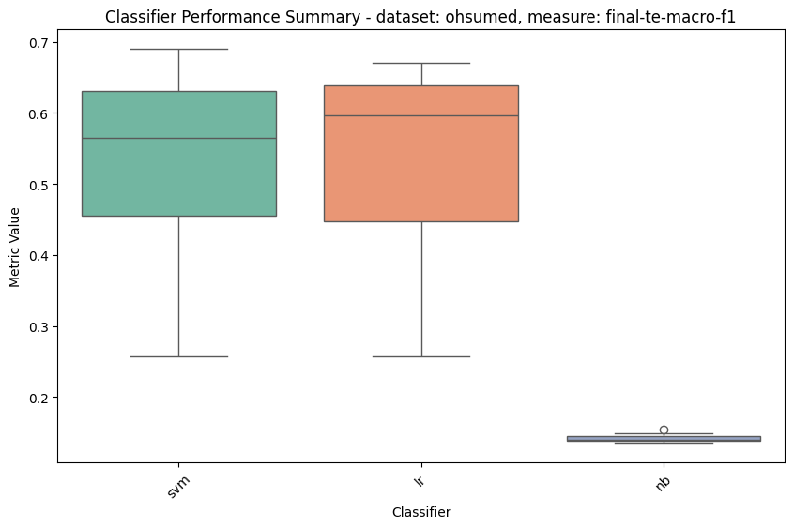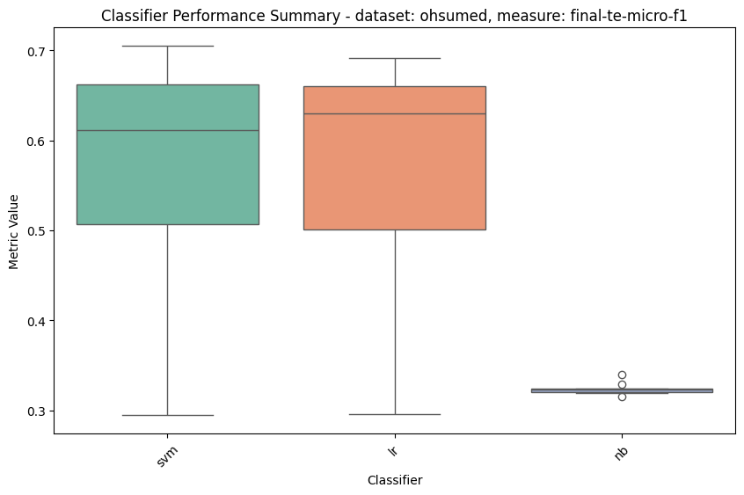

ML Representation Form by Dataset

20newsgroups

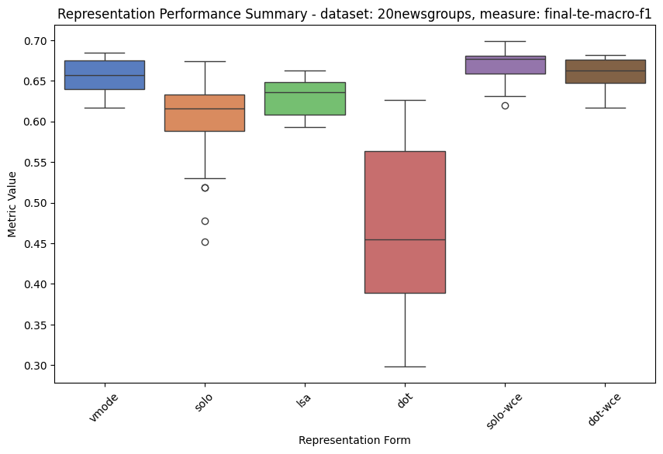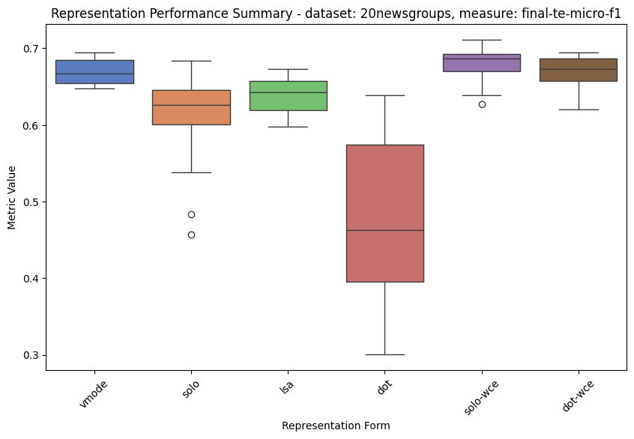

Ohsumed
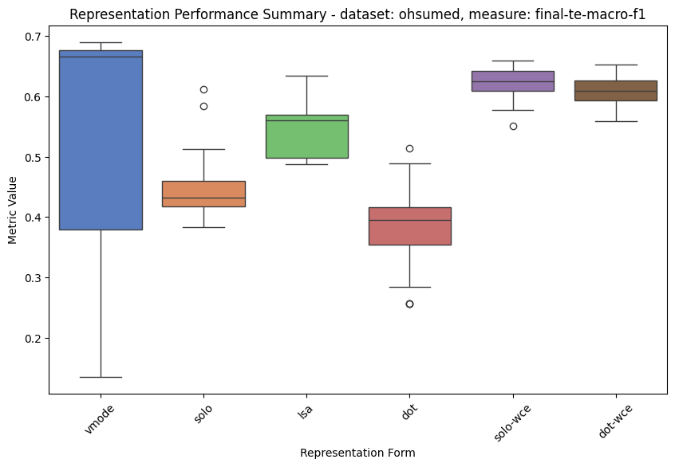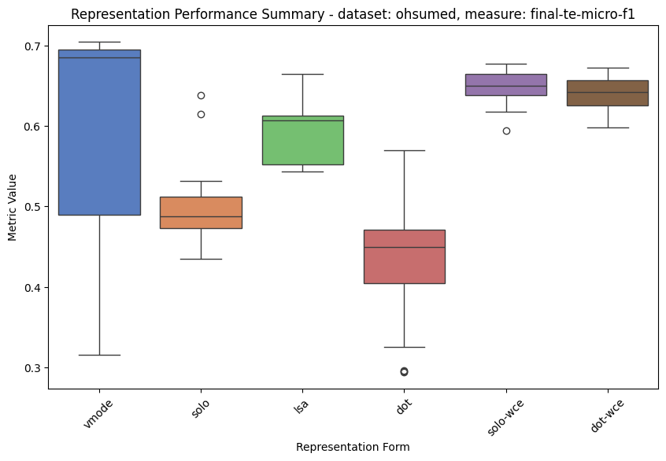

ML Timelapse Performance by Representation Form

20newsgroups
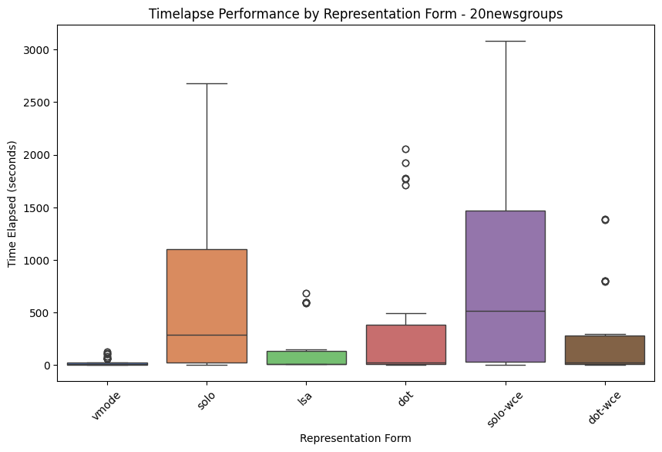

Ohsumed

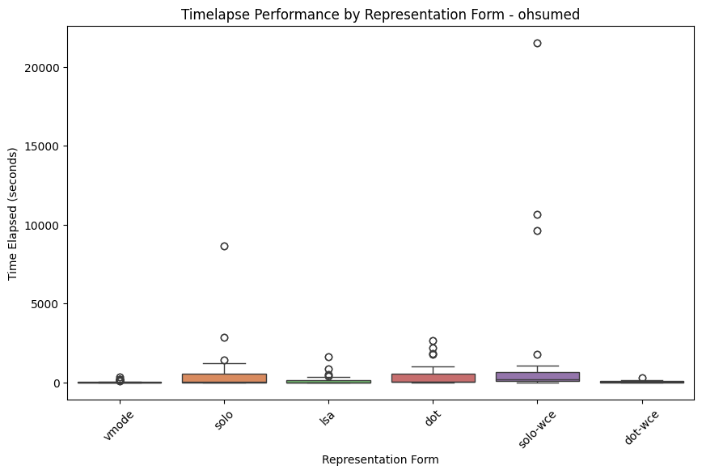

Language Model Performance Summary by Dataset

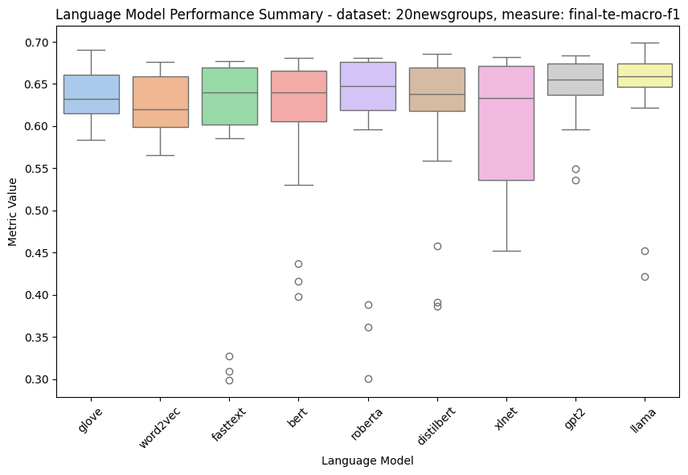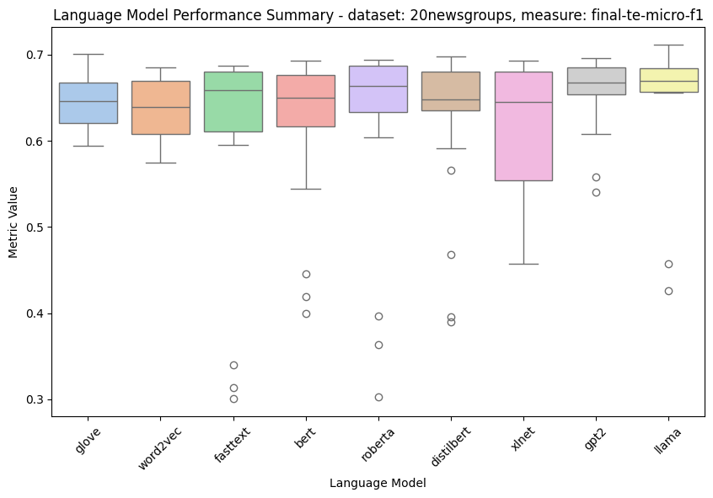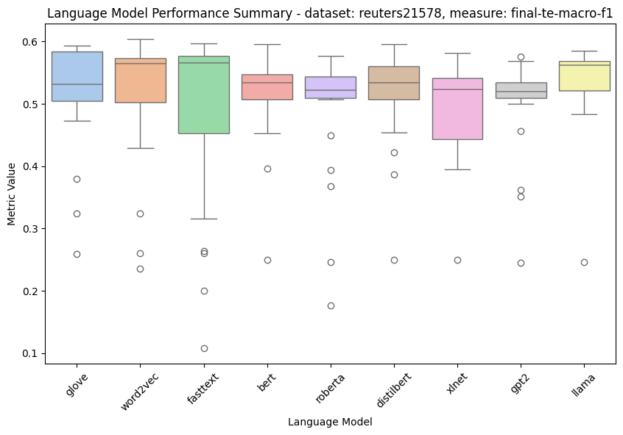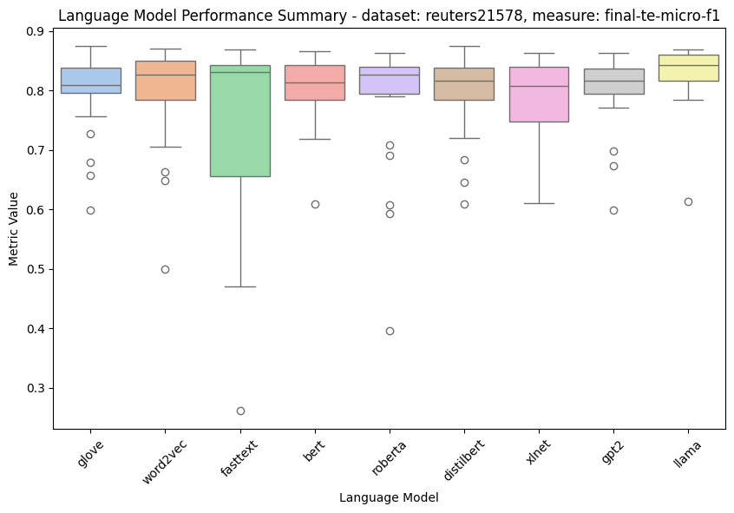

Timelapse Performance by Language Model

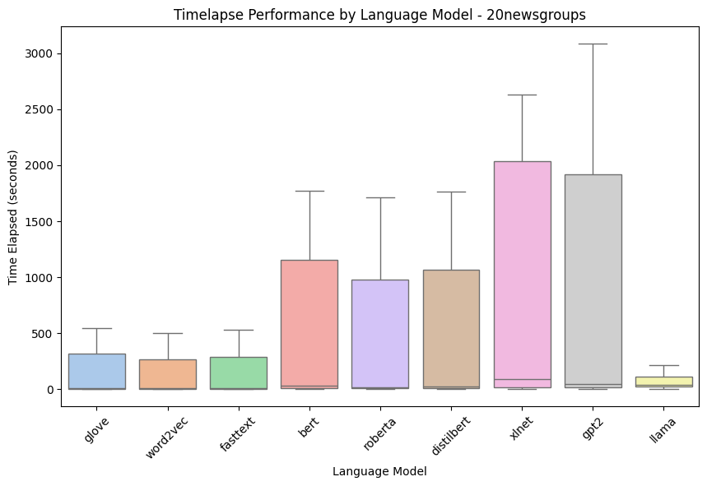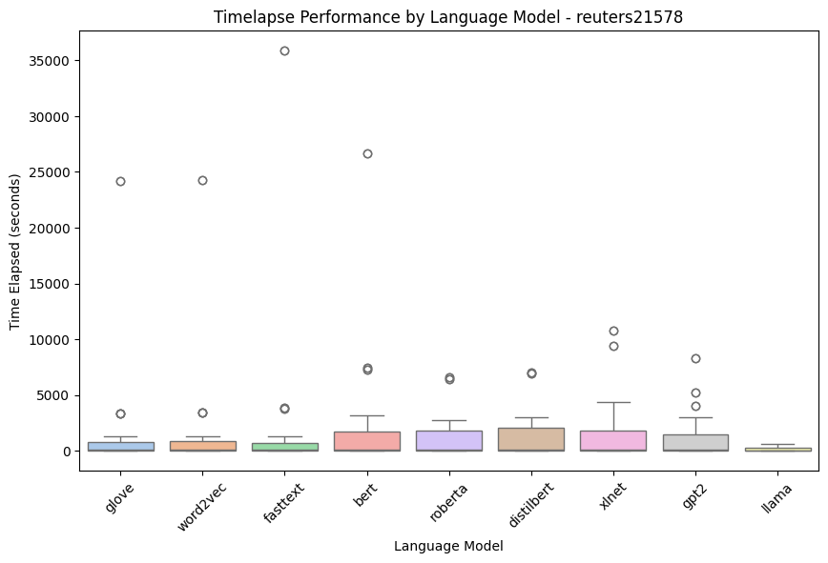

Language Model Performance by Representation (by Dataset)

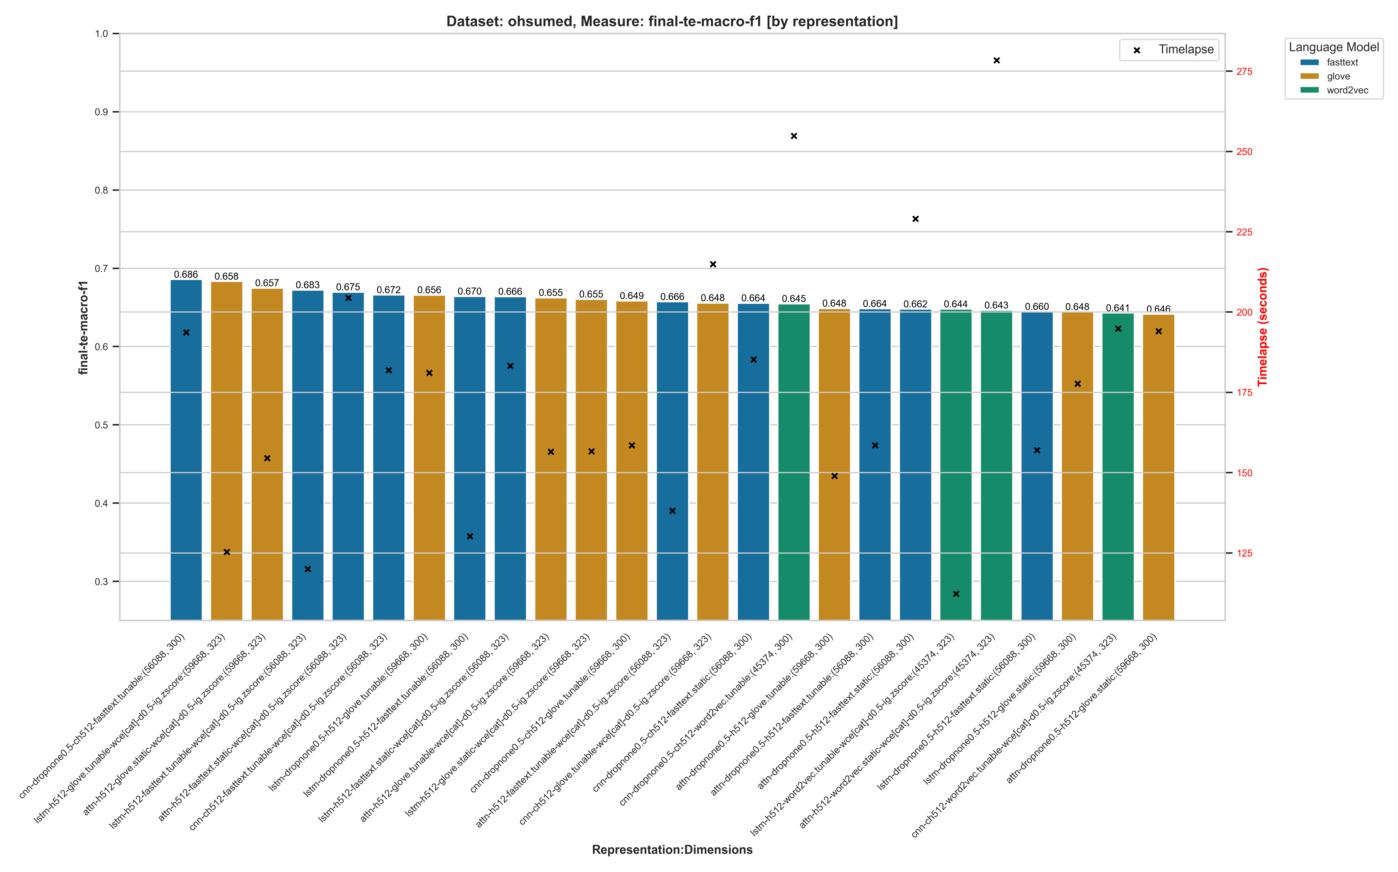
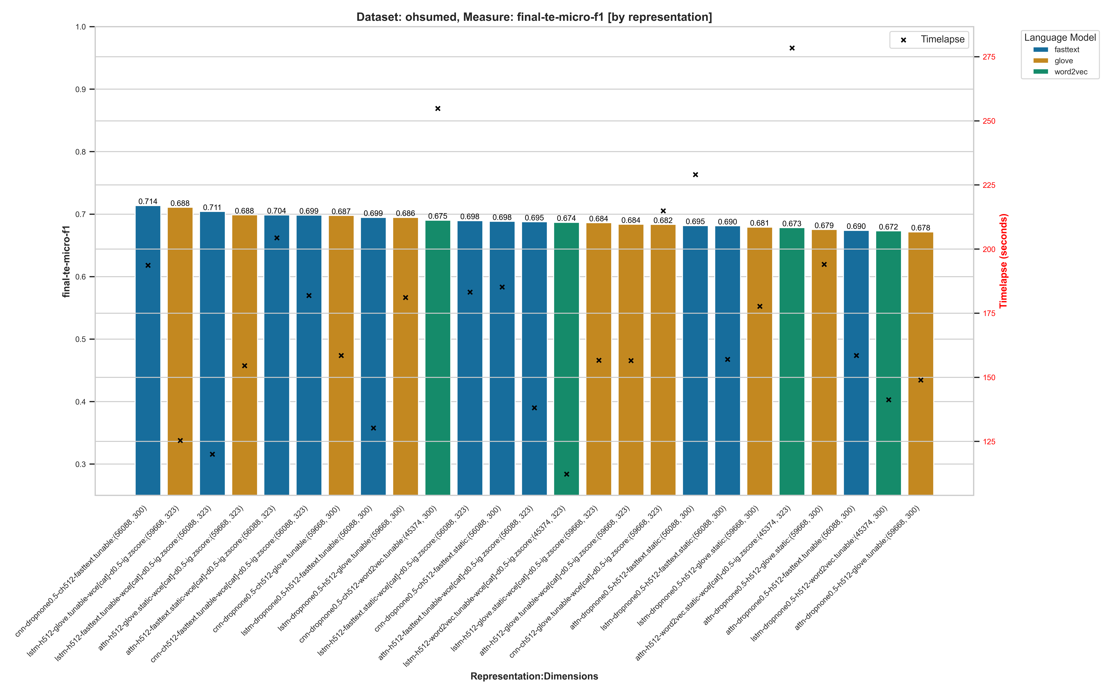

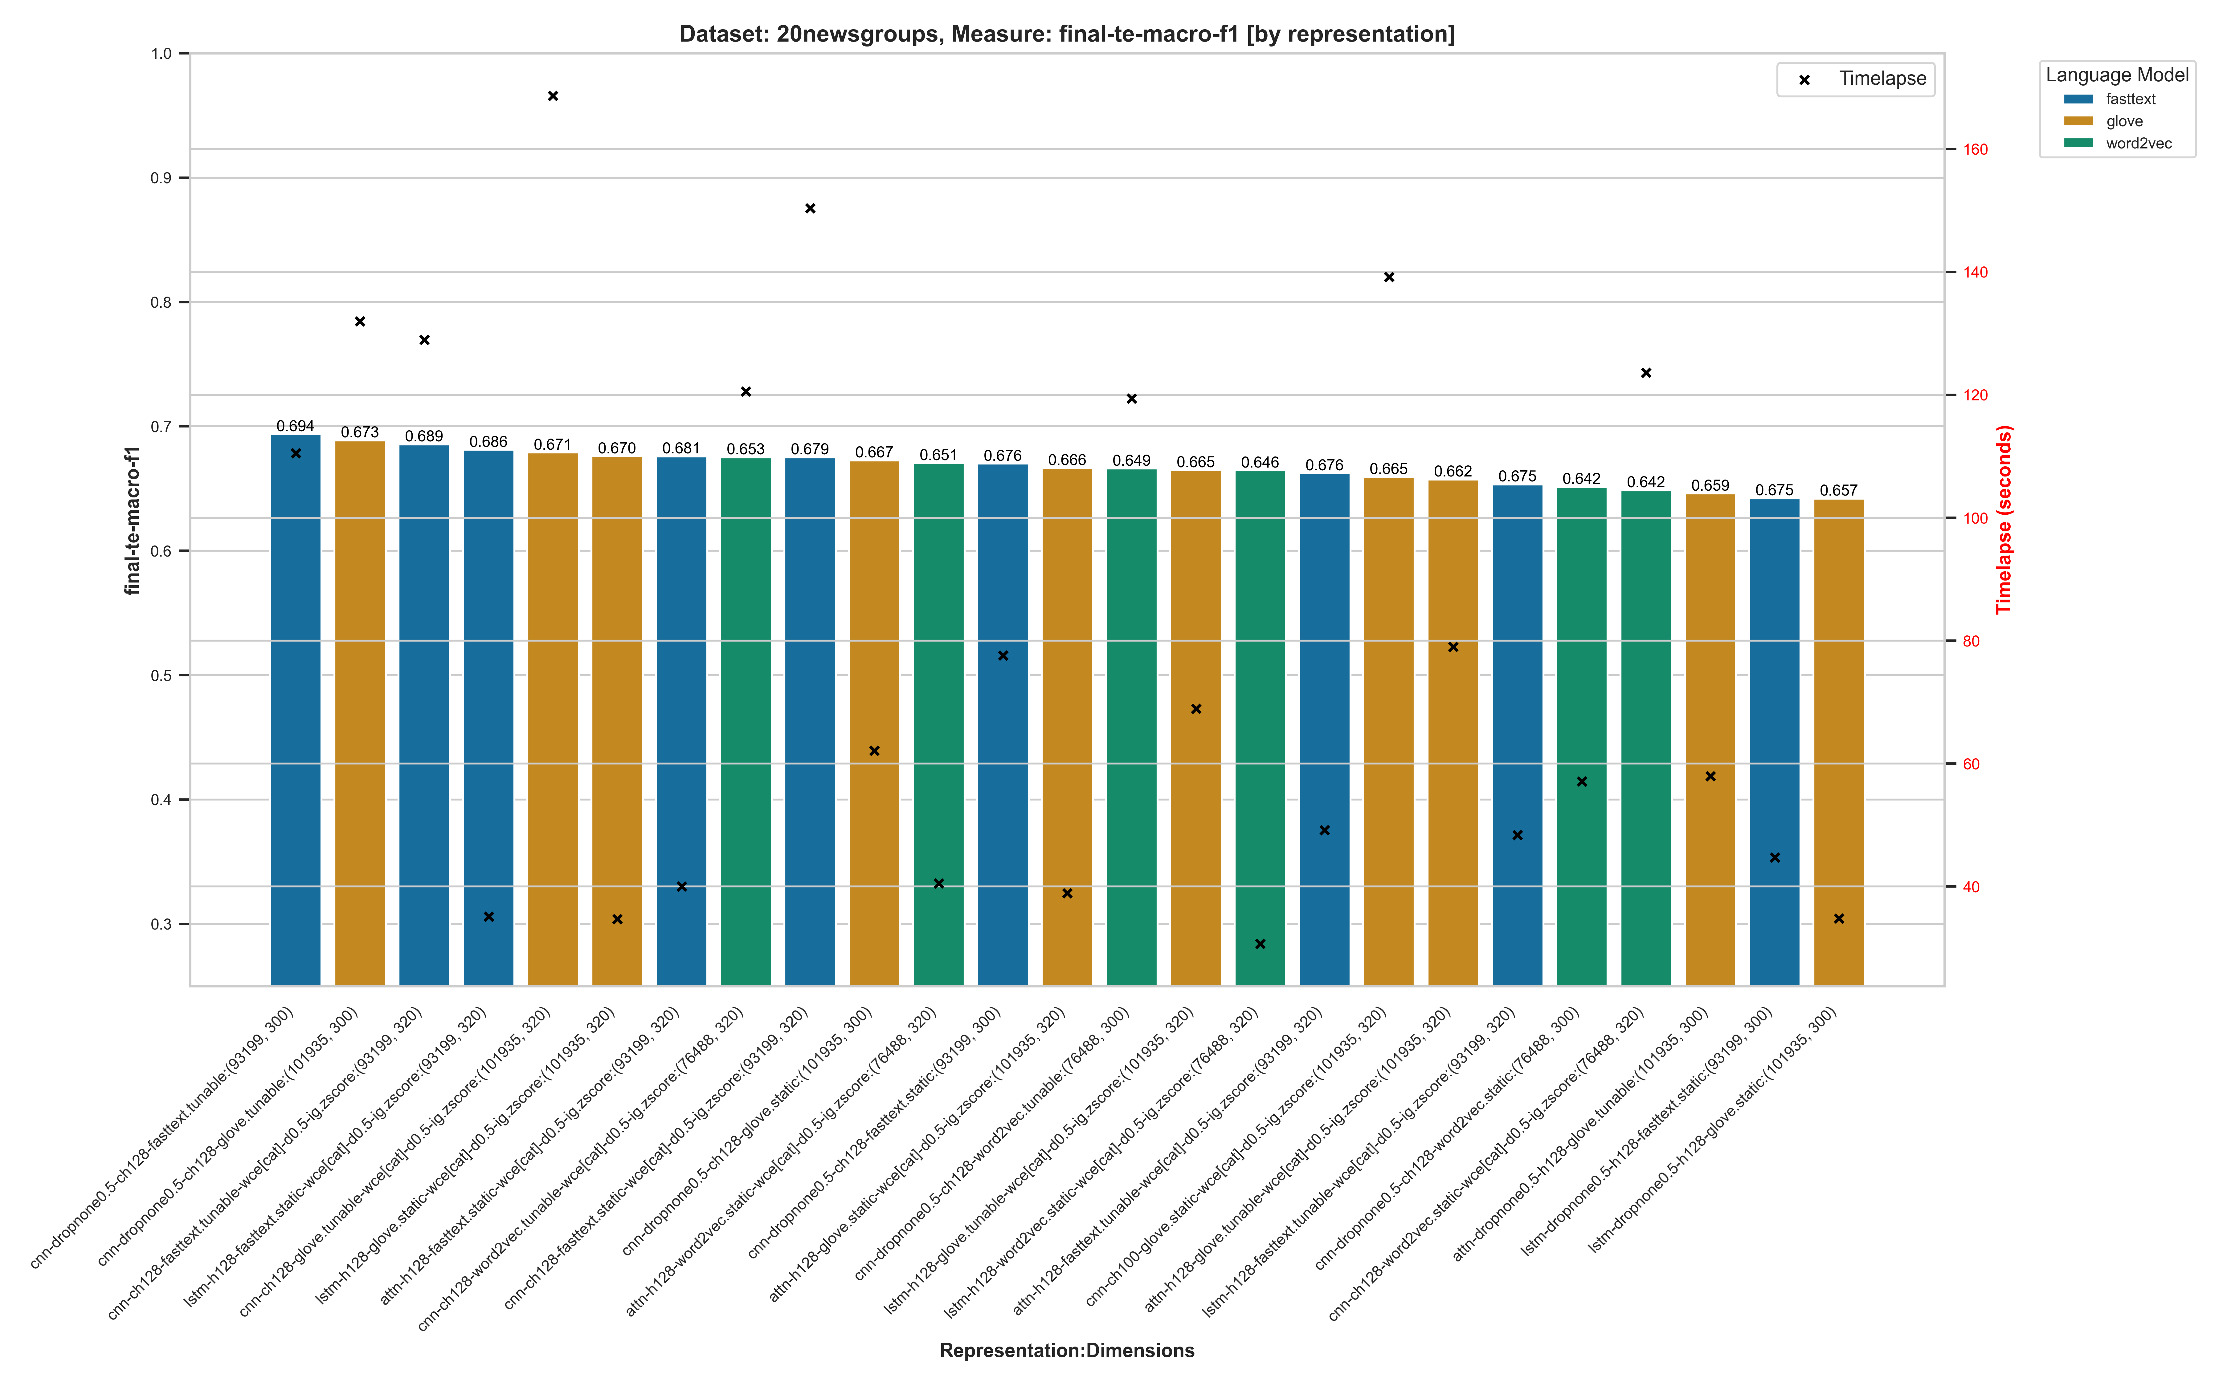
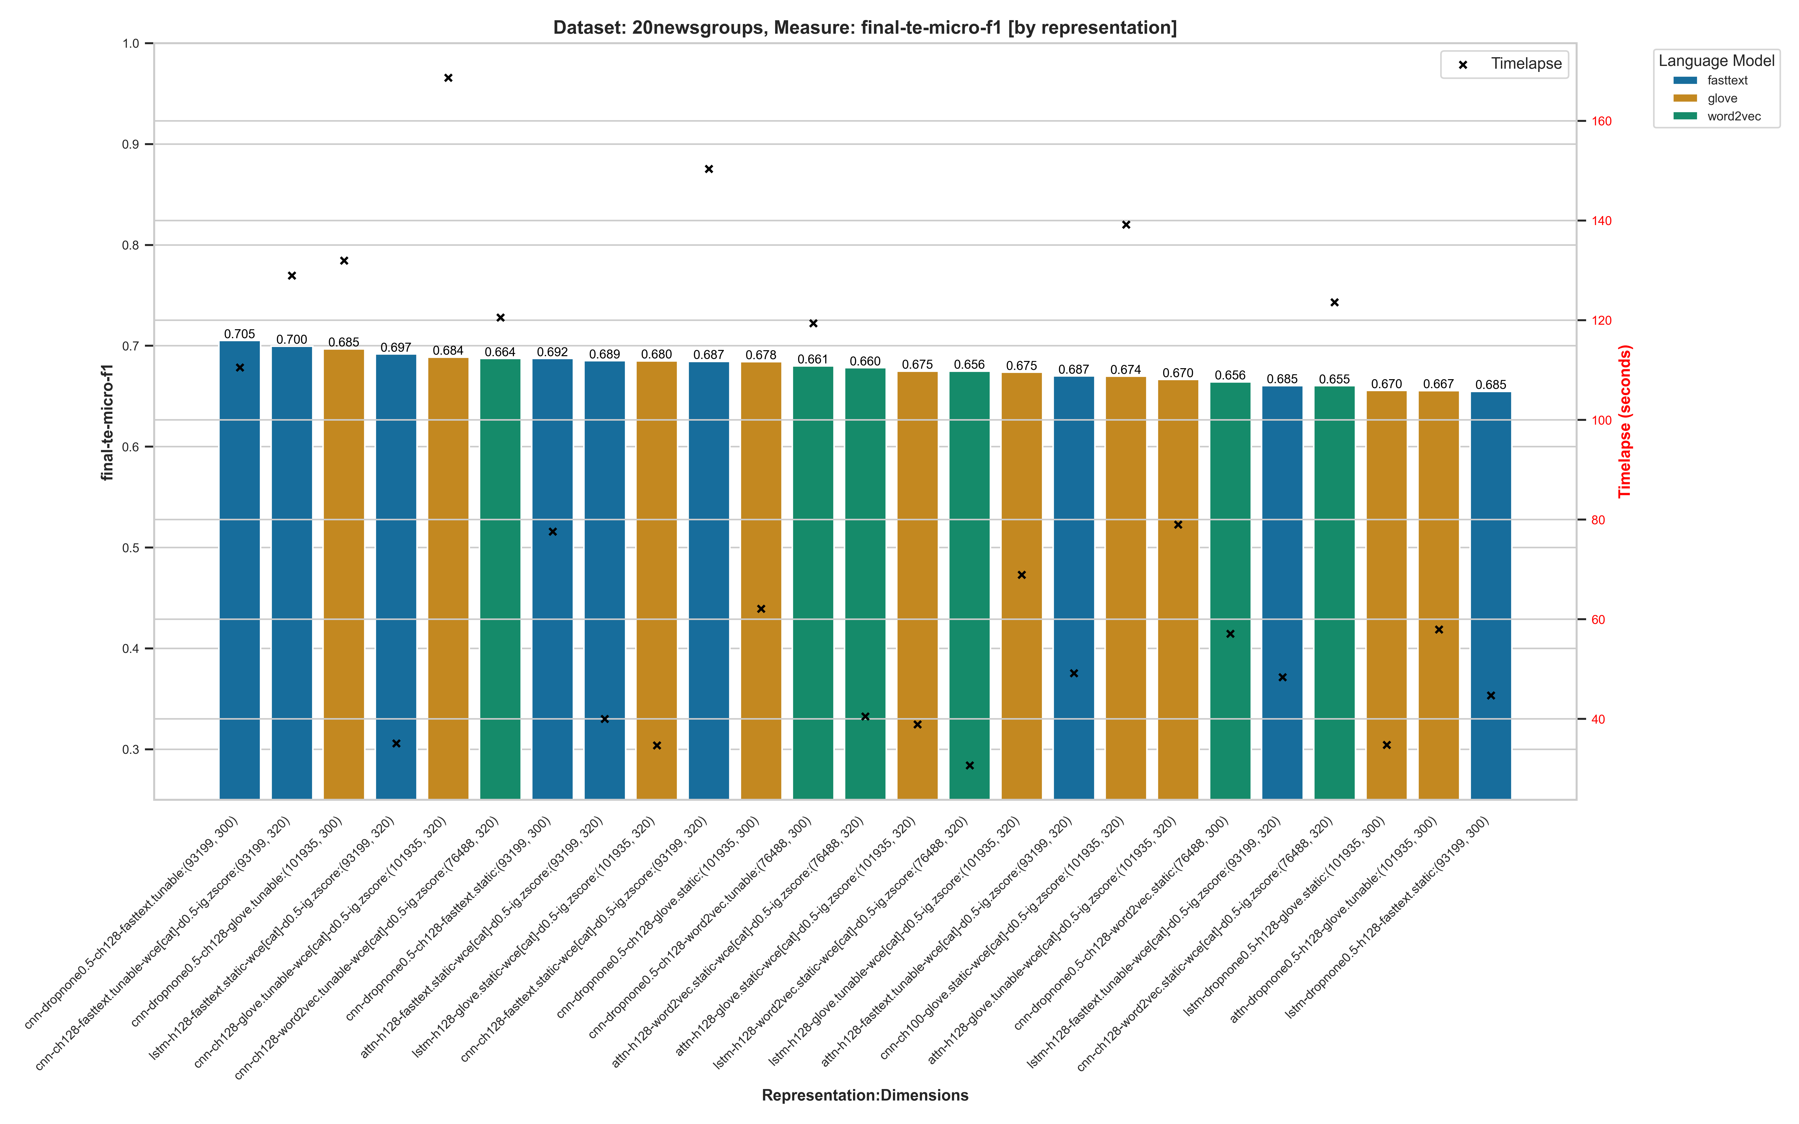

ML Representation Form Summary – by Dataset

