Layer Cake:
Text Classification, Word Embeddings, Language Representation and Transformers, a Comparative Performance Study

by Peter J Worth
Florida Atlantic University
Dept of Electrical Engineering and Computer Science

Spring 2025

Table of Contents
1 Table of Contents 1-2
2 Table of Figures 2-4
3 Abstract 3-5
4 Introduction 4-6
4.1 Text Classification & Natural Language Understanding 4-7
4.1.1 Deep Learning Models 4-8
4.1.2 Natural Language Understanding (NLU) 4-9
4.2 Language Representation Forms 4-11
4.2.1 Text Vectorization 4-14
4.2.2 Vector Space Models 4-16
4.2.3 Latent Semantic Analysis / Indexing 4-17
4.2.4 Static Word Embeddings (Co-Occurrence based models) 4-19
4.2.5 Contextualized Word Embeddings (Transformers) 4-23
4.2.6 Word (Token) Class Embeddings 4-28
5 Experimental Setup & Methodology 5-31
5.1 Supported Datasets 5-31
5.1.1 News Datasets 5-31
5.1.2 Research Articles (arXiv) 5-32
5.1.3 Medical Data 5-33
5.1.4 Movie Reviews 5-33
5.1.5 Summary 5-33
5.2 Supported Metrics 5-34
5.2.1 Precision 5-34
5.2.2 Recall 5-34
5.2.3 Macro-F1 Score 5-34
5.2.4 Micro-F1 Score 5-34
5.2.5 Accuracy 5-35
5.2.6 Hamming Loss 5-35
5.2.7 Jaccard Index 5-35
5.2.8 Summary 5-35
5.3 Tested Language Models 5-36
5.3.1 Static Word Embedding Models & Common Crawl 5-36
5.3.2 Dynamic Token Based Models (Transformers) 5-37
5.4 Systems Dependencies and Hardware Requirements 5-44
6 Baseline Machine Learning Classifiers 6-45
6.1 Support Vector Machines 6-45
6.2 Logistic Regression 6-46
6.3 Naive Bayes 6-48
6.4 Language Representation Forms 6-49
6.4.1 Representation Coding 6-50
6.4.2 Data Processing Workflow 6-53
6.5 Test Results & Analysis 6-55
6.5.1 Results by Classifier 6-55
6.5.2 Results by Representation Form 6-56
6.5.3 Results by Language Model Type 6-57
7 Neural Network Classifiers (Deep Learning) 7-60
7.1 Static Embedding Classifiers 7-62
7.1.1 Different Classifier Architectures 7-64
7.2 Dynamic, Context-Aware, Classifiers (Transformers) 7-67
7.2.1 HF Sequence Classifier 7-67
7.2.2 HF CNN Architecture 7-68
7.3 Test Results & Analysis 7-68
7.3.1 Language Model Performance Comparison 7-68
8 Summary Results & Concluding Remarks 8-74
8.1 ML vs DL Classifiers 8-74
8.2 Static vs Dynamic Language Models 8-74
8.3 Language Representation, Tokenization and OOV Handling 8-74
8.4 Word & Token Class Embeddings (WCEs and TCEs) 8-74
8.5 Concluding Remarks & Further Research 8-74
9 Bibliography 9-75

Table of Figures

Figure 1: document query in vector space 4-17
Figure 2: Latent Semantic Indexing using Singular Value Decomposition (Patel, 2019) 4-18
Figure 3: SVD in terms of scaling and rotation of vectors in Euclidean space 4-19
Figure 4: Word Embeddings in Vector Space 4-20
Figure 5: Word2Vec (deep) learning architecture 4-21
Figure 6: language model training compute requirements growth rate (Sevilla & Roldán, 2024) 4-24
Figure 7: Estimated AI Compute Costs as a % of GDP 4-25
Figure 8: Language Model Evolutionary Tree 4-26
Figure 9: Encoder-Decoder transformer architecture (Vaswani, et al., 2017) 4-27
Figure 10: BERT (encoder only) input representation (Devlin, et al., 2019) 4-28
Figure 11: visualization of max-margin hyperplane for an SVM with two classes 6-46
Figure 12: sigmoid function (logistic regression) 6-47
Figure 13: Classifier Performance Summary - ML Classifiers 6-56
Figure 14: Performance Summary by Language Representation Form – ML Classifiers 6-57
Figure 15: Representation Form Performance Runtimes – ML Classifiers 6-57
Figure 16: Language Model Performance Summary - ML Classifiers 6-58
Figure 17: Language Model Timelapse Performance - ML Classifiers 6-59
Figure 18: Convolutionary Neural Networks for Text Classification 7-65
Figure 19: LSTM for Text Classification Architecture 7-66
Figure 20: ATTN Neural Architecture 7-67
Figure 21: Neural Classifier Language Model Type Performance Summary 7-69
Figure 22: Neural Model Classifier Performance Summary 7-70
Figure 24: Static Pretrained Embedding Performance by Classifier (Ohsumed data) 7-71
Figure 25: Static Pretrained Embedding Neural Classifier Performance (20 Newsgroups) 7-72

Abstract

Pretrained language models have demonstrated impressive performance in various natural language processing tasks. However, their relative effectiveness across different embeddings and text representation techniques in multi-class text classification remains an active area of exploration and questions have been raised as to how effective deep learning methods, and transformer-based language models, are relative to their classical machine learning model counterparts such as Support Vector Machines, or even Logistic Regression. In this paper, we introduce "Layer Cake," an experimental framework designed to evaluate the performance of a range of pretrained language models across a variety of ML and Neural models, across a variety of dataset representation strategies such as TF-IDF vectorization, (pretrained) embedding representation, Word-Class embeddings, dictionary trained Poincaré embeddings, and combinations thereof.

Our analysis covers different types of pretrained embeddings that use different tokenization strategies, different underlying architectures, and different training techniques, illustrating the performance of various forms of data representation across a variety of models and embedding types. Our study includes performance metrics for both word-based (Word2Vec, GloVe) and subword-based (fastText) embeddings, as well as transformer and attention architecture trained language models such as BERT, RoBERTa, XLNet, and GPT-2. Our findings highlight significant differences in how these embeddings and various forms of language representation perform in linear classifiers such as Support Vector Machines (SVM) and Logistic Regression (LR), and in Neural models such as CNN, ATTN and LSTM. Through extensive experimentation, we provide insights into the role of embedding types and fine-tuning techniques in multi-class classification performance, offering recommendations for choosing the optimal pretrained models for this problem.

Keywords:

language representation, language models, large language models, LLMs, text representation learning, NLP, Natural Language Processing, Vector Space Models, Semantic Spaces, Word Embeddings, Representation Learning, Text Vectorization, Machine Learning, AI, Artificial Intelligence, Text Classification

Introduction

Natural Language Processing (NLP) is one of the most dominant and influential fields in artificial intelligence (AI) today, providing much of the theoretical and functional underpinnings for some of the most widely adopted ai applications on the market - applications such as Siri from Apple or Alexa from Amazon and ChatGPT from OpenAI, each of which is developed using the NLP practices and foundations that have been developed in Computer Science research communities over the last century. Acceleration, adoption, and research has accelerated in the last few years however, mainly due to the applications mentioned above which have come to the market which represent the culmination of this research combined with the availability of computational power and network infrastructure which makes these applications possible.

This work intends to focus on the underlying data structures and techniques that are used in the creation of what have come to be known in the industry and research literature as language models, or LLMs (large language models), which typically implies that such models are pre-trained and available for use in a wide array of NLP applications and in some cases even available via APIs for integration into applications. While there have been a few very good studies that survey the language representation and language model landscape (such as xxxx), we intend to focus here on just a few of the most widely discussed and industry relevant models, focusing on their underlying structure and method of creation, with a bent toward shedding light on how it is that such models have become so good at understanding natural language. As such, we will look toward the GLUE benchmark as a means of measuring the capabilities of such models, as well as a baseline for the notion of (natural language) understanding in this context.

Ultimately, we look to answer, or provide color, for the following questions with respect to this work = How is that the applications that are flooding the market today are so good at understanding natural language and given the current methods of construction of such models what are their inherent limitations.

Natural Language Understanding (NLU) and text classification are closely related concepts within artificial intelligence (AI), computer science (CS), and natural language processing (NLP). They are interconnected in how they use language models, the nature of problems they address, and the techniques employed to solve these problems.

NLU involves the ability of a computer program to understand human language as it is spoken or written. It encompasses a broad range of tasks beyond text classification, including semantic parsing, machine translation, sentiment analysis, entity recognition, and question answering. The goal of NLU is to achieve a comprehensive and nuanced understanding of human language, taking into account context, tone, intentions, and more.

Text classification is a specific type of NLU problem where the task is to assign a label or category to a given text. This could include categorizing news articles into topics, classifying emails as spam or not spam, or determining the sentiment expressed in a piece of text. Text classification is often seen as a foundational task in NLU, serving as a stepping stone to more complex language understanding tasks. Both NLU and text classification frequently utilize the same underlying language models. Models like BERT, GPT, and RoBERTa are leveraged for their powerful language representations that capture a wide range of linguistic features and contextual nuances. These models are pre-trained on large corpora and fine-tuned for specific tasks, whether they be broad NLU tasks or specific text classification objectives.
- For text classification, these models typically output embeddings that are then passed to a classifier layer to determine the most appropriate category based on the textual features learned during training.
- In broader NLU tasks, the same embeddings might be used for more complex decision-making processes, such as inferring relationships between entities in a sentence or understanding the implications of a given text in a conversational AI setting.

The techniques developed for text classification are often adapted and extended for other NLU tasks. For instance, the use of attention mechanisms and transformers in text classification has profoundly impacted how models perform at more complex NLU tasks like question answering or dialogue systems. Both fields benefit significantly from transfer learning, where a model trained on one task is adapted to perform another. This is particularly common in NLU, where models trained on massive datasets for text classification are fine-tuned for specific NLU tasks with smaller datasets.

NLP focuses on the linguistic aspects, such as understanding syntax, semantics, and pragmatics of language. It provides the theoretical backbone for both text classification and NLU, guiding how models should be structured to handle human language effectively. In this context, text classification can be seen as a subset of NLU, focused specifically on categorizing text into predefined labels. Both areas use similar language models and share many techniques, but NLU encompasses a broader set of challenges aimed at fully understanding and interpreting human language in all its complexity. The advancements in language models, primarily driven by deep learning and neural networks, have significantly propelled both fields, offering increasingly sophisticated tools to parse and understand text at a near-human level.

From an AI perspective, solving both text classification and NLU involves developing algorithms that can learn from data, make decisions, and generalize to new, unseen examples. CS contributes the frameworks, tools, and computational techniques necessary to build, train, and deploy these models efficiently.

Text Classification & Natural Language Understanding

Text classification, the core NL problem that is analyzed and tested with layer cake, and the results of which are the topic of this paper, is a foundational task in Natural Language Processing (NLP) that involves assigning predefined labels to textual data. From detecting spam emails to categorizing news articles and sentiment analysis, text classification has been instrumental in real-world applications, evolving alongside advances in computational linguistics and machine learning.

Recurrent Neural Networks (RNNs) and Long Short-Term Memory networks (LSTMs) became popular for handling sequences in text, enabling models to maintain context over longer sequences. References: Hochreiter, Sepp, and Jürgen Schmidhuber. "Long short-term memory." Neural computation 9.8 (1997): 1735-1780. Link

As datasets grew in size and complexity, feature engineering became critical for improving text classification performance. Techniques like term weighting (e.g., TF-IDF) and dimensionality reduction were widely adopted. Simultaneously, probabilistic topic models, such as Latent Dirichlet Allocation (LDA) (Blei et al., 2003), enabled unsupervised text classification by modeling documents as mixtures of latent topics.

The use of word embeddings, such as Word2Vec (2013) and GloVe (2014), marked a significant shift in text classification. These models allowed for words to be converted into vector representations that capture semantic meanings.
- Mikolov, Tomas, et al. "Efficient Estimation of Word Representations in Vector Space." ICLR Workshop Papers. 2013. Link
- Pennington, Jeffrey, et al. "Glove: Global vectors for word representation." Proceedings of the 2014 conference on empirical methods in natural language processing (EMNLP). 2014. Link

Over the last decade, text classification research has experienced transformative changes, largely due to the introduction and subsequent development of deep learning techniques, particularly transformer models and large language models (LLMs).

Deep Learning Models

The advent of deep learning in the 2010s brought transformative changes to text classification. The introduction of dense word embeddings, such as Word2Vec (Mikolov et al., 2013) and GloVe (Pennington et al., 2014), provided continuous vector representations that captured semantic relationships between words.
Deep learning models which were architected using RNNs, LSTMs and CNNs such as Recurrent Neural Networks (RNNs) and LSTMs (Hochreiter & Schmidhuber, 1997) and Convolutional Neural Networks (CNNs) (Kim, 2014) which were more commonly used in computer vision tasks, further enhanced text classification performance. These models reduced reliance on manual feature engineering and achieved state-of-the-art performance on benchmarks.

The introduction of the Transformer architecture (Vaswani et al., 2017) marked a new era in text classification. Unlike RNNs, Transformers relied on self-attention mechanisms to capture long-range dependencies in text efficiently. Notable models in this era include:

The introduction of the transformer architecture by Vaswani et al. in 2017 revolutionized text classification. Transformers use self-attention mechanisms to weigh the importance of different words in a sentence, regardless of their position. (Vaswani, Ashish, et al. "Attention is all you need." Advances in neural information processing systems. 2017. Link). Some key early examples of models developed using this attention based architecture that set new standards in text classification and other NLU tasks are:

- BERT (Bidirectional Encoder Representations from Transformers) (Devlin et al., 2019): Revolutionized text classification by pretraining on a masked language modeling objective, followed by task-specific fine-tuning.
  - BERT (Bidirectional Encoder Representations from Transformers) introduced by Devlin et al. at Google AI in 2018, demonstrated how transformers could be pre-trained on large corpora and fine-tuned for specific text classification tasks, setting new benchmarks across various NLP tasks.
  - Reference: Devlin, Jacob, et al. "BERT: Pre-training of deep bidirectional transformers for language understanding." NAACL HLT 2019. Link
- GPT (Generative Pre-trained Transformer) (Radford et al., 2019): Showcased the potential of unsupervised pretraining for text generation and classification.
- T5 (Text-to-Text Transfer Transformer) (Raffel et al., 2020): Unified text classification and other NLP tasks under a single text-to-text framework.

These models achieved state-of-the-art results across a wide range of tasks, including news categorization, sentiment analysis, and intent detection.

Models such as GPT-3 and T5 showcased the capabilities of large-scale transformers trained on vast amounts of data. These LLMs further advanced text classification by demonstrating that a single model could perform well across multiple tasks, including classification, without task-specific fine-tuning. (Brown, Tom B., et al. "Language models are few-shot learners." Advances in neural information processing systems 33 (2020): 1877-1901. Link) (Raffel, Colin, et al. "Exploring the limits of transfer learning with a unified text-to-text transformer." JMLR (2020). Link)

Recent research focuses on making these powerful models more efficient and accessible. Techniques like distillation, quantization, and pruning are used to reduce model size and computational requirements.

Few-Shot Learning and Zero-Shot Learning: These techniques, where models perform tasks with few or no labeled examples, are becoming more feasible with advances in LLMs.

Cross-Lingual Models: The ability to train models that can classify text in multiple languages, even those with little to no training data, is another area of focus, leveraging the multilingual capabilities of models like mBERT and XLM-R.

Robustness and Fairness: There is increasing attention to making models more robust to adversarial attacks and reducing bias in model predictions.

These developments highlight how transformer models and LLMs continue to drive forward the capabilities of text classification systems, providing more sophisticated, efficient, and generalizable solutions across a wide range of languages and contexts.

Natural Language Understanding (NLU)

Natural Language Understanding (NLU) is a subfield of artificial intelligence and computational linguistics that focuses on the interaction between computers and humans through natural language. The goal of NLU is to enable computers to understand and interpret the vast and nuanced human language in a way that is both meaningful and useful. NLU involves various tasks that test a computer system's ability to grasp syntax (the arrangement of words and phrases to create well-formed sentences) and semantics (the meaning of language), including the contextual cues that convey subtlety and nuance.

Natural Language Understanding (NLU) benchmarks have played a crucial role in measuring the progress and performance of AI models in understanding human language. Over the years, several major benchmarks have been introduced, each testing various aspects of language comprehension and contextual reasoning.

The General Language Understanding Evaluation (GLUE) benchmark was introduced as a tool to evaluate and promote the development of NLU systems capable of robustly understanding human language. It comprises a series of diverse NLU tasks designed to measure a model's performance across different forms of language understanding.

GLUE Benchmark

GLUE Benchmark (General Language Understanding Evaluation)

Introduced in 2018, GLUE is a collection of nine diverse tasks designed to test a model's ability to understand natural language. The tasks cover a range of NLU capabilities including sentiment analysis, textual entailment, and similarity.

The introduction of BERT marked a significant improvement in GLUE scores, demonstrating the effectiveness of bidirectional training and transformers.

Reference: Wang, Alex, et al. "GLUE: A multi-task benchmark and analysis platform for natural language understanding." arXiv preprint arXiv:1804.07461 (2018).

Specific Tasks in the GLUE Benchmark:

- CoLA (Corpus of Linguistic Acceptability)
  - Task: Measures whether an English sentence is linguistically acceptable.
  - Metric: Matthews correlation coefficient (MCC).
- SST-2 (Stanford Sentiment Treebank)
  - Task: Requires models to determine if sentences from movie reviews are positive or negative.
  - Metric: Accuracy.
- MRPC (Microsoft Research Paraphrase Corpus)
  - Task: Involved identifying whether sentences are semantically equivalent.
  - Metric: F1 score and accuracy.
- STS-B (Semantic Textual Similarity Benchmark)
  - Task: Involves measuring the degree of semantic similarity between two sentences.
  - Metric: Pearson and Spearman correlation coefficients.
- QQP (Quora Question Pairs)
  - Task: Determining whether pairs of question texts actually ask the same question.
  - Metric: F1 score and accuracy.
- MNLI (Multi-Genre Natural Language Inference)
  - Task: A text entailment task where a model must predict whether a premise sentence entails, contradicts, or is neutral to a hypothesis sentence.
  - Metric: Accuracy, with separate scores for matched (in-genre) and mismatched (cross-genre) sections.
- QNLI (Question Natural Language Inference)
  - Task: Derived from the Stanford Question Answering Dataset (SQuAD), requires determining whether the context sentence contains the answer to the question.
  - Metric: Accuracy.
- RTE (Recognizing Textual Entailment)
  - Task: A binary entailment task similar to MNLI but with much smaller datasets and drawn from several sources.
  - Metric: Accuracy.
- WNLI (Winograd Schema Challenge)
  - Task: Tests a model's ability to understand contextual word usage by solving coreference resolution problems.
  - Metric: Accuracy.

The GLUE benchmark has become a standard for comparing the performance of state-of-the-art NLU systems. It was designed to encourage the development of models that can understand language in varied contexts and genres, promoting more generalized NLU capabilities. Here are relevant references for further exploration:

- Original GLUE Paper: Wang, Alex, et al. "GLUE: A multi-task benchmark and analysis platform for natural language understanding." Proceedings of the 2018 EMNLP Workshop BlackboxNLP: Analyzing and Interpreting Neural Networks for NLP. 2018. Link
- NLU and Model Training Context: Devlin, Jacob, et al. "BERT: Pre-training of deep bidirectional transformers for language understanding." NAACL-HLT 2019. Link

These tasks and metrics collectively push the boundaries of what NLU models can achieve, ensuring they are not only accurate but also versatile in handling the complexity of human language across different contexts and applications.

Language Representation Forms

In any ML model, one of the most critical aspects of model construction is the process of identifying the most important and salient features, or inputs, that are both necessary and sufficient for the model to be effective. This concept, referred to as feature selection in the AI, ML and DL literature, is true of all ML/DL based applications and NLP is most certainly no exception here. The goal of feature selection is to hone the number of features down to the most elemental level while not losing any of the granularity or color of the overall model that is reflected on the various features, or inputs, which drive the learning model in question – effectively balancing computational performance against model predictability as it were.

In the NLP domain, given that the feature set is typically the dictionary size of the vocabulary in use, this problem is very acute and as such much of the research in NLP in the last few decades has been solving for this very problem and word embeddings in particular as a form of language (really word or token) representation represents the most modern solution to this problem. Word embeddings effectively reduce the representation of a word - or again a token or in some cases subword or even character – to a fixed size vector of real numbers. This is a very convenient form of representation for these fundamental linguistic, or textual, elements, one that is easily consumed by ML and DL models in the NLP space and one that addresses this curse of dimensionality problem which underlies NLP more broadly.

In classical physics we deal (mostly) with four dimensions - three in Euclidean (or Cartesian) space and a fourth dimension of time – while with ML problems we are operating in dimensional space which is defined by the set of features in our model (usually denoted by X), where dimension sizes of 100 or even sometimes 1000 are quite normal given how ubiquitous data is in the modern, Internet era. With the increase in dimensional complexity though comes a geometrically (if not exponentially) increase in computational resource requirements, a problem called the curse of dimensionality in ML and AI circles. In the NLP domain this problem is exacerbated by the fact that the feature set for some of the problem domains (like for example predictive text, chatbots, virtual assistants or language translation) can be almost the size of the language dictionary itself.

This curse of dimensionality, which the NLP domain is in particular is challenged with, has driven a significant amount of research into this particular aspect of ML, i.e. feature selection, which is basically the process of identifying the most important, or most relevant, set of features in a given model or problem domain such that the applications that are developed can effectively run in a reasonable time with a reasonable amount of computing resources. As such, much of the research in NLP in the last few decades, and many of the breakthroughs in terms of application performance and effectiveness (accuracy), have been in the area of encoding, or compressing, information related to various forms of language - words, phrases, n-grams, sentences or documents – to condense information, ultimately semantic information, into data structures (vectors, matrices) that machines can process efficiently, i.e. learn efficiently from – aka NLP feature selection. Again, this part of NLP application development can be understood as a projection of the natural language, i.e. the input text itself, into a fixed dimensional feature space, a process that is both necessary and fundamental to the solving of any and all machine learning problems and is especially significant in NLP.

This challenge of dealing with the sparsity of language data in vectorized form, which again is fundamental to the problem of machine learning and AI more generally, goes back to the 1980s with the advancement of techniques such as Vector Space Models (VSMs) and Latent Semantic Analysis (LSA) as well as random indexing, all techniques that were designed to convert sparse data and compress it for more efficient computation within the context of machine learning applications, i.e. dimension reduction or feature selection techniques. In 2000, neural networks were introduced into the problem domain to solve for some the same problems and eventually these techniques evolved into word embeddings which have the unique quality of being able to be self-generated, i.e. automatically generated using unsupervised learning methods, and which are a way of representing semantic information, or meaning, in a non-sparse way.

Generally, the process of learning the representation of text is referred to as representation learning which although applicable to machine learning generally consists of very specific techniques that are effective in NLP. In this context, representation learning involves the task of learning efficient, meaningful representations of words, phrases, sentences, or documents that can then be used for various downstream NLP tasks such as sentiment analysis, machine translation, question answering, and other NLP solves.

The process of representation learning is a fundamental concept in artificial intelligence (AI) that involves automatically discovering and learning useful representations of data, often in a lower dimensional space to be used by ML and DL algorithms, which are designed to capture, really encode, meaningful features and/or characteristics of the data in a structured and compact form, enabling effective learning and reasoning of the underlying data.

Representation learning and word embeddings are closely related topics in NLP and the vast majority of research literature devoted to representation learning in NLP in the last few decades has been focused on designing word embeddings which encode this information.

(Language) Representation Learning lies at the heart of Natural Language Processing (NLP), enabling machines to encode human language into mathematical structures for computational processing. The quest for effective language representations has been pivotal in the evolution of NLP, from rule-based symbolic representations to dense vector embeddings and contextualized models.

The earliest approaches to language representation in NLP were rule-based and symbolic. Words were treated as discrete units with no inherent relationship to one another. Techniques such as one-hot encoding emerged, where each word was represented as a sparse vector with a unique index. While simple, one-hot encoding suffered from scalability issues and failed to capture semantic relationships between words (e.g., "king" and "queen"). The 1990s brought the application of the distributional hypothesis (Harris, 1954): "Words that occur in similar contexts tend to have similar meanings." This idea formed the foundation for statistical language models, which used co-occurrence statistics to build vector representations.

One of the fundamental tenets of linguistics that has been well established since the middle of the last century is the idea that the meaning of a word can be understood by not just the context within which it is found (or heard as the case may be) but that generally, over a large corpus of text, or a large sampling of language as the case may be, that words found within a similar context should in most cases have similar meanings, leading to the now oft-used and famed expression in both linguistics and NLP circles that a word can be characterized, or understood in some sense, by the company it keeps. This is known in linguistics as well as NLP circles as the distributional hypothesis and it is this tenet that underpins many of the techniques described here which fall under the heading of word embeddings. It's upon this notion, the distributional hypothesis, that much of the semantic work in NLP is based, in particular as it relates to text vectorization and word embeddings, the topic of this paper. The idea being that if we can associate with a given work certain metrics that correlate to the word’s distribution throughout a given text or corpus, words that have similar meanings should in turn have similar distributional properties, i.e. are surrounded by similar words, throughout a given textual corpus.

Text Vectorization

In order to understand the information that ultimately comes to be stored and associated with a given word or token for a given text, it’s necessary to understand how it is that these ‘embedding’ structures are computed. This process, sometimes referred to as text vectorization, however can (and really should) be understood as a projection of the text, or tokens, into what we can be understood as a semantic space, a vector space of relative meaning that is calculated based upon the notion that words that are found in similar contexts, i.e. surrounded by similar words, have similar meanings – a notion in the linguistics world that is known as the distributional hypothesis, one of the most profound and yet simple concepts that underpins the effectiveness of LLMs in NLP and AI.

While one-hot encoding and count vector (Bag of Words) representations of text allow for the comparison of words in sentences, documents and sets of documents, they don’t store information related to the context of a given word, or sentence, within a given document, or corpus – such context is necessary for example when developing (ML/NLP) applications that solve for sentiment analysis, (machine) translation, or question-answering (chatbots or IVR) problems. These techniques also suffer from the fact that their number of dimensions (cf. curse of dimensionality), the semantic spatial boundaries you could call it, where the number of features or dimensions of the model is a function of the overall dictionary for the corpus at hand being analyzed. This becomes very cumbersome for ML generally given that the performance of a given model is a function of the feature set that is being analyzed and in this case the feature set is the scope of words being used, with each word in the set being associated with a vector that is sized based upon the total word count.

Text vectorization is a broader process of converting textual data into numerical representations (vectors) so that it can be used as input to machine learning models. It encompasses a variety of techniques, including:
- Bag of Words (BoW):
  - Each word in the vocabulary becomes a feature, and the value is the count or frequency of that word in a document.
  - Example: For a document with the vocabulary ['apple', 'banana', 'orange'], the vector for "apple banana" would be [1, 1, 0].
- TF-IDF (Term Frequency-Inverse Document Frequency):
  - Enhances BoW by weighing words based on their importance in a document relative to the entire corpus.
  - Example: Words that appear in many documents (e.g., "the", "and") are given lower weights.
- Count Vectorization:
  - Similar to BoW but simply counts word occurrences without applying weighting.

Text vectorization techniques are vocabulary based and rely on the frequency or importance of words in a corpus, yielding a feature space is as large as the vocabulary, often leading to sparse representations and the curse of dimensionality. Furthermore, this form of language representation does not encode any understanding of the relationships between words (e.g., "king" and "queen" are treated as unrelated).

TF-IDF or Count Vectorization (Algebraic Construction) or Numeric (explicit frequency-based)

These are explicit vector representations of words based on the frequency or co-occurrence of words in the corpus. The process relies on counting word occurrences and manipulating those counts through algebraic transformations.

- Count Vectorizer: The vector for each document is based on the raw counts of words.
- TF-IDF Vectorizer: The vector for each document is a transformation of raw word counts, adjusted by the inverse document frequency (IDF), which diminishes the weight of common words.

This is akin to constructing a vector by measuring the direct frequency of each word (or feature) in a document. Each dimension of the vector corresponds to a specific word in the vocabulary. Example: A document with the words “apple,” “banana,” and “fruit” might be represented as [2, 1, 3] if "apple" appears twice, "banana" once, and "fruit" three times.

TF-IDF, which stands for Term Frequency-Inverse Document Frequency, is a statistical measure used to evaluate the importance of a word to a document in a collection or corpus that has been around since the 1970s (Jones, 1972). It is often used as a weighting factor in searches of information retrieval, text mining, and user modeling. The importance increases proportionally to the number of times a word appears in the document but is offset by the frequency of the word in the corpus. This helps to adjust for the fact that some words appear more frequently in general.

Mathematically we have:

- TF (Term Frequency): The number of times a term t appears in a document d divided by the total number of terms in that document.

$$\text{TF}\left(t,d\right)=\frac{\text{Number of times term }t\text{ appears in document }d}{\text{Total number of terms in document }d}$$

- IDF (Inverse Document Frequency): The log of the number of documents D divided by the number of documents that contain the term t. This downscales words that appear a lot across documents.

$$\text{IDF}\left(t,D\right)=\log\left(\frac{\text{Total number of documents }D}{\text{Number of documents containing term }t}\right)$$
- TF-IDF:
$$\text{TF-IDF}\left(t,d,D\right)=\text{TF}\left(t,d\right)×\text{IDF}\left(t,D\right)$$

When we vectorize the texts we use the python sklearn TFIDFVectorizer API with the default settings except for with min_df=5, indicating that the term must show up in at least 5 documents in order to be included in the representation form, and sublinear = True which applies sublinear scaling, i.e. we convert tf to 1 + log(tf).

Vector Space Models

One of the key foundational representation elements in NLP is the notion of vector space models and word embeddings, two very much interrelated ideas that are fundamental to almost all of the modern LLMs and their predecessors which have revolutionized the field of AI the in the last two decades. To understand how it is that these word embeddings are constructed, trained from text really, and what an underlying vector space models is and why it is relevant to NLP solves, it’s necessary to start from the ground up so to speak and look at the text representation methods and training techniques used to build these models.

These Vector Space Models as they are sometimes called, originated as far back as in the 1970s, their design attributed to Gerard Salton who developed and documented a system called SMART in the early 1970s (Salton, 1971), granting him the moniker in some circles as the father of Information Retrieval. With SMART, Salton introduced the notion of Vector Space Models (VSMs) as a form of text representation to support the computation of document similarity and information retrieval, much of which provides the foundations for modern search systems. This model, along with the introduction of tf-idf as a statistical method for computing document terms across a given corpus (Sparck Jones, 1972), transformed the NLP landscape and opened the door for scalable and effective digital systems of information retrieval.

More formally, a vector space is described for a given vocabulary V, and a set of words w, where for each w $∈$ V, there is an associated vector $\vec{v_{w}}∈R^{d}$, where d is the fixed number of dimensions for the underlying vector space, effectively bounding the number of features that we use for our NLP model.

Given that word embeddings are really vectors in an underlying multi-dimensional vector space, they inherit mathematical properties which are a function of the underlying space (geometry) within which they live - a vector space which is the primary dwelling place studied in linear algebra, governing the behavior and properties of word vectors, denoted as $\vec{v_{w}},$which live is such a space.

Vector spaces, once initialized for a given semantic space that is learned from text, support the following properties:

- Vector Addition and Scalar Multiplication: The vector space must be closed under vector addition and scalar multiplication. This means for any vectors $\vec{\vec{v}},\vec{w}$ in the space, and any scalar $α$, the vector $\vec{v}+\vec{w}$ as well as $α\vec{v}$ are also in the space.
- Associativity and Commutativity of Addition: Vector addition is associative, meaning $\left(\vec{v}+\vec{w}\right)+\vec{u}=\vec{v}+\left(\vec{w}+\vec{u}\right)$, and commutative, meaning $\vec{v}+\vec{w}=\vec{w}+\vec{v}$.
- Distributivity of Scalar Multiplication with respect to Vector Addition: Scalar multiplication is distributive over vector addition, both from the left, $α\left(\vec{v}+\vec{w}\right)=α\vec{v}+α\vec{w}$, and from the right, $\left(α+β\right)\vec{v}=α\vec{v}+β\vec{v}$.
- Existence of Zero Vector: There exists a zero vector $\vec{0}$ in the space such that $\vec{v}+\vec{0}=\vec{v}$ for any vector $\vec{v}$.
- Existence of Additive Inverses: For every vector $\vec{v}$, there exists an inverse −$\vec{v}$ such that $\vec{v}+\left(-\vec{v}\right)=\vec{0}$
- Dimensionality: The vector space is finite-dimensional, where the number of dimensions is denoted by d, where d $∈N$ and is characterized by a set of basis vectors. The dimensionality d of the space is the number of vectors in any basis for the space, which corresponds to the number of features or coordinates each word vector has.
- Inner Product: Often, an inner product (or dot product) is defined on the space, enabling the measurement of angles and lengths. This is fundamental in calculating similarities between vectors, which is typically done using cosine similarity in these semantic spaces.
- Norm: Associated with the inner product, the norm of a vector $∥\vec{v}∥$ is defined, typically as $\sqrt{\vec{v}⋅\vec{v}}$​. This allows for the measurement of the magnitude of vectors and normalization of vectors.

These properties not only define the theoretical mathematical framework in which word embeddings operate but also provide the tools necessary for practical operations such as finding similar words, analogies, or clustering words based on their vector representations. This space mathematically bounds both the problem domain as well as the solution domain, and with word embeddings in particular, a modern variant of text vectorization, the dimensions are actually learned by the model itself in in order to ensure that the model exhibits certain properties, properties which are a function of what is known as the distribution hypothesis, more on this below.


Figure 1: document query in vector space

Latent Semantic Analysis / Indexing

Latent Semantic Analysis (LSA), also referred to as Latent Semantic Indexing (LSI) within the context of Information Retrieval. LSA / LSI identifies latent contextual, or semantic, relationships between words by using singular value decomposition (SVD), a method of eigendecomposition of square matrices that can be applied to term-document matrices and information retrieval (Deerwester, et al., 1990). From linear algebra we know that Singular Value Decomposition (SVD) is a factorization of a real or complex matrix that generalizes the eigendecomposition of a square normal matrix to any m × n matrix via an extension of the polar decomposition. Mathematically, if we have an m × n matrix (A), the singular value decomposition (SVD) of said matrix is a factorization of the form:

A = UΣV∗

where:
- U is an m × m orthogonal (or unitary, if complex) matrix,
- Σ is an m × n diagonal matrix with non-negative real numbers on the diagonal,
- V is an n ×n orthogonal (or unitary, if complex) matrix, and
- V∗ denotes the conjugate transpose of V (the transpose if V is real).


Figure 2: Latent Semantic Indexing using Singular Value Decomposition (Patel, 2019)

Geometrically, the factorization can be understood as a series of scaling and rotation transformations on the source matrix (M in this case) in multi-dimensional Euclidean space, as illustrated in the figure below.


Figure 3: SVD in terms of scaling and rotation of vectors in Euclidean space

So therefore it follows that there exists a decomposition of a matrix A into orthogonal matrices U and V, as a function of a specific diagonal matrix denoted as Σ, a technique that can be used to find latent similarities between documents in a corpus and leveraged to compute document (cosine) similarity, a factorization that is illustrated in the figure below and which can be used to identify latent

Static Word Embeddings (Co-Occurrence based models)

Approaches such as VSMs or LSI/LSA are sometimes as distributional semantics and they cross a variety of fields and disciplines from computer science to artificial intelligence, certainly to NLP, but also to cognitive science and even psychology. The methods, which are rooted in linguistic theory, use mathematical techniques to identify and compute similarities between linguistic terms based upon their distributional properties, with again TF-IDF as an example metric that can be leveraged for this purpose.

In this context, these methods which began as VSMs combined with or supplemented by LSI or LSA, have evolved into what we call in NLP research circles today as word embeddings, a semantically encoded (in vector space) representation of words, documents or terms based upon the premise that a given word’s meaning can be understood by its context, or in more vernacular terms, the company it keeps, i.e. what is known as the distributional hypothesis, an idea popularized by John Firth in the 1950s who coined the phrase ‘you shall know a word by the company it keeps’, i.e. that words found within a similar context should in most cases have similar meanings, the basic underlying principle behind the architecture, and effectiveness, of word embeddings.

Word embeddings are dense, low-dimensional, context-sensitive representations of words. They aim to capture semantic relationships between words by mapping them to continuous vector spaces. They are advanced forms of learned (language) representation created using neural networks or other statistical techniques on large corpora. Common methods include Word2Vec, in both its Skip-Gram, CBOW contexts, GloVe, or Global Vectors for Word Representation, and FastText, which are subword-based embeddings. These three classes of word embeddings represent the core of the word-based embedding tests that are in scope for layer cake testing.

With static word embeddings, each word is represented by a dense vector of much smaller dimensionality (e.g., 300 for GloVe and Word2Vec typically) and the embeddings are computed, i.e. ‘learned’, by taking advantage of the distributional hypothesis in order to capture semantic relationships, the classic example being king – man + woman = queen, i.e. words closer in meaning will have vectors closer in Euclidean or cosine space.


Figure 4: Word Embeddings in Vector Space

The introduction of dense word embeddings, or simply word embeddings, revolutionized language representation, allowing words to be represented as low-dimensional continuous vectors. This era was marked by research advancements such as Word2Vec (Mikolov, et al., 2013) which introduced Continuous Bag of Words (CBOW) and Skip-Gram models to learn word representations based on their contexts, providing the capability to measure semantic similarity of words - such as "king" - "man" + "woman" ≈ "queen" – which could be derived from simple mathematical calculations in the defined vector space.

Word2Vec & GloVe Architecture

In 2014 GloVe was introduced (Pennington, et al., 2014), a powerful method for computing word vectors which combines the advantages of global co-occurrence statistics and local context-based learning. Both of these models treat each word as a fixed vector, independent of its context, and even today form the basis for many NLP applications. Word2Vec and GloVe are implicit vector representations. Instead of relying directly on word counts, they use more sophisticated methods to learn latent representations of words based on their contexts (co-occurrences) in large corpora.

Word2Vec uses a neural network to predict either the target word given its context (CBOW) or the context given the target word (Skip-gram). During training, words that appear in similar contexts end up being represented by vectors that are geometrically close to each other in a high-dimensional space. This is akin to finding the coordinates of each word in a latent space where distances between vectors reflect their semantic similarity. For example, the word “apple” might have a vector like [0.25, -0.12, 0.75, ...], learned from context-based training, with dimensions representing abstract semantic relationships.


Figure 5: Word2Vec (deep) learning architecture

GloVe on the other hand, another core model that is thoroughly tested in the context of this research, uses global word co-occurrence statistics to derive word vectors, where words that frequently co-occur in the same context have similar vectors – again leveraging the distributional hypothesis. The optimization process minimizes the difference between the dot product of two-word vectors and the logarithm of their co-occurrence count, leading to a word embedding.

So the training process for GloVe is essentially:
- Build Co-occurrence Matrix X: For a given corpus, count how often each word i co-occurs with each other word j within a specified context window. This creates a symmetric co-occurrence matrix X, where each entry X_{ij.} corresponds to the count.
- Optimize the Objective Function: Using stochastic gradient descent (SGD), optimize J to find the word vectors $\vec{w_{i}}⋅\vec{w_{j}}$ and biases $b_{i}+b_{j}$ that minimize the loss.
- Output Word Embeddings: Combine the learned word vectors for $\vec{w_{i}}⋅\vec{w_{j}}$ to create the final word embedding, typically as:

Basically, GloVe tries to position words in a vector space such that their co-occurrence patterns can be expressed by linear relationships. For example, the word "king" might be placed in a high-dimensional space where the relationship "king - man + woman ≈ queen" holds, implying a more geometric interpretation.

FastText (sub-words)

FastText is similar to Word2Vec in that it is a co-occurrence-based model that represents words in a Euclidean space, but it has a key distinction: subword information. Unlike Word2Vec, which treats each word as a single atomic unit, FastText breaks down words into character n-grams (subword units). For example, the word "apple" might be broken down into character n-grams like "app," "ppl," and "ple.". Each word is represented not only by its word-level embedding but also by the embeddings of its subwords (n-grams). This enables FastText to generate embeddings for out-of-vocabulary words by composing them from the embeddings of their subwords.

For example, if Word2Vec is constructing a word vector from the entire word (as a whole point in space), FastText constructs word vectors from both the whole word and its parts (n-grams), distributing its construction across subword components. FastText, like Word2Vec, uses a Skip-gram or CBOW model, where the learning task involves predicting a word from its context (or vice versa). The vectors for words that appear in similar contexts end up close to each other in the embedding space, i.e. leveraging the distributional hypothesis. In this sense, FastText is also co-occurrence-based, leveraging the context of words in a large corpus to learn meaningful embeddings.

Just like Word2Vec, FastText operates in a continuous Euclidean space (or more generally, a vector space) where words with similar meanings have vectors that are close together and relationships between words can be modeled as linear transformations (e.g., "king - man + woman ≈ queen"). Since FastText breaks words into subword units (n-grams), this means that similar words (e.g., "running" and "runner") will have more similar vectors than they would in Word2Vec, due to shared subword components ("run").

FastText also constructs vectors geometrically, learning word and subword representations from their co-occurrence patterns in a latent space. During training however, FastText learns embeddings not just for entire words but also for their subword n-grams. When creating the final vector for a word, FastText aggregates the word's subword embeddings (and its own embedding if available) into a single vector, resulting in embeddings that can handle morphologically rich languages better than Word2Vec, which cannot break words into smaller units. FastText also computes and operates in Euclidean space, where words and subwords are represented as vectors. FastText also, like its word-based counterparts word2vec and glove, primarily uses co-occurrence statistics to generate its word embeddings (vectors) – i.e. words (and subwords) that frequently appear in similar contexts will have vectors close together in this space.

This geometric model allows FastText to capture not just word-level relationships, but also similarities across words with shared subwords, such as morphological variations of the verb ‘run’, such that the words "run," "running," "runner" will have closer embeddings because of shared subwords. Because of its inherent subword design, FastText can produce reasonable embeddings for out-of-vocabulary words based on their subwords than their word-based counterparts such as GloVe or Word2Vec.

FastText is indeed a co-occurrence-based model in Euclidean space, similar to Word2Vec and GloVe, however, its key innovation is the use of subword information. This allows FastText to generate more accurate embeddings for rare words, morphologically complex words, and even unseen words by leveraging character-level n-grams. In the Euclidean space, FastText ensures that both word-level and subword-level co-occurrence patterns are captured, making it robust for handling languages with rich morphology or large vocabularies.

Contextualized Word Embeddings (Transformers)

Perhaps the most significant advancement with respect to NLP in the last two decades is the introduction of attention-based architectures into language models, addressing polysemy and context within natural language processing in a way that was entirely novel. Many of the most well-known and widely used language models right now (aka large language models of LLM) leverage this attention based architecture which was first proposed in the landmark paper by Vaswani et al. (2017), “Attention is all you need”, in effect replacing Recurrent Neural Networks (RNNs) with self-attention mechanisms, achieving state-of-the-art results in machine translation, text classification, natural language understanding, and language generation tools. These models, and their associated platforms and operational infrastructures, have pushed the boundaries of NLP, enabling applications such as conversational agents, document summarization, and zero-shot learning.

TF-IDF / Count Vectorization is explicit, algebraic construction based on word frequencies. Each vector dimension represents a distinct, interpretable feature (e.g., the presence or absence of a word), representing a direct frequency-based transformation of the raw data. Word2Vec and GloVe on the other hand, are geometric based, implicit constructions of word vectors in a continuous latent space. Vectors are learned through training on large corpora to capture semantic and syntactic relationships. These are dense, distributed representations where each dimension captures abstract relationships rather than direct counts.

In essence, while TF-IDF and Count Vectorization build vectors through explicit algebraic transformations of text data, Word2Vec and GloVe use machine learning to geometrically place words into a latent vector space based on their usage patterns in large corpora. The former gives clear, interpretable vectors (e.g., word counts), while the latter produces more abstract, dense representations.

However, because these basic forms of word embeddings lack context awareness, i.e. are ‘static’, they therefore do not address problems of polysemy which are fundamental to human language. This is in stark contrast to contextualized, or dynamic word embeddings which represent the other portion of layer cake language representation forms which are tested throughout, a form of representation that is dominated by transformer based architectures that were introduced by the famous paper ‘Attention is all you need’ in 2018 (Vaswani, et al., 2017)

Despite their success, static embeddings struggled with polysemy and contextual nuances. The advent and proliferation of neural network-based models, i.e. deep learning, addressed this limitation by generating contextualized embeddings. Some of these influential early models of contextualized (dynamic) text representation learning were ELMo (Embeddings from Language Models) (Peters, et al., 2018) which generated contextualized word representations by combining layers of bidirectional LSTMs trained on a language modeling objective, and BERT (Bidirectional Encoder Representations from Transformers) (Devlin, et al., 2019), which leveraged the now ubiquitous transformer architecture (Vaswani, et al., 2017) to produce deeply contextualized embeddings. BERT’s ability to encode bidirectional context revolutionized NLP tasks such as sentiment analysis, question answering, and named entity recognition.

These language representation forms, although still ultimately working with embeddings and word vectors, enabled the creation of language models that could capture the meaning of words in specific contexts - such as "bank" in "river bank" versus "financial bank.” – which yield better results in many NLP tasks. BERT based models are tested extensively in this study within the context of the text classification problem and just how well these contextualized word embeddings perform against their static counterparts is one of the fundamental aspects of this study.


Figure 6: language model training compute requirements growth rate (Sevilla & Roldán, 2024)

Research agencies usually doesn’t publicly disclose the exact cost on model computation, but we can get some clue from model sizes. For instance, Google’s BERT-large contains roughly 350 million parameters. OpenAI’s openGPT2-XL model contains 1.5 billion parameters. AI2 released Grover, also containing 1.5 billion parameters. NVIDIA released Megatron-LM, containing over 8 billion parameters. Google’s T5–11B contains 11 billion parameters. Most recently, openAI released openGPT-3, containing 175 billion parameters. However, models of this size require specialized AI-dedicated hardware to be trained efficiently. As a result, high-end machines such as NVIDIA’s H100 ($33k) and CS-2 ($1,650k per year) are in high demand, along with cutting-edge hardware like Cerebras that can handle the enormous computational requirements of training models with over 20 billion parameters.

BERT-large and Grover are two examples of large language models that required significant computing resources for training. BERT-large, which was trained on 64 TPU chips, took four days to train and cost approximately $7,000, according to the article of Roy Schwartz from Hebrew University of Jerusalem. In contrast, Grover, with its 1.5B parameters, was trained on 256 TPU chips for two weeks and had an estimated training cost of $25,000, as reported by the same source. Roy introduced the concept of Red AI:
“Red AI refers to AI research that seeks to improve accuracy (or related measures) through the use of massive computational power while disregarding the cost — essentially “buying” stronger results.”

In today’s market and research, a clear preference exists in the AI community for accuracy-based performance measures, with less attention paid to measures of efficiency, such as model size or speed. A significant proportion of papers aim to achieve high accuracy levels, with approximately 90% of papers in the ACL domain, 80% of papers in the NeurIPS domain, and 75% of papers in the CVPR domain focusing on accuracy. Additionally, a small percentage of papers in empirical AI conferences such as ACL and CVPR, approximately 10% and 20% respectively, emphasize the importance of efficiency improvements.

There are other specialized models that have incredibly high training costs, one of which is AlphaGo. The most advanced version of AlphaGo required 1,920 CPUs and 280 GPUs. Reproducing the training job would be extremely expensive, with an estimated cost of $35,000,000.


Figure 7: Estimated AI Compute Costs as a % of GDP

Transformer models come in three major categories or architectures, each of which, given its particular design and training method, is designed and optimized for specific types of (NLP) tasks. The most well-known of these is the decoder only models, which are designed for (language) generation tasks, but then there are also encoder only models which we test thoroughly in this research which are designed for text classification tasks, and then encoder-decoder models which are designed for more explicit conversion tasks like text to text translation or text summarization.


Figure 8: Language Model Evolutionary Tree

Encoder-Decoder Models

Encoder-decoder type transformer models, as the name implies, consist of two distinct parts, an encoder which processes input data (e.g., text, image, or other modalities) and generates a context-rich representation (a latent state vector), and a decoder which uses the encoder’s output to generate a sequence (e.g., translated text, summaries) in the target domain. The encoder and decoder are linked by attention mechanisms, allowing the decoder to attend to the encoder's output.

A bidirectional encoder captures context from both past and future tokens in the input sequence and an autoregressive decoder predicts output tokens sequentially, using previously generated tokens and the encoder’s output. Examples of bidirectional, autoregressive encoder-decoder transformer architecture models are T5, the Text-to-Text Transfer Transformer (Raffel, et al., 2020) that came out of Google, BART (Bidirectional and Auto-Regressive Transformers) which combines bidirectional encoding with an autoregressive decoder (Lewis, et al., 2020) as well as the original transformer described in the seminal paper introduced by Vaswani et al. in 2017 (Vaswani, et al., 2017).

These models are designed for sequence-to-sequence tasks such as machine translation (e.g., English to French), text summarization or text-to-speech and image captioning applications which are designed to generate one modality from another.


Figure 9: Encoder-Decoder transformer architecture (Vaswani, et al., 2017)

Decoder-Only Models

Decoder-only transformer models consist of only the decoder component from the transformer architecture. These models train autoregressively, where each token is generated step-by-step, attending only to tokens already generated (aka causal masking). Because they are unidirectional, i.e. causal, tokens can only attend to earlier tokens in the sequence, ensuring the model predicts tokens in a left-to-right manner.

These types of models are mainly designed for generation tasks like chatbots or code generation tools (like chatGPT) and as such they can do without explicitly needing an input sequence encoder. Some of the best examples of these models are the GPT (Generative Pre-trained Transformer) class models which have been made famous by OpenAI and are the underlying models that power the various versions of ChatGPT (Radford & Narasimhan, 2018) (Brown, et al., 2020), as well as LLaMA (Touvron, et al., 2023) from Facebook (now META).

Aspect | Encoder-Decoder Models |  | Decoder-Only Models
Input | Input and target sequences (e.g., English to French). | Single sequence (e.g., text generation).
Attention Mechanism | Encoder: Bidirectional attention.  Decoder: Autoregressive (causal). | Causal (left-to-right) attention only.
Primary Use Cases | Sequence-to-sequence tasks like machine translation, summarization, and captioning. | Autoregressive generation (text generation, chat).
Training Objective | Cross-entropy loss over input-output pairs. | Autoregressive loss for next token prediction.
Output | Structured sequence-to-sequence mappings. | Open-ended, generative text.

Encoder Only Models

Encoder-only models process the input sequence to generate contextualized embeddings for downstream tasks. With encoder only models, input tokens are first embedded into a vector space and enriched with positional information where each token attends to every other token in the input sequence to create contextualized embeddings. To capture information from multiple subspaces, multi-head attention is used, and then each token’s embedding is passed through a position-wise feedforward network. The encoder outputs a sequence of contextual embeddings that can be pooled or directly used for downstream tasks.

Unlike decoder-only models, encoder-only models use bidirectional attention, allowing each token to attend to all other tokens simultaneously. They are designed to produce contextualized embeddings that capture relationships between tokens and are primarily used for tasks requiring comprehension rather than generation. These embeddings are usually used for text classification, regression, or other sequence-level or token-level tasks, and some of the best examples of this type of transformer architecture are BERT (Bidirectional Encoder Representations from Transformers) (Devlin, et al., 2019), RoBERTa: an optimized variant of BERT, (Liu, et al., 2019), and DistilBERT (Sanh, et al., 2020), a lightweight version of BERT - all three of which are used in this study.


Figure 10: BERT (encoder only) input representation (Devlin, et al., 2019)

In brief, encoder-only models (like BERT, DistilBERT and RoBERTa) focus on understanding the input, whereas decoder-only models (like GPT-2 and GPT-3) focus on autoregressive generation, and encoder-decoder models (like T5 or BART) handle both input comprehension and output generation.

Word (Token) Class Embeddings

Part of what we cover in terms of the ML models we test and the static word embedding models is support for Word Class Embeddings (WCEs), or Token Class Embeddings (TCEs) is probably more appropriate within the context of Layer Cake given that many of our models use tokenization strategies that are more granular than the word-based methods of GloVe or Word2Vec.

These TCEs are integrated into each of the models and tested for performance with various forms of language representation, the exception being the hugging face transformer models (the Hugging Face Sequence Classifier and the Hugging Face CNN models) where despite various attempts and approaches at integrating the WCEs/TCEs, they are shown to be ineffective.

Word Class Embeddings (WCE) are an extension of traditional word embeddings that incorporate both the semantic meaning of words and their association with predefined classes or labels. Unlike traditional word embeddings (e.g., Word2Vec, GloVe, FastText), which capture the contextual similarity between words, WCE is designed to include discriminative information by aligning word vectors with target classes.

This embedding technique is particularly useful in tasks such as text classification, sentiment analysis, and named entity recognition, where the association of words with specific categories is critical.

In traditional word embeddings, a word w is represented as a dense vector v_{w}​, learned to predict the word's context. For example, in Word2Vec's Skip-gram model:

$$P\left(w_{t} | w_{c}\right)=\frac{\exp\left(v_{w_{t}}⋅v_{w_{c}}\right)}{\sum_{w^{'}∈V}{}\exp\left(v_{w^{'}}⋅v_{w_{c}}\right)}$$
where:
- w_{t}​: Target word.
- w_{c}​: Context word.
- V: Vocabulary.
- $v_{w_{t}}⋅v_{w_{c}}$: Embeddings of w_{t}​ and w_{c}​.

With WCE, word embeddings are extended to include a class association term. Each word w is associated with a semantic embedding v_{w}​. and a class embedding $u_{c}$ where c ∈ {1,2,…,C} represents the target classes. The objective is to optimize the joint representation such that words are closer in the embedding space to the class they are associated with.

The probability of a word www being assigned to a class c is modeled as:

$$P\left(c | w\right)=\frac{\exp\left(v_{w}⋅u_{c}\right)}{\sum_{c^{'}∈C}{}\exp\left(v_{w}⋅u_{c^{'}}\right)}$$

The combined loss function is:

$L$ = $L$ _{context} + λ $L$ _{class}

where λ is a hyperparameter controlling the trade-off between the two objectives.

The contextual loss ensures that word embeddings preserve semantic relationships between words based on their context:

$L$ _{context}$=-\sum_{\left(w_{t},w_{c}\right)∈D}{}\log{P}\left(w_{t} | w_{c}\right)$

The class alignment loss aligns the word embeddings with their respective class vectors to make them class-discriminative:

$L$ _{class}$=-\sum_{\left(w,c\right)∈D}{}\log{P}\left(c | w\right)$

WCE has been shown to improve the performance of classifiers by providing class-discriminative word representations, especially in datasets with high class imbalance or in sentiment analysis or named entity recognition problems in NLP.

Our experiments consist of three separate modules that test the datasets and language models in scope within the context of different learning models, each of which requires its own unique preparation. We follow the 2019 paper by Moreo et al with an expanded footprint for the base machine learning models where we look at Logistic Regression and Naïve Bayes along with Support Vector Machines and then expand into the transformer-based models where we build off of the hugging face transformers library.

Experimental Setup & Methodology

Our experimental scope, following Moreo et al 2019, covers a baseline Machine Learning setup using Support Vector Machines that we use to get a ‘baseline’ set of metrics, and then the testing of several different neural models (i.e. deep learning as opposed to machine leaning in the literature), that are segregated, due to the nature of the underlying architecture, by static and dynamic. By static embeddings we mean those embeddings that are pretrained and remain mapped to given words, or subwords, regardless of context or underlying dataset versus dynamic embeddings which are ‘contextually aware’ which from a computation standpoint means that the embedding representation of the document tokens – because these transformer models work with tokens rather than words and they all have their own specific tokenization strategies – is computed at runtime as the text is being processed by the model.

The nature of the way the embeddings are computed, at least from a deep learning perspective, drives the neural model architecture so for example when using the transformers, the first set of layers in the model are the underlying transformer model itself which facilitates the computation of the embeddings, rather than a static, fixed embedding layer which is used with the word based, ie again static, embeddings. This has significant performance implications as we show, although also clearly there are some benefits as well in terms of model effectiveness. That tradeoff is something that we look to analyze here as the extra benefit one may gain from a transformer model may not be worth the computational and performance hit required to gain the associated uptick in performance.

Supported Datasets

For each of the models, we prepare the underlying dataset as needed, create the representation form of the dataset - which is represented as lists or arrays of documents in said representation form – and then we prepare the model with the underlying dataset representation, build the model using training and validation data, and then test the model and report results back based upon the model performance against the test data that we set aside – following classical ML and DL model building and testing procedures effectively.

The datasets we use for testing come from a variety of sources, covering news and academic content as well as medical data and reviews. We look at both single label classification, where a document is classified to a single category, and then we look at multi-label classification datasets where a document can belong to multiple categories. We also have one binary classification dataset (IMDB) which is affectively a sentiment analysis labelling scenario.

News Datasets

Reuters21578

The Reuters-21578 dataset is one of the most widely used benchmarks in text classification. It consists of news articles that appeared on the Reuters newswire in 1987. The dataset is multi-label, and consists of 115 classes, or labels. The classes are not so well balanced so in particular the neural models (deep learning models) have to be properly tuned to handle this case.

BBC News

The BBC News dataset consists of articles from the BBC news website, categorized into distinct topics. It is single label and consists of 5 different classes. Data is well balanced and relatively small so good for testing.

RCV1-v2

The Reuters Corpus Volume I (RCV1-v2) is a benchmark dataset consisting of over 800,000 news articles categorized into multiple topics. It is a very large dataset, the one that requires the most computational power (and time) to build and is multi-label and consists of 101 different classes. It is news data and there is a lot of overlap between classes as one might expect from a news site.

20 Newsgroups

The 20 Newsgroups dataset is a collection of newsgroup documents categorized into 20 distinct topics. It is single-label, and consists of 20 topics or labels. This is a very popular benchmark dataset and is a moderate size and is well balanced, making it ideal for single label text classification testing.

Research Articles (arXiv)

arXiv

The arXiv dataset consists of research papers categorized into different scientific topics based on their metadata and abstracts. The dataset is multi-label, articles can belong to more than one class (but at least one), and there are 58 class labels. Given the nature of the content, there are many scientific words or phrases (and some special characters) that must be managed to yield good model performance results.

arXiv protoformer

A derived or curated version of the arXiv dataset, often used in experiments with prototype-based models (e.g., Protoformer). The set we use is filtered for the most common classes (just 10) and is single label. This is a simplified variant of the full arXiv dataset, which is focused on distinct topics, avoiding overlapping categories.

Medical Data

OHSUMED

The OHSUMED dataset consists of medical abstracts from the Medline database, labeled with MeSH (Medical Subject Headings) terms. It is a multi-label test set, consisting of 23 distinct classes. It is focused on medical topics, making it highly domain-specific, meaning that many of the words and terms would not be found in a typical language model training set. Good example of how models handle OOV, or unseen words.

Movie Reviews

IMDB

The IMDB dataset is one of the most common datasets used in Machine Learning and Deep learning research, consisting of movie reviews from IMDB, each labeled with the sentiment (positive or negative) expressed in the review, making it a binary classification problem effectively. It is a well-balanced dataset with 25,000 training samples and 25,000 test samples. Text length varies, with some reviews being long and detailed.

Summary

Dataset | Type | Classes | Size | Characteristics
Reuters-21578 | Multi-label | 115 | 64 MB | News articles, imbalanced class distribution.
BBC News | Single-label | 5 | 6.7 MB | Balanced topics from BBC news.
arXiv | Multi-label | 58 | 5.5 GB | Research papers, overlapping categories.
arXiv Protoformer | Single-label | 10 | 147 MB | Simplified version of arXiv for single-label tasks.
IMDB | Single-label | 2 | 694 MB | Movie reviews, sentiment analysis.
OHSUMED | Multi-label | 23 | 387 MB | Medical abstracts, domain-specific.
RCV1-v2 | Multi-label | 101 | 7.4 GB | Large-scale news corpus, hierarchical topics.
20 Newsgroups | Single-label | 20 | 15 MB | Newsgroup articles, balanced and diverse topics.

Our approach with respect to dataset scope was intended to ensure that we had enough variety in terms of content and design such that we are in a position to derive some conclusions around both model performance, as well embedding performance.

Supported Metrics

For each of the above models, we test their effectiveness based on the following statistics, although primarily we focus on the macro and micro f1 scores which allow for better comparisons across the different types of datasets and models.

Precision
Precision measures the accuracy of positive predictions. It is the ratio of correctly predicted positive observations to the total predicted positives, or
$$\text{Precision}=\frac{TP}{TP+FP}$$
Where TP is true positives and FN is false negatives.

Recall
Recall (sensitivity) measures the ability of a model to find all the relevant cases (i.e., True Positives) within a dataset. It is the ratio of correctly predicted positive observations to all observations in the actual class, or
$$\text{Recall}=\frac{TP}{TP+FN}$$
Where TP is true positives and FN is false negatives.

Macro-F1 Score
Macro-F1 Score is the average F1 Score per class without taking into account the proportion of each class, i.e. the unweighted average of the F1 Score of each class – or mathematically:

$$\text{Macro-F1}=\frac{1}{N}\sum_{i=1}^{N}{2}×\frac{{\text{Precision}}_{i}×{\text{Recall}}_{i}}{{\text{Precision}}_{i}+{\text{Recall}}_{i}}$$

Where Precision and Recall are calculated as outlined above and N is the number of classes.

Micro-F1 Score

Micro-F1 Score aggregates the contributions of all classes to compute the average F1 Score, measuring the aggregate contributions of all classes with respect to the average score, or mathematically:

$$\text{Micro-F1}=2×\frac{\text{Micro-Precision}×\text{Micro-Recall}}{\text{Micro-Precision}+\text{Micro-Recall}}$$

Where Micro-Precision and Micro-Recall are the precision and recall calculated globally.

Accuracy

Accuracy is typically used to measure the overall correctness of the model, measuring the proportion of true results (both true positives and true negatives) among the total number of cases examined, or

$$\text{Accuracy}=\frac{TP+TN}{TP+TN+FP+FN}$$

Where TP denotes the total number of true positives, TN the total number of True Negatives, FP the total number of false positives and FN the total number of false negatives.

Hamming Loss
Hamming Loss measures the fraction of labels that are incorrectly predicted, i.e., the fraction of the wrong labels to the total number of labels:

$$\text{Hamming Loss}=\frac{1}{N}\sum_{i=1}^{N}{\frac{\text{XOR}\left(y_{i},\hat{y_{i}}\right)}{L}}$$

Jaccard Index
The Jaccard Index measures the similarity and diversity of sample sets. It is the size of the intersection divided by the size of the union of the sample sets:

$$\text{Jaccard Index}=\frac{\left|A∩B\right|}{\left|A∪B\right|}$$

Summary

- Precision is critical when the costs of False Positives are high.
- Recall is crucial when the cost of False Negatives is high (e.g., in medical diagnosis).
- Macro-F1 and Micro-F1 provide a balance between precision and recall, and are especially useful in unbalanced datasets.
- Accuracy is best used when the classes are balanced.
- Hamming Loss is particularly useful in multilabel classification problems to measure how many times on average the classification is wrong.
- Jaccard Index is useful for cases where true negatives don’t matter much.

These metrics provide a comprehensive picture of model performance, capturing errors of both omission (false negatives) and commission (false positives), and are essential for evaluating and comparing classification models, especially in imbalanced datasets.

Language Models

Our testing covers a variety of models which gives us an opportunity to compare different forms of language representation in different contexts and look at how what a language model was trained on, and how it was trained, performs on different datasets.

Given the nature of the different language models, Layer Cake was designed with three different test scripts, and three different type of classifiers, each of which was tested with a certain language representation form that is endemic to the underlying classifier that is being trained and tested, with data preprocessing steps that are specific to the underlying language model in question.

Static Pretrained Word Embeddings

For the static language models that we tested, whose embeddings are word based as opposed to token based as the transformer models are, we used a GloVe model, a Word2Vec model and a FastText model, each of which was trained on the Common Crawl dataset which consists of a massive, open source web archive that consists of petabytes of data collected by crawling the web. Common Crawl includes raw web pages, textual content (HTML), metadata (such as page structure), anchor links and other relevant site information.

The Common Crawl dataset, as used by FastText crawl-300d-2M trained language model which is used in this study contains 600+ billion tokens, making it one of the largest public corpora available for training NLP models. The dataset is multilingual, with content spanning hundreds of languages and while English is dominant, significant amounts of content are curated for other major languages like Spanish, French, and Chinese. The data is sourced from a wide range of websites, covering topics such as news articles, blogs, social media, scientific articles, forums and community sites and technical documentation, representation a broad range of data that supports the training of language models that cover the broad scope of human digital) language.

Typical preprocessing steps for large-scale NLP projects (like training embeddings for example), researchers typically preprocess the Common Crawl data by:
- cleaning HTML content: Removing tags, scripts, and inline elements.
- de-duping: Ensuring that the same content from mirrored or shared sites does not inflate the token counts.
- language detection: Filtering documents by their language using language identification tools.
- tokenization: Breaking the text into individual tokens while handling punctuation and special characters.
- normalization: Lowercasing, removing URLs, and handling special character sequences.

These steps ensure that the resulting dataset is useful for downstream NLP applications like word embeddings and large language model training.

We tested with three different static word embedding (language) models, each of which is trained in a specific way as referenced in the related research. All the language models were trained on Common Crawl, which consists of open-sourced web crawl data from a variety of sources on the Internet.

GloVe (Global Vectors for Word Representation)

glove.840B.300d.txt is the GloVe pretrained word embeddings set that was trained based on global co-occurrence statistics against the common (web) crawl dataset which includes 840B tokens and 2.2 million vocabulary words, is of dimension (vector size) 300, and around 2GB all in. The GloVe specific training method focuses on co-occurrence statistics from a word-context matrix across the entire corpus, capturing both syntactic and semantic relationships and was introduced in 2014 (Pennington, et al., 2014).

Word2Vec

GoogleNews-vectors-negative300.bin is the Word2Vec trained static word embeddings, originally trained by Google, which is also 300 dimension vectors, contains over 3 million words and phrases and is all in about 1.5 GB. The embeddings were trained from the Google News dataset, hence the name, and was built using the Word2Vec model, introduced in 2013 by (Mikolov, et al., 2013). Specifically the model is trained using the Continuous Bag of Words (CBOW) and skip-gram methods, where the skip-gram model predicts surrounding context words given a center word, and negative sampling is used to optimize training by selecting a few "noise" words during prediction instead of updating the entire vocabulary.

FastText

crawl-300d-2M.vec.bin is the binary format of the FastText static embedding variant we test with that is also of size 300 (dimensions of embedding vector), contains around 2M unique words, about 6GB all in and was also trained on the Common Crawl dataset, preprocessed to remove noisy content, duplicates, and non-linguistic data (e.g., scripts, images, ads).

This fastText language model was trained using a skip-gram method with negative sampling, trained on word context, and incorporating subword modeling (n-grams). FastText splits each word into character n-grams and builds word representations by summing subword vectors which enables it to handle OOV words by generating approximate embeddings based on their subword components. The model we use lacks the subword information but is trained to that effect. (Bojanowski, et al., 2017)

Dynamic Language Models (Transformers)

BERT Based Language Models

We use three BERT based models for this study and given BERT’s architecture and its well-known suitability for text classification. BERT, which stands for Bidirectional Encoder Representations from Transformers was released in 2019 (Devlin, et al., 2019), and was closely followed by several variants which optimized it in different ways, two of which we use for this study.

The first is RoBERTa, or Robustly Optimized BERT Pretraining Approach which was released shortly after BERT also in 2019 (Liu, et al., 2019) and, as the name suggests, represents a tuned and optimized variant of BERT. DistilBERT, a smaller and faster variant of BERT was also released in 2019 (Sanh, et al., 2020) and showed that the core model could be distilled in a manner that allowed it to perform faster and require less computational resources, i.e. was smaller, and yet still performant in core NLP and NLU capabilities.

BERT based transformer models, and transformer models in general, are based on deep contextualized embeddings using the transformer architecture that facilitates the generation of context aware embeddings introduced in the seminal 2017 paper some two years prior (Vaswani, et al., 2017). Generally these transformer model architectures can be described in algebraic, probabilistic, and geometric terms, but they diverge from simpler word embedding models because they generate context-dependent representations for each token using self-attention mechanisms, the core thrust of the 2017 work. The main difference between these models and earlier approaches (Word2Vec, GloVe, FastText) is that the embeddings generated by BERT and RoBERTa are:
- Contextual: The same word can have different embeddings depending on its context.
- Subword-based: They break words into subwords (word pieces), similar to FastText, but the focus is on dynamic tokenization based on context.
- Deep embeddings: Generated from multiple layers of Transformer networks.

BERT and RoBERTa are pretrained on massive amounts of text data using masked language modeling (MLM) and (for BERT) next sentence prediction (NSP). During pretraining, part of the sentence is hidden (masked), and the model is trained to predict the missing word. MLM introduces probabilistic predictions into the model’s learning process. The embeddings that result from MLM are optimized for downstream tasks, such as classification, named entity recognition, or question answering.

BERT considers the entire context of a word from both directions (left-to-right and right-to-left) using the self-attention mechanism. This means that the embedding for a word in BERT is influenced by both the preceding and succeeding words in a sentence, making the embeddings contextual and bidirectional. RoBERTa builds on BERT but removes the next sentence prediction (NSP) task and introduces changes to pretraining hyperparameters, such as training with larger batch sizes and more data. This leads to better generalization performance. RoBERTa uses dynamic masking during pretraining, meaning the mask positions are selected randomly each time a sequence is fed into the model. This leads to more robust embeddings.

With BERT/RoBERTa, each token's embedding is influenced by the entire sentence using a probabilistic attention mechanism. Words or subwords in the sentence contribute to the final embedding based on the attention weights learned during training. Embeddings are constructed by layering algebraic transformations (matrices of weights, biases, non-linear activations) across multiple layers (12 layers for BERT-base, 24 layers for BERT-large/RoBERTa-large), and embeddings are context-sensitive, meaning the same word has different embeddings depending on its surrounding words. Words are broken into subword units (WordPiece tokens), and their embeddings are learned and combined using attention mechanisms. This makes BERT and RoBERTa effective at handling out-of-vocabulary words and morphologically complex languages.

In the embedding space, BERT and RoBERTa learn to position words in a way that encodes both syntactic and semantic relationships, but these relationships are deeply tied to the specific context. In BERT/RoBERTa's embedding space, the distance between words is not just based on their isolated meaning but on how they interact with other words in a given sentence or passage. Thus, the same word can have multiple geometric positions depending on the sentence in which it appears. BERT and RoBERTa embeddings are contextual, probabilistic, and dynamic, differing from static embeddings like Word2Vec or GloVe, where each word has a single fixed vector. Instead, BERT and RoBERTa dynamically adjust word embeddings based on the context within the sentence. Just like Word2Vec or GloVe however, BERT and RoBERTa operate in Euclidean space, but with a much deeper and more sophisticated construction process that reflects the complex relationships between words in different contexts. In essence, BERT and RoBERTa construct embeddings through a combination of probabilistic attention mechanisms and deep algebraic transformations across multiple layers, resulting in rich, context-sensitive word vectors in Euclidean space.

RoBERTa iterates on BERT's architecture by modifying key hyperparameters, removing the next-sentence pretraining objective, and training with a much larger training corpus than its parent model. It also uses dynamic masking, where the masked tokens in a sequence change across training epochs, making the training more robust and, like its predecessor BERT (and distinct from traditional RNNs that look at words sequentially or autoregressive models like GPT which internally mask future tokens), allows the model to construct a bidirectional, contextually aware, representation of a given sequence of tokens which creates better embeddings, i.e. a richer language representation form ultimately as illustrated on its performance on a wide range of NLU and NLP tasks and benchmarks.

DistilBERT was pretrained on the same corpus as BERT but, using a technique called knowledge distillation, which is when a model uses a source model as a target (aka teacher model) and learns to mimic its outputs while not requiring the full training computational resources, yielding a smaller model that is comparable in performance. More specifically from a distillation perspective, DistilBERT uses a masking and cosine embedding loss algorithm to generate hidden states as close as possible as the BERT base model while again not requiring the full ensemble of training and parameters as its teacher model, yielding a model that is around 40% smaller than BERT and yet still retains some 97% of its performance across a variety of NLP and NLU benchmarks making it an ideal model to use on edge network devices who do not have access to a lot of computing power for example.

XLNet

XLNet is another transformer-based model that we use in Layer Cake that incorporates aspects of both encoder and decoder architectures but functions more like a generalized autoregressive model designed for bidirectional context understanding (Yang, et al., 2019). XLNet takes a hybrid approach to training, leveraging advantages of both BERT (bidirectional encoding) and GPT (autoregressive generation). XLNet is neither strictly encoder-only nor decoder-only, instead, it is built on the Transformer-XL framework, which uses a permutation-based autoregressive training objective that enables it to model bidirectional context without the need for masking (as in BERT). While it primarily focuses on understanding text (like encoder-only models), its architecture and training objectives are inspired by decoder-based autoregressive models.

XLNet predicts tokens based on previous tokens but does so in a permuted order. This allows the model to capture bidirectional context in a flexible way without relying on masking like BERT. Unlike BERT's Masked Language Modeling (MLM), XLNet models all positions of the sequence in random permutations during training, making it a generalized autoregressive model. XLNet extends Transformer-XL, which introduces a memory mechanism to learn dependencies over long sequences. This allows XLNet to handle longer contexts than standard Transformers like BERT.

XLNet incorporates ideas from Transformer-XL, the state-of-the-art autoregressive model, into the pretraining objective of BERT by maximizing the expected likelihood over all permutations of the input sequence tokens.

GPT-2 (Generative Pretrained Transformer)

GPT-2 (Generative Pretrained Transformer 2) is an unsupervised, auto-regressive, language model from OpenAI introduced in 2020 in the paper "Language Models are Few-Shot Learners." (Brown, et al., 2020). GPT2 is an English language model also uses the Transformer architecture, decoder only, leveraging a causal, or auto-regressive approach to training where tokens are predicted sequentially and are conditioned on previously conditioned tokens.

More precisely, inputs are sequences of continuous text of a certain length and the targets are the same sequence, shifted one token (word or piece of word) to the right. The model uses internally a mask-mechanism to make sure the predictions for the token i only uses the inputs from 1 to i but not the future tokens, allowing the model to construct an inner representation of the English language that can then be used to extract features useful for downstream tasks.

GPT-2 is designed to generate coherent, human-like text when given a prompt, i.e. language generation, but it can be fine-tuned for a wide range of downstream NLP tasks such as text completion, summarization, translation, and question answering and provides a good contrast model to the bidirectional, masked BERT models we test with, as well as a comparison to the other language generation models that we use in in Layer Cake (Llama and DeepSeek, more on these models below).

LLaMA (Large Language Model Meta AI)

Llama, or Large Language Model Meta AI, is the name for a family of open-source language models created by Meta (formerly Facebook), that was introduced in 2023 in the paper “LLaMA: Open and Efficient Foundation Language Models” (Touvron, et al., 2023). These are multi-lingual models whose tuned versions use supervised fine-tuning techniques (SFT) and reinforcement learning with human feedback (RLHF) to align utility goals with safety and security objectives.

LLaMA models are - similar to GPT2 - transformer based, decoder only, and trained auto-regressively. Like GPT2 they are also designed for language generation tasks primarily, i.e. what the market has come to understand and call LLMs. Its transformer-based architecture with decoder layers is optimized for scaling and it uses sparse attention mechanisms to handle longer documents effectively, focusing on dense token prediction during its auto-regressive token generation scheme. Given its underlying architecture and training design, the model is best suited for General-purpose tasks, including long-form generation, summarization, and document retrieval.

DeepSeek

DeepSeek is a Chinese company that has recently released a few families of language models that have made a significant impact on the overall LLM landscape given the efficiency gains in training that they have gained along with the effectiveness of their models according to a variety of NLU and NLP benchmarks. DeepSeek models use large-scale reinforcement learning (RL) without supervised fine-tuning (SFT) as a preliminary step and have demonstrated remarkable performance on reasoning that are comparable to LLaMA and OpenAI models.

These DeepSeek models are transformer based with both encoder and decoder aspects, and the R1 family in particular is designed for reasoning capabilities, a relatively new capability that is being actively worked on in the LLM community which allows the model to break tasks into components and solve problems sequentially and with dependencies, what is known as chain-of-thought (COT) capability in the research community.

DeepSeek has also produced several LLaMA and Qwen based distilled models, the latter of which (smallest version) we incorporate into this this study, which remain effective for a variety of NLP and NLU tasks (as we see here) and are computationally efficient as well given the distillation-based design.

Transformer Language Model Summary

The specific language models we use for Layer Cake testing are described and then summarized in a table below.

- BERT:
  - Model: bert-base-cased
  - Case-sensitive. The model preserves the case of the input (e.g., "Apple" vs. "apple" are treated differently).
  - Architecture and Dimensions:
    - 12 transformer layers (encoder layers)
    - Hidden size: 768 dimensions
    - Attention heads: 12 heads
    - Total parameters: ~110 million
  - Training Corpus: BooksCorpus (800M words) and English Wikipedia (2,500M words)

- RoBERTa:
  - Model: roberta-base
  - Case-insensitive: this model typically lowercases input during tokenization, but the model itself can still encode case differences if retained.
  - Architecture and Dimensions:
    - 12 transformer layers (same as BERT-base)
    - Hidden size: 768 dimensions
    - Attention heads: 12 heads
    - Total parameters: ~125 million
  - Training Corpus: BookCorpus + CC-News + OpenWebText + Stories (160 GB of text)

- DistilBERT:
  - Model: distilbert-base-cased
  - Case Sensitive
  - Architecture and Dimensions:
    - 6 transformer layers (half the layers of BERT-base)
    - Hidden size: 768 dimensions
    - Attention heads: 12 heads
    - Total parameters: ~66 million
  - Training Corpus: Same as BERT (BooksCorpus + English Wikipedia)

- XLNet:
  - Model: xlnet-base-cased
  - Case Sensitive
  - Training Data: Trained on a large corpus that includes BooksCorpus, English Wikipedia, Giga5, ClueWeb, and Common Crawl.
  - Architecture and Dimensions:
    - Uses 12 transformer layers,
    - Hidden Size: 768 dimensions

- GPT2:
  - Model: gpt2
  - Case Sensitive
  - Architecture and Dimensions:
    - The base model has 12 transformer layers, or blocks
    - Hidden Size: 768 hidden units, or dimensions.
    - Attention Heads: 12
    - Total Parameters: smallest version of GPT-2, with 124M parameters.
  - Training Corpus: Trained on a dataset called "WebText," a corpus consisting of over 8 million documents (40GB of text) scraped from the internet.

- LLaMA:
  - Model: Llama-3.2-1B
  - Case sensitive
  - Architecture & Dimensions:
    - 16-24 transformer layers (blocks), depending on model configuration
    - Attention Heads: 12-16 depending upon hidden dimension size
    - Dimensions: Typically, 4096 hidden dimensions for larger configurations, but the 1B model can have 768–1024 depending on configuration.
    - Total parameters: 1B
  - Training Data: Curated from Common Crawl, C4 datasets, academic literature, and Wikipedia, with an emphasis on scientific content and long-form text.

- DeepSeek:
  - Model: DeepSeek-R1-Distill-Qwen-1.5B
  - Case sensitive
  - Architecture & Dimensions:
    - Built using knowledge distillation techniques from the Qwen2.5-Math-1.5B base model
    - Typically 24 transformer layers, or blocks
    - Attention Heads: 16
    - Hidden Size (dimensions): 1536
    - Parameters: 1.5B parameters
  - Training Data: Web-scale corpora, including multilingual datasets, scientific articles, and specialized QA sets. Emphasizes multimodal inputs, including text with structured tables, code snippets, and HTML content.

Comparison Summary Table

Model | Dimensions | Transformer Layers (Blocks) | Attention Heads | Case Sensitivity | Training Dataset | Training Objective | Best Use Cases
BERT (bert-base-cased) | 768 | 12 | 12 | Case-sensitive | BooksCorpus + English Wikipedia | Masked Language Model + Next Sentence Prediction | Text classification, sentiment analysis, Q&A, named entity recognition (NER)
RoBERTa (roberta-base) | 768 | 12 | 12 | Case-insensitive | Common Crawl (160GB preprocessed data) | Masked Language Model (no NSP) | Long-text understanding, classification, and summarization
DistilBERT (distilbert-base-cased) | 768 | 6 | 12 | Case-sensitive | Distilled from BERT base | Masked Language Model (with distillation) | Lightweight Q&A, sentiment analysis, classification, mobile applications
GPT-2 (gpt2) | 768 | 12 | 12 | Case-insensitive | WebText (45GB web crawl corpus) | Causal Language Modeling | Text generation, conversational AI, summarization, and story generation
LLaMA 3.2-1B | 768 | 12 | 12 | Case-sensitive | Common Crawl + academic & curated corpora | Causal Language Modeling | Conversational AI, multilingual applications, and general NLP tasks
DeepSeek-R1-Distill-Qwen-1.5B | ~1,536 | ~24 | 16 | Unknown | Fine-tuned Qwen base models | Causal Language Modeling | Multi-modal AI, research-based summarization, dense retrieval, and multilingual

Layer Cake System Design and Dependencies

The code that we use to run the Layer Cake tests that we describe in this work consists of four different modules. While it is designed to support CPU, GPU and MPS (Apple MacOS M chips) based architectures, the final set of test runs were performed on a Linux Ubuntu system with the following hardware and software requirements:

- OS: Ubuntu Linux version 22.04, x86 architecture
- CPUs: 64 physical, 128 logical; 512 GB RAM (memory)
- GPUs: 4 NVIDIA RTX 6000 Ada Generation, 48GB of Memory each
- CUDA 12.4
- Python 3.10 (DeepSeek model dependencies)
  - PyTorch 1.4.1
  - Transformers 1.45.2
  - Sklearn 1.6.1

The structure of this paper follows this modular design more or less, as each of the modules has a slightly different approach to data preparation, the types of classifiers that are used, and the computational resources required to build said classifiers. This modular design and the underlying computational requirements in turn has implications on the findings and conclusions we draw not only in terms of which classifiers perform the best, but also which classifiers are the most cost effective.

Baseline Machine Learning Testing

The ML baseline testing module (ml_classification_test_version.py) module covers the baseline machine learning classifiers that we test with, namely Support Vector Machines and Logistic Regression and Naïve Bayes classifiers. We use the sklearn APIs to build and run the respective model, namely the LinearSVC, LogisticRegression, and MultinomialNB using OneVsRestClassifier for the multi-label datasets. This code is CPU bound for the most part, although the transformer embedding computations of the different dataset and language model combinations are GPU bound. This code ran on a single GPU system with the same spaces as described above.

Neural Classifier Testing

We divide our neural classifier tests into two different test scripts, one that is designed for static pretrained embeddings that uses CNN, ATTN and LSTM PyTorch based classifiers, and a separate test script that is designed to support transformer-based language models which leverages the HuggingFace transformer libraries.

The static pretrained embeddings (GloVe, Word2Vec and fastText) are tested within the context of three PyTorch constructed neural classifiers – a CNN, an Attention based classifier, and a LSTM classifier (each described in more detail below). The test script is housed in wrd_layer_cake_version.py and it supports only the static pretrained embeddings with the additional support for the Word-Class Embeddings following the 2021 WCE paper (Moreo, et al., 2021). This code is GPU bound but it does not support parallelism, i.e. it runs on a single GPU.

The dynamic, transformer based pretrained language model testing on the other hand supports all of the transformer models that are included in this research (BERT, RoBERTa, DistilBERT, Llama, DeepSeek, XLNet and GPT2) and this module, given its reliance on HuggingFace’s transformer library, does in fact support parallelism.

What is important to derive from these system dependencies is that given a) the ML testing is CPU bound, b) the neural model testing is all GPU bound, and c) the transformer model testing supports GPU parallelism, the timelapse numbers that we look at within the context of our analysis are not all equal – not in terms of which computational resources are used nor how much of that computational resource is required to build said classifier models.

Baseline Machine Learning Classifiers

We first describe the baseline machine learning models, the Support Vector Machines and the Logistic Regression models which effectively work by finding optimal separation spaces in high dimensional space, followed by a brief description of the Naïve Bayes classifier which allows for a baseline probabilistic number for the classification problem, and then a description of the deep learning/neural models which work, as all deep learning models do, by optimizing loss functions and gradients over multiple forward and backward passes through the model and dataset language representations.

The baseline tests we perform use three class Machine Learning approaches to text classification – Support Vector Machines, Logistic Regression and Naïve Bayes models. A basic description of the underlying computational mathematics of these models is provided below such that a sense as to how the semantic space is defined in terms of language representation is clear and how it is that these models, given their direct mathematical approach, classify the underlying text, can be clearly understood.

With these models we also experiment on a variety of forms of language representation as given the direct mathematical structure of the underlying models, we have an opportunity to look at the various forms of language representation, and related forms for feature reduction, to see which are most effective and which are the most performant from a runtime perspective.

These models are constructed using the base python sklearn libraries and as such they are CPU bound, as opposed to the GPU bound neural models that we describe below. This allows for greater flexibility in terms of where these models can be run although when we optimize them, they still take a good deal of time for model construction just as their deep learning counterparts do.

Support Vector Machines

Support Vector Machines (SVM) are powerful supervised learning models that have been widely used in text classification since the 1990s. Their mathematical design looks to find am optimal hyperplane that separates classes in a high-dimensional space feature space, often with a margin maximization principle. SVMs are particularly effective for high-dimensional datasets like text data, where features (words effectively, or tokens in the case of transformer models) significantly outnumber samples, i.e. documents. While there are many possible hyperplanes that can separate the classes of data in the feature space, SVMs look for the optimal separation, or margin (aka the support vector), between the two classes as illustrated in the figure below.

Figure 11: visualization of max-margin hyperplane for an SVM with two classes

For a linear SVM classifier, if the training data is linearly separable, we can represent the hyperplane using the equation $\vec{w}⋅\vec{x}-b=0$, where $\vec{w}$ is the weight vector perpendicular to the hyperplane, $\vec{x}$ represents the feature vectors, and $b$ is the bias (a scalar offset). The objective is to maximize the margin between the data points and the hyperplane. The decision function is defined as: $f\left(\vec{x}\right)=\text{sgn}\left(\vec{w}⋅\vec{x}-b\right)$ where sgn is the sign function. For the optimization problem, the conditions for the data points become:

$$y_{i}\left(\vec{w}⋅\vec{x_{i}}-b\right)≥1 ∀i$$

Generally speaking, the SVM is effective for text classification problems because it handles high-dimensional sparse data effectively and it is also at the same time robust to overfitting in text classification tasks with a large feature space.

Logistic Regression

Logistic Regression (LR) is a probabilistic model that was introduced into statistics in the 1950s (Cox, 1958) and is still used extensively for binary and multiclass text classification. It models the probability of a document belonging to a class using the logistic (sigmoid) function. Despite its simplicity, it has proven effective for text classification, especially when combined with regularization. In its basic form, logistical regression uses a logistic function to model a binary dependent variable. In the context of text classification, logistic regression is used to predict the probability that a given text belongs to one category or another, making it a popular choice for binary as well as multiclass classification problems.

Logistic regression computes the probability that a given feature set belongs to a particular class. The probability is modeled using the sigmoid function, or the logistic function, ensuring the output values range between 0 and 1, known for its ‘S’ formation primarily.


Figure 12: sigmoid function (logistic regression)

Mathematically, the logistic function models the probability that an input x belongs to the default class (y = 1), i.e.:
$$σ\left(z\right)=\frac{1}{1+e^{-z}}$$

Where z is the input to the function, typically a linear combination of input features weighted by model coefficients, or $z=β_{0}+β_{1}x_{1}+β_{2}x_{2}+…+β_{n}x_{n}$

In logistic regression, the sigmoid function is used to map predictions to probabilities. It transforms any real-valued number into the range 0 to 1, making it possible to interpret the output as a probability. The logistic regression model calculates the probability that a given input belongs to the positive class (class 1) as opposed to the negative class (class 0).

The logistic regression model defines a decision boundary and uses this boundary to infer the class of a text sample. If the predicted probability is greater than 0.5, the text is labeled as class 1; otherwise, it is labeled as class 0 (or vice versa, depending on the implementation).

Given an input vector $x$ and a parameter vector β, the probability that $x$ is in class 1 can be modeled as:

$$p=σ\left(β^{T}x\right)=\frac{1}{1+e^{-β^{T}x}}$$

Here:
- $β^{T}x$ is the dot product of the parameter vector β and the input vector $x$.

The decision rule for logistic regression can then be stated as:

- Predict 1 (the positive class) if p ≥ 0.5
- Predict 0 (the negative class) if p < 0.5

This translates to predicting the positive class if $β^{T}x$ ≥0 and the negative class otherwise.

Naive Bayes

Naive Bayes (NB) is a probabilistic model based on Bayes' theorem with the assumption of feature independence. Despite its simplicity, it is highly effective for text classification, particularly for spam filtering and sentiment analysis. Naive Bayes classifiers are a family of simple "probabilistic classifiers" based on applying Bayes' theorem with strong (naive) independence assumptions between the features. They are among the simplest Bayesian network models but have worked quite well in many complex real-world situations.

In text classification, the Naive Bayes model calculates the probability that a given text document belongs to a certain class, based on the text's content. It is particularly popular for spam filtering, sentiment analysis, and document classification due to its simplicity, efficiency, and often surprisingly good results.

The core assumption of the Naive Bayes model is that the presence (or absence) of each word in a document is independent of the presence (or absence) of any other word, given the class label. This simplification makes the calculation of probabilities tractable and means that each feature (word) contributes independently to the probability that a document belongs to a particular class, which is why it is called "naive."

Given a document d and a class c, Bayes’ theorem states:

$$P\left(c | d\right)=\frac{P\left(d | c\right)⋅P\left(c\right)}{P\left(d\right)}$$

where:
- $P\left(c | d\right)$ is the posterior probability of class c given document d.
- $P\left(d | c\right)$ is the likelihood of document d given class c.
- $P\left(c\right)$ is the prior probability of class c.
- $P\left(d\right)$ is the prior probability of document d.

Since $P\left(d\right)$ is constant for all classes, only $P\left(d | c\right)$ and $P\left(c\right)$ needs to be maximized. For text classification, the document d is represented as a vector of its word counts or word frequencies: d={w₁,w₂,…,w_{n}}. The likelihood $P\left(d | c\right)$is then approximated as:

$$P\left(d | c\right)≈\prod_{i=1}^{n}{P\left(w_{i} | c\right)}$$

where $P\left(w_{i} | c\right)$ is the probability of word w_{i}​ occurring in a document of class c, often calculated using Laplace smoothing to handle zero probabilities:

$$P\left(w_{i} | c\right)=\frac{N_{w_{i},c}+1}{N_{c}+V}$$
Here:
- $N_{w_{i},c}$​ is the number of times word w_{i}​ appears in documents of class c.
- $N_{c}$ is the total count of all words in documents of class c.
- V is the vocabulary size (the number of unique words in all documents).

Language Representation Forms

We have two basic forms of language representation that we test when working with the core machine learning models that are in scope for our testing, vectorization forms which use a default tf-idf approach to vectorization with the sklearn libraries, aka vmode, along with various forms of language model embedding representation, each of which are tested with and without WCEs or TCEs as the case may be, in addition to various forms of feature reduction which include LSA/LSI as well as various forms of dot product operations which project the doc representation from larger feature space (like tf-idf) into reduced feature space, aka vector space or following (Worth, 2023), semantic space - like the language model embedding space for example which would be a space defined by the number of dimensions of the underlying language model, 300 for GloVe, Word2Vec or fastText and 768 for most of the smaller transformer based language models.

The word embedding representation of the underlying dataset is also used as an alternative to the tf-idf representation of the dataset, which effectively maps the individual words (or tokens) in a given document for a given dataset to their corresponding embeddings in the model in question. So if we are using GloVe embeddings, which are vectors of size 300, the representation of that document would be the set of word embeddings that represent the underlying words (or again tokens) of the document in question.

All of the test results we report on include one or the other of these variants, each of which is tested with each of the ML classifiers that are in scope for this part of the study – namely SVM, Logistic Regression and Naïve Bayes Classifiers, all from the sklearn library which is publicly available. We then test these various forms of language representation with each of the underlying in scope ML classifiers to see the model performance both in terms of effectiveness - i.e. optimization of the underlying metrics such as macro-f1, micro-f1, etc. - as well as performance in terms of runtime and resource requirements.

A few salient points about the different forms of language representation that we use for the ML test portion of Layer Cake:

- WCE/TCE representation: With respect to the WCEs and TCEs - the latter of which is the mapping between the underlying language model tokens within the context of Transformer, tokenized based language models which are distinct from their word-based counterparts in terms of how the text is broken up or parsed - here indicates embeddings that are computed per word (or again token) for each underlying dataset class. So WCE/TCEs are of the shape is (d, c), where d is the size of the underlying dictionary of the given dataset with respect to the underlying language model that is being used to represent it and c is the number of classes, or categories, of the underlying dataset.
- document representation (encode_docs): when we refer to the underlying encode_docs form of dataset representation we are referring to the document encoding of the underlying dataset using the underlying language model in question, as a form of summary representation of each doc in the dataset. So if we are using a dataset who has 1000 training docs and 200 test docs, and the underlying language model embedding dimension is 300, like for GloVe for example, then the training (and validation and test) docs will be represented as a (num_docs, dims) matrix where num_docs is the number of docs in the training, validation or test dataset and the dims value is the size of the embeddings, i.e. text vectors. Given that this is a summary representation form of the underlying doc it has significant variability in terms of how it can be computed – for word-based language models we can compute a weighted average summary form of the doc or a simple mean, or average embedding form. For transformer-based models we support both the weighted average variant and the mean form, as well as – for BERT based transformer models in particular but also for GPT2 models – a summary form of representation of the doc which is computed by the transformer model itself, called the CLS token for BERT which is designed for this purpose.
- dataset dictionary representation (embedding_vocab_matrix): When we refer to the embedding_vocab_matrix below, or the language model embedding representation of the dataset dictionary, what we refer to is a non-contextualized, language model specific representation of the underlying dataset dictionary. So if for a given language model and a given dataset we have identified 1000 words, or again tokens, that represent the dictionary of the underlying dataset (not the language model dictionary but the dataset dictionary which is a subset of the language model token or word dictionary), the embedding_vocab_matrix would be of shape (v, d), where v is the dictionary size and d is the vector dimension size of the language model being used.

One of the advantages of looking at these different representation forms within the context of these classic machine learning classifiers is that the underlying mathematics, and the underlying forms of language representation are relatively straightforward and are coupled together directly, as a form of linear separation in vector space, in semantic space really following (Worth, 2023). Once we get to the transformer classifiers, we become constrained by the underlying language model itself in terms of how the text can be represented. We discuss this more below in the section on dynamic, contextualized deep learning classifiers, aka transformers.

Representation Coding

We use a shortform of encoding to facilitate the process of providing arguments to our ML classification scripts and also provide detail around representation forms for our logging and reporting modules that are a core part of Layer Cake functionality. Below we provide a summary of the different codes and how they come together in what we call throughout as our mode of representation which is the way in which we identify data points for reporting and analytics.

vmode
- Formula: raw tf-idf vectorized (min_df=5, sublinear=True) representation
- Description: Uses the raw TF-IDF or count vectorized representation of the dataset as input, without incorporating embeddings or other derived features. Baseline representation when no additional embeddings or transformations are needed.

solo
- Formula: embedding dataset representation (encode_docs) by itself
- Description: Uses the embedding representation of the dataset alone without incorporating any additional features like TF-IDF vectors or class embeddings as a form of concise feature reduction. Comes in three flavors:
  - weighted: Uses weighted embeddings (e.g., using TF-IDF weights).
  - avg: Uses average word embeddings for the training/test data.
  - summary: Uses summary embeddings, such as CLS tokens from BERT.

solo-wce
- Formula: embedding dataset representation (encode_docs) + WCEs
- Description: Uses the embedding representation of the dataset combined (concatenated) with WCEs/TCEs (weighted or token-based class embeddings) for better representation of the classification task. Suitable when class label interactions (WCEs/TCEs) are relevant for improving classification.

cat-doc
- Formula: tf-idf vectorized text representation + embedding dataset representation (encode_docs)
- Description: Concatenates the TF-IDF or count vectorized dataset representation with the chosen dataset and chosen language model embedding representation. Effective when combining the raw text features (TF-IDF) with contextual embeddings for enhanced representation.

cat-wce
- Formula: tf-idf vectorized text @ (embedding_vocab_matrix + WCE/TCEs)
- Description: The TF-IDF or count vectorized dataset representation projected into the embeddings space (dot product operation) of the dataset language model dictionary embedding space concatenated with the WCEs / TCEs. Useful for integrating both raw features and class-sensitive embeddings.

cat-doc-wce
- Formula: (tf-idf vectorized text @ (embedding_vocab_matrix + WCEs/TCEs)) + (tf-idf vectorized text + encode_docs)
- Description: Combines the vectorized dataset representation, the chosen embedding representation, and the WCEs/TCEs to produce a comprehensive feature set. Suitable when both embedding-based and raw text-based features, along with class-sensitive embeddings, are required for optimal model performance.

dot
- Formula: tf-idf vectorized text @ embedding_vocab_matrix
- Description: Projects the TF-IDF vectors directly into the embedding space using dot product (matrix multiplication). Suitable for applications where dimensionality reduction or embedding projections are crucial for the downstream task.

dot-wce
- Formula: (tf-idf vectorized text @ (embedding_vocab_matrix + WCEs/TCEs))
- Description: Similar to dot but incorporates WCEs by stacking them with the embedding space and projecting the vectorized dataset into this augmented space. Effective when weighted class embeddings provide additional discriminatory power.

lsa
- Formula: A = UΣV^{T} where:
  - A ∈ $R^{m×n}$ is the term-document matrix with m terms and n documents,
  - U ∈ $R^{m×k}$ is the left singular matrix (containing term-topic relationships),
  - Σ ∈ $R^{k×k}$ is the diagonal matrix containing singular values that represent the importance of each topic,
  - V^{T} ∈ $R^{k×n}$ is the right singular matrix (containing document-topic relationships), and
  - k is the rank (or number of dimensions kept) after applying Truncated SVD.
- Description: Applies Latent Semantic Analysis (LSA) using Truncated Singular Value Decomposition selects the top k singular values and corresponding vectors to reduce the dimensionality while preserving important semantic information which reduces the dimensionality of the TF-IDF or count vectorized representation to match the embedding dimensions. Useful for dimensionality reduction while retaining meaningful semantic content.

lsa-wce
- Formula: LSA[embedding_dim] + (tf-idf vectorized text @ (embedding_vocab_matrix + WCEs/TCEs))
- Description: Combines the reduced LSA features with the tf-idf vectorized representation of the data projected into the embedding_vocab_matrix + WCEs/TCEs embedding space. Effective when combining reduced feature sets with class-sensitive information.

As a form of shorthand, and the x axis labels on the majority of the analytics that we produce in layer cake, for each of the test runs that we do we have a representation field associated with the run that includes the classifier, the dataset and the language model (not the model type, this is a separate field), and then a description of the linear algebraic representation of the data that is used by the classifier. So for example, [svm:20newsgroups]:->tfidf[word2vec]:[opt] indicates that we are using an SVM classifier with the 20 Newsgroups data, the Word2Vec language model using a tfidf vectorization representation form. This is the ’vmode’ option described above, and the [opt] at the end of the representation field indicates the test run that we use is optimized which in the Layer Cake ML testing module leverages a RandomizedGridSearch approach to look for the best parameters.

Another example is [lr:bbc-news]:->tfidf+tfidf.(roberta+wce(tfidf)):[opt] which is a Logistic Regression Classifier (OneVsRest) model with the BBC-News dataset, that represents the data using tf-idf vectorized data concatenated with tfidf data which is projected (dot product operation) into a roberta representation of the dataset (using encode_docs) concatenated with TCEs – and again optimized using RandomizedGridSearch. This is the representation form of the ‘cat-wce’ option above.

Summary Table of Representations:
Representation | Description | Feature Sources | Key Use Case
solo | Embedding representation alone | Embeddings (weighted/avg/summary) | When embeddings alone are sufficient
solo-wce | Embeddings + Weighted Class Embeddings | Embeddings + WCEs/TCEs | When class interaction features improve results
cat-doc | Vectorized text + Embedding representation | TF-IDF/Count + Embeddings | When combining raw text and embeddings enhances performance
cat-wce | Vectorized text + Weighted Class Embeddings | TF-IDF/Count + WCEs/TCEs | When integrating raw text with class interaction features is needed
cat-doc-wce | Vectorized text + Embedding representation + Weighted Class Embeddings | TF-IDF/Count + Embeddings + WCEs/TCEs | Comprehensive representation combining raw, embedding, and class features
dot | Projection into embedding space via dot product | TF-IDF/Count + Embedding Space | When projecting text into embedding space is crucial
dot-wce | Projection into embedding space with Weighted Class Embeddings | TF-IDF/Count + Embeddings + WCEs/TCEs | Projection combined with class-sensitive embedding
lsa | Latent Semantic Analysis for dimensionality reduction | TF-IDF/Count + LSA | For dimensionality reduction while keeping semantic content
lsa-wce | LSA + Weighted Class Embeddings | TF-IDF/Count + LSA + WCEs/TCEs | When reduced features and class sensitivity are both needed
vmode | Raw vectorized representation (TF-IDF or Count) | TF-IDF/Count | Baseline approach using only vectorized data

Data Processing Workflow

The basic workflow of the ML classification test module follows the basic steps that you might see for all classifier type model construction code except that it is scripted using all of the datasets, language models and other configuration parameters (hyperparameters) to drive each of the test runs, with the output logged that captures all of the salient information related to the specific run of that classifier with the given hyperparameters (timelapse of the run, OS system configuration, number of GPUs, language model, language model type, etc.) that can be then used by the reporting and analytics module of layer cake to generate charts, heatmaps and summary data related to the builds, generating all the performance metrics that we are tracking throughout for each classifier in each configuration – i.e. macro-f1, mico-f1, accuracy, precision, recall, hamming loss and jacard-index values .

Data Preparation and Preprocessing

In preparing the data, we preprocess it by retrieving the data from the relevant Layer Cakes datasets subdirectory, downloading it if necessary, and then for the word and sub-word based language models (i.e. GloVe, Word2Vec and fastText) we lowercase the text, remove punctuation, and remove stopwords whereas for the token based, transformer models (GPT2, BERT, DistilBERT, DeepSeek, RoBERTa and XLNet) we leave the underlying text intact (as the transformer based models are designed to handle full sentences and given their dynamic, contextualized computational nature the stopwords and case sensitivity allows the models to generate better embeddings), then constructing the label matrices in the right form depending upon whether or not the underlying dataset is single-label classification or multi-label classification, vectorizing the text and then computing the relevant dataset dictionary and document encoding matrices to be used by the underlying classifiers.

The vectorized text is constructed using TFIDFVectorizer API from sklearn, which is CPU bound (as opposed to GPU bound as the deep learning classifiers are, requiring special hardware effectively), which is called a) with the min_df=5 flag which operates as a form of feature reduction by limiting the words, subwords or tokens that are included in the output tf-idf vectors to those tokens that are found in at least 5 documents (called ‘cutoff’ in the literature) and b) we use the sublinear argument to log normalize the tf-idf values, converting the term frequency (tf) value to 1 + log(tf).

We then compute the other representation forms of the underlying dataset and language model that we use for testing, namely the embedding_vocab_matrix structure which is a static representation of the dictionary of words or tokens that are in scope for the given dataset computed from the relevant underlying language model, and then the dataset representation in the underlying language model itself which is done via the encode_docs method that we describe above. Note that the latter form is a dynamic, contextualized representation in the case of the transformer models while the former form is static for all of the language model types given the lack of context that is used to compute the embedding for the dictionary of tokens.

Note that all of these representation forms are cached in pickle files for performance reasons as for the larger datasets these representation forms can take hours to compute depending upon the underlying hardware being used.

Model Training & Evaluation

Once we have the data representation forms computed, we then loop through all the different in scope Classifiers and all the in scope hyperparameters and representation forms, prepare the data and then test it against the test data we set aside during training and track and record the results. In the optimized form (denoted as [opt] in the representation shorthand we describe above), we use RandomizedGridSearchCV with number of parameters to select as 9 (n_iter argument) to try and find an optimal set of parameters for the underlying Classifier without running through all the possible model parameters which can get very computationally expensive in particular in the Logistic Regression model case.

For the multi-class datasets, we use a one-vs-all approach, encapsulated in the OneVsRestClassifier API from sklearn which involves fitting one classifier per class and then for each classifier the class is fitted against all other classes. For single-label datasets, Layer Cake uses the relevant classifier LinearSVC,, LogisticRegression, or MultinomialNB as the case may be, again we leverage the sklearn APIs for these classifiers as well.

After we train the model using the training and validation data from our preprocessing, we compute the relevant model metrics using the test data that we set aside and then log the data for all of the metrics to be picked up and analyzed later by the results_analysis module of Layer Cake. The system supports a considerable amount of runtime log information, including for example a final classification report, which facilitates testing and debugging of the platform.

Test Results & Analysis

Now we look at the summary results for the baseline machine learning classifiers evaluating performance across the classifiers, the representation forms and the language model types – evaluating each category by effectiveness in terms of classification as measured by our macro=f1 and micro-f1metrics as well as how the different variations stand up against each other in terms of model construction and evaluation performance (i.e. our ‘timelapse’ field).

To visualize these results, we use a box plot, aka a box-and-whisker plot, which shows the data distribution based on a five-number summary: minimum, first quartile (Q1), median, third quartile (Q3), and maximum which helps show the central tendency of the underlying data as well as the data spread and outliers. The “box”, which is the shaded area (from Q1 to Q3) represents the interquartile range (IQR), which is the range between the first quartile (Q1) and the third quartile (Q3). The height of the box gives you an idea of the spread of the middle 50% of the data, i.e. a taller box indicates more variability in the data, while a shorter box means the values are closer together.

Inside the box, there's a horizontal line that represents the median (50th percentile) of the data. The median divides the data into two equal halves. If the median is closer to Q1, it means the lower half of the data is more compact, and if it’s closer to Q3, the upper half is more compact. The whiskers extend from Q1 and Q3 to show the range of the data. The lower whisker extends from Q1 to the smallest value within 1.5 times the IQR below Q1 and the upper whisker extends from Q3 to the largest value within 1.5 times the IQR above Q3. Whiskers help visualize the overall spread of the data (excluding outliers). Outliers are data points that lie outside 1.5 times the IQR from Q1 or Q3. They are typically displayed as individual points or small circles beyond the whiskers. Outliers indicate observations that are unusually high or low compared to the rest of the data. Identifying them can help highlight potential anomalies.

Results by Classifier

When we look at how the different ML classifiers stand up against each other, both for a single-label and multi-label case, we can see that the SVM and Logistic Regression classifiers are comparable with each other, while the Naïve Bayes classifier, is slightly less effective. This holds true for all of the datasets.

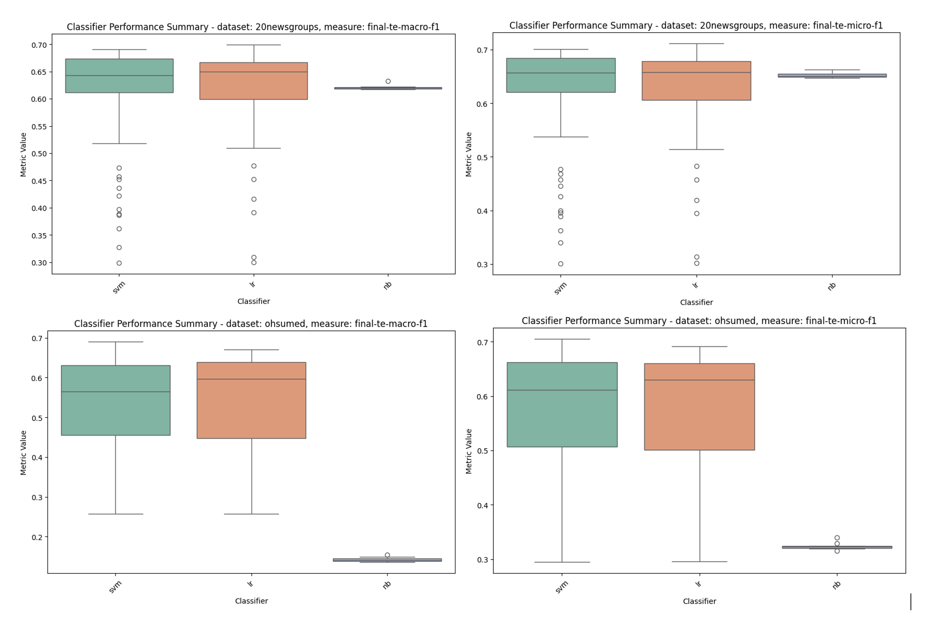
Figure 13: Classifier Performance Summary - ML Classifiers

Results by Representation Form

When we look at the various representation forms, and evaluate their performance in the various classifiers, we can see as might be expected, and certainly consistent with the data from (Moreo, et al., 2021), the tf-idf vectorized form of the data, even after the feature reduction that is applied (cutoff / min_df=5), performs the best on average, but the language model representation combined with the WCEs/TCEs also performs quite well.

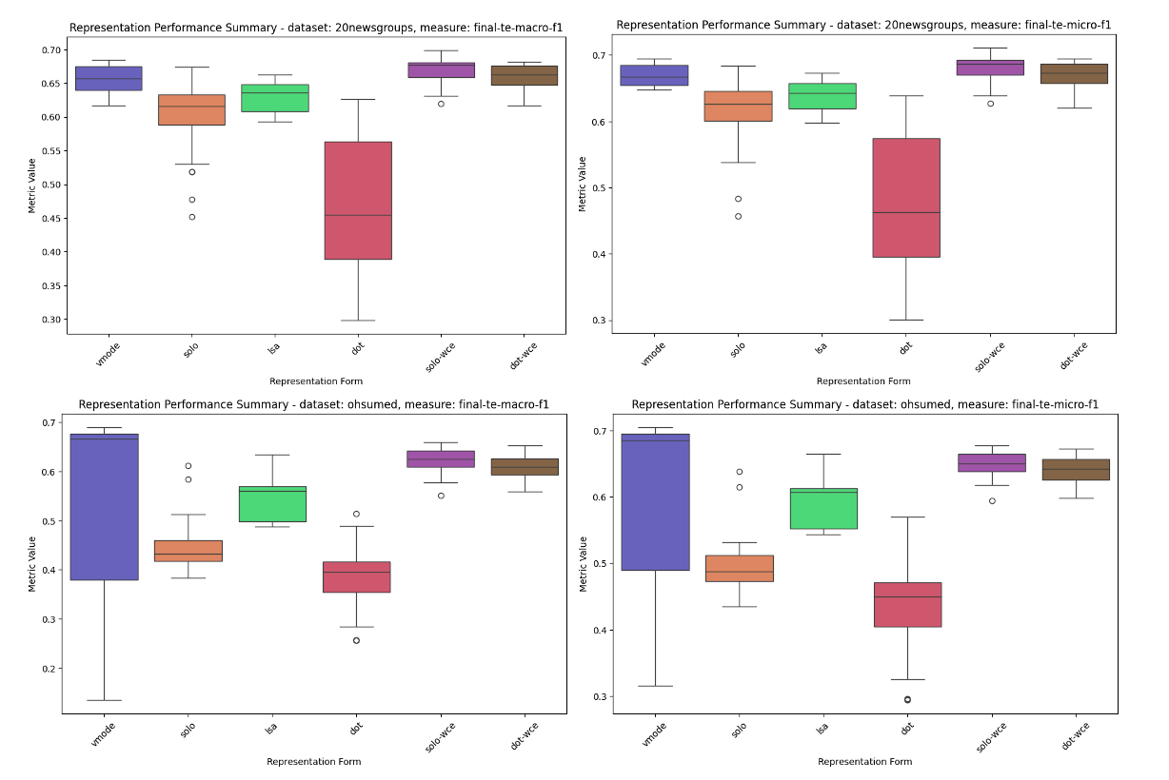
Figure 14: Performance Summary by Language Representation Form – ML Classifiers

While there is a slight runtime performance hit for the solo-wce representation form, it is negligible relatively speaking.

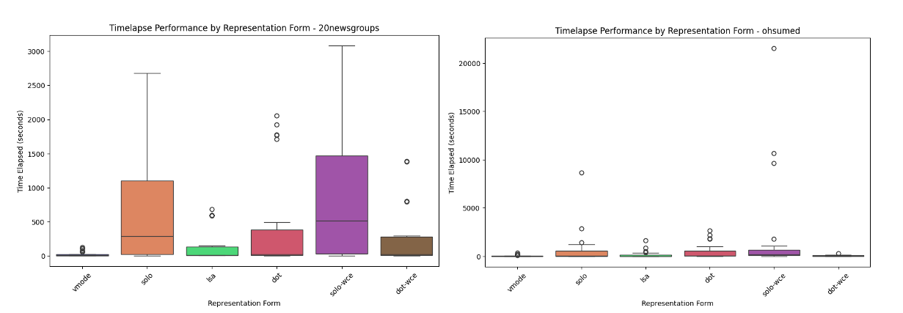
Figure 15: Representation Form Performance Runtimes – ML Classifiers

Results by Language Model Type

When we look at how the individual language model types perform on the various datasets, we can see that the different language model typed perform roughly the same on the various datasets, despite the fact that the word based language models are vectors of size 300 while the transformer based models are computed in a higher dimensional space – 768 for the smaller BERT, RoBERTa and DistilBERT, XLNet and GPT2 models we are using and 2048 for the Lllama model and 1536 for the DeepSeek model.

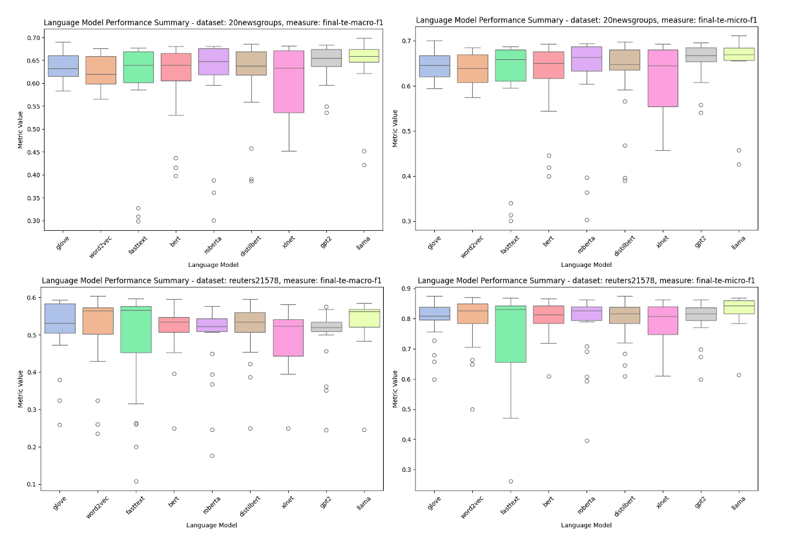
Figure 16: Language Model Performance Summary - ML Classifiers

You can see the effect of the underlying language model dimension size, again reflecting the underlying feature space of the language model, impact the runtime performance as reflected in the timelapse comparison by language model type plots below.

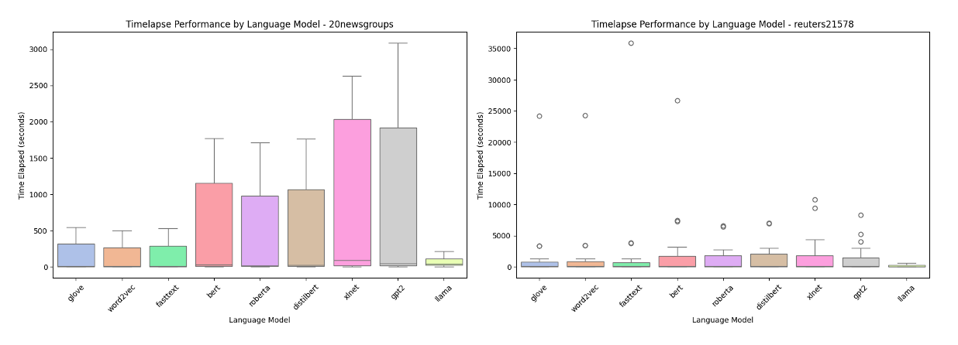
Figure 17: Language Model Timelapse Performance - ML Classifiers

Neural Network Classifiers (Deep Learning)

We have two different sets of neural classifiers that we test with within the scope of this research that are supported by Layer Cake, each of which was tested under various hyperparameter conditions and with various forms of language representation. The first set reflects the same fundamental neural models that were in the original paper that provided the impetus for this work (Moreo, et al., 2021), but expanded to support both Word2Vec and FastText static, word based embedding models along with GloVe which was fundamental to that study. These models are hand crafted Pytorch neural models that leverage straightforward CNN, ATTN and LSTM architectures, more on these and how they are applied for the text classification problem is below.

The second set of classifiers we use leverage the HuggingFace (HF) libraries which provide interfaces, API wrappers effectively, for most, if not all, of the publicly available language models. In particular we test the HuggingFace Sequence Classifiers which are specifically designed for classification like problems, along with a simple CNN based architecture as a classifier head on top of the HF language models that are in scope for this work. These classifiers are designed specifically for transformers and effectively embed the transformer models themselves which consist of the specific underlying neural architecture of the model along with the computational logic that is characteristic of the model that drives the creation of the context aware, dynamically generated embeddings which are the main distinguishing characteristics of the transformer-based models versus their static counterparts.

In other words, given the dynamic nature of the transformer based embeddings, the embeddings – the model really – has to sit in a different type of neural classifier entirely that accounts for, and incorporates, the underlying language model directly into the classifier so that the embeddings can be computed, dynamically, and then they can be pooled and fed to the classifier head portion of the model. One of the implications of this technical dependency is that the static based neural models are not only significantly less computationally intensive than their transformer based counterparts (one of the key measurement findings of this study), but also more flexible in terms of in terms of how the embedding layer can be structured – the embedding layer being the foundational structure of all of the neural model classifiers that is used to generate the embeddings that are used to represent the text of the underlying dataset, either as a straight index lookup in the forward pass of the model as is the case with the static neural models, or as inputs into the runtime computational dynamic embeddings that the transformer models generate and that can be consumed, and again pooled, for classification in the forward pass of model training.

Therefore our study includes two sets of classifier results – one for the static word embedding language models that are tested in conjunction with Word Class Embeddings, and another that is computationally incompatible with WCEs, really Token Class Embeddings (TCEs) for the transformer models that tokenize the text rather than simply parse the text into its constituent words as is the case with the static language models. When we say incompatible what we mean specifically is a) the TCEs cannot be added to the static, foundational underlying embedding layer for the transformer model given the constraints of the HuggingFace implementation of said transformer models, and b) when they are added at runtime, i.e. during the forward pass during model training, their inclusion into the language representation logic not only proves to be ineffective, but even proves to hurt the underlying model performance, indicating that – at least via the methods we have experimented with - adding embedding information into the transformer models appears to be, at least again as the models have been implemented by HuggingFace, not feasible.

We discuss the architecture, workflow and results of both the static language model neural classifiers as well as the transformer, dynamic based classifiers in the section below.

Following (Moreo, et al., 2021), we look at three different classifiers for the static word embeddings within the context of this research – CNN, ATTN, and LSTM classifiers - but relative to the data that is produced in that 2021 study we expand the scope to include Word2Vec and FastText embeddings alongside the GloVe embeddings so that we get a better sense as to the differences between the different language models in the different classifier models, and datasets, that we test with Layer Cake.

Following the same test, data preparation, model training and testing workflow that we used when we tested the baseline machine learning classifiers, each of the static word embedding neural classifiers are tested under different hyperparameter settings against each of the in scope datasets both with and without WCEs, resulting in metrics – like the initial set of ML classifier data – that can be directed compared against the 2021 study.

For the dynamic language models, i.e. the transformers, we have two different classifiers that we use, each of which that leverages the HuggingFace transformers library which provides a clean wrapper around a whole host of publicly available language models.

One of the primary differences between the static word embedding models and the dynamic ones, is the tokenization strategy that is used. While static word embeddings are designed to look at, and represent words, the transformer-based models break language down into tokens, which while solving for out of vocabulary and polysemy type problems, nonetheless moves the language representation form away from semantics – what something means - to something more basic and fundamental, and certainly more abstract.

The power of this transformer-based approach - which dominates the language model research and development landscape right now - with respect to specificity also results in some constraints with respect to not only forms of language representation that will work with, or are compatible with, the underlying model, but also in terms of (perhaps most profoundly) system resource and computational requirements.

Static Embedding Classifiers

The basic test workflow that we follow is as follows: we first initialize and prepare the underlying dataset, and, from a text preprocessing perspective, consistent with best practices for static language representations, we remove stopwords and punctuation from the text before we index it for input into the neural model. The text is then converted into an index representation form which is typical for NLP deep learning architectures, where each word is indexed into a dictionary that maps back to the associated index in the underlying language model, facilitating a lookup of the embedding for the word in question during the forward pass of training.

The language representation form that is used, again following the 2021 study, is to construct the neural model classifier embedding layer for the dataset in question using a) the dataset vocabulary words (post vectorization (i.e. vectorized using TFIDFVectorizer with ‘cutoff’ = 5 so that this dictionary is a subset of the entire dataset dictionary) combined with the static embeddings for all known words (i.e. words or terms that have defined static embedding representation as defined by the underlying language model, or in other words all words that are not in the vectorized dataset representation but exist in the underlying dataset doc set and have a corresponding definition in the underlying language model), together forming what you might call the static embedding layer dictionary.

The input text data is tokenized into individual words using the dataset’s vectorization strategy (e.g., TF-IDF or count vectorization) and each token is mapped to its corresponding embedding using the custom embedding layer, which is designed to support both pretrained embeddings, learnable embeddings, as well as supervised embeddings, i.e. WCEs, which serve to extend the pretrained language model representation of a given word using class, or label, co-occurrence statistics, serving to add additional information to the pretrained language model representation of the word and extending the dimensions of the underlying word vector by the number of classes in the dataset.

Pretrained embeddings (GloVe, Word2Vec, FastText) provide dense vector representations of words based on their semantic meaning. They enable the model to generalize better, especially when the training data is limited, by leveraging knowledge from large external corpora. The custom embedding layer combines pretrained embeddings with learnable embeddings, and optionally WCEs, to allow the model to be tailored specifically for the dataset in question that is fed into the model for training. This representation form is what is used to initialize the embedding layer of the neural models, which again is used at runtime, i.e. at training time, to be retrieved by the classifier and processed by the neural model in question, pooled together in batches, and ultimately classified the transformation layers of the different deep learning models we test with.

The indexed document representation form, which maps to the pretrained underlying word embeddings, is standard (best) practice for neural text classifiers as it allows for efficient lookup of token embeddings from the embedding matrix. Note that in the static neural model classification design, we also add special tokens for unknown words (UNKTOKEN), and padding (PADTOKEN), which are leveraged by the model to ensure the neural model handles the text representation form correctly for classification, meaning that all OOV terms are treated by the model in the same way as a special token, with its own embedding representation.

Once the dataset is indexed, the numerical representations of the documents are batched and passed to the model's embedding layer through the NeuralClassifier so that, via the EmbeddingCustom layer, the appropriate embeddings for each token from the embedding matrix (pretrained + learnable embeddings) can be retrieved and used for downstream processing. The embeddings are then, in the forward method of the classifier, processed by either the CNN, LSTM, or ATTN projection layers depending upon the model being used, the end result of which yields a contextual, language model embedding representation of the documents is created for the underlying model.

This optimized embedding dictionary layer initialization approach that we use to prepare the static word embedding deep learning classifiers can be contrasted with the transformer-based approach to Embedding layer initialization which by default loads the entire embedding dictionary, i.e. the entire language model itself really, into the Classifier. This not only has size and performance implications given that there are tokens – because the transformer-based models are token based as opposed to word based as their static counterparts are – included in the initialized embedding layer that are not needed for the dataset in question, i.e. are not part of the underlying dataset language dictionary, but nonetheless loaded into the model memory during training and testing. This optimization, or lack thereof really, makes a significant different in terms of the computational resources necessary to train and test the classifiers, both in terms of GPU count and memory resource requirements as well as the runtimes (what we track as the ‘timelapse’ field in Layer Cake) of the classifier construction and testing, i.e. the individual test cases that we track and report on in this work.

Specifically, the training of our neural classifier is done using mini-batch gradient descent with an optimizer (Adam), and a loss function - CrossEntropy or BCEWithLogits depending on whether we are using a single-label dataset or a multi-label set respectively – which looks at the aggregate token representation of the dataset sequence that is being processed that has been fed to it by the underlying projection layer that is either a CNN, ATTN or LSTM. In our code, model training involves looping through the text and feeding batches of data into the initialized NeuralClassifier which, in its forward method or forward pass, computes the loss of the data sequence for classification in the Linear layer, and then backpropagates and tunes the model weights in its backward pass, evaluating the model on a validation set periodically to monitor performance. At periodic intervals the model is tested (against the macro-f1 metric) to determine whether or not the model is improving (whether or not we should stop training), after which the model is then evaluated across a variety of metrics using the test data which is output to the logger and then used in Layer Cake’s reporting and analytics module.

Note that Layer Cake supports both single label classification datasets – where each document gets classified to one and only one class or label – as well as multi-label datasets where a document can be classified to one or more labels or classes. This is accomplished by ensuring that the preparation of the labels for the underlaying docs is in the appropriate form, and the use of an appropriate loss function that is designed specifically for either a single-label classification problem (CrossEntropyLoss), or a multi-label classification problem (BCEWithLogitsLoss), the loss function being the final layer of the Classifier which converts the final document representation form into its respective, learned class by comparing the logits output of the model against the ground truth labels by means of the respective loss function. For multi-label classification, the outputs are thresholded (> 0.5) to determine which labels are predicted.

Different Classifier Architectures

We test three different types of neural classifiers within the context of the static word embedding language model testing that is in scope for this research – a Convolutional Neural Network (CNN) architecture, a Long Short-Term Memory (LSTM) neural architecture, and a basic Attention & Masking (ATTN) based architecture which is constructed from a LSTM with an attention mechanism that facilitates a context aware computational approach. Each of these will be described in detail below.

Convolutional Neural Networks (CNN)

CNNs were originally developed for image processing and computer vision (LeCun, et al., 1998), but they have been successfully adapted to NLP tasks such as text classification, sentiment analysis, and question answering. The paper by titled “Convolutional Neural Networks for Sentence Classification,” was a major milestone in demonstrating that CNNs could achieve state-of-the-art performance on several text classification benchmarks (Kim, 2014).

Unlike images, text data has a sequential structure, so 1D convolutions are used instead of 2D convolutions and a sliding window (convolutional filter) moves across the input word embeddings, capturing local patterns or n-grams (e.g., "good movie," "not bad"). Multiple filters with different sizes (e.g., 2, 3, or 5 words) are used to capture varying lengths of local context. After applying the convolution, max pooling selects the most important features, reducing the dimensionality and making the model robust to position shifts. The pooled features are then concatenated and passed to a fully connected layer for classification.

CNNs for text classification generally are designed to capture local context by sliding filters over the input sequence, making them effective for capturing n-gram patterns (e.g., phrases or local dependencies). So as designed by (Moreo, et al., 2021), the static word embedding neural model consists of a base neural model with a projection layer(s) attached to it that is either CNN, ATTN or LSTM, with a simple Linear layer at the end that performs the final classification step – as shown in the figure below.


Figure 18: Convolutionary Neural Networks for Text Classification

During training, the neural model reshapes the input (static) embeddings (really a batched set of tokens which represent the text in question) into the first convolutional layer, each of which leverages a relu activation function followed by a max-pooling layer which reduces the sequence to a fixed-length vector. Each of the three CNN layers is applied sequentially to the text which is then concatenated and passed to a fully connected (Linear) layer for classification.

This fairly simple design is quite effective at text classification and furthermore is computationally quite efficient, as indicated in this study (see below) as well as a variety of other studies which are cited both in the section as well as in the introductory material to this work as outlined above. In brief, CNNs effectively represent text by capturing local contextual patterns (e.g., common phrases or word groups) using filters of different sizes, capturing local dependencies (e.g., key phrases) that make them well suited for text classification type NLP solves.

Long Short-Term Memory Networks (LSTM)

LSTMs were introduced by a paper of the same name in 1997 (Hochreiter & Schmidhuber, 1997) and represented when first introduced a significant step forward over basic recurrent neural networks (RNNs), which suffered from vanishing gradients and were ineffective in capturing long-term dependencies. The adoption of LSTMs for NLP was driven by their success in machine translation as demonstrated initially by (Sutskever, et al., 2014) and later extended to various tasks like text classification and sentiment analysis, and semantic analysis more broadly as indicated by (Tai, et al., 2015) for example.

An LSTM processes text sequentially, word by word, using hidden states and cell states to remember important information from previous words while discarding irrelevant information. A text classification LSTM uses a gated and filter-based approach to classify text, leveraging three gates - a Forget Gate, an Input Gate and an Output Gate – each of which is sequentially applied to the text which ultimately yields output which is then fed into (in our case) a final Linear layer which classifies the text sequence. This architecture is illustrated in the figure below.


Figure 19: LSTM for Text Classification Architecture

In text classification LSTMs, each of the gates does what its name applies, namely the Forget Gate throws certain input away, the Input Gate decides which information we are going to retain for further processing, and then the Output Gate decides what our data output looks like. So the forget gate and input gate control how much of the previous state is retained or updated, and the final hidden state of the LSTM contains a summary of the entire sequence, which is then used for classification.

LSTMs are designed to capture long-range dependencies in sequential data, making them effective for understanding context over longer passages, and since they model word order explicitly, they are suitable models for tasks that require context-aware understanding.

Attention Mechanism with LSTM (ATTN)

Attention based neural models for NLP changed the NLP and language generation game entirely, ushering in a whole new era of neural model architectures that are now ubiquitous in the NLP and language generation space. The attention mechanism was initially proposed in machine translation in 2016 in (Bahdanau, et al., 2016), where it was shown that these types of architectures - which apply a form of masking of the input sequences to capture attention, or context, within the text - allowed the model to focus on specific words in the source sentence when predicting the target word.

The use of self-attention in the Transformer architecture specifically was introduced shortly thereafter in the now infamous research work (Vaswani, et al., 2017) which is no exaggeration to state that it revolutionized NLP, in particular with respect to text classification problems as put forth by (Yang, et al., n.d.). These attention-based architecture neural models now sit at the heart of all leading generative AI (language) tools such as BERT and GPT and many others which dominate text classification today.

Attention based neural models assign different weights to different words in the input sequence based on their importance to the current task. In the context of LSTM-based models, attention computes the relevance of each hidden state to the final representation and the final document representation is a weighted sum of the LSTM outputs, where the attention weights determine the contribution of each token. Attention selectively focuses on important parts of the text, improving interpretability and given its flexible design can capture relationships between distant words.

Attention enhances the performance of LSTMs by mitigating their reliance on the final hidden state, again facilitating the ability of the model to focus on important parts of the input sequence, generally enhancing performance for tasks where not all words are equally important.


Figure 20: ATTN Neural Architecture

In our implementation, our ATTN projection layer is an LSTM that is extended with an attention layer. After the LSTM processes the input sequence, attention weights are computed using a dot product between the final hidden state and each hidden state and then a weighted sum of the hidden states is used as the document representation. Again, the attention mechanism allows the model to focus on the most relevant tokens or words in the document, making the representation more task-specific and effective.

Dynamic, Context-Aware, Classifiers (Transformers)

HF Sequence Classifier

HF CNN Architecture

Test Results & Analysis

We look at performance results by classifier and pretrained embeddings and integrate model training times into one graphic, focusing on the macro-f1 and micro-F1 metrics which are good, industry standard metrics to measure the performance of a classifier in both multi-label and single-label scenarios.

For analysis purposes we look at the Ohsumed dataset, which is medical data and has many medical specific terms that would not be found in a generic language model training corpus, and then 20 Newsgroups, which is a good example of a single-label dataset with clear benchmark standards. Combined charts are included in the figures below, with the x axis showing the representation shorthand that we describe above for each of the test scenarios. In addition, we append the embedding layer shape (dimensions) at the end of the representation field (x axis) so we can see how big the dictionary size is that is initialized for each set of pretrained embeddings, aka language models, for each of the individual test runs that we are evaluating.

The primary dimensions we are looking at here, when comparing the static pretrained embeddings against each other within the three different classifier architectures that are designed for said purpose, are:

- pretrained embedding performance comparison: which pretrained embeddings perform the best and by how much? Do certain pretrained embeddings perform better on certain datasets? If so why? If not why not?
- neural architecture performance comparison: which neural architectures perform the best in terms of model macro-f1 and micro-f1 metrics? Is this the same across all datasets or does it differ?
- system resource performance comparison: how long does each model take to run and which ones are more computationally expensive? What is the best model that takes the least amount of computing resources to train?

Each of these questions is addressed below.

Language Model Performance Comparison

As illustrated in the figure(s) below, which show the aggregate performance for maco-f1 and micro-f1 measures across all the different datasets, by language model type, we see on average relatively the same performance for the three static word embedding language models we test with (GloVe, Word2Vec and fastText models), each of which performs quite well in terms of computational resource requirements (the timelapse, secondary y-axis data). Given that they are of comparable size and are trained basically on the same underlying data (Web Common Crawl), this is not a surprising result and speaks to how comparable the different training methods are to each other when used in this type of neural model / text classification setting.
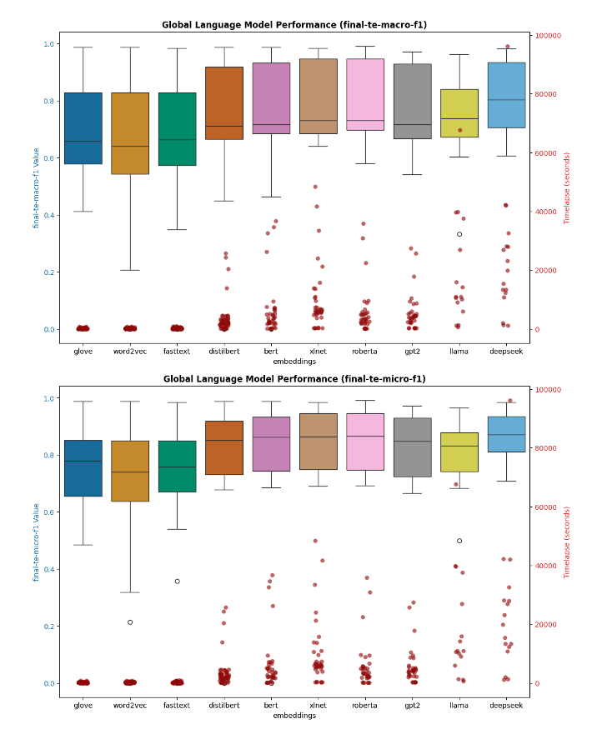
Figure 21: Neural Classifier Language Model Type Performance Summary

The transformer models in contrast, definitely show significantly better performance from a macro-f1 and micro-f1 measure perspective, but their computational resource requirements are significantly higher, on average two or three times the amount of computation resources are required for the dynamic classifiers to be trained. We see the best performance across all the datasets that we tested from XLNet and RoBERTa language models, with BERT, GPT2 and DeepSeek coming in very close behind those two frontrunners. The Llama model is the lowest performer from this vantage point.

When we look at the data in aggregate by Classifier, we see the same trend from another perspective – namely that the HuggingFace transformer classifiers perform better than their static counterparts but their training cost is significantly higher.
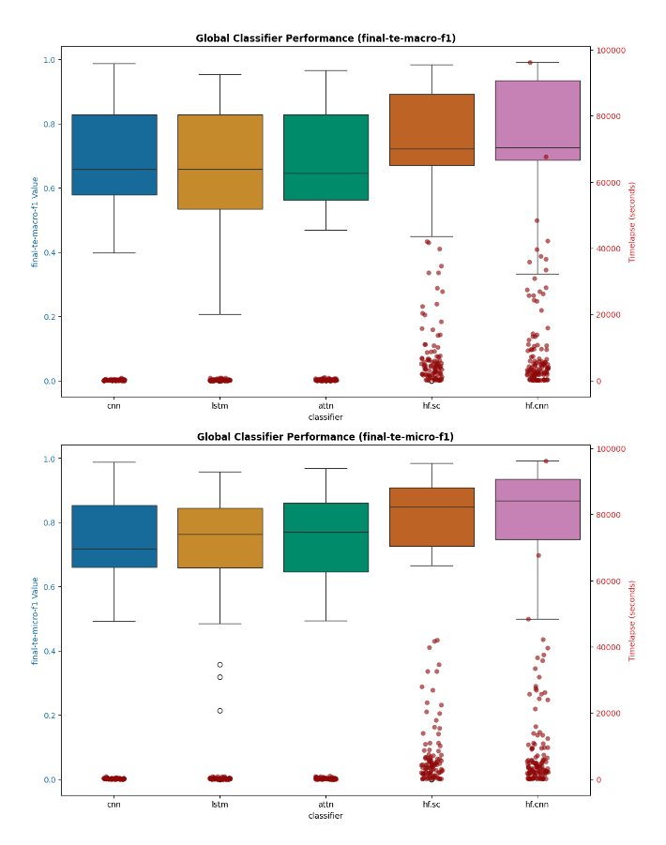
Figure 22: Neural Model Classifier Performance Summary

This is of course on average, if we drill into the language model performance for a given dataset for example, we will see some variability, as illustrated in the figure below which shows the macro-f1 and micro-f1 performance for various forms of representation for the Ohsumed dataset which contains medical data.
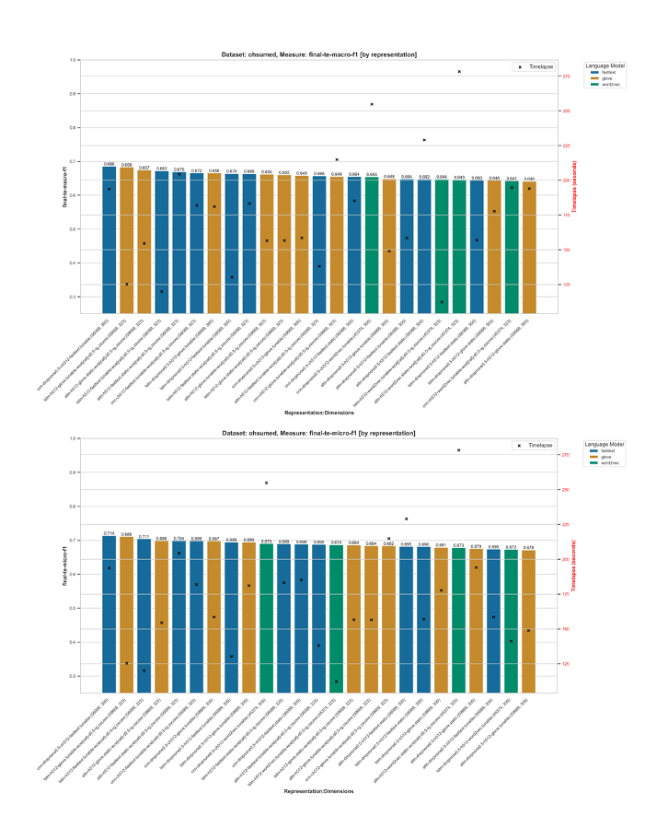
Figure 24: Static Pretrained Embedding Performance by Classifier (Ohsumed data)

We can see that the FastText model performs quite well compared to its GloVe and Word2Vec counterparts, while the dictionary sizes between the different models, which is a corollary for how many OOV terms are handled, is in the mid 50,000 range for FastText and GloVe and in the mid 40,000 range for the Word2Vec model we use.
The 20 Newsgroups dataset, which is a single label dataset rather than multi-label like Ohsumed, also shows minro variability by language model type, with again the FastText model ooutperrformign

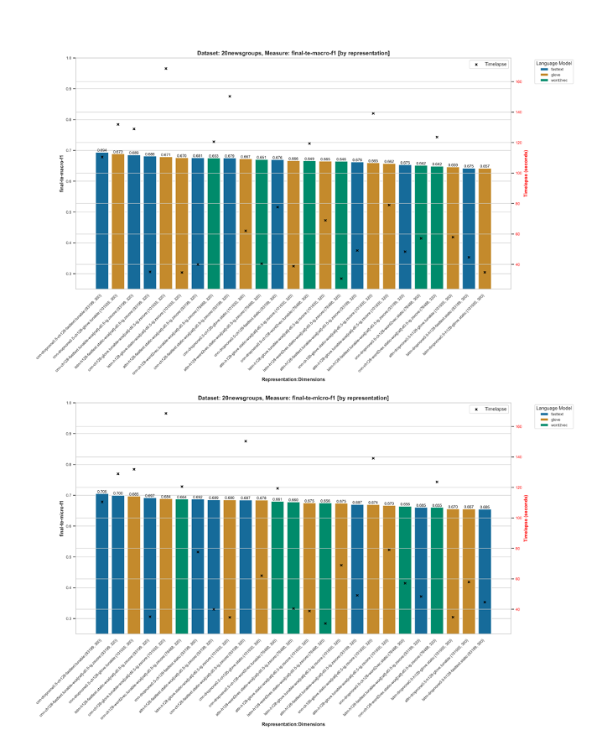
Figure 25: Static Pretrained Embedding Neural Classifier Performance (20 Newsgroups)

Summary Results & Concluding Remarks

ML vs DL Classifiers

Static vs Dynamic Language Models

Language Representation, Tokenization and OOV Handling

Word & Token Class Embeddings (WCEs and TCEs)

Concluding Remarks & Further Research

- Recommendations for selecting pretrained embeddings for different classification tasks.
- Potential areas for improving embedding representations.
- Summary of findings from the experiments.
- Key takeaways for improving multi-class text classification performance using pretrained embeddings.
- Limitations of the study and future research directions.

Bibliography
Albrecht, J., Ramachandran, S. & Winkler, C., 2020. Blueprints for Text Analytics Using Python. s.l.:O'Reilly Media, Inc..
Bahdanau, D., Cho, K. & Bengio, Y., 2016. Neural Machine Translation by Jointly Learning to Align and Translate. 19 May.p. https://doi.org/10.48550/arXiv.1409.0473.
Bai, J., 2023. Qwen Technical Report. arxiv, p. https://doi.org/10.48550/arXiv.2309.16609.
Bender, E. M. & Koller, A., 2020. Climbing towards NLU: On Meaning, Form, and Understanding in the Age of Data. s.l., Association for Computational Linguistics, pp. 5185-5198.
Bojanowski, P., Grave, E., Joulin, A. & Mikolov, T., 2017. Enriching Word Vectors with Subword Information. Transactions of the Association for Computational Linguistics, 01 06, Volume 5, pp. 135-146; https://doi.org/10.1162/tacl_a_00051.
Brown, T. B. et al., 2020. Language Models are Few-Shot Learners. Red Hook, NY, USA, Curran Associates Inc., pp. 1877-1901.
Chang, T. A. & Bergen, B. K., 2024. Language Model Behavior: A Comprehensive Survey. Computational Linguistics, 03, 50(1), pp. 293-350. https://doi.org/10.1162/coli_a_00492.
Chomsky, N., 1956. Three models for the description of language. IRE Transactions on Information Theory, September, 2(3), pp. 113-124. https://doi.org/10.1109/TIT.1956.1056813.
Chomsky, N., 1957. Syntactic Structures. Berlin, Boston: De Gruyter Mouton.
Chomsky, N., 1965. Aspects of the Theory of Syntax. Cambridge(MA): MIT Press.
Cortes, C. & Vapnik, V., 1995. Support-vector networks. Machine Learning, 01 09, 20(3), pp. 273-297: https://doi.org/10.1007/BF00994018.
Cox, D. R., 1958. The Regression Analysis of Binary Sequences. Journal of the Royal Statistical Society, July, 20(2), pp. 215-232; https://doi.org/10.1111/j.2517-6161.1958.tb00292.x.
Deerwester, S. et al., 1990. Indexing by latent semantic analysis. Journal of the American Society for Information Science, 41(6), pp. 391-407. https://doi.org/10.1002/(SICI)1097-4571(199009)41:6<391::AID-ASI1>3.0.CO;2-9.
Devlin, J., Chang, M.-W., Lee, K. & Toutanova, K., 2019. BERT: Pre-training of Deep Bidirectional Transformers for Language Understanding. Minneapolis, Minnesota, Association for Computational Linguistics, pp. 4171-4186. https://doi.org/10.48550/arXiv.1810.04805.
Farrando, J., Sarti, G., Bisazza, A. & Costa-jussà, M. R., 2024. A Primer on the Inner Workings of Transformer-based Language Models. Preprint, p. 55..
Fitch, W. T., 2010. The Evolution of Language. s.l.:Cambridge University Press.
Hochreiter, S. & Schmidhuber, J., 1997. Long Short-Term Memory. Neural Computation, 15 November, 9(8), pp. 1735-1780; https://doi.org/10.1162/neco.1997.9.8.1735.
Hutchins, J. W., 2004. The Georgetown-IBM experiment demonstrated in January 1954. Berlin, Heidelberg, Springer Berlin Heidelberg, pp. 102-114. https://doi.org/10.1007/978-3-540-30194-3_12.
Joachims, T., 1998. Text categorization with Support Vector Machines: Learning with many relevant features. Berlin, Springer Berlin Heidelberg, pp. 137-142; https://doi.org/10.1007/BFb0.
Jones, K. S., 1972. A STATISTICAL INTERPRETATION OF TERM SPECIFICITY AND ITS APPLICATION IN RETRIEVAL. Journal of Documentation, January, 28(1), pp. 11-21; https://doi.org/10.1108/eb026526.
Jurafsky, D. & Martin, J. H., 2024. Speech and Language Processing: An Introduction to Natural Language Processing, Computational Linguistics, and Speech Recognition. s.l.:Prentice Hall, Pearson Education International.
Khurana, D., Koli, A., Khatter, K. & Singh, S., 2022. Natural language processing: state of the art, current trends and challenges. Multimedia Tools and Applications, July, 82(3), pp. 3713-3744. http://dx.doi.org/10.1007/s11042-022-13428-4.
Kim, Y., 2014. Convolutional Neural Networks for Sentence Classification. Doha, Qatar, Association for Computational Linguistics, pp. 1746--1751; 10.3115/v1/D14-1181.
LeCun, Y., Bottou, Y., Bengio, Y. & Haffner, P., 1998. Gradient-based learning applied to document recognition. Proceedings of the IEEE, November, 86(11), pp. 2278-2324; doi: 10.1109/5.726791.
Lewis, M. et al., 2020. BART: Denoising Sequence-to-Sequence Pre-training for Natural Language Generation, Translation, and Comprehension. s.l., Association for Computational Linguistics, pp. 7871–7880; https://doi.org/10.18653/v1/2020.acl-main.703.
Liu, Y. et al., 2019. RoBERTa: A Robustly Optimized BERT Pretraining Approach. p. https://doi.org/10.48550/arXiv.1907.11692.
Mikolov, T., Chen, K., Corrado, G. & Dean, J., 2013. Efficient Estimation of Word Representations in Vector Space. s.l., arXiv, p. https://doi.org/10.48550/arXiv.1301.3781.
Minaee, S. et al., 2024. Large Language Models: A Survey. ArXiv, Volume abs/2402.06196.
Mitchell, M. & Krakauer, D. C., 2023. The debate over understanding in AI’s large language models. Proceedings of the National Academy of Sciences, March, 120(13), p. http://dx.doi.org/10.1073/pnas.2215907120.
Moreo, A., Esuli, A. & Sebastiani, F., 2021. Word-class embeddings for multiclass text classification. Data Mining and Knowledge Discovery, May, Volume 35, pp. 911-963. https://doi.org/10.1007/s10618-020-00735-3.
Patel, F., 2019. Singular Value Decomposition(SVD) : A simple, comprehensive and practical introduction. [Online]
Available at: https://medium.com/@faizanmukardam/singular-value-decomposition-svd-a-simple-comprehensive-and-practical-introduction-6add3dc6793d
[Accessed June 2024].
Pennington, J., Socher, R. & Manning, C. D., 2014. GloVe: Global Vectors for Word Representation. Doha, Qatar, Association for Computational Linguistics, pp. 1532-1543. 10.3115/v1/D14-1162.
Peters, M. E. et al., 2018. Deep contextualized word representations. New Orleans, Louisiana, Association for Computational Linguistics, pp. 2227-2237. https://doi.org/10.48550/arXiv.1802.05365.
Pierce, J. & Carroll, J. B., 1966. Language and Machines - Computers in Translation and Linguistics, Washington, DC: s.n.
Radford, A. & Narasimhan, K., 2018. Improving Language Understanding by Generative Pre-Training. [Online].
Raffel, C. et al., 2020. Exploring the Limits of Transfer Learning with a Unified Text-to-Text Transformer. Journal of Machine Learning Research, 06, Volume 21, pp. 1-67; https://doi.org/10.48550/arXiv.1910.10683.
Raiaan, M. Z. K. et al., 2024. A Review on Large Language Models: Architectures, Applications, Taxonomies, Open Issues and Challenges. IEEE Access, Volume 12, pp. 26839-26874. http://dx.doi.org/10.1109/ACCESS.2024.3365742.
Salton, G., 1971. The SMART Retrieval System-Expermients in Automatic Document Processing. s.l.:Prentic-Hall, Inc..
Sanh, V., Debut, L., Chaumond, J. & Wolf, T., 2020. DistilBERT, a distilled version of BERT: smaller, faster, cheaper and lighter. p. https://doi.org/10.48550/arXiv.1910.01108.
Schank, R. C., Goldman, N., Riager, C. J. & Rissbeck, C., 1973. Margie memory, analysis, response generation, and inference on English. San Francisco, CA, Morgan Kaufmann Publishers Inc., pp. 255-261.
Sevilla, J. & Roldán, E., 2024. Training Compute of Frontier AI Models Grows by 4-5x per Year. [Online]
Available at: https://epoch.ai/blog/training-compute-of-frontier-ai-models-grows-by-4-5x-per-year
[Accessed 23 01 2025].
Shardlow, M. & Przybyła, P., 2023. Deanthropomorphising NLP: Can a Language Model Be Conscious?. arXiv, p. https://doi.org/10.48550/arXiv.2211.11483.
Sparck Jones, K., 1972. A STATISTICAL INTERPRETATION OF TERM SPECIFICITY AND ITS APPLICATION IN RETRIEVAL. Journal of Documentation, 01 January, 28(1), pp. 11-21. https://doi.org/10.1108/eb026526.
Sutskever, I., Vinyals, O. & Le, Q. V., 2014. Sequence to sequence learning with neural networks. Cambridge, MA USA, MIT Press, p. 3104–3112; https://doi.org/10.48550/arXiv.1409.3215.
Tai, K. S., Socher, R. & Manning, C. D., 2015. Improved Semantic Representations From Tree-Structured Long Short-Term Memory Networks. Beijing, China, Association for Computational Linguistics, pp. 1556-1566; 10.3115/v1/P15-1150.
Touvron, H. et al., 2023. LLaMA: Open and Efficient Foundation Language Models. arXiv, p. https://doi.org/10.48550/arXiv.2302.13971.
Turing, A. M., 1950. Computing Machinery and Intelligence. Mind, October, 49(236), pp. 433-460. https://doi.org/10.1093/mind/LIX.236.433.
Vaswani, A. et al., 2017. Attention is All You Need. Long Beach, CA, Curran Associates Inc., p. https://doi.org/10.48550/arXiv.1706.03762.
Wan, Z. et al., 2024. Efficient Large Language Models: A Survey. ArXiv, Volume abs/2312.03863, p. https://doi.org/10.48550/arXiv.2312.03863.
Winograd, T., 1972. Procedures As A Representation For Data In A Computer Program For Understanding Natural Language. Cognitive Psychology, 3(1).
Worth, P., 2023. Word Embeddings and Semantic Spaces in Natural Language Processing. International Journal of Intelligence Science, 13(1), pp. 1-21. https://doi.org/10.4236/ijis.2023.131001.
Yang, J. et al., 2023. Harnessing the Power of LLMs in Practice: A Survey on ChatGPT and Beyond. p. https://doi.org/10.48550/arXiv.2304.13712.
Yang, Z. et al., 2019. XLNet: generalized autoregressive pretraining for language understanding. Red Hook, NY, Curran Associates Inc., p. 5753–5763.
Yang, Z. et al., n.d. Hierarchical Attention Networks for Document Classification. San Diego, CA, Association for Computational Linguistics, pp. 1480-1489; 10.18653/v1/N16-1174.
Zhao, W. X. et al., 2023. A Survey of Large Language Models. ArXiv, Volume abs/2303.18233, pp. 1-124. 10.48550/arXiv.2303.18223.

For a sense of scale, the English language has almost 200,000 words and Chinese has almost 500,000.
Semantic based analysis of text is distinct from syntax-based analysis which looks to break apart the text into components, for example using parts of speech tagging, dependency parsing, lemmatization or named entity recognition. While we won’t cover those topics here, these techniques all look to break down the text, the words and sentences, into their constituent parts and relationships.
This approach represents text as an unordered collection of words. Each word is counted for its frequency within the text, disregarding grammar and word order. It generates a sparse vector where each word has its unique index, and the value is the word frequency. An extension of the BoW model, the Term Frequency-Inverse Document Frequency (TF-IDF) method measures the importance of a word based on its occurrence in a document compared to all documents in the corpus. High scores mean the word is frequent in a specific document but infrequent across the corpus. It is useful for filtering out common words that don't carry significant meaning.
While there are methods for reducing this ‘feature size’, an elemental task in all machine learning problems (e.g., simply limiting the word count to the most used, or frequently used, top N words, or more advanced methods such as Latent Semantic Analysis), such methods are beyond the scope of this paper.
Also called ‘cut-off’ in the literature. See https://scikit-learn.org/1.5/modules/generated/sklearn.feature_extraction.text.TfidfVectorizer.html
“The upper left shows the unit disc in blue together with the two canonical unit vectors. The upper right shows the action of M on the unit disc: it distorts the circle to an ellipse. The SVD decomposes M into three simple transformations: a rotation V*, a scaling Σ along the coordinate axes and a second rotation U. The SVD reveals the lengths σ₁ resp. σ₂ of the semi-major axis resp. semi-minor axis of the ellipse; they are just the singular values which occur as diagonal elements of the scaling Σ. The rotation of the ellipse with respect to the coordinate axes is given by U.” - Image and description by Georg-Johann - CC BY-SA 3.0, https://commons.wikimedia.org/w/index.php?curid=11342212
Polysemy is a linguistics term that means a word can have different meanings in different linguistic contexts, i.e. ‘poly’ or many and ‘semy’ which is the same root for ‘semantics’ which means ‘meaning’.
https://medium.com/geekculture/business-analysis-ai-computational-cost-67a136957c95
ibid
Showing decoder only models in the blue branch, encoder only models in the pink branch, and encoder-decoder models in the green branch. Graphic from Yang et al 2023.
We also have support for Logistic Regression and Naïve Bayes models, but that data is not included in the results described herein due to computational, time and research paper length.
Details on the different in scope datasets can be found in the Appendix
The main goal of the Common Crawl project is to provide an open-access, large-scale web dataset for academic, industrial, and research use. Common Crawl data is publicly available and constantly updated through periodic crawls. Source: https://commoncrawl.org/
https://nlp.stanford.edu/projects/glove/
https://huggingface.co/openai-community/gpt2
https://huggingface.co/meta-llama/Llama-3.2-1B
https://huggingface.co/deepseek-ai/DeepSeek-R1-Distill-Qwen-32B
Qwen is an open-source family of language models developed by Alibaba Cloud in 2023 in the paper (Bai, 2023)
(Cortes & Vapnik, 1995) first introduced the concept of support vector machines and then their use for the problem of text classification explicitly was introduced in (Joachims, 1998).
Image by Larhmam - Own work, CC BY-SA 4.0, https://commons.wikimedia.org/w/index.php?curid=73710028
When data is not linearly separable, a kernel function can be used to map the input space to a higher-dimensional space.
The TFIDFVectorization arguments that we use, following the 2019 study, are min_df=5 which indicates that a word, or token, is only included in the doc vector if it exists in at least 5 documents across the dataset, and sublinear=True which applies sublinear scaling to the tf-idf values that are used in the underlying doc vector representation, i.e. the tf value is replaced with 1+log(tf), see https://scikit-learn.org/stable/modules/generated/sklearn.feature_extraction.text.TfidfVectorizer.html for details. Note also that while the Layer Cake platform supports Count vectorization as well, these results are not reported in this study as they are what one might expect, that the tf-idf representation performs better generally than the straight up count vectorization, i.e. bag of words model. Also note that the tf-idf vectorization of the text with min_df = 5 is a form of implicit feature reduction as well.
While the results vary by model we found that generally the average mean embedding computation method was the most effective, including in some BERT models where the CLS token is present.
While Count vectorization is supported by Layer Cake, we do not include those results in our study. They are what you would expect them to be, slightly less effective than the tf-idf vectorization representation form.
This approach follows (Moreo, et al., 2021). For details on TFIDFVectorizer API from sklearn see https://scikit-learn.org/stable/modules/generated/sklearn.feature_extraction.text.TfidfVectorizer.html.
It’s worth noting however that the variance in terms of model performance between these optimized models and the default parameter ([def] representation form) models is not as significant as one might think and the performance hit for building and testing the optimized classifiers is, at least for the ML test cases, significant.
See https://scikit-learn.org/0.24/modules/generated/sklearn.multiclass.OneVsRestClassifier.html
The Naïve Bayes classifier, MultinomialNB from sklearn, only supports the vectorized representation form given its dependency on positive embeddings only so this is the only representation form that is computational viable.
Effectively the transformer-based models, given their internal dependency on the underlying computational logic that is intrinsic to the language model type itself, cannot be extended horizontally (concatenated) with TCEs as is the case with the static models.
The WCEs are combined with the static language model embeddings via concatenation, i.e. we extend the embedding layer dimensions to include the WCEs yielding a richer word representation that is fed into the model during training.
We experimented with dot product operations, addition operations, and concatenation operations of the transformer generated embedding representations of the text with the TCEs that we computed per class (per token). None of these methods worked for any of the transformer models we tested. We hypothesize that, given how well the transformer models perform generally relative to both their static embedding counterparts and the baseline ML classifiers we test with (SVMs, Logistic Regression methods primarily), that this is because the additional information that is encapsulated in these TCEs is already part of the underlying transformer model representation of the text at some level and therefore adding it to the embeddings only proves to reduce the effectiveness of the classification portion of the classifier.
HuggingFace is an American company that, among other things, is known for its transformers API which is widely used in the Python AI and MNL community. A listing of supported models and overview of the API can be found at https://huggingface.co/docs/transformers/v4.17.0/en/index
Or in the case of fastText subwords but ultimately these are words in the sense that the subwords themselves do in fact have a semantic meaning
This is in contrast to the data preparation for the transformer based models where we keep the text case sensitive, and leave the stopwords and punctuation in place given that the transformer based models are designed to handle the full complement of language syntax, one of its prominent features that distinguishes it from its static language model counterparts which are not, by design, ‘context aware’.
The GloVe model we use for example, which performs very well relative to the other language models, is 840B tokens, 2.2M vocab, is cased (i.e. case sensitive), has vectors of 300 dimensions and is approximately 2.03 GB.
Supported statistics include macro-F1, micro-F1, accuracy, precision, recall, Hamming loss and Jaccard Index.
Mathematical details around the specific LSTM (RNN) architecture used by PyTorch can be found here: https://pytorch.org/docs/stable/generated/torch.nn.LSTM.html
Image from https://nzlul.medium.com/the-classification-of-text-messages-using-lstm-bi-lstm-and-gru-f79b207f90ad
Image from https://medium.com/analytics-vidhya/hierarchical-attention-networks-d220318cf87e
Specific formulas for metric calculation can be found in the Experimental Setup section of this work.
This is a one-time model construction comparison but given that we would expect in an operational context that these classifiers would be continually trained against new data as it arrives, that is a 2-3x times cost on an ongoing basis which, over time, leads to a geometric expansion of the amount of resources required (mainly GPUs which is the primary part of the expense) over time.
GoogleNews-vectors-negative300.bin

