Layer Cake: Performance Benchmarking LLMs for Text Classification, a Comparative Study

by Peter J Worth
Florida Atlantic University
Dept of Electrical Engineering and Computer Science

Spring 2025

Table of Contents
1 Table of Contents 1-2
2 Table of Figures 2-4
3 Abstract 3-5
4 Introduction 4-6
4.1 Problem Domain 4-7
4.2 Unique Contributions 4-7
4.3 Structure of this Work 4-9
5 Language Representation 5-10
5.1 Text Vectorization & Feature Selection 5-11
5.2 Latent Semantic Analysis 5-13
5.3 Vector Space Models & (Static) Word Embeddings 5-15
5.4 Context Aware Embeddings (Transformers) 5-18
5.5 Transformer Architectural Variants 5-20
5.6 Tokenization Strategies 5-22
5.7 Geometrical Considerations 5-23
6 Text Classifier Design & Architecture 6-26
6.1 Machine Learning (baseline) Classifiers 6-26
6.1.1 Logistic Regression 6-26
6.1.2 Support Vector Machines (SVM) 6-27
6.1.3 Naive Bayes Classifier 6-28
6.2 Deep Learning Models 6-29
6.2.1 Early Models: RNNs and LSTMs 6-30
6.2.2 Convolutional Neural Networks (2014) 6-31
6.2.3 Transformers (2016/2017) 6-32
6.3 Computational Complexity Perspectives 6-36
6.3.1 Machine Learning Classifier Computational Complexity 6-37
6.3.2 Neural Classifier Computational Complexity 6-39
6.3.3 Computational Complexity Summary 6-41
7 Layer Cake Setup & Scope 7-43
7.1 Supported Metrics 7-44
7.2 Supported Language Models 7-45
7.2.1 Static Embedding Models 7-46
7.2.2 Context-Aware Language Models (Transformers or LLMs) 7-47
7.3 Supported Datasets 7-52
7.3.1 Dataset Summary Table 7-54
7.4 System Dependencies and Parallelism 7-54
8 Test Results & Analysis 8-57
8.1 Machine Learning Classifiers 8-57
8.1.1 (Text) Representation Forms 8-58
8.1.2 Test Workflow 8-62
8.1.3 Test Results & Preliminary Analysis 8-64
8.2 Neural Network Classifiers (Deep Learning) 8-69
8.2.1 Static Embedding Models 8-70
8.2.2 Dynamic, Context-Aware, Classifiers (Transformers) 8-73
8.2.3 Test Results & Analysis 8-78
8.3 Global Analytical Perspective 8-87
8.3.1 By Classifier 8-88
8.3.2 By Language Model 8-89
8.3.3 By Dataset 8-90
9 Summary Findings & Concluding Remarks 9-95
9.1 Research Findings 9-96
9.2 Recommended Further Research 9-97
10 Bibliography 10-98

Table of Figures

Figure 1: Latent Semantic Indexing using Singular Value Decomposition (Patel, 2019) 5-14
Figure 2: SVD in terms of scaling and rotation of vectors in Euclidean space 5-14
Figure 3: document query in vector space 5-15
Figure 4: Word Embeddings in Vector Space 5-16
Figure 5: BERT (encoder only) input representation (Devlin, et al., 2019) 5-20
Figure 6: Encoder-Decoder transformer architecture (Vaswani, et al., 2017) 5-21
Figure 7: Language Model Evolutionary Tree 5-22
Figure 8: 2D Poincaré Disk representations of semantic space 5-24
Figure 9: sigmoid function (logistic regression) 6-27
Figure 10: visualization of max-margin hyperplane for an SVM with two classes 6-28
Figure 11: LSTM for Text Classification Architecture 6-31
Figure 12: Convolutionary Neural Networks for Text Classification 6-32
Figure 13: ATTN Neural Architecture 6-33
Figure 14: Language Model Evolutionary Tree 6-34
Figure 15: Encoder-Decoder transformer architecture (Vaswani, et al., 2017) 6-35
Figure 16: BERT (encoder only) input representation (Devlin, et al., 2019) 6-36
Figure 17: Classifier Computational Complexity Summary Chart 6-42
Figure 18: Static Neural Model Architecture (LSTM) 7-43
Figure 19: ML Classifier Performance Summary - Aggregate across datasets 8-65
Figure 20: ML Classifier Representation Form Summary 8-66
Figure 22: Language Model Performance Summary - ML Classifiers 8-68
Figure 23: Static Language Model Classifier (CNN Architecture) 8-70
Figure 24: LCSequenceClassifier (BERT) 8-74
Figure 25: LCCNNBERTCLassifier Architecture (transformers) 8-76
Figure 26: Neural Classifier Language Model Type Performance Summary 8-79
Figure 27: Neural Model Classifier Performance Summary 8-81
Figure 28: Macro-F1 scores for neural classifiers (Ohsumed dataset) 8-82
Figure 29: Micro-F1 scores for neural classifiers (Ohsumed dataset) 8-83
Figure 30: Macro-F1 values across neural classifiers (RCV1 dataset) 8-84
Figure 31: Micro-F1 values across neural classifiers (RCV1 dataset) 8-85
Figure 32: arxix neural classifier performance comparison (Macro-F1) 8-86
Figure 33: arxix neural classifier performance comparison (Micro-F1) 8-87
Figure 34: Global Classifier Performance Summary 8-89
Figure 35: Global Performance Summary by Language Model 8-90
Figure 36: language model training compute requirements growth rate (Sevilla & Roldán, 2024) 9-95

Abstract

The advent of larger and more sophisticated pretrained language models over the last few years have not only changed the NLP and AI research landscape but has also ushered in one of the most profound technological transformations in generations. The beginning of this technology revolution can be marked with the introduction of ChatGPT in November of 2022, but less than three years later Hugging Face reports over 3,000 language models available on their site and through their API. It’s not clear at all if and when the pace of evolution with regards to the capabilities of these models, so-called LLMs, will abate. What has come with this rapid transformation of the technological landscape is an extraordinary level of enthusiasm and speculation about what these language models are capable of, with some even suggesting that they exhibit a form of consciousness and self-awareness.

However, their relative effectiveness across different embeddings and text representation techniques in multi-class text classification remains an active area of exploration and questions have been raised as to how effective deep learning methods, and transformer-based language models, are relative to their classical machine learning model counterparts such as Support Vector Machines, or even Logistic Regression. To this end, what we devise within the context of this research is the testing of these language models against this fundamental NLP problem, namely text classification, to get a sense as to how much of an improvement over more classical machine learning approaches to the problem these LLMs are capable of, and – perhaps most poignantly - at what cost.

In this paper, we introduce Layer Cake, a custom benchmarking platform for text classification that tests various classifiers across both the machine learning and deep learning landscape, across a range of different language model types, both transformer models and non-transformer based one, each with different architectures and tokenization strategies, against a wide range of different datasets – single and multi-label. The platform also comes with suite of reports and analytics that were used to visualize the underlying data results across several different metrics and dimensions of analysis. Layer Cake, and the underlying data which took more than 6 months to curate, represents one of the most comprehensive studies of its kind that’s been published in the literature to date on text classification, one of the most fundamental problems in NLP that is a loose corollary for how well these models actually encode the underlying data in preparation for any and all logical or reasoning tasks, which is precisely where these models are headed.

Our findings highlight significant differences in how these different types of language models, and different types of language representation forms, perform within the context of these different models, models that have very different computational architectural dependencies (CPU bound versus GPU bound) which not only have a significant effect on model performance, but also have a significant effect on model complexity, training times, and ultimately cost – factors that are crucial to understanding the most appropriate and effective use cases for the different approaches that all more or less solve this problem satisfactorily.

Keywords:

NLP, Text Classification, Vector Space Models, Word Embeddings, LLMs, Large Language Models, Semantic Spaces, Language Representation Learning, Machine Learning, AI, Artificial Intelligence

Introduction

We live in an era of remarkable technological transformation that is underpinned by the conflation of several groundbreaking technologies which have come together to provide individuals from around the globe who have access to no more than the Internet and a smartphone not just access to the sum total of all human (digital) knowledge, but now thanks to advancements in artificial intelligence (AI) and in particular language generation tools such as OpenAI’s ChatGPT, Google’s Gemini and countless others which are broadly categorized as LLMs, or large language models, which have the ability to synthesize and amalgamate such information, and respond to human language prompts in a manner that has become virtually indistinguishable from human intelligence.

Certainly, with respect to how Alan Turing formulated the problem in his famed Turing test (Turing, 1950), the current state of AI is indistinguishable not just from a human being, but a highly intelligent human being at that whose intelligence is rapidly accelerating. Now of course the form within which this intelligence takes is very different than perhaps what Alan Turing envisioned when he wrote that paper in 1950, but certainly with advancements in robotics and computational power over the next few years we can expect to start to see humanoid looking robots that do in fact appear to possess, and for all intents and purposes is indistinguishable from, human intelligence - hence the concern from many around the globe with respect to governance of the technology.

The technological advancements necessary to facilitate these developments in AI however are not limited just to the language models and the underlying forms of language representation themselves, which arguably sit at the core of this AI revolution however, these advancements rest atop other technological advancements in networking and computing technology as well as deep learning and neural networks which have come together to revolutionize the technological landscape, all being ushered in by the networking revolution of the late 1990s and early 2000s with the humble concept of interconnecting computers via a network. All of these technological advancements have led to radical changes not only with respect to how humankind conducts and transacts business throughout the globe, but also – among other things - with respect to how we interact with each other, and even how nation states and corporations govern their constituents. It is fair to say that there are very few aspects of human life that have not, or will not, be impacted by the advent of AI in the coming years if they have not been radically changed already.

That being said, the field that sits at the very heart of these LLM advancements is Natural Language Processing (NLP), progress that has been rooted in developments in two key areas that have facilitated this explosion in LLM development over the last few years:

- deep learning techniques that drive various forms of sophisticated language representation, and
- advancements in computational power that drive the construction, i.e. the training, of said models,

It is these two areas of R&D which have arguably underpinned this AI revolution more than anything else, the combination of which underpins the functionality that is the hallmark characteristic of these LLMs which is almost indistinguishable from human intelligence.
This work intends to focus on the underlying data structures and techniques, as well as computational resource requirements that are necessary, in the fine tuning of these LLMs for a specific problem in NLP, namely text classification, from which we can deduce various conclusions about the pros and cons of the various approaches in terms of both (model) effectiveness as well runtimes and computational power costs with respect to the performance of these language models and their underlying training, really fine-tuning, techniques.

Problem Domain

Text classification, the core NL problem that is analyzed and tested in this research is one of the foundational problems in Natural Language Processing (NLP) that has applications across the commercial and application landscape ranging from topic classification for news and other related research sites and frameworks, to spam detection and filtering, to content moderation and compliance (sentiment analysis) to fraud prevention and malware detection in the security space. The problem, as we frame it here, involves assigning predefined labels to textual data and then building and training models to predict how new text (documents) are to be classified based upon historical data that has been fed into the model, i.e. a form of supervised training.

The problem today is heavily influenced by transformer architected language models, aka LLMs, which have broken new ground with respect to performance against a variety of text classification (and other) benchmarks, and this study aims to look at, among other things, a) how much performance gain can one expect by using transformers, i.e. context aware word/token embeddings over classical machine learning approaches to text classification (such as SVM and Logistic Regression models), b) what kind of performance gain do the transformer embedding models have over their static counterparts such as GloVe, Word2Vec or fastText, and c) what is the computational cost for said gains.

This study, one of the most comprehensive and largest of its kind in terms of the breadth of scope of the underlying language models and types of models that are tested, but also in terms of the data that is captured and analyzed and the platform within which the data is produced, aims at (among other things), specifically quantifying answers to the following questions, again specifically with respect to the problem of text classification but with intent to generalize as much as possible across a wide range of NLP problems:
- how much performance gain can one expect by using transformers, i.e. context aware embeddings, over classical machine learning approaches to text classification,
- what kind of performance gain do the transformer embedding models have over their static counterparts, and
- what is the computational cost for said gains.

It is perhaps the last item more than anything else that represents the unique contributions of this work as, for reasons that we will not speculate on here, there is a significant gap in the research literature around the development and training of LLMs related to the underlying computational requirements, and costs, of building and training these models. We hope to shed light on this subject here.

Unique Contributions

While there is much published research around LLM architecture and various specific problems in the NLP domain, like text classification for example which is the specific NLP solve we look at here with Layer Cake, this study incorporates model training and testing results across a wide range of classifiers, a range of language model types, and focuses specifically on language representation approaches between the different types of models. Most of the research in this area, particularly with respect to the neural transformer models, presumes that the language model representation is either a) a given, or b) not relevant from a performance standpoint given that it is typically the same across all different neural architectures / transformer language models. This assumption is inferred from the lack of coverage this aspect of NLP when it comes to deep learning at least.

modes within the context of both classical machine learning text classifiers, as well as neural model classifiers for both static and dynamic embeddings, allowing for a level of analysis and breadth of data to be able to look at how the language models compare with each other in terms of performance across model types, as well as to look at how the various neural models stand up against each other, and at the same time evaluating the computational costs of model improvements very precisely.

Given this breadth of scope, this work aims to quantifying the following:
- What forms of language representation are the most effective within the context of a classical machine learning approach to text classification,
- How do the classical machine learning models stand up against their neural counterparts in terms of performance and computational resource requirements,
- What performance gain can one expect with the use of context aware embeddings over their static embedding counterparts, and what is the computational cost for said gains.

This work presents the problem not just with respect to the different types of text classifier models – i.e. ML versus DL approaches – but also looks at underlying dimensional complexity with respect to the form of language representation used by the models in question, a topic that is typically not covered at all when discussing model performance and yet is fundamental to understanding how it is that the models are effective at solving NLP problems.

Furthermore, given the different types of models we test, we have an opportunity to look quite directly at the computational costs associated with fine tuning the language models in question, allowing for the extrapolation of computational costs directly with model effectiveness across a variety of datasets.

While it is perhaps the last two items mentioned that are unique to this work, we also publish the source code around the benchmarking platform itself which not only allows for the reproduction of the test results that we analyze here, but also allows the data footprint to expand to cover different language models that we do not cover, as well as different types of classifiers that the community would like to see included in the benchmark. Undoubtedly this work represents one of the largest of its kind in the text classification research literature which facilitates the depth and accuracy of the data and analysis that we derive from it.

Structure of this Work

What follows is a summary of the historical developments in research with respect to language representation in general and how developments in this area – broadly referred to in the literature as (Language) Representation Learning – are inextricably linked to advancements in NLP and the problem of text classification specifically, with a particular emphasis on neural network models, aka deep learning, and the transformer architecture which is the de facto standard for the most performant language models in use today which rest at the heart of NLP research today, with text classification being no exception.
This introductory material is followed by a detailed description of the test methodology that we use, followed by an analysis and summary of findings.

Language Representation

(Language) Representation Learning lies at the heart of Natural Language Processing (NLP), enabling machines to encode human language into mathematical structures for computational processing. The quest for effective language representations has been pivotal in the evolution of NLP, from rule-based symbolic representations to dense vector embeddings and contextualized models. In this context, representation learning involves the task of learning efficient, meaningful representations of words, phrases, sentences, or documents that can then be used for various downstream NLP tasks such as sentiment analysis, machine translation, question answering, and other NLP solves.

Text classifiers come in basically two variants, a classical machine learning approach which typically vectorizes the underlying text and then feeds it into the various ML classifiers for model construction and then more modern variants which use neural networks, i.e. deep learning, approaches which require a more sophisticated approach to representing the underling text involving a form of dictionary creation and indexing in conjunction with word embeddings, leading to a more granular, or more sophisticated one might say, view of the underlying text which in turn can be manipulated by the neural models which - as we see in this study and many others before it – yields better outcomes with respect to text classification problems specifically and NLP solves more generally.

Typically, the underlying language representation problem which is fundamental to the way these (large) language models learn in fact, is under-emphasized relative to the underlying architecture of the models in question that dominate NLP research. Most of the advancements NLP have come from the architectural improvements of the neural models so from a certain perspective this makes sense but when one wants to understand and appreciate how it is that these models are learning, it is absolutely essential to understand how it is that the natural language is parsed and processed and ultimately represented within the context of the underlying model in question.

One of the fundamental tenets of linguistics that has been well established since the middle of the last century is the idea that the meaning of a word can be understood by not just the context within which it is found (or heard as the case may be) but that generally, over a large corpus of text, or a large sampling of language as the case may be, that words found within a similar context should in most cases have similar meanings, leading to the now oft-used and famed expression in both linguistics and NLP circles that a word can be characterized, or understood in some sense, by the company it keeps.

The fundamental idea here being, linguistically and more specifically semantically, that if we can associate with a given word certain metrics that correlate to the word’s distribution throughout a given text or corpus, words that have similar meanings should in turn have similar distributional properties, i.e. are surrounded by similar words, throughout. This is known in linguistics as well as NLP circles as the distributional hypothesis and it is this tenet that underpins many of the techniques described here which fall under the heading of word embeddings. It's upon this notion, the distributional hypothesis, that much of the semantic work in NLP is based, in particular as it relates to text vectorization and word embeddings, the subject of this section of this work.

For the purposes of this study, which looks at model architecture across both the classical ML landscape as well as the DL landscape, the distinction between text vectorization forms of language representation and word embeddings, i.e. vector space models, are fundamental to understanding their relative performance – both in terms of effectiveness as measured by core model measures such as macro-f1, mico-f1, precision and accuracy (among others), but also in terms of computational requirements which is one of the areas of emphasis of this research.

Language Representation within the context of NLP can be broken out into two core fundamental approaches – Text Vectorization and Word Embeddings – the basic characteristics of each approach along with their respective evolution from a research and development standpoint are described below. In this section we look to outline the historical development of the various forms of language representation that are used in NLP from inception, looking at how this particular field of NLP research – Language Representation Learning – has developed and how intertwined the various developments and advancements in language representation have informed advancements in NLP which in turn have taken AI to places that the original founders of AI would perhaps have never have conceived.

Text Vectorization & Feature Selection

The process of representation learning, specifically in the NLP domain, involves the automated discovery and construction of representations of data that can be fed into models for model training and construction, and ultimately predictive purposes, often in a lower dimensional space to be used by ML and DL algorithms, which are designed to capture, really encode, meaningful features and/or characteristics of the data in a structured and compact form, enabling effective learning and reasoning of the underlying data.

Text vectorization, a process of converting textual data into numerical representations (vectors) so that it can be used as input to machine learning models, is the simplest method of language representation and it comes in two basic forms:

- Bag of Words (BoW) or Count Vectorization: Each word in the vocabulary becomes a feature, and the value is the count or frequency of that word in a document. For example, a document with the vocabulary ['apple', 'banana', 'orange'], the vector for "apple banana" would be [1, 1, 0].
- TF-IDF (Term Frequency-Inverse Document Frequency): Enhances BoW by weighing words based on their importance in a document relative to the entire corpus. For example, words that appear in many documents (e.g., "the", "and") are given lower weights and words that are relatively sparsely represented throughout the document corpus are given larger weights, presuming that these ‘special’ words are more distinctive than their more common linguistic counterparts.

The most commonly used, and most effective, of these core text vectorization methods is TF-IDF (Term Frequency-Inverse Document Frequency) vectorization which is a statistical measure used to evaluate the importance of a word to a document in a collection or corpus that has been around since the 1970s (Jones, 1972). The underlying mathematical description of this metric is the term frequency, which is number of times a term t appears in a document d divided by the total number of terms in that document, times the inverse document frequency, which is defined as log of the number of documents D divided by the number of documents that contain the term t, effectively downscaling words that appear a lot across documents that in effect do not represent distinguishing features of the document per se.

So we have:

And:

This process of text vectorization and feature reduction can (and really should) be understood as a projection of the text, or tokens, into what we can be understood as a semantic space, a vector space of relative meaning that is both formed globally, and calculated locally, based upon the notion that words that are found in similar contexts, i.e. surrounded by similar words, have similar meanings – a notion in the linguistics world that is known as the distributional hypothesis, one of the most profound and yet simple concepts that underpins the effectiveness of LLMs in NLP and AI.

This natural language projection into higher dimensional semantic space as it were, typically Euclidean, determines the boundaries and performance of the underlying mathematical model - both with machine learning models where the relationship between the space and the input is more direct, and deep learning models as well where the relationship is less direct as between the language representation form and the final model there are more complex calculations, modules and transformations involved in building the final model.

TF-IDF is often used as a weighting factor in searches of information retrieval, text mining, and user modeling, facilitating the representation of a word in a document in a given corpus to be represented by a single number that increases proportionally to the number of times a word appears in the document but is offset by the frequency of the word in the corpus.

Once we have a vectorized version of a document however, even with the application of tf-idf weighting of words, we are left with a very sparse representation of the document that is not optimized for machine learning models. What we want to understand therefore, within the context of this work and in the ML discipline more generally, is for a given problem domain and a given input dataset that we are processing, what are dominant features that can be culled from the entire feature set that maintain the model effectiveness so that we can then filter the feature space to map to these features and optimize model performance from both an effectiveness standpoint and a computational requirements standpoint. Generally, this problem is referred to as feature selection in the ML literature and various techniques have been developed and are applied depending upon the input data set and the problem domain. Within the context of this work, we use two in particular that need to be called out specifically.

This curse of dimensionality as it is called, which speaks to the exponential increase in necessary computational power as a function of the number of dimensions of a given model, is fundamental to solving practical NLP problems, is a significant aspect of language representation learning, and as such has driven a significant amount of research and development interest - i.e. feature selection which is basically the process of identifying the most important, or most relevant, set of features in a given model or problem domain such that the applications that are developed can effectively run in a reasonable time with a reasonable amount of computing resources.

As such, much of the research in NLP in the last few decades, and many of the breakthroughs in terms of application performance and effectiveness (accuracy), have been in the area of encoding, or compressing, information related to various forms of language - words, phrases, n-grams, sentences or documents – to condense information, ultimately semantic information, into data structures (vectors, matrices) that machines can process efficiently, i.e. learn efficiently from.

While there are various methods for reducing this ‘feature size’, an elemental task in all machine learning problems, one of the most straightforward approaches in NLP is simply limiting the word count to the most used, or frequently used, top N words, or limiting the underlying dimensional model to the space of all words that span a certain number of documents, a technique called cut-off, in the literature, a feature we use in the context for Layer Cake machine learning model testing. This technique is a modified form of count vectorization effectively (aka Bag-of-Words), where a document in a text corpus is transformed into a vector where each element in the vector corresponds to the number of times a given word in the dictionary is found in that document in the text corpus.

This technique, while straightforward and still quite common in various forms yields a quite sparse document representation, again sized according to the total dictionary size, which is not optimal to work with from a performance perspective. This is one of many text vectorization techniques which are vocabulary based and rely on the frequency of words in a corpus where the resulting feature space is as large as the vocabulary. Furthermore, this form of language representation does not encode any understanding of the relationships between words (e.g., "king" and "queen" are treated as unrelated).

Latent Semantic Analysis

Another form of feature reduction which is widely used in NLP application, which is also leveraged in this work, is Latent Semantic Analysis, sometimes referred to as Latent Semantic Indexing (LSI), which uses matrix factorization techniques to identify latent contextual, or semantic, relationships between words. The method employed is called singular value decomposition (SVD), which uses eigendecomposition of square matrices, which in turn can be applied to term-document matrices, a technique first introduced in 1990 (Deerwester, et al., 1990).

From linear algebra we know that Singular Value Decomposition (SVD) is a factorization of a real or complex matrix that generalizes the eigendecomposition of a square normal matrix to any m × n matrix via an extension of the polar decomposition. Mathematically, if we have an m × n matrix (A), the singular value decomposition (SVD) of said matrix is a factorization of the form:

A = UΣV∗

where:
- U is an m × m orthogonal (or unitary, if complex) matrix,
- Σ is an m × n diagonal matrix with non-negative real numbers on the diagonal,
- V is an n ×n orthogonal (or unitary, if complex) matrix, and
- V∗ denotes the conjugate transpose of V (the transpose if V is real).


Figure 1: Latent Semantic Indexing using Singular Value Decomposition (Patel, 2019)

Geometrically, the factorization can be understood as a series of scaling and rotation transformations on the source matrix (M in this case) in multi-dimensional Euclidean space, as illustrated in the figure below.

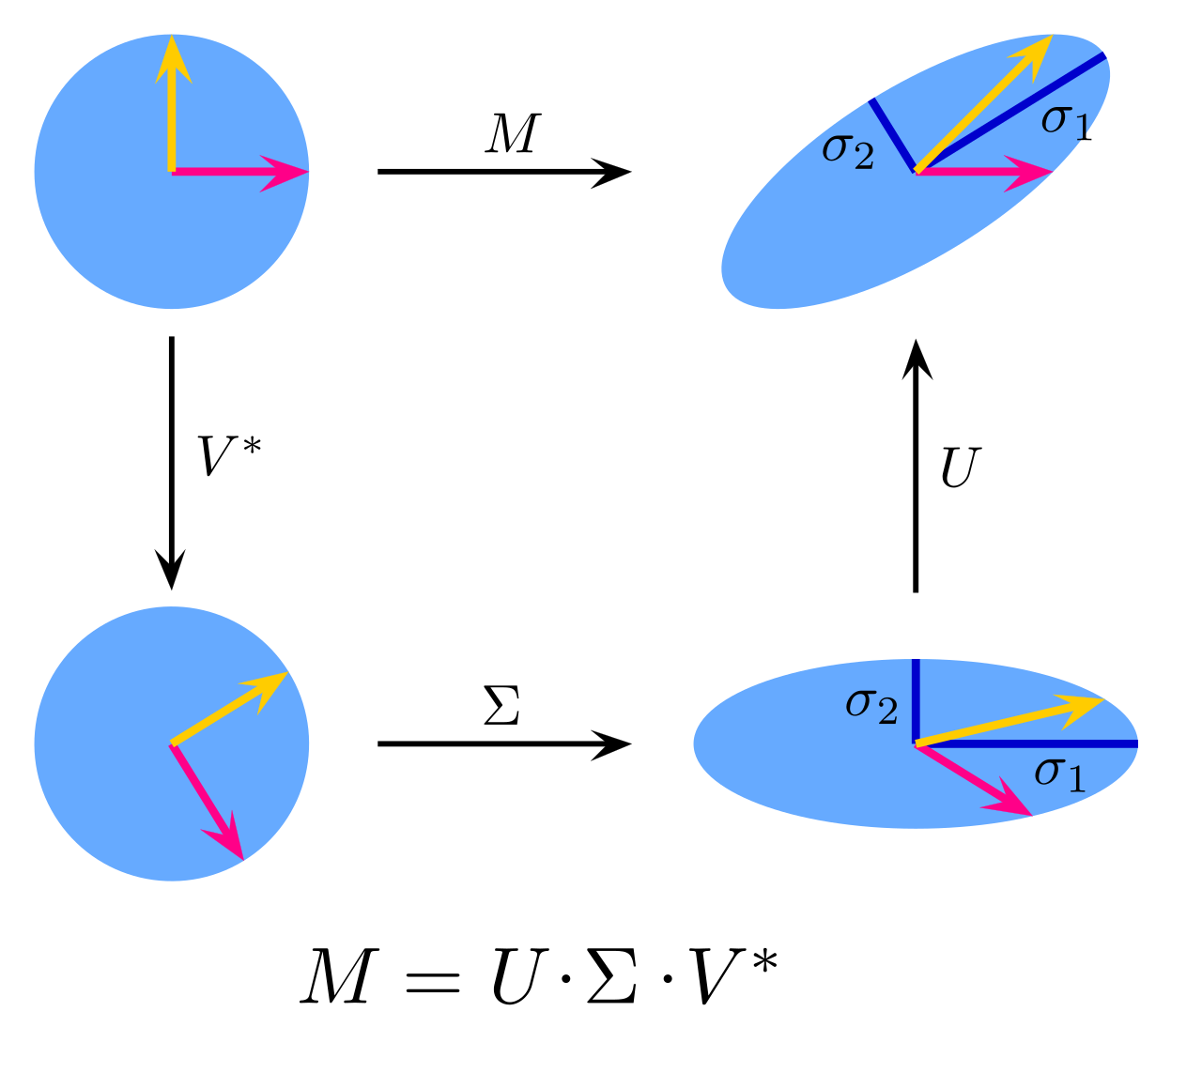
Figure 2: SVD in terms of scaling and rotation of vectors in Euclidean space

So therefore it follows that there exists a decomposition of a matrix A into orthogonal matrices U and V, as a function of a specific diagonal matrix denoted as Σ, a technique that can be used to find latent similarities between documents in a corpus and leveraged to compute document (cosine) similarity. We use this method as one of our baseline forms of feature reduction in the ML testing portion of Layer cake.

Vector Space Models & (Static) Word Embeddings

One of the most widely used techniques for feature space reduction in NLP, the foundations of which go back to the 1970s when NLP and AI fields of research were in their infancy, is vector space models and word embeddings, two very closely related concepts that underpin much of the data model design of the LLMs which dominate the AI landscape today.

Vector Space Models were introduced by Gerard Salton who developed and documented a system called SMART in the early 1970s (Salton, 1971) which was one of the first Information Retrieval systems ever built. This model, along with the introduction of tf-idf vectorization around the same time (Sparck Jones, 1972), set the stage for almost all future research in language representation learning, facilitating further design and development of NLP applications despite the inherent hardware and computational limitations of the time.

More formally, a vector space is described for a given vocabulary V, and a set of words w, where for each w V, there is an associated vector , where d is the fixed number of dimensions for the underlying vector space, effectively bounding the number of features that we use for our NLP model. Vector spaces, once initialized for a given semantic space that is learned from text, support many interesting properties such as vector addition and scalar multiplication, as well as associativity and commutativity in addition as well as a norm, and an inner product, the latter which makes the space especially useful for calculating similarity, or disparity, between words or tokens in the underlying space.


Figure 3: document query in vector space

Approaches such as VSMs or LSI/LSA are sometimes as distributional semantics and they cross a variety of fields and disciplines from computer science to artificial intelligence, certainly to NLP, but also to cognitive science and even psychology. The methods, which are rooted in linguistic theory, use mathematical techniques to identify and compute similarities between linguistic terms based upon their distributional properties, with again TF-IDF as an example metric that can be leveraged for this purpose.

In this context, these methods which began as VSMs combined with or supplemented by LSI or LSA, have evolved into what we call in NLP research circles today as word embeddings, a semantically encoded (in vector space) representation of words, documents or terms based upon the premise that a given word’s meaning can be understood by its context, or in more vernacular terms, the company it keeps, i.e. what is known as the distributional hypothesis, an idea popularized by John Firth in the 1950s who coined the phrase ‘you shall know a word by the company it keeps’, i.e. that words found within a similar context should in most cases have similar meanings, the basic underlying principle behind the architecture, and effectiveness, of word embeddings.

Representation learning and word embeddings are closely related topics in NLP and the vast majority of research literature devoted to representation learning in NLP in the last few decades has been focused on designing word embeddings which encode this natural language information, and in order to understand the information that ultimately comes to be stored and associated with a given word or token for a given text, it’s necessary to understand how it is that these ‘embedding’ structures are computed.

Word embeddings are dense, low-dimensional, context-sensitive representations of words. They aim to capture semantic relationships between words by mapping them to continuous vector spaces. They are advanced forms of learned (language) representation created using neural networks or other statistical techniques on large corpora. Common methods include Word2Vec, in both its Skip-Gram, CBOW contexts, GloVe, or Global Vectors for Word Representation, and FastText, which are subword-based embeddings. These three classes of word embeddings represent the core of the word-based embedding tests that are in scope for layer cake testing.

With static word embeddings, each word is represented by a dense vector of much smaller dimensionality (e.g., 300 for GloVe and Word2Vec typically) and the embeddings are computed, i.e. ‘learned’, by taking advantage of the distributional hypothesis in order to capture semantic relationships, the classic example being king – man + woman = queen, i.e. words closer in meaning will have vectors closer in Euclidean or cosine space.

Figure 4: Word Embeddings in Vector Space

Word2Vec for example, the earliest of these static word embedding (language) models, uses deep learning and word co-occurrence metrics to learn embeddings by predicting words based on (local) word contexts leveraging either a continuous bag of words (CBOW) approach, where the model is optimized to predict the target word given a specific context, or a Skip-Gram predictive approach where the context of a word is predicted given the target word. Ultimately, Word2Vec language models produce embeddings that reflect the distributional hypothesis, where words that appear in similar contexts are represented by embeddings that are geometrically close to each other as defined by the underlying embedding / vector space. In other words, the model is trained to find the coordinates each word in a latent feature space where distances between vectors reflect their semantic similarity.

GloVe (Global Vectors for Word Representation) embeddings on the other hand, introduced in 2014 (Pennington, et al., 2014), leverages both local and global word context to generate word embeddings, explicitly constructing a word co-occurrence matrix during training that records how often two words appear together within a context window across a corpus. It then factorizes this matrix via log-bilinear regression, optimizing a cost function which minimizes the difference between the dot product of two-word vectors and the logarithm of their co-occurrence count, effectively balancing both local and global co-occurrence statistics for the words in question.

FastText on the other hand, while very much related to Word2Vec in the sense that it is also a local co-occurrence computed (static) word embedding model, it is unique in that it introduces the concept of subwords, or n-grams, to provide better support for out of vocabulary terms (OOV) that were not including in the training dataset. Where Word2Vec and GloVe models treat each word as a single atomic unit, FastText breaks down words into character n-grams (subword units) - for example, the word "apple" might be broken down into character n-grams like "app," "ppl," and "ple." If the n-gram size were 3. In this model, each word is represented not only by its word-level embedding but also by the embeddings of its subwords (n-grams) which enables FastText to generate embeddings for OOV words by composing them from the embeddings of their subwords. During training, FastText learns embeddings not just for entire words but also for their subword n-grams, and when creating the final vector for a word, FastText aggregates the word's subword embeddings (and its own embedding if available) into a single vector, resulting in embeddings that can handle morphologically rich languages better than Word2Vec, which cannot break words into smaller units.

Just like Word2Vec, FastText operates in a continuous Euclidean space (or more generally, a vector space) where words with similar meanings have vectors that are close together and relationships between words can be modeled as linear transformations (e.g., "king - man + woman ≈ queen"). Since FastText breaks words into subword units (n-grams), this means that similar words (e.g., "running" and "runner") will have more similar vectors than they would in Word2Vec, due to shared subword components ("run"). FastText also constructs vectors geometrically, learning word and subword representations from their co-occurrence patterns in a latent space. This geometric model allows FastText to capture not just word-level relationships, but also similarities across words with shared subwords, such as morphological variations of the verb ‘run’, such that the words "run," "running," "runner" will have closer embeddings because of shared subwords. Because of its inherent subword design, FastText can produce reasonable embeddings for out-of-vocabulary words based on their subwords than their word-based counterparts such as GloVe or Word2Vec.

It is fair to say that the introduction of word embeddings, an offshoot of vector space models, revolutionized language representation, allowing words to be represented as low-dimensional continuous vectors, but because they are static representations, i.e. are not context aware, they are relatively easy to work with from both a computational standpoint as well as from a language representation architecture standpoint. That is to say, given the clean mapping of a word to an embedding, one can enhance this structure relatively easily within the context of a neural network classifier by simply concatenating one embedding form with another, a technique we use in the ML baseline testing part of this study for example.

Context Aware Embeddings (Transformers)

TF-IDF / Count Vectorization is explicit, algebraic construction based on word frequencies. Each vector dimension represents a distinct, interpretable feature (e.g., the presence or absence of a word), representing a direct frequency-based transformation of the raw data. Word2Vec and GloVe on the other hand, are geometric based, implicit constructions of word vectors in a continuous latent space. Vectors are learned through training on large corpora to capture semantic and syntactic relationships. These are dense, distributed representations where each dimension captures abstract relationships rather than direct counts. In essence, while TF-IDF and Count Vectorization build vectors through explicit algebraic transformations of text data, Word2Vec, FastText and GloVe embedding models use machine learning to geometrically place words into a latent vector space based on their usage patterns in large corpora – with Word2Vec and FastText using local co-occurrence information to construct the vector space and GloVe using global context to construct the vector space. The text vectorization techniques yield clear, interpretable vectors (e.g., word counts), while the latter produces more abstract, dense representations.

However, because these forms of text vectorization and word embeddings lack context awareness, i.e. are ‘static’, they therefore do not address problems of polysemy which are fundamental to human language. This is a significant intellectual boundary with respect to the utility of these models for driving more advanced, more intelligent, NLP applications as much of the meaning of language is driven by context, and therefore a language representation form which encapsulates and encodes the contextual meaning of language is necessary for NLP applications to have a proper “understanding” of the underlying text. This is precisely the next level of advancement in NLP that has revolutionized NLP applications and AI more broadly which was ushered by the introduction of context aware embedding generation techniques, i.e. transformers, which were introduced in 2017 by the seminal paper “Attention is all you need” (Vaswani, et al., 2017). These models facilitate the encoding of contextualized representations of natural language that can then be used to drive more advanced NLP solves – like for example what we see now in LLMs which are trained using transformer architected deep learning techniques designed specifically to capture the nuanced, contextualized structure of natural language and which computationally generate text representation forms (embeddings) which are specific to a given context within a specific corpus of text given a certain model design and training criteria.

Almost all the most popular and influential LLMs in use right now leverage this attention-based architecture which has replaced virtually all of the prior deep learning architectures that came before it (e.g. RNNs with self-attention mechanisms) which have underpinned state-of-the-art results in machine translation, text classification, natural language understanding, and (natural) language generation tools and applications. These models, and their associated platforms and operational infrastructures, have pushed the boundaries of NLP and AI, enabling applications such as conversational agents, document summarization, and zero-shot learning and have led to a technological revolution the likes of which we have not seen since the advent of the Internet two decades ago.

Transformers were first introduced in 2017 in the oft cited paper “Attention is all you need” which came out of Google’s AI research lab (Vaswani, et al., 2017) and was specifically designed to generate context-aware embeddings from natural language. Some of the early influential deep learning approaches to NLP which leveraged transformer architectures and attention mechanisms to compute contextualized (dynamic) text representation forms of natural language were ELMo (Embeddings from Language Models), which was introduced in 2018 (Peters, et al., 2018) which generated contextualized embedding representations of text via the combination of bidirectional LSTM layers, and BERT (Bidirectional Encoder Representations from Transformers) was introduced in 2019 (Devlin, et al., 2019) and leverages a unique, bidirectional approach to contextualized embedding computation which, in both its original form and in many branches of derivation, is still a common approach to NLP solves such as sentiment analysis, question answering, and named entity recognition.

Generally, these transformer model architectures can be described in algebraic, probabilistic, and geometric terms, but they diverge from simpler (static) word embedding models because they generate context-dependent representations for each token using self-attention mechanisms, the core thrust of the 2017 work. The main difference between these models and earlier approaches like Word2Vec, GloVe, or FastText is that the embeddings generated by BERT and RoBERTa are:
- Contextual: The same word can have different embeddings depending on its context.
- Subword-based: They break words into subwords (word pieces), similar to FastText, but the focus is on dynamic tokenization based on context.
- Deep embeddings: Generated from multiple layers of Transformer networks.

We use three BERT based models for this study and given BERT’s architecture and its well-known suitability for text classification. BERT, which stands for Bidirectional Encoder Representations from Transformers was released in 2019 (Devlin, et al., 2019), and was closely followed by several variants which optimized it in different ways, two of which we use for this study. The first is RoBERTa, or Robustly Optimized BERT Pretraining Approach which was released shortly after BERT also in 2019 (Liu, et al., 2019) and, as the name suggests, represents a tuned and optimized variant of BERT. DistilBERT, a smaller and faster variant of BERT was also released in 2019 (Sanh, et al., 2020) and showed that the core model could be distilled in a manner that allowed it to perform faster and require less computational resources, i.e. was smaller, and yet still performant in core NLP and NLU capabilities.

These language representation forms, although still ultimately working with embedding structures, encode sequential (language) data and as such have the capability - leveraging their specific type of transformation architecture (encoder, decoder, or encoder-decoder) - to capture, represent, and leverage the meaning of words (or subwords or tokens given the underlying model architecture), to solve the polysemy problem and drive better results across a wide variety of NLP tasks and problem domains. Transformers have now become de facto standard architecture for large-scale pretrained language models (LLMs) and techniques for tailoring and tuning the models for specific tasks and/or datasets - a method first introduced in 2018 by (Howard & Ruder, 2018) - is presently a very active area of research,

Transformer Architectural Variants

Transformer models come in three major categories or architectures, each of which, given its particular design and training method, is designed and optimized for specific types of (NLP) tasks. The most well-known of these is the decoder only models, which are designed for (language) generation tasks, but then there are also encoder only models which are designed for text classification tasks, and then encoder-decoder models which are designed for more explicit conversion tasks like text to text translation or text summarization.

Encoder-only models process the input sequence to generate contextualized embeddings for downstream tasks. With encoder only models, input tokens are first embedded into a vector space and enriched with positional information where each token attends to every other token in the input sequence to create contextualized embeddings. To capture information from multiple subspaces, multi-head attention is used, and then each token’s embedding is passed through a position-wise feedforward network. The encoder outputs a sequence of contextual embeddings that can be pooled or directly used for downstream tasks.

Unlike decoder-only models, encoder-only models use bidirectional attention, allowing each token to attend to all other tokens simultaneously. They are designed to produce contextualized embeddings that capture relationships between tokens and are primarily used for tasks requiring comprehension rather than generation. These embeddings are usually used for text classification, regression, or other sequence-level or token-level tasks, and some of the best examples of this type of transformer architecture are BERT (Bidirectional Encoder Representations from Transformers) (Devlin, et al., 2019), RoBERTa: an optimized variant of BERT, (Liu, et al., 2019), and DistilBERT (Sanh, et al., 2020), a lightweight version of BERT - all three of which are used in this study.


Figure 5: BERT (encoder only) input representation (Devlin, et al., 2019)

Decoder-only transformer models consist of only the decoder component from the transformer architecture. These models train autoregressively, where each token is generated step-by-step, attending only to tokens already generated (aka causal masking). Because they are unidirectional, i.e. causal, tokens can only attend to earlier tokens in the sequence, ensuring the model predicts tokens in a left-to-right manner. These types of models are mainly designed for generation tasks like chatbots or code generation tools (like ChatGPT) and as such they can do without explicitly needing an input sequence encoder. Some of the best examples of these models are the GPT (Generative Pre-trained Transformer) class models which have been made famous by OpenAI and are the underlying models that power the various versions of ChatGPT (Radford & Narasimhan, 2018) (Brown, et al., 2020), as well as LLaMA (Touvron, et al., 2023) from Facebook (now META).

Encoder-decoder type transformer models, as the name implies, consist of two distinct parts, an encoder which processes input data (e.g., text, image, or other modalities) and generates a context-rich representation (a latent state vector), and a decoder which uses the encoder’s output to generate a sequence (e.g., translated text, summaries) in the target domain. The encoder and decoder are linked by attention mechanisms, allowing the decoder to attend to the encoder's output. A bidirectional encoder, as they are sometimes called, captures context from both past and future tokens in the input sequence and an autoregressive decoder predicts output tokens sequentially, using previously generated tokens and the encoder’s output.


Figure 6: Encoder-Decoder transformer architecture (Vaswani, et al., 2017)

Examples of bidirectional, autoregressive encoder-decoder transformer architecture models are T5, the Text-to-Text Transfer Transformer (Raffel, et al., 2020) that came out of Google, BART (Bidirectional and Auto-Regressive Transformers) which combines bidirectional encoding with an autoregressive decoder (Lewis, et al., 2020) as well as the original transformer described in the seminal paper introduced by Vaswani et al. in 2017 (Vaswani, et al., 2017). These models are designed for sequence-to-sequence tasks such as machine translation (e.g., English to French), text summarization or text-to-speech and image captioning applications which are designed to generate one modality from another.

In brief, encoder-only models (like BERT, DistilBERT and RoBERTa) focus on understanding the input, whereas decoder-only models (like GPT-2 and GPT-3) focus on autoregressive generation, and encoder-decoder models (like T5 or BART) handle both input comprehension and output generation. We test a broad set of all three types of transformers in this work, giving us an opportunity to see how each type performs within the context of self-contained, well defined, text classification problem.


Figure 7: Language Model Evolutionary Tree

Tokenization Strategies
One of the other distinguishing, groundbreaking and yet oft not spoken of features of LLMs which facilitate their performance across a wide variety of NLP problem domains across a wide variety of languages in fact, including their ability to understand or make sense of words that they have not seen in training, is their tokenization strategies, which are quite sophisticated relative to their static embedding language model counterparts and which underpin model effectiveness across the NLP problem solving landscape.

Tokenization is the process of splitting text into smaller units, or tokens, which serve as the input to language models in the form of embedding structures that map to the individual tokens and then an indexed vectorization representation of the underlying text which is then used within the context of the model training forward pass (in the case of fine tuning for text classification that is covered in this work for example) to build the contextualized embedding representation of the text that can then be used as input into a classifier or some other neural network that is designed for a specific (NLP) task.

Word2Vec and GloVe use word-level tokenization, which results in significant OOV issues especially when one tries to use the model on a corpus of text that includes terms that the underlying model was not trained on – like medical data for example. FastText addresses this problem using a subword, or n-gram tokenization approach, which allows the model to generate embeddings for OOV words by constructing the embeddings using its n-gram / subword constituents. LLMs on the other hand, begin by tokenizing text into smaller units (words, subwords, or characters), where each token is mapped to a static, high-dimensional vector (which is sized according to the language model specification, e.g., 768-dimensional for BERT-base, 1024-dimensional for GPT-2, etc.) from an embedding matrix which is then used as input to the calculation of context aware embeddings during model training and fine tuning.

Some of the most important and relevant tokenization techniques used by modern transformers are

- WordPiece tokenization: Introduced in 2012 (Schuster & Nakajima, 2012) is used by BERT, RoBERTa and DistilBERT models and is designed to break split words into subwords, balancing the vocabulary size and coverage - for example, "unhappiness" is tokenized as ["un", "##happiness"]. This approach supports OOV words efficiently by representing rare words as sequences of subword tokens, like FastText.
- Byte Pair Encoding (BPE): introduced in 2016 (Sennrich, et al., 2016) iteratively merges the most common pairs of characters to create a fixed-size vocabulary. BPE is also a subword based tokenization method, but it merges character sequences based purely on frequency – e.g. ‘th’ + ‘e’ -> ‘the’. BPE works in a greedy and deterministic manner, which is different from the probabilistic approach taken by WordPiece tokenization. BPE is the underlying tokenization strategy for OpenAI’s GPT models as well as RoBERTa in its SentencePiece implementation form. BPE is an efficient form of compression and also gracefully handles OOV.
- SentencePiece tokenization: introduced in 2018 (Kudo & Richardson, 2018), which treats text as a raw stream of characters, learning subwords directly from unsegmented text, a method that is very different than the whitespace based tokenization methods that are characteristic of both BPE and WordPiece and facilitates the proper handling of languages that do not have explicit word boundaries, like Japanese or Chinese. XLNet, LLaMA and DeepSeek all employ SentencePiece tokenization methods, making them well suitable for Chinese and Japanese languages.

In aggregate, Transformer tokenization strategies (WordPiece, BPE, and SentencePiece) offer robust handling of OOV words, sound support for multilingual text as well as domain-specific languages, outperforming traditional word-based methods in. variety of NLP contexts and providing more flexibility than FastText’s fixed n-gram subwords. Innovations in tokenization which underpin transformers have played a pivotal role in their success.

Geometrical Considerations

In the LLM world, similar in many respects to their static embedding model counterparts, the embedding space within which the language representation lives is a continuous, high-dimensional vector space where semantically similar tokens are closer together - similar to the static word embedding models described above as well as vector space models in general.
However, it is worth noting here that given the level of contextual semantic information that is encoded into these transformer, deep learning generated embedding structures, research has also shown that there exist other more nuanced relationships between word (tokens) that gets encoded into the super high-dimensional semantic space within which these dynamic embedding structures exist and are co-created with essentially.

For example, semantic structures were found to be associated with transformer generated embeddings (i.e. LLMs) as a technique for visualizing embeddings structures in (Yun, et al., 2021), two interesting studies were performed in 2024 that show that syntactic relationships are encoded, at least to some degree, as linear transformations (Hernandez, et al., 2024), (Simon, et al., 2024), and implicit (semantic) hierarchies were shown to be extractable from LLMs in (He, et al., 2024). It's also been found that this same geometrical feature encodes categorical, or conceptual hierarchical information as well. For example, the study "The Geometry of Categorical and Hierarchical Concepts in Large Language Models" (Park, et al., 2024) demonstrates that LLMs represent categorical concepts as simplices in their embedding spaces. Moreover, another study also from 2024, from the same research team entitled “The linear representation hypothesis and the geometry of large language models” (Park, et al., 2024) has shown that hierarchically related concepts are organized into orthogonal subspaces which accurately reflect their hierarchical relationships.

All these studies point to sophisticated geometrical structures that align with word, or more precisely token, meanings that are encoded into, and can be extracted from, the high dimensional semantic space within which these embedding structures reside. In other words, the semantic spaces within which these LLMs operate, given the way the models are architected and how much they have been scaled at this point, support semantic similarity type relations like any vector space model, but they also inherently capture syntactic, as well as categorical and hierarchical information as well, a concept which has come to be known as the linear representation hypothesis.

Furthermore, there has been significant research, and proven effectiveness, of embedding spaces that are non-Euclidean, perhaps the most prominent of which are hyperbolic geometric spaces which are geometries that are n-dimensional Riemannian manifolds of constant curvature (equal to -1). The space is symmetrical, and due to its constant curvature property, and the ability in certain variations to have a distance measure that is differentiable, lends itself to the encoding of hierarchical (semantic) structures which can be extremely useful in various NLP application settings.

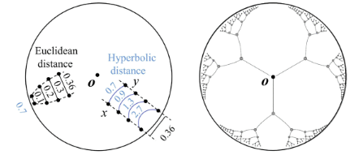
Figure 8: 2D Poincaré Disk representations of semantic space

Like for example in the illustration above which shows a 2D representation of a 3D hyperbolic geometrical structure (a slice of the 3D space basically) known as a Poincaré Disk, geometry that is used in many of the training methods that have proven to be effective at training word embeddings in NLP applications which require, or are enhanced by, hierarchical semantic relations – like those that are implicit in dictionary definitions for example. Some interesting studies along these lines are (Tifrea, et al., 2019) which shows a GloVe embedding trained approach in hyperbolic space, (Leimeister & Wilson, 2019) which shows a skip-gram (aka Word2Vec like) approach to building embeddings in hyperbolic space, and (Valentino, et al., 2024) which constructs hierarchical embeddings in hyperbolic space from dictionary entries.

These findings underscore the capacity of LLMs to encode and utilize hierarchical structures within their embedding spaces, aligning with the manifold hypothesis which is another profound mathematical principle that we see manifest in language (and therefore applies to NLP and AI) which states more or less that, at least mathematically speaking, despite the highly complex, inter-related and high-dimensional semantic structure of language, most core, meaningful linguistic data can actually be found on a lower-dimensional manifolds, meaning that language can be both modeled and understood to a large extent by focusing on smaller sets of underlying (semantic) variables or patterns, rather than considering every possible combination of features. This fundamental characteristic of language, inherited from linguistics (and in this case also mathematics) as many principles from NLP are, is exploited via principal Component Analysis, a popular, and extremely effective feature reduction technique used in NLP.

Text Classifier Design & Architecture

In this section we describe the classifiers that we use in Layer Cake, a broad set of models that have all proven to be very effective in the field of text classification, a core NLP research area that has a long history that predates deep learning and neural networks We cover the baseline ML models that we test with first briefly, followed by a longer description of neural networks and deep learning techniques in text classification problems, focusing on the models that are covered within the scope of this research.

We briefly cover the design of these baseline ML classifier designs and then look at the confluence of deep learning and text classification, the backbone of this work, focusing on the major design improvements and the classifiers that we use in this study primarily.

Machine Learning (baseline) Classifiers

There are a variety of Machine Learning models that solve classification problems, and in particular text classification problems which are characterized by high dimensional feature spaces. Three such models we cover here that have been shown to be very effective in this problem domain – namely Support Vector Machines, Logistic Regression and Naïve Bayes Classifiers. These three classifiers form the basis of what we call baseline metrics with respect to how well a classifier would be expected to perform against the datasets in question, using the various forms of language representation that we feed into the respective models.

Logistic Regression

Logistic Regression (LR) is a probabilistic model that was introduced into statistics in the 1950s (Cox, 1958) and is still used extensively for binary and multiclass text classification. It models the probability of a document belonging to a class using the logistic function, sometimes called a sigmoid function, which is also commonly used in a variety of neural networks as well as logistic regression models, the mathematical equation looks like the following:

where the function takes an input x and maps it to a value between 0 and 1. The denominator contains the exponential function , ensuring that the function is always positive and asymptotically approaches 0 for very negative inputs and 1 for very positive inputs. The logistic function is S-shaped (sigmoidal) and is useful for modeling probabilities, as in the figure below.


Figure 9: sigmoid function (logistic regression)

In logistic regression, the sigmoid function is used to map predictions to probabilities. It transforms any real-valued number into the range 0 to 1, making it possible to interpret the output as a probability. The logistic regression model calculates the probability that a given input belongs to the positive class (class 1) as opposed to the negative class (class 0).

The derivative, which is relatively easily computed, makes the calculation particularly useful for efficiently computing gradients in a neural network setting. The derivative looks like:

Despite its simplicity, it has proven effective for text classification, especially when combined with regularization. In its basic form, logistical regression uses a logistic function to model a binary dependent variable. The logistic regression model defines a decision boundary and uses this boundary to infer the class of a text sample. If the predicted probability is greater than 0.5, the text is labeled as class 1; otherwise, it is labeled as class 0 (or vice versa, depending on the implementation). In the context of text classification, logistic regression is used to predict the probability that a given text belongs to one category or another, making it a popular choice for binary as well as multiclass classification problems.

Support Vector Machines (SVM)

Support Vector Machines (SVM) are powerful supervised learning models that have been widely used in text classification since the 1990s. Their mathematical design looks to find am optimal hyperplane that separates classes in a high-dimensional space feature space, often with a margin maximization principle. SVMs are particularly effective for high-dimensional datasets like text data, where features (words effectively, or tokens in the case of transformer models) significantly outnumber samples, i.e. documents.

If the data is linearly separable, the decision function for SVM models is:

where w is the weight vector perpendicular to the hyperplane, x is the input feature vector (e.g., TF-IDF or word embeddings), and b is the bias term (scalar offset).


Figure 10: visualization of max-margin hyperplane for an SVM with two classes

The SVM aims to maximize the margin between the two classes while ensuring that all training points are classified correctly:

where are the class labels. Support vectors, as they are called, are the data points that lie closest to the decision boundary and define the (size of) the margin, as illustrated in the figure below. The SVM model is designed mathematically to find this optimal hyperplane in the underlying feature space

If the data is not linearly separable, there are a variety of techniques that are employed in order to transform the underlying feature space so that the data is linearly separable – these techniques include introducing a slack variable, called a soft margin, to allow for some level of misclassification, as well as what is called a kernel trick, which transforms the underlying data into a higher dimensional feature space where the data lends itself to being more (linearly) separable.

Naive Bayes Classifier

The Naive Bayes classifier (NB), which we also use in Layer Cake ML baseline testing, is a probabilistic model based on Bayes' theorem that assumes that features are independent (i.e. the naïve part). Despite its simplicity, it is highly effective for text classification, particularly for spam filtering and sentiment analysis. While they are among the simplest Bayesian network models, they have nonetheless proven to be quite effective in many complex real-world situations and provide a good probabilistic baseline metric for classification for the datasets we test.

In text classification, the Naive Bayes model calculates the probability that a given text document belongs to a certain class, based on the text's content. The core assumption of the Naive Bayes model is that the presence (or absence) of each word in a document is independent of the presence (or absence) of any other word, given the class label. This simplification makes the calculation of probabilities tractable and means that each feature (word) contributes independently to the probability that a document belongs to a particular class.

Given a document d and a class c, Bayes’ theorem states:

where:
- is the posterior probability of class c given document d.
- is the likelihood of document d given class c.
- is the prior probability of class c.
- is the prior probability of document d.

For text classification, the document d is represented as a vector of its word counts or word frequencies, i.e. d={w₁,w₂,…,w_{n}}. Since is constant for all classes, only and needs to be maximized, therefore the likelihood is then approximated as:

where is the probability of word w_{i}​ occurring in a document of class c, often calculated using Laplace smoothing to handle zero probabilities, or:

Here:
- ​ is the number of times word w_{i}​ appears in documents of class c.
- is the total count of all words in documents of class c.
- V is the vocabulary size (the number of unique words in all documents).

Deep Learning Models

Machine learning models however, given the way that they represent text and feed data into the underlying model, do not have the ability to account for sequential dependencies in text, leaving a significant gap in their ability to elicit meaning from text as it applies to a variety of NLP problems, text classification included. Recent advancements in NLP have significantly improved text classification through the development of advanced neural network designs, i.e. transformer-based models, which include an embedding layer and a form of language representation that accounts for sequences of text explicitly, using various tokenization strategies to parse the underlying text and feed the tokens into the model for ‘transformation’.

There have been a variety of good research surveys written that shed light on this topic, albeit somewhat dated given the rapid advancements in the field, with particular focus on Pretrained Language Models for NLP broadly published in 2020 (Qiu, et al., 2020), Deep Learning models with respect to Text Classification specifically (Minaee, et al., 2021), and perhaps most applicable with respect to the work here a survey for traditional ML and Deep Learning methods for text classification published in 2022 (Li, et al., 2022).

Early Models: RNNs and LSTMs

The confluence of Deep Learning and Text Classification started in the mid 1990s when Recurrent Neural Networks (RNNs) and Long Short-Term Memory networks (LSTMs) became popular for handling sequences in text, enabling models to maintain context over longer sequences and therefore perform better against text classification benchmarks. One might say that this deeper understanding of the text, with the neural models facilitating greater contextual awareness and more granular and refined processing capabilities (than the machine learning models for example), the models naturally became more effective at classifying the underlying text.

Research in the mid 1980s, for example, showed that neural networks could be very effective at solving text classification problems, with Recurrent Neural Networks (RNNs), one of the simplest form of neural network models, which leveraged the notion of backpropagation for neural network training (Rumelhart, et al., 1986), could be used to effectively process sequences of text for categorization, i.e. text classification. The original RNN research was published in 1990, was entitled “Finding structure in time” (Elman, 1990), and marked the beginning of the evaluation of text in terms of sequences of terms and context as opposed to its individual constituents (phonemes or words) or grammatical syntax.

RNNs however, suffer from the vanishing gradient problem, limiting their ability to retain information over long sequences. Long Short-Term Memory (LSTM) networks are a type of RNN explicitly designed to overcome the vanishing gradient problem. They achieve this through gated mechanisms that control the flow of information, allowing the network to retain important long-term dependencies and forget irrelevant ones. LSTMs were introduced in 1997 (Hochreiter & Schmidhuber, 1997) and, when first introduced, represented a significant step forward over basic recurrent neural networks (RNNs), which suffered from vanishing gradients and were ineffective in capturing long-term dependencies. The adoption of LSTMs for NLP was driven by their success in machine translation as demonstrated initially by (Sutskever, et al., 2014) and later extended to various tasks like text classification and sentiment analysis, and semantic analysis more broadly as indicated by (Tai, et al., 2015) for example.

An LSTM processes text sequentially, word by word, using hidden states and cell states to remember important information from previous words while discarding irrelevant information. A text classification LSTM uses a gated and filter-based approach to classify text, leveraging three gates - a Forget Gate, an Input Gate and an Output Gate – each of which is sequentially applied to the text which ultimately yields output which is then fed into (in our case) a final Linear layer which classifies the text sequence. This architecture is illustrated in the figure below.


Figure 11: LSTM for Text Classification Architecture

LSTMs are designed to capture long-range dependencies in sequential data, making them effective for understanding context over longer passages, and since they model word order explicitly, they are suitable models for tasks that require context-aware understanding. In tasks like text classification, understanding context across sentences is important and since text has an implicit order which reflects the underlying meaning of the text, and LSTMs maintain this context certainly better than RNNs at scale given their problems with vanishing gradients, LSTMs have been proven to improve text classification accuracy over their predecessors, their key innovation (over RNNs) is the linear path through the cell states which allows gradients to flow unimpeded during backpropagation.

Convolutional Neural Networks (2014)

LSTMs, however, are computationally expensive, and researchers sought alternative architectures for efficient processing of textual data. Convolutional Neural Networks (CNNs), previously successful in computer vision (LeCun, et al., 1998), were applied to NLP by learning local patterns and phrases in text using convolutional filters to address some of these drawbacks of LSTMs and have now been successfully adapted to NLP tasks such as text classification, sentiment analysis, and question answering. The paper by titled “Convolutional Neural Networks for Sentence Classification”, published in 2014, was a major milestone in demonstrating that CNNs could achieve state-of-the-art performance on several text classification benchmarks (Kim, 2014).

Unlike images, text data has a sequential structure, so 1D convolutions are used instead of 2D convolutions and a sliding window (aka convolutional filter) moves across the input word embeddings, capturing local patterns or n-grams (e.g., "good movie," "not bad"). Multiple filters with different sizes (e.g., 2, 3, or 5 words) are used to capture varying lengths of local context. After applying the convolution, max pooling selects the most important features, reducing the dimensionality and making the model robust to position shifts. The pooled features are then concatenated and passed to a fully connected layer for classification. An illustration for how this model works is provided in the figure below.


Figure 12: Convolutionary Neural Networks for Text Classification

CNNs for text classification generally are designed to capture local context by sliding filters over the input sequence, making them effective for capturing n-gram patterns (e.g., phrases or local dependencies). This fairly simple design is quite effective at text classification and furthermore is computationally quite efficient, as indicated in this study (see below), as well as a variety of other studies which are cited both in the section as well as in the introductory material to this work as outlined above.

In brief, CNNs effectively represent text by capturing local contextual patterns (e.g., common phrases or word groups) using filters of different sizes, capturing local dependencies (e.g., key phrases) that make them well suited for text classification type NLP solves.

Transformers (2016/2017)

Both LSTMs and CNNs however are not very good at capturing global dependencies efficiently, especially in long documents, and here is where transformers, which are designed to capture this attention, or context, enter the picture. The first framework that was introduced using a type of attention mechanism to contextualize the representation of text was in 2016 (Bahdanau, et al., 2016), where it was shown that these types of architectures - which apply a form of masking of the input sequences to capture context - allowed the model to focus on specific words in the source sentence regardless of their position in the text. This approach was of course made famous by the 2017 paper “Attention is all you Need” (Vaswani, et al., 2017), which - along with advancements in chip architectures which greatly sped up the training of large neural models – led to a new era of NLP and AI with respect to LLMs and language generation tools which underpins much of the advancement in AI applications which has revolutionized the technology landscape today.

Attention based neural models assign different weights to different words in the input sequence based on their importance to the current task. When used in the context of LSTM-based models, attention computes the relevance of each hidden state to the final representation and the final document representation is a weighted sum of the LSTM outputs, where the attention weights determine the contribution of each token. Attention selectively focuses on important parts of the text, improving interpretability and given its flexible design can capture relationships between distant words. Attention based models, in their modern form known as transformers, enhances the performance of LSTMs by mitigating their reliance on the final hidden state, again facilitating the ability of the model to focus on important parts of the input sequence, generally enhancing performance for tasks where not all words are equally important.


Figure 13: ATTN Neural Architecture

With respect to text classifiers specifically, early attention based models such as BERT (Devlin, et al., 2019), and its successors like RoBERTa (Liu, et al., 2019), DistilBERT (Sanh, et al., 2020) and XLNet (Yang, et al., 2019), have dominated the field by leveraging bidirectional context capabilities, dynamic masking training techniques, and knowledge distillation to achieve computational performance gains. Meanwhile, lightweight models like TinyBERT (Jiao, et al., 2020), and MobileBERT (Sun, et al., 2020) have optimized efficiency for mobile applications, and domain specific models have been developed such as SciBERT (Beltagy, et al., 2019) that show the adaptability of these models. Furthermore, it has been shown – as we demonstrate in this work for example – that fine-tuning strategies, aka transfer learning, are effective approaches for tailoring these large, pretrained language models for specialized, targeted problems (like text classification), as outlined for example in (Howard & Ruder, 2018), (Fu, et al., 2023), and (Ding, et al., 2023).

Transformer models come in three major categories or architectures, each of which, given its particular design and training method, is designed and optimized for specific types of (NLP) tasks. The most well-known of these is the decoder only models, which are designed for (language) generation tasks, but then there are also encoder only models which we test thoroughly in this research which are designed for text classification tasks, and then encoder-decoder models which are designed for more explicit conversion tasks like text to text translation or text summarization. A good illustration of the evolution of these different types of transformers, and whether or not they are open or closed source, is illustrated in the oft referenced graphic below from (Yang, et al., 2024).

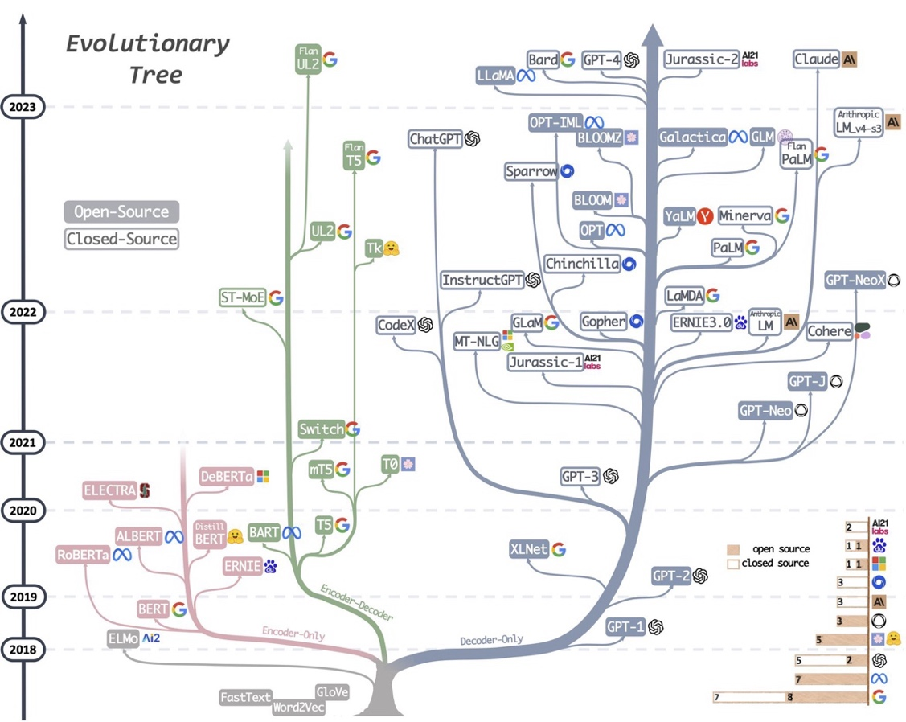
Figure 14: Language Model Evolutionary Tree

Encoder-decoder type transformer models, as the name implies, consist of two distinct parts, an encoder which processes input data (e.g., text, image, or other modalities) and generates a context-rich representation (a latent state vector), and a decoder which uses the encoder’s output to generate a sequence (e.g., translated text, summaries) in the target domain. The encoder and decoder are linked by attention mechanisms, allowing the decoder to attend to the encoder's output.

A bidirectional encoder captures context from both past and future tokens in the input sequence and an autoregressive decoder predicts output tokens sequentially, using previously generated tokens and the encoder’s output. Examples of bidirectional, autoregressive encoder-decoder transformer architecture models are T5, the Text-to-Text Transfer Transformer (Raffel, et al., 2020) that came out of Google, BART (Bidirectional and Auto-Regressive Transformers) which combines bidirectional encoding with an autoregressive decoder (Lewis, et al., 2020) as well as the original transformer described in the seminal paper introduced by Vaswani et al. in 2017 (Vaswani, et al., 2017).

These models are designed for sequence-to-sequence tasks such as machine translation (e.g., English to French), text summarization or text-to-speech and image captioning applications which are designed to generate one modality from another.

Figure 15: Encoder-Decoder transformer architecture (Vaswani, et al., 2017)

Decoder-only transformer models consist of only the decoder component from the transformer architecture. These models train autoregressively, where each token is generated step-by-step, attending only to tokens already generated (aka causal masking). Because they are unidirectional, i.e. causal, tokens can only attend to earlier tokens in the sequence, ensuring the model predicts tokens in a left-to-right manner. These types of models are mainly designed for generation tasks like chatbots or code generation tools (like ChatGPT) and as such they can do without explicitly needing an input sequence encoder. Some of the best examples of these models are the GPT (Generative Pre-trained Transformer) class models which have been made famous by OpenAI and are the underlying models that power the various versions of ChatGPT (Radford & Narasimhan, 2018) (Brown, et al., 2020), as well as LLaMA (Touvron, et al., 2023) from Facebook (now META).

Aspect | Encoder-Decoder Models |  | Decoder-Only Models
Input | Input and target sequences (e.g., English to French). | Single sequence (e.g., text generation).
Attention Mechanism | Encoder: Bidirectional attention.  Decoder: Autoregressive (causal). | Causal (left-to-right) attention only.
Primary Use Cases | Sequence-to-sequence tasks like machine translation, summarization, and captioning. | Autoregressive generation (text generation, chat).
Training Objective | Cross-entropy loss over input-output pairs. | Autoregressive loss for next token prediction.
Output | Structured sequence-to-sequence mappings. | Open-ended, generative text.

Encoder-only models process the input sequence to generate contextualized embeddings for downstream tasks. With encoder only models, input tokens are first embedded into a vector space and enriched with positional information where each token attends to every other token in the input sequence to create contextualized embeddings. To capture information from multiple subspaces, multi-head attention is used, and then each token’s embedding is passed through a position-wise feedforward network. The encoder outputs a sequence of contextual embeddings that can be pooled or directly used for downstream tasks.

Unlike decoder-only models, encoder-only models use bidirectional attention, allowing each token to attend to all other tokens simultaneously. They are designed to produce contextualized embeddings that capture relationships between tokens and are primarily used for tasks requiring comprehension rather than generation. These embeddings are usually used for text classification, regression, or other sequence-level or token-level tasks, and some of the best examples of this type of transformer architecture are BERT (Bidirectional Encoder Representations from Transformers) (Devlin, et al., 2019), RoBERTa: an optimized variant of BERT, (Liu, et al., 2019), and DistilBERT (Sanh, et al., 2020), a lightweight version of BERT - all three of which are used in this study.

Figure 16: BERT (encoder only) input representation (Devlin, et al., 2019)

In brief, encoder-only models (like BERT, DistilBERT and RoBERTa) focus on understanding the input, whereas decoder-only models (like GPT-2 and GPT-3) focus on autoregressive generation, and encoder-decoder models (like T5 or BART) handle both input comprehension and output generation. The field continues to evolve with increasing emphasis on scalability, efficiency, and adaptability, ensuring that text classification remains a central pillar of NLP research. Surveys like those by (Minaee, et al., 2021) and (Li, et al., 2022) while somewhat dated, nonetheless provide essential overviews of these advancements, summarizing progress and outlining future challenges in NLP, and the 2024 study (Yang, et al., 2024) providing perhaps the best overview of the LLM landscape after the introduction of ChatGPT.

Computational Complexity Perspectives

Part of what we look to shed light on in this work is the different computational requirements of the different models, in particular in light of the fact that the underlying hardware dependencies for the different models are different – with the machine learning classifiers being CPU bound and the neural models being GPU bound. This of course means, and this is especially true given the underlying cost of a high-end GPU versus a high end CPU, that we are not dealing with apples to apples comparisons when we look at the performance of the classical ML (CPU bound) vs neural (GPU bound) classifiers with respect to training time (the timelapse value in Layer Cake).

GPUs are, at present at least, particularly the high-end GPUs, more costly than high end CPUs and require specific software libraries to be used effectively – like for example CUDA which is used throughout this work to test the neural classifiers. When building neural classifiers, the only choice to build the models at scale is to use a parallel GPU environment, aka a High Performance Computing environment, and then use the underlying software libraries – PyTorch in our case – to manage the parallelism across the GPUs. It’s worth noting that given the size of LLMs, in almost all cases except the smallest of the models, a parallel GPU computational environment is necessary to do any computation at all as the models themselves will not fit on a single GPU.

Having said that, in order to fully appreciate the runtime computational costs of the various classifiers that we look at within the context of this work, its necessary to establish the theoretical computational requirements of each of the models that we are working with, even if those models are running on different hardware. To that end, we describe the computational complexity of each of the classifiers we test with within the context of Layer Cake and this research below.

Machine Learning Classifier Computational Complexity

Generally speaking, when evaluating running times in Natural Language Processing (NLP), the underlying computational complexity rests on three fundamental properties of the program essentially:

- number of classes in our dataset (C),
- number of training samples (n),
- feature dimension (vocabulary size, embeddings, etc.) (d), and
- model-specific operations (optimization, probability computation, etc.)

We look at each of the different ML classifiers we use within the context of this work along these three dimensions (and others), suing the classic Big O notation, which is the way in which running time performance, also known as computational complexity requirements in theoretical computer science, is measured.

Logistic Regression

The Logistic Regression (LR) classifier we use is a linear model that optimizes a logistic loss using gradient descent or quasi-Newton methods (e.g., L-BFGS), the latter of which we use in this study which is the default mode for the sklearn API we leverage in Layer Cake (LogisticRegression). For the multi-label case, we use a OneVsRest approach, the more complex classification case where the computational complexity is:

where:
- C is the number of classes,
- n is the number of training samples, and
- d is the number of features in the model (which for a non-reduced tf-idf or count vectorizer is the size of the dictionary for the underlying dataset).

Given this computational complexity model, we can understand that LR classifiers are efficient for small and medium size datasets, but given the quadratic dependency on n, the number of training samples in our dataset, we can expect the training time of these types of classifiers to slow considerably when working with datasets that have a lot of training samples. We see this issue arise for example when we are working with the RCV1 dataset which has 800,000 documents in its training set, significantly larger than most of the other datasets we test with.

Predicting the class label on the other hand only requires computing w ⋅ x + b and applying the sigmoid function which, in the multi-label case, is which makes logistic regression very efficient for real-time classification, once the model is trained and constructed.

(Linear) Support Vector Machine

Support Vector Machines (SVMs) come in two flavors, a simple case which uses what is known as primal optimization, or linear SVM, or a more sophisticated dual optimization approach if the underlying data is not linearly separable, known as a kernel SVM model. We use the former approach in Layer Cake taking advantage of the LinearSVC API from sklearn, again leveraging the OneVsRest classification approach for multi-label classification.

With LinearSVC, we have a runtime complexity that is quite similar to the LR model we are using, that is:

where again we have:
- C is the number of classes,
- n is the number of training samples,
- d is the number of features in the model (which for a non-reduced tf-idf or count vectorizer is the size of the dictionary for the underlying dataset), and
- k is the number of iterations of the SVM solver

The difference here with the LR model being that a) we are not quadratic with respect to n (# of training samples), and b) we add an additional parameter to the complexity estimate which is the number of iterations that the model must run in order for the optimal support vector to be found (k).

Similar to our LR model, the Inference complexity is also , so generally speaking we should expect the SVM and LR classifiers to have almost the same inference times and for the SVM classifier to be a bit more efficient when working with the larger datasets.

Naïve Bayes

The Naïve Bayes (NB) classifier we use, is a probabilistic classifier that assumes feature independence (i.e. is naïve). In Layer Cake, we use the MultinomialNB API from sklearn, again using the OneVsRest approach for classification of our multi-label datasets. In these types of models, training involves computing probabilities from frequency counts, which (in the multi-label case) is:

where:
- C is the number of classes,
- n is the number of training samples, and
- d is the number of features in the model (which for a non-reduced tf-idf or count vectorizer is the size of the dictionary for the underlying dataset), and

This is faster than either the SVM or the LR models we use, making it ideal for large datasets and a good benchmark in terms of both model construction time and model efficacy.

To classify a new document, i.e. or the inference time of the NB model, the model must compute the posterior probability for each class c ∈ {1, 2, …, C} using the formula:

which has a running time complexity of , making inference time also very efficient.

Having said that, one of the underlying constraints of using a Naïve Bayes classifier is that it does not support negative values (what’s a negative probability?) which makes the model well suited for vectorization techniques like TF-IDF or Count (Bag of Words) language representation forms but ill-suited for embeddings which typically work in a negative space. This holds true for both static or dynamic embedding language models.

Comparison Table
Classifier | Training Complexity | Inference Complexity | Notes
Logistic Regression |  |  | Fast training with SGD, efficient inference
Linear SVM |  |  | Similar to logistic regression
Naïve Bayes |  |  | Fastest, but relies on independence assumption

Neural Classifier Computational Complexity

Neural classifiers do not have a dependency on the number of classes or the number of features in the model per se but are tied to the complexity of the neural model in terms of how it computes the class for a given input sequence and what the underlying embedding size, aka hidden layer size, is.

We look at the CNN, LSTM and ATTN based model computational complexity parameters below, keeping in mind that from a hardware perspective, we are performing different types of operations on different types of chip architectures so while the theoretical bounds may be looked at within the context of the model and training data sizes just like we do for the ML classifiers, we again are not dealing with an apples to apples comparison here in terms of the actual runtime it takes to perform a given operation.

In other words, the operations themselves that we are evaluating within the context of neural classifiers (linear algebraic operations on GPUs) are significantly more complex in and of themselves that then operations that we are evaluating from a computational complexity standpoint in the ML model cases (mathematical operations on CPUs).

Convolutional Neural Networks (CNNs)

CNNs are used in NLP by applying 1D convolutions over sequences of word embeddings (e.g., Kim’s CNN for text classification). A 1D convolution over a sentence with length n and embedding size d using f filters of size k requires:

where:
- n is the sequence length, i.e. the number of tokens,
- d is the dimensionality of the input embeddings (i.e. the hidden layer size in the transformer models),
- f is the number of convolutional filters, or layers, and
- k is the kernel (filter) size

If there are multiple layers (depth L), the total complexity becomes:

At inference, applying the same convolutions and max pooling has complexity , which is efficient at least as compared to recurrent models.

Long Short-Term Memory (LSTM) Networks

LSTMs process input sequentially, making them – relatively speaking - computationally expensive. With respect to computational complexity for model training, or construction, we must account for the fact that each LSTM cell has 4 matrix multiplications per time step, yielding:

where:
  - n is the sequence length,
  - d is the input embedding size,
  - h is the hidden state size

If we have multiple layers (L), the total complexity for model training is:

An important factor here is that this complexity grows linearly with sequence length, which means that LSTMs, as well as CNNs in fact, start to slow down (linearly) for long documents as a function of sequence, or document size.

Inference computational complexity in turn has the same time complexity as training, i.e. .

Attention-Based Models (Transformers)

Transformers use self-attention instead of recurrence, making them highly parallelizable. Their training computational complexity is a function of the attention weights for all pairs of words (in the masked attention block, so as a function of context window), or

where:
- n is the sequence length, and
- d is the input embedding size,

This means we have a quadratic type of computational requirement relative to the sequence size, which makes these models even more sensitive to longer (text) sequences, or documents as they are typically called in NLP.

A full Transformer model with multi-head attention and feedforward layers has a computational complexity of:

where:
- n is the sequence length,
- d is the input embedding size, and
- L is the number of Transformer layers.

Unlike LSTMs, attention can be parallelized but still requires which makes inference time for attention-based models, i.e. transformers, slower for long documents than CNNs.

Computational Complexity Summary

The summary of the Big O notational perspective then for each of our classifiers looks like the following summary table below, again keeping in mind that the operations for the ML classifiers are by their nature different than, and simpler (and more cost effective than) their neural counterparts which more or less require GPUs in order to run in any reasonable time for any reasonably sized model and/or dataset.

Model | Training Complexity | Inference Complexity | Notes
Logistic Regression |  |  | Fast training with SGD, efficient inference
Linear SVM |  |  | Similar to logistic regression
Naïve Bayes |  |  | Fastest, but relies on independence assumption
CNN |  |  | Fastest for local patterns
LSTM |  |  | Slowest, processes sequentially
ATTN (transformer) |  |  | Best for long-range dependencies

When looking at this from a chart perspective, we get something like the chart in the figure below, which is a sort of corollary for what we would expect from a runtime / computational complexity perspective with our models.

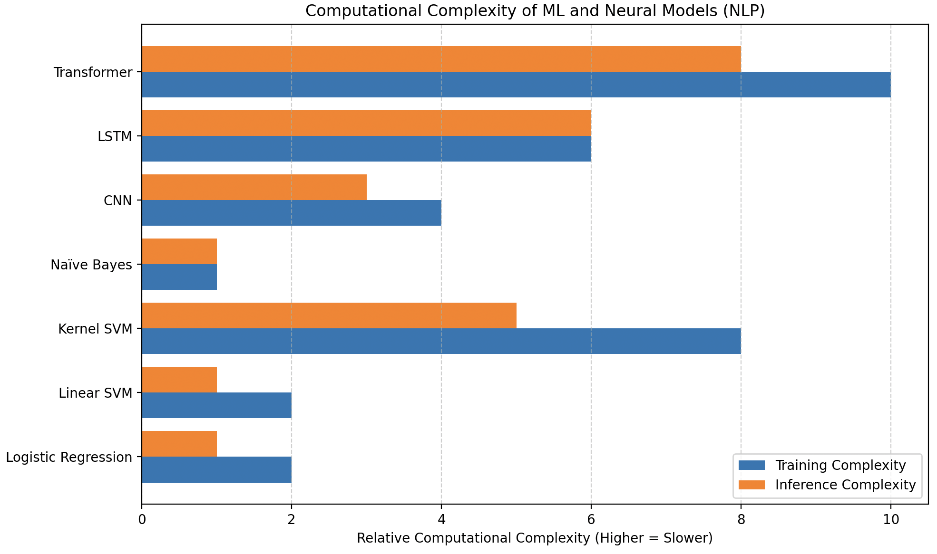
Figure 17: Classifier Computational Complexity Summary Chart

And indeed, most of our results bear out this analysis, as we would expect.

Layer Cake Setup & Scope

Our experiments consist of three separate test scripts, each of which tests a different set of classifiers with each of the language models and each of the datasets, using different language representation forms which vary by classifier, each of which requires a slightly different dataset preparation. We follow the 2019 paper by (Moreo, et al., 2021) with an expanded footprint for the base machine learning models where we look at Logistic Regression and Naïve Bayes along with Support Vector Machines and then expand into the transformer-based models where we build off of the hugging face transformers library.

The ML baseline testing module (ml_classification_test_version.py) module covers the baseline machine learning classifiers that we test with, namely Support Vector Machines and Logistic Regression and Naïve Bayes classifiers. We use the sklearn APIs to build and run the respective model, namely the LinearSVC, LogisticRegression, and MultinomialNB, using a OneVsRestClassifier approach for the multi-label datasets. This code is CPU bound for the most part, although the transformer embedding computations of the different dataset and language model combinations are GPU bound. This code ran on a single GPU system with the same spaces as described above.

The nature of the way the embeddings are computed, at least from a deep learning perspective, drives the neural model architecture so for example when using the transformers, the first set of layers in the model are the underlying transformer model itself which facilitates the computation of the embeddings, rather than a static, fixed embedding layer which is used with the word based, ie again static, embeddings. This has significant performance implications as we show, although also clearly there are some benefits as well in terms of model effectiveness. That tradeoff is something that we look to analyze here as the extra benefit one may gain from a transformer model may not be worth the computational and performance hit required to gain the associated uptick in performance.

Our neural classifier tests therefore consist of two different test scripts, one that is designed for static pretrained embeddings that uses CNN, ATTN and LSTM PyTorch based classifiers, and a separate test script that is designed to support transformer-based language models which leverages the HuggingFace transformer libraries. The static pretrained embeddings (GloVe, Word2Vec and fastText) are tested within the context of three PyTorch constructed neural classifiers – a CNN, an Attention based classifier, and a LSTM classifier (each described in more detail below). The test script is housed in wrd_layer_cake_version.py and it supports only the static pretrained embeddings with the additional support for the Word-Class Embeddings following the 2021 WCE paper (Moreo, et al., 2021). This code is GPU bound but it does not support parallelism, i.e. it runs on a single GPU.

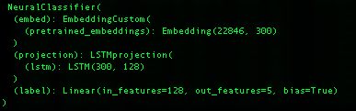
Figure 18: Static Neural Model Architecture (LSTM)

The dynamic, transformer based pretrained language model testing on the other hand supports all of the transformer models that are included in this research (BERT, RoBERTa, DistilBERT, Llama, DeepSeek, XLNet and GPT2) and this module, given its reliance on HuggingFace’s transformer library, does in fact support parallelism. The TCEs were tested thoroughly in this context, against many different classifiers with no effect, in fact a slightly detrimental effect, and therefore these results are left out of our analysis.

The structure of this section of the work follows this modular design, as each of the modules has a slightly different approach to data preparation, the types of classifiers that are used, and the computational resources required to build said classifiers. This modular design and the underlying computational requirements in turn have implications on the findings and conclusions we draw not only in terms of which classifiers perform the best, but also which classifiers are the most cost effective.

Supported Metrics

Primarily we look at macro-f1 and micro-f1 scores for the different classifier, language model, and representation form test runs, but we also track precision, recall, accuracy, Hamming Loss and Jaccard Index numbers for each model run as well. We use the macro-f1 score to determine whether or not our neural models are improving and to determine whether or not we have met our early-stop condition.
Essentially, Precision is critical when the costs of False Positives are high and Recall is crucial when the cost of False Negatives is high (e.g., in medical diagnosis). Macro-F1 and Micro-F1 provide a balance between precision and recall and are especially useful in unbalanced datasets, and Accuracy is best used when the classes are balanced. Hamming Loss is particularly useful in multilabel classification problems to measure how many times on average the classification is wrong, and Jaccard Index is useful for cases where true negatives don’t matter much.

These metrics provide a comprehensive picture of model performance, capturing errors of both omission (false negatives) and commission (false positives), and are essential for evaluating and comparing classification models, especially in imbalanced datasets.

As a brief refresher on how these measures are calculated, we have the following:

Precision
Precision measures the accuracy of positive predictions. It is the ratio of correctly predicted positive observations to the total predicted positives, or

Where TP is true positives and FN is false negatives.

Recall
Recall (sensitivity) measures the ability of a model to find all the relevant cases (i.e., True Positives) within a dataset. It is the ratio of correctly predicted positive observations to all observations in the actual class, or

Where TP is true positives and FN is false negatives.

Macro-F1 Score
Macro-F1 Score is the average F1 Score per class without taking into account the proportion of each class, i.e. the unweighted average of the F1 Score of each class – or mathematically:

Where Precision and Recall are calculated as outlined above and N is the number of classes.

Micro-F1 Score
Micro-F1 Score aggregates the contributions of all classes to compute the average F1 Score, measuring the aggregate contributions of all classes with respect to the average score, or mathematically:

Where Micro-Precision and Micro-Recall are the precision and recall calculated globally.

Accuracy
Accuracy is typically used to measure the overall correctness of the model, measuring the proportion of true results (both true positives and true negatives) among the total number of cases examined, or

Where TP denotes the total number of true positives, TN the total number of True Negatives, FP the total number of false positives and FN the total number of false negatives.

Hamming Loss
Hamming Loss measures the fraction of labels that are incorrectly predicted, i.e., the fraction of the wrong labels to the total number of labels:

Jaccard Index
The Jaccard Index measures the similarity and diversity of sample sets. It is the size of the intersection divided by the size of the union of the sample sets:

Supported Language Models

As mentioned, given the nature of the different language models, Layer Cake was designed with three different test scripts, and three different type of classifiers, each of which was tested with a certain language representation form that is endemic to the underlying classifier that is being trained and tested, with data preprocessing steps that are specific to the underlying language model in question. Our testing covers a variety of models which gives us an opportunity to compare different forms of language representation in different contexts and look at how what a language model was trained on, and how it was trained, performs on different datasets.

Static Embedding Models

For the static language models that we tested, whose embeddings are word based as opposed to token based as the transformer models are, we used a GloVe model, a Word2Vec model and a FastText model, each of which was trained on the Common Crawl dataset which consists of a massive, open source web archive that consists of petabytes of data collected by crawling the web.

GloVe: glove.840B.300d.txt
glove.840B.300d.txt is the GloVe pretrained word embeddings set that was trained based on global co-occurrence statistics against the common (web) crawl dataset which includes 840B tokens and 2.2 million vocabulary words, is of dimension (vector size) 300, and around 2GB all in. The GloVe specific training method focuses on co-occurrence statistics from a word-context matrix across the entire corpus, capturing both syntactic and semantic relationships and was introduced in 2014 (Pennington, et al., 2014).

Word2Vec: GoogleNews-vectors-negative300.bin
GoogleNews-vectors-negative300.bin is the Word2Vec trained static word embeddings, originally trained by Google, which is also 300 dimension vectors, contains over 3 million words and phrases and is all in about 1.5 GB. The embeddings were trained from the Google News dataset, hence the name, and was built using the Word2Vec model, introduced in 2013 by (Mikolov, et al., 2013). Specifically, the model is trained using the Continuous Bag of Words (CBOW) and skip-gram methods, where the skip-gram model predicts surrounding context words given a center word, and negative sampling is used to optimize training by selecting a few "noise" words during prediction instead of updating the entire vocabulary.

FastText: crawl-300d-2M.vec.bin
crawl-300d-2M.vec.bin is the binary format of the FastText static embedding variant we test with that is also of size 300 (dimensions of embedding vector), contains around 2M unique words, about 6GB all in and was also trained on the Common Crawl dataset, preprocessed to remove noisy content, duplicates, and non-linguistic data (e.g., scripts, images, ads). This fastText language model was trained using a skip-gram method with negative sampling, trained on word context, and incorporating subword modeling (n-grams). FastText splits each word into character n-grams and builds word representations by summing subword vectors which enables it to handle OOV words by generating approximate embeddings based on their subword components. The model we use lacks the subword information but is trained to that effect. (Bojanowski, et al., 2017)

Context-Aware Language Models (Transformers or LLMs)

For the transformer tests, we use three different BERT variants, XLNet and GPT2, as well as a small LLaMA model and a small, distilled DeepSeek model, each of these models is briefly described below.

BERT, RoBERTa and DistilBERT

BERT and RoBERTa are pretrained on massive amounts of text data using masked language modeling (MLM) and (for BERT) next sentence prediction (NSP). During pretraining, part of the sentence is hidden (masked), and the model is trained to predict the missing word. MLM introduces probabilistic predictions into the model’s learning process. The embeddings that result from MLM are optimized for downstream tasks, such as classification, named entity recognition, or question answering. BERT considers the entire context of a word from both directions (left-to-right and right-to-left) using the self-attention mechanism. This means that the embedding for a word in BERT is influenced by both the preceding and succeeding words in a sentence, making the embeddings contextual and bidirectional. RoBERTa builds on BERT but removes the next sentence prediction (NSP) task and introduces changes to pretraining hyperparameters, such as training with larger batch sizes and more data. This leads to better generalization performance. RoBERTa uses dynamic masking during pretraining, meaning the mask positions are selected randomly each time a sequence is fed into the model. This leads to more robust embeddings.

With BERT/RoBERTa, each token's embedding is influenced by the entire sentence using a probabilistic attention mechanism. Words or subwords in the sentence contribute to the final embedding based on the attention weights learned during training. Embeddings are constructed by layering algebraic transformations (matrices of weights, biases, non-linear activations) across multiple layers (12 layers for BERT-base, 24 layers for BERT-large/RoBERTa-large), and embeddings are context-sensitive, meaning the same word has different embeddings depending on its surrounding words. Words are broken into subword units (WordPiece tokens), and their embeddings are learned and combined using attention mechanisms. This makes BERT and RoBERTa effective at handling out-of-vocabulary words and morphologically complex languages.

In the embedding space, BERT and RoBERTa learn to position words in a way that encodes both syntactic and semantic relationships, but these relationships are deeply tied to the specific context. In BERT/RoBERTa's embedding space, the distance between words is not just based on their isolated meaning but on how they interact with other words in a given sentence or passage. Thus, the same word can have multiple geometric positions depending on the sentence in which it appears. BERT and RoBERTa embeddings are contextual, probabilistic, and dynamic, differing from static embeddings like Word2Vec or GloVe, where each word has a single fixed vector. Instead, BERT and RoBERTa dynamically adjust word embeddings based on the context within the sentence. Just like Word2Vec or GloVe however,
BERT and RoBERTa operate in Euclidean space, but with a much deeper and more sophisticated construction process that reflects the complex relationships between words in different contexts. In essence, BERT and RoBERTa construct embeddings through a combination of probabilistic attention mechanisms and deep algebraic transformations across multiple layers, resulting in rich, context-sensitive word vectors in Euclidean space.

RoBERTa iterates on BERT's architecture by modifying key hyperparameters, removing the next sentence pretraining objective, and training with a much larger training corpus than its parent model. It also uses dynamic masking, where the masked tokens in a sequence change across training epochs, making the training more robust and, like its predecessor BERT (and distinct from traditional RNNs that look at words sequentially or autoregressive models like GPT which internally mask future tokens), allows the model to construct a bidirectional, contextually aware, representation of a given sequence of tokens which creates better embeddings, i.e. a richer language representation form ultimately as illustrated on its performance on a wide range of NLU and NLP tasks and benchmarks.

DistilBERT was pretrained on the same corpus as BERT but, using a technique called knowledge distillation, which is when a model uses a source model as a target (aka teacher model) and learns to mimic its outputs while not requiring the full training computational resources, yielding a smaller model that is comparable in performance. More specifically from a distillation perspective, DistilBERT uses a masking and cosine embedding loss algorithm to generate hidden states as close as possible as the BERT base model while again not requiring the full ensemble of training and parameters as its teacher model, yielding a model that is around 40% smaller than BERT and yet still retains some 97% of its performance across a variety of NLP and NLU benchmarks making it an ideal model to use on edge network devices who do not have access to a lot of computing power for example.

The specific models we use for Layer Cake are described below:

BERT
- Model: bert-base-cased
- Case-sensitive. The model preserves the case of the input (e.g., "Apple" vs. "apple" are treated differently).
- Architecture and Dimensions:
  - 12 transformer layers (encoder layers)
  - Hidden size: 768 dimensions
  - Attention heads: 12 heads
  - Total parameters: ~110 million
- Training Corpus: BooksCorpus (800M words) and English Wikipedia (2,500M words)

RoBERTa
- Model: roberta-base
- Case-insensitive: this model typically lowercases input during tokenization, but the model itself can still encode case differences if retained.
- Architecture and Dimensions:
  - 12 transformer layers (same as BERT-base)
  - Hidden size: 768 dimensions
  - Attention heads: 12 heads
  - Total parameters: ~125 million
- Training Corpus: BookCorpus + CC-News + OpenWebText + Stories (160 GB of text)

DistilBERT
- Model: distilbert-base-cased
- Case Sensitive
- Architecture and Dimensions:
  - 6 transformer layers (half the layers of BERT-base)
  - Hidden size: 768 dimensions
  - Attention heads: 12 heads
  - Total parameters: ~66 million
- Training Corpus: Same as BERT (BooksCorpus + English Wikipedia)

XLNet

XLNet is another transformer-based model that we use in Layer Cake that incorporates aspects of both encoder and decoder architectures but functions more like a generalized autoregressive model designed for bidirectional context understanding (Yang, et al., 2019). XLNet incorporates ideas from Transformer-XL (Dai, et al., 2019), the state-of-the-art autoregressive model, into the pretraining objective of BERT by maximizing the expected likelihood over all permutations of the input sequence tokens.

XLNet takes a hybrid approach to training, leveraging advantages of both BERT (bidirectional encoding) and GPT (autoregressive generation). XLNet is neither strictly encoder-only nor decoder-only, instead, it is built on the Transformer-XL framework, which uses a permutation-based autoregressive training objective that enables it to model bidirectional context without the need for masking (as in BERT). While it primarily focuses on understanding text (like encoder-only models), its architecture and training objectives are inspired by decoder-based autoregressive models.

XLNet predicts tokens based on previous tokens but does so in a permuted order. This allows the model to capture bidirectional context in a flexible way without relying on masking like BERT. Unlike BERT's Masked Language Modeling (MLM), XLNet models all positions of the sequence in random permutations during training, making it a generalized autoregressive model. XLNet extends Transformer-XL, which introduces a memory mechanism to learn dependencies over long sequences. This allows XLNet to handle longer contexts than standard Transformers like BERT.

- Model: xlnet-base-cased
- Case Sensitive
- Training Data: Trained on a large corpus that includes BooksCorpus, English Wikipedia, Giga5, ClueWeb, and Common Crawl.
- Architecture and Dimensions:
  - Uses 12 transformer layers,
  - Hidden Size: 768 dimensions

GPT-2 (Generative Pretrained Transformer)

GPT-2 (Generative Pretrained Transformer 2) is an unsupervised, auto-regressive, language model from OpenAI introduced in 2020 in the paper "Language Models are Few-Shot Learners." (Brown, et al., 2020). GPT2 is an English language model also uses the Transformer architecture, decoder only, leveraging a causal, or auto-regressive approach to training where tokens are predicted sequentially and are conditioned on previously conditioned tokens.

More precisely, inputs are sequences of continuous text of a certain length and the targets are the same sequence, shifted one token (word or piece of word) to the right. The model uses internally a mask-mechanism to make sure the predictions for the token i only uses the inputs from 1 to i but not the future tokens, allowing the model to construct an inner representation of the English language that can then be used to extract features useful for downstream tasks.

GPT-2 is designed to generate coherent, human-like text when given a prompt, i.e. language generation, but it can be fine-tuned for a wide range of downstream NLP tasks such as text completion, summarization, translation, and question answering and provides a good contrast model to the bidirectional, masked BERT models we test with, as well as a comparison to the other language generation models that we use in in Layer Cake (Llama and DeepSeek, more on these models below).

- Model: gpt2
- Case Sensitive
- Architecture and Dimensions:
  - The base model has 12 transformer layers, or blocks
  - Hidden Size: 768 hidden units, or dimensions.
  - Attention Heads: 12
  - Total Parameters: smallest version of GPT-2, with 124M parameters.
- Training Corpus: Trained on a dataset called "WebText," a corpus consisting of over 8 million documents (40GB of text) scraped from the internet.

LLaMA (Large Language Model Meta AI)

Llama, or Large Language Model Meta AI, is the name for a family of open-source language models created by Meta (formerly Facebook), that was introduced in 2023 in the paper “LLaMA: Open and Efficient Foundation Language Models” (Touvron, et al., 2023). These are multi-lingual models whose tuned versions use supervised fine-tuning techniques (SFT) and reinforcement learning with human feedback (RLHF) to align utility goals with safety and security objectives.

LLaMA models are - similar to GPT2 - transformer based, decoder only, and trained auto-regressively. Like GPT2 they are also designed for language generation tasks primarily, i.e. what the market has come to understand and call LLMs. Its transformer-based architecture with decoder layers is optimized for scaling and it uses sparse attention mechanisms to handle longer documents effectively, focusing on dense token prediction during its auto-regressive token generation scheme. Given its underlying architecture and training design, the model is best suited for General-purpose tasks, including long-form generation, summarization, and document retrieval.

- Model: Llama-3.2-1B
- Case sensitive
- Architecture & Dimensions:
  - 16-24 transformer layers (blocks), depending on model configuration
  - Attention Heads: 12-16 depending upon hidden dimension size
  - Dimensions: Typically, 4096 hidden dimensions for larger configurations, but the 1B model can have 768–1024 depending on configuration.
  - Total parameters: 1B
- Training Data: Curated from Common Crawl, C4 datasets, academic literature, and Wikipedia, with an emphasis on scientific content and long-form text.

DeepSeek

DeepSeek is a Chinese company that has recently released a few families of language models that have made a significant impact on the overall LLM landscape given the efficiency gains in training that they have gained along with the effectiveness of their models according to a variety of NLU and NLP benchmarks. DeepSeek models use large-scale reinforcement learning (RL) without supervised fine-tuning (SFT) as a preliminary step and have demonstrated remarkable performance on reasoning that are comparable to LLaMA and OpenAI models.

These DeepSeek models are transformer based with both encoder and decoder aspects, and the R1 family in particular is designed for reasoning capabilities, a relatively new capability that is being actively worked on in the LLM community which allows the model to break tasks into components and solve problems sequentially and with dependencies, what is known as chain-of-thought (COT) capability in the research community.

DeepSeek has also produced several LLaMA and Qwen based distilled models, the latter of which (smallest version) we incorporate into this this study, which remain effective for a variety of NLP and NLU tasks (as we see here) and are computationally efficient as well given the distillation-based design.

- Model: DeepSeek-R1-Distill-Qwen-1.5B
- Case sensitive
- Architecture & Dimensions:
  - Built using knowledge distillation techniques from the Qwen2.5-Math-1.5B base model
  - Typically 24 transformer layers, or blocks
  - Attention Heads: 16
  - Hidden Size (dimensions): 1536
  - Parameters: 1.5B parameters
- Training Data: Web-scale corpora, including multilingual datasets, scientific articles, and specialized QA sets. Emphasizes multimodal inputs, including text with structured tables, code snippets, and HTML content.

Summary Table

The specific language models we use for Layer Cake testing are described and then summarized in a table below.

Comparison Summary Table

Model | Dimensions | Transformer Layers (Blocks) | Attention Heads | Case Sensitivity | Training Dataset | Training Objective | Best Use Cases
BERT (bert-base-cased) | 768 | 12 | 12 | Case-sensitive | BooksCorpus + English Wikipedia | Masked Language Model + Next Sentence Prediction | Text classification, sentiment analysis, Q&A, named entity recognition (NER)
RoBERTa (roberta-base) | 768 | 12 | 12 | Case-insensitive | Common Crawl (160GB preprocessed data) | Masked Language Model (no NSP) | Long-text understanding, classification, and summarization
DistilBERT (distilbert-base-cased) | 768 | 6 | 12 | Case-sensitive | Distilled from BERT base | Masked Language Model (with distillation) | Lightweight Q&A, sentiment analysis, classification, mobile applications
GPT-2 (gpt2) | 768 | 12 | 12 | Case-insensitive | WebText (45GB web crawl corpus) | Causal Language Modeling | Text generation, conversational AI, summarization, and story generation
LLaMA 3.2-1B | 768 | 12 | 12 | Case-sensitive | Common Crawl + academic & curated corpora | Causal Language Modeling | Conversational AI, multilingual applications, and general NLP tasks
DeepSeek-R1-Distill-Qwen-1.5B | ~1,536 | ~24 | 16 | Unknown | Fine-tuned Qwen base models | Causal Language Modeling | Multi-modal AI, research-based summarization, dense retrieval, and multilingual

Supported Datasets

For each of the models, we prepare the underlying dataset as needed, create the representation form of the dataset - which is represented as lists or arrays of documents in said representation form – and then we prepare the model with the underlying dataset representation, build the model using training and validation data, and then test the model and report results back based upon the model performance against the test data that we set aside – following classical ML and DL model building and testing procedures effectively.

The datasets we use for testing come from a variety of sources, covering news and academic content as well as medical data and reviews. We look at both single label classification, where a document is classified to a single category, and then we look at multi-label classification datasets where a document can belong to multiple categories. We also have one binary classification dataset (IMDB) which is affectively a sentiment analysis labelling scenario.

Our approach with respect to dataset scope was intended to ensure that we had enough variety in terms of content and design such that we are in a position to derive some conclusions around both model performance, as well embedding performance.

A brief description of each dataset we used in our different test scripts is provided below.

Reuters21578
The Reuters-21578 dataset is a cornerstone in text categorization research, comprising 21,578 news documents from the Reuters newswire in 1987 originally collected and labeled by Carnegie Group, Inc. and Reuters, Ltd. The dataset is multi-label and each document is labeled across 115 different categories, and although not very well balanced across categories, nonetheless it is one of the standard benchmarks for multi-label text classification tasks. Researchers have extensively utilized this dataset to evaluate various machine learning and natural language processing algorithms.

BBC News
The BBC News dataset contains 2,225 news articles from the BBC website, categorized into five distinct topics: business, entertainment, politics, sport, and tech. This single-label, balanced dataset is particularly useful for testing text classification models given that it is relatively small in size, single-label and well balanced across labels.

RCV1-v2
The Reuters Corpus Volume I (RCV1-v2) is an extensive dataset comprising over 800,000 newswire stories from Reuters, covering the period between August 20, 1996, and August 19, 1997. This multi-label dataset spans 103 categories, providing a rich resource for large-scale text classification and clustering research. Its size and complexity make it ideal for evaluating algorithms that need to handle large, real-world datasets with overlapping categories. It is news data and there is a lot of overlap between classes as one might expect from a news site.

20 Newsgroups
The 20 Newsgroups dataset is a collection of approximately 20,000 newsgroup documents, partitioned across 20 different newsgroups. Each document is labeled with a single category, and the dataset is well-balanced, making it ideal for testing out different classifiers and as such has been a popular benchmark dataset for evaluating text classification algorithms.

arXiv
The arXiv dataset consists of research papers from the arXiv repository, categorized into various scientific disciplines. The dataset is multi-label, articles can belong to more than one class (but at least one), and there are 58 class labels. Given the nature of the content, there are many scientific words or phrases (and some special characters) that must be managed to yield good model performance results and as such makes it a good test dataset to evaluate how well models handle domain-specific terminology and semantics.

arXiv protoformer
A derived or curated version of the arXiv dataset, often used in experiments with prototype-based models (e.g., Protoformer). The set we use is filtered for the most common classes (just 10) and is single label. This is a simplified variant of the full arXiv dataset, which is focused on distinct topics, avoiding overlapping categories.

OHSUMED
The OHSUMED dataset consists of medical abstracts from the Medline database, labeled with MeSH (Medical Subject Headings) terms. It is a multi-label test set, consisting of 23 distinct classes. It is focused on medical topics, making it highly domain-specific, meaning that many of the words and terms would not be found in a typical language model training set. The specialized vocabulary presents challenges for text classification models, particularly in handling out-of-vocabulary terms and understanding complex medical jargon.

IMDB
The IMDB dataset is one of the most common datasets used in Machine Learning and Deep learning research, consisting of movie reviews from IMDB, each labeled with the sentiment (positive or negative) expressed in the review, making it a binary classification problem effectively. It is a well-balanced dataset with 25,000 training samples and 25,000 test samples. Text length varies, with some reviews being long and detailed.

Dataset Summary Table

A summary table of the different datasets we use with Layer Cake and their basic characteristics is provided below.

Dataset | Type | Classes | Size | Characteristics
Reuters-21578 | multi-label | 115 | 64 MB | News articles, imbalanced class distribution.
BBC News | single-label | 5 | 6.7 MB | Balanced topics from BBC news.
arXiv | multi-label | 58 | 5.5 GB | Research papers, overlapping categories.
arXiv Protoformer | single-label | 10 | 147 MB | Simplified version of arXiv for single-label tasks.
IMDB | single-label | 2 | 694 MB | Movie reviews, sentiment analysis.
OHSUMED | multi-label | 23 | 387 MB | Medical abstracts, domain-specific.
RCV1-v2 | multi-label | 101 | 7.4 GB | Large-scale news corpus, hierarchical topics.
20 Newsgroups | single-label | 20 | 15 MB | Newsgroup articles, balanced and diverse topics.

System Dependencies and Parallelism

The code that we use to run the Layer Cake tests that we describe in this work consists of four different modules – three for classifier testing and another for reporting & analytics. While the system is designed to support CPU, GPU and MPS (Apple MacOS M chips) based architectures, the final set of test runs were performed on a Linux Ubuntu system with the following hardware and software requirements:

- OS: Ubuntu Linux version 22.04, x86 architecture
- CPUs: 64 physical, 128 logical; 512 GB RAM (memory)
- GPUs: 4 NVIDIA RTX 6000 Ada Generation, 48GB of Memory each
- CUDA 12.4
- Python 3.10 (DeepSeek model dependencies)
  - PyTorch 1.4.1
  - Transformers 1.45.2
  - Sklearn 1.6.1

The ML models are CPU bound but can take advantage of parallelism as needed – like for example in multi-label cases where the classification algorithm is done once per class (OneVsRest). The neural model classifiers that are designed for the static embeddings are GPU bound (CUDA), although they also run on MPS / Apple Silicon. These do not support parallelism and are designed to run on a single GPU.

The transformer models however (trans_layer_cake_version.py), which leverage the Hugging Face libraries, do support parallelism and we describe this approach briefly here. We use the simplest form of data parallelism here which is referred to as Data Parallel (DP) in the technical documentation and is the default form of data parallelism that is applied when using the transformers library which effectively replicates the (neural) model on each GPU. This of course comes with significant scaling constraints when working with the larger language model variants but for the purposes of our study this was sufficient (we used the smaller models).

This technique, which is juxtaposed with the more sophisticated and more scalable Distributed Data Parallel (DDP) PyTorch capabilities, splits the input data into chunks and then processes each chunk on a separate GPU, aggregates the results, and then updates the model using a synchronized gradient step. DDP on the other hand, the more scalable and robust option of parallelism with PyTorch (and by inheritance the HuggingFace transformers library), creates one process per GPU (DP uses a single process to manage the work across multiple GPUs), assigning one model instance to each process (and GPU), and then handles parallelism in the following way:
- Parallel execution: each process handles its subset of data independently, performing the forward pass locally on its GPU on its subset of data,
- local gradient computation: gradients, i.e. the net result of the backward pass around a neural model, are computed locally,
- gradient synchronization: gradients are synchronized across GPUs using PyTorch’s allreduce method, a sophisticated means of data synchronization in a parallelized GPU environment that supports a single node (OS instance), or multiple nodes in a cluster (across systems),
- gradient synchronization: gradients are averaged across processes (as opposed to being collected on a single GPU), and each process updates its local model independently with the synchronized gradients.

In particular if you are using a model that cannot fit on a single GPU due to memory constraints (which is typical for almost all of the medium and larger model sizes), it is necessary to use a DDP parallelism strategy to train but again for our purposes, the default PyTorch DP method was sufficient.

A summary table of the different PyTorch forms of parallelism is provided below.

Feature | Data Parallel (DP) | Distributed Data Parallel (DDP)
Model Replication | Model is replicated on each GPU but managed on a single process | Each GPU is assigned its own model and process (multi-process)
Data Splitting | Input batch is split and distributed across GPUs in one process | Each process loads and splits data independently across nodes/GPUs
Gradient Synchronization | Gradients are gathered on the main GPU (bottleneck) | Gradients are averaged across GPUs using all-reduce (efficient)
Communication Overhead | Centralized communication—one main GPU handles updates | Decentralized communication—all GPUs exchange gradients
System Requirements | No specific requirements beyond having multiple GPUs | Requires multi-process execution, NCCL backend, and torch.distributed
Scaling | Limited scalability (best for 2-4 GPUs) | Highly scalable (recommended for large clusters)
Efficiency | Less efficient for large models or high GPU counts | More efficient—scales well with large models and high GPU counts
Fault Tolerance | Low—failure in one GPU can cause issues | Better—individual processes can be restarted or rescheduled
Typical Use Cases | Small-scale training, small transformer models | Large-scale distributed training, large models like GPT, BERT

What is important to understand with respect to these system dependencies for Layer Cake is that:

- the ML testing is CPU bound,
- the neural model testing is all GPU bound, and
- the transformer model testing supports GPU parallelism

In other words, the timelapse numbers that we look at within the context of our analysis are not all equal – not in terms of which computational resources are used nor how much of that computational resource is required to build said classifier models. That is to say, our transformer models used a 4 GPU environment whereas our ML baseline script, and our static pretrained neural model classifiers, only depend on a single GPU, an important distinction we will call out in the analysis section below when we look at model training and testing times.

Test Results & Analysis

In this section we go through the results analysis of our tests, following the modular design of Layer Cake and leveraging our Reporting & Analytics module to generate a variety of charts and analytics which look at how the different types of classifiers perform against different hyperparameter settings, different language representation forms, and with different types of language models.

We first describe the baseline machine learning models - Support Vector Machines, Logistic Regression and Naïve Bayes classifier models which effectively work by finding optimal separation spaces in high dimensional space, leveraging the sklearn libraries from Python for our model training and testing.

Then we analyze the results of our neural models, which train by fine tuning weights via optimizing loss functions and gradients over multiple forward and backward passes. These come in two forms, the neural models that are designed to work with static word embedding language models such as GloVe and Word2Vec (and FastText), and then the transformer architecture models which are much more sophisticated and computationally intensive than their static model counterparts. For these latter models we leverage the Hugging Face APIs which not only provide the ability to work with the various models that are included in this study but also come with predesigned Sequence Classifier models that are designed specifically for sequence, i.e. text or natural language, classification.

Machine Learning Classifiers

The baseline tests we perform use three class Machine Learning approaches to text classification – Support Vector Machines, Logistic Regression and Naïve Bayes models. With these models we also experiment on a variety of forms of language representation as given the direct mathematical structure of the underlying models, we have an opportunity to look at the various forms of language representation, and related forms for feature reduction, to see which are most effective and which are the most performant from a runtime perspective. These models are constructed using the base python sklearn libraries and as such they are CPU bound, as opposed to the GPU bound neural models that we describe below.

While we primarily look at these baseline ML classifiers as reference models to be viewed against the backdrop of their neural counterparts, the latter of which have been shown to be more effective in a variety of NLP contexts with this work being no exception, these models are nonetheless effective in and of themselves and are relatively straightforward to set up, train and test relative to the neural models that we test with here and relative to neural models generally which have a lot of hyperparameter settings and need to be tuned especially for a given task in order to be effective.

Also given the nature of the ML classifiers with respect to how the data is input into the model, we have more flexibility with these models in terms of how we prepare the data into these models which gives us an opportunity to look at different language representation forms, along with different language models, and evaluate their relative performance in the different ML classifiers we test with.

This optimized embedding dictionary layer initialization approach that we use to prepare the static word embedding deep learning classifiers can be contrasted with the transformer-based approach to Embedding layer initialization which by default loads the entire embedding dictionary, i.e. the entire language model itself really, into the Classifier. This not only has size and performance implications given that there are tokens – because the transformer-based models are token based as opposed to word based as their static counterparts are – included in the initialized embedding layer that are not needed for the dataset in question, i.e. are not part of the underlying dataset language dictionary, but nonetheless loaded into the model memory during training and testing. This optimization, or lack thereof really, makes a significant different in terms of the computational resources necessary to train and test the classifiers, both in terms of GPU count and memory resource requirements as well as the runtimes (what we track as the ‘timelapse’ field in Layer Cake) of the classifier construction and testing, i.e. the individual test cases that we track and report on in this work.

(Text) Representation Forms

We have two basic forms of language representation that we test when working with the core machine learning models that are in scope for our testing:
- vectorization forms: which use a default tf-idf approach to vectorization with the sklearn libraries, aka vmode,
- embedding forms: which are computed from pretrained language models (static and dynamic)

Each of these representation form types is tested with and without Word-Class Embeddings, as well as using different feature reduction techniques which include Latent Semantic Analysis/Indexing as well as various methods of semantic spatial space compression using basic linear algebraic methods (dot product operations for example) which project the vectorized feature space into a more compressed form akin to what the language models themselves are designed to do (reflected in the solo and doc representation forms described below).

A few salient points about the different forms of language representation that we use for the ML test portion of Layer Cake:
- WCE/TCE representation: With respect to the WCEs and TCEs - the latter of which is the mapping between the underlying language model tokens within the context of transformer, tokenized based language models which are distinct from their word-based counterparts in terms of how the text is broken up or parsed - here indicates embeddings that are computed per word (or again token) for each underlying dataset class. So WCE/TCEs are of the shape is (d, c), where d is the size of the underlying dictionary of the given dataset with respect to the underlying language model that is being used to represent it and c is the number of classes, or categories, of the underlying dataset.
- document representation (encode_docs): when we refer to the underlying encode_docs form of dataset representation we are referring to the document encoding of the underlying dataset using the underlying language model in question, as a form of summary representation of each doc in the dataset. So if we are using a dataset who has 1000 training docs and 200 test docs, and the underlying language model embedding dimension is 300, like for GloVe for example, then the training (and validation and test) docs will be represented as a (num_docs, dims) matrix where num_docs is the number of docs in the training, validation or test dataset and the dims value is the size of the embeddings, i.e. text vectors. Given that this is a summary representation form of the underlying doc it has significant variability in terms of how it can be computed – for word-based language models we can compute a weighted average summary form of the doc or a simple mean, or average embedding form. For transformer-based models we support both the weighted average variant and the mean form, as well as – for BERT based transformer models in particular but also for GPT2 models – a summary form of representation of the doc which is computed by the transformer model itself, called the CLS token for BERT which is designed for this purpose.
- dataset dictionary representation (embedding_vocab_matrix): When we refer to the embedding_vocab_matrix below, or the language model embedding representation of the dataset dictionary, what we refer to is a non-contextualized, language model specific representation of the underlying dataset dictionary. So if for a given language model and a given dataset we have identified 1000 words, or again tokens, that represent the dictionary of the underlying dataset (not the language model dictionary but the dataset dictionary which is a subset of the language model token or word dictionary), the embedding_vocab_matrix would be of shape (v, d), where v is the dictionary size and d is the vector dimension size of the language model being used.

One of the advantages of looking at these different representation forms within the context of these classic machine learning classifiers is that the underlying mathematics, and the underlying forms of language representation are relatively straightforward and are coupled together directly, as a form of linear separation in vector space, in semantic space really following (Worth, 2023). Once we get to the transformer classifiers, we become constrained by the underlying language model itself in terms of how the text can be represented. We discuss this more below in the section on dynamic, contextualized deep learning classifiers, aka transformers.

Each of the representation forms we use for the ML Classifier testing portion of Layer Cake is described below. All of the test results we report on include one or the other of these variants, each of which is tested with each of the ML classifiers that are in scope for this part of the study. Our testing focuses on (classifier) model performance both in terms of effectiveness, i.e. macro-f1 and micro-f1 metrics, as well as performance in terms of runtime and resource requirements.

vmode
- Formula: Raw count or tf-idf vectorization (min_df=5, sublinear=True) representation
- Description: Uses the raw TF-IDF or Count vectorized representation of the dataset as input, without incorporating embeddings or other derived features. Baseline representation when no additional embeddings or transformations are needed.

solo
- Formula: embedding dataset representation (encode_docs) by itself
- Description: Uses the embedding representation of the dataset alone without incorporating any additional features like TF-IDF vectors or class embeddings as a form of concise feature reduction. Comes in three flavors:
  - weighted: Uses weighted embeddings (e.g., using TF-IDF weights).
  - avg: Uses average word embeddings for the training/test data.
  - summary: Uses summary embeddings, such as CLS tokens from BERT.

solo-wce
- Formula: embedding dataset representation (encode_docs) + WCEs
- Description: Uses the embedding representation of the dataset combined (concatenated) with WCEs/TCEs (weighted or token-based class embeddings) for better representation of the classification task. Suitable when class label interactions (WCEs/TCEs) are relevant for improving classification.

cat-doc
- Formula: tf-idf vectorized text representation + embedding dataset representation (encode_docs)
- Description: Concatenates the TF-IDF or count vectorized dataset representation with the chosen dataset and chosen language model embedding representation. Effective when combining the raw text features (TF-IDF) with contextual embeddings for enhanced representation.

cat-wce
- Formula: tf-idf vectorized text @ (embedding_vocab_matrix + WCE/TCEs)
- Description: The TF-IDF or count vectorized dataset representation projected into the embeddings space (dot product operation) of the dataset language model dictionary embedding space concatenated with the WCEs / TCEs. Useful for integrating both raw features and class-sensitive embeddings.

cat-doc-wce
- Formula: (tf-idf vectorized text @ (embedding_vocab_matrix + WCEs/TCEs)) + (tf-idf vectorized text + encode_docs)
- Description: Combines the vectorized dataset representation, the chosen embedding representation, and the WCEs/TCEs to produce a comprehensive feature set. Suitable when both embedding-based and raw text-based features, along with class-sensitive embeddings, are required for optimal model performance.

dot
- Formula: tf-idf vectorized text @ embedding_vocab_matrix
- Description: Projects the TF-IDF vectors directly into the embedding space using dot product (matrix multiplication). Suitable for applications where dimensionality reduction or embedding projections are crucial for the downstream task.

dot-wce
- Formula: (tf-idf vectorized text @ (embedding_vocab_matrix + WCEs/TCEs))
- Description: Similar to dot but incorporates WCEs by stacking them with the embedding space and projecting the vectorized dataset into this augmented space. Effective when weighted class embeddings provide additional discriminatory power.

lsa
- Formula: A = UΣV^{T} where:
  - A ∈ is the term-document matrix with m terms and n documents,
  - U ∈ is the left singular matrix (containing term-topic relationships),
  - Σ ∈ is the diagonal matrix containing singular values that represent the importance of each topic,
  - V^{T} ∈ is the right singular matrix (containing document-topic relationships), and
  - k is the rank (or number of dimensions kept) after applying Truncated SVD.
- Description: Applies Latent Semantic Analysis (LSA) using Truncated Singular Value Decomposition selects the top k singular values and corresponding vectors to reduce the dimensionality while preserving important semantic information which reduces the dimensionality of the TF-IDF or count vectorized representation to match the embedding dimensions. Useful for dimensionality reduction while retaining meaningful semantic content.

lsa-wce
- Formula: LSA[embedding_dim] + (tf-idf vectorized text @ (embedding_vocab_matrix + WCEs/TCEs))
- Description: Combines the reduced LSA features with the tf-idf vectorized representation of the data projected into the embedding_vocab_matrix + WCEs/TCEs embedding space. Effective when combining reduced feature sets with class-sensitive information.

Summary Representation Form Table

The table below summarizes the various forms of language representation that are used within the context of the ML baseline testing of Layer Cake.

Representation | Description | Feature Sources | Key Use Case
solo | Embedding representation alone | Embeddings (weighted/avg/summary) | When embeddings alone are sufficient
solo-wce | Embeddings + Weighted Class Embeddings | Embeddings + WCEs/TCEs | When class interaction features improve results
cat-doc | Vectorized text + Embedding representation | TF-IDF/Count + Embeddings | When combining raw text and embeddings enhances performance
cat-wce | Vectorized text + Weighted Class Embeddings | TF-IDF/Count + WCEs/TCEs | When integrating raw text with class interaction features is needed
cat-doc-wce | Vectorized text + Embedding representation + Weighted Class Embeddings | TF-IDF/Count + Embeddings + WCEs/TCEs | Comprehensive representation combining raw, embedding, and class features
dot | Projection into embedding space via dot product | TF-IDF/Count + Embedding Space | When projecting text into embedding space is crucial
dot-wce | Projection into embedding space with Weighted Class Embeddings | TF-IDF/Count + Embeddings + WCEs/TCEs | Projection combined with class-sensitive embedding
lsa | Latent Semantic Analysis for dimensionality reduction | TF-IDF/Count + LSA | For dimensionality reduction while keeping semantic content
lsa-wce | LSA + Weighted Class Embeddings | TF-IDF/Count + LSA + WCEs/TCEs | When reduced features and class sensitivity are both needed
vmode | Raw vectorized representation (TF-IDF or Count) | TF-IDF/Count | Baseline approach using only vectorized data

Representation Shortform

Also, we use a shortform of encoding to both facilitate the process of providing arguments to our ML classification scripts and also provide detail around representation forms for our logging and reporting modules – charting and analytics plots - that are a core part of Layer Cake functionality. This representation form shorthand, we use to label many of the axes of our reports and charts to identify the parameters used to generate the result in question.

So for example, [svm:20newsgroups]:->tfidf[word2vec]:[opt] indicates that we are using an SVM classifier with the 20 Newsgroups data, the Word2Vec language model using a tfidf vectorization representation form. This is the ’vmode’ option described above, and the [opt] at the end of the representation field indicates the test run that we use is optimized which in the Layer Cake ML testing module leverages a RandomizedGridSearch approach to look for the best parameters. Another example is [lr:bbc-news]:->tfidf+tfidf.(roberta+wce(tfidf)):[opt] which is a Logistic Regression Classifier (OneVsRest) model with the BBC-News dataset, that represents the data using tf-idf vectorized data concatenated with tfidf data which is projected (dot product operation) into a roberta representation of the dataset (using encode_docs) concatenated with TCEs – and again optimized using RandomizedGridSearch. This is the representation form of the ‘cat-wce’ option above.

Test Workflow

The basic workflow of the ML classification test module follows the basic steps that you might see for all classifier type model construction code except that it is scripted using all of the datasets, language models and other configuration parameters (hyperparameters) to drive each of the test runs, with the output logged that captures all of the salient information related to the specific run of that classifier with the given hyperparameters (timelapse of the run, OS system configuration, number of GPUs, language model, language model type, etc.) that can be then used by the reporting and analytics module of layer cake to generate charts, heatmaps and summary data related to the builds, generating all the performance metrics that we are tracking throughout for each classifier in each configuration – i.e. macro-f1, mico-f1, accuracy, precision, recall, hamming loss and jacard-index values .

In preparing the data, we preprocess it by retrieving the data from the relevant Layer Cakes datasets subdirectory, downloading it if necessary, and then for the word and sub-word based language models (i.e. GloVe, Word2Vec and fastText) we lowercase the text, remove punctuation, and remove stopwords whereas for the token based, transformer models (GPT2, BERT, DistilBERT, DeepSeek, RoBERTa and XLNet) we leave the underlying text intact as the transformer based models are designed to handle full sentences and given their dynamic, contextualized computational nature the stopwords and case sensitivity allows the models to generate better embeddings. We then construct the label matrices from the training and validation data in the right form depending upon whether or not the underlying dataset is single-label classification or multi-label classification, and then proceed to compute, and cache, the various base representation forms of the text which include vectorization forms as well as the embedding dataset dictionary and document encoding structures to be used by the underlying classifiers for the different. These operations can be computationally expensive, so we do them once for each dataset, language model and representation form and then use these cached files, pickle files, throughout.

The vectorized text is constructed using TFIDFVectorizer API from sklearn, which is CPU bound (as opposed to GPU bound as the deep learning classifiers are, requiring special hardware effectively), which is called a) with the min_df=5 flag which operates as a form of feature reduction by limiting the words, subwords or tokens that are included in the output tf-idf vectors to those tokens that are found in at least 5 documents (called ‘cutoff’ in the literature) and b) we use the sublinear argument to log normalize the tf-idf values, converting the term frequency (tf) value to 1 + log(tf).

We then compute the other representation forms of the underlying dataset and language model that we use for testing, namely the embedding_vocab_matrix structure which is a static representation of the dictionary of words or tokens that are in scope for the given dataset computed from the relevant underlying language model, and then the dataset representation in the underlying language model itself which is done via the encode_docs method that we describe above. Note that the latter form is a dynamic, contextualized representation in the case of the transformer models while the former form is static for all of the language model types given the lack of context that is used to compute the embedding for the dictionary of tokens.

Once we have the data representation forms computed, we then loop through all the different in scope Classifiers and all the in scope hyperparameters and representation forms, prepare the data and then test it against the test data we set aside during training and track and record the results. For the multi-class datasets, we use a one-vs-all approach, encapsulated in the OneVsRestClassifier API from sklearn which involves fitting one classifier per class and then for each classifier the class is fitted against all other classes. For single-label datasets, Layer Cake uses the relevant classifier LinearSVC, LogisticRegression, or MultinomialNB as the case may be, again we leverage the sklearn APIs for these classifiers as well. The test data we look at below uses the default model parameters.

After we train the model using the training and validation data from our preprocessing, we compute the relevant model metrics using the test data that we set aside and then log the data for all of the metrics to be picked up and analyzed later by the results_analysis module of Layer Cake. The system supports a considerable amount of runtime log information, including for example a final classification report, which facilitates testing and debugging of the platform.

Test Results & Preliminary Analysis

Now we look at the summary results for the baseline machine learning classifiers evaluating performance across the classifiers, the representation forms and the language model types – evaluating each category by effectiveness in terms of classification as measured by our macro=f1 and micro-f1metrics as well as how the different variations stand up against each other in terms of model construction and evaluation performance (i.e. our ‘timelapse’ field).

To visualize these results, we use a box plot, aka a box-and-whisker plot, which shows the data distribution based on a five-number summary: minimum, first quartile (Q1), median, third quartile (Q3), and maximum which helps show the central tendency of the underlying data as well as the data spread and outliers. The “box”, which is the shaded area (from Q1 to Q3) represents the interquartile range (IQR), which is the range between the first quartile (Q1) and the third quartile (Q3). The height of the box gives you an idea of the spread of the middle 50% of the data, i.e. a taller box indicates more variability in the data, while a shorter box means the values are closer together.

Inside the box, there's a horizontal line that represents the median (50th percentile) of the data. The median divides the data into two equal halves. If the median is closer to Q1, it means the lower half of the data is more compact, and if it’s closer to Q3, the upper half is more compact. The whiskers extend from Q1 and Q3 to show the range of the data. The lower whisker extends from Q1 to the smallest value within 1.5 times the IQR below Q1 and the upper whisker extends from Q3 to the largest value within 1.5 times the IQR above Q3. Whiskers help visualize the overall spread of the data (excluding outliers). Outliers are data points that lie outside 1.5 times the IQR from Q1 or Q3. They are typically displayed as individual points or small circles beyond the whiskers. Outliers indicate observations that are unusually high or low compared to the rest of the data. Identifying them can help highlight potential anomalies.

When we look at how the different ML classifiers stand up against each other across all the datasets for the macro-f1 and micro-f1 metrics, on average across the datasets the Logistic Regression (LR) models perform slightly better than the SVM classifiers, and both the SVM and LR classifiers perform slightly better than the Naïve Bayes models, as illustrated in the figure below.

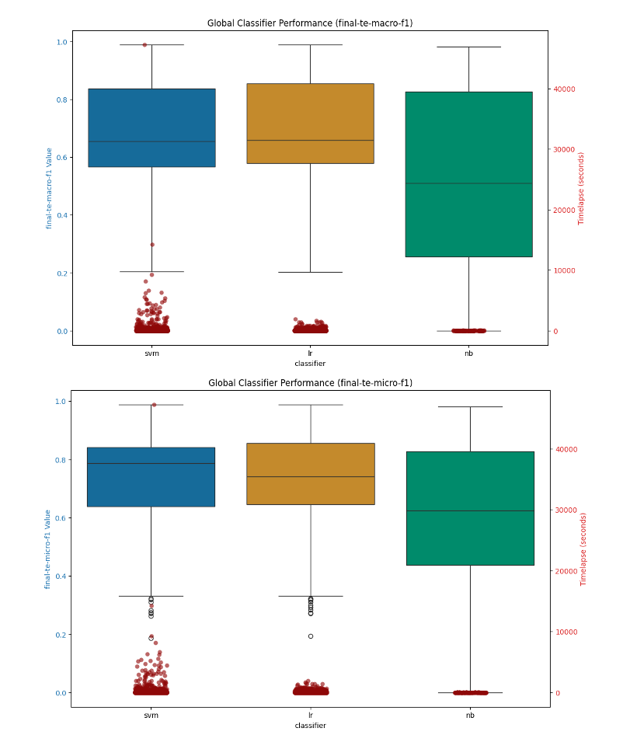
Figure 19: ML Classifier Performance Summary - Aggregate across datasets

The runtimes for the classifiers are clustered below 10,000 seconds, which equates to just under three hours for model construction, with the bulk of the classifiers, particularly for the Logistic Regression models, at around 1000 seconds which is 16 minutes, very reasonable. The SVM classifier models take slightly more time to build which is expected given the computational complexity of the underlying mathematics for SVMs versus their LR or NB counterparts.

When we look at the various representation forms, and evaluate their performance in the various classifiers, we find that, perhaps surprisingly, that the lsa, lsa-wce, solo, and solo-wce representation forms perform the best, slightly outperforming both the tf-idf and count vectorization forms, the latter of which include the cutoff feature reduction technique we describe earlier (min_df=5).

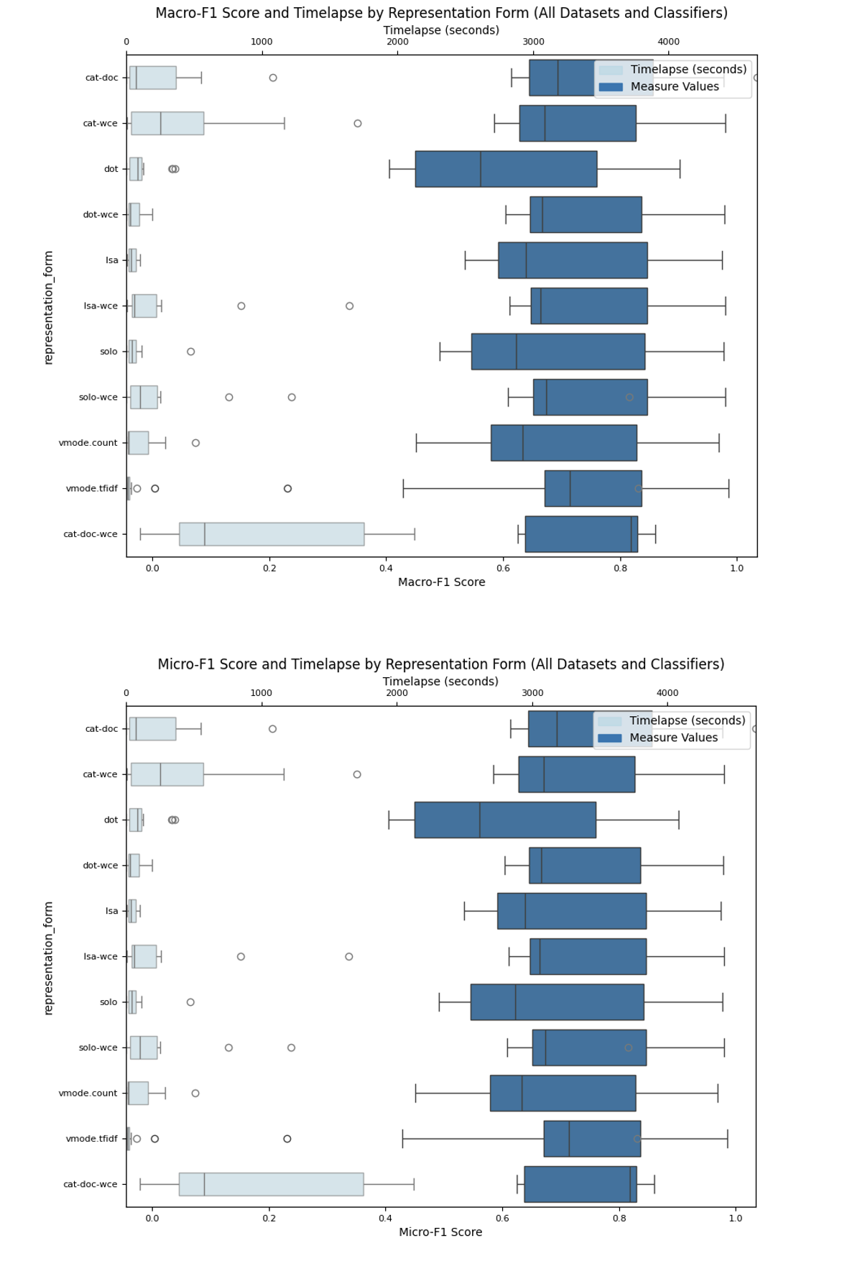
Figure 20: ML Classifier Representation Form Summary

We find also that the lsa and solo representation forms, the latter of which is the language model encoded document representation form, also perform the best in terms of computational efficiency, which is not surprising given that they have built in feature reduction techniques that are mapped to the hidden dimension size of the underlying language model (300 for the static embeddings and 768 for most of the transformer models).

When we look at how the individual language model types perform across the ML classifiers and datasets, we find, as illustrated in the box plot figures below, that the different language model types perform roughly the same on the various datasets, despite the fact that the word based language models are vectors of size 300 while the transformer based models are computed in a higher dimensional space – 768 for the smaller BERT, RoBERTa and DistilBERT, XLNet and GPT2 models we are using and 2048 for the Lllama model and 1536 for the DeepSeek model.

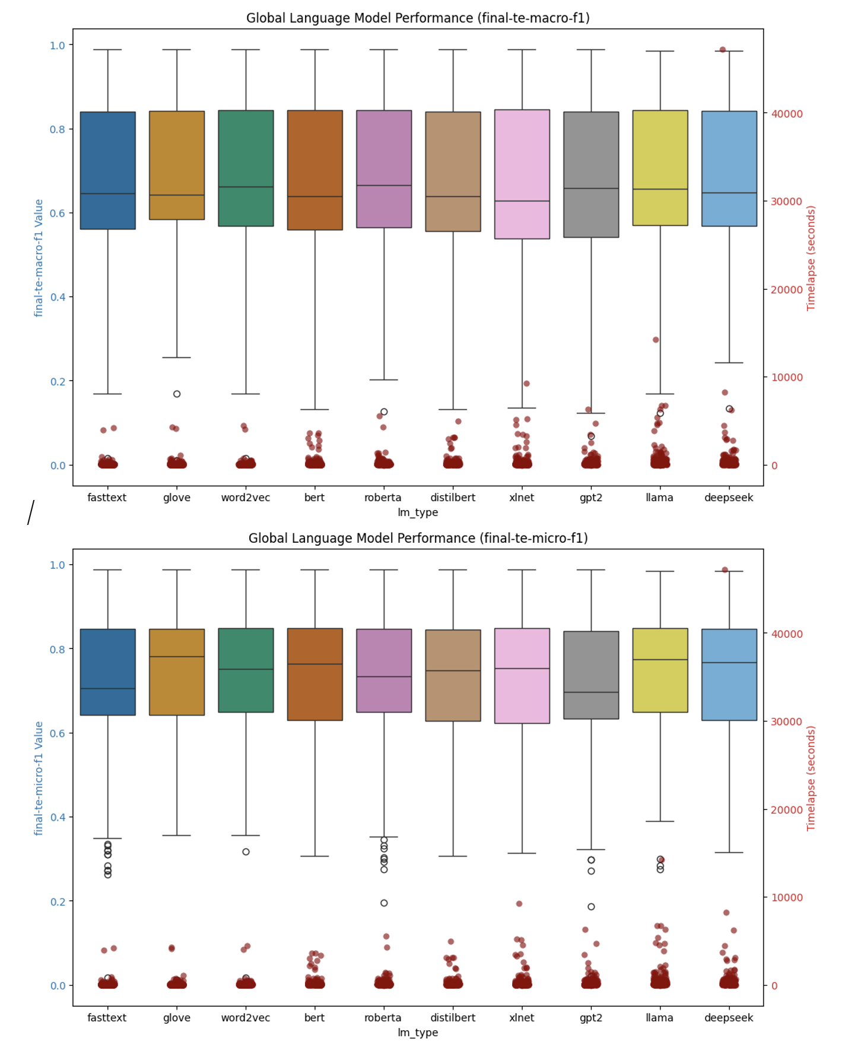
Figure 22: Language Model Performance Summary - ML Classifiers

You can see the effect of the underlying language model dimension size in terms of computational time for model creation (timelapse), reflecting the underlying feature space of the language model

Neural Network Classifiers (Deep Learning)

We have two different sets of neural classifiers that we test with within the scope of this research that are supported by Layer Cake, each of which was tested under various hyperparameter conditions and each with its own distinct, although related, form of language representation. The first neural models are designed to support the static language models, and these classifiers follow the original paper that provided the impetus for this work (Moreo, et al., 2021), but expanded to support both Word2Vec and FastText along with GloVe. These classifiers are effectively hand crafted PyTorch models that are set up in very simple CNN. LSTM and ATTN (attention) based forms.

The second set of classifiers we use leverage the HuggingFace (HF) libraries which provide interfaces (APIs), for most, if not all, of the publicly available language models. For the dynamic language models, i.e. the transformers, we have two different classifiers that we use, each of which that leverages the HuggingFace transformers library which provides a clean wrapper around a whole host of publicly available language models. In particular we test the HuggingFace Sequence Classifiers which are specifically designed for classification like problems, along with a simple CNN based architecture as a classifier head on top of the HF language models that are in scope for this work.

Both of these HF classifiers are designed specifically for transformers and embed the transformer models themselves into the classifier. In other words, the primary difference from a neural model perspective between the static classifiers and the dynamic ones is that the HF classifiers are dynamically computing the embeddings so in order to get the embedding into the final classifier to ‘train’ the model, you have to run through the underlying transformer model itself first, during classification, in order to generate the context aware embedding structure to feed into the classifier.

Therefore our study includes two sets of classifier results – one for the static word embedding language models that are tested in conjunction with Word Class Embeddings, and another that is computationally incompatible with WCEs, really Token Class Embeddings (TCEs) for the transformer models that tokenize the text rather than simply parse the text into its constituent words as is the case with the static language models. When we say incompatible what we mean specifically is a) the TCEs cannot be added to the static, foundational underlying embedding layer for the transformer model given the constraints of the HuggingFace implementation of said transformer models, and b) when they are added at runtime, i.e. during the forward pass during model training, their inclusion into the language representation logic not only proves to be ineffective, but even proves to hurt the underlying model performance, indicating that – at least via the methods we have experimented with - adding embedding information into the transformer models appears to be, at least again as the models have been implemented by HuggingFace, not feasible.

We discuss the architecture, workflow and results of both the static language model neural classifiers as well as the transformer, dynamic based classifiers in the section below. We cover each set of models separately and then combine the analysis so we get a sense as to how the models and their respective classifiers compare with each other – primarily focusing on model effectiveness in terms of macro-f1 and micro-f1 measures, and computational requirements which underpin the different approaches.

Static Embedding Models

Following (Moreo, et al., 2021), we use three different types of neural classifiers within the context of the static word embedding language model testing that is in scope for this research – a Convolutional Neural Network (CNN) architecture, a Long Short-Term Memory (LSTM) neural architecture, and a basic Attention & Masking (ATTN) based architecture which is constructed from a LSTM with an attention mechanism that facilitates a context aware computational approach. However, relative to the data that is produced in that 2021 study we expand the scope to include Word2Vec and FastText embeddings alongside the GloVe embeddings so that we get a better sense as to the differences between the different language models in the different classifier models, and datasets, that we test with Layer Cake.

We generally follow the same test, data preparation, model training and testing workflow that we used when we tested the baseline machine learning classifiers, except that now given that we are working with a neural model, we have very specific requirements with respect to how we represent the data such that the neural model can do its job. Essentially this involves, as discussed earlier, building a dictionary for the underlying dataset that is a function of the language model (and tokenization strategy) we are working with, and then indexing the dataset against this dictionary and then using these static embeddings at runtime (in the forward method of the neural model training) to represent the text (sequence) which is fed into the classifier head.

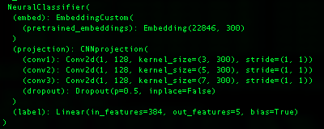
Figure 23: Static Language Model Classifier (CNN Architecture)

If we look at the CNN neural architecture for example in the figure above, it is the EmbeddingCustom layer which encodes the (static) embeddings for the entire vocabulary that is in scope for the dataset in question. Given that the neural model is ‘hand-crafted’ so to speak, we actually are populating this embedding layer only with words (or subwords in the case of fastText) that exist in the dataset we are classifying, an optimization that we do not have the flexibility to implement with the dynamic, transformer models in fact and one of the reasons that these static models are so much more efficient computationally than their dynamic counterparts.

Note that Layer Cake supports both single label classification datasets – where each document gets classified to one and only one class or label – as well as multi-label datasets where a document can be classified to one or more labels or classes. This is accomplished by ensuring that the preparation of the labels for the underlaying docs is in the appropriate form, and the use of an appropriate loss function that is designed specifically for either a single-label classification problem (CrossEntropyLoss), or a multi-label classification problem (BCEWithLogitsLoss), the loss function being the final layer of the Classifier which converts the final document representation form into its respective, learned class by comparing the logits output of the model against the ground truth labels by means of the respective loss function. For multi-label classification, the outputs are thresholded (> 0.5) to determine which labels are predicted.

Language Representation & Test Dataflow

The basic test workflow that we follow is as follows: we first initialize and prepare the underlying dataset, and, from a text preprocessing perspective, consistent with best practices for static language representations, we remove stopwords and punctuation from the text before we index it for input into the neural model. The text is then converted into an index representation form which is typical for NLP deep learning architectures, where each word is indexed into a dictionary that maps back to the associated index in the underlying language model, facilitating a lookup of the embedding for the word in question during the forward pass of training.

The language representation form that is used, again following the 2021 study, is to construct the neural model classifier embedding layer for the dataset in question using a) the dataset vocabulary words (post vectorization (i.e. vectorized using TFIDFVectorizer with ‘cutoff’ = 5 so that this dictionary is a subset of the entire dataset dictionary) combined with the static embeddings for all known words (i.e. words or terms that have defined static embedding representation as defined by the underlying language model, or in other words all words that are not in the vectorized dataset representation but exist in the underlying dataset doc set and have a corresponding definition in the underlying language model), together forming what you might call the static embedding layer dictionary.

The input text data is tokenized into individual words using the dataset’s vectorization strategy (e.g., TF-IDF or count vectorization) and each token is mapped to its corresponding embedding using the custom embedding layer, which is designed to support both pretrained embeddings, learnable embeddings, as well as supervised embeddings, i.e. WCEs, which serve to extend the pretrained language model representation of a given word using class, or label, co-occurrence statistics, serving to add additional information to the pretrained language model representation of the word and extending the dimensions of the underlying word vector by the number of classes in the dataset.

Pretrained embeddings (GloVe, Word2Vec, FastText) provide dense vector representations of words based on their semantic meaning. They enable the model to generalize better, especially when the training data is limited, by leveraging knowledge from large external corpora. The custom embedding layer combines pretrained embeddings with learnable embeddings, and optionally WCEs, to allow the model to be tailored specifically for the dataset in question that is fed into the model for training. This representation form is what is used to initialize the embedding layer of the neural models, which again is used at runtime, i.e. at training time, to be retrieved by the classifier and processed by the neural model in question, pooled together in batches, and ultimately classified the transformation layers of the different deep learning models we test with.

The indexed document representation form, which maps to the pretrained underlying word embeddings, is standard (best) practice for neural text classifiers as it allows for efficient lookup of token embeddings from the embedding matrix. Note that in the static neural model classification design, we also add special tokens for unknown words (UNKTOKEN), and padding (PADTOKEN), which are leveraged by the model to ensure the neural model handles the text representation form correctly for classification, meaning that all OOV terms are treated by the model in the same way as a special token, with its own embedding representation.

Once the dataset is indexed, a process which must be aligned with the tokenization strategy of the underlying language model we are working with, we then test each of the static word embedding neural classifiers under different hyperparameter settings and with each of the in scope datasets, both with and without WCEs, resulting in metrics – like the initial set of ML classifier data – that can be directed compared against the 2021 study. During training, these indexed, numerical representations of the documents are batched and passed to the model's embedding layer through the NeuralClassifier so that, via the EmbeddingCustom layer, the appropriate embeddings for each token from the embedding matrix (pretrained + learnable embeddings) can be retrieved and used for downstream processing. The embeddings are then, in the forward method of the classifier, processed by either the CNN, LSTM, or ATTN projection layers depending upon the model being used, the end result of which yields a contextual, language model embedding representation of the documents is created for the underlying model.

More specifically, the training of our neural classifier is done using mini-batch gradient descent with an optimizer (Adam), and a loss function - CrossEntropy or BCEWithLogits depending on whether we are using a single-label dataset or a multi-label set respectively – which looks at the aggregate token representation of the dataset sequence that is being processed that has been fed to it by the underlying projection layer that is either a CNN, ATTN or LSTM. In our code, model training involves looping through the text and feeding batches of data into the initialized NeuralClassifier which, in its forward method or forward pass, computes the loss of the data sequence for classification in the Linear layer, and then backpropagates and tunes the model weights in its backward pass, evaluating the model on a validation set periodically to monitor performance. At periodic intervals the model is tested (against the macro-f1 metric) to determine whether or not the model is improving (whether or not we should stop training), after which the model is then evaluated across a variety of metrics using the test data which is output to the logger and then used in Layer Cake’s reporting and analytics module.

Dynamic, Context-Aware, Classifiers (Transformers)

One of the primary differences between the static word embedding models and the dynamic ones, is the tokenization strategy that is used. While static word embeddings are designed to look at, and represent words, the transformer-based models break language down into tokens, which while solving for out of vocabulary and polysemy type problems, nonetheless moves the language representation form away from semantics – what something means - to something more basic and fundamental, and certainly more abstract.

The power of this transformer-based approach, which dominates the language model research and development landscape right now given how effective they have proven to be, is predicated on what might be called its ‘specificity’, or ‘granularity’, in embedding creation, also results in constraints with respect to not only forms of language representation that will work with, or are compatible with, the underlying model, but also in terms of (perhaps most profoundly) system resource and computational requirements which are necessary to generate the kind of granularity necessary to drive the performance improvements.

The figure below shows the HF Sequence Classifier model architecture for BERT, which we use throughout this study and which has been shown to work very well for classification tasks. As you can see from the neural architecture, the first two parts of the neural model are the BertModel itself, followed by the BertEncoder, these two neural components which work together to provide the context aware embeddings for the sequence classification task. These embeddings then are fed into the BertPooler, which is a simple Linear layer followed by a tanh activation function, followed by a DropOut (for overfitting control) and then another Linear layer, followed by the CrossEntropyLoss function (single-label classification case) and then the final Linear layer which is sized based upon the underlying model hidden layer size (768 in this case) and outputs to the number of classes (5 in this case, the BBC-News dataset).


Figure 24: LCSequenceClassifier (BERT)

Much of the computational complexity around working with these models is from this runtime complexity that is driven from the complexity of the underlying language model itself, which clearly does a lot of work to generate the context aware embeddings, which are of course the main distinguishing characteristic of the transformer-based models versus their static counterparts. In other words, given the dynamic nature of the transformer based embeddings, the embeddings – the model really – has to sit in a different type of neural classifier entirely that accounts for, and incorporates, the underlying language model directly into the classifier so that the embeddings can be computed, dynamically, and then they can be pooled and fed to the classifier head portion of the model.

One of the implications of this technical dependency is that the static based neural models are not only significantly less computationally intensive than their transformer based counterparts (one of the key measurement findings of this study), but also more flexible in terms of in terms of how the embedding layer can be structured – the embedding layer being the foundational structure of all of the neural model classifiers that is used to generate the embeddings that are used to represent the text of the underlying dataset, either as a straight index lookup in the forward pass of the model as is the case with the static neural models, or as inputs into the runtime computational dynamic embeddings that the transformer models generate and that can be consumed, and again pooled, for classification in the forward pass of model training.

The HF CNN architecture, as the name implies, leverages a CNN neural architectural approach to classification constructed directly on top of the HF transformer model itself, bypassing the HF Sequence Classifier neural models, effectively as a point of comparison against the HF Sequence classifiers themselves. The figure below shows what that neural model looks like and while similar to its SequenceClassifier cousin it is nonetheless distinct and provides a connecting architecture with the static models which also have a CNN architecture test case.

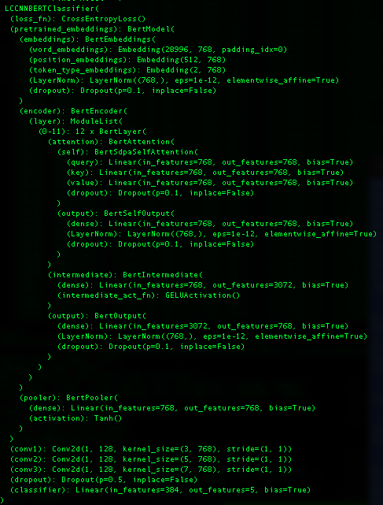
Figure 25: LCCNNBERTCLassifier Architecture (transformers)

With these neural models we once again see the transformer model itself at the top of the stack as it were, followed by three CNN layers, just like the static neural models, and then a final linear transformation layer which maps to the labels of the dataset – 5 in this case indicating that we are working with BBC-News test case (CrossEntropyLoss for single label datasets).

We would point out that for both of these transformer model classifiers that we test with, the embedding layer is fixed, and constrained by the underlying language model itself – which in this case consists of 28,996 token embeddings, each of which is a vector of size 768 and each of which maps back to a token in the dictionary space of the specific BERT language model variant being used - bert-base-cased in our work. As mentioned previously, given the tight coupling of this embedding layer with the runtime computational requirements to generate the context aware embeddings, we were not able to extend, or minimize (optimize) this embedding layer at all for any of the transformer models, so its fair to say that with the extra complexity comes a lack of flexibility with respect to how it is we can set up these models and how, if at all, they can be extended to embed additional information into them – like TCEs for example.

Test Workflow

The test script is designed to train and evaluate a Transformer-based text classifier using multiple pretrained models (BERT, RoBERTa, DistilBERT, XLNet, GPT-2, Llama and DeepSeek) with two distinct classifier architectures that are built off of the Hugging Face libraries - namely the SequenceClassifier and a simple CNN, neural network architectures that are shown in the prior two figures.

The test workflow, similar to the workflows for the ML classifier testing module and the static embedding test module, consists of the following basic sequential steps, yielding a Classifier with a given pretrained language model, a given underlying dataset, and a set of program and model hyperparameters that define the test run. Each run is logged with details around system parameters (OS, GPUs, CPUs, memory, etc.), language model type and attributes, the dataset and classifier type, and other hyperparameters to be used by Layer Cake Reporting & Analytics module for analysis.

The basic components, and sequential steps we use for our transformer classification test script include argument parsing and initialization, dataset loading and preprocessing, model construction and training, followed by test run evaluation and logging. For dataset preprocessing, we leave the text as is for the most part, allowing the transformer model tokenizers to do their thing and capture as much information about the underlying text as possible, something that distinguishes the transformer models from their static embedding counterparts which use word, or subword (n-gram) tokenization strategies and generally are not designed to handle punctuation.

We support a vanilla CNN classifier that is akin to the CNN architecture we use for the static embeddings as well as Hugging Faces’s built in Sequential Classifier which is designed specifically for classification type tasks. We use a custom vectorizer which ensures that the tokenization strategies used to vectorize the text are aligned with the language model’s tokenization strategy. The language representation form generation is computationally expensive so we cache this information using pickle files for later use.

We then construct the classifier based upon the test run configuration parameters, the dataset we want to use, and the pretrained language model (transformer) we are using, train the model and then evaluate it, logging all relevant information to our logger to be picked up for later analysis and reporting. Our core classifier parameters include the number of epochs to run as well as how many iterations to test before triggering early stopping but generally the model performs well against all the different test datasets, which include single label and multi-label variants. Because we use the Hugging Face Trainer API, we get GPU parallelism for free basically, although the form of parallelism we use is Data Parallelism which has limitations with respect to model size because it does not support splitting the model up to different GPUs.

Our final output all goes to the logging module which includes a wealth of information about the run hyperparameters, the underlying system properties, the type of pretrained language model we are testing with, and records the model performance metrics that we track throughout such as macro-f1, micro-f1, precision, recall, accuracy, Jacard-Index, and Hamming loss values. This log file captures all of the details of the different test run data for all the different modules in Layer Cake and is later parsed by Layer Cake results_analysis script which analyzes the underlying data and generates various charts and summary outputs that show the different test run performance, model efficacy and other relevant statistics and charts.

Test Results & Analysis

For the purposes of our analysis, we group the static and dynamic classifier test results together, yielding a comparative perspective for this specific dimension, static versus dynamic language models, which gives us a unique perspective on a) how much better the transformers are for this particular use case (classification) and b) what the underlying cost is computationally for this improvement. This puts us in a unique position to be able to ascertain the cost, again computationally, for the step up in model improvement – a measure we have not seen in the literature before.

Within the context of our neural model analysis specifically, we look at performance results by classifier and by (pretrained) language models and integrate the results with model training times (timelapse field) into one graphic, focusing on the macro-f1 and micro-F1 metrics which are good, industry standard metrics to measure the performance of a classifier in both multi-label and single-label scenarios.

The primary questions we are looking at answering here are:
- pretrained embedding performance comparison: which pretrained language models perform the best and by how much? Do certain pretrained embeddings perform better on certain datasets? If so why? If not why not?
- neural architecture performance comparison: which neural architectures perform the best in terms of model macro-f1 and micro-f1 metrics? Is this the same across all datasets or does it differ?
- system resource performance comparison: how long does each model take to run and which ones are more computationally expensive? What is the best model that takes the least amount of computing resources to train?

Language Model Performance Comparison

When looking at the on average best performing language models, of the model variants that we have chosen for this work, we find that XLNet and RoBERTa stand out as top performers, with the transformer models outperforming their static counterparts, even when they were assisted with WCEs, again on average. We can see this illustrated in the language model summary macro-f1 and micro-f1 charts (box plots) below. With the box plot graphic, which looks at the left y-axis which shows the measurement value between 0 and 100 (%), with the center line representing the median value, the shaded box area the interquartile range between the 25th and 75th percentiles, and outliers represented as unshaded circles. Overlaid on these graphics is the timelapse value which shows how it took, in seconds, to build (train) the model.

We also see, again on average across all the datasets, relatively the same performance for the three static word embedding language models we test with (GloVe, Word2Vec and fastText models). Given that they are of comparable size and are trained basically on the same underlying data (Web Common Crawl), this is not a surprising result and speaks to how comparable the different training methods are to each other when used in this type of neural model / text classification setting. We see the best performance across all the datasets that we tested from the XLNet and RoBERTa language models, with BERT, GPT2 and DeepSeek coming in very close behind those two frontrunners.


Figure 26: Neural Classifier Language Model Type Performance Summary

Notably however, from a computational resource requirements perspective (the timelapse, secondary y-axis data on the right), the static models are significantly cheaper to build. According to our analysis, the computational resource requirements of the transformer models are 50x those of their static counterparts, and this does not take into account the 4 to 1 GPU ratio that the model training of the transformers used. This accounts for some 200x more computational resources required by the transformer model training versus the static model in our analysis.

Model Type | Avg Training Time (seconds) | Average Training Time (minutes)
Static | 182.8344083 | 3.047240138
Transformer | 9978.987402 | 166.3164567
 | Training time Factor: | 54.5793732

Classifier Performance Comparison

When we look at the data in aggregate by Classifier, we see the same trend from another perspective – namely that the HuggingFace transformer classifiers perform better than their static counterparts, but their training cost is significantly higher.


Figure 27: Neural Model Classifier Performance Summary

Between the two types of neural classifiers, on average across all the datasets, the average difference between the Macro-F1 and Micro-F1 values is .02 for macro-f1 values and .03 for micro-f1 values. The point being of course that if one is trying to select which type of neural model to use, once should consider just how significant that extra uptick in model performance is worth.

Model Type | Avg Macro-F1 | Avg Micro-F1
Static | 0.726 | 0.743
Transformer | 0.746 | 0.772

Individual Datasets

This is of course on average, if we drill into the language model performance for a given dataset for example, we will see some variability, as illustrated in the figure below which shows the macro-f1 and micro-f1 performance for various forms of representation for the Ohsumed dataset which contains medical data and therefore is littered with many medical specific terms that would not be found in a generic language model training corpus.

We use the representation shorthand to describe the classifier hyperparameter settings and language representation form (left y-axis) which we append the embedding layer shape (dimensions) at the end so we get a sense as to the size of the embedding dictionary we are using, at least at model initialization time. We also have timelapse data on the same chart (right y-axis) with the actual the measure value on the bottom of the chart on the x axis.


Figure 28: Macro-F1 scores for neural classifiers (Ohsumed dataset)


Figure 29: Micro-F1 scores for neural classifiers (Ohsumed dataset)

Of the top 25 models, we can see that none of the static models even made the list, with the DeepSeek and Llama models slightly edging out the rest of the transformer models for both macro-f1 and micro-f1 statistics.

When we look at the RCV1 dataset macro-f1 and micro-f1 combined charts, news data which the language models were no doubt pre-trained on (from a categorical perspective), we see again the transformer models dominating from a performance standpoint, with the HF CNN classifier performing the best, on average.

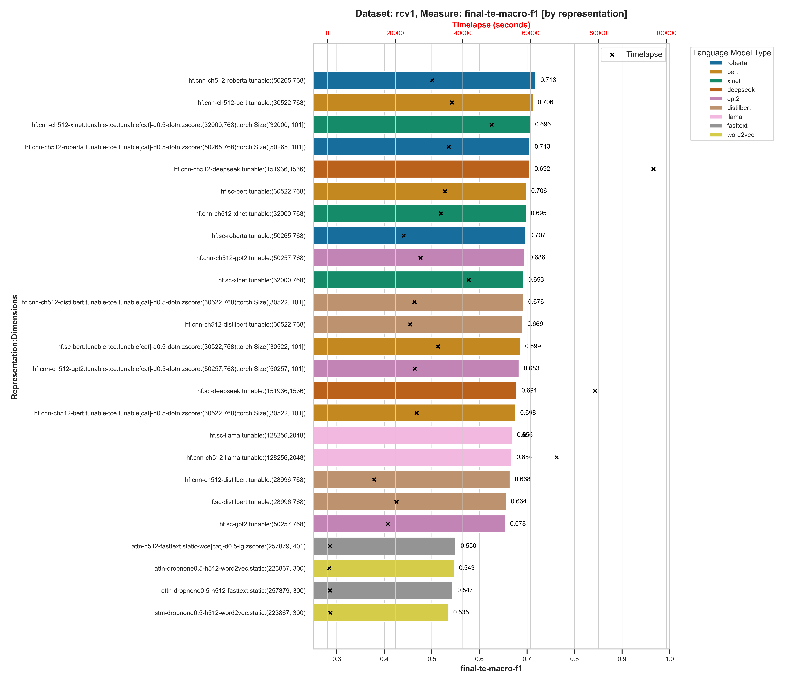
Figure 30: Macro-F1 values across neural classifiers (RCV1 dataset)

Figure 31: Micro-F1 values across neural classifiers (RCV1 dataset)

For the rcv1 dataset, we can see a significant gap between the performance of the best transformer models, .718 for hd.cnn-roberta:(50265,768) for macro-f1 and .871 for hf.cnn-deepseek:(151936, 1536) for micro-f1, while the static pretrained embedding classifiers did not get past .56 for macro-f1 and .81 for micro-f1 respectively.

When we look at the arxiv data, which is academic research papers (which should be included in most transformer model training datasets but not necessarily in the static pretrained embedding models), we see a similar trend, with DeepSeek again performing better than the rest of the transformer models across both macro-f1 and micro-f1 measures and the static embedding neural models, even with the Word-Class Embeddings, lagging behind.

Figure 32: arxix neural classifier performance comparison (Macro-F1)

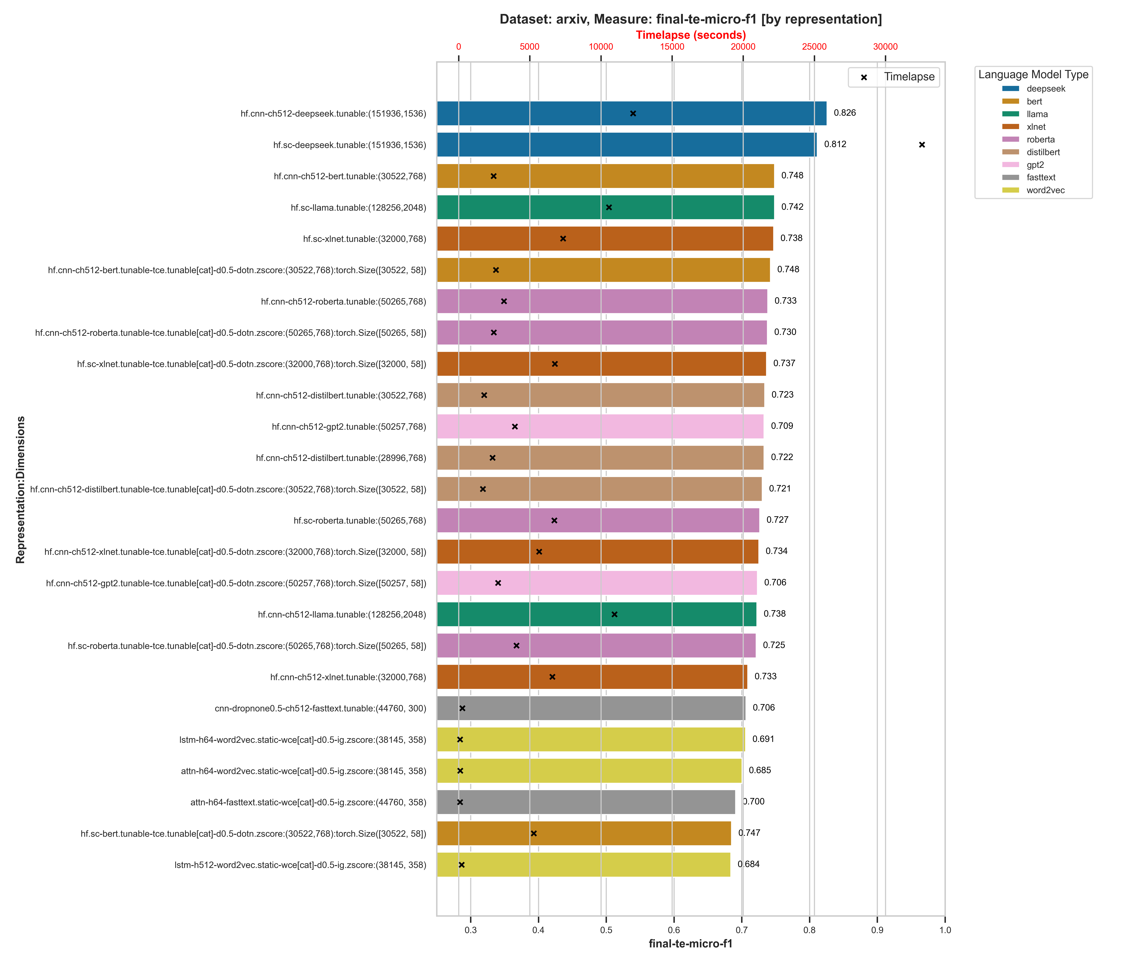
Figure 33: arxix neural classifier performance comparison (Micro-F1)

Over a 10% gap between the best static embedding model and the best performing transformer model in fact, for both the macro-f1 and micro-f1 measures, although the best performing static embedding language model classifiers came close to some of the worst performing transformer models, within .30%.

So even though the incremental improvement on average between the static versus the dynamic (transformer) models is .02% for the macro-f1 measure across all models and %.03 for micro-f1, when we drill into the individual classifier performance statistics at the dataset level, we see a significant gap between the best performing transformer classifiers (the HuggingFace Sequence Classifier typically) and the best performing static pretrained embedding classifier, even with the Word-Class Embeddings for improved performance.

Global Analytical Perspective

We now look at the results across the entire range of Layer Cake tests – the machine learning classifiers, the static neural embedding classifiers, and the transformers to see what patterns emerge from the data.

By Classifier

When we look at the entire picture, the performance of all of the classifiers against each other, we see what we might have expected, that the transformer models perform – again on average – better than their static model counterparts, as well as their ML classifier counterparts. What is perhaps somewhat surprising is that the ML classifiers perform just as well as the static neural models.

The training times across the models again lines up with what we would expect, with the transformer models averaging somewhere in the neighborhood of 20,000 seconds to train, which is almost 6 hours, with more than a few outliers which took greater than 10 hours to train. Almost all of the ML and static embedding neural models were under 6 hours and most of them were under an hour.

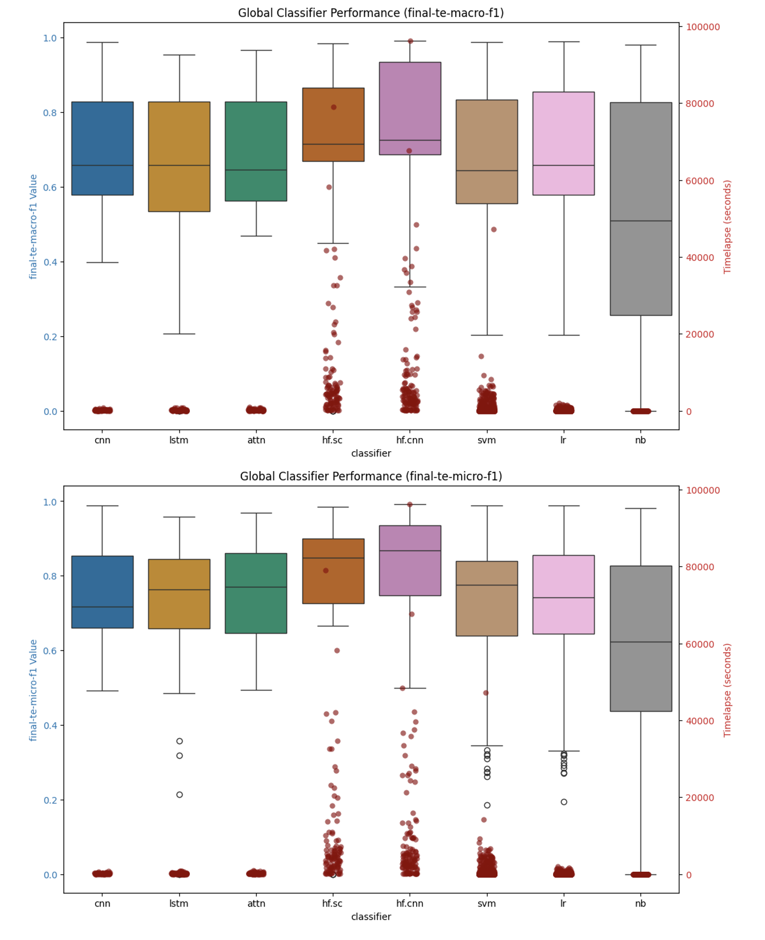
Figure 34: Global Classifier Performance Summary

By Language Model

When we look at the global view by language model, we find perhaps something is surprising. All of the language models, when looked at through the lens of all the datasets and classifiers, perform almost exactly the same, while the larger models – as you might expect – take longer to train.

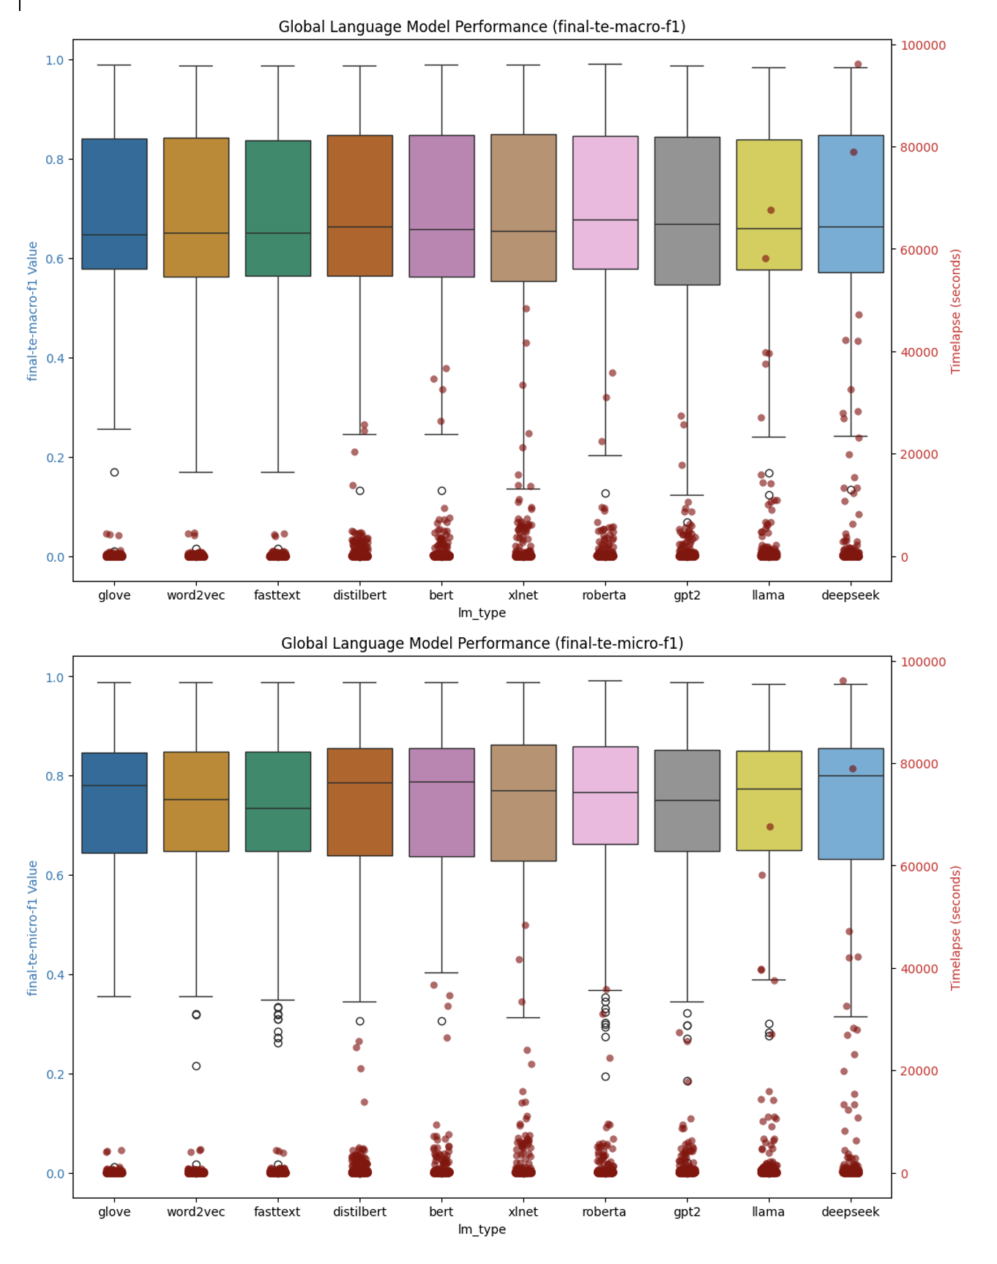
Figure 35: Global Performance Summary by Language Model

By Dataset

If we look at individual datasets however and look at how the different classifiers perform relative to each other (given that it’s fair to say that it is the classifier architecture rather than the underling language model that drives the bulk of the performance of the classifiers relatively speaking), we see a slightly more nuanced and perhaps surprising result emerge.

Let’s look at the top 10 results for macro-f1 and micro-f1 measures for a few datasets – specifically we look at the result detail associated with the 20newsgroups and reuters21578 datasets which represented the base single-label and multi-label test datasets in our research, and then in addition we look at the arxiv_protoformer and Ohsumed datasets, single-label and multi-label examples respectively that both contain a lot of technically specific language that has a high(er) probability of not being included in training sets for the various language models we are testing with, in particular the static embedding models which are trained on common crawl data primarily.

20NewsGroups [Single-Label, 20 Classes]

Macro-F1 Top 10 Results

dataset | classifier | lm_type | representation | value | timelapse
20newsgroups | hf.sc | deepseek | solo | 0.706 | 15468.50
20newsgroups | hf.cnn | bert | solo | 0.704 | 1875.76
20newsgroups | hf.cnn | distilbert | solo | 0.702 | 2323.23
20newsgroups | lr | llama | solo-wce | 0.701 | 36.34
20newsgroups | hf.sc | bert | solo | 0.699 | 2659.65
20newsgroups | hf.cnn | roberta | solo | 0.698 | 1834.15
20newsgroups | cnn | fasttext | solo | 0.694 | 110.54
20newsgroups | hf.cnn | deepseek | solo | 0.693 | 10835.79
20newsgroups | hf.sc | xlnet | solo | 0.689 | 5236.63
20newsgroups | hf.sc | roberta | solo | 0.689 | 1690.47

Micro-F1 Top 10 Results

dataset | classifier | lm_type | representation | value | timelapse
20newsgroups | hf.cnn | bert | solo | 0.713 | 1875.76
20newsgroups | lr | llama | solo-wce | 0.713 | 36.34
20newsgroups | hf.cnn | distilbert | solo | 0.711 | 2323.23
20newsgroups | hf.cnn | deepseek | solo | 0.710 | 10835.79
20newsgroups | hf.cnn | roberta | solo | 0.709 | 1834.15
20newsgroups | hf.sc | deepseek | solo | 0.708 | 15468.50
20newsgroups | hf.sc | bert | solo | 0.705 | 2659.65
20newsgroups | cnn | fasttext | solo | 0.705 | 110.54
20newsgroups | hf.sc | xlnet | solo | 0.702 | 5236.63
20newsgroups | svm | llama | solo-wce | 0.702 | 133.89

Reuters21578 [Multi-Label, 115 Classes]

Macro-F1 Top 10 Results

dataset | classifier | lm_type | representation | value | timelapse
reuters21578 | hf.sc | xlnet | solo | 0.665 | 6270.53
reuters21578 | hf.cnn | xlnet | solo | 0.659 | 6531.26
reuters21578 | hf.sc | deepseek | solo | 0.651 | 23166.31
reuters21578 | hf.cnn | deepseek | solo | 0.647 | 13317.33
reuters21578 | hf.cnn | roberta | solo | 0.619 | 4912.37
reuters21578 | hf.cnn | bert | solo | 0.606 | 5075.94
reuters21578 | hf.cnn | llama | solo | 0.606 | 15962.77
reuters21578 | svm | glove | cat-doc | 0.606 | 19.01
reuters21578 | svm | fasttext | cat-doc | 0.606 | 16.72
reuters21578 | hf.cnn | gpt2 | solo | 0.606 | 4736.67

Micro-F1 Top 10 Results

Dataset | classifier | lm_type | representation | value | timelapse
reuters21578 | attn | fasttext | solo | 0.867 | 240.57
reuters21578 | attn | glove | solo | 0.860 | 204.13
reuters21578 | attn | word2vec | solo | 0.862 | 231.05
reuters21578 | cnn | fasttext | solo | 0.856 | 59.22
reuters21578 | cnn | glove | solo | 0.845 | 122.65
reuters21578 | cnn | word2vec | solo | 0.851 | 109.41
reuters21578 | hf.cnn | bert | solo | 0.897 | 5075.94
reuters21578 | hf.cnn | deepseek | solo | 0.896 | 13400.41
reuters21578 | hf.cnn | distilbert | solo | 0.890 | 1986.27
reuters21578 | hf.cnn | gpt2 | solo | 0.887 | 4736.67

Arxiv Protoformer [Single-Label, 10 Classes]

Macro-F1 Top 10 Results

dataset | classifier | lm_type | representation | value | timelapse
arxiv_protoformer | hf.sc | deepseek | solo | 0.865 | 42047.7
arxiv_protoformer | hf.cnn | deepseek | solo | 0.864 | 42243.9
arxiv_protoformer | lr | llama | solo | 0.856 | 184.9
arxiv_protoformer | lr | deepseek | solo | 0.855 | 154.6
arxiv_protoformer | hf.cnn | xlnet | solo | 0.852 | 21222.4
arxiv_protoformer | hf.cnn | distilbert | solo | 0.851 | 4579.3
arxiv_protoformer | svm | deepseek | solo | 0.850 | 238.7
arxiv_protoformer | svm | deepseek | cat-doc | 0.850 | 1571.7
arxiv_protoformer | hf.sc | bert | solo | 0.850 | 6661.2
arxiv_protoformer | hf.sc | distilbert | solo | 0.849 | 4506.9

Micro-F1 Top 10 Results

dataset | classifier | lm_type | representation | value | timelapse
arxiv_protoformer | hf.sc | deepseek | solo | 0.865 | 42047.65
arxiv_protoformer | hf.cnn | deepseek | solo | 0.865 | 42243.94
arxiv_protoformer | lr | llama | solo | 0.856 | 184.94
arxiv_protoformer | lr | deepseek | solo | 0.855 | 154.60
arxiv_protoformer | hf.cnn | xlnet | solo | 0.852 | 21222.40
arxiv_protoformer | hf.cnn | distilbert | solo | 0.852 | 4579.25
arxiv_protoformer | hf.sc | bert | solo | 0.851 | 6661.19
arxiv_protoformer | svm | deepseek | solo | 0.850 | 238.68
arxiv_protoformer | svm | deepseek | cat-doc | 0.850 | 1571.72
arxiv_protoformer | svm | llama | solo | 0.849 | 315.12

Ohsumed [Multi-Label, 23 classes]

Macro-F1 Top 10 Results

dataset | classifier | lm_type | representation | value | timelapse
ohsumed | hf.cnn | deepseek | solo | 0.748 | 28201.4
ohsumed | hf.sc | deepseek | solo | 0.745 | 27905.8
ohsumed | hf.sc | llama | solo | 0.740 | 27007.4
ohsumed | hf.cnn | llama | solo | 0.736 | 37576.8
ohsumed | hf.cnn | xlnet | solo | 0.735 | 9609.6
ohsumed | hf.sc | roberta | solo | 0.734 | 5755.1
ohsumed | hf.sc | xlnet | solo | 0.734 | 11027.5
ohsumed | hf.cnn | roberta | solo | 0.733 | 5001.3
ohsumed | hf.cnn | bert | solo | 0.733 | 4968.2
ohsumed | hf.cnn | gpt2 | solo | 0.719 | 5970.5

Micro-F1 Top 10 Results

dataset | classifier | lm_type | representation | value | timelapse
ohsumed | hf.cnn | deepseek | solo | 0.770 | 28201.37
ohsumed | hf.sc | deepseek | solo | 0.764 | 27905.77
ohsumed | hf.sc | llama | solo | 0.754 | 27007.43
ohsumed | hf.sc | xlnet | solo | 0.752 | 11027.47
ohsumed | hf.cnn | xlnet | solo | 0.751 | 9609.57
ohsumed | hf.sc | roberta | solo | 0.751 | 5755.08
ohsumed | hf.cnn | roberta | solo | 0.750 | 3289.45
ohsumed | hf.cnn | llama | solo | 0.749 | 37576.85
ohsumed | hf.cnn | bert | solo | 0.749 | 4968.19
ohsumed | hf.cnn | distilbert | solo | 0.741 | 3592.11

In all but the Ohsumed dataset case in fact, there exists a top performing ML classifier that builds very quickly (low timelapse value for training) that has a competitive value for both macro-f1 and micro-f1 relative to the neural models we use for static embeddings as well as the transformer models. While this result is consistent with other results along the same lines (Wahba, et al., 2023), the result is nonetheless surprising and reinforced given the breadth and depth of the testing involved with this research.

Summary Findings & Concluding Remarks

Classifying natural language into predefined categories is a classical problem in NLP that has applicability across a wide range of industries, the foundations of which are instrumental in solving problems around topic modeling and sentiment analysis in news and online media, threat and anomaly detection in cyber security, disease diagnosis in biology, genomics and healthcare, and of course document classification in NLP more generally which has applications in finance, legal, compliance and other sectors of the economy. It is a foundational problem that also serves as a good test case for comparing the performance of various LLMs, the main thrust of this study.

Over the last decade, text classification research has experienced transformative changes due to the introduction of neural network models and deep learning in NLP more broadly, with the bulk of recent research focused on the performance of LLMs which have largely eclipsed classical ML models in most areas of NLP, text classification being no exception. However, there is research – supported by this work – that indicates that the gains one gets from using LLMs is - given the current economic landscape associated with the cost and availability of high end GPUs which are fundamental to the training and fine-tuning of such models – is not necessarily cost effective, of course depending upon the problem that is being solved for.

Figure 36: language model training compute requirements growth rate (Sevilla & Roldán, 2024)

With this work we create a platform for the testing of text classification models across a wide variety of datasets and language models (Layer Cake), focusing on model performance metrics in terms of efficacy (how well the data is classified), as well as performance (what are the computational requirements for model construction), and in so doing we have shed light on the opportunity cost of working with LLMs versus more simple models and by doing so help both researchers as well as practitioners to hone in on the right model for the right problem – one of the most important facets of building out any ML or AI based solution.

With the introduction of Layer Cake and this research, we look to focus the attention specifically on this particular question – namely how much better do these LLMs actually perform on a foundational NLP problem like text classification, relative to their more classical, and less computationally intensive, predecessors, and as such reframe the conversation around how and when LLMs should be used to solve practical, real-world, NLP solves for businesses where cost, and time, are important ingredients for successful outcomes. In short, in this work we look to answer the question, again within the context of text classification specifically but with broader implications on how these LLMs are being used to solve NLP problems more generally, what kind of performance improvement can we expect to gain by using these LLMs and at what (computational) cost?

Research Findings

What we find is that in fact, consistent with research on LLM performance in NLP, the best performing models are in fact LLMs, but a) they cost significantly more time and money to train and b) in almost all cases there exists a classical ML, CPU bound alternative that performs almost as well as best transformer models for that particular dataset.

The exception to this is the Ohsumed dataset, which is highly specific to the healthcare and medical industry and as such includes a lot of very specific, technical terms. In this scenario, and this conclusion can undoubtedly be broadened around classes of NLP problems that work with technically specific language, i.e. termed out of vocabulary terms in the NLP literature, it seems evident that the LLMs handle this language text better than their static embedding language model counterparts (like Word2Vec, GloVe or fastText) and better than their ML classifier predecessors which do not have a good way to build dynamic embedding structures which can account for this type technically specific jargon which is not part of the common core language set in daily use which is primarily what these pretrained language models are trained on.

What we also find, is that Word-Class Embeddings, which have been shown to improve the performance of text classification models in both ML classifier context as well as static embedding neural models, are not at all effective in a transformer, context-aware embedding environment. This is in all likelihood due to some combination of a) the already granular, context-aware nature of the transformer models which include this type of word/token to class type information, and b) the transformer-based models are designed to be self-contained and are not set up to be augmented with additional embedding information that comes from outside the model.

When we look at the various forms of language representation in turn, particularly within the context of the ML testing section of this work which allows for a clean treatment of various forms of language representation given the underlying architecture of the models (SVM or Logistic Regression in particular), we do find two very effective feature reduction techniques that stand out in terms of performance. One is the tried and true Latent Semantic Indexing approach which uses matrix factorization techniques to identify the most salient features (words or tokens) in a given dataset representation, and another – perhaps more surprisingly – is the approach that uses the embedding representation form of the underlying dataset, either with or without the use of Word (or Token as the case may be) Class Embeddings. WCEs / TCEs were also shown to be effective when combined with the output of an LSA reduction of the vectorized text as well. Both of these approaches to language representation stood up very well, and in most cases outperformed, the standard tf-idf vector representation forms, both in terms of efficacy (macro and micro f1 scores), as well as in terms of performance and computational complexity.

Recommended Further Research

One of the unique perspectives that we provide here is mapping model effectiveness directly back to the form of language representation that is being used, particularly in the ML part of the analysis. One of the interesting questions we were not able to answer with this research is how different types of embedding geometries would perform in some of the different classifiers that we test with. In particular some of the embeddings that are trained in hyperbolic spaces would be interesting to look at within the context of Layer Cake and text classification problems in general but unfortunately we did not have time for that research with Layer Cake.

From a computational perspective, it would also be interesting to see what the effect might be of using different parallelism approaches to transformer model training to see what effect that had on model training times and ultimately GPU computational requirements which are a significant part of the training or fine tuning of LLMs. In our case, we used the default Data Parallel (DP) approach which comes built in to the Hugging Face APIs but the Distributed Data Parallel (DDP) PyTorch capabilities are supposed to surpass those of the more straightforward DP form of parallelism so it would be interesting to see what this difference was performance wise in terms of model training.

Using DPP would also allow the testing of larger LLMs, LLMs that could be spread across multiple GPUs – models that could not be included in this study due to single GPU memory constraints that prevent the use of larger models in a DP type of setup. Another area of further research would be around expanding the framework to support DPP and then see how much more effective, if at all, the larger transformer models are within the context of text classification problems that we test here.

Bibliography
Albrecht, J., Ramachandran, S. & Winkler, C., 2020. Blueprints for Text Analytics Using Python. s.l.:O'Reilly Media, Inc..
Bahdanau, D., Cho, K. & Bengio, Y., 2016. Neural Machine Translation by Jointly Learning to Align and Translate. 19 May.p. https://doi.org/10.48550/arXiv.1409.0473.
Bai, J., 2023. Qwen Technical Report. arxiv, p. https://doi.org/10.48550/arXiv.2309.16609.
Beltagy, I., Lo, K. & Cohan, A., 2019. SciBERT: A Pretrained Language Model for Scientific Text. Hong Kong, China, Association for Computational Linguistics, pp. 3615-3620; https://doi.org/10.18653/v1/D19-1371.
Bender, E. M. & Koller, A., 2020. Climbing towards NLU: On Meaning, Form, and Understanding in the Age of Data. s.l., Association for Computational Linguistics, pp. 5185-5198.
Bojanowski, P., Grave, E., Joulin, A. & Mikolov, T., 2017. Enriching Word Vectors with Subword Information. Transactions of the Association for Computational Linguistics, 01 06, Volume 5, pp. 135-146; https://doi.org/10.1162/tacl_a_00051.
Brown, T. B. et al., 2020. Language Models are Few-Shot Learners. Red Hook, NY, USA, Curran Associates Inc., pp. 1877-1901.
Chang, T. A. & Bergen, B. K., 2024. Language Model Behavior: A Comprehensive Survey. Computational Linguistics, 03, 50(1), pp. 293-350. https://doi.org/10.1162/coli_a_00492.
Chomsky, N., 1956. Three models for the description of language. IRE Transactions on Information Theory, September, 2(3), pp. 113-124. https://doi.org/10.1109/TIT.1956.1056813.
Chomsky, N., 1957. Syntactic Structures. Berlin, Boston: De Gruyter Mouton.
Chomsky, N., 1965. Aspects of the Theory of Syntax. Cambridge(MA): MIT Press.
Cortes, C. & Vapnik, V., 1995. Support-vector networks. Machine Learning, 01 09, 20(3), pp. 273-297: https://doi.org/10.1007/BF00994018.
Cox, D. R., 1958. The Regression Analysis of Binary Sequences. Journal of the Royal Statistical Society, July, 20(2), pp. 215-232; https://doi.org/10.1111/j.2517-6161.1958.tb00292.x.
Dai, Z. et al., 2019. Transformer-XL: Attentive Language Models Beyond a Fixed-Length Context. arxiv, 2 June.p. https://doi.org/10.48550/arXiv.1901.02860.
Deerwester, S. et al., 1990. Indexing by latent semantic analysis. Journal of the American Society for Information Science, 41(6), pp. 391-407. https://doi.org/10.1002/(SICI)1097-4571(199009)41:6<391::AID-ASI1>3.0.CO;2-9.
Devlin, J., Chang, M.-W., Lee, K. & Toutanova, K., 2019. BERT: Pre-training of Deep Bidirectional Transformers for Language Understanding. Minneapolis, Minnesota, Association for Computational Linguistics, pp. 4171-4186. https://doi.org/10.48550/arXiv.1810.04805.
Ding, N. et al., 2023. Parameter-efficient fine-tuning of large-scale pre-trained language models. Nature Machine Intelligence, 3 March, Issue 3, pp. 220-235; https://doi.org/10.1038/s42256-023-00626-4.
Elman, J. L., 1990. Finding structure in time. Cognitive Science, 14(2), pp. 179-211; https://doi.org/10.1016/0364-0213(90)90002-E.
Farrando, J., Sarti, G., Bisazza, A. & Costa-jussà, M. R., 2024. A Primer on the Inner Workings of Transformer-based Language Models. Preprint, p. 55..
Fitch, W. T., 2010. The Evolution of Language. s.l.:Cambridge University Press.
Fu, Z. et al., 2023. On the effectiveness of parameter-efficient fine-tuning. s.l., AAAI Press, pp. 12799 - 12807; 10.1609/aaai.v37i11.26505.
Hernandez, E. et al., 2024. Linearity of Relation Decoding in Transformer Language Models. arxiv, 15 02.p. https://doi.org/10.48550/arXiv.2308.09124.
He, Y., Yuan, M., Chen, J. & Horrocks, I., 2024. Language Models as Hierarchy Encoders. arxiv, 21 November.p. https://doi.org/10.48550/arXiv.2401.11374.
Hochreiter, S. & Schmidhuber, J., 1997. Long Short-Term Memory. Neural Computation, 15 November, 9(8), pp. 1735-1780; https://doi.org/10.1162/neco.1997.9.8.1735.
Howard, J. & Ruder, S., 2018. Universal Language Model Fine-tuning for Text Classification. Melbourne, Australia, Association for Computational Linguistics, pp. 328-339; 10.18653/v1/P18-1031.
Hutchins, J. W., 2004. The Georgetown-IBM experiment demonstrated in January 1954. Berlin, Heidelberg, Springer Berlin Heidelberg, pp. 102-114. https://doi.org/10.1007/978-3-540-30194-3_12.
Jiao, X. et al., 2020. TinyBERT: Distilling BERT for Natural Language Understanding. s.l., Association for Computational Linguistics, pp. 4163-4174; 10.18653/v1/2020.findings-emnlp.372.
Joachims, T., 1998. Text categorization with Support Vector Machines: Learning with many relevant features. Berlin, Springer Berlin Heidelberg, pp. 137-142; https://doi.org/10.1007/BFb0.
Jones, K. S., 1972. A STATISTICAL INTERPRETATION OF TERM SPECIFICITY AND ITS APPLICATION IN RETRIEVAL. Journal of Documentation, January, 28(1), pp. 11-21; https://doi.org/10.1108/eb026526.
Jurafsky, D. & Martin, J. H., 2024. Speech and Language Processing: An Introduction to Natural Language Processing, Computational Linguistics, and Speech Recognition. s.l.:Prentice Hall, Pearson Education International.
Katz, D. M., Bommarito, M. J., Gao, S. & Arredondo, P., 2024. GPT-4 Passes the Bar Exam. Philosophical Transactions of the Royal Society, 26 February, 382(2270), p. https://doi.org/10.1098/rsta.2023.0254.
Khurana, D., Koli, A., Khatter, K. & Singh, S., 2022. Natural language processing: state of the art, current trends and challenges. Multimedia Tools and Applications, July, 82(3), pp. 3713-3744. http://dx.doi.org/10.1007/s11042-022-13428-4.
Kim, Y., 2014. Convolutional Neural Networks for Sentence Classification. Doha, Qatar, Association for Computational Linguistics, pp. 1746--1751; 10.3115/v1/D14-1181.
Kudo, T. & Richardson, J., 2018. SentencePiece: A simple and language independent subword tokenizer and detokenizer for Neural Text Processing. Brussels, Belgium, Association for Computational Linguistics, pp. 66-71; 10.18653/v1/D18-2012.
LeCun, Y., Bottou, Y., Bengio, Y. & Haffner, P., 1998. Gradient-based learning applied to document recognition. Proceedings of the IEEE, November, 86(11), pp. 2278-2324; doi: 10.1109/5.726791.
Leimeister, M. & Wilson, B. J., 2019. Skip-gram word embeddings in hyperbolic space. arxiv, 27 May.
Lewis, M. et al., 2020. BART: Denoising Sequence-to-Sequence Pre-training for Natural Language Generation, Translation, and Comprehension. s.l., Association for Computational Linguistics, pp. 7871–7880; https://doi.org/10.18653/v1/2020.acl-main.703.
Li, Q. et al., 2022. A Survey on Text Classification: From Traditional to Deep Learning. ACM Transactions on Intelligent Systems and Technology (TIST), 8 April, 13(2), pp. 1-41; https://doi.org/10.1145/3495162.
Liu, Y. et al., 2019. RoBERTa: A Robustly Optimized BERT Pretraining Approach. p. https://doi.org/10.48550/arXiv.1907.11692.
Mikolov, T., Chen, K., Corrado, G. & Dean, J., 2013. Efficient Estimation of Word Representations in Vector Space. s.l., arXiv, p. https://doi.org/10.48550/arXiv.1301.3781.
Minaee, S. et al., 2021. Deep Learning--based Text Classification: A Comprehensive Review. ACM Computing Surveys (CSUR), April, 54(3), pp. 1-40; https://doi.org/10.1145/3439726.
Minaee, S. et al., 2024. Large Language Models: A Survey. ArXiv, Volume abs/2402.06196.
Mitchell, M. & Krakauer, D. C., 2023. The debate over understanding in AI’s large language models. Proceedings of the National Academy of Sciences, March, 120(13), p. http://dx.doi.org/10.1073/pnas.2215907120.
Moreo, A., Esuli, A. & Sebastiani, F., 2021. Word-class embeddings for multiclass text classification. Data Mining and Knowledge Discovery, May, Volume 35, pp. 911-963. https://doi.org/10.1007/s10618-020-00735-3.
Park, K., Choe, Y. J., Jiang, Y. & Veitch, V., 2024. The Geometry of Categorical and Hierarchical Concepts in Large Language Models. arxiv, 9 Oct.p. https://doi.org/10.48550/arXiv.2406.01506.
Park, K., Choe, Y. J. & Veitch, V., 2024. The linear representation hypothesis and the geometry of large language models. Vienna, Austria, JMLR.org, pp. 39643 - 39666; .
Patel, F., 2019. Singular Value Decomposition(SVD) : A simple, comprehensive and practical introduction. [Online]
Available at: https://medium.com/@faizanmukardam/singular-value-decomposition-svd-a-simple-comprehensive-and-practical-introduction-6add3dc6793d
[Accessed June 2024].
Peng, W. et al., 2022. Hyperbolic Deep Neural Networks: A Survey. IEEE Transactions on Pattern Analysis and Machine Intelligence, December, 44(12), pp. 10023-10044; 10.1109/TPAMI.2021.3136921.
Pennington, J., Socher, R. & Manning, C. D., 2014. GloVe: Global Vectors for Word Representation. Doha, Qatar, Association for Computational Linguistics, pp. 1532-1543. 10.3115/v1/D14-1162.
Peters, M. E. et al., 2018. Deep contextualized word representations. New Orleans, Louisiana, Association for Computational Linguistics, pp. 2227-2237. https://doi.org/10.48550/arXiv.1802.05365.
Pierce, J. & Carroll, J. B., 1966. Language and Machines - Computers in Translation and Linguistics, Washington, DC: s.n.
Qiu, X. et al., 2020. Pre-trained models for natural language processing: A survey. Science China Technological Sciences, 15 September, 63(10), pp. 1872-1897; https://doi.org/10.1007/s11431-020-1647-3.
Radford, A. & Narasimhan, K., 2018. Improving Language Understanding by Generative Pre-Training. [Online].
Raffel, C. et al., 2020. Exploring the Limits of Transfer Learning with a Unified Text-to-Text Transformer. Journal of Machine Learning Research, 06, Volume 21, pp. 1-67; https://doi.org/10.48550/arXiv.1910.10683.
Raiaan, M. Z. K. et al., 2024. A Review on Large Language Models: Architectures, Applications, Taxonomies, Open Issues and Challenges. IEEE Access, Volume 12, pp. 26839-26874. http://dx.doi.org/10.1109/ACCESS.2024.3365742.
Rudman, W. & Eickhoff, C., 2023. Stable Anisotropic Regularization. arxiv, May.p. https://doi.org/10.48550/arXiv.2305.19358.
Rumelhart, D. E., Hinton, G. E. & Williams, R. J., 1986. Learning representations by back-propagating errors. Nature, 9 October, 323(6088), pp. 533-536; https://doi.org/10.1038/323533a0.
Salton, G., 1971. The SMART Retrieval System-Expermients in Automatic Document Processing. s.l.:Prentic-Hall, Inc..
Sanh, V., Debut, L., Chaumond, J. & Wolf, T., 2020. DistilBERT, a distilled version of BERT: smaller, faster, cheaper and lighter. p. https://doi.org/10.48550/arXiv.1910.01108.
Schank, R. C., Goldman, N., Riager, C. J. & Rissbeck, C., 1973. Margie memory, analysis, response generation, and inference on English. San Francisco, CA, Morgan Kaufmann Publishers Inc., pp. 255-261.
Schuster, M. & Nakajima, K., 2012. Japanese and Korean voice search. Kyoto, Japan, IEEE, pp. 5149-5152; 10.1109/ICASSP.2012.6289079.
Sennrich, R., Haddow, B. & Birch, A., 2016. Neural Machine Translation of Rare Words with Subword Units. Berlin, Germany, Association for Computational Linguistics, pp. 1715–1725; 10.18653/v1/P16-1162.
Sevilla, J. & Roldán, E., 2024. Training Compute of Frontier AI Models Grows by 4-5x per Year. [Online]
Available at: https://epoch.ai/blog/training-compute-of-frontier-ai-models-grows-by-4-5x-per-year
[Accessed 23 01 2025].
Shardlow, M. & Przybyła, P., 2023. Deanthropomorphising NLP: Can a Language Model Be Conscious?. arXiv, p. https://doi.org/10.48550/arXiv.2211.11483.
Simon, P. J. D. et al., 2024. A Polar coordinate system represents syntax in large language models. s.l., Curran Associates, Inc., pp. 105375-105396; https://doi.org/10.48550/arXiv.2412.05571.
Sparck Jones, K., 1972. A STATISTICAL INTERPRETATION OF TERM SPECIFICITY AND ITS APPLICATION IN RETRIEVAL. Journal of Documentation, 01 January, 28(1), pp. 11-21. https://doi.org/10.1108/eb026526.
Sun, Z. et al., 2020. MobileBERT: a Compact Task-Agnostic BERT for Resource-Limited Devices. s.l., Association for Computational Linguistics, pp. 2158-2170; 10.18653/v1/2020.acl-main.195.
Sutskever, I., Vinyals, O. & Le, Q. V., 2014. Sequence to sequence learning with neural networks. Cambridge, MA USA, MIT Press, p. 3104–3112; https://doi.org/10.48550/arXiv.1409.3215.
Tai, K. S., Socher, R. & Manning, C. D., 2015. Improved Semantic Representations From Tree-Structured Long Short-Term Memory Networks. Beijing, China, Association for Computational Linguistics, pp. 1556-1566; 10.3115/v1/P15-1150.
Tifrea, A., Bécigneul, G. & Ganea, O.-E., 2019. Poincaré GloVe: Hyperbolic Word Embeddings. New Orleans, Louisiana, s.n.
Touvron, H. et al., 2023. LLaMA: Open and Efficient Foundation Language Models. arXiv, p. https://doi.org/10.48550/arXiv.2302.13971.
Turing, A., 1950. Computing Machinery and Intelligence. Mind, 59(236), pp. 433-460; 10.1093/mind/lix.236.433.
Turing, A. M., 1950. Computing Machinery and Intelligence. Mind, October, 49(236), pp. 433-460. https://doi.org/10.1093/mind/LIX.236.433.
Valentino, M., Carvalho, D. S. & Freitas, A., 2024. Multi-Relational Hyperbolic Word Embeddings from Natural Language Definitions. St Julian's, Malta, Association for Computational Linguistics, pp. 23-34; https://doi.org/10.48550/arXiv.2305.07303.
Vaswani, A. et al., 2017. Attention is All You Need. Long Beach, CA, Curran Associates Inc., p. https://doi.org/10.48550/arXiv.1706.03762.
Wahba, Y., Madhavji, N. & Steinbacher, J., 2023. A Comparison of SVM Against Pre-trained Language Models (PLMs) for Text Classification Tasks. Cham, Switzerland, Springer Nature, pp. 304-313; https://doi.org/10.1007/9.
Wan, Z. et al., 2024. Efficient Large Language Models: A Survey. ArXiv, Volume abs/2312.03863, p. https://doi.org/10.48550/arXiv.2312.03863.
Winograd, T., 1972. Procedures As A Representation For Data In A Computer Program For Understanding Natural Language. Cognitive Psychology, 3(1).
Worth, P., 2023. Word Embeddings and Semantic Spaces in Natural Language Processing. International Journal of Intelligence Science, 13(1), pp. 1-21. https://doi.org/10.4236/ijis.2023.131001.
Yang, J. et al., 2023. Harnessing the Power of LLMs in Practice: A Survey on ChatGPT and Beyond. p. https://doi.org/10.48550/arXiv.2304.13712.
Yang, J. et al., 2024. Harnessing the Power of LLMs in Practice: A Survey on ChatGPT and Beyond. ACM Transactions on Knowledge Discovery from Data, April, 18(6), pp. 1-32; https://doi.org/10.1145/3649506.
Yang, Z. et al., 2019. XLNet: generalized autoregressive pretraining for language understanding. Red Hook, NY, Curran Associates Inc., p. 5753–5763.
Yang, Z. et al., 2016. Hierarchical Attention Networks for Document Classification. San Diego, CA, Association for Computational Linguistics, pp. 1480-1489; 10.18653/v1/N16-1174.
Yun, Z., Chen, Y., Olshausen, B. & LeCun, Y., 2021. Transformer visualization via dictionary learning: contextualized embedding as a linear superposition of transformer factors. s.l., Association for Computational Linguistics, pp. 1-10; 10.18653/v1/2021.deelio-1.1.
Zhao, W. X. et al., 2023. A Survey of Large Language Models. ArXiv, Volume abs/2303.18233, pp. 1-124. 10.48550/arXiv.2303.18223.

With perhaps the most notable example being GPT-4 successful passing of the bar exam in 2023 (Katz, et al., 2024)
At present there are over 300,000 language models hosted by Hugging Face that are readily available through their APIs for integration into applications.
Ironically the best method for distinguishing between human intelligence and artificial intelligence at this point is AI itself.
The ML literature is filled with feature reduction techniques and approaches and optimizations, speaking to the relevance and importance that various forms of language representation have on model training times and overall model performance efficiacy.
Source code for Layer Cake available at https://github.com/pworth1971/layer-cake
In most of the historical literature around AI, the field’s origination is traced back to a series of seminars and meetings held at Dartmouth College in the summer of 1956, in Hanover, New Hampshire. The primary goal of the seminar was to explore the concept of "thinking machines" and to investigate whether computers could be programmed to exhibit intelligent behavior.
Semantic based analysis of text is distinct from syntax-based analysis which looks to break apart the text into components, for example using parts of speech tagging, dependency parsing, lemmatization or named entity recognition. While we won’t cover those topics here, these techniques all look to break down the text, the words and sentences, into their constituent parts and relationships.
There are other geometries that are used to build the language representation that are beyond the scope of this work, however hyperbolic space natural language learning is one field that holds promise in certain areas of NLP and also it has been shown that Hilbert spaces can also be used as a means for building NLP models.
“The upper left shows the unit disc in blue together with the two canonical unit vectors. The upper right shows the action of M on the unit disc: it distorts the circle to an ellipse. The SVD decomposes M into three simple transformations: a rotation V*, a scaling Σ along the coordinate axes and a second rotation U. The SVD reveals the lengths σ₁ resp. σ₂ of the semi-major axis resp. semi-minor axis of the ellipse; they are just the singular values which occur as diagonal elements of the scaling Σ. The rotation of the ellipse with respect to the coordinate axes is given by U.” - Image and description by Georg-Johann - CC BY-SA 3.0, https://commons.wikimedia.org/w/index.php?curid=11342212
Window context being defined as for example 5 words before or after the current target word where 5 is configurable training parameter for the model.
For example, we concatenate and use other forms of linear algebraic transformations with basic text representation forms, LSA forms of data, and Word-Class Embedding structures as well, leveraging the code and test methodology introduced in (Moreo, et al., 2021).
Polysemy is a linguistics term that means a word can have different meanings in different linguistic contexts, i.e. ‘poly’ or many and ‘semy’ which is the same root for ‘semantics’ which means ‘meaning’.
Showing decoder only models in the blue branch, encoder only models in the pink branch, and encoder-decoder models in the green branch. Graphic from Yang et al 2023.
With the exception of FastText which uses a subword, or n-gram approach to text parsing and tokenization but is nonetheless static in its representation form just as Word2Vec and GloVe embedding models are.
Image from (Peng, et al., 2022), a good survey of Hyperbolic Deep Neural Networks published in 2022.
(Cortes & Vapnik, 1995) first introduced the concept of support vector machines and then their use for the problem of text classification explicitly was introduced in (Joachims, 1998).
Image by Larhmam, CC BY-SA 4.0, https://commons.wikimedia.org/w/index.php?curid=73710028
The vanishing gradient problem arises in RNNs due to their sequential nature, where outputs from previous time steps are fed as inputs to subsequent steps. During backpropagation through time (BPTT), gradients are computed by applying the chain rule through many layers (or time steps). As the network becomes deeper, the gradients of the loss with respect to earlier layers can become very small due to repeated multiplication of small values (usually from sigmoid or tanh activation functions). In NLP and text classification tasks, where input sequences (sentences or documents) can be long, this problem becomes particularly severe. The network struggles to learn dependencies between distant tokens because the gradients diminish as they are propagated back through time, leading to the failure to capture long-range dependencies (e.g., understanding the relationship between subjects and verbs in long sentences), and poor performance on tasks that require context understanding (e.g., sentiment classification in long reviews).
Mathematical details around the specific LSTM (RNN) architecture used by PyTorch can be found here: https://pytorch.org/docs/stable/generated/torch.nn.LSTM.html
Image from https://nzlul.medium.com/the-classification-of-text-messages-using-lstm-bi-lstm-and-gru-f79b207f90ad
Image from https://medium.com/analytics-vidhya/hierarchical-attention-networks-d220318cf87e
Showing decoder only models in the blue branch, encoder only models in the pink branch, and encoder-decoder models in the green branch. Graphic from Yang et al 2023.
We assume the reader is familiar with Bog O notation, one of the cornerstones of theoretical computer science.
See https://scikit-learn.org/stable/modules/generated/sklearn.linear_model.LogisticRegression.html for details.
See https://scikit-learn.org/stable/modules/generated/sklearn.svm.LinearSVC.html for details.
See https://scikit-learn.org/stable/modules/generated/sklearn.naive_bayes.MultinomialNB.html for details.
The Layer Cake results we track for NB classifiers includes only the vectorization methods language representation forms.
The Common Crawl dataset, as used by FastText crawl-300d-2M trained language model which is used in this study contains 600+ billion tokens, making it one of the largest public corpora available for training NLP models. The dataset is multilingual, with content spanning hundreds of languages and while English is dominant, significant amounts of content are curated for other major languages like Spanish, French, and Chinese. The data is sourced from a wide range of websites, covering topics such as news articles, blogs, social media, scientific articles, forums and community sites and technical documentation, representation a broad range of data that supports the training of language models that cover the broad scope of human digital) language. The main goal of the Common Crawl project is to provide an open-access, large-scale web dataset for academic, industrial, and research use. Common Crawl data is publicly available and constantly updated through periodic crawls. Source: https://commoncrawl.org/
https://nlp.stanford.edu/projects/glove/
https://huggingface.co/openai-community/gpt2
https://huggingface.co/meta-llama/Llama-3.2-1B
https://huggingface.co/deepseek-ai/DeepSeek-R1-Distill-Qwen-32B
Qwen is an open-source family of language models developed by Alibaba Cloud in 2023 in the paper (Bai, 2023)
Details on the different in scope datasets can be found in the Appendix
For a more detailed treatment of parallelism using PyTorch and/or Hugging Face we suggest https://huggingface.co/docs/transformers/v4.13.0/en/parallelism.
For more information on the PyTorch allreduce method, see https://pytorch.org/docs/stable/distributed.html
The TFIDFVectorization arguments that we use, following the 2019 study, are min_df=5 which indicates that a word, or token, is only included in the doc vector if it exists in at least 5 documents across the dataset, and sublinear=True which applies sublinear scaling to the tf-idf values that are used in the underlying doc vector representation, i.e. the tf value is replaced with 1+log(tf), see https://scikit-learn.org/stable/modules/generated/sklearn.feature_extraction.text.TfidfVectorizer.html for details. Note also that while the Layer Cake platform supports Count vectorization as well, these results are not reported in this study as they are what one might expect, that the tf-idf representation performs better generally than the straight up count vectorization, i.e. bag of words model. Also note that the tf-idf vectorization of the text with min_df = 5 is a form of implicit feature reduction as well.
As defined in the study of the same name published in 2021 (Moreo, et al., 2021) which forms the basis of the foundational code for Layer Cake.
While the results vary by model we found that generally the average mean embedding computation method was the most effective, including in some BERT models where the CLS token is present.
This approach follows (Moreo, et al., 2021). For details on TFIDFVectorizer API from sklearn see https://scikit-learn.org/stable/modules/generated/sklearn.feature_extraction.text.TfidfVectorizer.html.
In the optimized form (denoted as [opt] in the representation shorthand we describe above), where we use RandomizedGridSearchCV API with 9 as the n_iter argument (9 options are tried) to try and find an optimal set of parameters for the underlying Classifier without running through all the possible model parameters which can get very computationally expensive in particular in the Logistic Regression model case. It’s worth noting however that the variance in terms of model performance between these optimized models and the default parameter ([def] representation form) models is not as significant as one might think and the performance hit for building and testing the optimized classifiers is, at least for the ML test cases, significant.
See https://scikit-learn.org/0.24/modules/generated/sklearn.multiclass.OneVsRestClassifier.html
The Naïve Bayes classifier, MultinomialNB from sklearn, only supports the vectorized representation form given its dependency on positive embeddings only so this is the only representation form that is computational viable.
As of this writing Hugging Face supports over 300,000 language models.
HuggingFace is an American company that, among other things, is known for its transformers API which is widely used in the Python AI and MNL community. A listing of supported models and overview of the API can be found at https://huggingface.co/docs/transformers/v4.17.0/en/index
The WCEs are combined with the static language model embeddings via concatenation, i.e. we extend the embedding layer dimensions to include the WCEs yielding a richer word representation that is fed into the model during training.
We experimented with dot product operations, addition operations, and concatenation operations of the transformer generated embedding representations of the text with the TCEs that we computed per class (per token). None of these methods worked for any of the transformer models we tested. We hypothesize that, given how well the transformer models perform generally relative to both their static embedding counterparts and the baseline ML classifiers we test with (SVMs, Logistic Regression methods primarily), that this is because the additional information that is encapsulated in these TCEs is already part of the underlying transformer model representation of the text at some level and therefore adding it to the embeddings only proves to reduce the effectiveness of the classification portion of the classifier.
Although of course the primary reason the dynamic models are so much more computationally expensive than their static counterparts is their dynamic nature which require the embeddings to be computed at runtime rather than just once during their pretraining.
This is in contrast to the data preparation for the transformer based models where we keep the text case sensitive, and leave the stopwords and punctuation in place given that the transformer based models are designed to handle the full complement of language syntax, one of its prominent features that distinguishes it from its static language model counterparts which are not, by design, ‘context aware’.
The GloVe model we use for example, which performs very well relative to the other language models, is 840B tokens, 2.2M vocab, is cased (i.e. case sensitive), has vectors of 300 dimensions and is approximately 2.03 GB.
Supported statistics include macro-F1, micro-F1, accuracy, precision, recall, Hamming loss and Jaccard Index.
Or in the case of fastText subwords but ultimately these are words in the sense that the subwords themselves do in fact have a semantic meaning
Effectively the transformer-based models, given their internal dependency on the underlying computational logic that is intrinsic to the language model type itself, cannot be extended horizontally (concatenated) with TCEs as is the case with the static models.
This is important for example if we want to add TCEs into the model which are computed off of the vectorized representation form of the text. TCEs, while tested, were shown to not improve model efficacy at all in fact to slightly detract from model performance.
Specific formulas for metric calculation can be found in the Experimental Setup section of this work.
Also, it’s also important to understand that this computational costs is not just a one time cost, in the event that you want your model to be updated on an ongoing basis, which is the case in any operational setting, that represents a 50x incremental resource cost for each and every model training update on an ongoing basis which, over time, geometrically expands the gap resource wise between what would be required to train a static embedding model versus a transformer, dynamic model.

