Manual Test
Run the GameControl.java, it should display a standard chess board with all chess pieces on its starting position.
The following screen shots should be the right result:
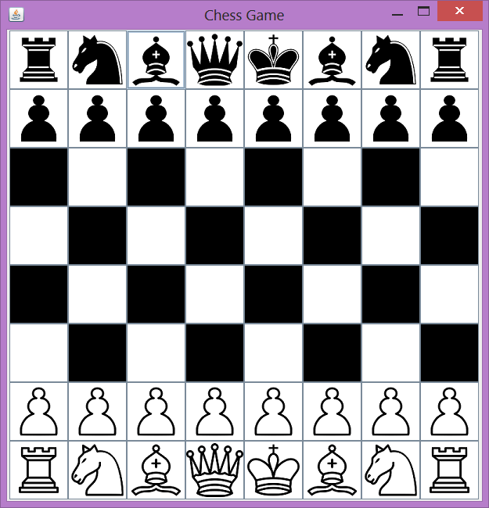

Move Some Pieces and see if it can move correctly.

Steps:
1.Display the initial board setting.
2.Player able to input player name.
3.Show whose turn is it.
4.Move a white pawn to a valid position. The chess board should display the change.
5.The turn should be passed to the black player.
6.Try to move a white piece, the GUI should give message that it's an invalid move.
7.Try to move other black pieces invalidly. Like Move pawn three steps, or move queen across blocking pawn.
8.Test undo functionality.
9.Test if checked message is shown.
10.Test checkmate and stalemate functionality.
11.Test draw functionality.

