3036274164_q1

PENG, Xin

2024-04-15

knitr::opts_chunk$set(echo = TRUE)  
setwd("/Users/amypxx/Library/CloudStorage/OneDrive-TheUniversityofHongKong-Connect/adv stat/final exam")  
library(openxlsx)  
library(ggplot2)  
library(survival)

# Q1 A

q1 <- read.csv('exam_question1.csv')  
head(q1)

## id male age heart comorbid covid anxiety  
## 1 1 1 35 0 0 1 0  
## 2 2 0 28 1 1 1 0  
## 3 3 1 35 0 0 1 0  
## 4 4 0 19 0 0 1 0  
## 5 5 0 22 0 0 1 0  
## 6 6 1 22 0 0 1 0

summary(q1)

## id male age heart   
## Min. : 1.0 Min. :0.000 Min. :18.00 Min. :0.0000   
## 1st Qu.: 750.8 1st Qu.:0.000 1st Qu.:39.00 1st Qu.:0.0000   
## Median :1500.5 Median :1.000 Median :52.00 Median :0.0000   
## Mean :1500.5 Mean :0.541 Mean :51.38 Mean :0.2017   
## 3rd Qu.:2250.2 3rd Qu.:1.000 3rd Qu.:64.00 3rd Qu.:0.0000   
## Max. :3000.0 Max. :1.000 Max. :95.00 Max. :1.0000   
## comorbid covid anxiety   
## Min. :0.000 Min. :0.0 Min. :0.0000   
## 1st Qu.:0.000 1st Qu.:0.0 1st Qu.:0.0000   
## Median :0.000 Median :0.5 Median :0.0000   
## Mean :0.402 Mean :0.5 Mean :0.1333   
## 3rd Qu.:1.000 3rd Qu.:1.0 3rd Qu.:0.0000   
## Max. :2.000 Max. :1.0 Max. :1.0000

lm1 <- glm(anxiety ~ covid + male + age + heart + comorbid, family = "binomial", data = q1)  
  
ci <- exp(confint(lm1))

## Waiting for profiling to be done...

or <- exp(coef(lm1))  
  
results <- cbind(  
 Variable = rownames(ci),  
 OR = round(or,2),  
 round(ci,2)  
)  
  
knitr::kable(results, caption = "OR and 95% CI", digits = 2)

OR and 95% CI

|  | Variable | OR | 2.5 % | 97.5 % |
| --- | --- | --- | --- | --- |
| (Intercept) | (Intercept) | 0.01 | 0.01 | 0.02 |
| covid | covid | 1.6 | 1.28 | 2 |
| male | male | 1.17 | 0.94 | 1.46 |
| age | age | 1.04 | 1.03 | 1.05 |
| heart | heart | 1.31 | 1.02 | 1.68 |
| comorbid | comorbid | 1.07 | 0.92 | 1.23 |

**COVID-19 infections significantly increase the risk of anxiety disorder adjusting for various confounders.**

# Q1 B

psq1 <- glm(covid ~ male + age + heart + comorbid, family = "binomial", data = q1)  
  
summary(psq1)

##   
## Call:  
## glm(formula = covid ~ male + age + heart + comorbid, family = "binomial",   
## data = q1)  
##   
## Coefficients:  
## Estimate Std. Error z value Pr(>|z|)   
## (Intercept) -0.431475 0.128471 -3.359 0.000784 ***  
## male 0.052912 0.073794 0.717 0.473358   
## age 0.005158 0.002351 2.194 0.028213 *   
## heart 0.200203 0.094209 2.125 0.033579 *   
## comorbid 0.244814 0.053941 4.539 5.66e-06 ***  
## ---  
## Signif. codes: 0 '***' 0.001 '**' 0.01 '*' 0.05 '.' 0.1 ' ' 1  
##   
## (Dispersion parameter for binomial family taken to be 1)  
##   
## Null deviance: 4158.9 on 2999 degrees of freedom  
## Residual deviance: 4119.3 on 2995 degrees of freedom  
## AIC: 4129.3  
##   
## Number of Fisher Scoring iterations: 4

q1$ps <- predict(psq1, type = "response")  
  
p1 <- ggplot(q1, aes(x = ps, fill = as.factor(covid))) +  
 geom_histogram(alpha = 0.5, position = "identity", bins = 30) +  
 labs(title = "Distribution of Propensity Scores by COVID-19 Infection",  
 x = "Propensity Score",  
 fill = "COVID-19 Infection")  
  
p1

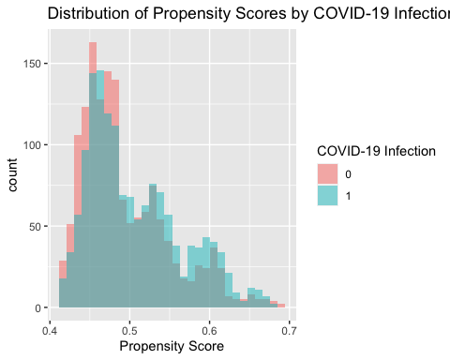

# Exponentiate coefficients to get odds ratios  
exp(coef(psq1))

## (Intercept) male age heart comorbid   
## 0.6495501 1.0543371 1.0051716 1.2216504 1.2773839

**Female, older people, people with heart disease and people with more comorbidity are more likely to get COVID-19 infection.**

**Common support in the range of 0.4 to 0.7.**

# Q1 C

## stratification by propensity score quintiles  
  
ps.boundary <- quantile(q1$ps, 0:5/5)   
ps.boundary

## 0% 20% 40% 60% 80% 100%   
## 0.4161432 0.4519327 0.4711594 0.4997593 0.5460530 0.6902536

q1$psq <- cut(q1$ps, ps.boundary, right=F, include.lowest=T, label=1:5)  
head(q1$psq)

## [1] 1 4 1 1 1 1  
## Levels: 1 2 3 4 5

head(q1)

## id male age heart comorbid covid anxiety ps psq  
## 1 1 1 35 0 0 1 0 0.4506554 1  
## 2 2 0 28 1 1 1 0 0.5394115 4  
## 3 3 1 35 0 0 1 0 0.4506554 1  
## 4 4 0 19 0 0 1 0 0.4173971 1  
## 5 5 0 22 0 0 1 0 0.4211649 1  
## 6 6 1 22 0 0 1 0 0.4341151 1

q1$covid<-as.factor(q1$covid)  
  
### age by PS strata  
ggplot(q1, aes(x=covid, y=age)) +   
 geom_boxplot(aes(fill=covid)) + facet_grid(psq ~ ., labeller=label_both) +   
 coord_flip()

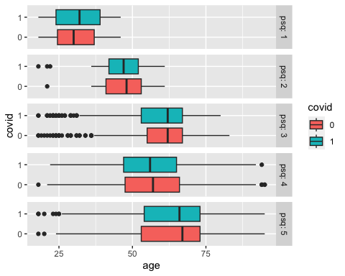

# sex by PS strata  
ggplot(q1, aes(x=male)) +   
 geom_histogram(binwidth=1, fill='blue') +   
 facet_grid(covid ~ psq, labeller=label_both)

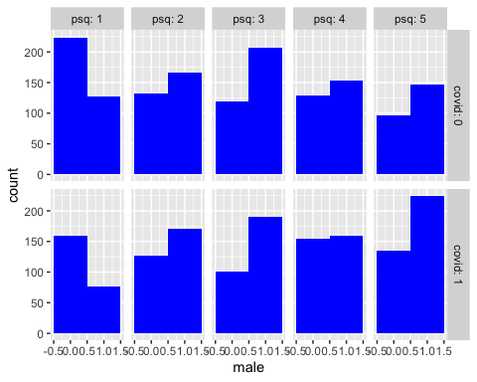

# heart disease by PS strata  
ggplot(q1, aes(x=heart)) +   
 geom_histogram(binwidth=1, fill='blue') +   
 facet_grid(covid ~ psq, labeller=label_both)

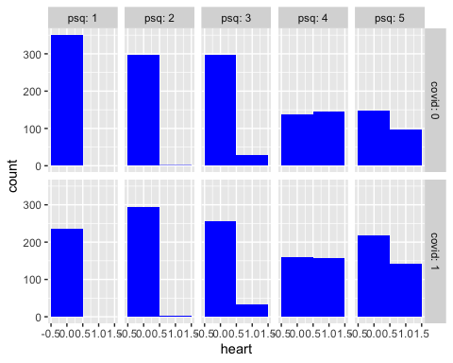

# comorbidity by PS strata  
ggplot(q1, aes(x=comorbid)) +   
 geom_histogram(binwidth=1, fill='blue') +   
 facet_grid(covid ~ psq, labeller=label_both)

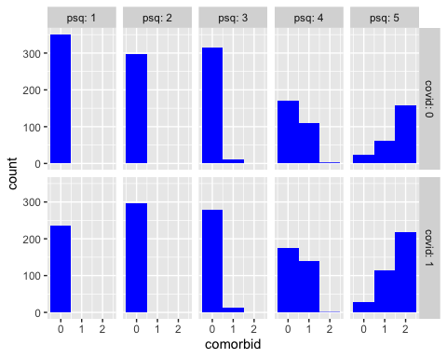

**Patient characteristics are more balanced within each propensity score strata.**

# Q1 D

Conditional Independence: This assumption presumes that all known confounders are included in the model. However, the existence of unobserved confounders cannot be completely excluded. Common Support: The overlap observed in the propensity score distribution between the treatment and control groups suggests that this assumption is reasonably met.

# Q1 E

mean.cp <- aggregate(anxiety~covid+psq, data=q1,   
 FUN=mean) # infection rates   
count.cp <- aggregate(anxiety~covid+psq, data=q1,   
 FUN=length) # number of infections  
cbind(mean.cp, count.cp$anxiety)

## covid psq anxiety count.cp$anxiety  
## 1 0 1 0.02564103 351  
## 2 1 1 0.08016878 237  
## 3 0 2 0.09731544 298  
## 4 1 2 0.10774411 297  
## 5 0 3 0.11692308 325  
## 6 1 3 0.21649485 291  
## 7 0 4 0.10954064 283  
## 8 1 4 0.16825397 315  
## 9 0 5 0.19341564 243  
## 10 1 5 0.21944444 360

n.psq <- as.numeric(table(q1$psq))  
n.psq

## [1] 588 595 616 598 603

covid.strata <- mean.cp$anxiety[mean.cp$covid==1]-  
 mean.cp$anxiety[mean.cp$covid==0]   
  
covid.est <- sum(covid.strata*n.psq)/sum(n.psq)   
  
## Estimated overall effect  
  
round(covid.est,2) # Weighted Mean of the Stratum-specific effect

## [1] **0.05**

var.cp <- aggregate(anxiety~covid+psq, data=q1, FUN=var)  
cbind(var.cp, count.cp$covid)

## covid psq anxiety count.cp$covid  
## 1 0 1 0.02505495 0  
## 2 1 1 0.07405421 1  
## 3 0 2 0.08814092 0  
## 4 1 2 0.09646010 1  
## 5 0 3 0.10357075 0  
## 6 1 3 0.17020974 1  
## 7 0 4 0.09788738 0  
## 8 1 4 0.14039025 1  
## 9 0 5 0.15665068 0  
## 10 1 5 0.17176571 1

covid.var <- sum((var.cp$anxiety/count.cp$anxiety)*rep(n.psq, each=2)^2)/sum(n.psq)^2   
  
## Variance of estimated effect  
covid.var

## [1] 0.0001540265

## 95% CI  
cl<-covid.est-1.96*sqrt(covid.var)  
cu<-covid.est+1.96*sqrt(covid.var)  
  
print(paste('95%CI:',round(cl,2),",",round(cu,2)))

## [1] "**95%CI: 0.03 , 0.07**"

# Q1 F

model_ps <- glm(anxiety ~ covid + ps, data = q1, family = "binomial")  
ci_ps <- exp(confint(model_ps))

## Waiting for profiling to be done...

or_ps <- exp(coef(model_ps))  
  
results_table_ps <- cbind(  
 "OR" = exp(coef(model_ps)),  
 exp(confint(model_ps))  
)

## Waiting for profiling to be done...

knitr::kable(results_table_ps, caption = "OR and 95% CI Using Propensity Score as a Covariate", digits = 2)

OR and 95% CI Using Propensity Score as a Covariate

|  | OR | 2.5 % | 97.5 % |
| --- | --- | --- | --- |
| (Intercept) | 0.00 | 0.00 | 0.01 |
| covid1 | 1.57 | 1.26 | 1.96 |
| ps | 1328.32 | 239.01 | 7348.76 |

The primary finding is that covid infection is significantly associated with the occurrence of anxiety disorders in the studied population, based on the available data and after adjusting for several covariates, including propensity scores. The influence of other factors may be more pronounced and warrants further investigation.