3036274164_q2

PENG, Xin

2024-04-15

# Q2 A

library(metafor)

## Loading required package: Matrix

## Loading required package: metadat

## Loading required package: numDeriv

##   
## Loading the 'metafor' package (version 4.6-0). For an  
## introduction to the package please type: help(metafor)

q2<-read.csv("exam_question2.csv")  
head(q2)

## study country year prev prev.lb prev.ub  
## 1 Sotelo Argentina 2011 0.345 0.300 0.389  
## 2 Bastos Brazil 2018 0.296 0.279 0.313  
## 3 Chhim Cambodia 2017 0.059 0.046 0.071  
## 4 Shan China 2018 0.076 0.053 0.100  
## 5 Zea Colombia 2015 0.138 0.049 0.227  
## 6 Shaw India 2016 0.153 0.100 0.207

summary(q2)

## study country year prev   
## Length:20 Length:20 Min. :2010 Min. :0.03700   
## Class :character Class :character 1st Qu.:2013 1st Qu.:0.09175   
## Mode :character Mode :character Median :2016 Median :0.14550   
## Mean :2015 Mean :0.17785   
## 3rd Qu.:2017 3rd Qu.:0.27650   
## Max. :2018 Max. :0.36900   
## prev.lb prev.ub   
## Min. :0.00700 Min. :0.0580   
## 1st Qu.:0.04975 1st Qu.:0.1343   
## Median :0.08700 Median :0.2170   
## Mean :0.12690 Mean :0.2289   
## 3rd Qu.:0.22025 3rd Qu.:0.3165   
## Max. :0.30400 Max. :0.4350

q2$se.prev <- (q2$prev.ub-q2$prev.lb)/(2*1.96)  
q2.fe <- rma(yi=prev, sei=se.prev, slab=study, method="FE", data=q2)  
q2.fe

##   
## Fixed-Effects Model (k = 20)  
##   
## I^2 (total heterogeneity / total variability): 97.99%  
## H^2 (total variability / sampling variability): 49.80  
##   
## Test for Heterogeneity:  
## Q(df = 19) = 946.2532, p-val < .0001  
##   
## Model Results:  
##   
**## estimate se zval pval ci.lb ci.ub   
## 0.1206 0.0032 37.5167 <.0001 0.1143 0.1269 \*\*\***   
##   
## ---  
## Signif. codes: 0 '***' 0.001 '**' 0.01 '*' 0.05 '.' 0.1 ' ' 1

# Q2 B

summary(q2.fe)

##   
## Fixed-Effects Model (k = 20)  
##   
## logLik deviance AIC BIC AICc   
## -415.0438 946.2532 832.0876 833.0833 832.3098   
##   
## I^2 (total heterogeneity / total variability): 97.99%  
## H^2 (total variability / sampling variability): 49.80  
##   
## Test for Heterogeneity:  
## Q(df = 19) = 946.2532, **p-val < .0001**  
##   
## Model Results:  
##   
## estimate se zval pval ci.lb ci.ub   
## 0.1206 0.0032 37.5167 <.0001 0.1143 0.1269 ***   
##   
## ---  
## Signif. codes: 0 '***' 0.001 '**' 0.01 '*' 0.05 '.' 0.1 ' ' 1

Q <- q2.fe$QE  
I2 <- (Q-(q2.fe$k-1))/Q * 100  
I2

## [1] 97.99208

**Yes, both Cochran’s Q test: p<0.0001 and I2=97.99% indicate substantial heterogeneity.**

# Q2 C

q2.re <- rma(yi=prev, sei=se.prev, slab=study, method="REML",   
 data=q2)  
  
with(q2.re, c(b, ci.lb, ci.ub))

## [1] 0.1758405 0.1286532 0.2230277

**Based on a random effects model, the T2D prevalence among heavy drinkers is 17.58% (95%CI:12.87%~22.30%).**

# Q2 D

forest(q2.re, order=year, slab=paste(study, country,year, sep=", "), refline=0,   
 showweights=T, xlab="Prevalence, %",xlim=c(-3,3))  
text(-3,22.5,"Study",pos=4,font=0)  
text(3,22.5,"Prevalence [95% CI]",pos=2,font=0)

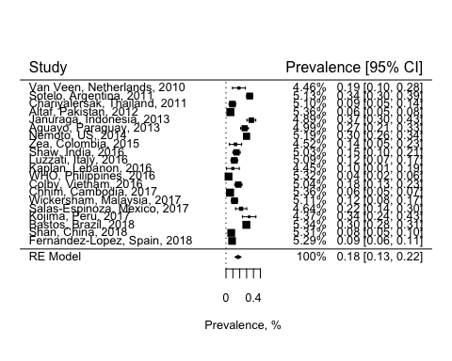

# Q2 E

funnel(q2.re)

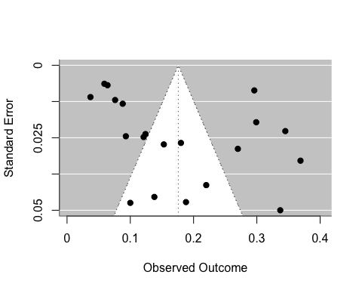

## Egger’s test  
regtest(q2.re)

##   
## Regression Test for Funnel Plot Asymmetry  
##   
## Model: mixed-effects meta-regression model  
## Predictor: standard error  
##   
## Test for Funnel Plot Asymmetry: z = 1.5938, p = 0.1110  
## Limit Estimate (as sei -> 0): b = 0.1080 (CI: 0.0132, 0.2027)

**No obvious asymmetry can be seen from the funnel plot, and there was no strong evidence of asymmetry from Egger’s test. No evidence of publication bias.**

# Q2 F

prev_high <- c("Argentina", "Brazil", "Colombia", "Mexico", "Paraguay", "Peru")  
high <- q2[q2$country%in%prev_high,]  
non_high <- q2[!q2$country %in% prev_high,]  
  
t_test <- t.test(high$prev, non_high$prev)  
print(t_test)

##   
## Welch Two Sample t-test  
##   
## data: high$prev and non_high$prev  
## t = 3.1494, df = 11.46, p-value = 0.00883  
## alternative hypothesis: true difference in means is not equal to 0  
## 95 percent confidence interval:  
## 0.03907545 0.21754360  
## sample estimates:  
## mean of x mean of y   
## 0.2676667 0.1393571

q2$high <- 0  
q2$high[q2$country%in% c("Argentina", "Brazil", "Colombia", "Mexico", "Paraguay", "Peru")] <- 1  
  
q2.re.sen <- rma(yi=prev, sei=se.prev, slab=study, method="REML", data=q2, subset=(high==0))  
  
# compare the original estimate vs estimate from sensitivity analysis  
with(q2.re, c(b, ci.lb, ci.ub)) # original estimate for all regions

## [1] **0.1758405 0.1286532 0.2230277**

with(q2.re.sen, c(b, ci.lb, ci.ub)) # estimates for regions excluded Latin-America

## [1] **0.13702439 0.08768204 0.18636673**

# Q2 G

**The estimated T2D prevalence among heavy drinkers is 17.58% (95%CI:12.87%~22.30%) based on the random effects model. Sensitivity analysis shows that the inclusion of Latin-American regions where T2D prevalence is higher may impact the overall estimates. The funnel plot showed that there was no evidence of publication bias.**