总结:题目出的好啊!思路真妙

https://leetcode-cn.com/problems/fu-za-lian-biao-de-fu-zhi-lcof/solution/jian-zhi-offer-35-fu-za-lian-biao-de-fu-zhi-ha-xi-/

## 复制+拆分--很巧妙

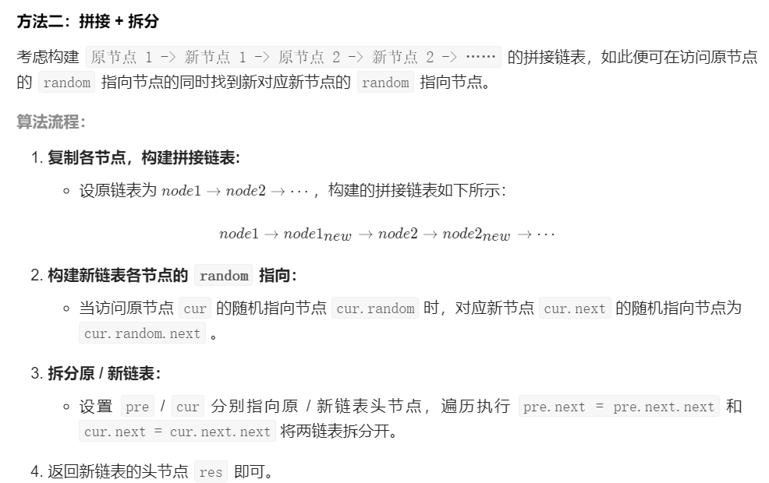

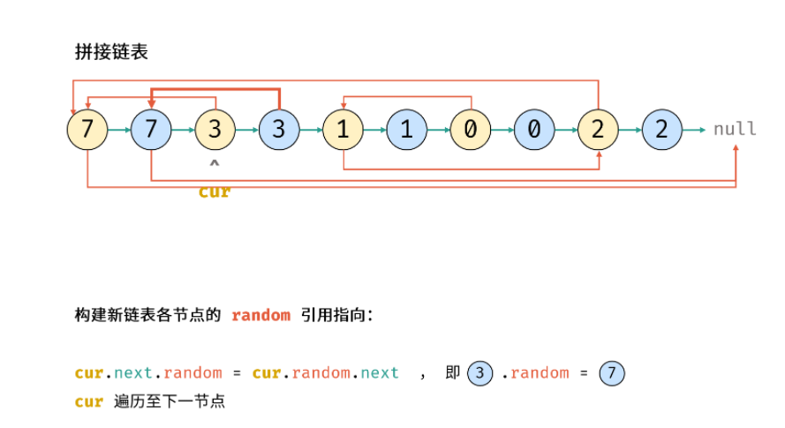

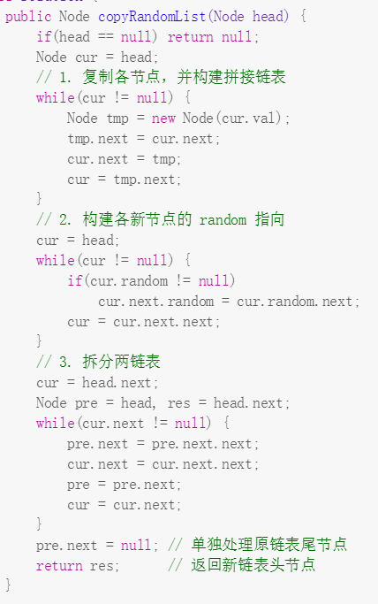

## 哈希表--比较简单

