# dp

https://leetcode-cn.com/problems/zui-chang-bu-han-zhong-fu-zi-fu-de-zi-zi-fu-chuan-lcof/solution/mian-shi-ti-48-zui-chang-bu-han-zhong-fu-zi-fu-d-9/

## 分析



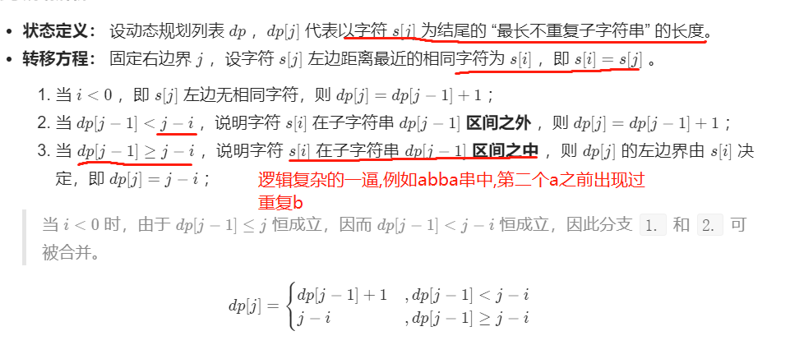

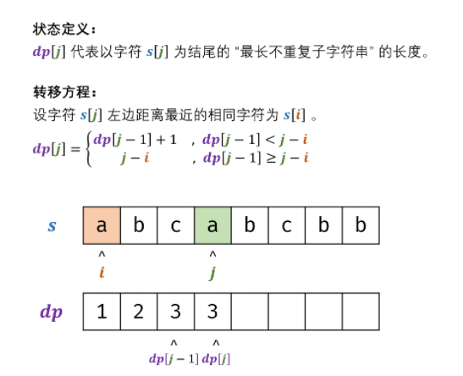

我他妈思维枯竭了

## 代码--空间复杂度不优化!!!!!!

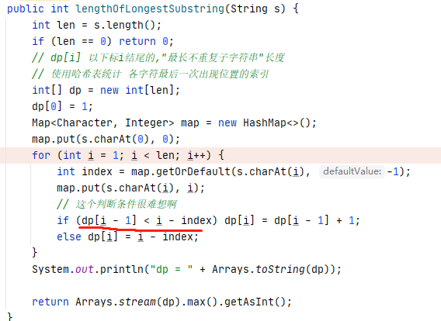

# 双指针

