从**暴力法出发**去理解问题,推导出动态规划

https://leetcode-cn.com/problems/nge-tou-zi-de-dian-shu-lcof/solution/jian-zhi-offer-60-n-ge-tou-zi-de-dian-sh-z36d/

## 暴力法

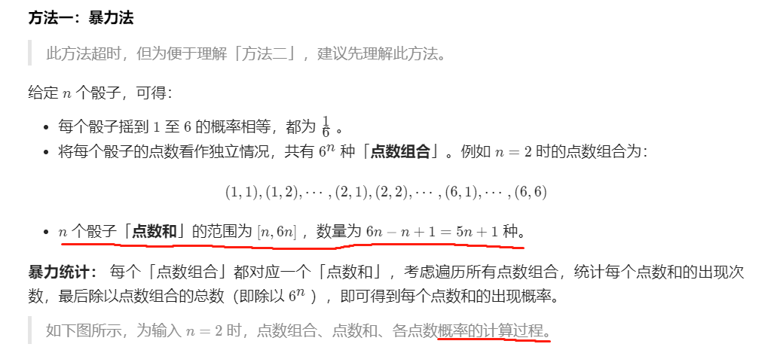

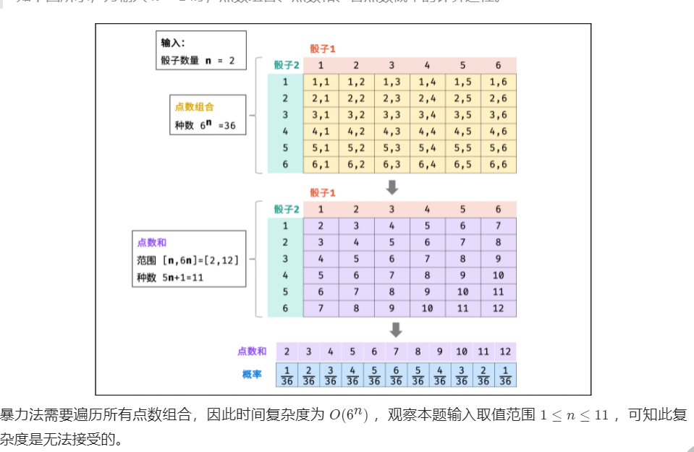

## dp

分析--是个计算概率问题

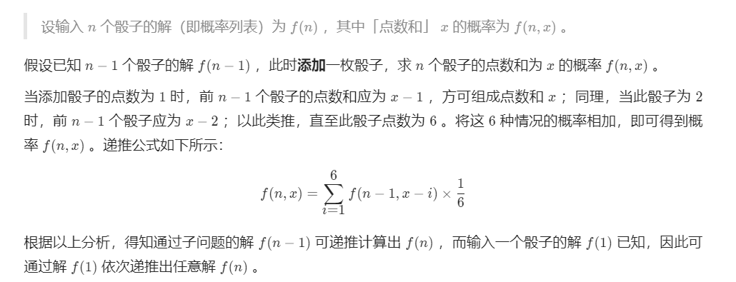

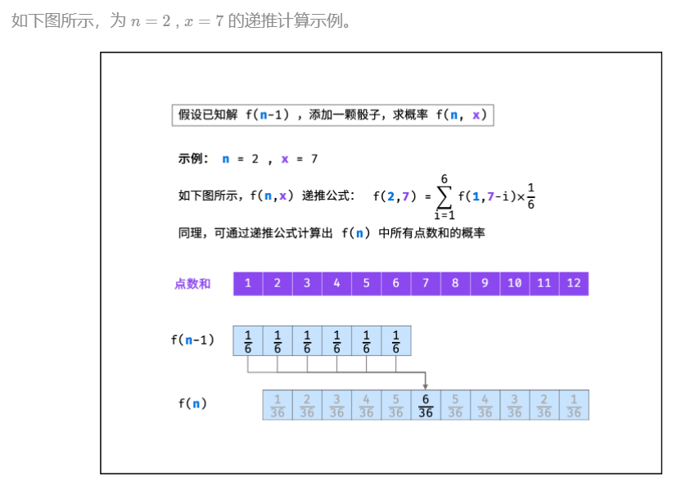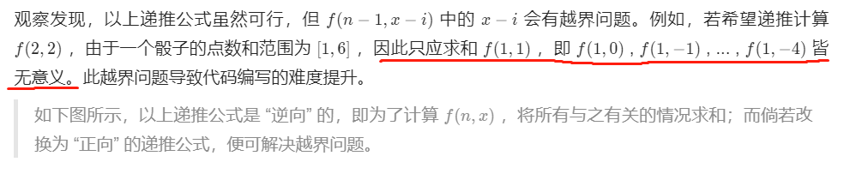

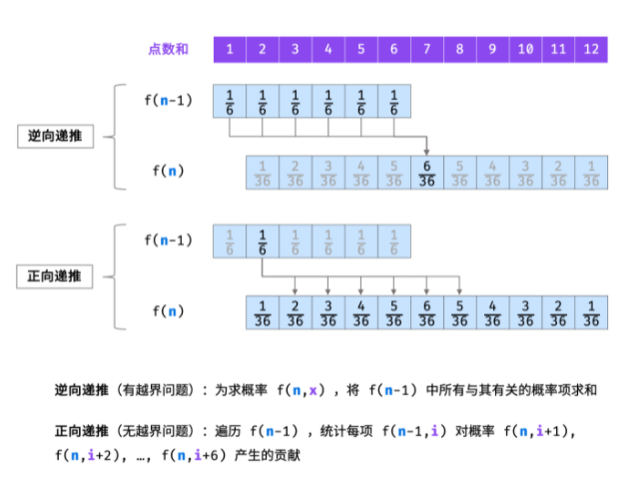

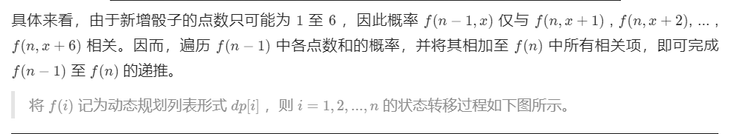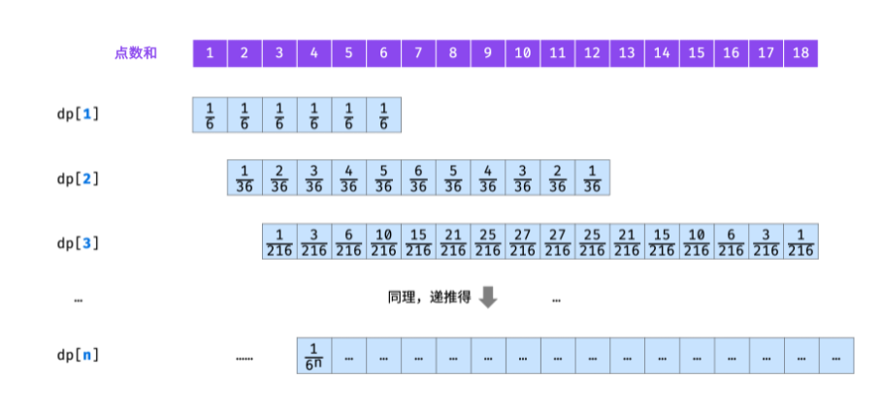

## 代码--二维

