## 题目分析

<https://leetcode-cn.com/problems/container-with-most-water/solution/sheng-zui-duo-shui-de-rong-qi-by-leetcode-solution/>

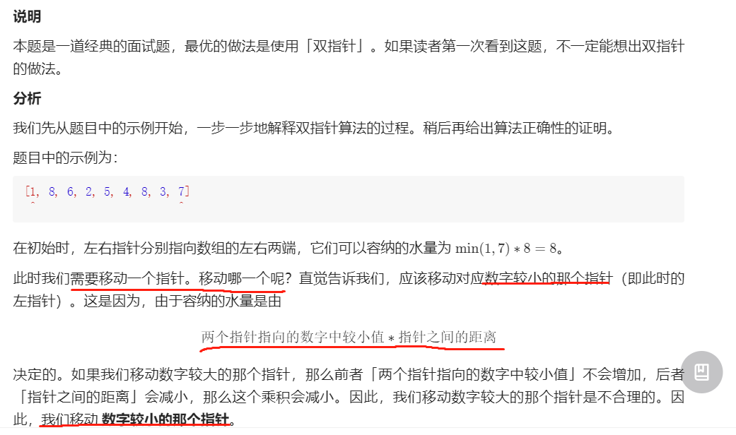

给个例子看下运行过程:

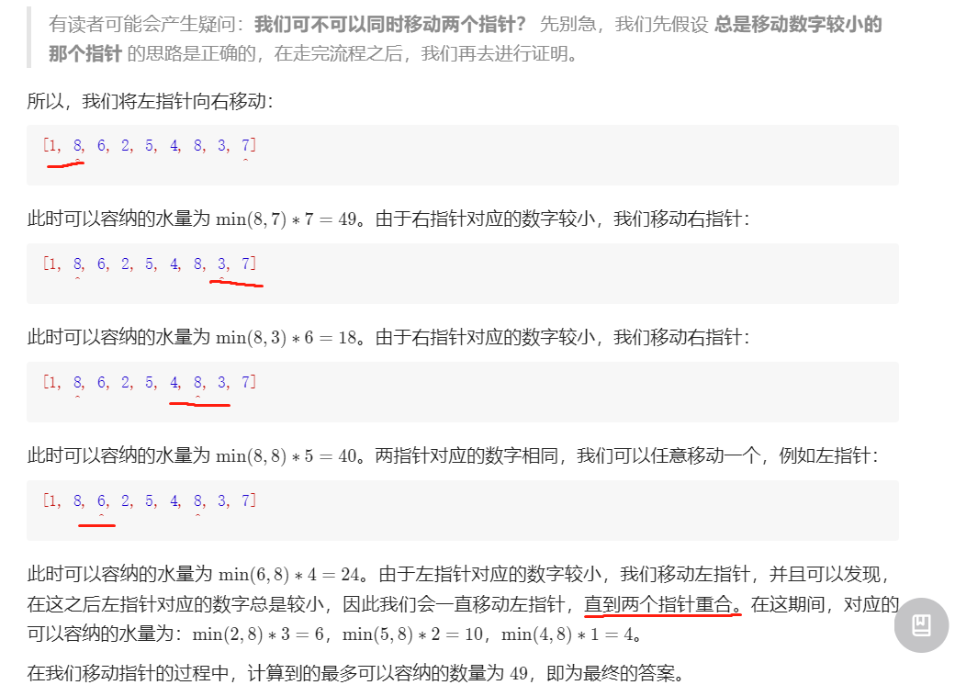

证明过程:略

## 代码--先想出算法流程再写代码!

