## 题目分析

https://leetcode-cn.com/problems/profitable-schemes/solution/ying-li-ji-hua-by-leetcode-solution-3t8o/

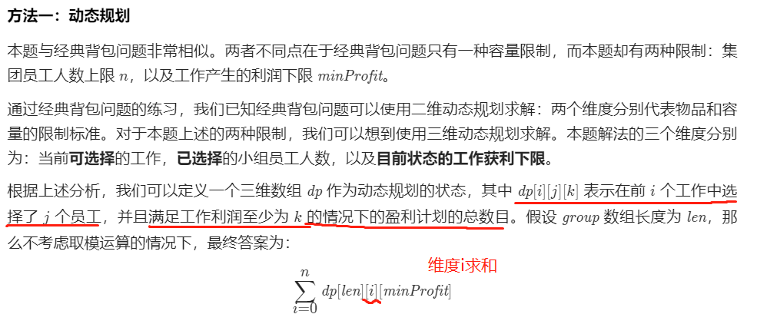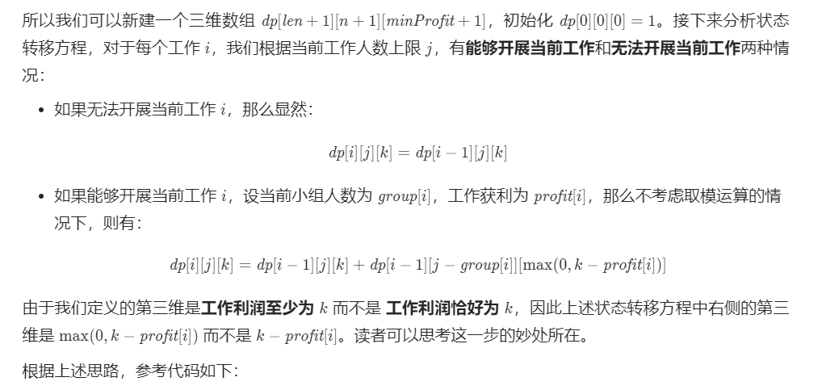

**Math.max(0, k-earn)** 写得好,逻辑是:

