## 题目描述

## 题目分析

<https://leetcode-cn.com/problems/trapping-rain-water/solution/jie-yu-shui-by-leetcode-solution-tuvc/>

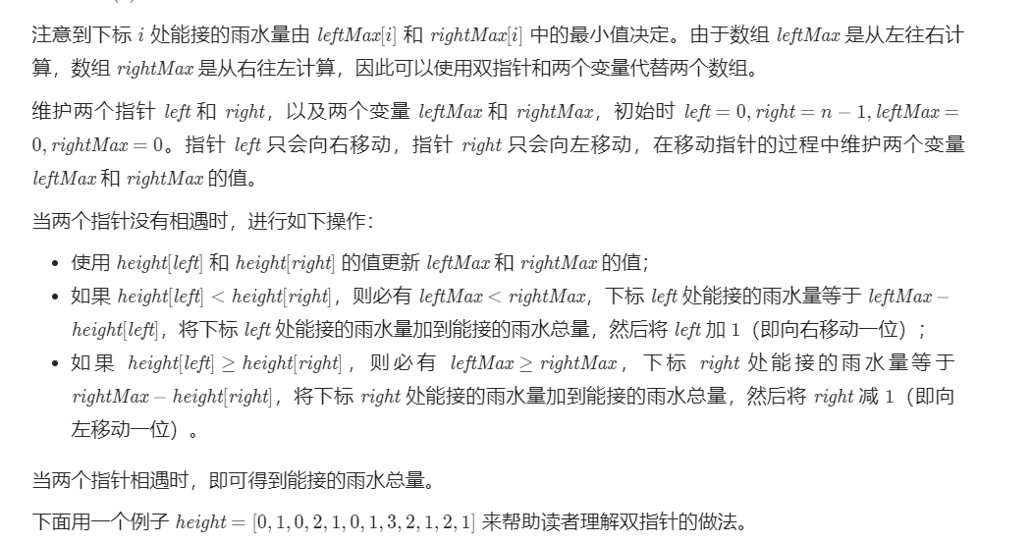

## 代码

### 暴力法

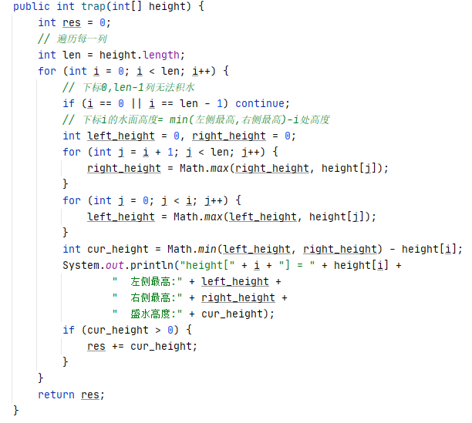

### 双指针

