## 题目描述

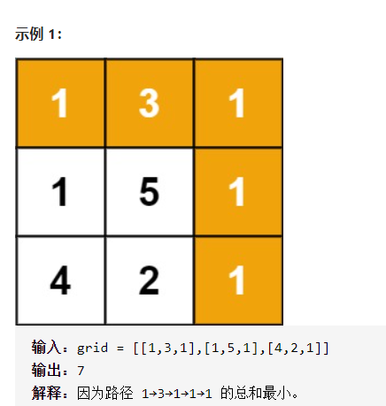

## my解法:回溯 评价--超时

## 解法一:dp

<https://leetcode-cn.com/problems/minimum-path-sum/solution/zui-xiao-lu-jing-he-by-leetcode-solution/>

## 解法二:记忆化dfs

<https://leetcode-cn.com/problems/minimum-path-sum/solution/dfs-ji-yi-ji-hu-100-by-piaohao/>