C= P * A/P * E/A * C/E= p* a* e *c

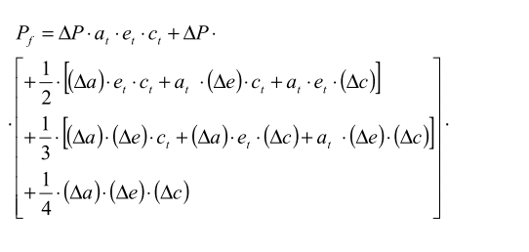

求P_f, a_f, e_f, c_f