PROJECT REPORT
Topic: Python App CI/CD with Docker Agents

Submitted by:
Priyanshu kumar (12407370)
Somnath kumar (12414229)
Faculty in Charge:
Harpreet kaur
Priyanka gupta
Subject Code: PETV137

Abstract
This project focuses on the automation of software delivery pipelines using Continuous Integration and Continuous Deployment (CI/CD) methodologies. The primary objective is to streamline the deployment of a Python-based microservices application (comprising a web service and a rendering service) using Docker agents. The infrastructure is distributed across three separate Amazon EC2 instances to ensure robust isolation and scalability: one instance dedicated to the Jenkins CI/CD server, another for the SonarQube static code analysis server, and a third serving as the primary Deployment server. By leveraging Docker containers, the pipeline guarantees consistency across environments. The implementation ensures that any code committed to the repository is automatically built, analyzed for code quality, and deployed seamlessly, significantly reducing manual overhead and minimizing the risk of integration issues.

1. Introduction
In modern software engineering, Continuous Integration and Continuous Deployment (CI/CD) have become essential practices to deliver high-quality applications rapidly and reliably. This project implements a fully automated CI/CD pipeline for a Python application using Jenkins as the orchestration engine and Docker as the containerization platform.
The infrastructure comprises three Amazon Elastic Compute Cloud (EC2) instances:
- 1. Jenkins Server: Acts as the master orchestrator for the CI/CD pipeline, coordinating builds, tests, and deployments.
- 2. SonarQube Server: Responsible for continuous inspection of code quality, detecting bugs, vulnerabilities, and code smells before deployment.
- 3. Deployment Server: The production environment where the Dockerized Python application and its dependencies (like Ollama and Node.js components) are deployed and executed.

2. System Architecture & Data Flow Diagram (DFD)
The architecture is designed to enforce a strict quality gate mechanism. Developers push their code to a remote version control repository (GitHub). This action triggers the Jenkins pipeline, which executes multiple stages inside isolated Docker containers. The source code is evaluated by the SonarQube server. Upon successful analysis, the final deployment stage uses SSH to pull the latest code and spin up the updated containers on the Deployment server.

2.1 Data Flow Diagram
The following Data Flow Diagram (DFD) illustrates the flow of code and commands across the different nodes in our infrastructure:
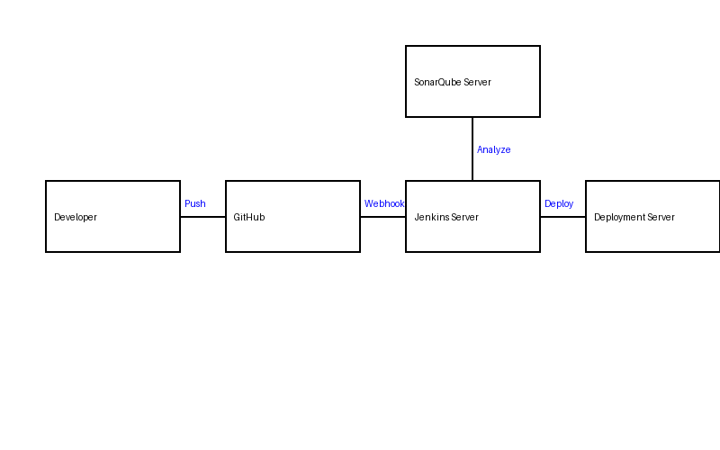

2.2 Project Architecture
The architectural diagram represents the microservices topology deployed on the server.
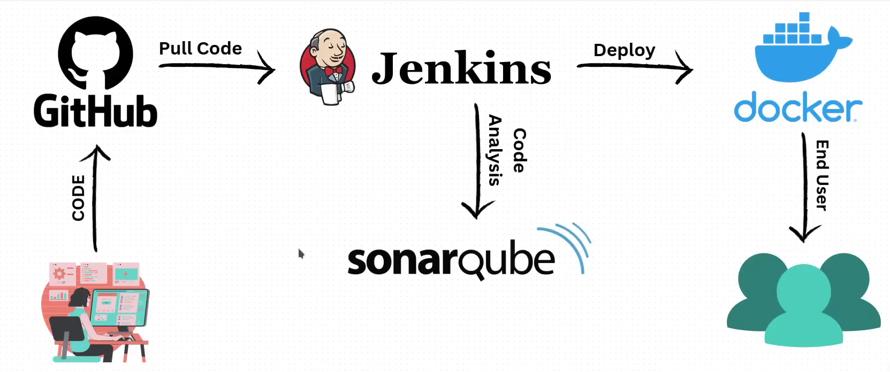

3. Implementation Details
The deployment utilizes Docker Compose to manage multiple services. The primary components include the frontend web service, the Python-based rendering backend, and a local inference service (Ollama). The Jenkinsfile defines a declarative pipeline with the following key stages:
- 1. Web Install: Uses a Node.js Docker agent to install frontend dependencies.
- 2. Renderer Check: Uses a Python Docker agent to validate the backend code syntax and install requirements.
- 3. SonarQube Analysis: Leverages the Sonar Scanner CLI container to perform static code analysis against the dedicated SonarQube EC2 instance.
- 4. Deploy: Executes only on the main branch. It connects to the deployment EC2 instance via SSH, updates the repository, and rebuilds the Docker containers using docker-compose.

4. Testing and Results
The system was rigorously tested across multiple deployment iterations. The isolated EC2 instances successfully communicated with each other, and the pipeline correctly blocked deployments when code quality gates failed. Below are the execution results from our live servers.

4.1 AWS EC2 Instances
Three separate EC2 instances were provisioned and configured to host Jenkins, SonarQube, and the Deployment environment respectively.
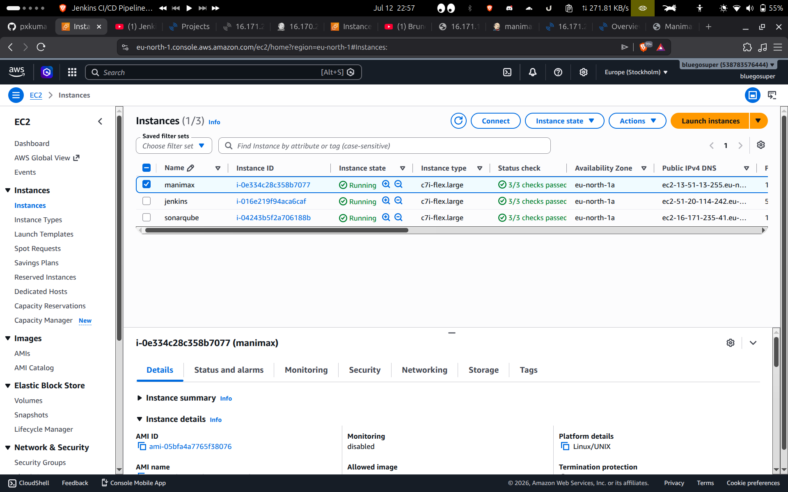

4.2 Jenkins Pipeline Execution
The Jenkins pipeline executed all stages successfully. The use of ephemeral Docker agents ensured that each build step ran in a clean, reproducible environment.
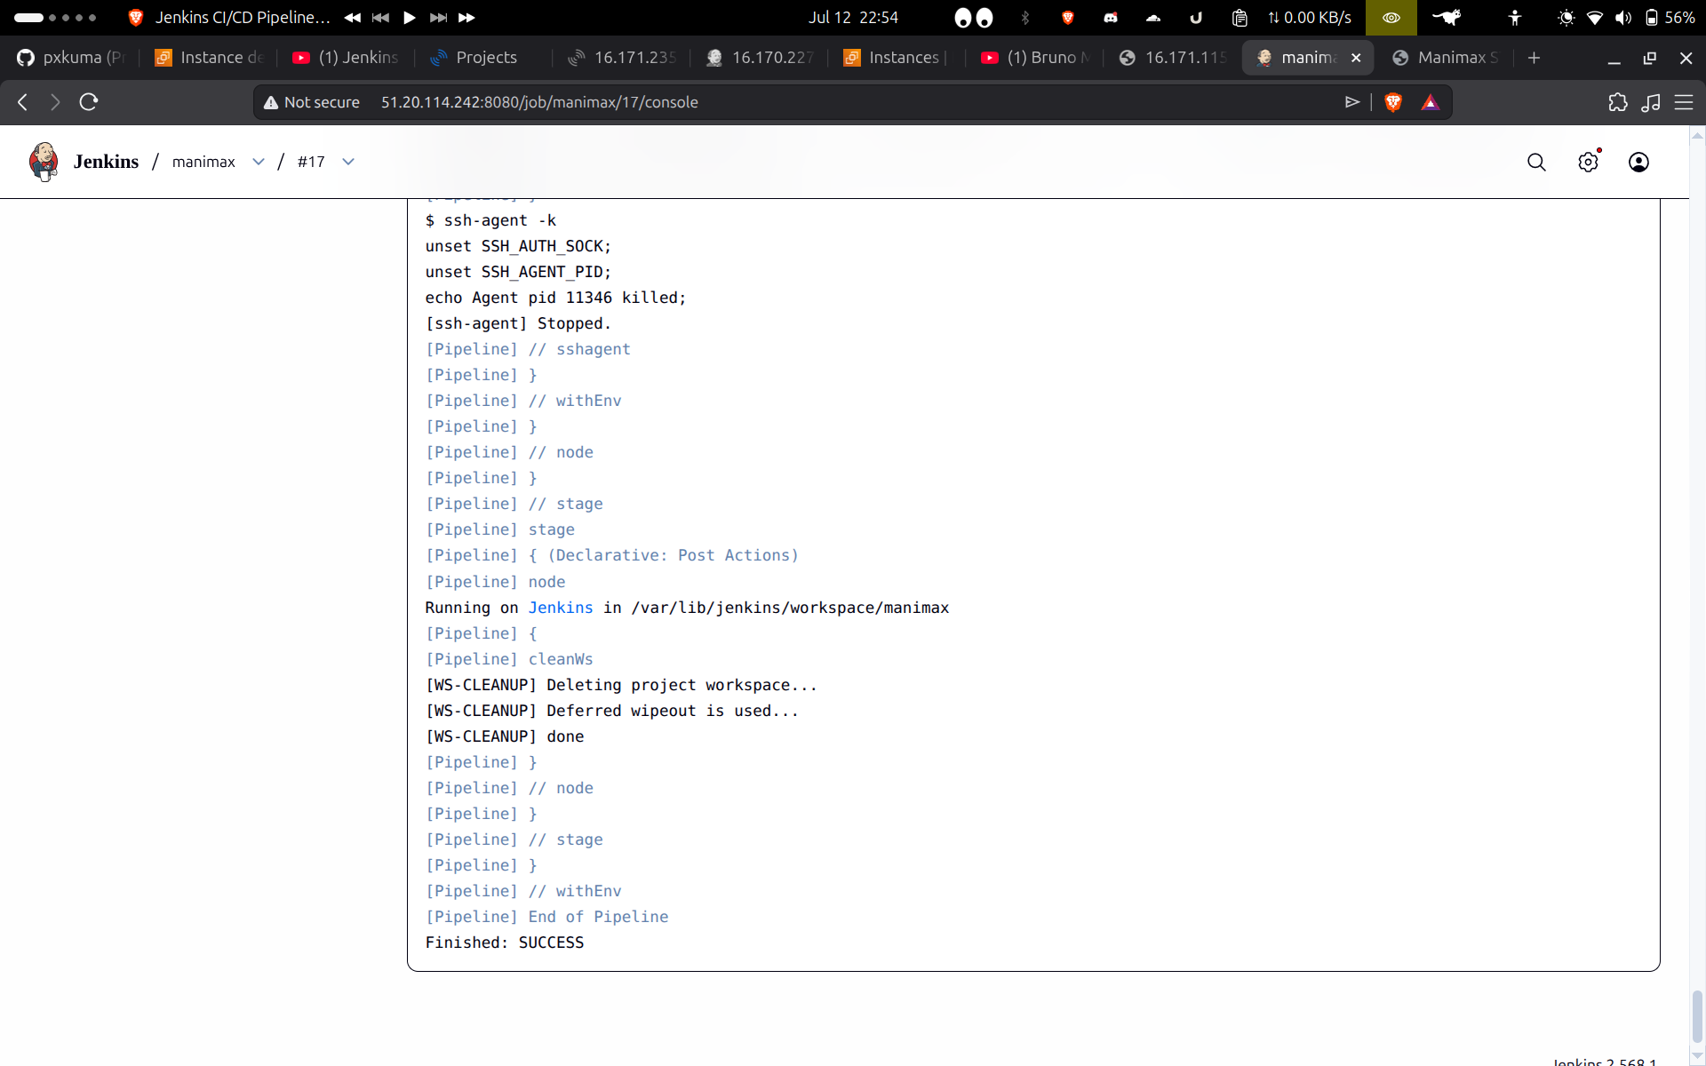

4.3 SonarQube Code Analysis
The SonarQube server processed the source code and evaluated it against predefined quality profiles. The code successfully passed the quality gate.
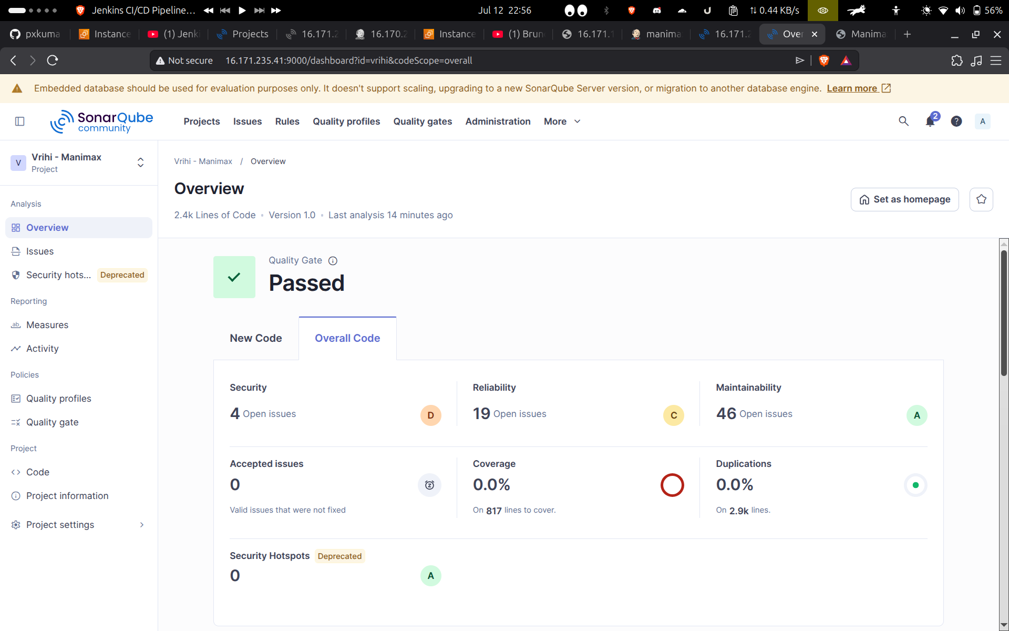

4.4 Application Deployment
Following the successful pipeline execution, the Python application was deployed on the production server. The containers were verified to be in a healthy, running state.
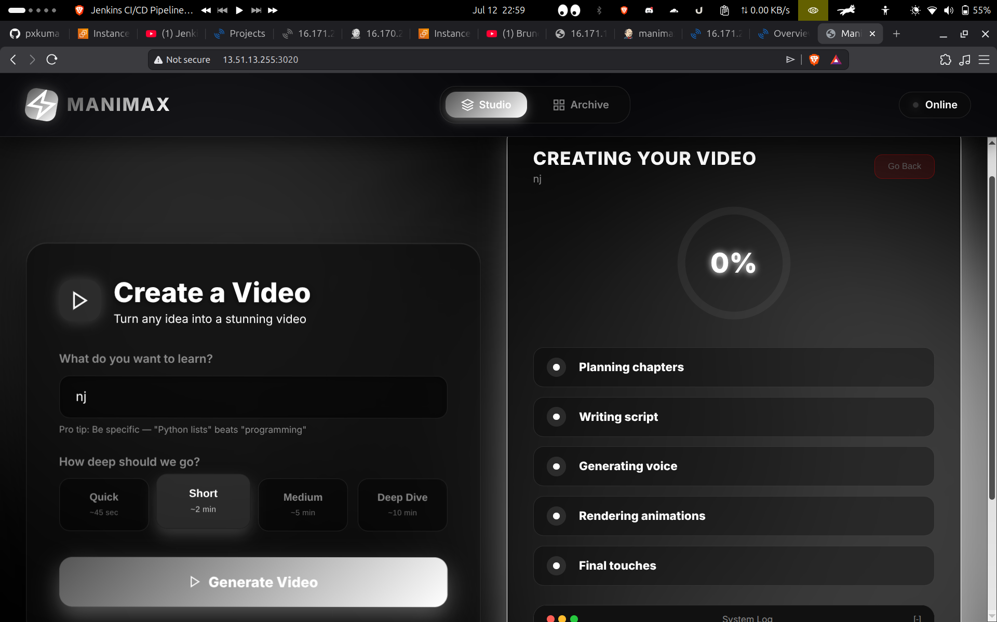

5. Conclusion
The implementation of a Docker-based CI/CD pipeline across distributed EC2 instances has proven to be highly effective. By decoupling the build, analysis, and deployment environments into three distinct servers (Jenkins, SonarQube, and Deployment), the architecture achieves superior fault tolerance and security. The integration of SonarQube guarantees high code quality standards, while Jenkins automates the delivery process, enabling rapid and reliable software releases. This project successfully demonstrates a modern, scalable approach to continuous integration and continuous deployment for Python microservices.

