Photo
THIS CERTIFICATE IS PROUDLY PRESENTED TO
Mr./Ms. MADAN RAI
Certificate No.: EXP-2083-007

This is to certify that Mr. MADAN RAI, Son of Mr. DEVENDRA RAI, Date of Birth 2066/07/24, has successfully completed the Basic Computer Course conducted by Expert Learning Hub. The recipient has successfully fulfilled all the training requirements and demonstrated satisfactory performance throughout the course.
We congratulate Mr. MADAN RAI on this accomplishment and wish him continued success in his future academic, professional, and personal endeavors.
Course Duration: 2083/01/12 To 2083/04/11 (90 Days)
Certify Date: 2083/04/11
CERTIFICATEE
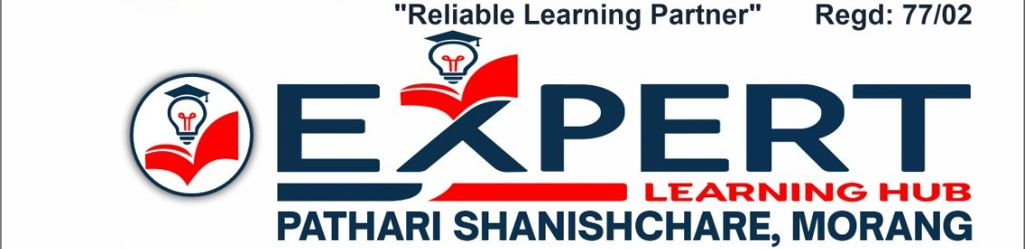

Course Instructor | Director/Principal
Adarsha Nepal | Bhim Raj Adhikari | Official Seal

