Automatic Routing of Customer Support Tickets with a Fine-Tuned DistilBERT Model, and a Connected Multi-Agent Triage System
Pelin Su Üstün - 05220000319
Gülay Ertan - 05220001140
Department of Computer Engineering, Ege University
Computational Intelligence and Deep Learning - Term Project (Project 2), 2025-2026 Spring

Abstract
Companies get a large number of support tickets every day, and each one has to reach the right department before anyone can work on it. Sorting them by hand is slow and people make mistakes. In this project we fine-tuned DistilBERT, a small transformer language model, so that it reads a support ticket and predicts which of ten departments should handle it (for example Technical Support, Billing and Payments, or IT Support). We used a public dataset of 28,261 English tickets. To see what affects the result we trained 9 different configurations and changed the number of epochs, the learning rate, the input length, how much training data we used, and whether we weighted the loss for the rare classes. Our best configuration reached 71.3% accuracy on the test set and 81.6% top-2 accuracy, which means the correct department was one of the model's two best guesses about 82% of the time. The macro-F1 was 0.68. Compared with our first baseline that is an improvement of roughly 26 percentage points. In the second part of the project we built a small multi-agent system with CrewAI, where three agents (a classifier, a router and a responder) deal with a ticket together. The classifier agent calls our trained model as a tool, so the model from the first part is actually used inside the agent system. The whole project runs locally on a single 8 GB laptop GPU, and the agents are driven by a local language model through Ollama.

1. Introduction
Customer support is an important part of most companies, and the first step in handling any ticket is deciding which team should deal with it. If a ticket ends up in the wrong queue it gets delayed, passed around, and solved later than it should be, and the customer is left unhappy. When the number of tickets is large, sorting them by hand does not scale.
This is a natural language processing problem: if a model can read the text of a ticket and predict the responsible department, the sorting can be automated. Most modern NLP is based on the transformer architecture [1], and in particular on pre-trained language models such as BERT [2] that are then fine-tuned on a specific task. These models work well but they are large and need a lot of compute. DistilBERT [3] is a smaller version of BERT, trained with knowledge distillation, that keeps about 97% of BERT's accuracy while being about 40% smaller and 60% faster. That made it a good choice for us, because we had to train everything on a laptop GPU.
The project has two parts that are connected:
1. Train a ticket-routing classifier by fine-tuning DistilBERT, and run the performance comparison that the assignment asks for.
2. Put that model inside a multi-agent system (Appendix 5), where several agents work together to triage a ticket and one of them uses our classifier as a tool.
The rest of the paper defines the problem and the methods (Section 2), looks at related work (Section 3), explains our method (Section 4), reports the experiments and results (Section 5), and concludes (Section 6). The appendices follow.

2. Problem Definition and Methods Used

2.1 Problem Definition
A ticket has a short subject line and a longer body of free text. The task is multi-class text classification: put the ticket into exactly one of ten departments (the dataset's 'queue' field). Given a ticket text x, we want a function f(x) = y where y is one of the ten department labels.
Two things make this harder than it sounds. First, the classes are not balanced: the biggest department is about 29% of the tickets and the smallest is about 1%. Second, some departments overlap in meaning. Technical Support, IT Support and Product Support all describe similar problems, so even a person would mix them up sometimes. This puts a limit on how high the accuracy can realistically go.

2.2 Methods Used (Background)
Transformers and self-attention: The transformer [1] dropped recurrence and used self-attention instead, which lets every word look at every other word in the sentence at the same time. This captures long-distance relationships between words and trains efficiently on a GPU.
BERT: BERT [2] is a transformer encoder that is pre-trained on a large amount of unlabelled text by predicting masked words. After pre-training it can be fine-tuned for a specific task by adding a small classification layer on top.
DistilBERT: DistilBERT [3] is a compressed BERT made with knowledge distillation. It has 6 transformer layers instead of 12 and about 66 million parameters, so it is quick to fine-tune on modest hardware. That is why we used it.
Fine-tuning: Instead of training from scratch, we start from the released distilbert-base-uncased weights and keep training on our labelled tickets. A linear layer on top of the model produces a score for each of the ten departments, and we train it with the cross-entropy loss.
Multi-agent systems: Beyond a single model, recent work connects several language-model agents, each with a role and some tools, into a workflow where they cooperate. Frameworks like CrewAI, AutoGen and LangGraph handle this. We use this idea in Appendix 5 to wrap our classifier in a small triage crew.

3. Previous Studies (Literature Review)
Transformer and pre-trained models: Vaswani et al. [1] introduced the transformer, which is the basis of almost all current NLP. Devlin et al. [2] showed that a pre-trained bidirectional encoder (BERT), fine-tuned with one extra layer, reached the best results of its time on many tasks, which set up the pre-train then fine-tune approach that we follow. Sanh et al. [3] proposed DistilBERT and showed that a distilled model keeps most of BERT's accuracy at a much lower cost, which is what makes on-device training possible.
Transformers for support tickets: Using these models on support tickets is a common and practical task. Several papers and industry write-ups describe fine-tuning BERT-type models to sort IT support tickets and customer complaints, and they report that the models often converge in only a few epochs on domain data. Some report that even very small variants such as BERT-Tiny classify most complaints into the right category, which shows that the approach is both effective and cheap. Other work tunes transformers for customer-service tasks such as predicting the topic of an incoming request. Our project is in this line of work. We confirm the approach on a 10-class routing problem, and we add a careful study of how the configuration (epochs, learning rate, input length, data size, class weighting) changes the result.
Multi-agent and agentic AI: A newer set of tools connects several language-model agents into one system. By 2024 and 2025 the main frameworks were CrewAI, Microsoft's AutoGen and LangGraph. CrewAI describes agents as team members with set roles, such as planner or writer, and supports tool use, which fits a support-triage crew well. We use CrewAI in Appendix 5.
Full references are listed at the end. We wrote the summaries above in our own words. Appendix 3 lists the resources we used and how our work is different.

4. Proposed Method

4.1 Overview
Part 1 is the classifier: The ticket subject and body are joined into one text, tokenized, and passed through DistilBERT; the output of the [CLS] position goes through a linear layer of size 10 and a softmax to give the predicted department.
Part 2 is the agent system: The saved model becomes a tool inside a CrewAI crew, where a classifier agent calls it, a router agent decides the team and priority, and a responder agent writes the customer reply. So the model trained in Part 1 is the decision-maker inside Part 2.
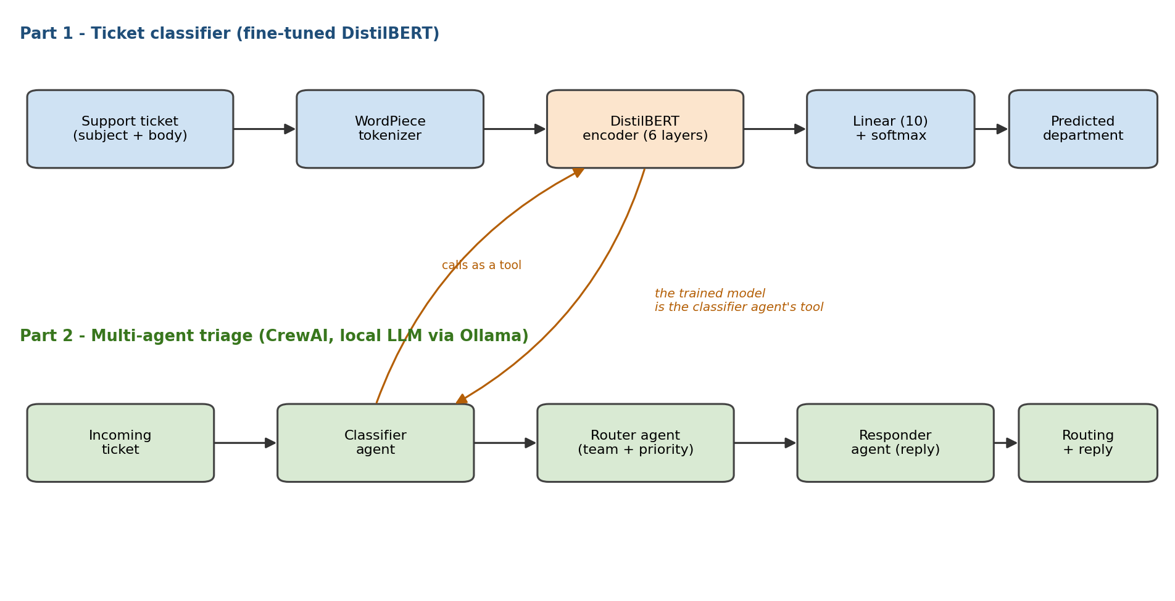System architecture. The fine-tuned DistilBERT (Part 1) is used as a tool by the classifier agent (Part 2).

4.2 Feature Extraction / Input
We build one text feature by joining the ticket subject and body. The text is tokenized with DistilBERT's WordPiece tokenizer and cut or padded to a fixed length. We compared 128 and 256 tokens and used 256 for the final model, because the ticket bodies are often longer than 128 tokens and were being cut off. We did not add any hand-made features; the transformer learns the representation from the raw text.

4.3 Model and training
Base model: Distilbert-base-uncased (6 layers, about 66M parameters) with a linear head of size 10.
Loss: Cross-entropy. For one experiment (Appendix 1) we used a class-weighted cross-entropy, with weights equal to the inverse class frequency, to see how it affects the rare classes.
Optimiser: AdamW [6], with mixed-precision (FP16) training so the model fits in 8 GB of GPU memory.
Settings we compared: Epochs in {1,2,3,4,5,6,7}, learning rate in {2e-5, 3e-5, 5e-5}, input length in {128, 256}, training data {8k subset, full set}, class weighting {off, on}.
Evaluation: After every epoch on the validation set, with the final numbers reported on a separate test set. We report accuracy, macro-F1 (which is fairer when classes are imbalanced) and top-2 accuracy.

4.4 Data Preparation and Training Protocol
From the raw data we kept the English rows, removed empty tickets, mapped the ten department names to integer labels, and made a stratified split (each split keeps the same class proportions) of 80% train, 10% validation and 10% test. We train on the training split, pick the best configuration on the validation split, and report the final numbers on the test split, which the model never sees during training. We used a single stratified split rather than k-fold cross-validation, because the dataset is large enough for a stable split and we had to run many training jobs, so k-fold would have been too slow.

5. Experimental Studies

5.1 Dataset
Name and link: Customer Support Tickets by Tobias Bueck, on HuggingFace Datasets, Tobi-Bueck/customer-support-tickets, licence CC-BY-NC-4.0 (used for an academic project).
Topic: Customer Support / IT Incident Ticket Routing.
Number of classes: 10 departments (the 'queue' field): Technical Support, Product Support, Customer Service, IT Support, Billing and Payments, Returns and Exchanges, Service Outages and Maintenance, Sales and Pre-Sales, Human Resources, General Inquiry.
Number of features: One text feature (subject + body). The raw data also has metadata (priority, type, tags), which we did not use as input.
Number of samples: 28,261 English tickets, split into 22,608 train, 2,826 validation and 2,827 test.
Class balance: Imbalanced. Technical Support is about 28.8% of the training tickets and General Inquiry is about 1.4% (a ratio of about 20 to 1). This is why we also report macro-F1.

5.2 Experimental Conditions (Hardware and Libraries)
Hardware: NVIDIA GeForce RTX 4070 Laptop GPU (8 GB), driver 555.97, CUDA 12.5.
Software: Windows 11, Python 3.13.5.
Libraries and versions: torch 2.6.0+cu124, transformers 4.57.6, datasets 4.8.5, evaluate 0.4.6, accelerate 1.13.0, tokenizers 0.22.2, scikit-learn 1.9.0, numpy 2.4.6, pandas 3.0.3, matplotlib 3.10.9. For the agent part: crewai 1.14.6, crewai-tools 1.14.6, and Ollama 0.24.0 running llama3.2 (3B). The full list is in requirements.txt.
Fixed training settings: Batch size 16, AdamW optimiser, FP16, evaluation each epoch.

5.3 Results
Each configuration was trained on its own and evaluated on the validation and test sets. Table 1 shows the test-set results. The full numbers, including the validation scores, are in results/results.csv.
Table 1. Performance comparison across configurations (full dataset, 256-token inputs).
# | Epochs | Learning rate | Class weights | Test acc. | Test top-2 | Test macro-F1
1 | 1 | 5e-5 | no | 44.5% | - | 0.34
2 | 2 | 5e-5 | no | 51.4% | - | 0.42
3 | 3 | 3e-5 | no | 55.6% | - | 0.46
4 | 3 | 2e-5 | no | 52.9% | - | 0.43
5 | 3 | 3e-5 | yes | 43.6% | - | 0.45
6 | 4 | 3e-5 | no | 65.1% | - | 0.58
7 | 5 | 3e-5 | no | 65.8% | - | 0.60
8 | 6 | 3e-5 | no | 69.8% | 81.7% | 0.65
9 (best) | 7 | 3e-5 | no | 71.3% | 81.6% | 0.68

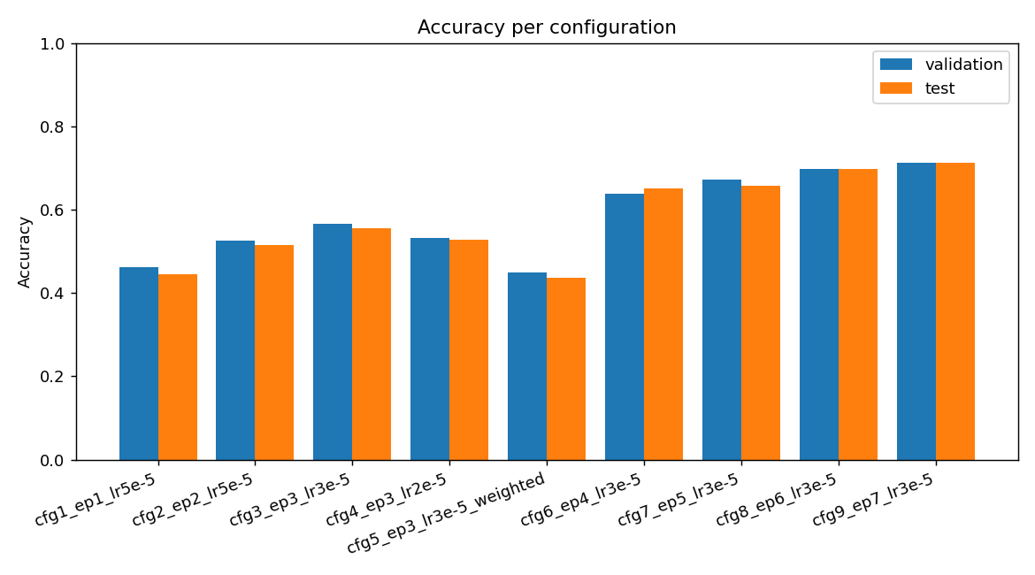
Figure 1. Validation and test accuracy per configuration (file: results/accuracy.png).
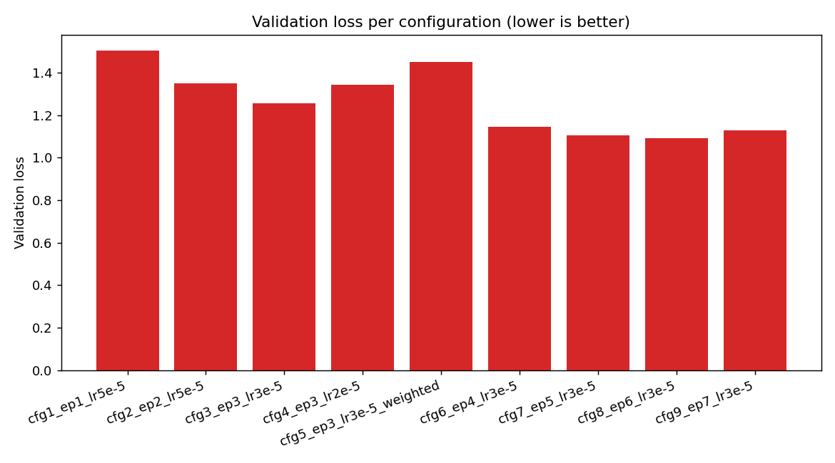
Figure 2. Validation loss per configuration (file: results/loss.png).
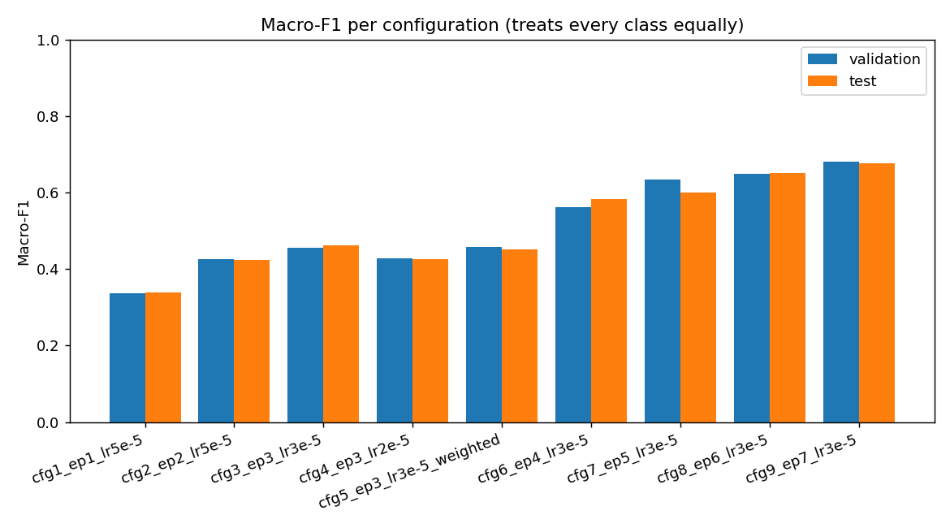
Figure 3. Macro-F1 per configuration (file: results/f1_macro.png).

5.4 Interpretation
The number of epochs mattered most. Test accuracy went up steadily with more training: 44.5% at 1 epoch, 55.6% at 3, 65.8% at 5, and 71.3% at 7. The validation and test accuracy stayed close to each other, so the model was generalising and not just memorising the training data.
The learning rate had a clear best value. At 3 epochs, 3e-5 (55.6%) beat the slower 2e-5 (52.9%), so 3e-5 was the best trade-off between learning speed and stability.
Class weighting traded accuracy for fairness. Configuration 5 got the best macro-F1 at 3 epochs but the lowest accuracy, because giving the rare classes more weight made the model confuse the common ones more. So we kept the unweighted model and reported the trade-off in Appendix 1.
Top-2 accuracy was high, about 82%. Because some departments overlap, the right one is very often the model's second guess when it is not the first, which is useful for a routing assistant that can suggest two likely teams.
For context, 71.3% on ten imbalanced classes is about 2.5 times the majority-class baseline (29%) and about 7 times a random guess (10%).

6. Conclusion
We built a ticket-routing system by fine-tuning DistilBERT, and we used a nine-configuration study to show how the training choices change the result. The final model sorts tickets into ten departments with 71.3% test accuracy and 81.6% top-2 accuracy, which is about 26 points better than our first baseline, and it all runs on one 8 GB laptop GPU. We then connected this model to a multi-agent system in CrewAI, where three agents classify, route and answer a ticket, using the trained model as a tool. The main limitation is the dataset itself: it is synthetic and some departments overlap, which caps how high the accuracy can go. In future work we could try a larger model such as RoBERTa, use 512-token inputs, or merge the overlapping departments, and we could give the agents more tools such as a knowledge-base search.

References
[1] A. Vaswani, N. Shazeer, N. Parmar, J. Uszkoreit, L. Jones, A. N. Gomez, L. Kaiser, and I. Polosukhin, "Attention Is All You Need," Advances in Neural Information Processing Systems (NeurIPS), 2017. arXiv:1706.03762.
[2] J. Devlin, M.-W. Chang, K. Lee, and K. Toutanova, "BERT: Pre-training of Deep Bidirectional Transformers for Language Understanding," Proc. NAACL-HLT, 2019, pp. 4171-4186. arXiv:1810.04805.
[3] V. Sanh, L. Debut, J. Chaumond, and T. Wolf, "DistilBERT, a distilled version of BERT: smaller, faster, cheaper and lighter," NeurIPS EMC^2 Workshop, 2019. arXiv:1910.01108.
[4] T. Wolf et al., "Transformers: State-of-the-Art Natural Language Processing," Proc. EMNLP 2020: System Demonstrations, pp. 38-45.
[5] T. Bueck, "Customer Support Tickets" dataset, HuggingFace Datasets, 2024. https://huggingface.co/datasets/Tobi-Bueck/customer-support-tickets
[6] I. Loshchilov and F. Hutter, "Decoupled Weight Decay Regularization (AdamW)," Proc. ICLR, 2019. arXiv:1711.05101.
[7] CrewAI, framework for orchestrating role-playing autonomous AI agents. https://www.crewai.com/ (accessed 2026).

Appendix 1 - Performance Improvement
We started from a weak baseline on purpose and improved it step by step. Table A1 shows the path in test accuracy.
Table A1. Improvement path (test accuracy).
Stage | Change applied | Test acc. | Change
Baseline | 8k subset, 128 tokens, 3 epochs | 45.0% | -
+ data & length | full data (22.6k) + 256 tokens, 3 epochs | 55.6% | +10.6
+ epochs (5) | full data, 256 tokens, 5 epochs | 65.8% | +10.2
+ epochs (7) | full data, 256 tokens, 7 epochs (final) | 71.3% | +5.5
Total | baseline to final |  | +26.3

What helped, and by how much:
1. More data and longer inputs (8k to full, 128 to 256 tokens) gave the biggest single jump, about +10.6 points. The longer input stops the ticket body from being cut off.
2. More epochs (3 to 5 to 7) added about another 15 points. The model was under-trained at 3 epochs, and validation and test stayed close, so it was not overfitting.
3. Choosing the learning rate (2e-5 / 3e-5 / 5e-5): 3e-5 worked best.
4. Class weighting was something we tried that did not help accuracy. It raised macro-F1 a little (0.455 to 0.457) but dropped accuracy a lot (55.6% to 43.6%). We report this honestly as an accuracy-versus-fairness trade-off and kept the unweighted model.
Overall the model went from 45.0% to 71.3% test accuracy, a gain of about 26 points, with 81.6% top-2 accuracy and 0.68 macro-F1.

Appendix 2 - Originality and Contribution
Earlier work (Section 3) shows that BERT-type models classify support tickets well, but they usually report just one trained model. What we add is:
- A controlled comparison of nine configurations that isolates the effect of epochs, learning rate, input length, data size and class weighting on the same dataset and split. Most applied write-ups only report a final model.
- We report top-2 accuracy and macro-F1, not only accuracy, and we discuss the accuracy-versus-fairness trade-off of class weighting.
- We connect the classifier to a multi-agent system (Appendix 5), where the model is used as an agent tool. This 'model becomes part of an automated workflow' angle is not common in student ticket-classification projects.
- The whole project is reproducible on a normal laptop GPU with pinned library versions and a local language model, so there is no paid API.
For context: a majority-class baseline gives about 29% accuracy and random guessing about 10%, while our model reaches 71.3% (top-2 81.6%).

Appendix 3 - Resources Used and Differences
- Pre-trained weights: distilbert-base-uncased from HuggingFace [3]. We fine-tuned it; we did not train a language model from scratch.
- Libraries: HuggingFace transformers, datasets and evaluate [4], PyTorch, scikit-learn for the metrics, and CrewAI [7]. We wrote all of the task-specific code ourselves: the data preparation, the experiment runner, the class-weighted trainer, the classifier tool and the agent crew. The libraries only provide the generic training and serving parts.
- Dataset: the Tobi-Bueck Customer Support Tickets set [5], used as is and filtered to English.
- Background reading: the transformer, BERT and DistilBERT papers [1-3] and the applied BERT-for-tickets work in Section 3. Our differences are the controlled comparison, the extra metrics, and the agent integration.
- Generative AI help: We used an Microsoft Copilot coding assistant to help write and debug the code and to draft this report. All of the design decisions, experiments and results are ours and were checked by running the code.

Appendix 4 - New Skills and First-Time Work
Things we learned or did for the first time in this project:
- Fine-tuning a transformer (DistilBERT) with the HuggingFace Trainer.
- Using mixed-precision (FP16) training and working within an 8 GB GPU (trading off input length and batch size, and switching to eager attention to avoid a GPU kernel that kept crashing).
- Writing a custom class-weighted loss by subclassing the Trainer.
- Reporting macro-F1 and top-2 accuracy for imbalanced multi-class data.
- Building a multi-agent system for the first time (CrewAI), including turning a trained model into an agent tool.
- Running a local language model with Ollama, including making a custom context-limited model so it fits the GPU, so the agents need no paid API.

Appendix 5 - Multi-Agent Agentic AI Project
(a) Topic and scenario: Automatic support-ticket triage. When a ticket comes in, three agents work together to find the right department, decide which team it goes to and at what priority, and write a short reply to the customer.
(b) Framework and environment: CrewAI (v1.14.6) runs the agents in a sequential process. The agents use a local language model, llama3.2:3b, served by Ollama (v0.24.0) as a custom model called ticket-triage-llm with a 4k context window so it fits in the 8 GB GPU. There is no cloud API or key.
(c) How we built it: Each agent has a role, a goal and a short backstory. The classifier agent is given a tool, ticket_classifier, which wraps our fine-tuned DistilBERT (the classify_ticket function in src/classifier_tool.py). When the crew runs, the classifier agent calls this tool on the ticket, the router agent uses the predicted department to choose a team and a priority, and the responder agent writes the reply. The model is loaded once at the start for reliability. The code is in agent/crew_ticket_triage.py.

(d) Agents, tasks and capabilities:
Agent | Task | Main Capability / Tool
Ticket Classification Specialist | Find the department | Tool use: calls the trained DistilBERT classifier
Support Triage Router | Choose team and priority (Low/Med/High/Critical) | Reasoning over simple rules (e.g. network/VPN to IT, urgent to High)
Customer Response Writer | Write a short acknowledgement | Text generation

(e) Example input and output: A saved run is in agent/example_output.md. For example, for a ticket that says the office internet is down and the VPN keeps disconnecting before an important client demo, the classifier agent predicts Technical Support (with IT Support close behind), the router agent sends it to IT Support at High priority, and the responder agent writes a short reply that confirms the issue, says which team is handling it, and mentions the urgency of the demo.

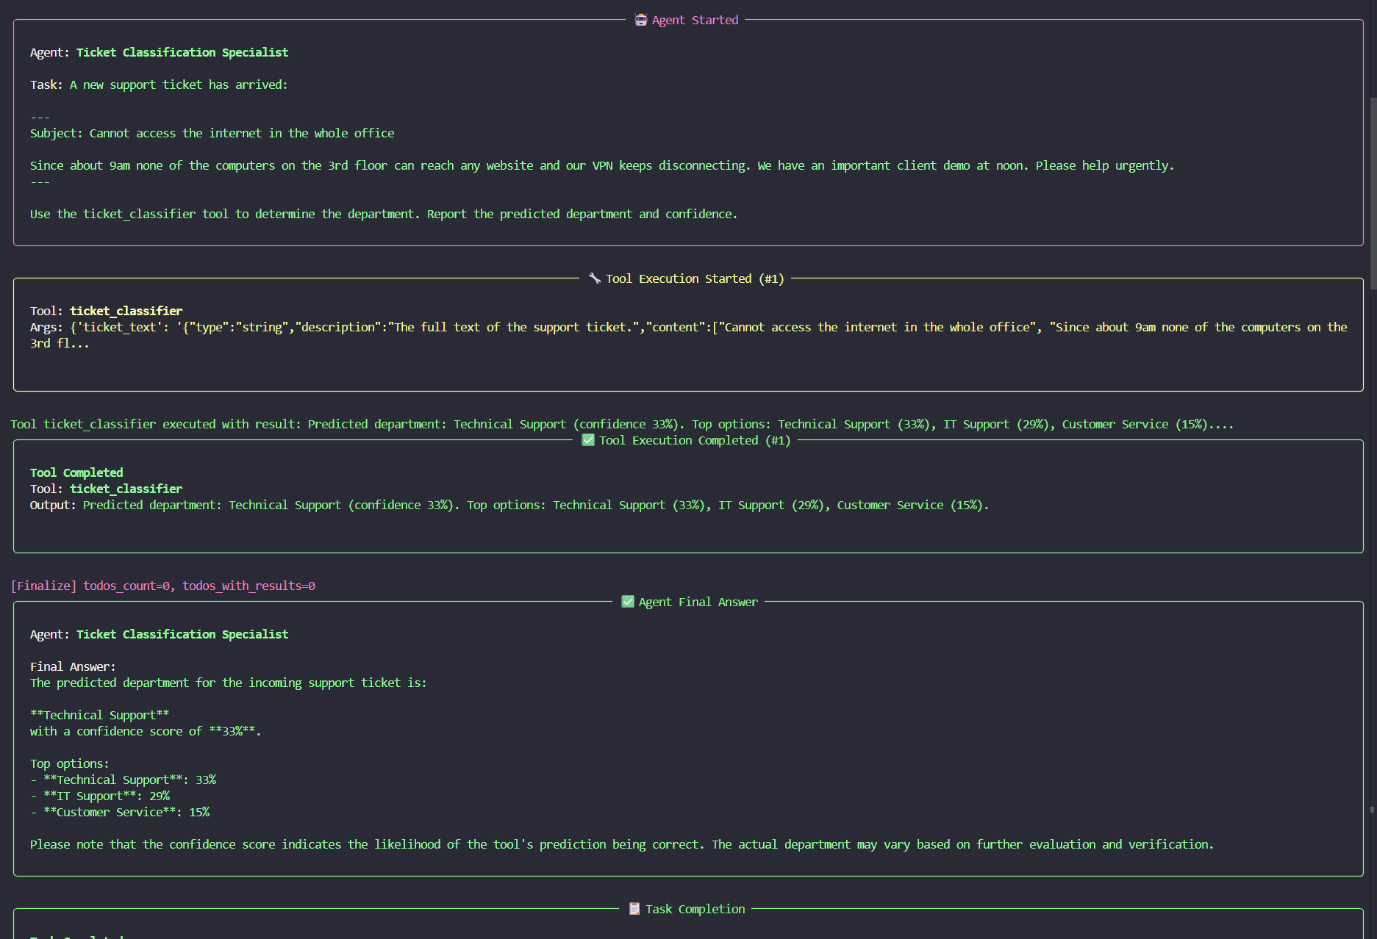

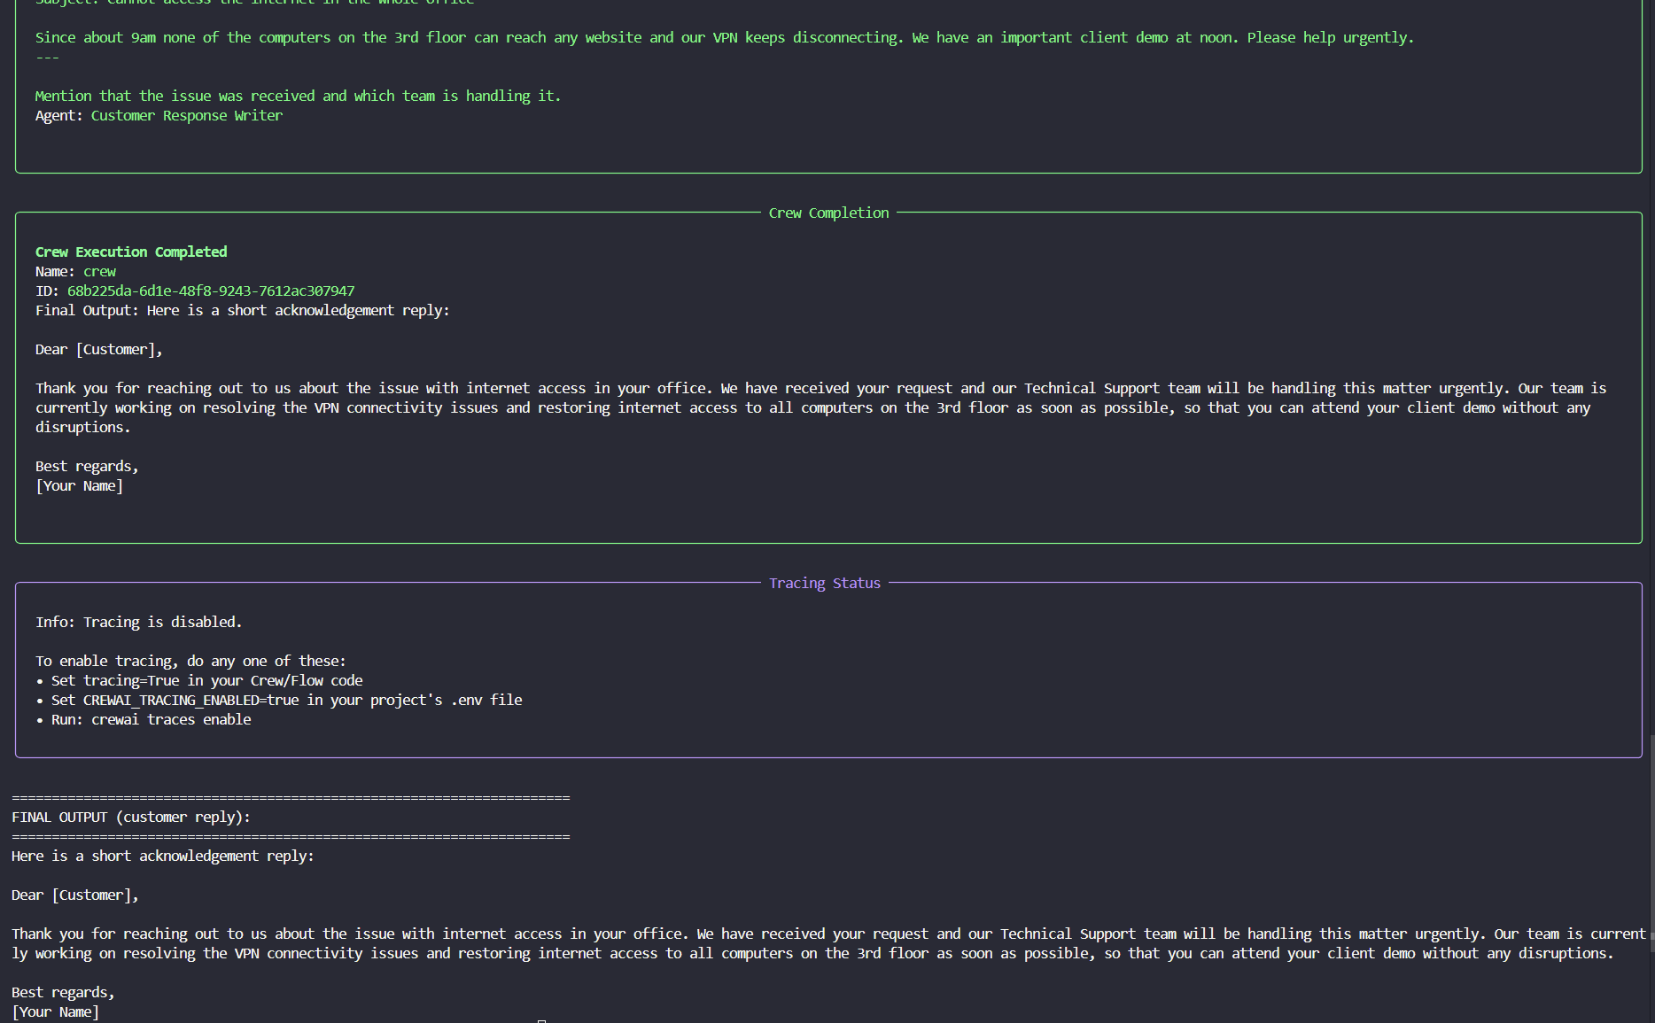

Appendix 6 - Work Packages and Division of Labour

WP | Dates | Work package | Mainly done by | Deliverable
WP1 | Apr 22 - Apr 28 | Literature review, topic and dataset selection | Gülay Ertan  (with Pelin Su Üstün) | Topic fixed: ticket routing with transformers
WP2 | Apr 29 - May 5 | Dataset search and analysis, preprocessing design | Both team members | Cleaned 10-class English set, stratified split
WP3 | May 6 - May 15 | Environment setup, baseline DistilBERT training, debugging | Pelin Su Üstün | Working GPU pipeline (~45% baseline)
WP4 | May 16 - May 26 | Performance experiments and improvement, tables and charts | Pelin Su Üstün (Gülay Ertan: helped interpret) | 9-config comparison, 71.3% best, Appendix 1
WP5 | May 27 - Jun 1 | Multi-agent CrewAI system, classifier as a tool | Pelin Su Üstün (code), Gülay Ertan (write-up) | 3-agent triage crew and example output
WP6 | Jun 2 - Jun 5 | Paper writing, self-evaluation, demo video | Gülay Ertan (with Pelin Su Üstün’s review) | Paper and video
- | Jun 6 | Final submission | Both team members | Code, paper and video

We reviewed each other's parts continously.

Self-Evaluation Table
Points we expect for each criterion.
# | Requested item (max) | Done | Est. | Explanation
1 | Abstract, Introduction, Conclusion (10) | Yes | 9 | All present and specific to the project.
2 | Previous Studies (10) | Yes | 8 | Main transformer/BERT/DistilBERT and applied ticket work cited in our own words; could add more domain papers.
3 | Problem Definition and Proposed Method (10) | Yes | 9 | Clear problem, model, feature extraction and training described.
4 | Experimental Studies and Appendix 1 (10) | Yes | 10 | Nine-config comparison, tables and three charts, +26-point improvement.
5 | Format, organisation, length, references (10) | Yes | 8 | Full structure and references; final formatting and figures to finish.
6 | Appendix 2 - originality (10) | Yes | 8 | Controlled comparison, extra metrics, agent integration.
7 | Appendix 3 - resources and differences (10) | Yes | 9 | Resources listed with a clear difference.
8 | Appendix 4 - new skills (5) | Yes | 5 | Several real first-time skills.
9 | Appendix 5 - Multi-Agent AI (10) | Yes | 9 | Working 3-agent CrewAI system that uses the model as a tool; screenshot to add.
10 | Appendix 6 - work packages (5) | Yes | 5 | Work-package table with division of labour.
11 | Self-Evaluation Table (10) | Yes | 10 | This table.
 | Total (100) |  | about 90 | Pending final formatting, figures and the screenshot.

What we could still improve: add the chart figures and the agent screenshot, add a few more domain papers, and optionally try a larger model for higher accuracy.

