Title: Continuous Control of a Lunar Lander
Name: Peter Nguyen
Course: EE5329
Term: Spring 2026
1. Task definition
Environment: LunarLanderContinuous-v3
Goal: Safely land a lunar lander as close as possible to the designated landing pad. The lander must try to remain stable and upright during the landing.
Observation: A total of 8 states is available to the agent. This includes, x/y position and velocity, roll angle, angular velocity, and left or right legs on the ground.
Action: The agent can perform 2 continuous actions, which are the firing of the main engine and the side (left or right) engine. The actions are independent and thus it is possible for the engine to fire both engines at the same time. The actions are normalized to a value between ±1 which are mapped to the engine thrust as:
- $m_{power}=\left\{\begin{aligned}0, a_{main}<0 \\ &0.5+0.5a_{main}, a_{main}≥0\end{aligned}\right.$
- $s_{power}=\left\{\begin{aligned}-0.5, a_{side}<0 \\ 0, a_{side}=0 \\ 0.5, a_{side}>0\end{aligned}\right.$
Reward: The reward uses potential based reward shaping. This allows for the reward to provide clear feedback as a function of the agent’s states. A terminal reward of ±100 is given when the agent either successfully lands or crashes(respectively). Each frame, the agent is provided with a reward based on a function of its position, velocity, roll angle, thrust usage, and if it touches the ground. The calculations of these rewards are shown below:
- +10 points for each leg on the ground
- Fuel Penalty: $-0.3*m_{power} -0.03*s_{power}$
- Position Penalty : $-100*\sqrt{x^{2}+y^{2}}$
- Velocity Penalty: $-100*\sqrt{v_{x}^{2}+v_{y}^{2}}$
- Roll Angle Penalty: $-100*ϕ$
Episode ending condition: A crash is defined as when any part of the lander (except the legs) touches the ground. A successful landing is defined as when the lander comes to rest on its feet for at least 0.5s. Both conditions are the terminal conditions for ending the episode. The entire environment is defined as a 2x2 box with the landing pad centered at the coordinates (0,0). If the lander flies outside the “box” the episode is also terminated. Lastly, to avoid an infinite episode, the number of steps is limited to 1000 steps. The max allowable steps could be tuned to simulate a fuel limit (in the gym environment, fuel is treated as infinite).
Why this task is interesting: Thrust control is important for precise and stable maneuvering for any aircraft. For this project, the aim is to autonomously control a Lunar Lander to land safely on a designated path. The lessons learned here can be reapplied to many other applications such as landing and recovery of rockets (such as those used by SpaceX)
2. Baseline setup
Algorithm: TD3
Key hyperparameters:
- Learning Rate = 0.001
- Buffer Size = 1,000,000
- Learning Starts = 100
- Batch Size = 256
- Tau = 0.005
- Gamma = 0.99
- Gradient Steps = 1
- Train Frequency = 1
- Target Policy Noise = 0.2
- Target Noise Clip = 0.5
Software:
- Python: 3.13.13
- Stable-Baselines3: 2.8.0
- PyTorch: 2.11.0+cu130
- Gymnasium: 1.2.3
Random seed(s): 42 (training), 1 (eval)
What files/scripts you used: train.py, eval.py, eval_anime.py, compare_models.py, create_environment.sh
3. Experiments
Experiment A (baseline): Default parameters from SB3. These parameters are supposedly derived from the original research paper that introduced TD3. This was chosen as the baseline largely because it was defined by the authors of TD3 and provides a relatively simple option for understanding how the tuning of other parameters may impact the algorithm. The training was run for a total of 100,000 time steps.
Experiment B (one change): The gradient steps were changed to a value of 3. This was chosen since an increase in gradient steps corresponds directly to number of updates the critics perform for every time step taken. In this instance, for every step taken, the critics will randomly sample from the replay buffer 3 times which may in turn help the actor improve much faster.
Experiment C: Based on the performance from the previous two experiments, it became clear additional time-steps were needed. The number of timesteps increased to 500,000. The change was made on top of the change from experiment B. This is a simple brute force method to examine how well tuned the default parameters and if any potential improvements could be made.
Experiment D: The buffer size was reduced to 125,000. This was done to examine the effects of reducing the diversity of the buffer since the default is 1,000,000 which would mean that all prior experiments retained all memory. By reducing the buffer size, this was an attempt to try to allow the agent to forget early “low” quality learning steps in favor of late training steps. This will result in the buffer to be completely replaced a total of 4 times.
Experiment E: The buffer size was further reduced to 50,000. This would mean that in 500,000-time steps, the replay buffer is completely replaced 10 times. We somewhat expected instability but did this to observe the effects it may have on training.
4. Results
Evaluation metric: Each experiment was evaluated by examining the mean and standard deviation of the rewards across 100 episodes. The seed=1 was used to allow equal evaluation.
Baseline result: See table 1 below
Comparison result(s): See table 1 below.
Table 1. Experiment Results Comparison
Experiment Name | What Changed | Mean Reward | Std. Deviation | Training Time (seconds)
Baseline | Default | 120.54 | 129.17 | 438
Experiment B | Gradient steps = 3 | 239.29 | 80.09 | 1143
Experiment C | Timesteps = 500,000 | 276.91 | 16.42 | 5643
Experiment D | Buffer Size = 125,000 | 288.76 | 18.57 | 5670
Experiment E | Buffer Size reduced to 50,000 | 229.92 | 135.56 | 1144

What the training curve showed: The baseline training curve (figure 1) showed continuous gradual improvement indicating that with the baseline parameters, the model can learn. The reward hasn’t quite converged and variance remains high, indicating the model requires more training time. In experiment B we observe that the increase in the gradient steps did allow the agent to converge to a reward much quicker. Variance still remains high (see figure 2 However, with the additional gradient steps, we do observe that after the 100,000 time steps, the reward begins peaks around 250 to 300 points. With experiment C, we observe that with 500,000 time steps, the reward has converged to a mean ~275 points and the standard deviation during learning have settled. This shows that the default parameters are sufficient for training. The last experiment focused on trying to improve at a faster rate by reducing the buffer size to capitalize on late training experience.

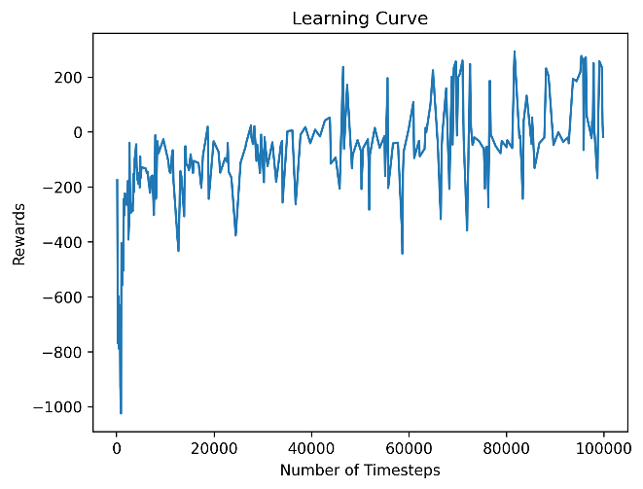
Figure 1. Baseline Learning Curve
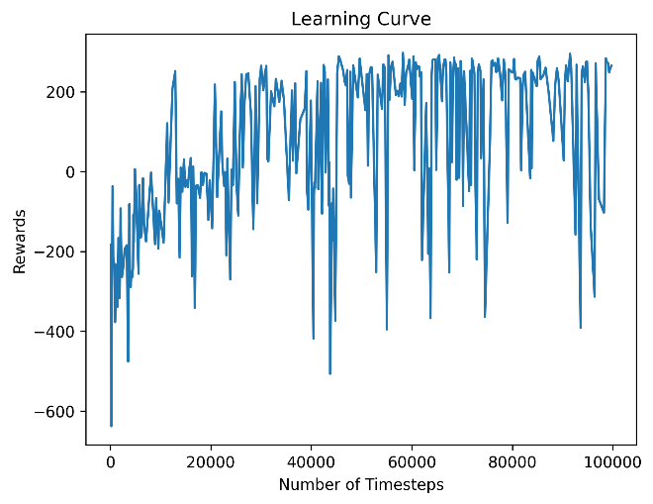Figure 2. Experiment B
(Gradient Steps =3 ) Learning Curve
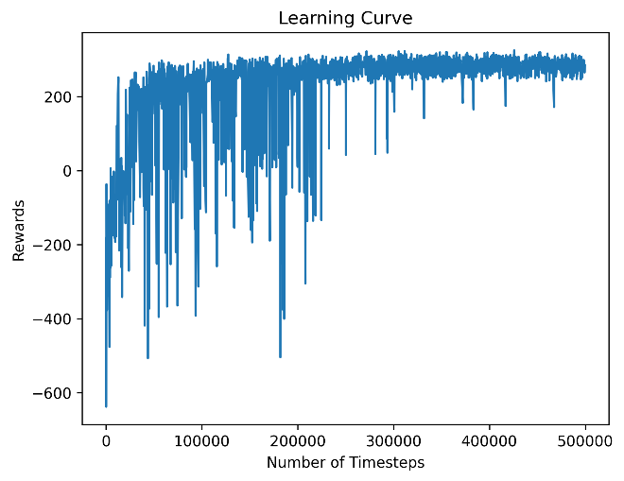
Figure 3. Experiment C
(Timesteps = 500,000) Learning Curve
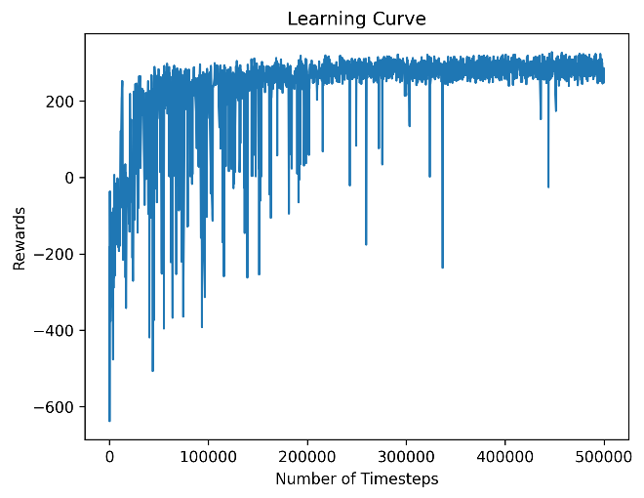
Figure 4. Experiment D
(Buffer Size = 125,000) Learning Curve
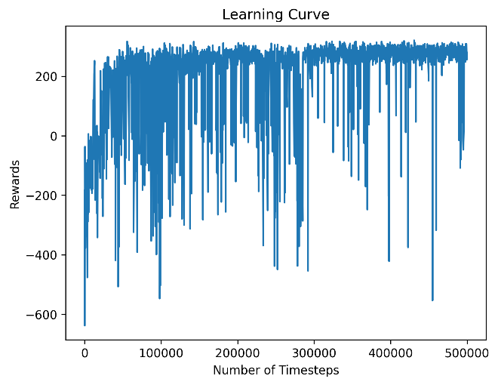
Figure 5. Experiment E
(Buffer Size = 50,000) Learning Curve
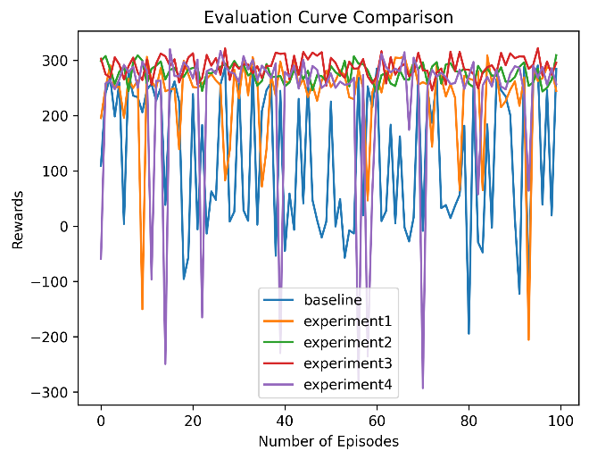
Figure 6. Reward over 100 episodes Evaluation Comparison
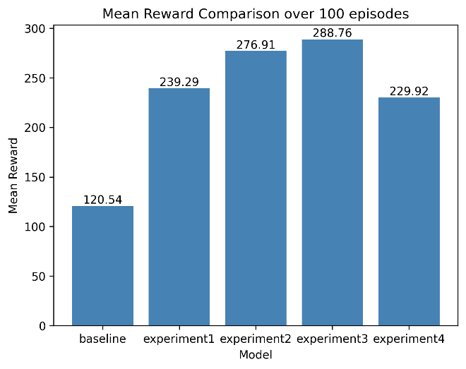
Figure 7. Mean Rewards over 100 episodes
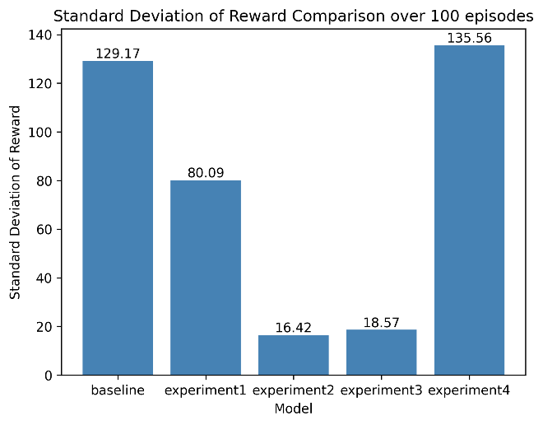Figure 8. Standard Deviation of Rewards over 100 episodes

5. Analysis
What worked: Based on the result comparison, we observed that the immediate effect of increasing the gradient steps improved how much the agent learned in the same amount of time steps. We note here that this did triple the wall-clock time it took for the agent to train. Overall, the baseline hyperparameters appear to be satisfactory for the environment as experiment 2 showed that with continued training time, the agent was able to fully learn how to land safely. Balancing the replay buffer size also benefits learning by removing low quality experience from early training. We observe from figure 7 this helped increase the mean reward by 12 points with standard deviation only increasing by 2 points.
What did not work: To small of a buffer size results in training to become unstable. We note here that the gradient steps of 3 also requires a diverse replay buffer to sample from. In experiment 4, the replay buffer size decreased to 50,000 steps. Although this may be good to remove the early training steps, this has a negative impact on late training when the agent runs into a new scenario and reacts poorly to it. This poor experience may saturate the buffer and result in the agent to diverge or becoming inconsistent (as seen from the results)
Why you think the results look this way: Well balanced hyperparameters helped the agent consistently improve and avoid reacting/capitalizing on sudden changes that may cause overestimation or instability. With the experiments ran, we saw the importance of the replay buffer and ensuring it had enough samples for the agent to sufficiently learn.
Any reward-design, observation-design, or hyperparameter lessons: Experiment 3 and 4 showed the importance of buffer diversity for the TD3 algorithm. Too small of a buffer size resulted in the model to become unstable as when the agent encountered poor scenarios later in the training stage, this may cause the replay buffer to quickly become saturated with poor experiences which in turn may cause the agent to diverge or become inconsistent.
6. Reproducibility checklist
[x] I included installation instructions
[x] I included training and evaluation commands
[x] I logged version numbers
[x] I saved the final model or checkpoint
[x] I used fixed seed(s) where possible
7. Conclusion
Main takeaway: The TD3 algorithm works extremely well for the Lunar Lander environment. The baseline parameters presented by the authors of TD3 are well tuned and provided mostly consistent results.
Next thing I would try: Explore the tuning of the learning rate and other parameters to further decrease learning time (if possible). We’ve seen that by 500,000 steps, the mean and variance have stabilized. Further exploration may want to see if there is any setup that could result in learning to be completed in less timesteps or even improving the wall clock training time.

