**Prathyusha Rayabaram**

**700747674**

**Neural Networks and Deep Learning**

**Assignment-7**

In class programming:

1. Follow the instruction below and then report how the performance changed.(apply all at once)

• Convolutional input layer, 32 feature maps with a size of 3×3 and a rectifier activation function.

• Dropout layer at 20%.

• Convolutional layer, 32 feature maps with a size of 3×3 and a rectifier activation function. • Max Pool layer with size 2×2.

• Convolutional layer, 64 feature maps with a size of 3×3 and a rectifier activation function. • Dropout layer at 20%.

• Convolutional layer, 64 feature maps with a size of 3×3 and a rectifier activation function. • Max Pool layer with size 2×2.

• Convolutional layer, 128 feature maps with a size of 3×3 and a rectifier activation function. • Dropout layer at 20%.

• Convolutional layer,128 feature maps with a size of 3×3 and a rectifier activation function. • Max Pool layer with size 2×2.

• Flatten layer.

• Dropout layer at 20%.

• Fully connected layer with 1024 units and a rectifier activation function.

• Dropout layer at 20%.

• Fully connected layer with 512 units and a rectifier activation function.

• Dropout layer at 20%.

• Fully connected output layer with 10 units and a Softmax activation function Did the performance change?

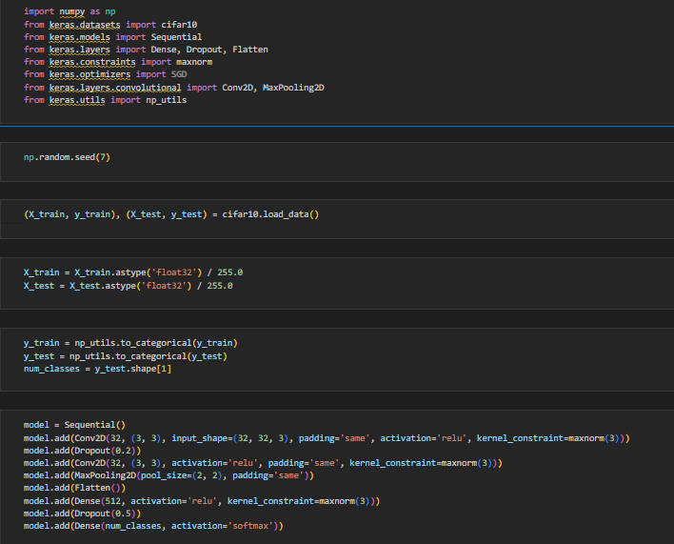

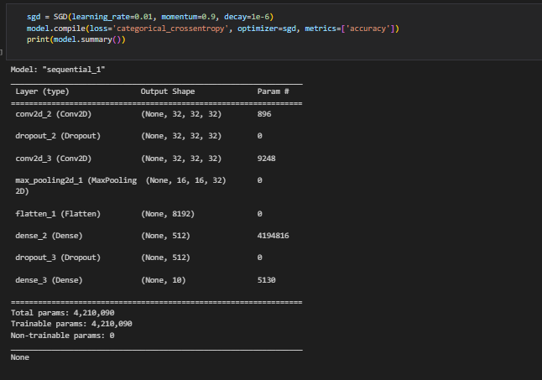

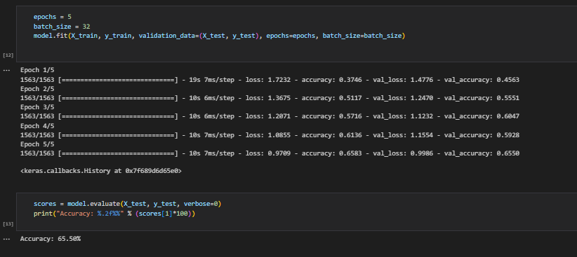

2

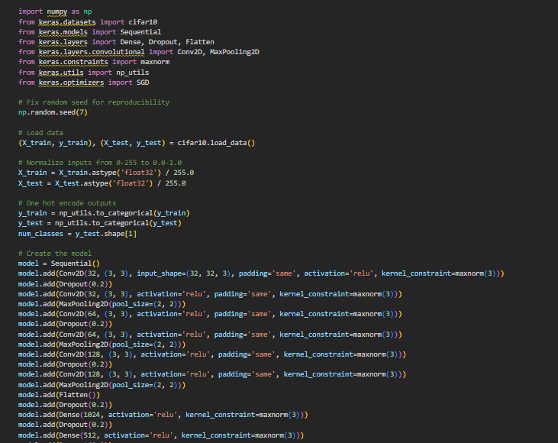

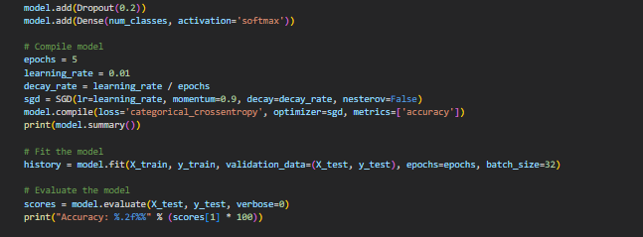

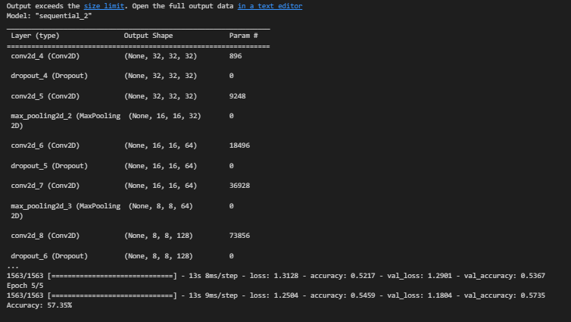

2. Predict the first 4 images of the test data using the above model. Then, compare with the actual label for those 4 images to check whether or not the model has predicted correctly.

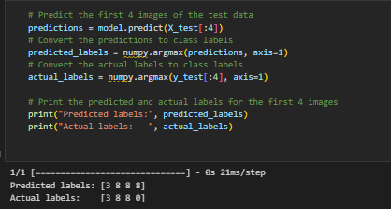

3. Visualize Loss and Accuracy using the history object

