**Prathyusha Rayabaram**

**700747674**

**Neural Networks and Deep Learning**

**Assignment-5**

1. Implement Naïve Bayes method using scikit-learn library Use dataset available with name glass Use train_test_split to create training and testing part Evaluate the model on test part using score and 

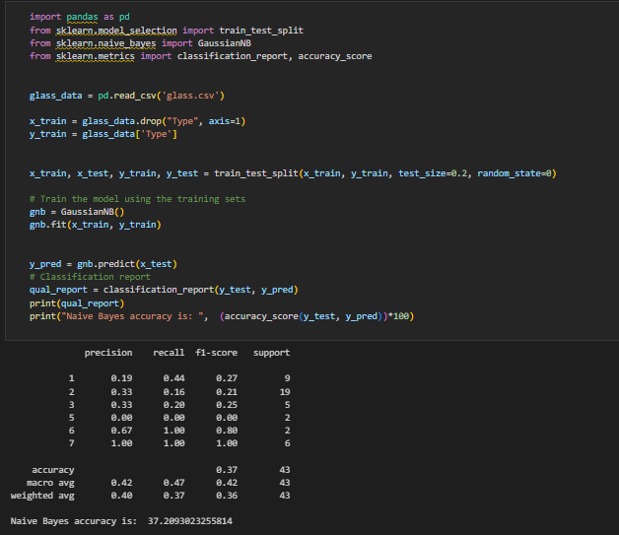

1. Implement linear SVM method using scikit library Use the same dataset above Use train_test_split to create training and testing part Evaluate the model on test part using score and 

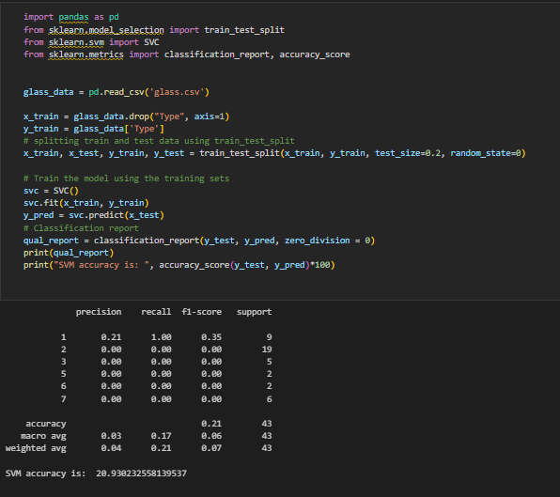

Which algorithm you got better accuracy? Can you justify why?

Naïve Bayes method algorithm gives better accuracy when compared with SVM method algorithm. As the accuracy we got upon training on Naïve Bayes is greater than that of SVM