Activity 01 – Flowcharts and Pseudocodes

**Flowcharts**

A flowchart is a diagram that depicts a process, system or computer algorithm. They are widely used in multiple fields to document, study, plan, improve and communicate often complex processes in clear, easy-to-understand diagrams. Flowcharts, sometimes spelled as flow charts, use rectangles, ovals, diamonds and potentially numerous other shapes to define the type of step, along with connecting arrows to define flow and sequence.

A flowchart is a graphical representation of steps. It was originated from computer science as a tool for representing algorithms and programming logic but had extended to use in all other kinds of processes. Nowadays, flowcharts play an extremely important role in displaying information and assisting reasoning. They help us visualize complex processes, or make explicit the structure of problems and tasks.

Example:

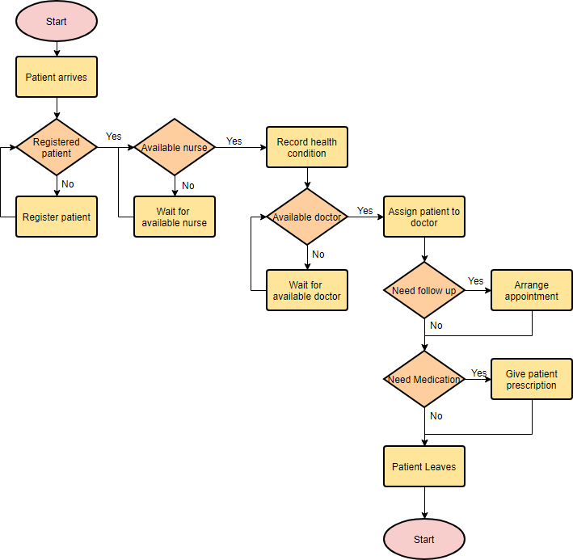

## Flowchart Symbols

Different flowchart shapes have different conventional meanings. The meanings of some of the more common shapes are as follows:

### **Terminator**

The terminator symbol represents the starting or ending point of the system.

Flowchart symbol: Terminator

Process

A box indicates some particular operation.

Flowchart symbol: Process

### **Document**

This represents a printout, such as a document or a report.

Flowchart symbol: Document

### **Decision**

A diamond represents a decision or branching point. Lines coming out from the diamond indicates different possible situations, leading to different sub-processes.



### **Data**

It represents information entering or leaving the system. An input might be an order from a customer. Output can be a product to be delivered.

Flowchart symbol: Data

### **On-Page Reference**

This symbol would contain a letter inside. It indicates that the flow continues on a matching symbol containing the same letter somewhere else on the same page.

Flowchart symbol: On page reference

### **Off-Page Reference**

This symbol would contain a letter inside. It indicates that the flow continues on a matching symbol containing the same letter somewhere else on a different page.

Flowchart symbol: Off page reference

### **Delay or Bottleneck**

Identifies a delay or a bottleneck.

Flowchart symbol: Delay

### **Flow**

Lines represent the flow of the sequence and direction of a process.

Flowchart symbol: Flow

**Uses of Flowcharts:**

Flowcharts are used for a variety of purposes in manufacturing, architecture, engineering, business, technology, education, science, medicine, government, administration and many other aspects.

* Project planning
* Program or system design through [flowchart programming](https://www.smartdraw.com/flowchart/flowchart-programming.htm)
* Process documentation
* Audit a process for inefficiencies or malfunctions
* Map computer algorithms
* Documenting workflow

**Importance of Flowcharts:**

Flow charts are an important tool for the improvement of processes. By providing a graphical representation, they help project teams to identify the different elements of a process and understand the interrelationships among the various steps. Flow charts may also be used to gather information and data about a process as an aid to decision making or performance evaluation. For example, the owner of a small advertising agency who hopes to reduce the time involved in creating a print ad might be able to use a flow chart of the process to identify and eliminate unnecessary steps.

**Pseudocodes**

Pseudocode is a detailed yet readable description of what a computer program or algorithm must do, expressed in a formally-styled natural language rather than in a programming language. Pseudocode is sometimes used as a detailed step in the process of developing a program. It allows designers or lead programmers to express the design in great detail and provides programmers a detailed template for the next step of writing code in a specific programming language.

**Pseudo code** is a term which is often used in programming and algorithm-based fields. It is a methodology that allows the programmer to represent the implementation of an algorithm. It is a language for describing algorithms that allows the algorithm designer to focus on the logic of the algorithm without being distracted by details of programming language syntax.

Example:

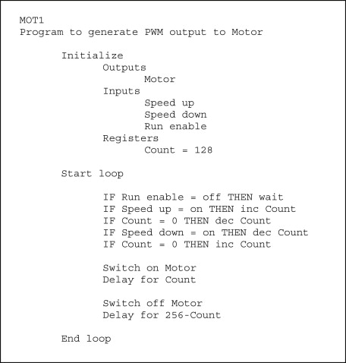

**Advantages of using Pseudocodes:**

* Improves the readability of any approach. It’s one of the best approaches to start implementation of an algorithm.
* Acts as a bridge between the program and the algorithm or flowchart. Also works as a rough documentation, so the program of one developer can be understood easily when a pseudo code is written out. In industries, the approach of documentation is essential. And that’s where a pseudo-code proves vital.
* The main goal of a pseudo code is to explain what exactly each line of a program should do, hence making the code construction phase easier for the programmer.

References:

Rouse, M., Smith, S., Rouse, M., & Rouse, M. (n.d.). What is pseudocode? - Definition from WhatIs.com. Retrieved from <https://whatis.techtarget.com/definition/pseudocode>.

GeeksforGeeks. December 2018 . How to write a Pseudo Code? Retrieved from <https://www.geeksforgeeks.org/how-to-write-a-pseudo-code/>

What is a Flowchart. (n.d.). Retrieved from <https://www.lucidchart.com/pages/what-is-a-flowchart-tutorial>

(n.d.). Retrieved from <https://www.visual-paradigm.com/tutorials/flowchart-tutorial/>

Flowchart. (n.d.). Retrieved from <https://www.smartdraw.com/flowchart/>

Flow Charts. November 2001. Retrieved from <https://www.inc.com/encyclopedia/flow-charts.html>