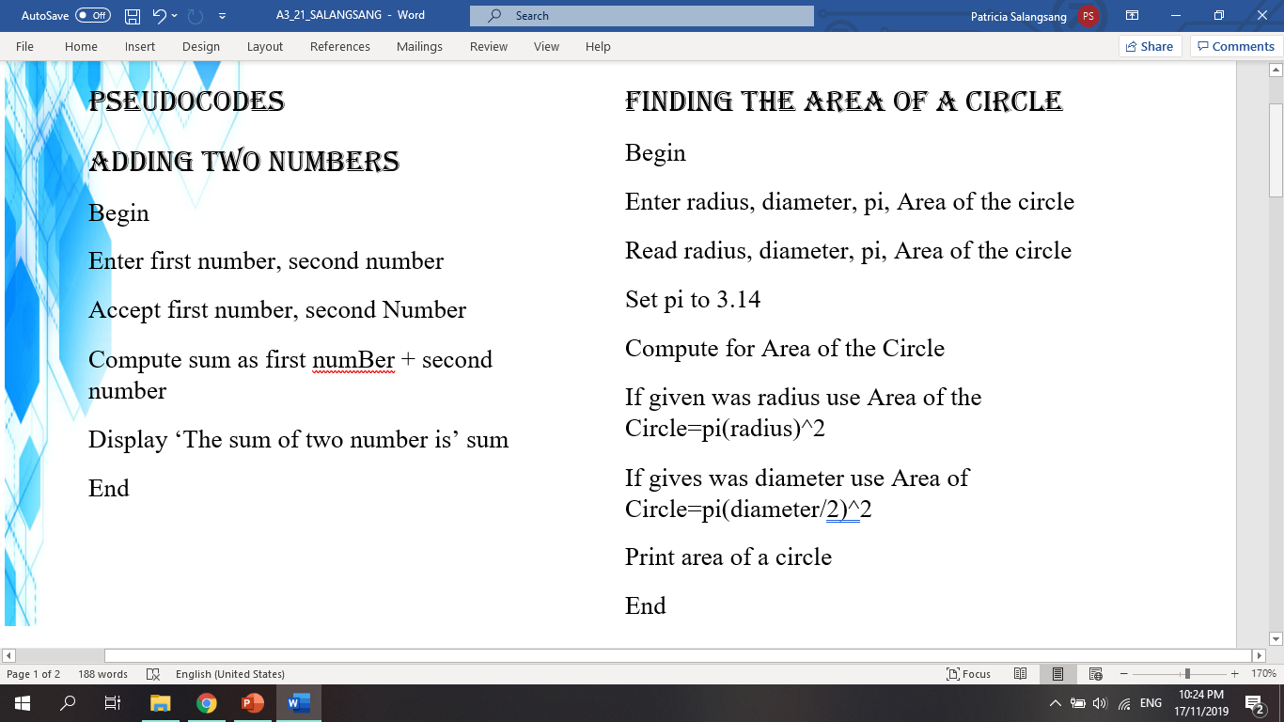PSEUDOCODES

ADDING TWO NUMBERS

Begin

Enter first number, second number

Accept first number, second Number

Compute sum as first numBer + second number

Display

‘The sum of two number is’ sum

End

IDENTIFYING WHETHER A NUMBER IS ODD OR EVEN

Procedure

1. Insert or identify a number

2. Read the number

3. Divide the number by 2

4. Examine if the remainder is equal to zero

5. If yes, proceed to step 7

6. If no, proceed to step 8

7. Display “EVEN” and proceed to step 9

8. Display “ODD” and proceed to step 9

9. Display options “Try again or Stop”

10. If “Try again” go proceed to step 1

11. If “Stop” end



Start

Declare “a”

Read “a”

If %2==0 then

print “EVEN”;

else

print “ODD”;

end if

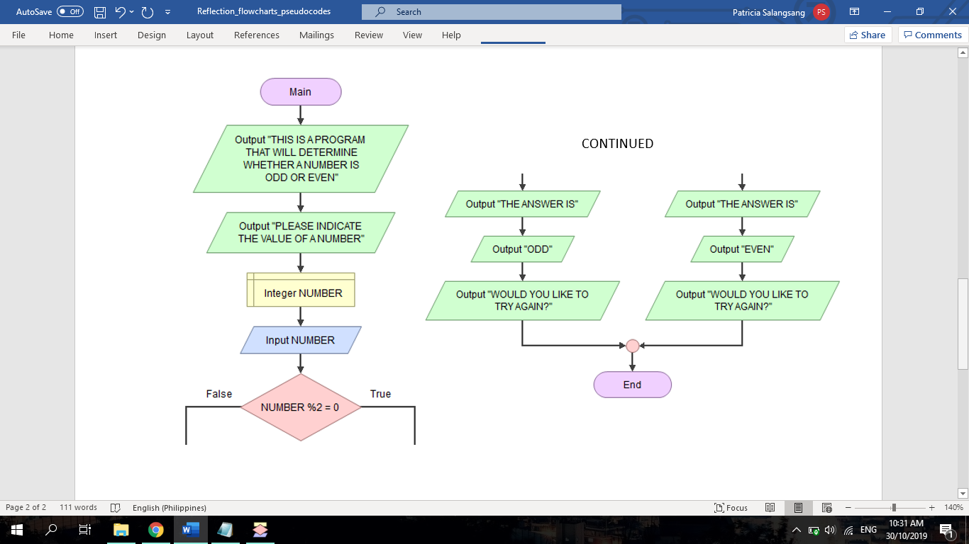Stop

